
AMRITA SCHOOL OF ENGINEERING, BENGALURU

DEPARTMENT OF ELECTRONICS & COMMUNICATION ENGINEERING

B. TECH. V SEMESTER (ECE AND EAC) AY 2025-2026

ASSIGNMENT FOR 23ECE302 VLSI DESIGN

SYSTEM DESIGN FOR 23ECE383 VLSI DESIGN LABORATORY
REPORT
JULY TO NOVEMBER 2025

TITLE OF THE SYSTEM DESIGN

Submitted by

BL.EN.U4ECE23208 D.S.V.SAINATH REDDY
BL.EN.U4ECE23213 G.SRISHANTH
BL.EN.U4ECE23215 MANSI AYYADEVARA
BL.EN.U4ECE23232 P.HARSHITHA

BATCH NUMBER:

FACULTY EXAMINER SIGNATURE WITH EVALUATION DATE

TITLE OF THE SYSTEM DESIGN PROJECT: Circuit implementation of a UWB pulse generator using the proposed dual-pulse frequency notching approach.

TITLE OF THE PAPER: Frequency Notching Applicable to CMOS Implementation of WLAN Compatible IR-UWB Pulse Generators

DETAILS OF THE PAPER (SOURCE OF THE TITLE):
Authors: Ming Shen , Jan H. Mikkelsen , Hao Jiang , Ole K. Jensen , Torben Larsen
Published in: IEEE International Conference on Ultra-Wideband (ICUWB), 2012.
Volume: N/A
Pages: 36–40
Publication Date: September 2012

CIRCUIT DIAGRAM:

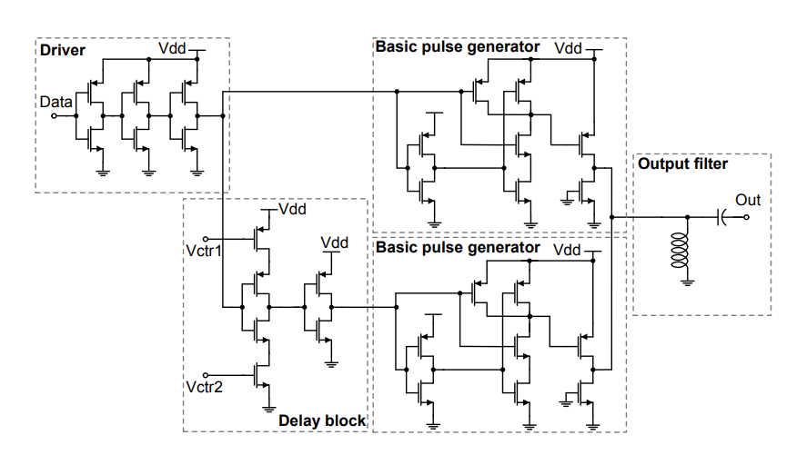

TOOL & TECHNOLOGY USED: Cadence Virtuoso , 45nm Technology

THEORY AND WORKING PRINCIPLE:
Impulse Radio Ultra-Wideband (IR-UWB) communication uses very short-duration pulses that spread energy across a wide frequency band (3.1–10.6 GHz). This band overlaps with WLAN (Wi-Fi) frequency bands, particularly around 5.15–5.85 GHz, causing mutual interference between UWB devices and Wi-Fi systems.
To reduce this interference, the UWB signal must be shaped such that its Power Spectral Density has notches at specific frequencies corresponding to WLAN bands. Traditional waveform-shaping techniques require complex mathematical pulse designs, which are difficult to implement on CMOS chips.
The Dual-Pulse Frequency Notching (DPFN) method provides a simpler approach. It relies on combining two identical UWB pulses separated by a precise time delay. This time delay causes destructive interference at specific frequencies in the frequency spectrum, thereby creating frequency notches without the need for complex pulse shaping equations.

- Generate a Basic UWB Pulse: A standard UWB pulse is produced using a basic pulse generator (e.g., Gaussian derivative pulse).
- Duplicate the Pulse: The same waveform is generated twice using two identical pulse generator blocks on the CMOS chip.
- Introduce a Time Delay (Td): One of the pulses is delayed by a controlled delay cell by a short time Td (typically in the order of 200–300 ps).
- Combine the Two Pulses: The delayed and non-delayed pulses are added together at the output.
- Destructive Interference Creates Notches: In the frequency domain, adding two time-shifted pulses results in a factor:
This factor causes destructive interference at frequencies:
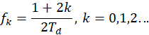
Thus, deep notches appear in the UWB spectrum at predictable frequencies.
By adjusting Td, the location of notches is tunable to fall exactly in WLAN bands (~5.5 GHz).

SCREENSHOT OF THE SIMULATOR BASED CIRCUIT IMPLEMENTATION:
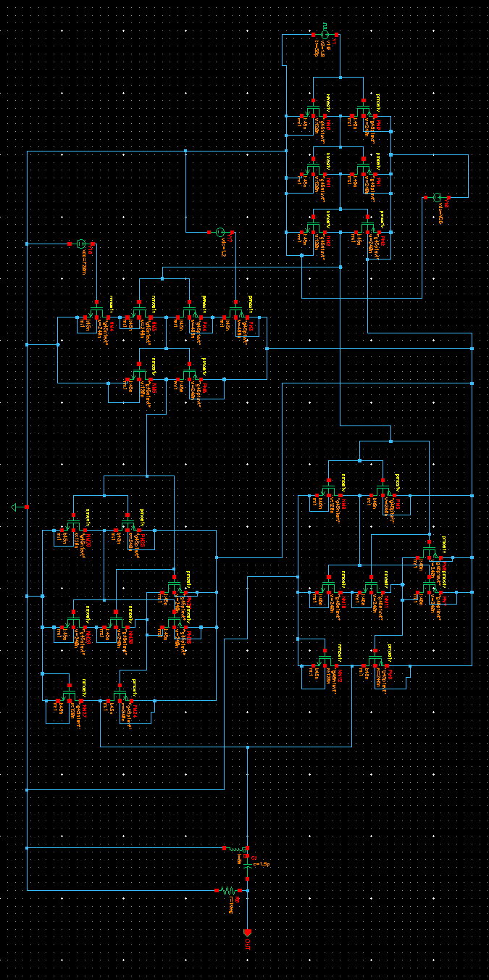

SCREENSHOT OF THE OUTPUT WAVEFORM OBTAINED FROM THE SIMULATOR

TRANSIENT
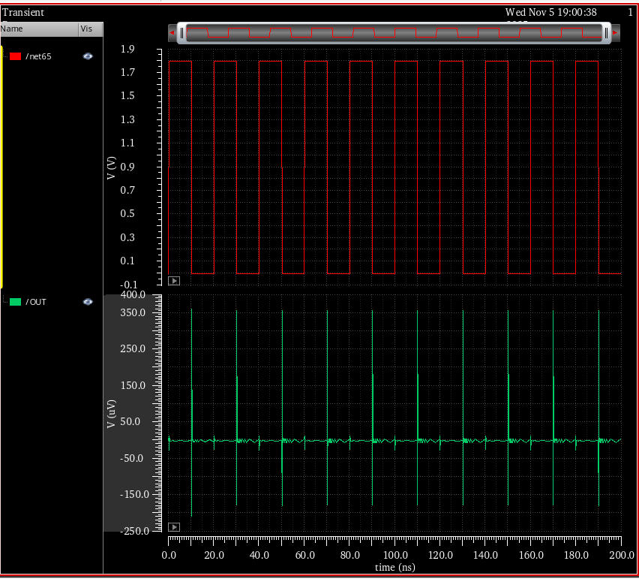

DC
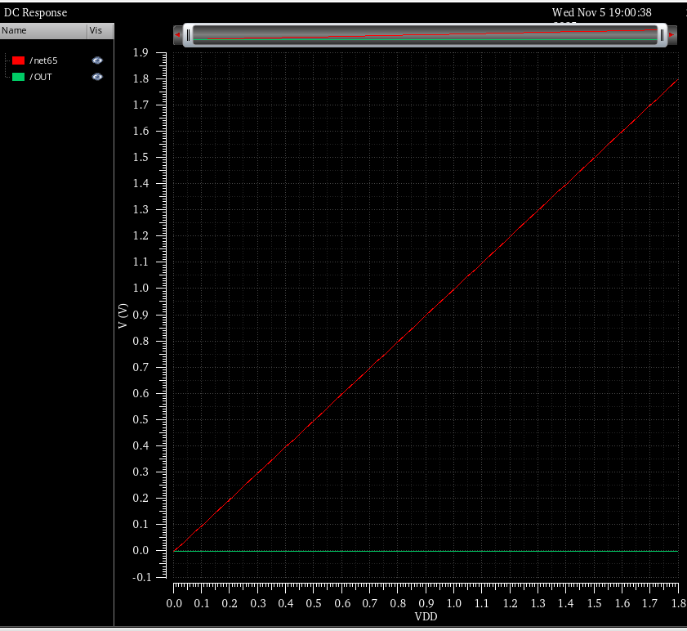

SCREENSHOT OF THE CIRCUIT BASED ON SIZING CONCEPT:

SCREENSHOT OF THE OUTPUT WAVEFORM OBTAINED FROM THE SIMULATOR FOR THE CIRCUIT WITH SIZING CONCEPT:

TRANSIENT:
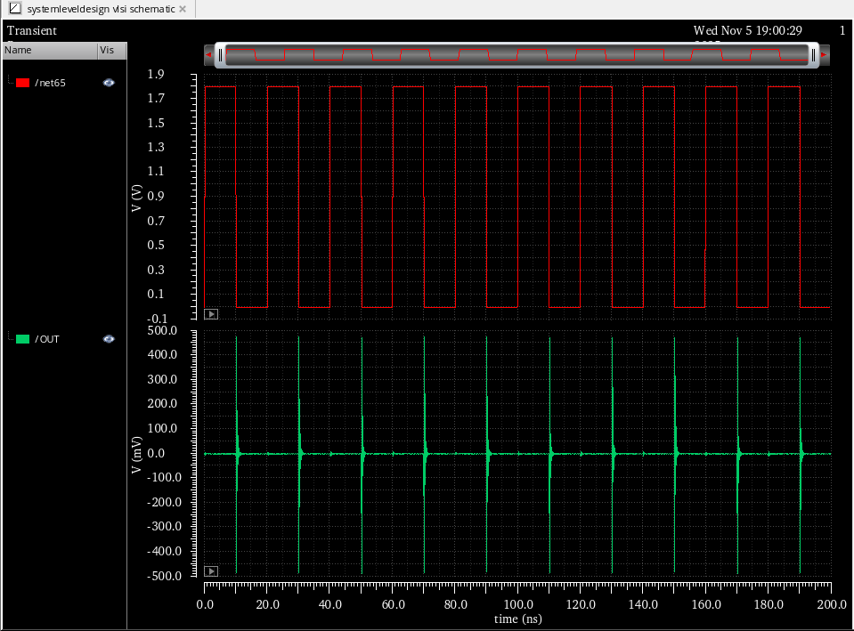

DC:
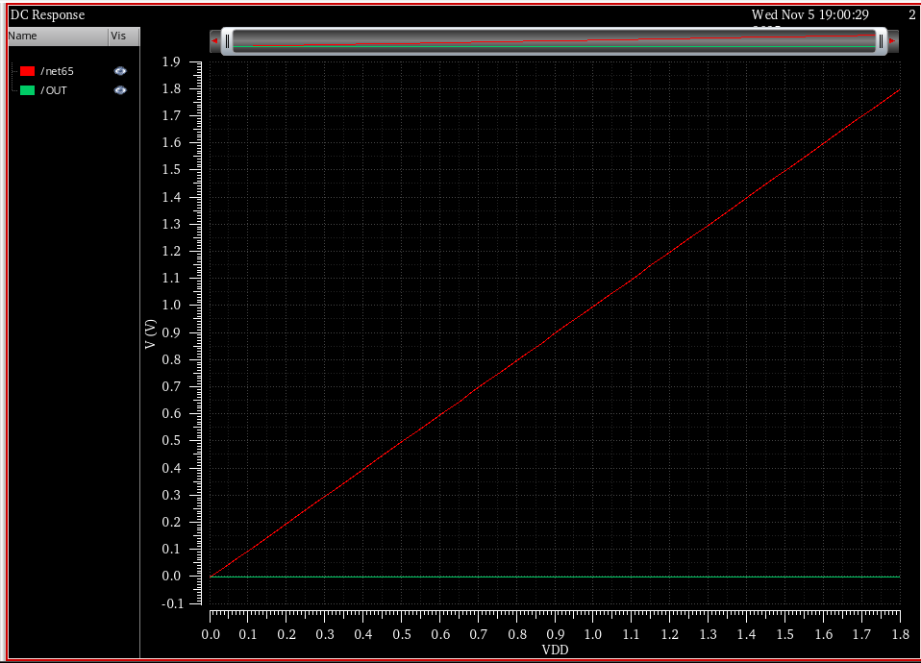

PROVIDE THE VALUES FOR THE FOLLOWING ALONG WITH THE SCREENSHOTS AS PROOF:

Parameter | Value without Sizing | Value with Sizing
Power calculation  (Total Power) | 888.2E-9 | 1.434E-6
Delay Calculation | - | 23.50E-12
Power Delay Product | - | 33.70E-18

POWER CALCULATION(BEFORE SIZING)

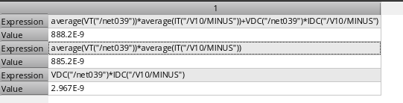

POWER CALCULATION(AFTER SIZING)

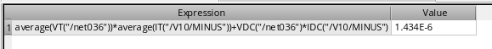

DELAY AND POWER DELAY CALCULATION(AFTER SIZING)

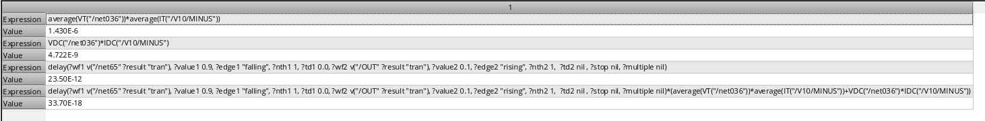

SCREENSHOT OF THE PVT ANALYSIS:
BEFORE SIZING:
TOTAL POWER
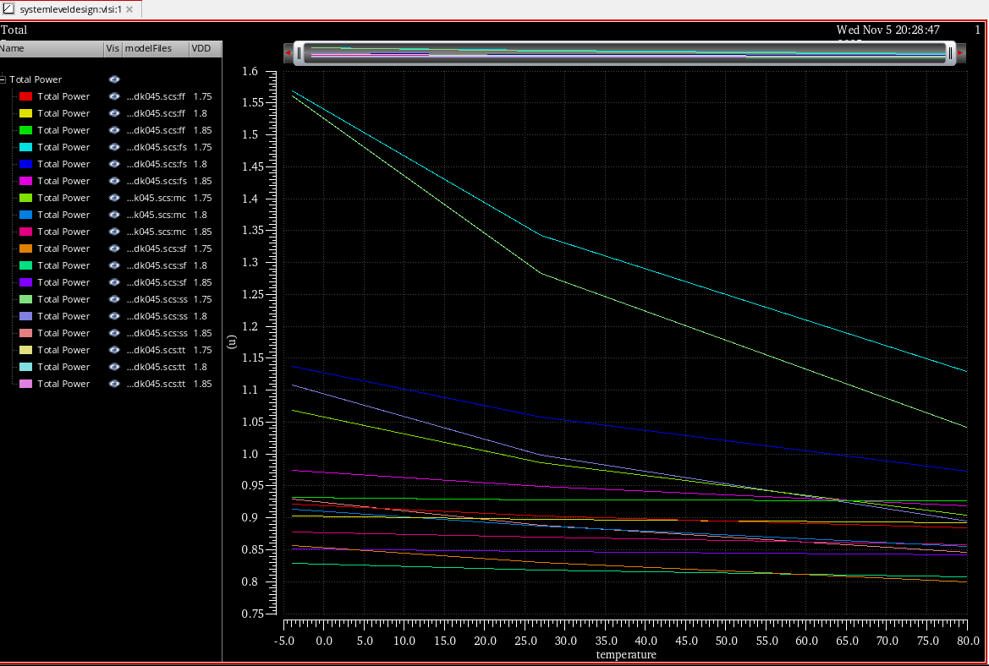

AFTER SIZING:
TOTAL POWER
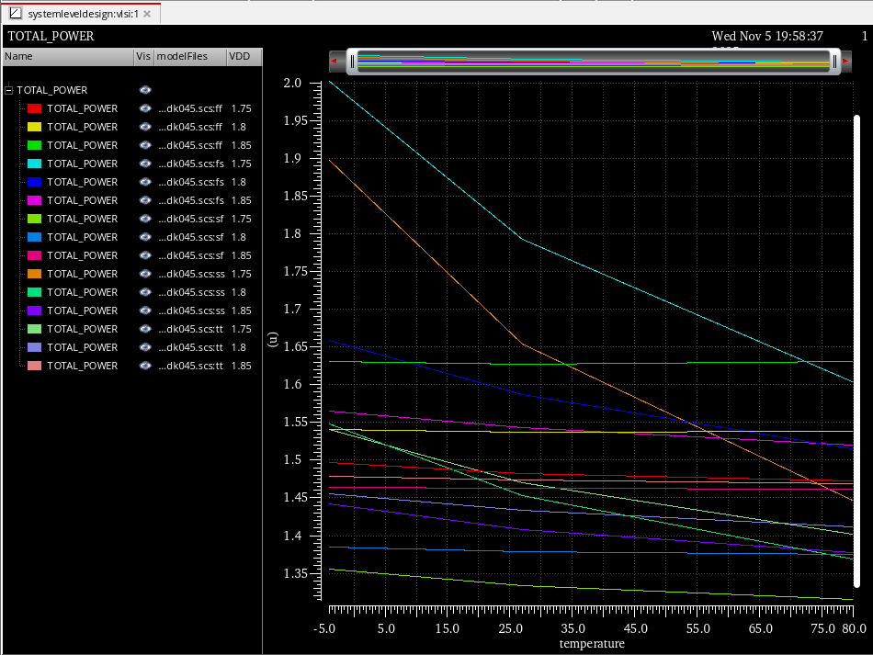

DELAY:

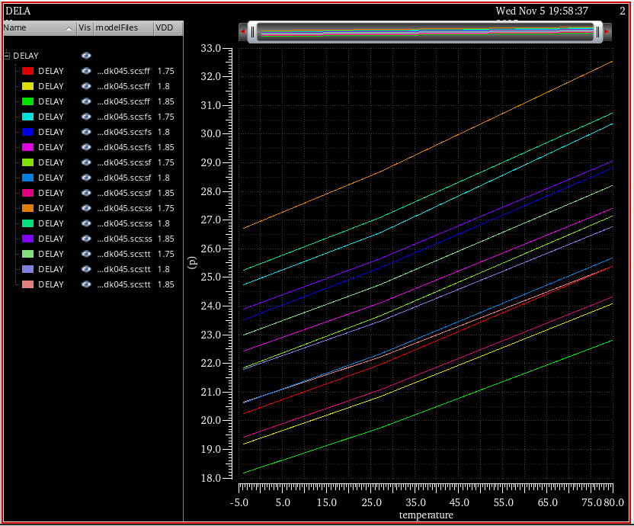

POWER DELAY:

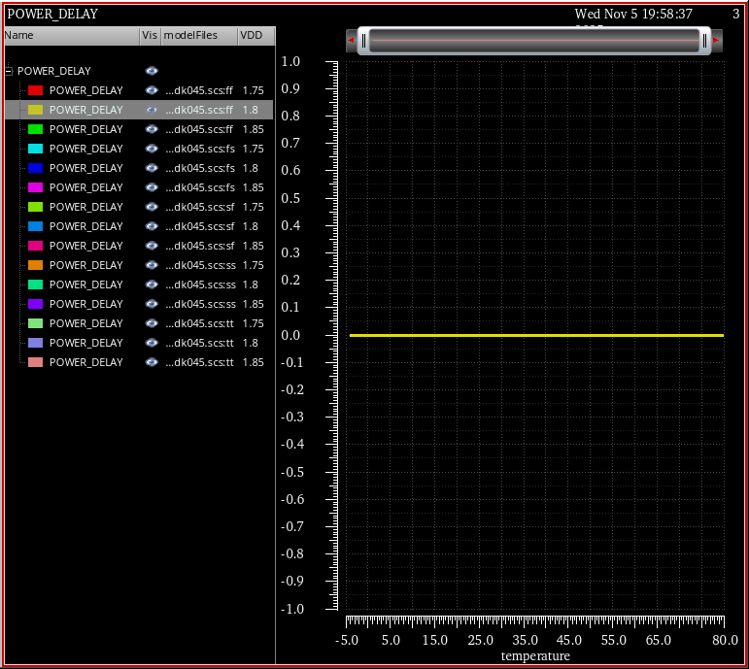

SCREENSHOT OF THE LAYOUT (WITHOUT SIZING):

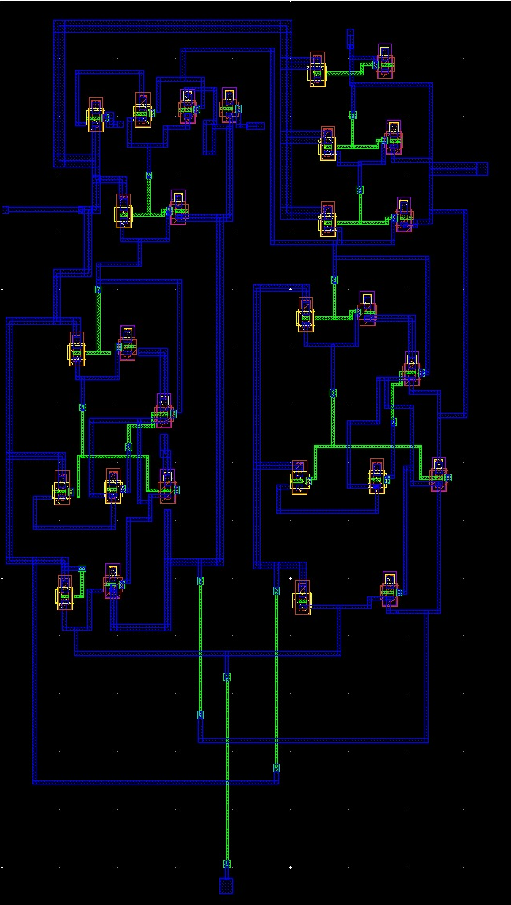

SCREENSHOT OF THE LAYOUT (WITH SIZING):

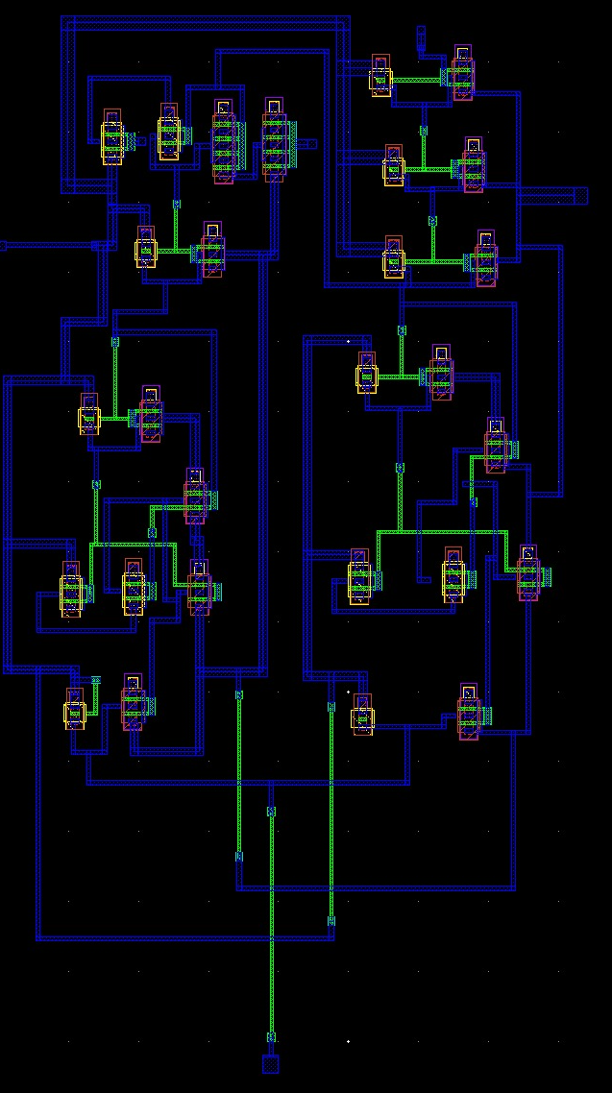

CONCLUSION:
The dual-pulse frequency notching UWB pulse generator was successfully designed and analyzed. Power, pulse delay, and overall timing delay were calculated to verify correct pulse shaping and notch formation. PVT (Process, Voltage, Temperature) analysis confirmed that the circuit maintains stable delay and notch positions under variations, ensuring reliable performance. The final layout was completed with matched routing for the two pulse paths to minimize amplitude mismatch and preserve notching depth. Overall, the design meets the intended spectral requirements while maintaining low power and robustness across operating conditions.

PROBLEMS FACED DURING THE IMPLEMENTATION:

- While calculating power and delay, issues occurred due to multiple Vdc sources in the schematic, as each symbol-based module had its own power and ground connections, leading to incorrect simulation results.

- During PVT (Process, Voltage, and Temperature) analysis, it was difficult to observe and compare how parameters such as power and delay varied with temperature across multiple process corners.

- In layout design, connecting transistors after sizing was challenging because some transistors had multiple gate, source, drain, and bulk terminals, making it hard to establish proper connectivity.

PROBLEMS RESOLVED USING SOLUTIONS:

- The circuit was redesigned at the transistor level without using separate symbol blocks, ensuring a single Vdc source and common ground for accurate power and delay measurement.

- Simulation data for 45 process corners were exported into a CSV file, and graphs were plotted externally to clearly analyze parameter variations during PVT analysis.

- The layout connectivity issue was resolved by learning that transistors in Cadence can be generated with all terminals internally connected by setting parameters such as the number of fingers or shared diffusion, simplifying the connection process.

REFERENCES:
Frequency Notching Applicable to CMOS Implementation of WLAN Compatible IR-UWB Pulse Generators
Ming Shen , Jan H. Mikkelsen , Hao Jiang , Ole K. Jensen , Torben Larsen

