# Introduction

The World Bank geospatial team have set up a github repository to store the information and training delivered to GSS from November 4th – 15th. This is a brief guide on how to set-up and use the github repository:

1. How to download the repository
2. How to participate in the repository
   1. Sign-up for github
   2. Download github desktop for windows
   3. Clone repository
   4. Make changes
   5. Push

Github is a change management and collaboration platform designed to allow collaborators to work together on code and projects.

# How to download the repository

Visit the repository <https://github.com/worldbank/GSS_Census_Tools>. In the top right there will be a button marked clone or download. Here you can download the zip file containing the entire repository.

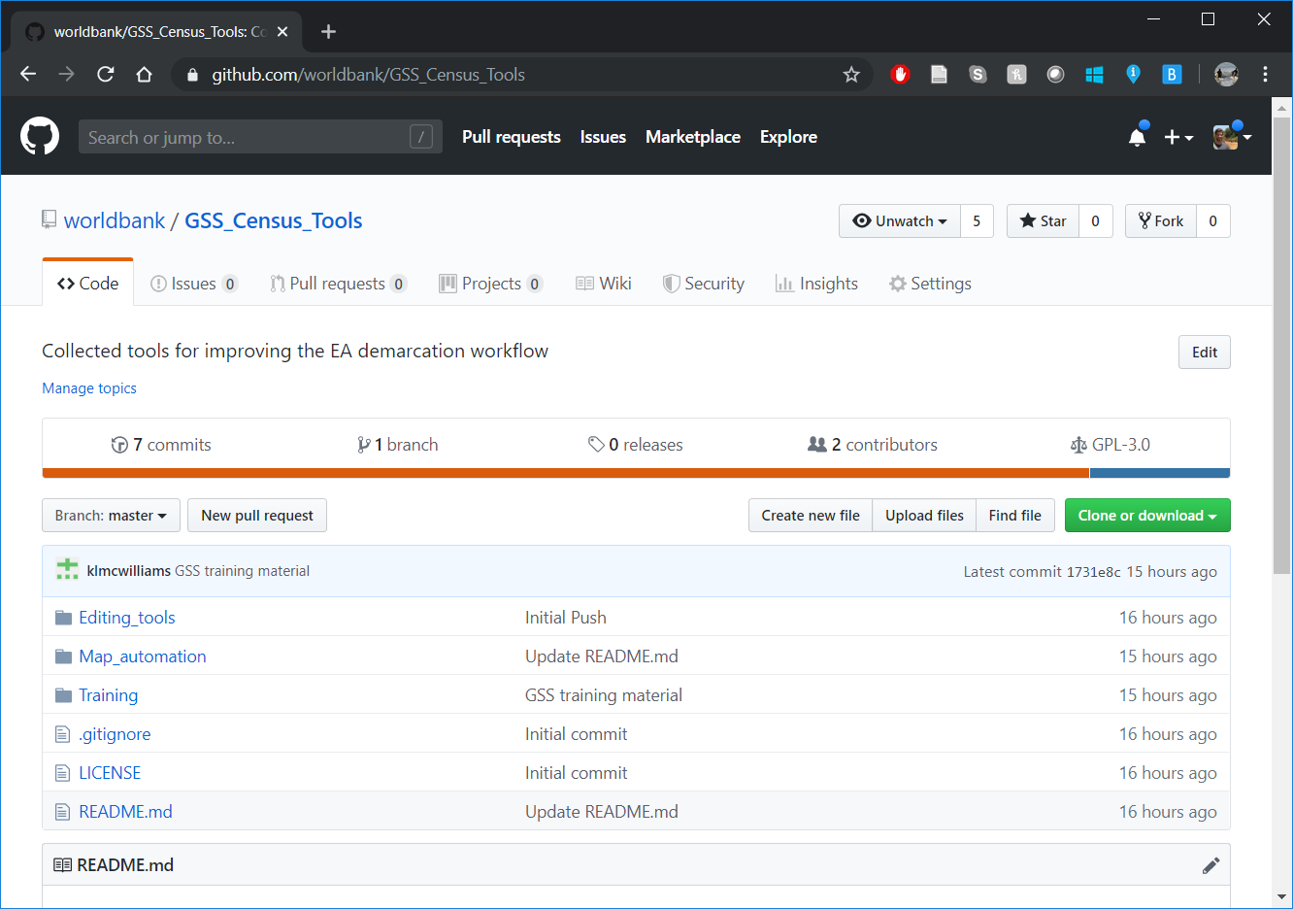

# How to participate in the repository

The github repository serves both as a method for disseminating information, and a place where we can discuss problems and new issues. It also serves as a place for collaboration – if someone outside the World Bank wants to add information or tools, they can equally contribute to the tool as well

## Creating a github user account

In order to participate in the issues tracker or in the repository content, you need to have a github username, and you need to ask the World Bank to add you as a trusted user to the account. Visit <https://github.com> and sign up for a FREE account. Once you have completed this process, send your username to [bstewart@worldbank.org](mailto:bstewart@worldbank.org), and Ben will add you to the github repository.

## Issues

The issue tracker is where GSS staff should send comments/questions about existing tools and suggestions/requests for new tools. At the top of the repository, there is a tab for issues. **In order to use the issue tracker, you need to be logged in**.



In the issue tracker you can either raise a new issue using the New Issue button, or you can check out an existing issue and either provide comments or a solution. It is important to consider tags and titles when using the issue tracker to make the information more searchable.

