

online Gas production shop
PROJECT

Software Requirements Specification
Version 2
<13/07/2023>

Đỗ Đức Hiếu
Lead Software Engineer

– Hanoi, Summer 2023 –

Revision History
Date | Description | Author | Comments
16/05/2023 | Version 1 | Đỗ Đức Hiếu, Nhâm Mạnh Hùng, Trần Quang Nam, Nguyễn Hoàng Dương | Basic client site
30/05/2023 | Version 2 | Đỗ Đức Hiếu, Nhâm Mạnh Hùng, Trần Quang Nam, Nguyễn Hoàng Dương | Basic client and admin site
13/06/2023 | Version 2.1 | Đỗ Đức Hiếu, Nhâm Mạnh Hùng, Trần Quang Nam, Nguyễn Hoàng Dương | Functions and features modified and added to admin site
22/06/2023 | Version 2.2 | Đỗ Đức Hiếu, Nhâm Mạnh Hùng, Trần Quang Nam, Nguyễn Hoàng Dương | Functions and features modified and added to client site
29/06/2023 | Version 3 | Đỗ Đức Hiếu, Nhâm Mạnh Hùng, Trần Quang Nam, Nguyễn Hoàng Dương | Complete, summarize functions, planning for future functions and features
13/07/2023 | Version 3.1 | Đỗ Đức Hiếu, Nhâm Mạnh Hùng, Trần Quang Nam, Nguyễn Hoàng Dương | Complete project

Document Approval
The following Software Requirements Specification has been accepted and approved by the following:
Signature | Printed Name | Title | Date
 | Đỗ Đức Hiếu | Leader | 13/07/2023
 | Nguyễn Thành Ý | Instructor, SWP 391 | 13/07/2023

Table of content
Revision History ii
Document Approval ii
Table of content iii
1. Introduction 1
1.1 Overview 1
1.2 Purpose 1
1.3 Scope 2
1.4 Definitions, Acronyms, and Abbreviations 2
2. General Description 2
2.1 Product Perspective 2
2.2 Product Functions 2
2.3 User Characteristics 3
2.4 General Constraints 3
3. Specific Requirements 4
3.1 External Interface Requirements 4
3.1.1 User Interfaces 4
3.1.2 Hardware Interfaces 4
3.1.3 Software Interfaces 4
3.1.4 Communications Interfaces 4
3.2 Functional Requirements 4
3.2.1 System Functional Overview 4
3.2.2 Tables of functional requirements 11
3.3 Use Cases 46
3.2.1 Use Case Overview 47
3.2.2 Use Case Admin 48
3.2.3 Use Case Staff 49
3.2.4 Use Case Customer 50
3.2.5 Use Case Guests 51
3.4 Non-Functional Requirements 51
3.4.1 Performance 51
3.4.2 Availability 52
3.4.3 Security 52
3.5 Other Requirements 52
A. Appendices 52
A.1 Business Rule 52
A.2 References 52

1. Introduction

1.1 Overview
The project intend to build an online website which connects the gas supplier to customers as well as support the sales of gas production such as gas tank, gas stove or gas-related accessories providing customers to the best experience with utility features, searching, ordering, purchasing and giving feedback for products. In addition, the site provides following services (warranty, repairing services, etc.) for each of the products sold.

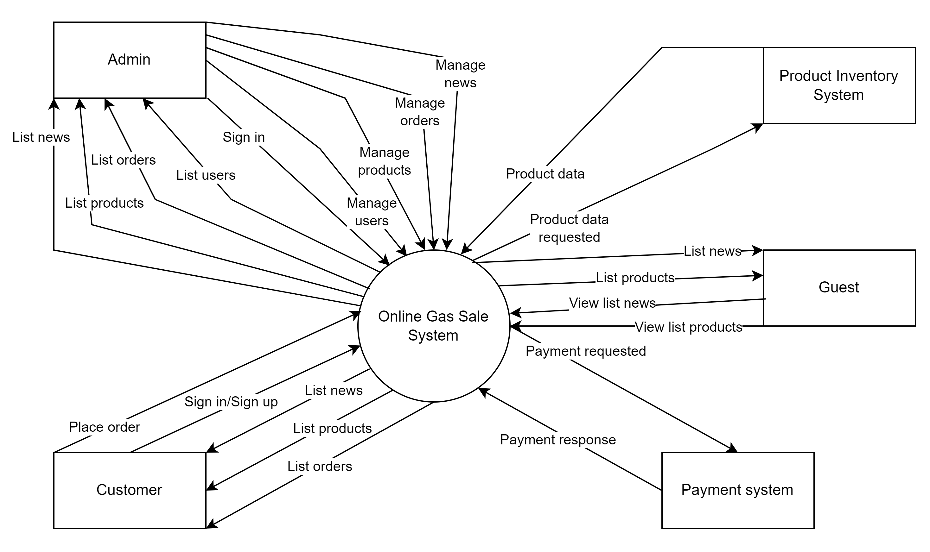
Figure 1.1. Context diagram for Online Gas Production Sale System

1.2 Purpose
The purpose of this document is to present a detailed description of the Gas Production Sale System. It will explain the purpose and features of the system, the interfaces of the system, what the system will do, the constraints under which it must operate and how the system will react to external stimuli. This document is intended for both the stakeholders and the developers of the system and will be proposed to the company’s board of directors for its approval.

1.3 Scope
This software system will be a Gas Production Sale System for a gas retailor shop. This system will be designed to maximize the productivity of selling gas production by providing tools to assist in automating the product management and ordering process, which would otherwise have to be performed manually. In addition, the warranty services can also be proceeded online where customer can contact to seller or choose a service directly through the website. By maximizing the managing efficiency and production the system will meet the customer’s needs while remaining easy to understand and use.
More specifically, this system is designed to allow an administrator to manage and record customers buying data to understand their demand of products and needs. The software will provide customers with bunch of promotions and information about products via E-Mail. The system also contains a relational database containing a list of Products, Customers, Orders, etc.

1.4 Definitions, Acronyms, and Abbreviations

SRS | Software Requirements Specifications
BR | Business Rule
UI | User Interface
N/A | Not applicable, not available
Use Case(s) | Diagram describe system requirements
UC | User Case
Figure 1.2. Table of definitions, acronyms and abbreviations

2. General Description

2.1 Product Perspective
- The Web Publishing System has four active actors and one cooperating system.
- The Customer or Guests accesses the Online Gas Production Shop through the Internet. Any activity such as ordering or commenting will be performed through the system online. The Administrator accesses the entire system directly.

2.2 Product Functions
- Client site:
- View list products: view list brief information of all products in the database.
- View product detail: view full information of a single product.
- View list news: view list brief information of all news in the database.
- View news detail: view full content of a single news.
- View list orders: view list of previous purchased order with brief information of a customer.
- View order detail: view full information of a single order.
- Purchase order: pay for an order through cash or online banking
- Search: search for products according to conditions (if there are some).
- Admint site
- Order management: allow users with customer role to add, edit, purchase orders.
- Customers management: allow users with administrator role to view customer’s data.
- Products management: allow users with administrator role to view, add, edit, and remove products data.
- News management: allow users with administrator role to view, add, edit, and remove news data.
- Services management: allow users with administrator role to view warranties data.
- Contents management: allow users with administrator role to view, add, edit, and remove contents data displayed in client screens.

2.3 User Characteristics
The system consists of roles namely Guests, Customer and Administrator.
- Guests: Users who visits the website without an account and only have the ability to view the information of products, news or comments. Buying and viewing cart information is disallowed.
- Customers: Users who has an account and have the full access to customer’s function such as viewing the information of products, news, comments, cart, cart history, etc. , placing order and use warranty service. The customer's role is to be the consumer of the online store's products and services. Customers can track or renew warranty when the product has a fault.
- Administrators: Users who runs the entire operation of the online store, including tasks such as managing products, orders, customers information, operating with statistics and also customizing the website. The administrator's role is to ensure that the operation of the website runs smoothly and efficiently, customer’s needs should be met, business goals should be achieved.

2.4 General Constraints
To run the application, the following conditions should be met:
- Apache NetBeans 13
- Apache Tomcat Server 10 and above
- Microsoft SQL Server 2019 and above

3. Specific Requirements

3.1 External Interface Requirements

3.1.1 User Interfaces
- UI-1: The website is responsive designed
- UI-2: The website is friendly to users, easy to interact
- UI-3: The website satisfies SEO standard
- UI-4: Theme colors are  (#242849) and  (#FF8C00)

3.1.2 Hardware Interfaces
- No hardware interfaces have been identified.

3.1.3 Software Interfaces
Specify the use of other required software products (e.g., a DBMS or operating system), and interfaces with other application systems. For each required software product, provide the following:
- JSP/JavaScript/CSS
- Java/Servlet
- Apache Tomcat Server
- Microsoft SQL Server

3.1.4 Communications Interfaces
- The web browser will automatically log out if the user does not use the system within 10 minutes
- In associated with VNPAY

3.2 Functional Requirements

3.2.1 System Functional Overview
- The system consists of about 18 screens on client site providing many functions where some screens are restricted to customer role only.
- The system consists of about 21 screens on admin site providing many functions where some screens are restricted to specific level of administrator.

3.2.1.1 Screens Flow
3.2.1.1.1. Client site

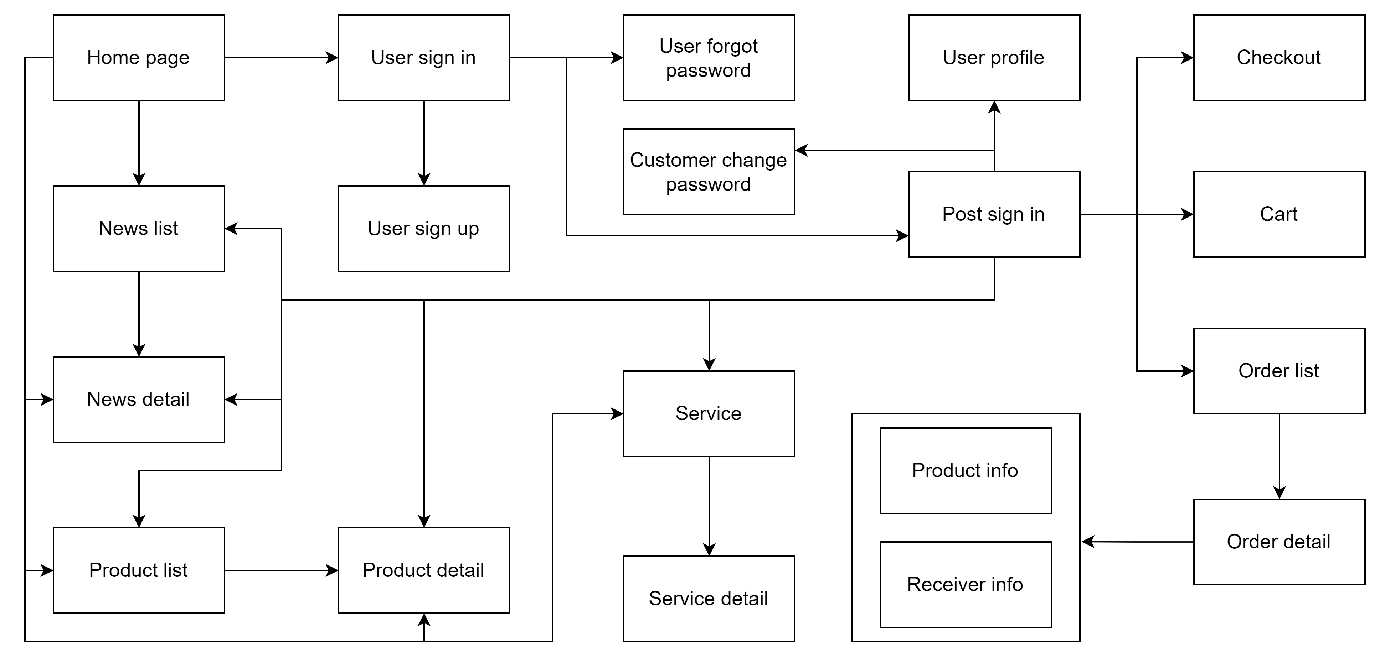
Figure 3.1. Screen flow diagram for Client site

3.2.1.1.1. Admin site

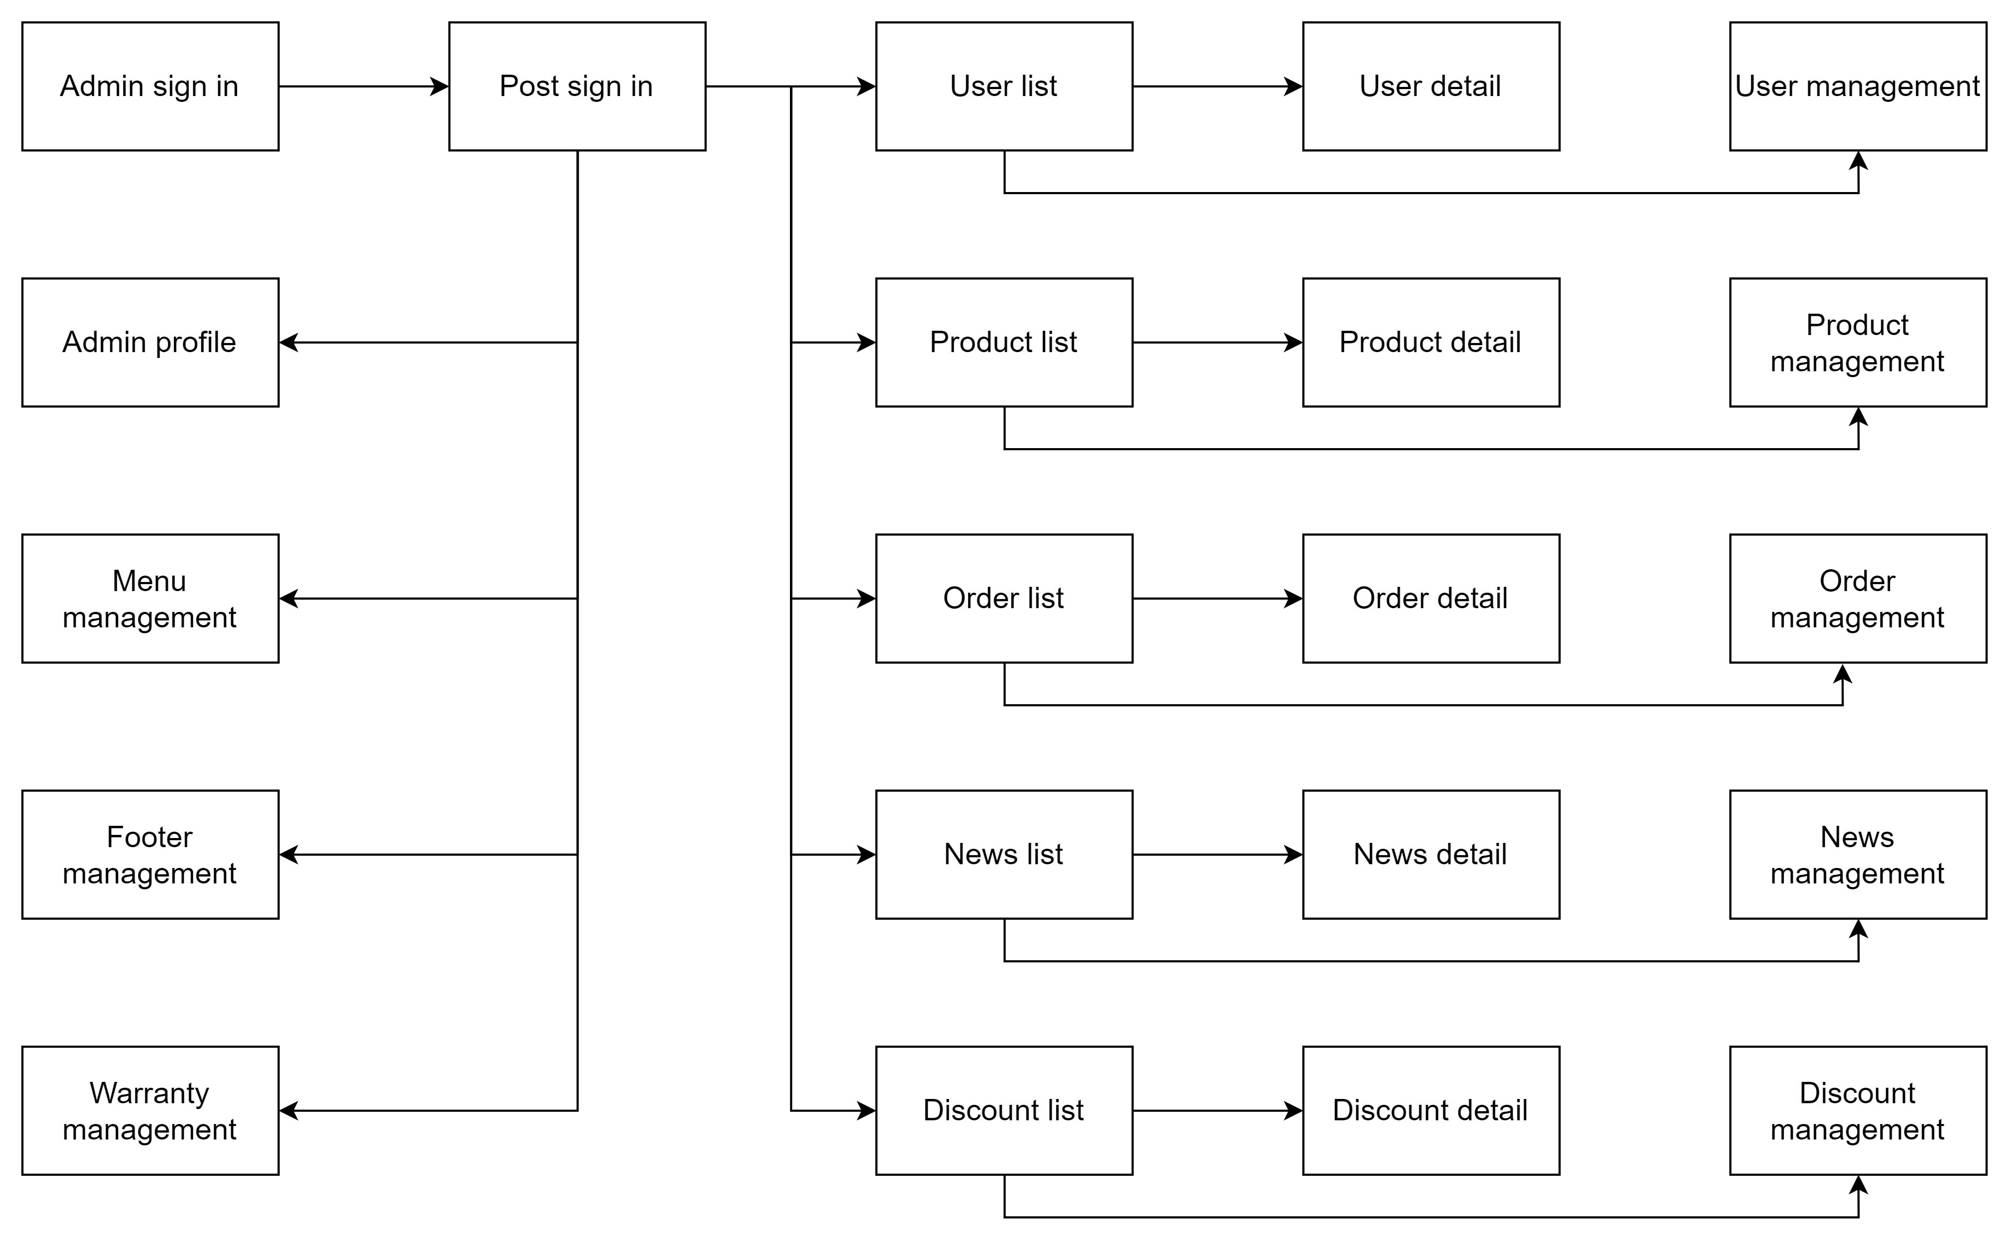

Figure 3.2. Screen flow diagram for Admin site

3.2.1.2 Screen Descriptions
3.2.1.2.1. Client site

# | Feature | Screen | Description
1 | View products | Home | View different lists of latest, most viewed products
2 | Sign up | Register | User create account with customer’s information
3 | Login | Login | Access to the website as customer role
4 | Update user | User detail | Update latest information of user profile
5 | View News | News | View the list of news
6 | View news detail | News detail | View detail information of a specific news
7 | View products | Product | View list all of products or group of products
8 | View product detail | Product detail | View detail information of a specific product
9 | View order history | Purchase history | View the list of orders have been ordered of the customer
10 | Add to cart | Cart | View the cart, add, delete or update products in the cart
11 | Checkout the order | Checkout | Fill in the information to check out the cart
12 | View order detail | Order detail | View a specific order of user (They can export it to a pdf file)
13 | Service | Service | Search for warranty expiration date or service information, request a service
14 | Service detail | Service detail | View detail information of a service bill

3.2.1.2.2. Admin site

# | Feature | Screen | Description
1 | Login | Login | Access to the website as admin role
2 | View data | Home | View general data such as statistics, charts.
3 | View list users | User management | View, sort, filter, search list users
4 | View user detail | User detail | View information of a user
5 | View list products | Product management | View, sort, filter, search, add, delete list products
6 | View product detail | Product detail | View detail information, update a product
7 | View list news | News management | View, sort, filter, search, add, delete list news
8 | View news detail | News detail | View detail information, update a news
9 | View list orders | Order management | View, sort, filter, search list orders
10 | View order detail | Order detail | View information of an order
11 | View list discounts | Discounts management | View, sort, filter, search, add, delete list discounts
12 | View discounts detail | Discounts detail | View detail information, update a discounts
13 | View list warranties | Warranty management | View, sort, filter, search list warranty bills
14 | View warranty detail | Warranty detail | View detail information of a warranty bill
15 | Modify menu contents of client site | Menu management | Add, delete or update contents displayed in the menu navigation bar in client site
16 | Modify footer contents of clients site | Footer management | Add, delete or update contents displayed in the footer in client site

3.2.1.3 Screen Authorization
Screen | Admin | Customer | Guests
Home Page | X | X | X
Product List | X | X | X
Product Details | X | X | X
View his/her orders |  | X
Employee Edit | X
News List | X | X | X
Add News | X
News Details | X | X | X
Edit News information | X
Coupon List | X
Coupon Details | X | X | X
Add new Coupon | X
Update Coupon | X
User Login | X | X | X
User Register | X | X | X
Forgot Password | X | X | X
Change Password | X | X | X
User Profile | X | X
Accounts List | X
Account Details | X
Customers List | X
Customers Details | X | X
Settings List | X
Setting Details | X
Figure 3.3. Table of screen authorization

3.2.1.4 Non-Screen Functions
- No non-screen functions have been identified.

3.2.1.5 Entity Relationship Diagram

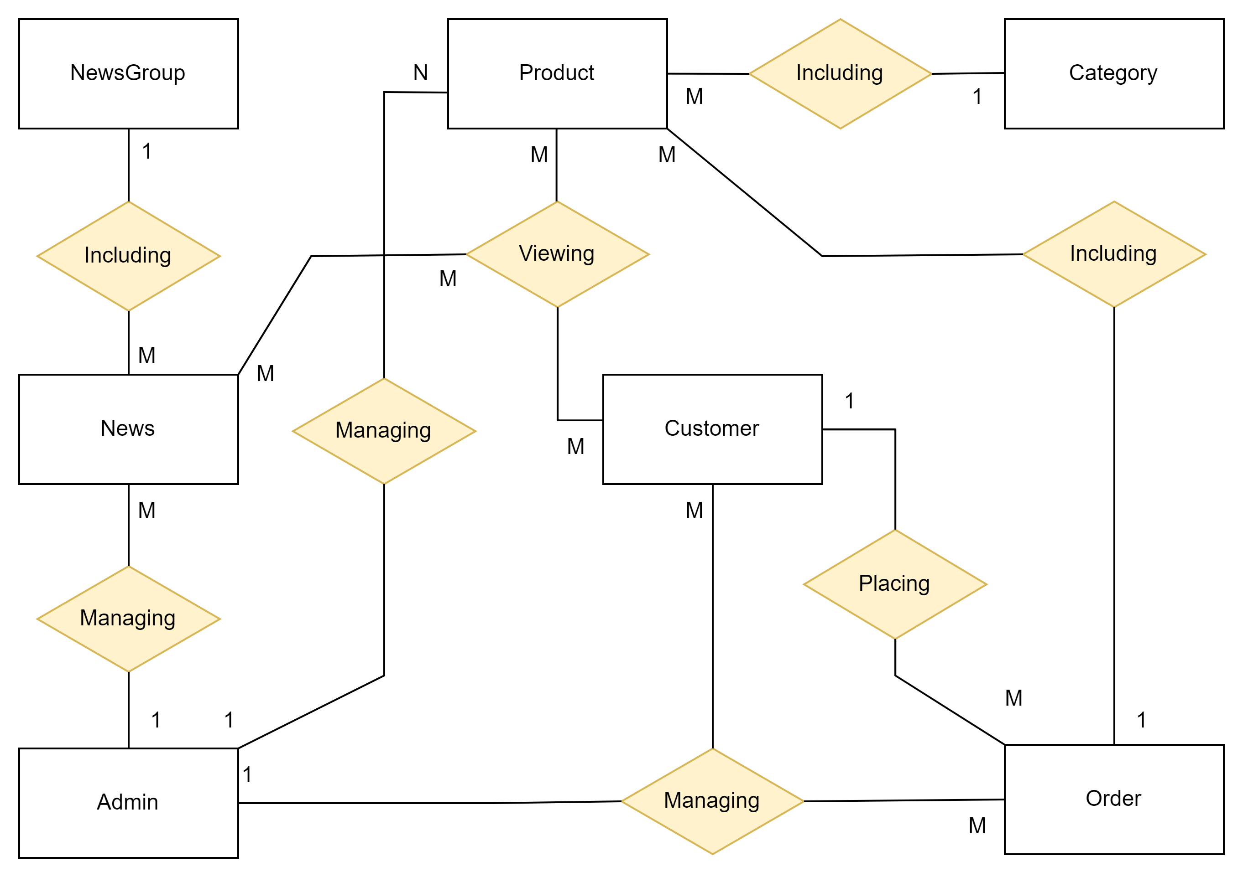
Figure 3.4. Entity Relationship Diagram

3.2.1.6 Entities Description
# | Entity | Description
1 | Customer | View, purchasing, commenting
2 | Product | Information delivered to users
3 | Category | Classifications of products
4 | Order | Purchases made by users
5 | Discount | Discounts applied to orders or products
6 | News Group | Classifications of news
7 | News | Elements on web interfaces or news of events
8 | Admin | Managing the system
Figure 3.8. Entities description table

3.2.2 Tables of functional requirements

3.2.2.1. Account

UC-1. Sign in with password (Client)

UC ID and Name: | Sign in with password
Created By: | HungNM | Date Created: | 23/05/2023
Primary Actor: | Customer | Other  Actors: | N/A
Trigger: | Actor clicks Sign In button
Description: | Actor can access exist account via phone number and password
Preconditions: | Exist account in databases & click button Sign in
Postconditions: | Actor is redirected to the home page after successful login authentication.
Normal Flow: | 1 - Actor accesses the Sign In page.  2 - Actor enters phone number and password.  3 - Actor presses the "Sign In" button.  4 - The system checks the phone number, password and validates it with the data in database  5 - The system redirects the user to the home page after successful login
Alternative Flows: | N/A
Exceptions: | If phone number or password is incorrect or null, deny access and show message
Priority: | Normal
Frequency of Use: | Usually
Business Rules: | BR-01, BR-03, BR-04, BR-05, BR-08, BR-12
Other Information: | N/A
Assumptions: | N/A

UC-2. Sign in with password (Admin)
UC ID and Name: | Sign in with password
Created By: | HungNM | Date Created: | 22/06/2023
Primary Actor: | Admin | Other  Actors: | N/A
Trigger: | Actor enter right url
Description: | Actor can access exist account via phone number and password
Preconditions: | Exist account in databases & click button Sign in
Postconditions: | Actor is redirected to the home page after successful login authentication.
Normal Flow: | 1 - Actor enter the right url to access Sign in page  2 - Actor enters phone number and password.  3 - Actor presses the "Sign In" button.  4 - The system checks the phone number, password and validates it with the data in database  5 - The system redirects the user to the home page after successful login
Alternative Flows: | N/A
Exceptions: | If phone number or password is incorrect or null, deny access and show message
Priority: | Normal
Frequency of Use: | Usually
Business Rules: | BR-01, BR-03, BR-04, BR-05, BR-08, BR-12
Other Information: | N/A
Assumptions: | N/A

UC-3. Sign up with password
UC ID and Name: | Sign up with password
Created By: | HungNM | Date Created: | 23/05/2023
Primary Actor: | Guests | Other  Actors: | N/A
Trigger: | Actor clicks Sign Up
Description: | Actor can create account to become Customer with password
Preconditions: | Invalid phone number & Click button Sign up
Postconditions: | Actor is successfully registered and has a new account in the system. Actor is redirected to the home page
Normal Flow: | 1 - Actor accesses the Sign Up page.  2 - Actor fills in necessary information such as first name, last name, phone number and password.  3 - Actor presses the "Sign Up" button.  4 - The system checks the validity of the phone number with the data in the database.  5 - The system creates a new account for the Actor and sign in automatically
Alternative Flows: | N/A
Exceptions: | If account is existed in database, show an error message and don’t allow make account
Priority: | Normal
Frequency of Use: | Usually
Business Rules: | BR-01, BR-03, BR-04, BR-05, BR-08, BR-09, BR-12
Other Information: | N/A
Assumptions: | N/A

UC-4. Sign Out
UC ID and Name: | Sign out
Created By: | HungNM | Date Created: | 23/05/2023
Primary Actor: | Customer | Other  Actors: | Admin
Trigger: | Actor clicks Sign Out
Description: | Actor can be out of their account
Preconditions: | Actor already Sign in or Sign up.
Postconditions: | Actor logs out of account and is redirected to the home page.
Normal Flow: | 1 - Actor presses the "Sign Out" button on the top-right screen  2 - The system deletes the current sign in from the session and redirects the actor to the home page.
Alternative Flows: | N/A
Exceptions: | N/A
Priority: | Normal
Frequency of Use: | Usually
Business Rules: | N/A
Other Information: | N/A
Assumptions: | N/A

UC-5. Sign In and Sign Up with Google
UC ID and Name: | Sign In and Sign Up with Google
Created By: | HungNM | Date Created: | 06/6/2023
Primary Actor: | Customer | Other  Actors: | Guests
Trigger: | Actor clicks the Google icon in the sign in page
Description: | Actor can access the account which is linked with Google account or create new account with Google account
Preconditions: | Actor have Google account
Postconditions: | Actor is redirected to the home page after successful authentication.
Normal Flow: | 1 - Actor clicks the Google icon in the sign in page and choose their Google account  2 - The system checks the Google account information  + Create new account with Google account information if that is new Google account  + Access the account if it's a previously linked google account  3 – Actor is redirected to the home page
Alternative Flows: | N/A
Exceptions: | If the Google server die, can’t access account or make account
Priority: | Normal
Frequency of Use: | Usually
Business Rules: | N/A
Other Information: | N/A
Assumptions: | N/A

UC-6. Forgot password
UC ID and Name: | Forgot password
Created By: | HungNM | Date Created: | 05/06/2023
Primary Actor: | Customer | Other  Actors: | Admin
Trigger: | Actor clicks forgot password button in Sign In page
Description: | Actor can make new password with phone number verify
Preconditions: | Actor already have account with password in database
Postconditions: | New account password is made
Normal Flow: | 1 - Actor clicks forgot password button in Sign In page  2 - Actor enter phone number of the account  3 - Actor click send button to send verify code to their phone  4 - The system checks the validity of the phone number and send verify code to that phone number  5 – Actor enter the verify code and click verify button to check  6 – The system checks the verify code in system with the code which is entered by Actor and move to make new password page  7 – Actor enter new password and re-new password  8 – The system check the validity of the new password and move to Sign in page with message
Alternative Flows: | N/A
Exceptions: | If phone number is invalid, verify code is not the same as the code in system, new password is not the same as re-new password ,don’t allow to move to make new password page and send message
Priority: | Normal
Frequency of Use: | Usually
Business Rules: | BR-01, BR-03, BR-04, BR-05, BR-06, BR-08, BR-10, BR-12
Other Information: | N/A
Assumptions: | N/A

UC-7. Update User Detail
UC ID and Name: | Update customer profile
Created By: | HungNM | Date Created: | 30/05/2023
Primary Actor: | Customer | Other  Actors: | Admin
Trigger: | Actor clicks their name on the top-right screen
Description: | Actor can add, update their information account
Preconditions: | Actor already Sign in or Sign up
Postconditions: | Actor information is successfully updated in the system.
Normal Flow: | 1 - Actor presses their name on the top-right screen to access Update page  2 - Actor can see their phone number and edits information like first name, last name, email, avatar  3 - Actor presses the "Save" button to update the information.  4 - The system checks the validity of the update and performs the update in the database.
Alternative Flows: | N/A
Exceptions: | If email, phone number is not in format, avatar image is invalid type, don’t allow to update and send message
Priority: | Normal
Frequency of Use: | Usually
Business Rules: | BR-02, BR-13
Other Information: | N/A
Assumptions: | N/A

UC-8. Change password
UC ID and Name: | Change password
Created By: | HungNM | Date Created: | 25/05/2023
Primary Actor: | Customer | Other  Actors: | N/A
Trigger: | Actor clicks change password in update user detail page
Description: | Actor can make new password via old password
Preconditions: | Actor already Sign in or Sign up with password
Postconditions: | Account password is changed
Normal Flow: | 1 - Actor presses their name on the top-right screen to access Update page  2 - Actor click Change password button  3 - Actor enter old password, new password and repassword  4 - The system checks the validity of the password and performs the change in the database.
Alternative Flows: | N/A
Exceptions: | If old password is invalid and new password is not the same as re-new password, don’t allow to change and send message
Priority: | Normal
Frequency of Use: | Usually
Business Rules: | BR-04, BR-05, BR-06
Other Information: | N/A
Assumptions: | N/A

UC-9. View list customer account
UC ID and Name: | View list user account
Created By: | HungNM | Date Created: | 01/06/2023
Primary Actor: | Admin | Other  Actors: | N/A
Trigger: | Actor clicks Customer management in sidebar
Description: | Actor can view list Customer account with related information
Preconditions: | Having admin account and already Sign in
Postconditions: | Actor view list Customer account with related information
Normal Flow: | 1 - Actor clicks user management in sidebar  2 - The system list all user account  3 – Actor choose fitler to order the list
Alternative Flows: | N/A
Exceptions: | If there is no Customer account, show “No information” in Customer management page
Priority: | Normal
Frequency of Use: | Usually
Business Rules: | N/A
Other Information: | N/A
Assumptions: | N/A

UC-10. Authorize staff
UC ID and Name: | Authorize staff
Created By: | HungNM | Date Created: | 28/06/2023
Primary Actor: | Admin | Other  Actors: | N/A
Trigger: | Actor clicks staff management on the side bar
Description: | Actor can authorize staff
Preconditions: | Having admin account and already Sign in
Postconditions: | Staff role is changed
Normal Flow: | 1 - Actor clicks staff management in in sidebar  2 – Actor choose the role of each account, click submit button to confirm, delete button to delete account  3 - The system checks account in database and update data
Alternative Flows: | N/A
Exceptions: | N/A
Priority: | Normal
Frequency of Use: | Usually
Business Rules: | N/A
Other Information: | N/A
Assumptions: | N/A

3.2.2.2. Home

UC-1. Edit navbar
UC ID and Name: | Change password
Created By: | HungNM | Date Created: | 15/06/2023
Primary Actor: | Admin | Other  Actors: | N/A
Trigger: | Actor clicks menu management in client management in sidebar
Description: | Actor can edit the navbar in client
Preconditions: | Having admin account and already Sign in
Postconditions: | Navbar change
Normal Flow: | 1 - Actor clicks menu management in client management in sidebar  2 – Actor drop and drag to change the order of elements in navbar clicks submit button to confirm  3- Actor clicks elements to show delete button with can delete elements  4 – Actor enter new element, link and click Add button to add new element to navbar
Alternative Flows: | N/A
Exceptions: | N/A
Priority: | Normal
Frequency of Use: | Usually
Business Rules: | N/A
Other Information: | N/A
Assumptions: | N/A

UC-2. Edit footer
UC ID and Name: | Edit footer
Created By: | HungNM | Date Created: | 23/6/2023
Primary Actor: | Admin | Other  Actors: | N/A
Trigger: | Actor clicks footer management in client management in sidebar
Description: | Actor can edit footer in client
Preconditions: | Having admin account and already Sign in
Postconditions: | Footer in client is changed
Normal Flow: | 1 - Actor clicks footer management in client management in sidebar  2 – Actor click each section to see the corresponding links  3 - Actor click add button in the end of each section to add new links  4 – Actor click delete icon to delete that link  5 – Actor enter footer content and click save button to confirm
Alternative Flows: | N/A
Exceptions: | If footer content is too long, don’t allow to update and show message
Priority: | Normal
Frequency of Use: | Usually
Business Rules: | - Content is no more than 750 characters
Other Information: | N/A
Assumptions: | N/A

UC-3. Edit slide banner
UC ID and Name: | Edit home slide banner
Created By: | HungNM | Date Created: | 27/06/2023
Primary Actor: | Admin | Other  Actors: | N/A
Trigger: | Actor clicks footer management in client management in sidebar
Description: | Actor can edit slide banner in client
Preconditions: | Having admin account and already Sign in
Postconditions: | Home slide banner is changed
Normal Flow: | 1 - Actor clicks banner management in client management in sidebar  2 – Actor enter banner information such as title, content, image  3- Actor clicks save button to confirm
Alternative Flows: | N/A
Exceptions: | if content is too long and image is invalid type, don’t allow to add and show message
Priority: | Normal
Frequency of Use: | Usually
Business Rules: | - Content is no more than 750 characters
Other Information: | N/A
Assumptions: | N/A

3.2.2.3. Product

UC-1. View the product page (Client)
UC ID and Name: | View the product page (Client)
Created By: | DuongNH | Date Created: | 23/05/2023
Primary Actor: | Customer | Other  Actors: | Guests
Trigger: | Actor hovers on the product page navigation link and clicks on the sub-links.
Description: | Actor can view the shop products with related information
Preconditions: | N/A
Postconditions: | Access the product page website successfully.
Normal Flow: | 1. Hover on "Product " button on the menu from home page, then, a dropdown list of the categories will appear  2. Actor can click on the list categories to select or click on “All Product” to see all products available  3. Click on product links will access to its detail page  4. Click on categories group on the side to filter types of products  5. Click on page below to view different sheet of products when there are too many product to display
Alternative Flows: | N/A
Exception: | N/A
Priority: | Normal
Frequency of Use: | Usually
Business Rules: | N/A
Other Information: | N/A
Assumptions: | N/A

UC-2. View the product page (Admin)
UC ID and Name: | View the product page (Admin)
Created By: | DuongNH | Date Created: | 12/06/2023
Primary Actor: | Admin | Other  Actors: | N/A
Trigger: | Actor clicks on the product management navigator in the sidebar
Description: | Actor can view the shop products with all information in the database
Preconditions: | Having admin account and already Sign in
Postconditions: | Access the product management site successfully.
Normal Flow: | 1. Actor clicks on the Product management link in the sidebar  2. Actor access to the Product page
Alternative Flows: | N/A
Exception: | Actor access the page (with the link of the page in url) without login, the application takes them to the 404 page.
Priority: | Normal
Frequency of Use: | Usually
Business Rules: | N/A
Other Information: | N/A
Assumptions: | N/A

UC-3. View the product detail
UC ID and Name: | View the product detail page
Created By: | DuongNH | Date Created: | 23/05/2023
Primary Actor: | Customer | Other  Actors: | Guests
Trigger: | Actor clicks on a random product link
Description: | Actor can view detailed description of products
Preconditions: | N/A
Postconditions: | User access the product detail page successfully.
Normal Flow: | 1. Actor can see the list of all products, which can be viewed by categories or sorted (most viewed, latest, al). The list has been paginated.  2. Each product have view detail, add, update and delete button for that news.  3. Actors can search the news they want by the search box. (The result is the products (paginated) have name or model related to the word of the search box)
Alternative Flows: | N/A
Exceptions: | N/A
Priority: | Normal
Frequency of Use: | Usually
Business Rules: | N/A
Other Information: | N/A
Assumptions: | N/A

UC-4. Post comments on products
UC ID and Name: | Post comments on products
Created By: | DuongNH | Date Created: | 23/05/2023
Primary Actor: | Customer | Other  Actors: | Guests
Trigger: | Actor clicks on the review card in the product detail page
Description: | Actor can post their comments and ratings for the of products
Preconditions: | N/A
Postconditions: | Comments posted successfully and saved to database for the host to view, customer can see their comments below the product detail
Normal Flow: | Actor click on review card to post reviews. Actor is required to fill in name, title and description in order to post review
Alternative Flows: | N/A
Exceptions: | N/A
Priority: | Normal
Frequency of Use: | Usually
Business Rules: | BR-09
Other Information: | N/A
Assumptions: | N/A

UC-5. Search products by filters (Client)
UC ID and Name: | Search product by filters (client)
Created By: | DuongNH | Date Created: | 13/06/2023
Primary Actor: | Customer | Other  Actors: | Guests
Trigger: | Actor clicks on the search button in the product page
Description: | Actor can using product filters to search for the desired products
Preconditions: | N/A
Postconditions: | Display all products met the required filters to the shop page
Normal Flow: | 1. Actor fill in search information, price range, category,…  2. Actor press enter to search filter
Alternative Flows: | N/A
Exceptions: | N/A
Priority: | Normal
Frequency of Use: | Usually
Business Rules: | N/A
Other Information: | N/A
Assumptions: | N/A

UC-6. Search products by filters (Admin)
UC ID and Name: | Search product by filters (admin)
Created By: | DuongNH | Date Created: | 13/06/2023
Primary Actor: | Admin | Other  Actors: | N/A
Trigger: | Actor clicks on the Apply button in the product management page
Description: | Actor can using product filters to search for the desired products by name, model, category and sort the result with editable pagination
Preconditions: | Having admin account and already Sign in
Postconditions: | Display all products met the required filters to the shop page in pagination
Normal Flow: | 1. Actor fill in search information, category, sorting option, number of product displayed,…  2. Actor clicks on Apply to search filter
Alternative Flows: | N/A
Exceptions: | Actor access the page (with the link of the page in url) without login, the application takes them to the 404 page.
Priority: | Normal
Frequency of Use: | Usually
Business Rules: | N/A
Other Information: | N/A
Assumptions: | N/A

UC-7. Add new product
UC ID and Name: | Add new product
Created By: | DuongNH | Date Created: | 13/06/2023
Primary Actor: | Admin | Other  Actors: | N/A
Trigger: | Actor clicks on the Add item in the product management page
Description: | Actor can add new product to the shop
Preconditions: | Having admin account and already Sign in
Postconditions: | Add a new product to the Product table in the database
Normal Flow: | 1. Actor fill in new product information, name, model, price range, category, manufacturer, image,…  2. Actor press enter to add new product
Alternative Flows: | N/A
Exceptions: | - Actor access the page (with the link of the page in url) without login, the application takes them to the Maintain page.  - If any information is missing, website will notify the user  - If model of the product already exist, website does not allow add
Priority: | Normal
Frequency of Use: | Usually
Business Rules: | BR-09, BR-14
Other Information: | N/A
Assumptions: | N/A

UC-8. Update products
UC ID and Name: | Update products
Created By: | DuongNH | Date Created: | 13/06/2023
Primary Actor: | Admin | Other  Actors: | N/A
Trigger: | Actor clicks on the update button (pencil icon) in the product management page
Description: | Actor can update product information
Preconditions: | Having admin account and already Sign in
Postconditions: | Product information is updated in the Product table in database
Normal Flow: | 1. Actor fill in new updated product information, name, model, price range, category, manufacturer, image,…  2. Actor press submit to update
Alternative Flows: | N/A
Exceptions: | - Actor access the page (with the link of the page in url) without login, the application takes them to the 404 page.  - If an input is blank, the website will notify the actor to fill it
Priority: | Normal
Frequency of Use: | Usually
Business Rules: | BR-09
Other Information: | N/A
Assumptions: | N/A

UC-9. Delete products
UC ID and Name: | Delete products
Created By: | DuongNH | Date Created: | 13/06/2023
Primary Actor: | Admin | Other  Actors: | N/A
Trigger: | Actor clicks on the delete button (trash icon) in the product management page
Description: | Actor can delete product
Preconditions: | Having admin account and already Sign in
Postconditions: | Product is removed from the database
Normal Flow: | 1. Actor clicks on delete button next to product displayed in product management table  2. If actor press yes to the alert pop-up, product is deleted, else actor return to the management page
Alternative Flows: | N/A
Exceptions: | - Actor access the page (with the link of the page in url) without login, the application takes them to the 404 page.
Priority: | Normal
Frequency of Use: | Usually
Business Rules: | N/A
Other Information: | N/A
Assumptions: | N/A

3.2.2.4. Order

UC-1. Add to cart
UC ID and Name: | Add product(s) to cart
Created By: | HieuDD | Date Created: | 23/05/2023
Primary Actor: | Customer | Other  Actors: | N/A
Trigger: | Actor clicks the “Add to cart” button of a specific product.
Description: | Actor adds item(s) to his/her personal cart to store and check out later on.
Preconditions: | Actor already Sign in or Sign up.
Postconditions: | Information of actor and product are added to the database.
Normal Flow: | 1 - Actor chooses a product and enter the quantity  2 - The system checks the the validation quantity  3 - Actor clicks the “Add to cart” button  4 - Actor can view the information of cart in Cart page
Alternative Flows: | N/A
Exceptions: | If the quantity of items exceeds stock quantity, add denied and error message is shown.
Priority: | Normal
Frequency of Use: | Usually
Business Rules: | N/A
Other Information: | N/A
Assumptions: | N/A

UC-2. Delete from cart
UC ID and Name: | Delete product(s) from cart
Created By: | HieuDD | Date Created: | 23/05/2023
Primary Actor: | Customer | Other  Actors: | N/A
Trigger: | Actor clicks the “X” button for deleting a single product.  Actor clicks the “Delete” button for deleting multiples product.
Description: | Actor removes item(s) from his/her personal cart.
Preconditions: | Actor already Sign in or Sign up.
Postconditions: | Information of product in cart is updated in the database.
Normal Flow: | 1 - Actor chooses a single product / ticks on products  2 - Actor clicks the “X” or “Delete” button  3 - The system removes the product / products in the  database  4 - Actor can view the information of cart in Cart page
Alternative Flows: | N/A
Exceptions: | If no item selected for deleting, show error message
Priority: | Normal
Frequency of Use: | Usually
Business Rules: | N/A
Other Information: | N/A
Assumptions: | N/A

UC-3. Check out
UC ID and Name: | Checkout
Created By: | HieuDD | Date Created: | 23/05/2023
Primary Actor: | Customer | Other  Actors: | N/A
Trigger: | Actor clicks the “Checkout” button.
Description: | Actor selects item(s) from his/her personal cart and proceed to checkout stage.
Preconditions: | Actor already Sign in or Sign up and cart is not empty or no items selected.
Postconditions: | Information of order is updated in the database.
Normal Flow: | 1 - Actor ticks on products  2 - Actor clicks the “Checkout” button  3 - The system validates the information of products  4 - Actor can view the detail information in Checkout page
Alternative Flows: | N/A
Exceptions: | If no item selected for checking out, show error message
Priority: | Normal
Frequency of Use: | Usually
Business Rules: | N/A
Other Information: | N/A
Assumptions: | N/A

UC-4. Place order
UC ID and Name: | Place order
Created By: | HieuDD | Date Created: | 23/05/2023
Primary Actor: | Customer | Other  Actors: | N/A
Trigger: | Actor clicks the “Place order” button.
Description: | - Actor fills out all the information required then finishes purchasing his/her item(s).
Preconditions: | Actor already Sign in or Sign up and all input field has been filled.
Postconditions: | Information of order is updated in the database.
Normal Flow: | 1 - Actor enters all required information (address, last name, first name...)  2 - Actor enters a discount code (if have)  3 - The system calculates the totals of order  4 - Actor check the detail information of the order  5 - The system saves the order details in database
Alternative Flows: | N/A
Exceptions: | - If not all required data fields are filled out, show error message and disable place order function  - If the quantity of item exceeds the stock quantity, show error message and return to cart page
Priority: | Normal
Frequency of Use: | Usually
Business Rules: | BR-08, BR-12, BR-09
Other Information: | N/A
Assumptions: | N/A

UC-5. Drop order
UC ID and Name: | Drop order
Created By: | HieuDD | Date Created: | 23/05/2023
Primary Actor: | Customer | Other  Actors: | N/A
Trigger: | Actor clicks the “Drop order” button.
Description: | Actor cancel the order checkout before purchase completed
Preconditions: | Actor already Sign in or Sign up and the order is on the check out state.
Postconditions: | Information of order is updated in the database.
Normal Flow: | 1 - Actor clicks the “Drop order” button  2 - The system returns the information to cart  3 - Actor is redirected to Cart Page
Alternative Flows: | N/A
Exceptions: | N/A
Priority: | Normal
Frequency of Use: | Usually
Business Rules: | N/A
Other Information: | N/A
Assumptions: | N/A

UC-6. Cancel order
UC ID and Name: | Cancel order
Created By: | HieuDD | Date Created: | 21/06/2023
Primary Actor: | Customer | Other  Actors: | N/A
Trigger: | Actor clicks the “Cancel order” button.
Description: | Actor cancel an order of which purchase is completed.
Preconditions: | Actor already Sign in or Sign up and the order is on the pending or purchased state.
Postconditions: | Information of order is updated in the database.
Normal Flow: | 1 - Actor clicks the “Cancel order” button  2 - The system changes the status of the order and re-update data  3 - Actor is redirected to Order History Page
Alternative Flows: | N/A
Exceptions: | N/A
Priority: | Normal
Frequency of Use: | Usually
Business Rules: | N/A
Other Information: | N/A
Assumptions: | N/A

UC-7. View order detail
UC ID and Name: | View order detail
Created By: | HieuDD | Date Created: | 23/05/2023
Primary Actor: | Customer | Other  Actors: | Admin
Trigger: | Actor clicks the “Detail” link.
Description: | Actor accesses full detail of an order.
Preconditions: | Actor already Sign in or Sign up and the order is placed.
Postconditions: | Detail information of an order is displayed to the screen.
Normal Flow: | 1 - Actor clicks the “Detail” link  2 - The system returns the information of order  3 - Actor is redirected to Order Detail Page
Alternative Flows: | N/A
Exceptions: | N/A
Priority: | Normal
Frequency of Use: | Usually
Business Rules: | N/A
Other Information: | N/A
Assumptions: | N/A

UC-8. Export PDF file
UC ID and Name: | Export PDF file of an order
Created By: | HieuDD | Date Created: | 23/05/2023
Primary Actor: | Customer | Other  Actors: | Admin
Trigger: | Actor clicks the “Print” icon.
Description: | Actor downloads an order item in PDF format.
Preconditions: | Actor already Sign in or Sign up.
Postconditions: | An PDF file of order is dowloaded.
Normal Flow: | 1 - Actor clicks the “Print” icon  2 - The system export an PDF file of current order detail page  3 – Actor can now download the PDF file or print it
Alternative Flows: | N/A
Exceptions: | N/A
Priority: | Normal
Frequency of Use: | Usually
Business Rules: | N/A
Other Information: | N/A
Assumptions: | N/A

UC-9. View list of orders
UC ID and Name: | View list orders
Created By: | HieuDD | Date Created: | 09/06/2023
Primary Actor: | Admin | Other  Actors: | N/A
Trigger: | Actor access the Order Management page.
Description: | Actor accesses to list of all orders in the database.
Preconditions: | Actor has access to Order management screen.
Postconditions: | Actor has already signed in.
Normal Flow: | 1 - Actor access the Order Management page  2 - The system return list of orders  3 – Actor can view the list
Alternative Flows: | N/A
Exceptions: | If there is no order, show “No information” in Order management page
Priority: | Normal
Frequency of Use: | Usually
Business Rules: | N/A
Other Information: | N/A
Assumptions: | N/A

UC-10. Sort/filter list of orders
UC ID and Name: | View list orders
Created By: | HieuDD | Date Created: | 09/06/2023
Primary Actor: | Admin | Other  Actors: | N/A
Trigger: | Actor access the Order Management page.
Description: | Actor sorts and/or filters the list of all orders in the database by specific criteria.
Preconditions: | Actor has access to Order management screen.
Postconditions: | - List orders is loaded to the screen.
Normal Flow: | 1 - Actor access the Order Management page  2 - The system return list of orders  3 - Actor can view the list  4 – Actor selects criteria(s) from sort criterion list and/or filter criteria list  5 – The system sorts and/or filter then returns the list  6 – Actor can view the sorted and/or filtered list
Alternative Flows: | N/A
Exceptions: | If there is no Order, show “No information” in Order management page
Priority: | Normal
Frequency of Use: | Usually
Business Rules: | N/A
Other Information: | N/A
Assumptions: | N/A

UC-11. Search an order
UC ID and Name: | Search an order
Created By: | HieuDD | Date Created: | 09/06/2023
Primary Actor: | Admin | Other  Actors: | N/A
Trigger: | Actor click the “Search” button.
Description: | Actor searches for a desired order.
Preconditions: | Actor has access to Order management screen.
Postconditions: | Order to be searched is shown to the screen.
Normal Flow: | 1 - Actor enter ID of an order needed searching  2 - Actor click the “Search” button  2 - The system return the desired order  3 – Actor can view the order
Alternative Flows: | N/A
Exceptions: | If no items found, show ‘not found’ message
Priority: | Normal
Frequency of Use: | Usually
Business Rules: | N/A
Other Information: | N/A
Assumptions: | N/A

3.2.2.5. Discount

UC-1. View the discount page
UC ID and Name: | Manage all of the discount
Created By: | NamTQ | Date Created: | 19/06/2023
Primary Actor: | Admin | Other  Actors: | N/A
Trigger: | User click on "Discount Management" button on the sidebar menu of the home page
Description: | Actor can view list of discounts by search or type
Preconditions: | Having admin account and already Sign in
Postconditions: | Access the discount management page.
Normal Flow: | 1. Actor can see the list of all discount, which can be viewed by their type. The list has been paginated.  2. Each discount has detail and delete button for that discount  3. Click on the delete button will remove that discount of the list  4. Click on the update button will access the detail page of that discount  5. There is a “Add discount” button, click it to access the add discount page  6. Actors can search the discount they want by the search box. (The result is the discount has name, description or code related to the word of the search box)
Alternative Flows: | N/A
Exceptions: | Actor access the page (with the link of the page in url) without login, the application takes them to the 404 page.
Priority: | Normal
Frequency of Use: | Usually
Business Rules: | N/A
Other Information: | N/A
Assumptions: | N/A

UC-2. Add discount
UC ID and Name: | Add discount
Created By: | NamTQ | Date Created: | 19/06/2023
Primary Actor: | Admin | Other  Actors: | N/A
Trigger: | Click the add discount button of the discount management page.
Description: | Actor can add discount to the list
Preconditions: | Having admin account and already Sign in
Postconditions: | Access the discount news page
Normal Flow: | - There are attributes of discount need inputted. Fill in these inputs with the information of the discount  - Click the submit button to add the discount to the database
Alternative Flows: | N/A
Exceptions: | Actor access the page (with the link of the page in url) without login, the application takes them to the 404 page.  If an input is blank, the website will notify the actor to fill it
Priority: | Normal
Frequency of Use: | Usually
Business Rules: | BR-07, BR-09
Other Information: | N/A
Assumptions: | N/A

UC-3. Delete discount
UC ID and Name: | Delete discount
Created By: | NamTQ | Date Created: | 19/06/2023
Primary Actor: | Admin | Other  Actors: | N/A
Trigger: | Click the delete button of the selected discount in the discount management page.
Description: | Actor can delete a selected discount from the list
Preconditions: | Having admin account and already Sign in
Postconditions: | Access the discount management page.
Normal Flow: | For each discount of the list, it has a delete button. Click the button will have a confirm box to delete discount. If actor clicks yes, this discount will be deleted from the database
Alternative Flows: | N/A
Exceptions: | Actor access the page (with the link of the page in url) without login, the application takes them to the 404 page.
Priority: | Normal
Frequency of Use: | Usually
Business Rules: | N/A
Other Information: | N/A
Assumptions: | N/A

UC-4. Update discount
UC ID and Name: | Update selected news
Created By: | NamTQ | Date Created: | 19/06/2023
Primary Actor: | Admin | Other  Actors: | N/A
Trigger: | Click the updated button of the selected discount in the discount management page.
Description: | Actor can update a selected discount with its new information
Preconditions: | Having admin account and already Sign in
Postconditions: | Access the update discount page
Normal Flow: | - There are attributes of discount, they already filled with the information before. Edit them as the way adding discount. (Some attribute may not be edited as the primary key of this discount)  - Click the submit button to update that discount to the database
Alternative Flows: | N/A
Exceptions: | Actor access the page (with the link of the page in url) without login, the application takes them to the 404 page.  If an input is blank, the website will notify the actor to fill it
Priority: | Normal
Frequency of Use: | Usually
Business Rules: | BR-07, BR-09
Other Information: | N/A
Assumptions: | N/A

3.2.2.6. Service

UC-1. Search warranty expiration date
UC ID and Name: | Search for warranty expiration date
Created By: | HieuDD | Date Created: | 25/06/2023
Primary Actor: | Customer | Other  Actors: | Guests
Trigger: | Actor clicks ‘Search’ button after entering serial number.
Description: | Actor can view the expiration date of a product after providing serial number.
Preconditions: | Actor accesses the Warranty Service Page.
Postconditions: | The expiration date of the product displayed on the screen.
Normal Flow: | 1 - Actor accesses the Warranty Service Page  2 - Actor enters serial number of the product he/she wishes to view date  3 - The system check for the product in the database then return the expiration date  4 – Actor view the expiration date
Alternative Flows: | N/A
Exceptions: | If the product with provided serial number does not exist in the database, error message is shown to user.
Priority: | Normal
Frequency of Use: | Usually
Business Rules: | N/A
Other Information: | N/A
Assumptions: | N/A

UC-2. Purchase warranty service(s)
UC ID and Name: | Purchase warranty service(s)
Created By: | HieuDD | Date Created: | 25/06/2023
Primary Actor: | Customer | Other  Actors: | Guests
Trigger: | Actor clicks ‘Proceed’ button.
Description: | Actor selects a service from list then proceeds to purchase.
Preconditions: | Actor selected service and provided all required information.
Postconditions: | The service is purchased and is applied to the product.
Normal Flow: | 1 - Actor accesses the Warranty Service Page  2 - Actor selects the appropriate service  3 - Actor fills out all required information and proceed to purchase  4 - The request is added to waiting list  5 - Admin approves the request and the process is completed
Alternative Flows: | N/A
Exceptions: | If the product with provided serial number does not exist in the database, error message is shown to user.
Priority: | Normal
Frequency of Use: | Usually
Business Rules: | BR-09
Other Information: | N/A
Assumptions: | N/A

UC-3. Approve a service request
UC ID and Name: | Approve a service request
Created By: | HieuDD | Date Created: | 26/06/2023
Primary Actor: | Admin | Other  Actors: | N/A
Trigger: | Actor clicks ‘Approve’ button.
Description: | Actor accept the service request
Preconditions: | Actor already signed in.
Postconditions: | The request service is approved.
Normal Flow: | 1 - Actor accesses the Request List Page  2 - Actor clicks ‘Approve’ button  2 - The system changes the status of the request  3 - The request service is approved
Alternative Flows: | N/A
Exceptions: | N/A
Priority: | Normal
Frequency of Use: | Usually
Business Rules: | N/A
Other Information: | N/A
Assumptions: | N/A

UC-3. View service request list
UC ID and Name: | View service request list
Created By: | HieuDD | Date Created: | 26/06/2023
Primary Actor: | Admin | Other  Actors: | N/A
Trigger: | Actor clicks ‘Request list’ button.
Description: | Actor view list of all service requests in the database.
Preconditions: | Actor already signed in.
Postconditions: | The service request list is displayed to the screen.
Normal Flow: | 1 - Actor accesses the Request List Page  2 - The system returns the service request list  3 - Actor view the list
Alternative Flows: | N/A
Exceptions: | N/A
Priority: | Normal
Frequency of Use: | Usually
Business Rules: | N/A
Other Information: | N/A
Assumptions: | N/A

UC-4. Add a service
UC ID and Name: | Add a service
Created By: | HieuDD | Date Created: | 26/06/2023
Primary Actor: | Admin | Other  Actors: | N/A
Trigger: | Actor clicks ‘Add’ button.
Description: | Actor add a new service to the system
Preconditions: | Actor already signed in and accessed Service Manager Page.
Postconditions: | The new service is added to the database.
Normal Flow: | 1 - Actor accesses the Service Manager Page  2 - Actor enters all necessary properties then clicks ‘Add’  3 - The new service is added to the database
Alternative Flows: | N/A
Exceptions: | If not all required fileds are filled, error message is shown to the screen
Priority: | Normal
Frequency of Use: | Usually
Business Rules: | BR-09
Other Information: | N/A
Assumptions: | N/A

UC-5. View service detail
UC ID and Name: | View service detail
Created By: | HieuDD | Date Created: | 26/06/2023
Primary Actor: | Admin | Other  Actors: | N/A
Trigger: | Actor clicks ‘Detail & Update’ button.
Description: | Actor view detail of a service.
Preconditions: | Actor already signed in and accessed Service Manager Page.
Postconditions: | The service detail is displayed to the screen.
Normal Flow: | 1 - Actor accesses the Service Manager Page  2 - Actor clicks ‘Detail & Update’ button  3 - The system returns the detail of service to the screen
Alternative Flows: | N/A
Exceptions: | N/A
Priority: | Normal
Frequency of Use: | Usually
Business Rules: | N/A
Other Information: | N/A
Assumptions: | N/A

UC-6. Update service detail
UC ID and Name: | Update service detail
Created By: | HieuDD | Date Created: | 26/06/2023
Primary Actor: | Admin | Other  Actors: | N/A
Trigger: | Actor clicks ‘Update’ button.
Description: | Actor update detail of a service.
Preconditions: | Actor already signed in and accessed Service Detail Page.
Postconditions: | The service detail is updated to the database.
Normal Flow: | 1 - Actor accesses the Service Detail Page  2 - Actor modifies the properties and clicks ‘Update’  3 - The service detail is updated to the database
Alternative Flows: | N/A
Exceptions: | If any required field is left empty or wrong in format, error message is shown to the screen.
Priority: | Normal
Frequency of Use: | Usually
Business Rules: | BR-09
Other Information: | N/A
Assumptions: | N/A

UC-7. Delete a service
UC ID and Name: | Delete a service
Created By: | HieuDD | Date Created: | 26/06/2023
Primary Actor: | Admin | Other  Actors: | N/A
Trigger: | Actor clicks ‘Delete’ button.
Description: | Actor deletes a service.
Preconditions: | Actor already signed in and accessed Service Manager Page.
Postconditions: | The service is deleted from the database.
Normal Flow: | 1 - Actor accesses the Service Manager Page  2 - Actor click ‘Delete’ button of the desired service  3 - The system checks if the service is appropriate to be deleted  4 - If the service is appropriate, the system deletes it, else denies deletion.
Alternative Flows: | N/A
Exceptions: | If the service is not appropriate for deletion, error message is shown to the screen.
Priority: | Normal
Frequency of Use: | Usually
Business Rules: | N/A
Other Information: | N/A
Assumptions: | N/A

UC-8. Edit policies
UC ID and Name: | Edit policies
Created By: | HungNM | Date Created: | 28/06/2023
Primary Actor: | Admin | Other  Actors: | N/A
Trigger: | Actor clicks policies management in client management in sidebar
Description: | Actor can edit policies of the web
Preconditions: | Having admin account and already Sign in
Postconditions: | Policies are changed
Normal Flow: | 1 - Actor clicks policies management in client management in sidebar  2 – Actor enter policies in the text area  3 - The system checks the content and update in database
Alternative Flows: | N/A
Exceptions: | N/A
Priority: | Normal
Frequency of Use: | Usually
Business Rules: | N/A
Other Information: | N/A
Assumptions: | N/A

3.2.2.7. News

UC-1. View the news page (Client)
UC ID and Name: | View the news page and news group
Created By: | NamTQ | Date Created: | 23/05/2023
Primary Actor: | Customer | Other  Actors: | Guests
Trigger: | Actor clicks the news page and news groups.
Description: | Actor can view list of news by grouped
Preconditions: | Actor access the home page website successfully.
Postconditions: | Access the news page.
Normal Flow: | 1. Click on "News " button on the menu from home page  2. Actor can see the list of latest news and the promotions on the side bar  3. Click on random news will access to its detail page  4. Click on news group below the menu to filter types of news
Alternative Flows: | N/A
Exceptions: | N/A
Priority: | Normal
Frequency of Use: | Usually
Business Rules: | N/A
Other Information: | N/A
Assumptions: | N/A

UC-2. View the news page (Admin)
UC ID and Name: | Manage the news page
Created By: | NamTQ | Date Created: | 13/06/2023
Primary Actor: | Admin | Other  Actors: | N/A
Trigger: | Actor click on "News Management" button on the sidebar menu of the home page
Description: | Actor can view the list of news by grouped, sorted and search
Preconditions: | Having admin account and already Sign in
Postconditions: | Access the news management page.
Normal Flow: | 1. Actor can see the list of all news, which can be viewed by grouped or sorted (Most viewed, latest). The list has been paginated.  2. Each news have detail and delete button for that news.  3. Click on the delete button will remove that news of the list  4. Click on the update button will access the detail page of that news  5. There is a “Add news” button, click it to access the add news page  6. Actors can search the news they want by the search box. (The result is the news have title or author related to the word of the search box)
Alternative Flows: | N/A
Exceptions: | Actor access the page (with the link of the page in url) without login, the application takes them to the 404 page.
Priority: | Normal
Frequency of Use: | Usually
Business Rules: | N/A
Other Information: | N/A
Assumptions: | N/A

UC-3. View the news detail
UC ID and Name: | View the news detail page
Created By: | NamTQ | Date Created: | 23/05/2023
Primary Actor: | Customer | Other  Actors: | Guests
Trigger: | Actor clicks on a random news or promotion.
Description: | Actor can view a selected news detaily
Preconditions: | Actor access the news page website successfully.
Postconditions: | Access the news detail page.
Normal Flow: | 1. Click on the title or image of the news on the news list from news page  2. Actor can see the attributes of selected news like heading, postdate, title, content, image and author  3. Actor can click other news on the side bar to view the detail of these news  4. Click on “News” button on the menu in order to return to the man news page
Alternative Flows: | N/A
Exceptions: | N/A
Priority: | Normal
Frequency of Use: | Usually
Business Rules: | N/A
Other Information: | N/A
Assumptions: | N/A

UC-4. Add news
UC ID and Name: | Add news
Created By: | NamTQ | Date Created: | 13/06/2023
Primary Actor: | Admin | Other  Actors: | N/A
Trigger: | Click the add news button of the news management page.
Description: | Actor can add news to the list
Preconditions: | Having admin account and already Sign in
Postconditions: | Access the add news page
Normal Flow: | - There are attributes of news need inputted. Fill in these inputs with the information of the news  - Click the submit button to add the news to the database
Alternative Flows: | N/A
Exceptions: | Actor access the page (with the link of the page in url) without login, the application takes them to the 404 page.  If an input is blank, the website will notify the actor to fill it
Priority: | Normal
Frequency of Use: | Usually
Business Rules: | BR-07, BR-09, BR-13
Other Information: | N/A
Assumptions: | N/A

UC-5. Update news
UC ID and Name: | Update selected news
Created By: | NamTQ | Date Created: | 13/06/2023
Primary Actor: | Admin | Other  Actors: | N/A
Trigger: | Click the updated button of the selected news in the news management page.
Description: | Actor can update a selected news with its new information
Preconditions: | Having admin account and already Sign in
Postconditions: | Access the update news page
Normal Flow: | - There are attributes of news, they already filled with the information before. Edit them as the way adding news.  - Click the submit button to update that news to the database
Alternative Flows: | N/A
Exceptions: | Actor access the page (with the link of the page in url) without login, the application takes them to the 404 page.  If an input is blank, the website will notify the actor to fill it
Priority: | Normal
Frequency of Use: | Usually
Business Rules: | BR-07, BR-09, BR-13
Other Information: | N/A
Assumptions: | N/A

UC-6. Delete news
UC ID and Name: | Delete news
Created By: | NamTQ | Date Created: | 13/06/2023
Primary Actor: | Admin | Other  Actors: | N/A
Trigger: | Click the delete button of the selected news in the news management page.
Description: | Actor can delete a selected news from the list
Preconditions: | Having admin account and already Sign in
Postconditions: | Access the news management page.
Normal Flow: | For each news of the list, it has a delete button. Click the button will have a confirm box to delete news. If actor clicks yes, this news will be deleted from the database
Alternative Flows: | N/A
Exceptions: | Actor access the page (with the link of the page in url) without login, the application takes them to the 404 page.
Priority: | Normal
Frequency of Use: | Usually
Business Rules: | N/A
Other Information: | N/A
Assumptions: | N/A

3.3 Use Cases
Actor(s)
# | Actor | Description
1 | Administrator | - An user who has role of an administrator  - Manage website data, customize website, authorize staff
2 | Staff | - An user who has role of an sub administrator  - Manage website data, customize website
3 | Customer | - An user who has role of an customer  - View products, add to cart, place order, comment, rate
4 | Guests | - An user who has role of a guests  - View products, comment
5 | Product inventory system | - A system that process operations on product  - Display list of products, single product detail
6 | Payment system | - A system process operations on purchases  - Online banking, etc.

Diagram(s)

3.3.1 Use Case Overview

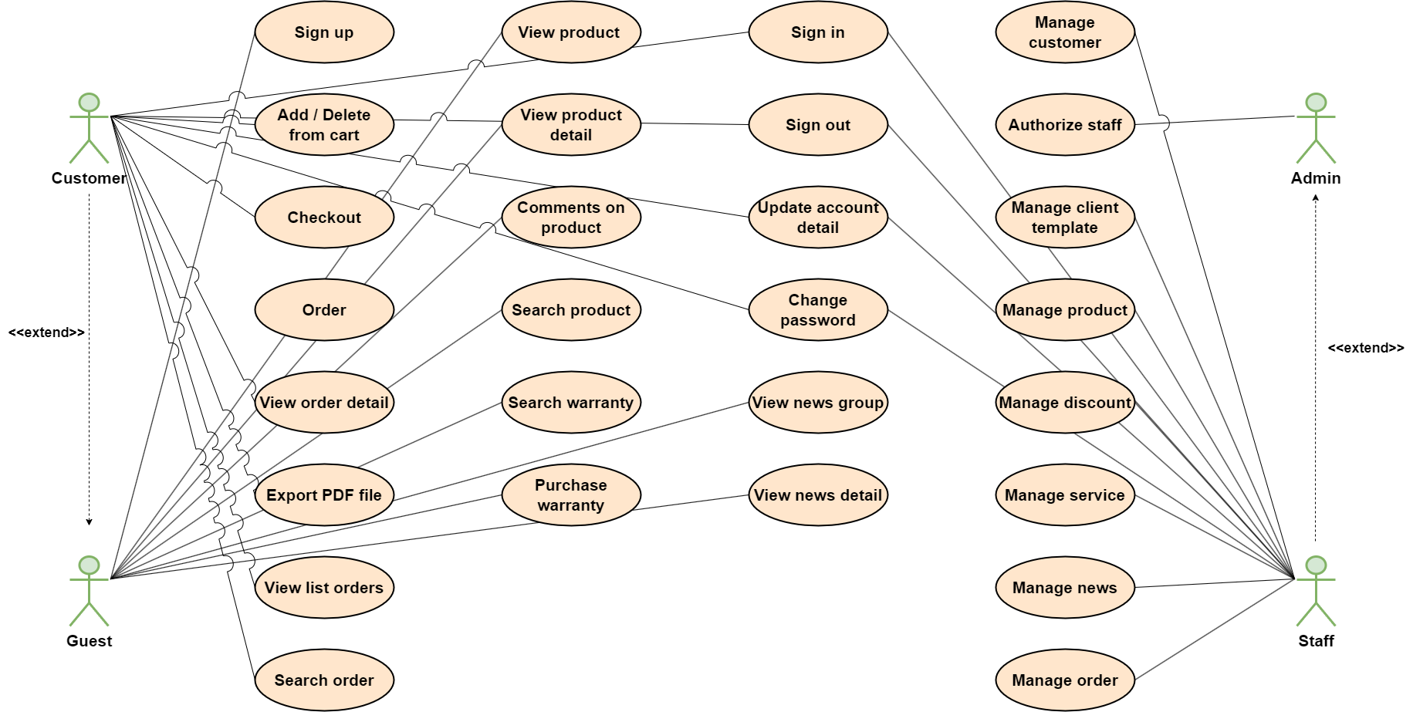

Figure 3.5. Use case overview

3.3.2 Use Case Admin
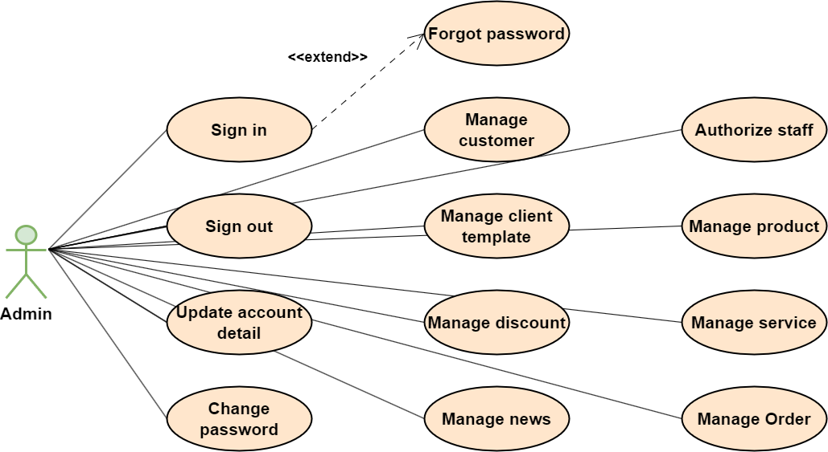

Figure 3.6. Use case admin

3.3.3 Use Case Staff
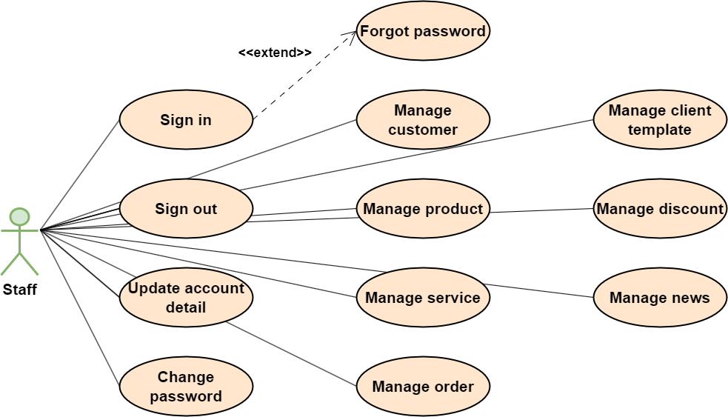

Figure 3.7. Use case staff

3.3.4 Use Case Customer
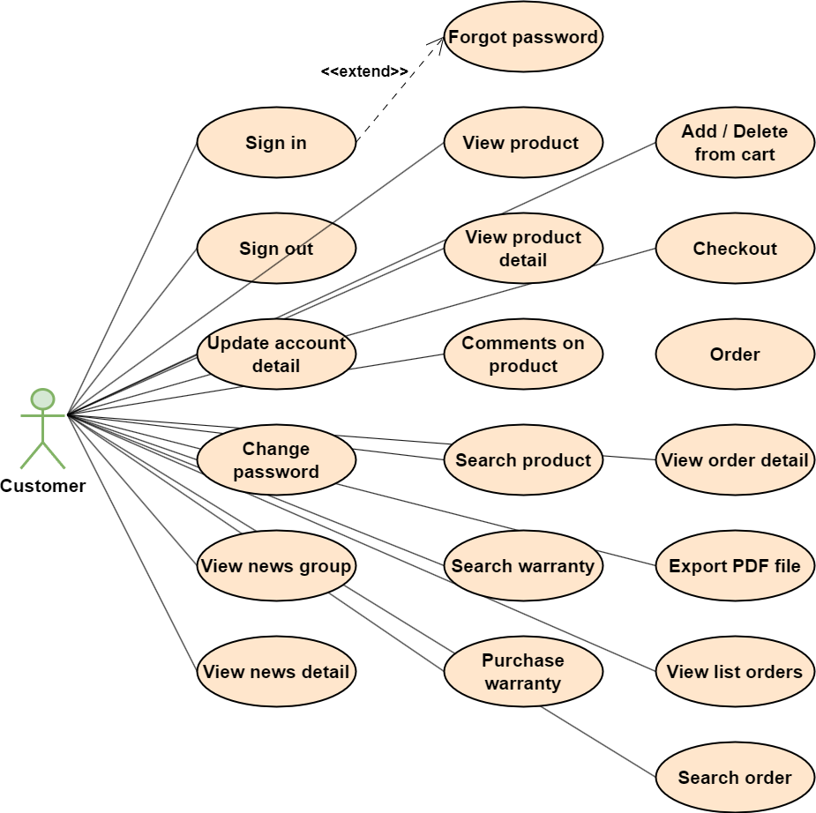
Figure 3.8. Use case customer

3.3.5 Use Case Guests
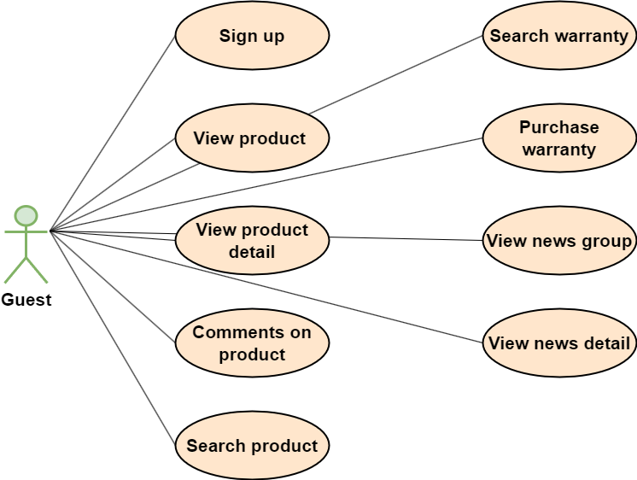
Figure 3.9. Use case guests

3.4 Non-Functional Requirements
- The Online Gas Production Shop will be on a server with high speed Internet capability. The physical machine to be used will be determined by the owner company. The software developed here assumes the use of a tool such as Tomcat for connection between the Web pages and the database. The speed of the Customer’s connection will depend on the hardware used rather than characteristics of this system.
- The Website Management will run on the editor’s PC and will contain an Access database. Access is already installed on this computer and is a Windows operating system.

3.4.1 Performance
- The system runs well under high-pressure situation such as high number of requests sent to the server, the maintenance is occurring, etc.
- The website is compatible to and rún well on multiple browsers and platforms.

3.4.2 Availability
- The system is guaranteed to be 90 percent available to use at anytime

3.4.3 Security
- The system is designed based on MVC model.
- The system is designed based on OOP model.
- System data is hidden.

3.5 Other Requirements
- No other requirements identified.

A. Appendices

A.1 Business Rule
- BR-01 Each mobile is only registered for an account.
- BR-02 Email must be in the correct format: “abc123@gmail.com”.
- BR-03 Mobile number must be unique.
- BR-04 Password must be encrypted.
- BR-05 Password is more than 6 chars, contains digit, uppercase, lowercase, special characters and no spaces
- BR-06 When changing the password, the user must enter the old password.
- BR-07 Date of birth must be before current time.
- BR-08 Mobile number contains only digits and does not contain spaces and special characters.
- BR-09 Fields marked with an asterisk (*) cannot be left blank.
- BR-10 Verify code must have 4 digit
- BR-11 When register account, the user must enter the password twice.
- BR-12 Phone can only contain 10 digits and start with 0.
- BR-13 Image must be .jpg
- BR-14 Product models must be unique

A.2 References
- IEEE Recommended Practice for Software Requirements Specifications," in IEEE Std 830-1998, vol., no., pp.1-40, 20 Oct. 1998
- IEEE Guide for Developing System Requirements Specifications," in IEEE Std 1233-1996, vol., no., pp.1-30, 22 Dec. 1996.

