我们要从framework里去掉MC-BR polishing的部分。需要做以下实验以及根据实验结果生成新的表格
- independent final exploitability evaluation，M=200,000…. full TEL-PPO raw outputs； ablation raw outputs; analytical-equilibrium profiles, as evaluator floor；
- Ablation实验不考虑MC-BR polishing
- Sensitivity analysis: 对结果不是很理想的两组（3P,q=55 & Het.ability q=55）, 再做一组 $ϵ=0.01, M=65,536$,
- 重新生成新的图表，请确认figure和表格里的内容符合实验

- Figure 1. Framework (已经更新)
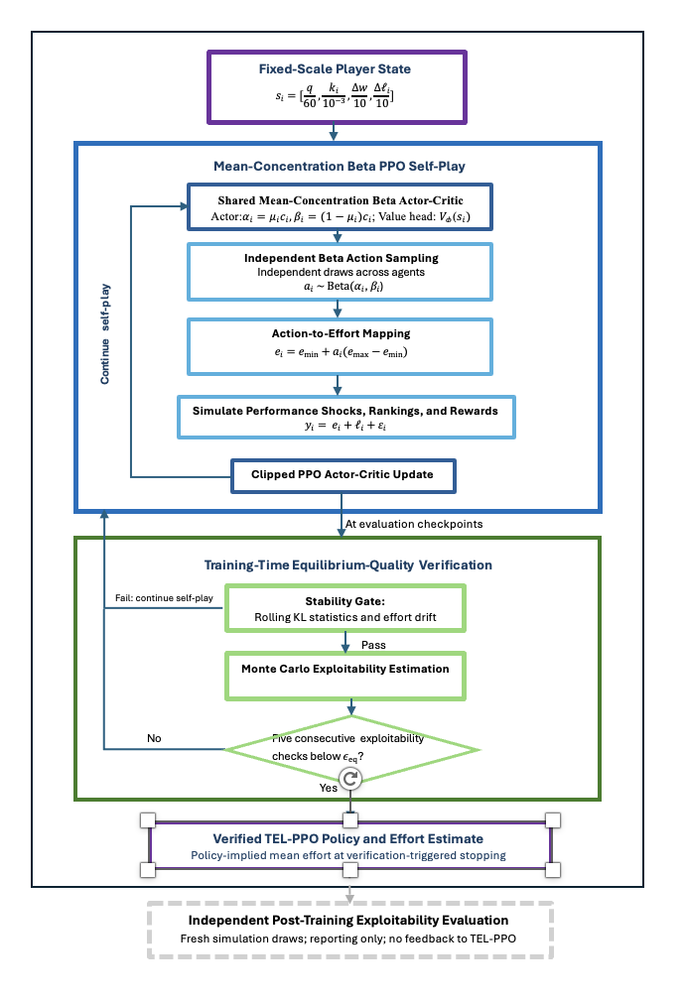

- Figure 2. TEL-PPO Effort Dynamics Across Noise Levels

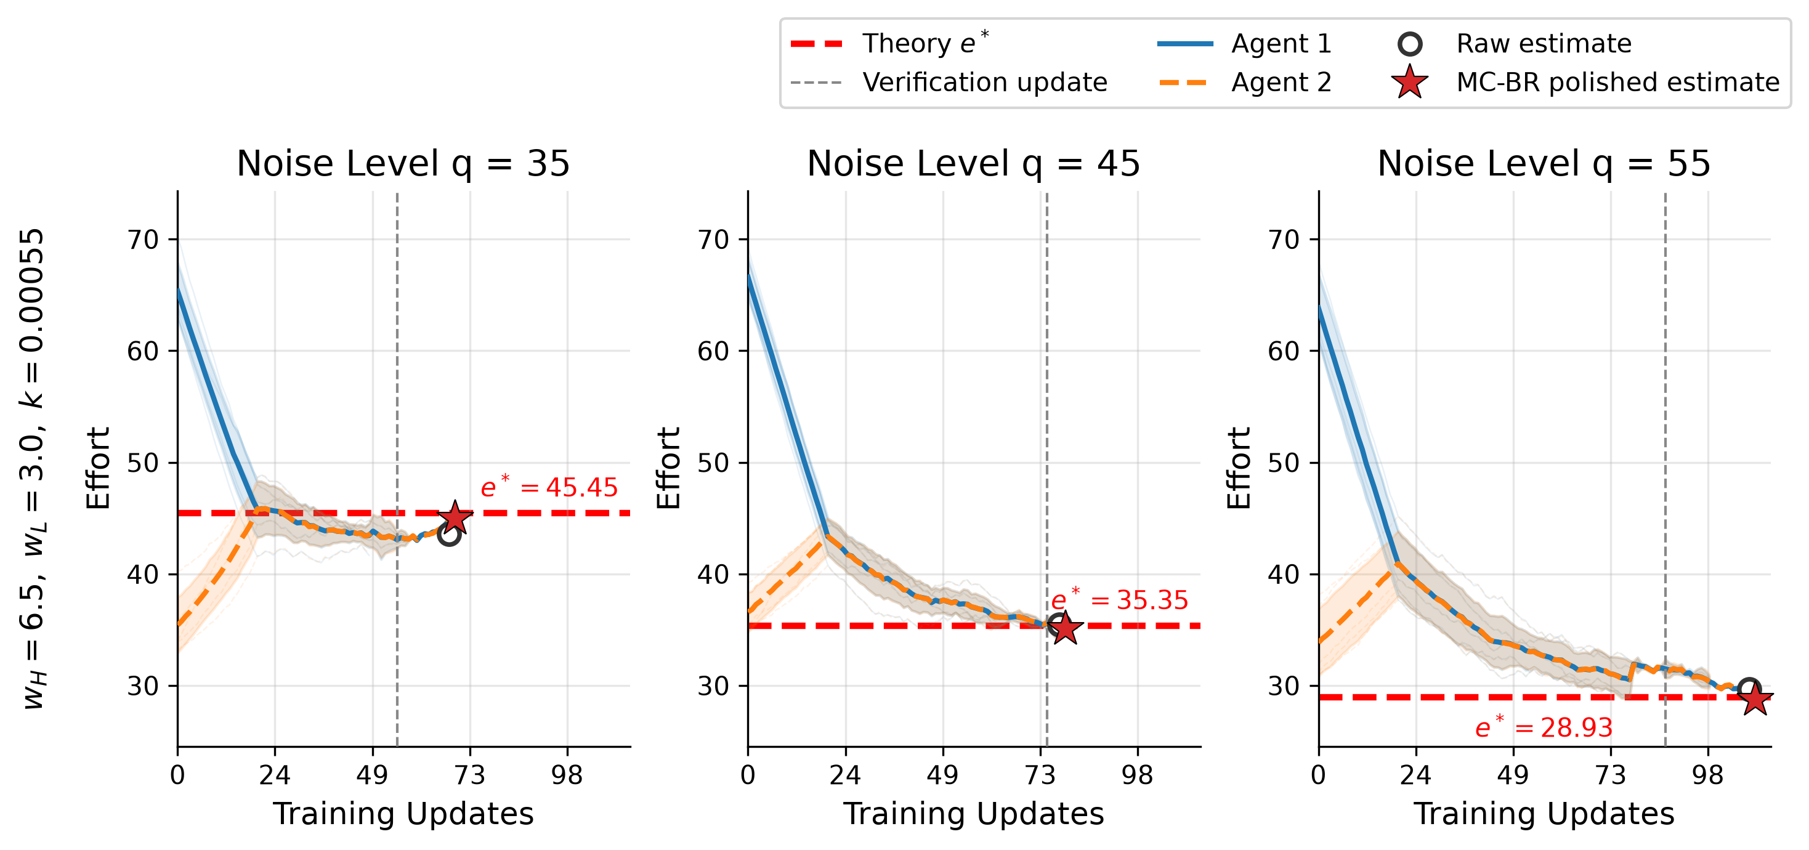
- 去掉MC-BR polished estimate
- Verification-triggered stopping update
- Raw estimate 改为Verified TEL-PPO Estimate
- 把 ○ 移到竖线上

面板 | e* | ○ raw | 差 | 相对误差 | 跨 seed SD | 显著性 | ★ polished | 差 | 相对误差
Set 1, q=35 | 45.45 | 43.58 | −1.87 | 4.12% | 1.25 | 3.4×SE | 44.95 | −0.51 | 1.12%
Set 1, q=45 | 35.35 | 35.46 | +0.11 | 0.31% | 0.60 | 0.4×SE | 35.09 | −0.26 | 0.74%
Set 1, q=55 | 28.93 | 29.65 | +0.73 | 2.52% | 0.76 | 2.1×SE | 28.76 | −0.17 | 0.58%
Set 2, q=35 | 47.62 | 44.60 | −3.01 | 6.33% | 0.87 | 7.7×SE | 47.04 | −0.57 | 1.21%
Set 2, q=45 | 37.04 | 36.46 | −0.58 | 1.57% | 0.79 | 1.7×SE | 36.75 | −0.29 | 0.77%
Set 2, q=55 | 30.30 | 31.36 | +1.06 | 3.49% | 0.77 | 3.1×SE | 30.13 | −0.18 | 0.58%

- Figure 3 Training-Time Exploitability Verification During PPO Self-play
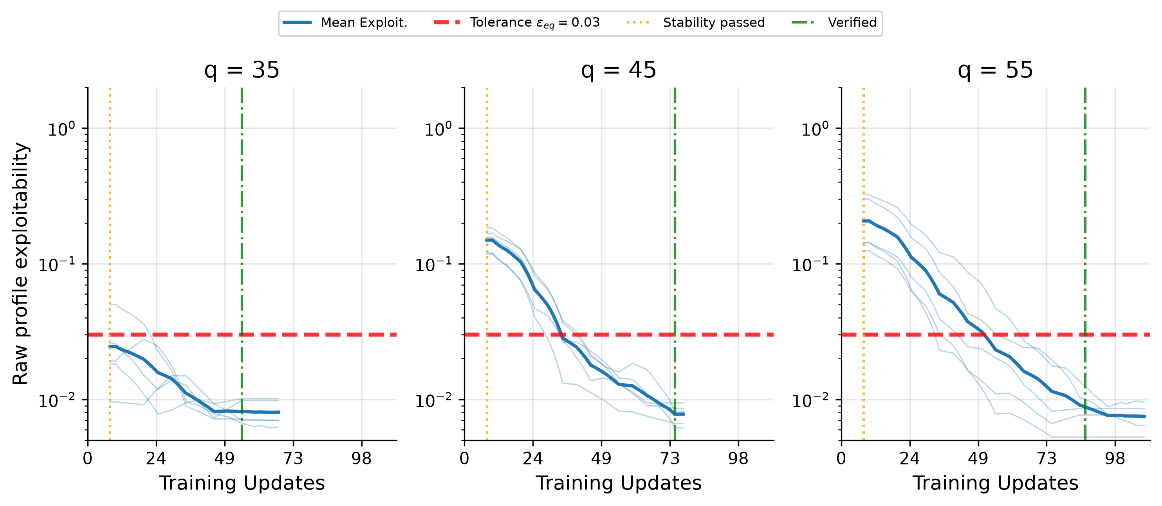
- Raw policy exploitability改为 Estimated Exploitability
- Stability pass
- Verified改为Verification-triggered stop
- Figure 4 Verified TEL-PPO Effort Estimate Relative to Analytical Benchmark
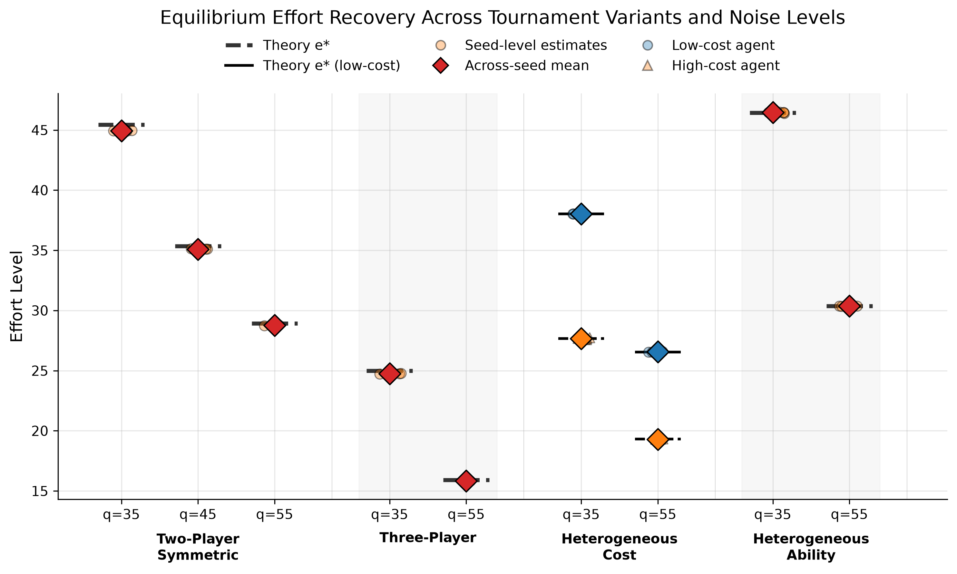
- Verified TEL-PPO Effort Estimate Relative to Analytical Benchmarks
- Seed-Level TEL-PPO outputs, Across-seed mean, low-cost agent, high-cost agent
- Table 1
Component | Configuration
Number of players | n = 2 by default; n = 3 in the three-player setting
Prize pairs | ${(w}_{H, }w_{L })∈\left\{\left(6.5, 3\right),\left(8,4\right),(8,5.5)\right\}$
Cost parameter | $k=0.00055$ in the default symmetric benchmark; $,k= 0.0006$ in the alternative symmetric setting; player-specific ${(k}_{1},k_{2})=(0.0004, 0.00055)$ in the heterogeneous-cost cases; k=0.001 in the three-player variant; k=0.0005 in the heterogeneous-ability setting
Ability parameter | Common $l$ in symmetric settings; player-specific ${(l}_{1},l_{2})=(10,5)$ in heterogeneous ability settings
Effort bounds | $$\left[e_{min, } e_{max}\right]=[0, 100]$$
Noise distribution | $${ ε}_{i}∼U\left[-q, q\right]$$
Noise parameter | $q∈\left\{35, 45, 55\right\}$for two-player benchmark; $q∈\{35, 55\}$ for other scenarios
Scenario classes | Two-player symmetric; three-player; heterogeneous cost; heterogeneous ability

- Table 2. TEL-PPO Training and Verification Configuration
Category | Parameter | Value
Optimization | Optimizer | Adam
Optimization | Learning rate | 5×10⁻⁵ → 2×10⁻⁵
Optimization | Batch size | 4096 episodes/update
Optimization | Minibatch size | 1024
Optimization | Epochs/update | 1
Optimization | Maximum PPO update | Up to 1500
Optimization | Random Seeds | $N_{\text{seed}}$ = 5
PPO / Policy | Clip range | 0.20 → 0.15
PPO / Policy | Value-loss coefficient | 0.5
PPO / Policy | Entropy coefficient | 0 for the entire run
PPO / Policy | Discount factor $γ$ | 0.99
PPO / Policy | GAE parameter $λ$ | 0.95
Network | Architecture | Shared actor–critic network with two 128-unit Tanh hidden layers, a mean–concentration Beta actor head, and a separate value head.  $$μ_{i}=σ\left(z_{μ,i}\right), \\ c_{i}=100+softplus⁡\left(z_{c,i}\right), \\ α_{i}=μ_{i}c_{i}, β_{i}=\left(1-μ_{i}\right)c_{i}.$$
State | Input variables | $$s_{i}=\left[q , / , 60 , k_{i}/{10}^{-3} \left(w_{H}-w_{L}\right)/10 \left(l_{i}-{\overline{l}}_{-i}\right)/10\right]$$
Diagnostics | KL window | 20
Diagnostics | KL threshold | mean 0.015 + std 0.012
Diagnostics | Effort-drift threshold | 8.0
Diagnostics | Exploitability tolerance | $ε_{eq}$= 0.03
Diagnostics | Exploitability patience | 5 consecutive checks
TEL-PPO Verification | Payoff evaluation | 16,384
TEL-PPO Verification | Search grid & coarse-to-fine steps | 5.0, 1.0, and 0.25
TEL-PPO Verification | Final check | Independent post-training exploitability evaluation of the reported profile  $$M=200,000, Δe=0.25, \left[0 , 100\right]$$

- Std和v2对比表
Category | Parameter | r5_sampled_std | r5_sampled_v2
Optimization | Learning rate | 3×10⁻⁴ → 2×10⁻⁴ | 5×10⁻⁵ → 2×10⁻⁵
Optimization | Epochs/update | 6 | 1
PPO / Policy | Clip range | 0.50 → 0.35 | 0.20 → 0.15
PPO / Policy | Entropy coefficient | 0.03 → 0.005（live） | 0 全程
PPO / Policy | KL target | 0.08 | 0.06
PPO / Policy | Ratio-stop threshold | 无 | 2.2
Network | Policy head | 独立 softplus α, β | mean × concentration
Network | Concentration floor | n/a | 100 → 1000
Network | Concentration scale | n/a | 100 → 10000
Network | Concentration cap | n/a | 100000
Network | Variance-loss coefficient | 0 | 0 → 0.05
Network | Ramp warm-up / steps | n/a | 200 / 50

- Component ablation of TEL-PPO across noise levels
Table 3. Component Ablation of TEL-PPO （删除MC-BR polishing部分）
Ablation Variant | TEL-PPO Output (mean $±$ SD)  $$q=35/45/55$$ | Absolute Bias | Final Exploitability  $$q=35/45/55$$ | Mean Verification Update  $$q=35/45/55$$ | Number of Exploitability Calss | Training outcome
TEL-PPO | 44.95 ±0.02)/  35.09 ±0.03 /  28.76 ±0.02 | 0.51/  0.26/  0.17 | (1.09±0.35) / (1.02±0.44) / (0.87±0.49) e-3 | 55.0±8.9/  75±5.5/  87±16.4 |  | Verified
w/o stability screening | 42.88 ± 1.30 / 35.11 ± 1.09 / 30.22 ± 1.05 | 2.57/  0.24/  1.30 | (3.56±2.16) / (1.70±0.89) / (3.33±2.38) e-3 | 53.0 ± 8.9 /  79 ±10.0/  81±13.0 |  | Verified
w/o exploitability-based verification and stopping | 44.60 ± 3.53 / 32.05 ± 1.38 / 29.51 ± 1.73 | 0.85/  3.31/  0.58 | (8.49±7.51) / (5.86±5.91) / (2.84±3.51) e-3 | N/A |  | Reached budget

- Table 4. Verified TEL-PPO Results Across Tournament Settings
Scenario | q | Analytical e* | Verified TEL_PPO Estimate ê | Err. | Independent Final exploitability
Two-player | 35 | 45.45 | 43.58 ± 1.25 | 1.87 | (1.09 ± 0.35)×10⁻³
Two-player | 45 | 35.35 | 35.46 ± 0.60 | 0.11 | (1.02 ± 0.44)×10⁻³
Two-player | 55 | 28.93 | 29.65 ± 0.76 | 0.73 | (0.87 ± 0.49)×10⁻³
Three-player | 35 | 25.00 | 22.99 ± 0.28 | 2.01 | (0.87 ± 0.36)×10⁻³
Three-player | 55 | 15.91 | 15.31 ± 1.13 | 0.60 | (0.45 ± 0.13)×10⁻³
Het. cost | 35 | 38.03 / 27.66 | 37.71 ± 1.02 /  27.24 ± 1.56 | 0.32 / 0.42 | (0.59 ± 0.43)×10⁻³
Het. cost | 55 | 26.54 / 19.30 | 26.39 ± 0.64 /  19.03 ± 2.42 | 0.14 / 0.27 | (0.41 ± 0.27)×10⁻³
Het. ability | 35 | 46.43 | 43.99 ± 0.20 | 2.44 | (1.29 ± 0.37)×10⁻³
Het. ability | 55 | 30.37 | 29.70 ± 0.85 | 0.67 | (0.36 ± 0.27)×10⁻³

