- Figure 1. TEL-PPO Framework
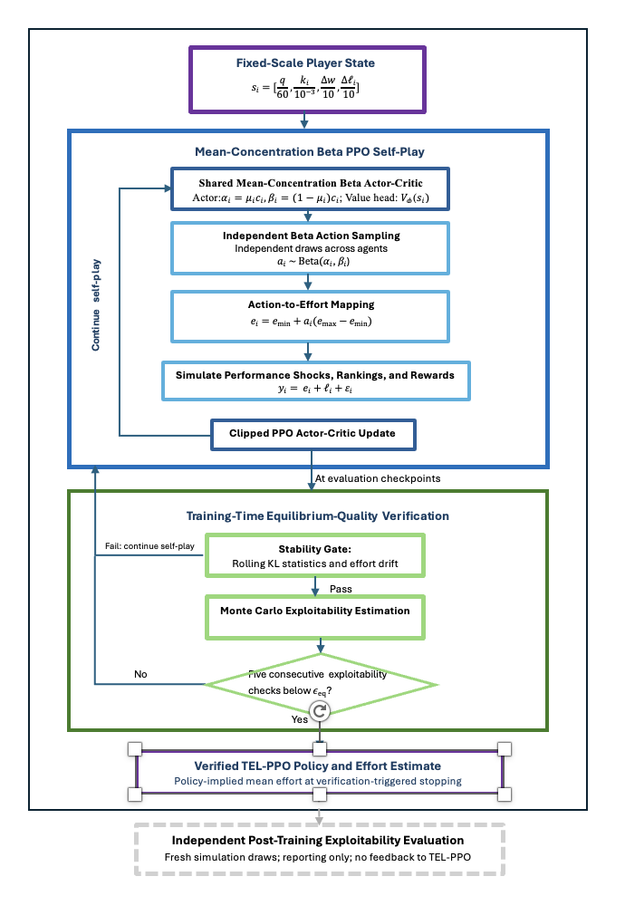
- Figure 2. TEL-PPO Effort Dynamics Across Noise Levels

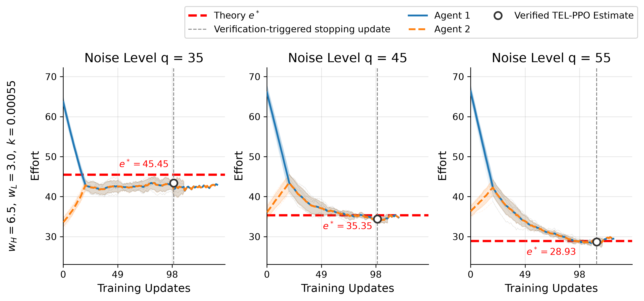
- Theory $e^{*}$改为Analytical equilibrium $e^{*}$
- 交换 Verified TEL-PPO estimate 与 Verification-triggered stopping update 的位置
- Verification-triggered stopping update改为Mean verification-triggered stop
- Agent 1 sampled effort, Agent 2 sampled effort
- 横轴坐标刻度改为0，25，50，75之类的，并写成PPO updates
- K值改为科学记数法
- 请确认每个seed的stop update没有 forward filling
- Figure 3 Training-Time Exploitability Verification During PPO Self-Play
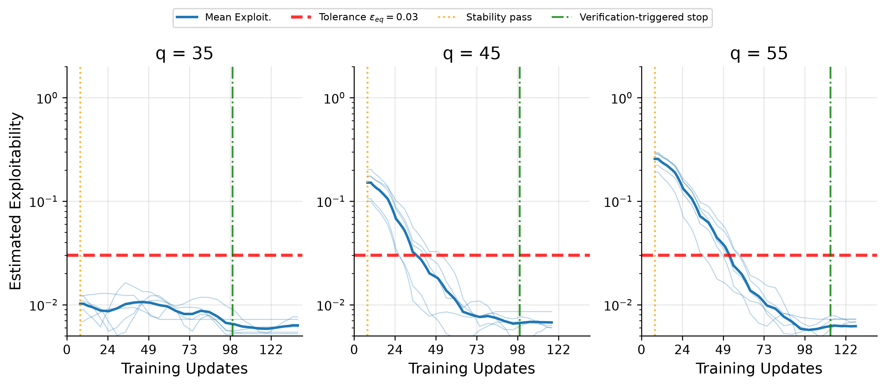
- 改为Mean Exploitability
- Tolerance 改为0.01, 红线现在位置不对
- 橙线和绿线是across-seed mean是吧，改为Mean stability pass和Mean verified stop
- 横轴改为PPO updates，刻度改的更自然一些，0，25.。。
- 请确认每个seed的exploitability curve没有 forward filling
- Figure 4 Verified TEL-PPO Effort Estimate Relative to Analytical Benchmarks
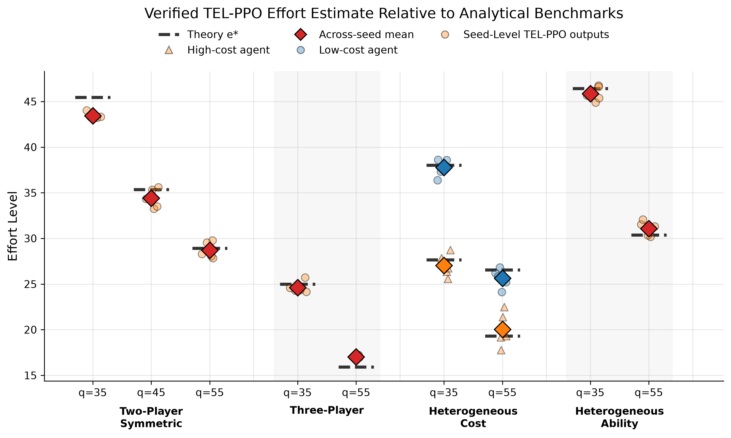
- Theory 改为Analytical Equilibrium $e^{*}$，用黑色实线，避免误认为误差棒
- Seed-Level 改为Seed-level
- Legend第一行：Analytical Equilibrium $e^{*}$ 空的大菱形代表Across-seed mean，空的小圆形代表Seed-level TEL-PPO output
- Legend 第二行：Red: Common-effort profile，Blue: Low-cost agent, Orange: High-cost agent
- Table 1:
Component | Configuration
Number of players | n = 2 by default; n = 3 in the three-player setting
Prize pairs | ${(w}_{H, }w_{L })∈\left\{\left(6.5, 3\right),(8,5.5)\right\}$
Cost parameter | $k=0.00055$ in the default symmetric benchmark; player-specific ${(k}_{1},k_{2})=(0.0004, 0.00055)$ in the heterogeneous-cost cases; k=0.001 in the three-player variant; k=0.0005 in the heterogeneous-ability setting
Ability parameter | $$l_{i}=0\text{ in settings without ability heterogeneity}$$
Effort bounds | $$ε_{i}∈\left[e_{min, } e_{max}\right]=[0, 100]$$
Noise distribution | $${ ε}_{i}∼U\left[-q, q\right]$$
Noise parameter | $q∈\left\{35, 45, 55\right\}$for two-player benchmark; $q∈\{35, 55\}$ for other scenarios
Scenario classes | Two-player symmetric; three-player; heterogeneous cost; heterogeneous ability

- Table 2
Table 2. TEL-PPO Training, Verification, and Independent Evaluation Configuration
Parameter | Value
Optimization
Optimizer | Adam
Learning rate schedule | 5×10⁻⁵ → 2×10⁻⁵, linear
Batch/minibatch/epochs | 4096 episodes / 1024 / 1 per PPO update
Maximum PPO updates | Up to 1500
Random Seeds | $N_{\text{seed}}$ = 5
PPO / Policy
Clip range | 0.20 → 0.15, linear
PPO coefficients | $$c_{v}=0.5, c_{ent}=0, γ=0.99, λ=0.95$$
Architecture | Shared actor–critic; two 128-unit Tanh hidden layers; mean–concentration Beta actor and a separate value head
Beta parameterization | $$μ_{i}=σ\left(z_{μ,i}\right), \\ c_{i}=100+softplus⁡\left(z_{c,i}\right), \\ α_{i}=μ_{i}c_{i}, β_{i}=\left(1-μ_{i}\right)c_{i}.$$
State representation
Fixed-scale player-centered state | $$s_{i}=[\frac{q}{60},\frac{k_{i}}{{10}^{-3}},\frac{∆w}{10},\frac{Δl_{i}}{10}]$$
Diagnostics and training-time verification
Stability window and threshold | 20 evaluation points; rolling mean KL $≤0.015$; rolling KL SD $≤0.012$; effort drift $≤8.0$
Evaluation checkpoint interval | ?
Exploitability criterion | $ε_{eq}$= 0.01 for 10 consecutive verifier checks
Payoff evaluation | $M_{ver}$= 65,536 Monte Carlo draws per call, with common random numbers across candidate deviations
Deviation search | [0,100], coarse-to-fine spacings $5.0, 1.0, 0.25$
Independent final evaluation
Evaluation protocol | $M_{final}=200,000$; grid $[0,100]$with $Δe=0.25;$ fresh draws independent of PPO sampling and training-time verification; reporting only, with no feedback to learning, verification, or stopping

- Table 3

Table 3. Verified TEL-PPO Results Across Tournament Settings
Scenario | q | Analytical effort e* | Verified TEL-PPO effort $ê^{TEL}$ | Absolute error | Independent Final Exploitability(×10⁻³) | Evaluator Baseline at e* (×10⁻³)
Two-player | 35 | 45.45 | 43.43 ± 0.34 | 2.03 | 2.56 ± 1.16 | 1.22 ± 1.20
Two-player | 45 | 35.35 | 34.40 ± 1.05 | 0.95 | 1.55 ± 0.99 | 0.74 ± 0.45
Two-player | 55 | 28.93 | 28.70 ± 0.89 | 0.22 | 1.55 ± 0.79 | 0.61 ± 0.38
Three-player | 35 | 25.00 | 24.61 ± 0.64 | 0.39 | 2.56 ± 1.43 | 1.51 ± 0.46
Three-player | 55 | 15.91 | 17.03 ± 0.15 | 1.12 | 3.12 ± 0.72 | 0.64 ± 0.39
Het. cost | 35 | 38.03 / 27.66 | 37.77 ± 0.95 / 27.05 ± 1.25 | 0.25 /  0.61 | 1.51 ± 1.13 | 0.51 ± 0.25
Het. cost | 55 | 26.54 / 19.30 | 25.64 ± 1.02 / 20.02 ± 1.88 | 0.90 /  0.72 | 1.82 ± 1.33 | 0.28 ± 0.18
Het. ability | 35 | 46.43 | 45.86 ± 0.80 | 0.57 | 2.04 ± 1.63 | 0.88 ± 0.54
Het. ability | 55 | 30.37 | 31.09 ± 0.81 | 0.71 | 1.28 ± 0.92 | 0.85 ± 0.41
Verified efforts are reported as the across-seed mean $±$ one sample standard deviation over five training seeds. Absolute error is $∣{\overset{‾}{\hat{e}}}^{ TEL}-e^{*}∣$ and is calculated using the unrounded across-seed mean. Independent final exploitability reports $\max_{i}{\hat{Exploit}}_{i}$ under the common post-training evaluator with fresh simulation draws. The Monte Carlo baseline is obtained by applying the same evaluator to the analytical equilibrium profile. Paired entries in the heterogeneous-cost settings are ordered as low-cost/high-cost players. Baseline values are reported as the mean $±$sample standard deviation over five independent evaluator replications.（请确认生成方式）

