I marked the figures or tables that we currently plan to keep in red.
- Framework:
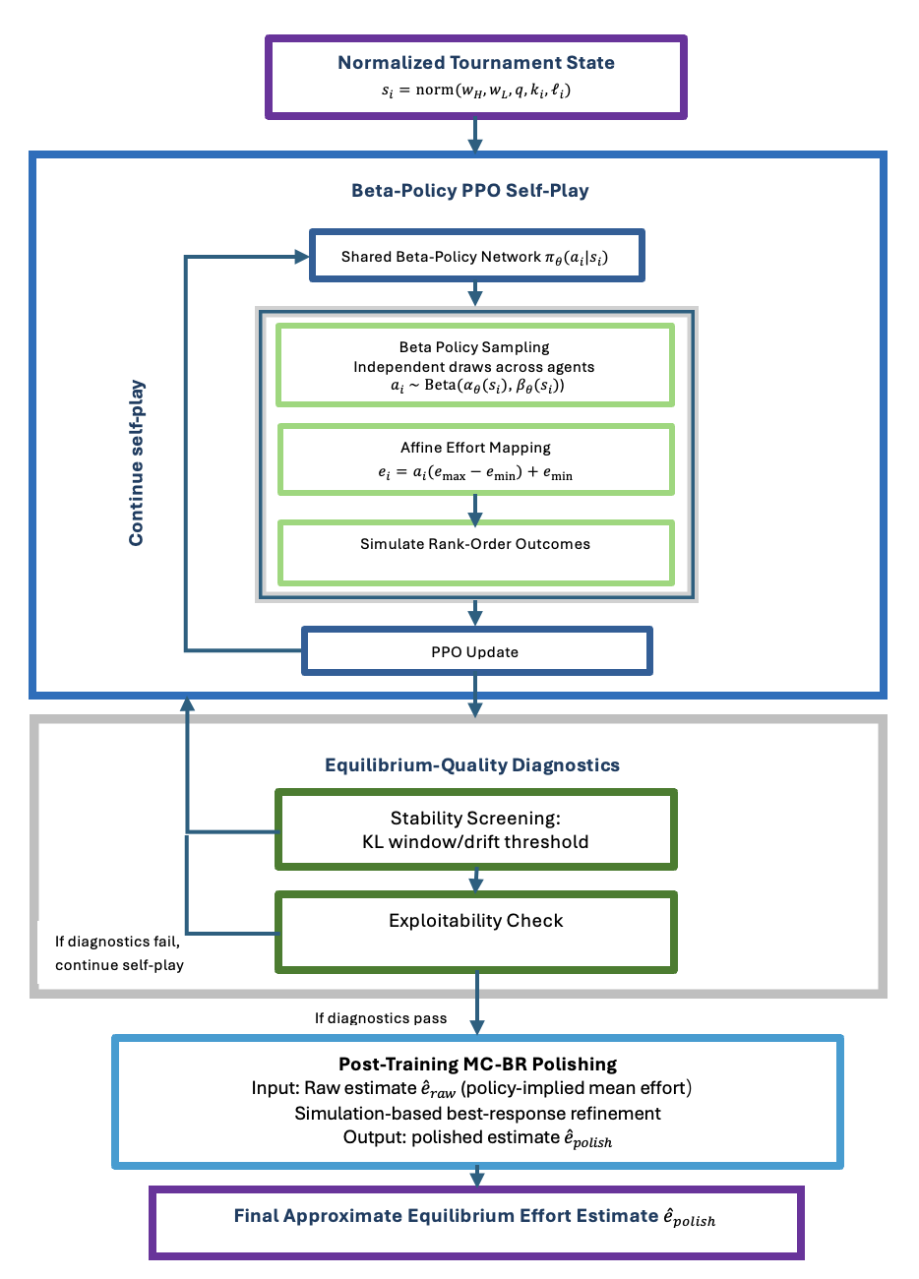

- TEL-PPO Effort Dynamics Across Noise Levels
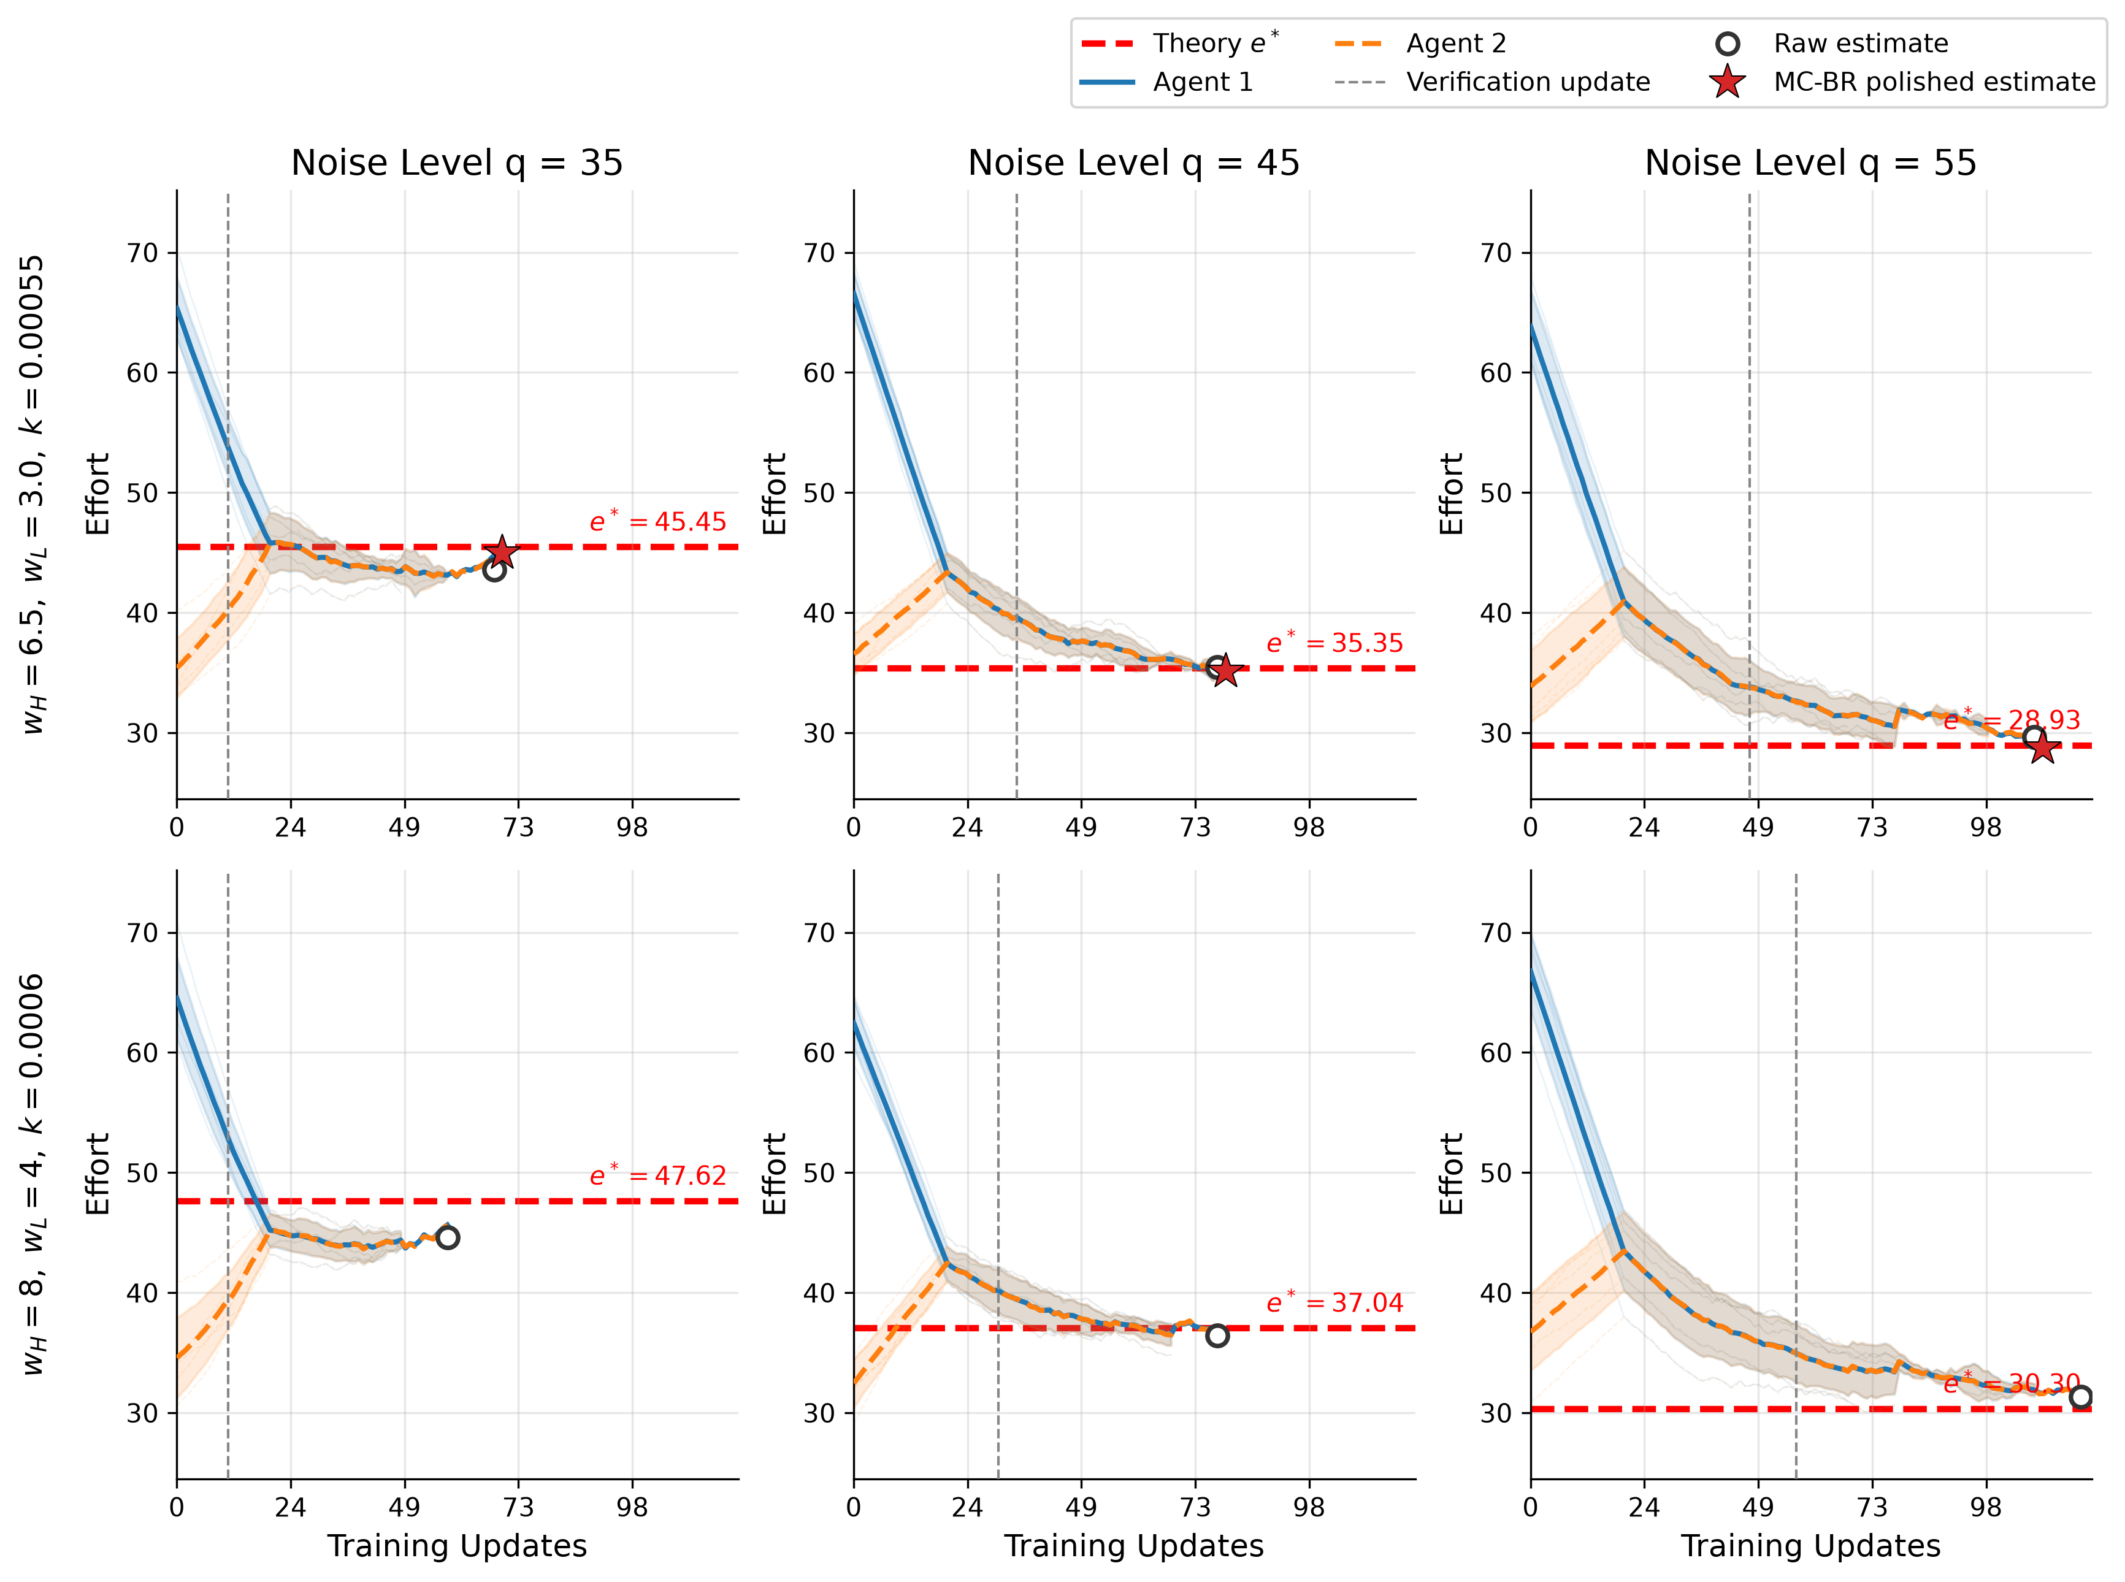
- 请确定这里的灰线是raw TEL-PPO首次满足equilibrium-quality criterion的verification update；
- 后面加一个空心圆和星号，表示raw & polished estimates；
- Convergence update改为Verification update， 加上Raw estimate，MC-BR polished estimate
- 请另做一张1x3的panel，保留（6.5，3），如果还需要缩减，就采用1x3的
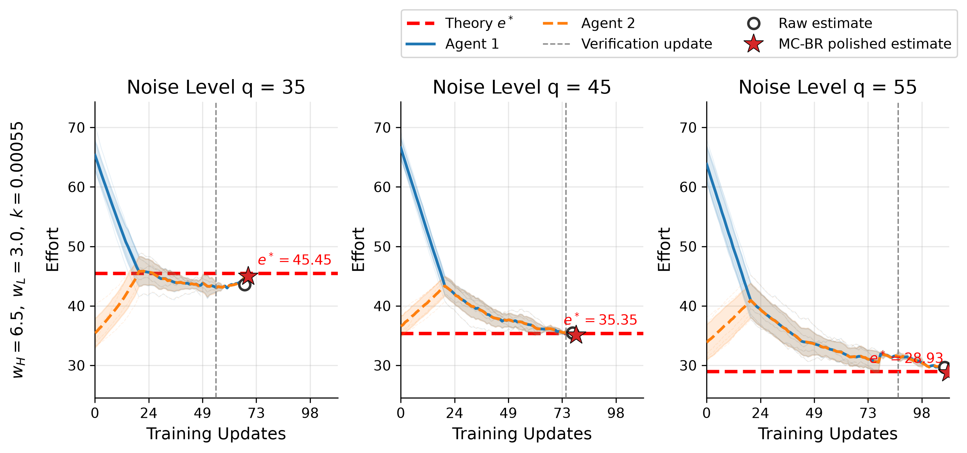

1. 灰线问题 — 数据没调错,已改回 verified stop
我先独立核查了数据链路,灰线画的确实就是它声称的"第一次通过 exploitability 检查的 update"(q35 各 seed 为 [9,9,9,9,19],均值 11，q=35 在曲线相距很远时就"通过",
灰线已改回 verified stop(stopped_at_update 的 5-seed 均值,即 5 连击完成、训练停止、final.effort 读出的位置,和 Claim-B 表格的 Conv. Update 一致):Set-1 为 55 / 75 / 87,Set-2 为 51 / 71 / 97——q35 处在两条曲线汇合(~update 22)之后,不会再误导。

- Effort drift across noise levels. 计划删除
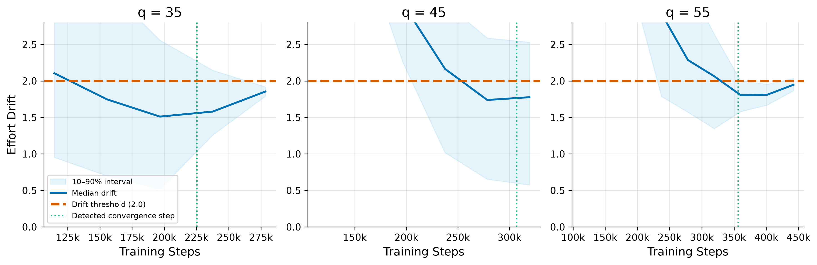

- KL Divergence across Noise Levels计划删除
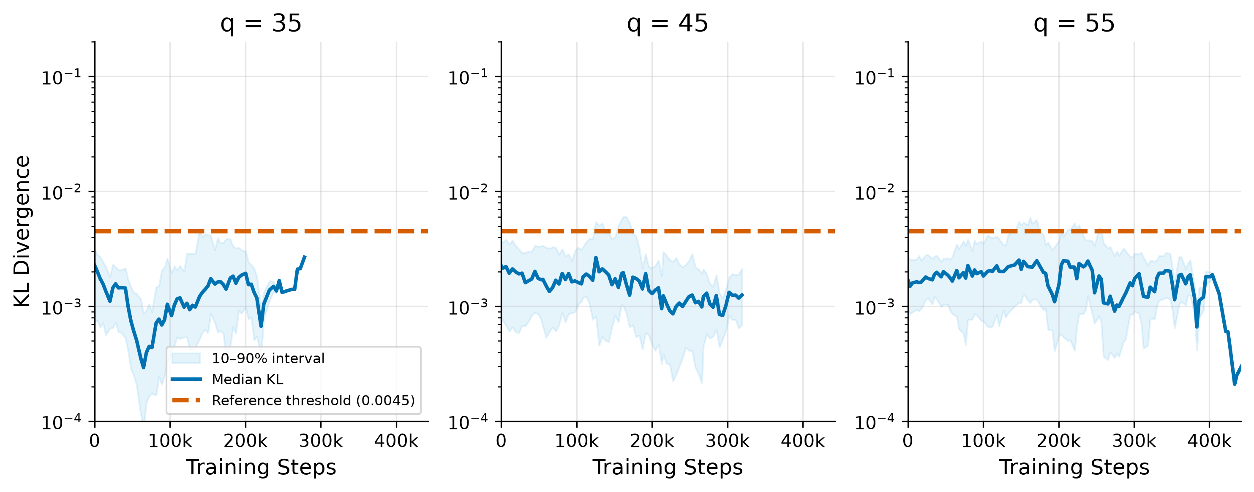
- Convergence Error to the Analytical Equilibrium 避免额外疑问，准备删除

为什么 q=35 仍不单调
因为 q=35 的策略"过冲"了均衡点。 训练从高处（effort≈50，在 e=45.45 之上）下降，在 ~73–102k 处穿过 e*，然后继续下降、过冲到 e* 之下的 basin（≈43.5）。所以"到 e 的距离"本质上是个 V 形：
- effort 从 50 逼近 e* → 距离缩小（下降段）；
- 在 ~100k 穿过 e（|mean−e| 一度到 0.07）→ 距离到达最小；
- effort 继续过冲到 43.2（最低、离 e* 最远）→ 距离回升到 ~2.27；
- 末端 43.2→43.58 略微回收（其中 seed45 是唯一训到最后、且收敛得最高的 seed）→ 1.87。
MAE 的最小值是 1.37 而不是 0，是因为它是 5 个 seed 误差的平均，seed 间还有 ~1.8 的散布把 V 底"填平"了。

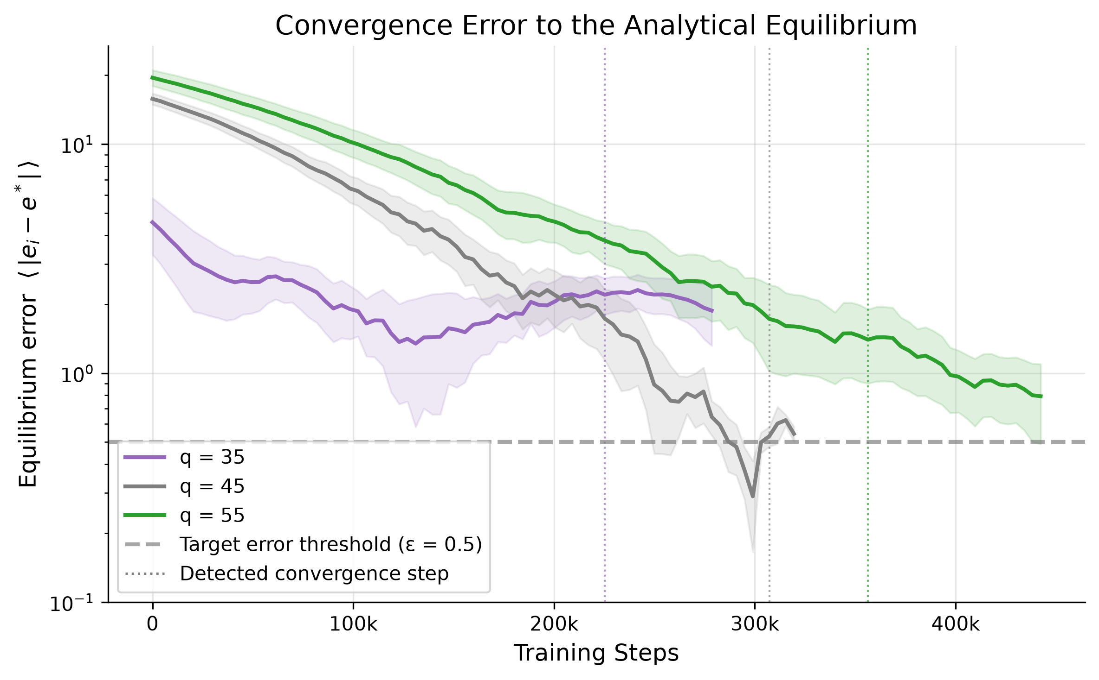
- Evolution of the learned policy distribution over training?
- Figure 6 Exploitability-Based Verification During PPO Self-play

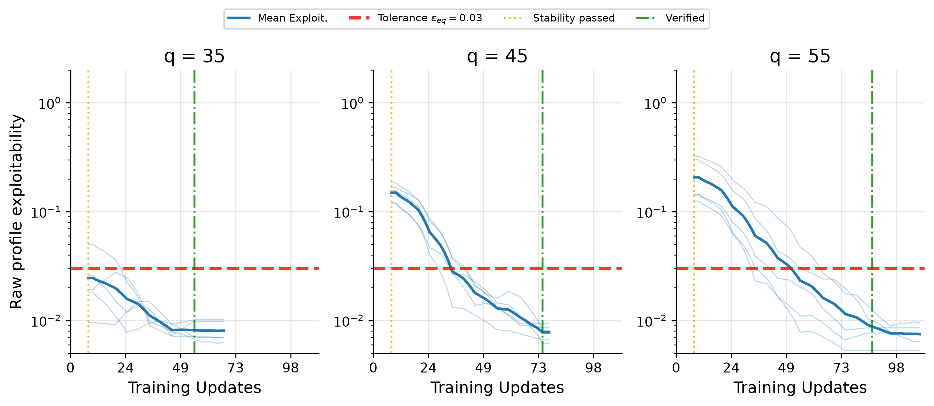
- 这个图是 PPO训练阶段的 exploitability吧？If yes，y轴改为Raw profile exploitability。
- 修改Legend（太长压缩图本身）：Mean Exploit. /Tolerance $E_{eq}=0.03$/Stability passed / Verified
- Component ablation of TEL-PPO across noise levels？
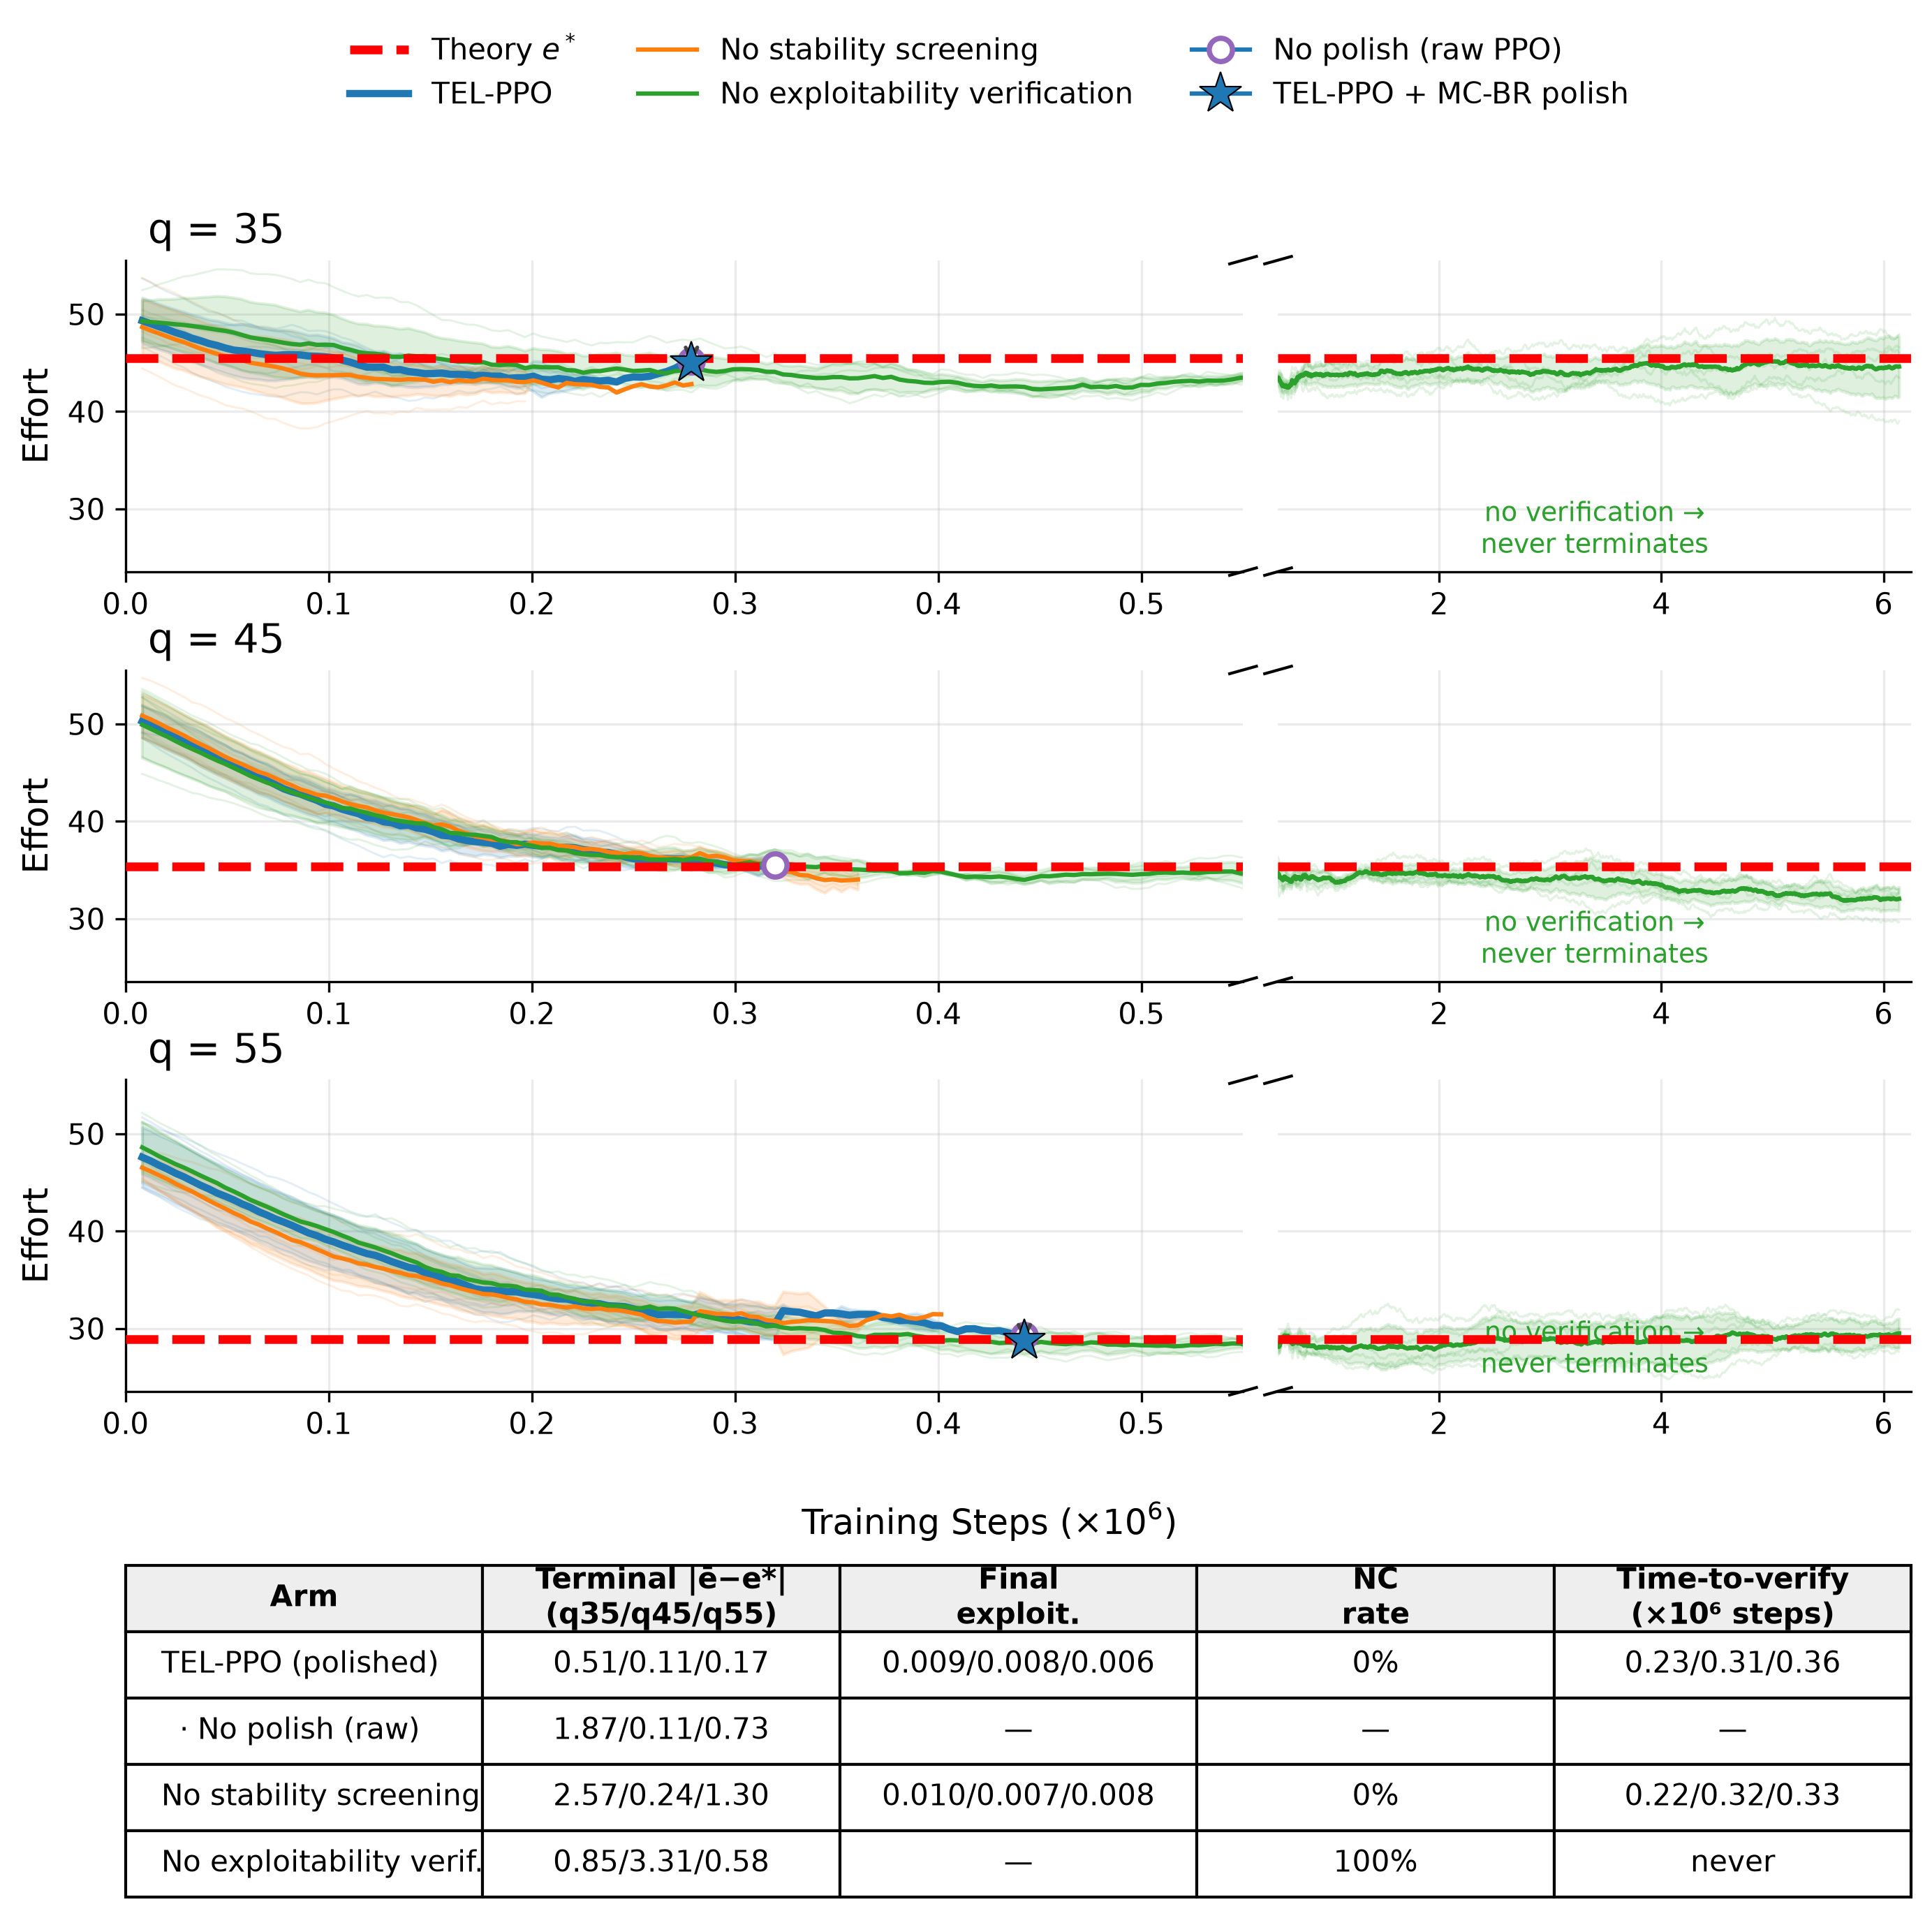
取消图，改用表格 Component Ablation of TEL-PPO
Ablation Variant | Final Error  $$q=35/45/55$$ | Final Exploitability  $$q=35/45/55$$ | Steps to Verification  $$q=35/45/55$$ | Training outcome
TEL-PPO | 0.51 (±0.02) / 0.26 (±0.03) / 0.17 (±0.02) | 8.6×10⁻⁵ / 2.7×10⁻⁵ / 1.1×10⁻⁵ ᵈᵉᵗ | 55 / 75 / 87 | Verified
w/o MC-BR polishing | 1.87 (±1.25) / 0.11 (±0.60) / 0.73 (±0.76) | 0.0086 / 0.0084 / 0.0064 ⁱⁿ | 55 / 75 / 87 (identical runs) | Verified
w/o stability screening | 2.57 (±1.30) / 0.24 (±1.09) / 1.30 (±1.05) | 0.0096 / 0.0067 / 0.0077 ⁱⁿ | 53 / 79 / 81 | Verified
w/o exploitability verification | 0.85 (±3.53) / 3.31 (±1.38) / 0.58 (±1.73) | 0.0109 (±0.0071) / 0.0086 (±0.0055) / 0.0044 (±0.0031) ᵐᶜ | — (never verified) | Reached budget

"55 / 75 / 87 (identical runs)"——"w/o MC-BR polishing"这一行不是独立训出来的。Polish 是训练结束后对最终 profile 的 post-hoc 后处理，去掉它不会改变训练本身的任何东西，所以这个 arm 的训练轨迹、verification check、停止点和完整 TEL-PPO 是同一批 5 个 seed 的 run——唯一区别是终点报 raw 值（○）还是 polished 值（★）。
"— (never verified)"——"w/o exploitability verification"这一行把停止判据整个拆掉了，训练里不再有 exploitability check 去触发 verified stop，所以这些 run 永远不会"通过验证"，全部 15 个（3 个 q × 5 seeds）都跑满固定 budget 才停：1500 updates × 4096 = 6.144M steps，stop_reason = "max_updates"。"到验证的步数"这个量对它不存在，所以填破折号。这也是被退役那张图用断裂横坐标的原因（它比其他 arm 长 15–20 倍），以及它的 Final Exploitability 是 MISSING 的原因——训练里从没算过这个量，follow-up prompt 的 Task 2 就是去补测这 15 个终点。
结论:不是 bug——数字都对,是两个已知机制在 q=45 恰好"对撞",而且只在 err-of-mean 这个口径下显得变差。 证据链如下:

1. raw 的 0.11 是跨 seed 符号抵消的"巧合",不是单 seed 的精度
q=45 逐 seed(e*=35.3535,来自 committed JSON):
seed | raw | 符号误差 | polished | 符号误差
42 | 34.864 | −0.49 | 35.106 | −0.25
43 | 35.772 | +0.42 | 35.057 | −0.30
44 | 36.010 | +0.66 | 35.052 | −0.30
45 | 35.908 | +0.55 | 35.106 | −0.25
46 | 34.755 | −0.60 | 35.130 | −0.22
raw 是 3 上 2 下,单 seed 误差都在 0.42–0.66(per-seed MAE = 0.544),只是正负相抵后均值凑巧在 e* 附近(0.108)。没有任何一个 raw seed 真的有 0.11 的精度。

2. polish 做的事:方差塌缩到采样不动点,不动点带 −0.26 的系统偏移
polish 把 5 个 seed 全部收到 35.05–35.13(sd 0.60 → 0.034,压缩 18×),但落点是求解器"采样博弈"的不动点 e_fp,它系统性地低于解析 e*。这正是 Phase-0 已确立的分解 err_pol ≈ (e_fp − e*) + solver noise(~0.02),且 offset 随 q 单调:q35 −0.51 / q45 −0.26 / q55 −0.17

3. 换个口径看,q45 的 polish 仍然是改善
- per-seed MAE:0.544 → 0.263,误差减半(CSV 新列里两种口径都在:raw_mae_across_seeds=0.54 vs raw_err_of_mean=0.11);
- exploitability 口径与 effort 口径自洽:EXP_det@raw_mean = 1.06×10⁻⁵ 略优于 EXP_det@polish = 2.74×10⁻⁵(两者都比 ε_eq=0.03 低 3 个量级)——因为 raw 均值 恰好离 e* 更近。

Equilibrium Recovery Across Scenarios and Noise Levels

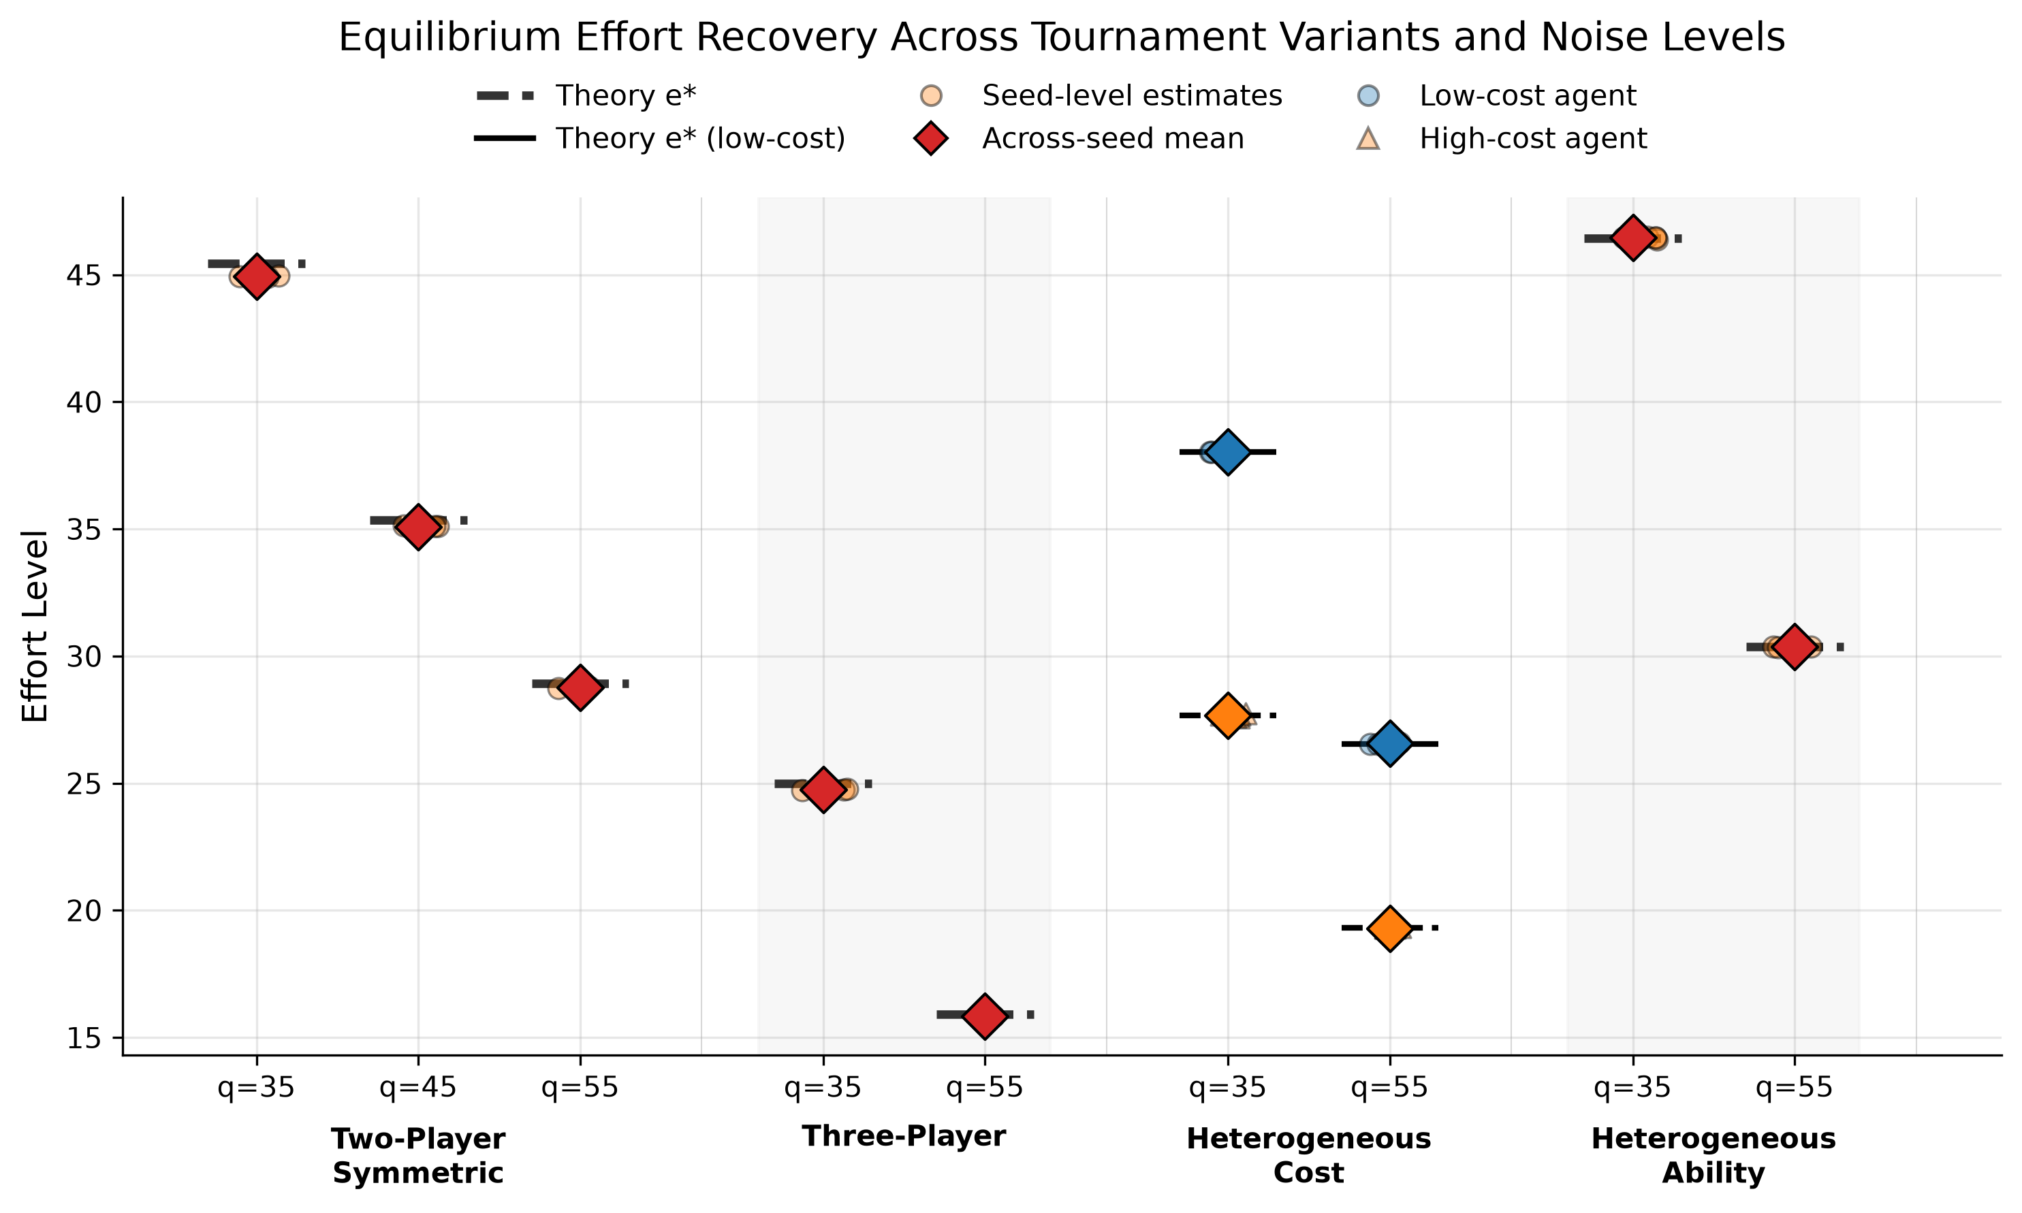
  - 标题改为Equilibrium Effort Recovery Across Tournament Variants and Noise levels；
  - y-axis 改为Effort Level;
  - 有什么办法让seed更明显一些；
  - per-seed estimate改为Seed-level estimates;
  - Agent 1 /Agent 2改为 low-cost agent/high-cost agent
  - Heterogeneous cost的theory effort线改为黑色
- Table 1. Tournament Environment Configuration
Component | Configuration
Number of players | n = 2 by default; n = 3 in the multi-player variant
Prize pairs | ${(w}_{H, }w_{L })∈\left\{\left(6.5, 3\right),\left(8,4\right),(8,5.5)\right\}$
Cost parameter | $k=0.00055$ in the default symmetric benchmark; $,k= 0.0006$ in the alternative symmetric setting; player-specific ${(k}_{1},k_{2})=(0.0004, 0.00055)$ in the heterogeneous-cost cases
Ability parameter | Common $l$ in symmetric settings; player-specific ${(l}_{1},l_{2})=(10,5)$ in heterogeneous ability settings
Effort bounds | $$\left[e_{min, } e_{max}\right]=[0, 100]$$
Noise distribution | $${ ε}_{i}∼U\left[-q, q\right]$$
Noise parameter | $q∈\left\{35, 45, 55\right\}$for two-player benchmark; $q∈\{35, 55\}$ for other scenarios
Scenario classes | Two-player symmetric; three-player; heterogeneous cost; heterogeneous ability

- Table 2. TEL-PPO Training, Diagnostics, and Polishing Configuration
Table 2 我可能还会根据篇幅进行格式调整，请先根据实验检查及填补表格内容
Category | Parameter | Value
Optimization | Optimizer | Adam
Optimization | Learning rate | 5×10⁻⁵ → 2×10⁻⁵
Optimization | Batch size | 4096 episodes/update
Optimization | Minibatch size | 1024
Optimization | Epochs/update | 1
Optimization | Maximum PPO update | Up to 1500
Optimization | Random Seeds | $N_{\text{seed}}$ = 5
PPO / Policy | Clip range | 0.20 → 0.15
PPO / Policy | Value-loss coefficient | 0.5
PPO / Policy | Entropy coefficient | 0 for the entire run
PPO / Policy | Discount factor $γ$ | 0.99
PPO / Policy | GAE parameter $λ$ | 0.95
Network | Architecture | Shared actor-critic network；two Tanh hidden layers, hidden size128；but the as-built head is ActorCriticMeanConc: sigmoid mean head × softplus concentration head, α = mean·conc, β = (1−mean)·conc (conc floor ramped 100→1000, warmup 200 via --override-conc-ramp-warmup) ⚠️ — not the separate softplus+1 α/β heads of ActorCritic
State | Input variables | Normalized $(w_{H},w_{L},q{,k}_{i},l_{i})$
Diagnostics | KL window | 20
Diagnostics | KL threshold | mean 0.015 + std 0.012
Diagnostics | Effort-drift threshold | 8.0
Diagnostics | Exploitability tolerance | $ε_{eq}$= 0.03
Diagnostics | Exploitability patience | 5 consecutive checks
MC-BR/Verification | Payoff evaluation | 8192 MC samples with common random numbers
MC-BR/Verification | Search grid & coarse-to-fine steps | 5.0, 1.0, and 0.25
MC-BR/Verification | Final check | Independent MC exploitability evaluation after polishing
Scenario | q | e* | ê_raw | Raw Err. | ê_polish | Polished Err. | Final exploitability
Two-player | 35 | 45.45 | 43.58 ± 1.25 | 1.87 | 44.95 ± 0.02 | 0.51 | 8.6×10⁻⁵ ᵈᵉᵗ [0.009]
Two-player | 45 | 35.35 | 35.46 ± 0.60 | 0.11 | 35.09 ± 0.03 | 0.26 | 2.7×10⁻⁵ ᵈᵉᵗ [0.008]
Two-player | 55 | 28.93 | 29.65 ± 0.76 | 0.73 | 28.76 ± 0.02 | 0.17 | 1.1×10⁻⁵ ᵈᵉᵗ [0.006]
Three-player | 35 | 25.00 | 22.99 ± 0.28 | 2.01 | 24.75 ± 0.02 | 0.25 | 0.0008 ᵃ [0.009]
Three-player | 55 | 15.91 | 15.31 ± 1.13 | 0.60 | 15.84 ± 0.01 | 0.07 | 0.0007 ᵃ [0.005]
Het. cost | 35 | 38.03 / 27.66 | 37.71 ± 1.02 / 27.24 ± 1.56 | 0.32 / 0.42 | 38.04 ± 0.02 / 27.66 ± 0.07 | 0.01 / 0.01 | 0.0006 ᵃ [0.002]
Het. cost | 55 | 26.54 / 19.30 | 26.39 ± 0.64 / 19.03 ± 2.42 | 0.14 / 0.27 | 26.56 ± 0.02 / 19.30 ± 0.04 | 0.02 / 0.00 | 0.0002 ᵃ [0.002]
Het. ability | 35 | 46.43 | 43.99 ± 0.20 | 2.44 | 46.45 ± 0.04 | 0.02 | 0.0010 ᵃ [0.029]
Het. ability | 55 | 30.37 | 29.70 ± 0.85 | 0.67 | 30.37 ± 0.01 | 0.01 | 0.0005 ᵃ [0.026]
- Table 3 and Table 4合并:

合并表 T-C 的 two-player q=45 行(raw err 0.11 → polished 0.26)和 ablation 表 T-A 的 "w/o MC-BR polishing" vs "full" 在 q=45 的那对格子,用的是完全相同的数据(同 5 个 seed 的 raw 终点和同 5 个 polish 落点。
- raw 的 0.11 是跨 seed 符号抵消(单 seed 误差 0.42–0.66,3 上 2 下,per-seed MAE 0.544);
- polish 把所有 seed 收到采样不动点 35.09(sd 0.60→0.034),带 −0.26 的系统偏移(offset 随 q 单调:−0.51/−0.26/−0.17,q45 完全在规律上);
- init-independence 探针(q45_polish_probe.json:起点 {raw, 0, 50} 落点 spread 0.0199)确认 35.09 是不动点本身;
- 按 per-seed MAE 口径 polish 在 q45 仍然减半(0.54→0.26);exploitability 两者都在 10⁻⁵ 量级,比 ε_eq 低三个数量级。
q45 是 T-C 全表 9 个 cell 里唯一一个 polished err > raw err 的,其余 8 个 cell polish 都是大幅改善——这恰好说明它是"raw 均值碰巧落在 e* 上"的孤例,而不是 polish 的系统性问题。
Table 3. Quantitative summary for symmetric two-player and three-player settings
Scenario | q | Method | Mean effort±std | |ē−e*| | Relative error | Exploitability | Effort Gap | Steps to Convergence
Two-Player | 35 | Theory | 45.45 | 0.00 | 0.00% | 0.000 | 0.00 | -
Two-Player | 35 | TEL-PPO | 44.10±1.97 | 1.96 | 4.30% | 0.011 | 0.08 | NC
Two-Player | 45 | Theory | 35.35 | 0.00 | 0.00% | 0.000 | 0.00 | -
Two-Player | 45 | TEL-PPO | 34.96±0.98 | 0.74 | 2.08% | 0.008 | 0.04 | NC
Two-Player | 55 | Theory | 28.93 | 0.00 | 0.00% | 0.000 | 0.00 | -
Two-Player | 55 | TEL-PPO | 28.88±0.81 | 0.68 | 2.36% | 0.006 | 0.07 | NC
Three-Player | 35 | Theory | 25.00 | 0.00 | 0.00% | 0.000 | 0.00 | -
Three-Player | 35 | TEL-PPO | 22.60±0.11 | 2.40 | 9.62% | 0.022 | 0.00 | NC
Three-Player | 55 | Theory | 15.91 | 0.00 | 0.00% | 0.000 | 0.00 | -
Three-Player | 55 | TEL-PPO | 14.89±0.09 | 1.02 | 6.38% | 0.024 | 0.00 | NC

Table 4 Quantitative summary for heterogeneous tournament settings
Scenario | q | Method | Mean effort±std | |ē−e*| | Relative error | Exploitability | Effort Gap | Steps to Convergence
Het. Cost | 35 | Theory | 32.84 | 0.00 | 0.00% | 0.000 | 0.00 | -
Het. Cost | 35 | TEL-PPO | 31.38±0.58 | 1.46 | 4.44% | 0.035 | 9.99 | NC
Het. Cost | 55 | Theory | 22.92 | 0.00 | 0.00% | 0.000 | 0.00 | -
Het. Cost | 55 | TEL-PPO | 21.66±0.23 | 1.26 | 5.51% | 0.027 | 7.42 | NC
Het. Ability | 35 | Theory | 46.43 | 0.00 | 0.00% | 0.000 | 0.00 | -
Het. Ability | 35 | TEL-PPO | 43.26±0.54 | 3.17 | 6.83% | 0.037 | 0.00 | NC
Het. Ability | 55 | Theory | 30.37 | 0.00 | 0.00% | 0.000 | 0.00 | -
Het. Ability | 55 | TEL-PPO | 28.85±0.74 | 1.52 | 5.01% | 0.028 | 0.00 | NC

