- Framework: state dimension = 4
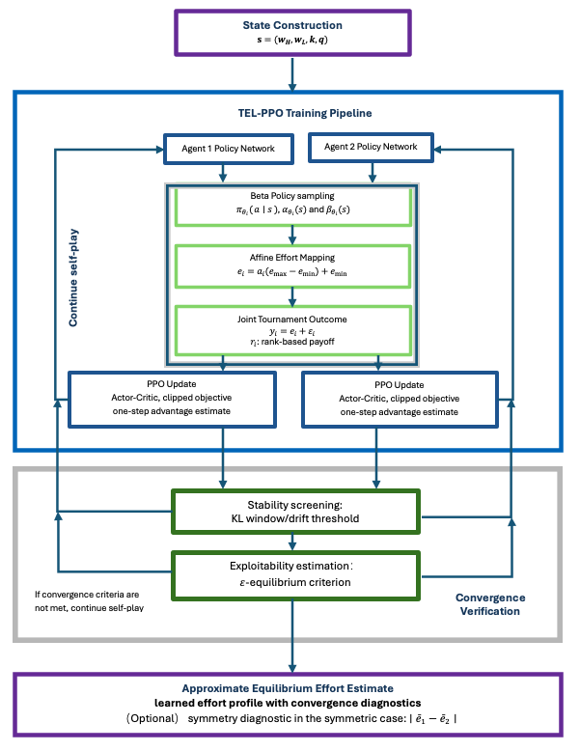
- Convergence of TEL-PPO under Increasing Noise
  - 标出$e^{*}$的值
  - 加上一个vertical dashed convergence line：first update satisfying the convergence criteria
  - X-axis统一，显示高噪声训练更久
  - Legend放到图外或者右上角
- Effort drift across noise levels.
  - q=45, 55的结果是否能改进
  - Detected convergence step没有
- KL Divergence across Noise Levels
- Convergence Error to the Analytical Equilibrium
  - q = 35 不够单调，q = 55反弹
  - shaded region 太宽，seed之间差异明显，convergence？
  - 是否可以体现Detected convergence step
- Evolution of the learned policy distribution over training?
  - q = 40,
  - (w_{H}​,w_{L}​)=(6.5,3)
  - 有没有error小一点的图？（没有的话，我在考虑删去）
- Figure 6 Exploitability and approximate equilibrium verification across noise levels
  - Exploitability q=35,45, 确定是直线？
  - Thick blue line: mean？
  - X轴统一
  - Approx $ε$-equilibrium verified
  - Stability screen passed
- Component ablation of TEL-PPO across noise levels?新图只有theory和tel-ppo
  - 统一y轴
  - Theory线更明显些
  - Baseline 改为TEL-PPO
  - No cheap gate 改为No stability screening
  - No exploitability改为No exploitability verification
  - TEL-PPO更粗些，ablation略细一些
  - Training steps（x10⁶）
  - q=35,40,55,去掉.0
  - 是否能加上一个小的summary：
- terminal absolute error
- final exploitability
- NC rate
- time-to-pass verification
- Equilibrium Recovery Across Scenarios and Noise Levels
- Table 1. Tournament Environment Configuration
Parameter | Value/Description
Number of players | n = 2 by default; n = 3 in the multi-player variant
Winner and loser prizes | $w_{H }∈\left\{6.5, 8\right\}; w_{H }∈\{3.0, 4, 5.5\}$
Cost parameter | $$k∈\{0.00055, 0.001, 0.0005\}$$
Effort bounds | $$\left[e_{min, } e_{max}\right]=[0, 100]$$
Noise distribution | $${ ε}_{i}∼U\left[-q, q\right]$$
Noise parameter | $$q∈\left\{35, 45, 55\right\} or \{35, 55\}$$
Default benchmark scenario | $n=2; w_{H}=6.5; w_{L}=3; k=0.00055$; $q∈ \left\{35, 45, 55\right\}$
Scenario protocol | Each experimental scenario is defined by a specific parameter configuration, while the TEL-PPO training and verification procedure is kept fixed unless otherwise stated.
Scenario classes | symmetric two-player benchmark; three-player extension; heterogeneous-cost variant; heterogeneous-ability variant
Analytical benchmark validity | Closed-form benchmark is used only in analytically valid interior cases; cases that violate benchmark validity are treated separately
Additional scenario-specific settings | Exact heterogeneous-cost and heterogeneous-ability parameter values are reported in Section 5.2

- Table 2. TEL-PPO Training and Verification Configuration
Category | Parameter | Value
Optimization | Optimizer | Adam
Optimization | Learning rate (start $→$end) | 3×10⁻⁴→2×10⁻⁴
Optimization | Batch size episodes/update | 4096
Optimization | Minibatch size | 1024
Optimization | Epochs per update | Baseline: 6; Theory-align-v2: 1
Optimization | Maximum PPO update | 500/1500？
Optimization | Random Seeds $N_{\text{seed}}$ | 5
PPO / Policy | Clip range (start $→$end) $ε_{clip}$ | Baseline: 0.30→0.15  Theory-align-v2: 0.2→0.15
PPO / Policy | Value-loss coefficient | Baseline: 0.5; Theory-align-v2: 1.0
PPO / Policy | Entropy coefficient | Baseline: 0.03 → 0.005 annealed schedule; v2: 0
PPO / Policy | Discount factor $γ$ | Baseline: 0.99; v2: 1.0
PPO / Policy | GAE parameter $λ$ | Baseline: 0.95; v2: 1.0
Network | Actor/critic architecture | Shared actor-critic network；two hidden layers with Tanh, hidden=128；separate alpha, beta, and value heads
State input | State variables | Normalized $( k,q,w_{H},w_{L},)$
Stability / Verification | KL window | 20
Stability / Verification | KL threshold | 0.01
Stability / Verification | Effort-drift threshold | 2.0
Stability / Verification | Exploitability tolerance $ε_{eq}$ | 0.03? 0.05?
Stability / Verification | Exploitability patience | 5
Stability / Verification | Best-response approximation | 8192 MC samples; coarse-to-fine effort grid with steps 5.0, 1.0, and 0.25
Termination | Minimum training steps/updates | 100

Table 3 and Table 4:
- NC? Should converge
- Accuracy
- Effort gap (table 4)
- Table 3. Quantitative summary for symmetric two-player and three-player settings
Scenario | q | Method | Mean effort±std | |ē−e*| | Relative error | Exploitability | Effort Gap | Steps to Convergence
Two-Player | 35 | Theory | 45.45 | 0.00 | 0.00% | 0.000 | 0.00 | -
Two-Player | 35 | Gradient | 45.45±0.00 | 0.00 | 0.01% | - | 0.00 | -
Two-Player | 35 | TEL-PPO | 44.10±1.97 | 1.96 | 4.30% | 0.011 | 0.08 | NC
Two-Player | 45 | Theory | 35.35 | 0.00 | 0.00% | 0.000 | 0.00 | -
Two-Player | 45 | Gradient | 35.35±0.00 | 0.00 | 0.01% | - | 0.00 | -
Two-Player | 45 | TEL-PPO | 34.96±0.98 | 0.74 | 2.08% | 0.008 | 0.04 | NC
Two-Player | 55 | Theory | 28.93 | 0.00 | 0.00% | 0.000 | 0.00 | -
Two-Player | 55 | Gradient | 28.92±0.00 | 0.00 | 0.00% | - | 0.00 | -
Two-Player | 55 | TEL-PPO | 28.88±0.81 | 0.68 | 2.36% | 0.006 | 0.07 | NC
Three-Player | 35 | Theory | 25.00 | 0.00 | 0.00% | 0.000 | 0.00 | -
Three-Player | 35 | Gradient | 25.00±0.00 | 0.00 | 0.00% | - | 0.00 | -
Three-Player | 35 | TEL-PPO | 22.60±0.11 | 2.40 | 9.62% | 0.022 | 0.00 | NC
Three-Player | 55 | Theory | 15.91 | 0.00 | 0.00% | 0.000 | 0.00 | -
Three-Player | 55 | Gradient | 15.91±0.00 | 0.00 | 0.00% | - | 0.00 | -
Three-Player | 55 | TEL-PPO | 14.89±0.09 | 1.02 | 6.38% | 0.024 | 0.00 | NC

- Table 4 Quantitative summary for heterogeneous tournament settings
Scenario | q | Method | Mean effort±std | |ē−e*| | Relative error | Exploitability | Effort Gap | Steps to Convergence
Het. Cost | 35 | Theory | 32.84 | 0.00 | 0.00% | 0.000 | 0.00 | -
Het. Cost | 35 | Gradient | 32.84±0.00 | 0.00 | 0.01% | - | 10.38 | -
Het. Cost | 35 | TEL-PPO | 31.38±0.58 | 1.46 | 4.44% | 0.035 | 9.99 | NC
Het. Cost | 55 | Theory | 22.92 | 0.00 | 0.00% | 0.000 | 0.00 | -
Het. Cost | 55 | Gradient | 22.92±0.00 | 0.00 | 0.02% | - | 7.24 | -
Het. Cost | 55 | TEL-PPO | 21.66±0.23 | 1.26 | 5.51% | 0.027 | 7.42 | NC
Het. Ability | 35 | Theory | 46.43 | 0.00 | 0.00% | 0.000 | 0.00 | -
Het. Ability | 35 | Gradient | 46.45±0.00 | 0.02 | 0.04% | - | 0.00 | -
Het. Ability | 35 | TEL-PPO | 43.26±0.54 | 3.17 | 6.83% | 0.037 | 0.00 | NC
Het. Ability | 55 | Theory | 30.37 | 0.00 | 0.00% | 0.000 | 0.00 | -
Het. Ability | 55 | Gradient | 30.38±0.00 | 0.01 | 0.03% | - | 0.00 | -
Het. Ability | 55 | TEL-PPO | 28.85±0.74 | 1.52 | 5.01% | 0.028 | 0.00 | NC

