1. Which Industry has the third highest average employment? (Category vs Value / Bar)  
     
   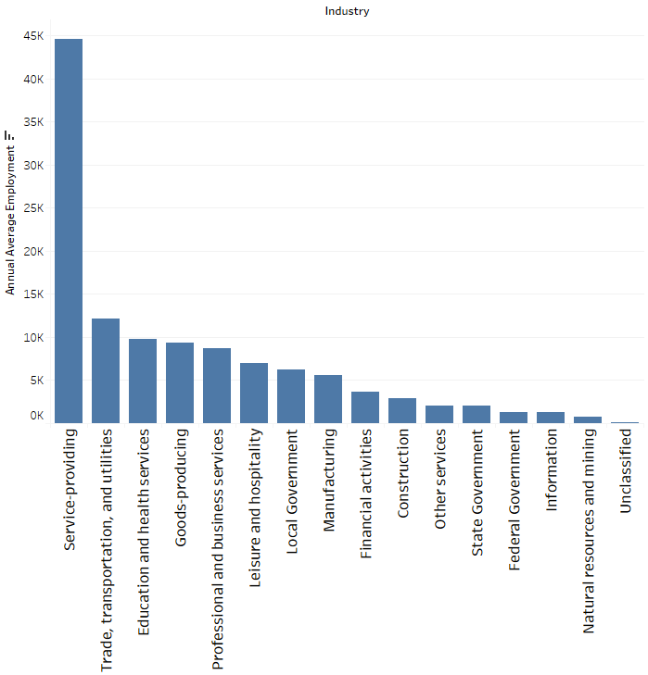  
     
   1. State Government
   2. **Education and Health Services**
   3. Goods-producing
   4. Professional and Business Services
2. Which State has the lowest average annual pay? (Value vs Location / Filled Map)  
     
   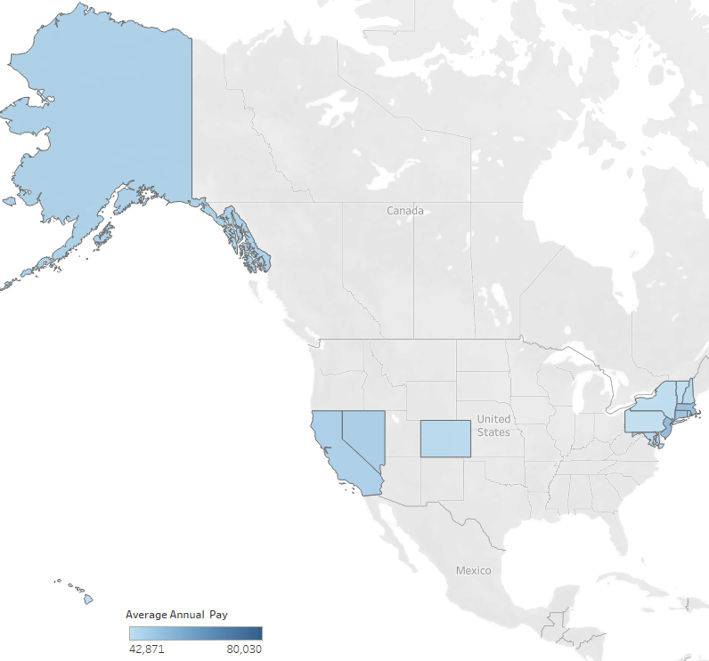  
   1. MD
   2. **PA**
   3. CO
   4. AK
3. In which year did Education and Health Services first pass 35K in Average Annual Pay? (Value vs Time / Circle)  
     
   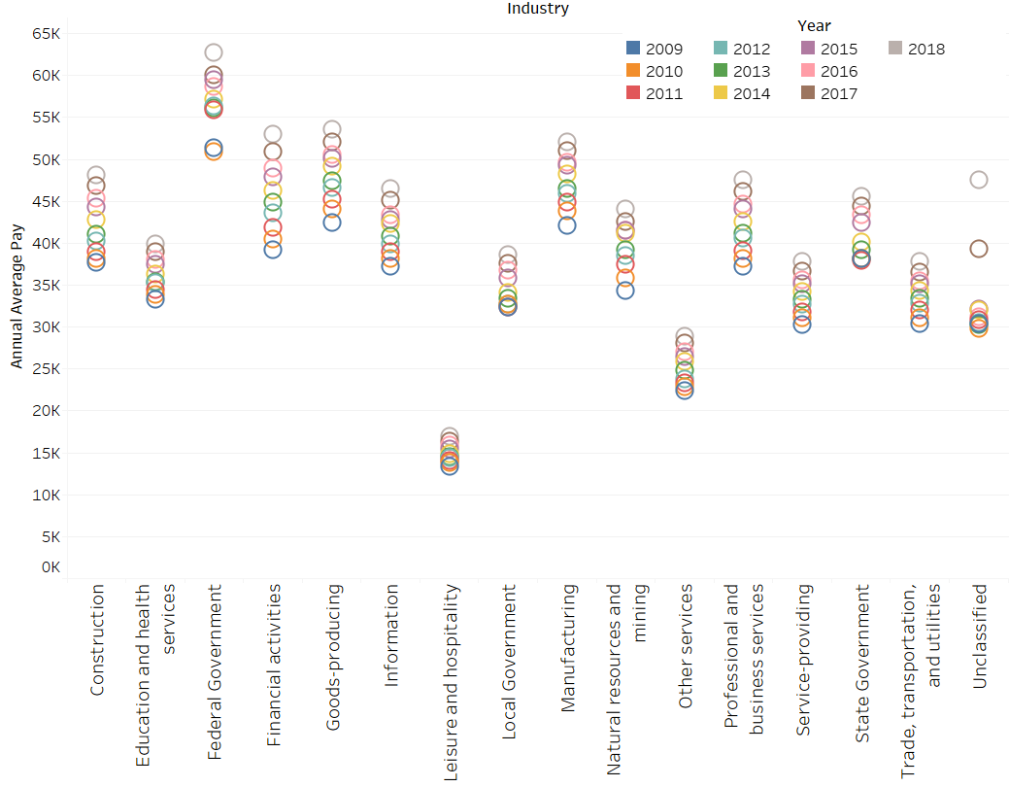  
   1. 2013
   2. 2010
   3. **2012**
   4. 2015
4. Are more industries paying annual wages above or below the average? (Comparison / Bars)  
     
   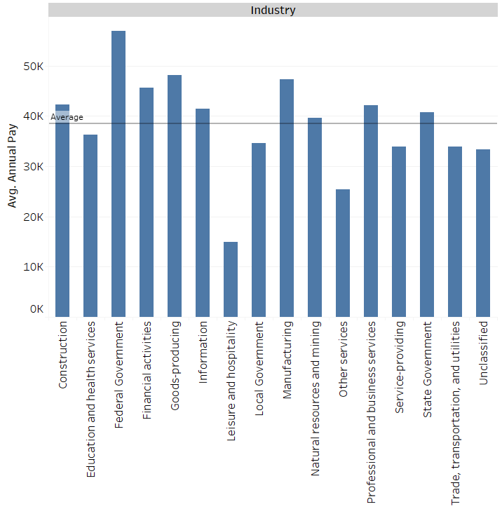  
   1. **Above**
   2. Below
5. Which Industry has the third highest average employment? (Category vs Value / Bubble)  
     
   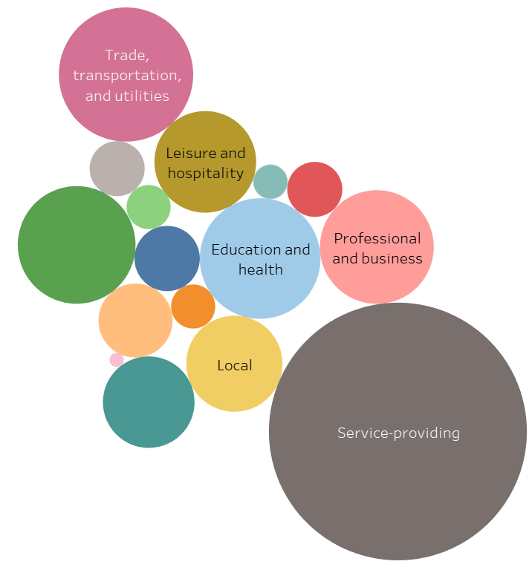  
   1. Professional and Business Services
   2. Goods-producing
   3. **Education and Health Services**
   4. Local
6. Which State has the lowest average annual pay? (Value vs Location / Bar)  
     
   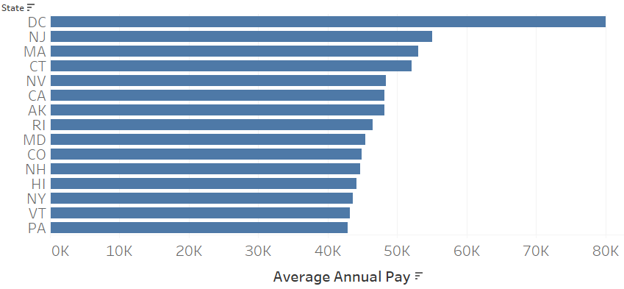  
   1. HI
   2. VT
   3. **PA**
   4. MD
7. Which State has the county with the highest paying jobs? (Value vs Value/Bubble)  
     
   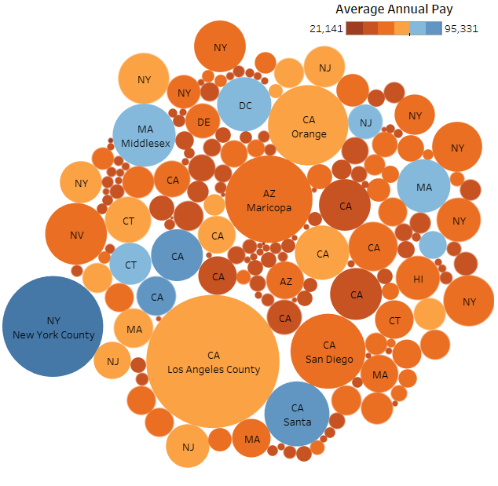  
   1. California
   2. **New York**
   3. Arizona
   4. Massachusetts
8. In which year did Education and Health Services first pass 35K in Average Annual Pay? (Value vs Time / Chart)  
     
   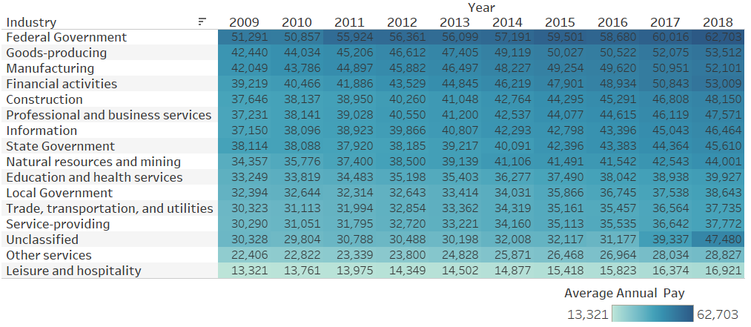  
   1. 2010
   2. **2012**
   3. 2013
   4. 2015
9. Are more industries paying annual wages above or below the average? (Comparison / Chart)  
     
   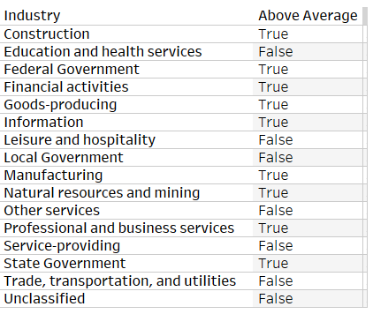  
   1. Below
   2. **Above**
10. Which Industry has the third highest average employment? (Category vs Value / Tree)  
      
    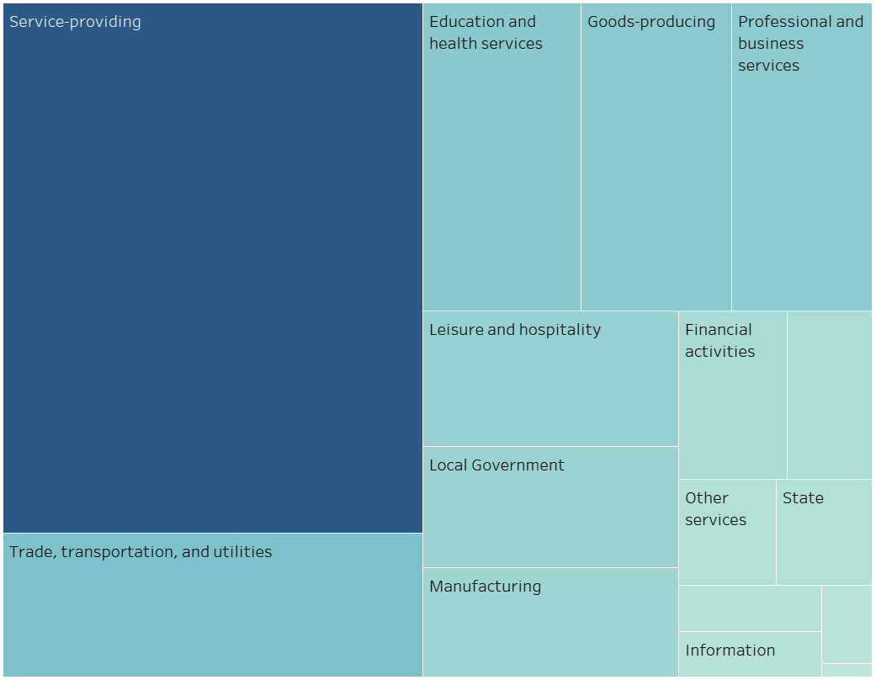
11. Professional and Business Services
12. Goods-producing
13. Local Government
14. **Education and Health Services**
15. Which State has the county with the highest paying jobs? (Value vs Value/Scatter)  
      
    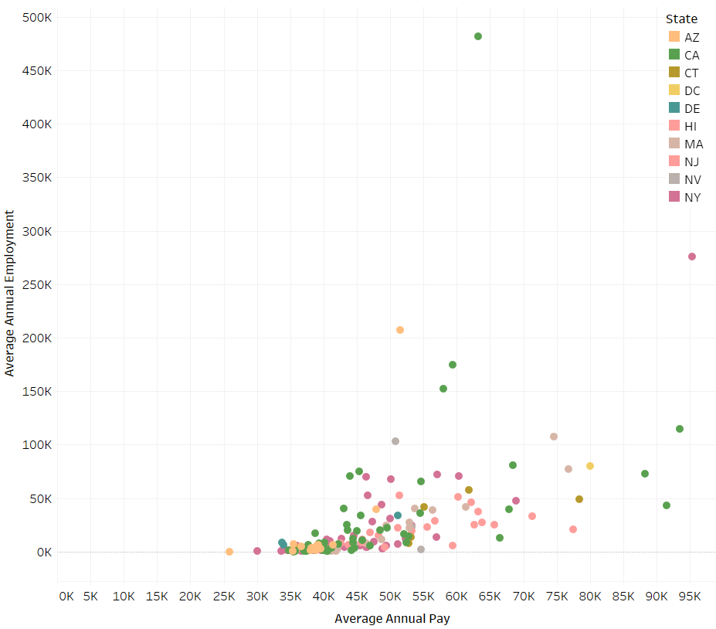  
    1. Arizona
    2. California
    3. Connecticut
    4. **New York**
16. Are more industries paying annual wages above or below the average? (Comparison / Columns)  
      
    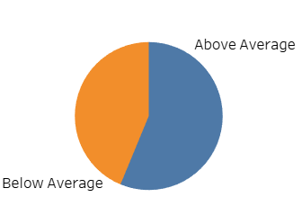
17. Below
18. **Above**
19. In which year did Education and Health Services first pass 35K in Average Annual Pay? (Value vs Time / Line)  
      
    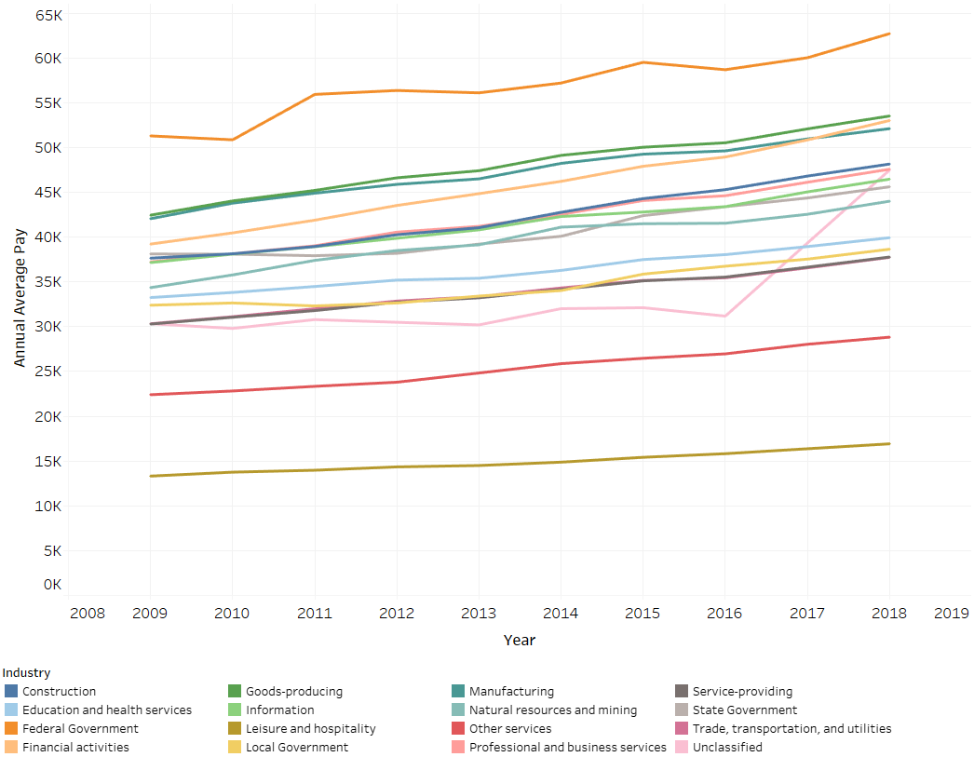
20. **2012**
21. 2013
22. 2014
23. 2015
24. Which State has the lowest average annual pay? (Value vs Location / Map)  
      
    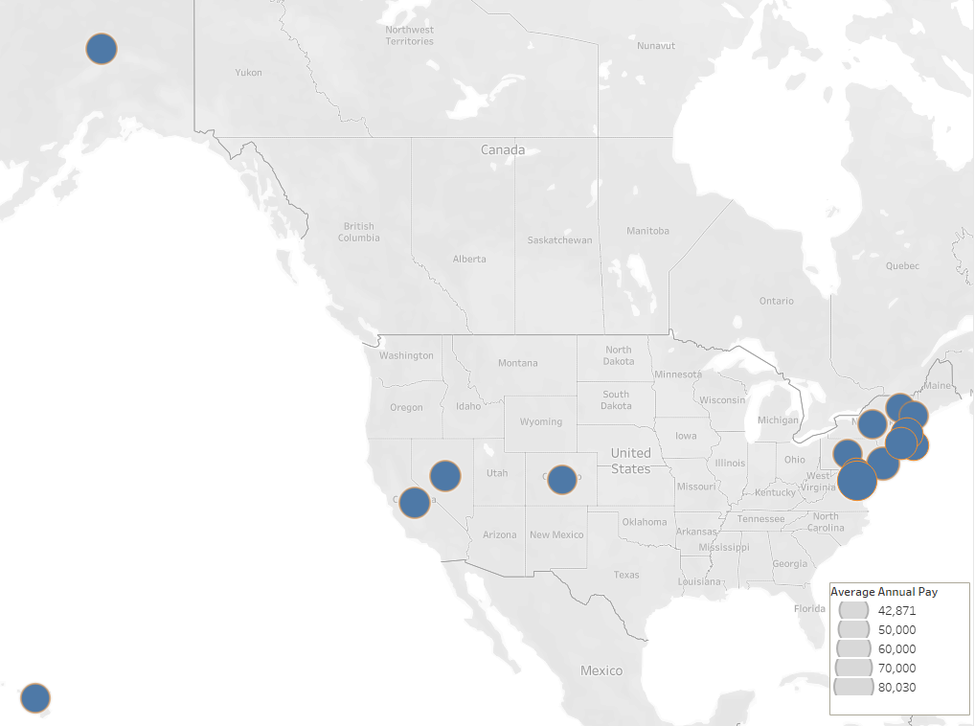
25. **PA**
26. NV
27. NH
28. MA
29. Which Industry has the third highest average employment? (Category vs Value / Pie)  
      
    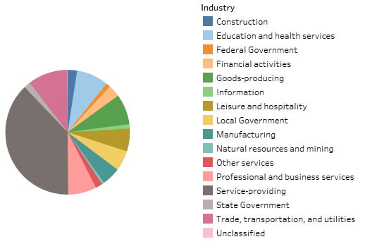
30. **Education and Health Services**
31. Professional and Business Services
32. Goods-producing
33. Trade, Transportation, and Utilities