BMTNet: A Transformer Network for Polyp Segmentation Based on Boundary Awareness and Multi-Scale Fusion

Abstract
We propose a Transformer network for polyp segmentation based on boundary awareness and multi-scale fusion. The network addresses segmentation challenges in complex scenarios by explicitly modeling contour information and collaboratively aggregating multi-scale features. We construct a model with PVTv2-b2 as the backbone, incorporating a multi-scale attention enhancement module (EMA) and a boundary branch composed of a local dilated gated boundary extraction module (LDGA) and a cross-scale boundary attention module (LSCAB), and design a two-stage fusion mechanism combining feature-level and output-level fusion. During prediction, EMA effectively enhances responses in key polyp regions, the boundary branch explicitly extracts contour details, and the fusion mechanism jointly models fine-grained spatial contour information and global semantic context through multi-scale feature interaction, thereby correcting the final prediction. Experiments on five public polyp segmentation datasets demonstrate competitive performance. In particular, on the highly challenging ETIS-LaribPolypDB dataset, the method achieves a mean Dice of 0.840 and a Recall of 0.922; its mean Dice is 3.9% higher than that of the recent method Fu-TransHNet.
Keywords: polyp segmentation; medical image segmentation; Transformer; boundary awareness; multi-scale attention; feature fusion

Chapter 1 Introduction
Colorectal cancer is a common malignant tumor of the digestive tract in clinical practice, and its development is closely associated with colorectal polyps [4,7]. Polyps generally appear as abnormal tissue growing from the intestinal surface. Although most are benign, some adenomatous polyps carry a potential risk of malignant transformation [4]. Therefore, timely and accurate detection and removal of polyps during early electronic colonoscopic screening are of great clinical importance for reducing the incidence and mortality of colorectal cancer [7,8].
In clinical examinations, manually identifying and delineating polyp regions is labor-intensive, highly dependent on physicians’ experience, and subjective [5,7]. Polyp images are also often affected by complex backgrounds, including intestinal folds, specular reflections, mucus occlusion, and low contrast. Polyps from different patients vary markedly in color, size, shape, and boundary clarity, readily leading to missed detections or misjudgments [4,8]. Image segmentation is one of the most fundamental and challenging tasks in computer vision; its core objective is to classify every pixel in an image semantically. With the development of deep learning, this technique has been widely applied to medical image analysis in specific fields, including pancreas segmentation, cell detection, brain tumors, and polyp segmentation [4,9]. Previous studies have generally adopted attention or edge-guidance ideas from salient object detection and extracted multi-scale features using general encoder-decoder architectures (e.g., U-Net [11] and its variants such as PraNet [7], HarD-MSEG [3], UACANet [8], and Polyp-PVT [6]). They have used mechanisms such as reverse attention [7] or uncertainty-augmented context attention [8] to focus on polyp regions. Despite this progress, challenges remain, including blurred boundaries, substantial scale variation, loss of local details, and weak cross-dataset generalization [5,13]. In boundary regions in particular, conventional segmentation losses may overlook ambiguous pixels, producing overly smooth edges or local omissions, while obtaining additional pixel-level edge annotations is often costly [2,4].
To address these issues, this paper proposes a Transformer network for polyp segmentation based on boundary awareness and multi-scale fusion. The method uses PVTv2-b2 as a hierarchical backbone to extract multi-scale semantic features. To enhance responses in key polyp regions and suppress background interference, an EMA attention module is introduced into the main segmentation branch. To address the loss of boundary information, the boundary branch explicitly models boundaries using a boundary-aware module composed of the local dilated gated boundary attention module (LDGA) and the cross-scale boundary attention module (LSCAB), effectively capturing local multi-scale boundary details and integrating cross-scale dependencies without costly edge annotations. Finally, a two-branch, two-stage fusion mechanism combining feature-level and output-level fusion enables complementary correction between boundary priors and semantic region information during prediction.
We evaluated the proposed method on five widely used polyp segmentation benchmark datasets: CVC-300, CVC-ClinicDB, Kvasir, CVC-ColonDB, and ETIS-LaribPolypDB. The method achieved competitive state-of-the-art performance. In particular, on the highly challenging ETIS-LaribPolypDB dataset, it demonstrated strong resistance to interference, achieving a mean Dice of 0.840 and a Recall of 0.922. Extensive ablation experiments and visual analyses further verified the effectiveness of each module.
In summary, the main contributions of this paper are as follows:
- A hierarchical extraction and differentiated enhancement strategy for multi-scale semantic features is designed;
- An EMA-enhanced main segmentation branch and a boundary-aware branch comprising the local dilated gated boundary extraction module (LDGA) and the cross-scale boundary attention module (LSCAB) are designed to explicitly model complex contour information without costly edge annotations;
- A multi-scale collaborative fusion mechanism is proposed. Through multi-scale feature interaction, it jointly models fine-grained spatial contour information and global semantic context and corrects the final prediction, effectively improving segmentation accuracy in complex scenarios.
Chapter 2 Related Work
2.1 Semantic Segmentation and Vision Transformers
Fully convolutional networks (FCNs) first enabled end-to-end pixel-level classification [10]. Subsequently, architectures such as PSPNet and DeepLab enlarged the receptive field through atrous convolution and pyramid pooling to capture multi-scale contextual information [16,17]. However, because of the local inductive bias of convolutional kernels, CNN-based methods of this kind have inherent limitations in modeling long-range dependencies [18]. With the introduction of Transformers to computer vision, SETR [19] was the first to formulate semantic segmentation as a sequence-to-sequence task and capture global context using a pure Transformer encoder. SegFormer [20] further combined a hierarchical Transformer encoder with a lightweight MLP decoder, producing multi-scale features while maintaining efficiency. Hybrid architectures such as TransUNet [21] also integrate the global modeling capability of Transformers into the U-Net encoder. In this context, the Pyramid Vision Transformer (PVT) was proposed as a general-purpose multi-scale backbone. By introducing spatial reduction and a hierarchical structure, it retains multi-scale features while reducing computational complexity [22]. Its replaceability with CNN backbones has led to its widespread use in various Transformer-based segmentation networks. Given the large variation in polyp scale and the complexity of the background, this paper selects PVTv2-b2 [14] as the backbone. It combines the local feature extraction capability of CNNs with the global contextual modeling advantages of Transformers, addressing the limitations of conventional CNNs in extracting semantic features from complex endoscopic scenes [14,18,22].
2.2 Attention Mechanisms
By reweighting feature maps, attention mechanisms have become important components for improving segmentation network performance. Early channel attention mechanisms, such as SENet [23], establish channel dependencies through adaptive pooling, while CBAM [24] further combines spatial and channel dimensions. The ECA [25] module uses one-dimensional convolution for efficient cross-channel interaction, while dual attention networks such as DANet [26] capture long-range spatial and channel dependencies through self-attention. However, under strong illumination variation and interference from complex intestinal folds, attention mechanisms based on global statistics or fixed receptive fields often struggle to focus precisely on the target itself and may produce false background activations [2,5]. Recent models such as APCNet [27] and LDNet [28] strengthen attention-based context capture through multi-level aggregation and iterative updates, but they mainly emphasize global semantic relationships and still lack explicit modeling of spatial details such as local texture. Lightweight variants such as Efficient Attention [29] and coordinate attention [30] also seek to preserve spatial positional information while improving computational efficiency, but neither fully addresses the distinctive challenge of blurred boundaries in medical images [2,5].

2.3 Polyp Segmentation and Boundary-Aware Methods
Because polyp segmentation is essentially a pixel-level binary classification task that distinguishes abnormal from normal regions, U-Net and its improved variants (e.g., ResUNet++ and SFA) are widely used in this field; they fuse shallow spatial information with deep semantic information through skip connections [7,8,11]. However, polyp boundaries are often blurred and irregular, and conventional region-based segmentation losses can readily overlook boundary pixels, resulting in overly smooth edges or local omissions [2,4]. To improve contour recovery, models such as PraNet [7] introduce reverse attention to capture residual details from reverse-predicted regions. Edge-guided networks such as EGNet and BANet explicitly introduce an edge branch through multi-task learning and improve edge quality using additional pixel-level edge labels [4,5]. BDG-Net and FeNet further strengthen boundary supervision by modeling boundary distributions or jointly optimizing edges and object regions. However, these methods generally rely on costly edge annotations, and additional edge supervision may introduce redundant information unrelated to the target, limiting generalization to large-scale clinical datasets lacking fine-grained annotations [4,8].
2.4 Multi-Scale Feature Fusion
Multi-scale feature extraction and fusion are central problems in medical image segmentation. “Multi-scale” involves two distinct dimensions: receptive-field scale, which aims to capture local structural variations at different granularities using kernels of different sizes or dilation rates; and semantic hierarchy, which aims to fuse high-resolution spatial texture information from shallow layers with low-resolution abstract semantic information from deep layers.
In terms of receptive-field scale, PSPNet introduces spatial grids of different sizes through pyramid pooling. The DeepLab series expands the receptive field using atrous convolutions with different dilation rates to capture multi-scale local context. In terms of semantic hierarchy, FPN aggregates features at different depths through element-wise addition, whereas U-Net and its variants, such as U-Net++, bridge the semantic gap between shallow and deep features through channel-wise concatenation or dense connections. More recently, Transformer-based methods such as Polyp-PVT have naturally enabled feature filtering from local details to global semantics through hierarchical self-attention. However, whether expanding the receptive field with fixed dilation rates or simply adding hierarchical features, naive feature superposition often blurs semantic information and cannot precisely refine extremely small local contours at the final prediction layer. How to fully exploit complementary relationships between features while integrating spatial and semantic scales remains an open problem in this field.
Chapter 3 Method
This section presents the architecture and component details of the proposed Transformer network for polyp segmentation based on boundary awareness and multi-scale fusion. We first describe the overall PVTv2-b2-based framework and its information flow (Section 3.1), and then detail the internal structure of each core component: the EMA attention module for enhancing responses in key polyp regions (Section 3.2); the Boundary Branch for explicitly modeling contour details, comprising the LDGA local dilated gated boundary attention module and the LSCAB cross-scale boundary attention module (Section 3.3); and the two-branch, two-stage fusion mechanism for complementarity between semantic region information and boundary priors (Section 3.4).
3.1 Overall Network Architecture
Polyp regions typically exhibit substantial morphological variation and high visual similarity to surrounding tissue, causing automatic segmentation models to produce inaccurate boundary localization, miss small polyps, or generate incomplete predictions. Although Transformer-based methods can capture long-range dependencies through self-attention, their greater emphasis on high-level semantic information leaves them short of local details when processing complex medical edge structures. To address these issues, this paper proposes a polyp segmentation network based on boundary-aware enhancement and two-branch fusion.
As shown in Fig. 1, the network uses PVTv2-b2 as the encoder to extract multi-scale features from the input image, producing X1–X4. As the hierarchy deepens, spatial resolution decreases and semantic abstraction increases, while local details are progressively diluted during deep feature abstraction. Accordingly, the network uses a two-branch structure to process features.
In the main segmentation branch, a differentiated enhancement strategy is adopted: X1, which retains the richest original spatial details, is fed directly to the decoder, while X2, X3, and X4 are fed into the improved EMA module. Multi-scale attention establishes global semantic relationships, and its edge-aware pathway compensates for local details diluted in deep features. The enhanced features pass through the decoder to progressively recover spatial resolution and generate the main segmentation prediction.$X_{2}$$X_{3}$$X_{4}$
In the boundary branch, to make full use of the rich spatial edge information in shallow features, the two feature maps are separately projected to a unified channel count through 1 × 1 convolutions, spatially aligned, concatenated along the channel dimension, and fed into the LDGA module. LDGA captures local multi-scale contour variations using depthwise atrous convolutions with different dilation rates. Its output, together with the projected and upsampled feature maps, is fed into the LSCAB module, which fuses boundary features across spatial and channel dimensions through cross-scale attention. The boundary branch ultimately outputs two results: a multi-channel boundary feature map (for feature-level fusion with the main segmentation branch) and a single-channel boundary prediction map (for boundary supervision and output-level fusion).$X_{1}$$X_{2}$$X_{3}$$X_{4}$
Finally, the two-branch, two-stage fusion strategy combines fine-grained structural information extracted by the boundary branch with semantic information from the main segmentation branch. Feature-level fusion introduces boundary features into the feature representations at the decoding stage, while output-level fusion uses the boundary prediction to correct the final result. This mechanism effectively improves the model’s localization of complex polyp boundaries and its overall segmentation accuracy.

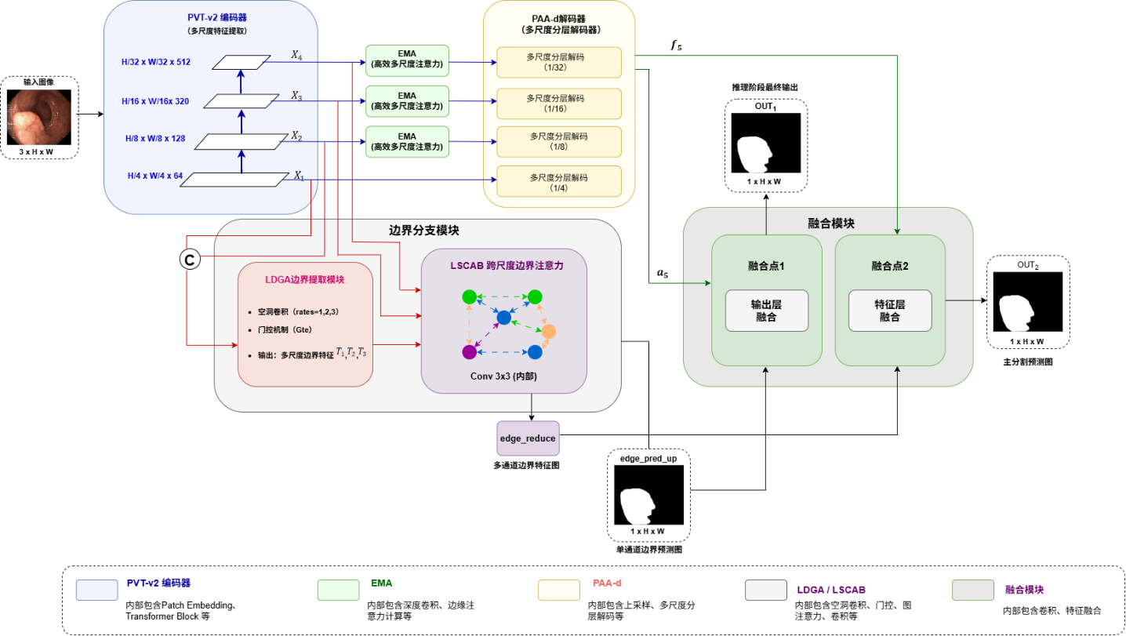
Fig. 1. Overall architecture of the proposed BMTNet. The network consists of four core components: (a) a PVTv2-B2-based encoder for extracting multi-scale hierarchical features; (b) a two-branch fusion module, including feature-level fusion (fusion point 1) and output-level fusion (fusion point 2), for jointly integrating semantic and boundary information; (c) a boundary enhancement branch containing LDGA and LSCAB modules for explicitly extracting and enhancing multi-scale boundary features; and (d) the PAA-d decoder and EMA edge-aware attention module in the main segmentation branch for enhancing responses in key regions and recovering spatial resolution, ultimately producing a high-precision segmentation result.
3.2 EMA Multi-Scale Attention Enhancement Module
Although self-attention in Transformer architectures effectively establishes long-range spatial relationships, polyp images contain many low-contrast regions and blurred or even interrupted boundaries, making global attention alone insufficient for capturing local boundary variations. The Value branch of the original EMA module mainly derives from a direct mapping of the original features and lacks explicit modeling of local texture and edge information, limiting detail perception under complex anatomical structures [1,5]. In addition, shallow features are dominated by spatial details, while local details in deep semantic features are progressively diluted. Applying identical attention enhancement at all levels can therefore over-smooth shallow details or leave deep features without adequate detail compensation.
Based on this analysis, we propose an improved EMA module, whose overall structure is shown in Fig. 2.
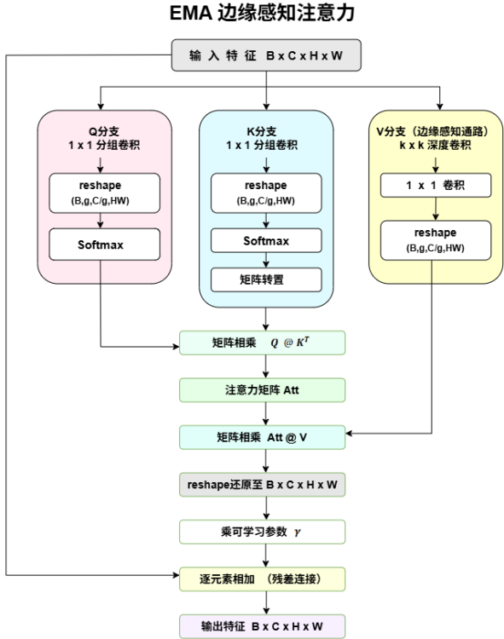
Fig. 2. Structure of the proposed EMA module, which consists of three parallel branches and attention fusion: (a) the Q branch uses 1
× 1 grouped convolution to extract features and compute the query matrix; (b) the K branch uses 1 × 1 grouped convolution to extract the key matrix and transpose it; and (c) the V branch (edge-aware pathway) introduces depthwise convolution to explicitly extract local edge and texture features. The attention matrix is then generated by multiplying Q and K and is used to weight the enhanced features from the V branch. Finally, the weighted features are residually connected to the input to produce the final enhanced features.
Specifically, we introduce an edge-aware pathway into the Value branch of EMA and use depthwise convolution (DWConv) to enhance local spatial structure, allowing the model to attend to both global semantic regions and local boundary details. Given an input feature, where B denotes the batch size, C the number of channels, and H and W the height and width of the feature map, respectively, the input is first mapped to the Query, Key, and Value branches and then reshaped to dimensions:$X ∈ R^{B ×C ×H ×W}$$B × g ×\frac{C}{g} ×HW$
$$Q= Softmax\left(W_{q}\left(X\right)\right)$$
$$K= Softmax\left(W_{k}\left(X\right)\right)$$
$$V= W_{v}\left(DWConv\left(X\right)\right)$$
where are the weights of the grouped 1 × 1 convolution, denotes the 1 × 1 convolution weights, denotes the depthwise convolution operation, g is the number of groups, is the number of channels per group, and is the total number of spatial pixels. Unlike the conventional EMA structure, which directly uses the original features as Value, we use depthwise convolution to extract spatial structural features from local neighborhoods and explicitly capture edge variations. This prevents redundant overlap between the extracted edge-texture features and the original global features, while strengthening their influence in subsequent attention computations.$W_{q}$$W_{k}$$W_{v}$$DWConv\left(⋅\right)$$\frac{C}{g}$$HW$
The attention relationships are then computed through matrix multiplication and used to weight the Value features:
$$Att=QK^{T}$$
$$Y= Att ⋅ V$$
where Y denotes the boundary feature map after multi-scale spatial convolution fusion, denotes the attention matrix, and T denotes matrix transposition. The attention matrix weights the enhanced Value features, and a learnable parameter adjusts the enhancement ratio before residual fusion with the input:$Att$$γ$$Y_{out}= γY+X$
where denotes the weighted Value features, is a learnable scaling parameter that balances the enhanced features against the original input, and denotes the final output features. With this design, the improved EMA module retains the global contextual modeling capability of the Transformer architecture and introduces a local edge-aware mechanism. This substantially improves the model’s response to blurred details such as polyp boundaries, compensating for the lack of local information in global attention.$Y$$γ$$Y_{out}$
3.3 Boundary-Aware Branch
Polyp boundaries are often blurred by low color contrast, folds, and specular reflections, and region-based supervision alone can lead to broken contours. We design a boundary-aware Boundary Branch that follows a progressive “local refinement, global integration” approach and precisely perceives complex contours through cascaded LDGA and LSCAB modules.
3.3.1 LDGA Local Dilated Gated Boundary Extraction Module
The overall structure of the LDGA module is shown in Fig. 3.
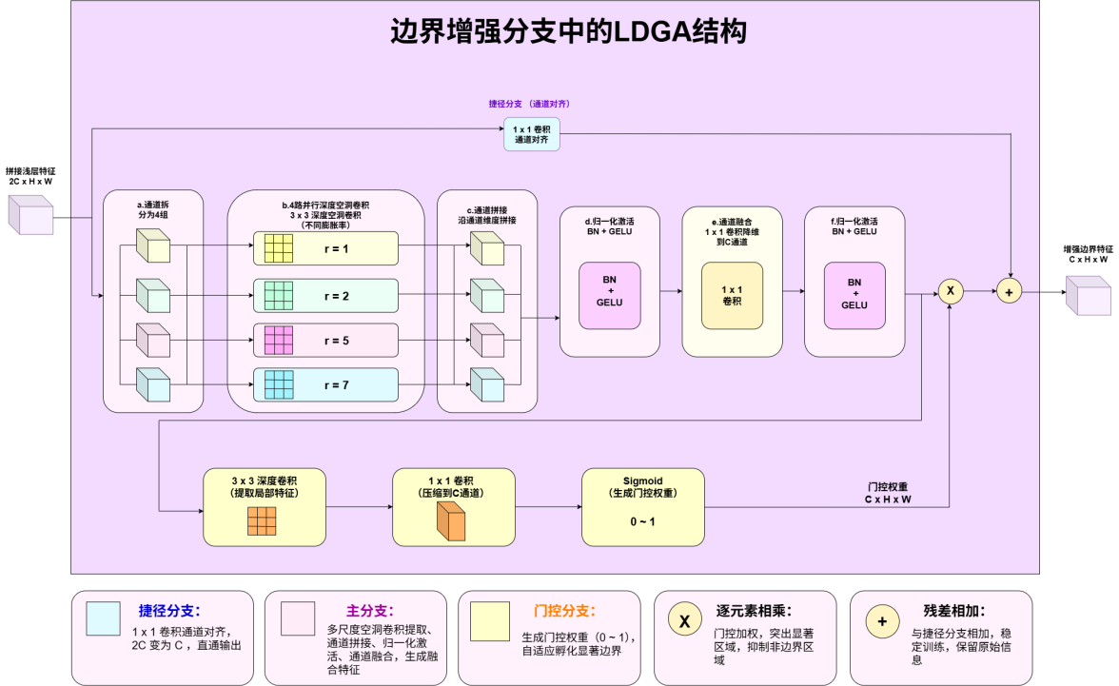
Fig. 3. Structure of the LDGA module in the boundary enhancement branch. It consists of three main branches and a fusion operation: (a) the main branch splits the features into four groups and extracts multi-scale features using parallel 3 × 3 depthwise atrous convolutions, then concatenates them along the channel dimension and fuses them with a 1 × 1 convolution; (b) the gating branch extracts local features with a 3 × 3 depthwise convolution and generates gating weights in [0,1] through a 1 × 1 convolution and Sigmoid function to adaptively highlight salient boundaries; and (c) the shortcut branch aligns channels with a 1 × 1 convolution, reducing 2C channels to C. Finally, the fused main-branch features are multiplied element-wise by the gating weights to highlight salient regions and suppress non-boundary regions, then added residually to the shortcut branch to stabilize training and preserve the original information.
The module consists of coordinated main, gating, and shortcut branches. In the main branch, the concatenated shallow feature F (with 2C channels) is first divided into four groups by channel splitting;
$$F= \left\{F_{1},F_{2},F_{3},F_{4}\right\}$$
The groups are then fed separately into four depthwise atrous convolutions with different dilation rates to capture local contour variations at multiple scales. The feature extraction process is as follows:$\left(r_{i}∈ \left\{1,2,5,7\right\}，where r_{i}denotes the dilation rate of the i-th branch\right)$
$$Y_{i}=DWConv_{r_{i}}\left(F_{i}\right)$$
where denotes the input feature of group , denotes the corresponding multi-scale boundary feature, and denotes a depthwise atrous convolution with dilation rate . The outputs at different scales are then concatenated along the channel dimension and fused using a 1 × 1 convolution, reducing the result to C channels:$F_{i}$$i$$Y$$i$$DWConv_{r_{i}}\left(⋅\right)$$r_{i}$
$$P=Conv_{1×1}\left(Concat\left(Y_{1},Y_{2},Y_{3},Y_{4}\right)\right)$$

where P denotes the boundary feature map fused from multi-scale atrous convolutions, denotes concatenation along the channel dimension, and denotes a 1 × 1 convolution.$Concat\left(⋅\right)$$Conv_{1×1}\left(⋅\right)$
In the gating branch, the main-branch output feature T passes through a 3 × 3 depthwise convolution and a 1 × 1 convolution for channel compression, followed by a Sigmoid activation to generate dynamic gating weights in [0,1]:$G$
$$G= σ\left(Conv_{1×1}\left(DWConv\left(Y\right)\right)\right)$$
where denotes the Sigmoid activation function, denotes the 3 × 3 depthwise convolution, and denotes the generated gating weights. Finally, the gating weights are multiplied element-wise by the main-branch output, which is then added residually to the shortcut branch whose channels have been aligned through a 1 × 1 convolution, producing the boundary feature:$σ\left(⋅\right)$$DWConv\left(⋅\right)$$G$$Y$$F_{shortcut}$
$$F_{out}=G ×Y+ F_{shortcut}$$
where denotes the shortcut feature after reducing the channel count from 2C to C using a 1 × 1 convolution, X denotes element-wise multiplication, and denotes the final boundary feature map. The multi-scale atrous convolutions address the inability of a fixed receptive field to adapt to boundary variations at different scales, while the gating mechanism precisely suppresses background noise.$F_{shortcut}$$F_{out}$
3.3.2 LSCAB Cross-Scale Boundary Attention Module
Although LDGA extracts local boundaries, information at a single scale remains isolated. We therefore design the LSCAB module, whose overall structure is shown in Fig. 4.
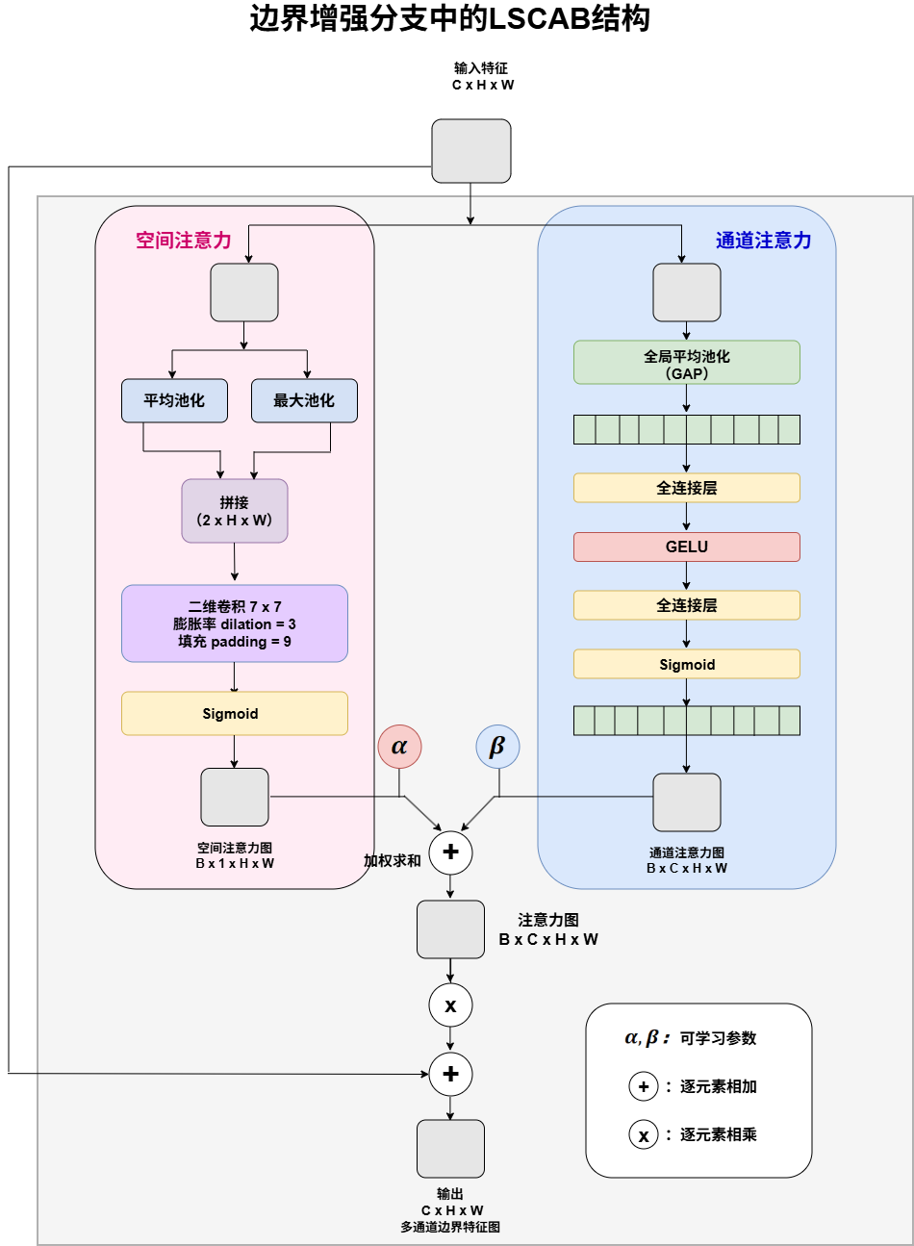
Fig. 4. Structure of the LSCAB module in the boundary enhancement branch. The module uses a two-branch parallel attention mechanism: (a) the spatial attention branch extracts features through average and max pooling, concatenates them, and applies a 7 × 7 two-dimensional atrous convolution (dilation rate = 3, padding = 9) and Sigmoid activation to generate a spatial attention map; (b) the channel attention branch obtains channel descriptors through global average pooling (GAP), passes them successively through a fully connected layer, GELU activation, and another fully connected layer, and applies Sigmoid activation to generate a channel attention map. The two attention maps are then combined by a weighted sum using learnable parameters to generate a joint attention map. Finally, the joint attention map is multiplied element-wise by the input feature, which is also added residually, yielding a multi-channel boundary feature map.$α$$β$
The module receives shallow boundary features from LDGA and feature maps aligned through projection and upsampling, and enhances the input features at each scale separately using a two-branch parallel attention mechanism. In the spatial attention pathway, the features are average-pooled and max-pooled, then concatenated. A 7 × 7 atrous convolution (dilation rate 3, padding 9) extracts broad spatial context, and a Sigmoid activation generates the spatial attention map:$X_{3}$$X_{4}$
$$A_{s}= σ\left(Conv_{7×7}\left(\left[AvgPool\left(F\right) ,MaxPool\left(F\right)\right]\right)\right)$$
In the channel attention pathway, global average pooling (GAP) produces channel descriptors. These are passed successively through a fully connected layer, GELU activation, and another fully connected layer, followed by Sigmoid activation to generate the channel attention map:
$$A_{c}= σ\left(MLP\left(GAP\left(F\right) \right)\right)$$
where consists of two fully connected layers: the first reduces the number of channels to ( is the reduction ratio), and the second restores it to C. The two maps are combined through a weighted sum using learnable parameters to form the joint attention map:$MLP$$C/γ$$γ$$α$$β$
$$A= αA_{c}+ βA_{s}$$
Finally, the attention map is multiplied element-wise by the input feature and added residually:
$$F^{'}=F ×A+F$$
After applying the above operation to the inputs at all three scales, three sets of enhanced boundary features are produced and sent to subsequent convolutional feature fusion. This design enables the model to attend to both the spatial positions of boundary pixels and key feature channels, effectively strengthening complementarity among cross-scale boundary features.
3.4 Two-Branch Fusion Module
To fully exploit the semantic information from the main segmentation branch and the structural information from the boundary branch, we design a two-level fusion strategy. The two-branch fusion module, shown in Fig. 5, comprises feature-level and output-level fusion. Feature-level fusion injects fine-grained structural information from the boundary branch into the semantic feature representation of the main branch, while output-level fusion uses the boundary prediction to correct the main branch’s coarse segmentation pixel by pixel. The two stages work together to enable deep interaction between boundary priors and semantic information.

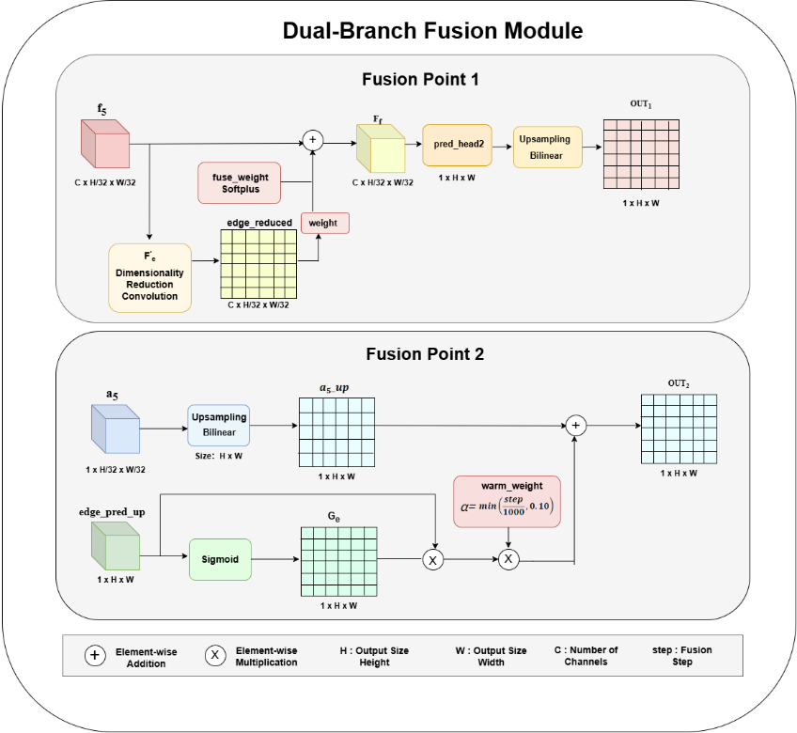
Fig. 5. Structure of the proposed two-branch fusion module, which contains two fusion points: (a) fusion point 1 (feature-level fusion) combines the aligned boundary features with the semantic features of the main branch to generate a refined prediction; (b) fusion point 2 (output-level fusion) uses the boundary prediction to generate a gate that corrects the main branch’s coarse prediction and produces the final result.$f_{5 }$$edge_reduced$$OUT_{1}$$edge_pred_up$$G_{e}$$a5$${Out}_{2}$
3.6.1 Feature-Level Fusion
During feature-level fusion, the multi-channel boundary feature map from the boundary branch is first mapped to the channel space of the main segmentation branch using a 1 × 1 convolution, yielding aligned boundary features. To ensure that the fusion weight is always positive, we introduce a learnable scalar parameter and apply the Softplus function to obtain the fusion weight:$edge_reduced$$θ$
$$weight=Softplus\left(fuse_weight\right)$$
The semantic features output by the main segmentation branch decoder are then added element-wise to the weighted boundary features to obtain the fused features:$F_{5 }$
$$F_{f}=f_{5 }+weight⋅edge_reduced$$
A convolutional prediction head is applied to these features to generate the refined segmentation prediction. This fusion method effectively injects fine-grained boundary structure into the high-level semantic representation of the main branch, compensating for the lack of local details in deep features.$OUT_{1}$
3.6.1 Output-Level Fusion
During output-level fusion, the single-channel boundary prediction from the boundary branch is passed through a Sigmoid activation to generate a boundary gate that quantifies the probability of each pixel belonging to a boundary region:$edge_pred_up$$G_{e}$
$$G_{e}=σ\left(P_{e}\right)$$
Meanwhile, the coarse segmentation prediction from the main segmentation branch is upsampled to the original image size, yielding . The boundary gate is then combined with through weighted fusion to obtain the output-level fused result.$a_{5}$$a5_up$$a5_up$$OUT_{2}$
$${Out}_{2}= a5_up+ ∝G_{e}P_{e}$$
where denotes the dynamically adjusted weight.$∝$
This strategy further enhances boundary regions in the prediction, making the final segmentation result more precise.

3.7 Loss Function
We adopt a multi-task learning strategy in which the training loss consists of a main segmentation loss and a boundary supervision loss, jointly supervising the polyp region segmentation branch and the boundary prediction branch. The overall training objective is defined as follows:
$$L_{total} ={ L}_{main} + λL_{edge}$$
where denotes the loss function of the main segmentation branch, denotes the loss function of the boundary branch, and is a balancing hyperparameter that adjusts the contribution of boundary supervision to the overall training objective.${ L}_{main}$$L_{edge}$$λ$
Because the main segmentation branch is not yet stable at the beginning of training, introducing overly strong boundary supervision too early may interfere with convergence of the primary task. We therefore use a dynamic weighting strategy to adjust in stages.$λ$
$$λ=\left\{\begin{aligned}0.5， epoch<50 \\ 0.4， 50≤epoch<120 \\ 0.25，epoch≥120\end{aligned}\right.$$

3.7.1 Main Segmentation Branch Loss

The main segmentation branch combines weighted binary cross-entropy loss with weighted IoU loss to account for both pixel-level classification accuracy and global structural consistency [7,9]. Let the probability map output by the network be , and the corresponding ground-truth mask be . The main-branch loss is defined as follows:$P∈ {\left[0，1\right]}^{H×W}$$G∈ {\left\{0，1\right\}}^{H×W}$
$$L_{main} ={ L}_{wFocalBCE} + L_{wIoU}$$

To increase the network’s focus on polyp boundary regions, we construct a pixel-level weight map W from the difference between the ground-truth mask and its mean-pooled version:
$$W = 1 + 5 · \left|AvgPool_{31}\left(G\right) − G\right|$$
where denotes mean pooling with a 31 × 31 kernel, stride 1, and padding 15. Pixels closer to the polyp boundary receive higher weights, encouraging the network to focus during training on difficult-to-classify boundary regions.$AvgPool_{31}\left(·\right)$
On this basis, we supervise the main branch using focal weighted binary cross-entropy loss, defined as follows:
$${ L}_{wFocalBCE} = \frac{\sum_{i,j}{W_{ij}·α{\left(1−p_{ij}\right)}^{γ}\left[−G_{ij}logP_{ij}−\left(1−G_{ij}\right)log\left(1−P_{ij}\right)\right]}}{\sum_{i,j}{W_{ij}}}$$
where denotes the probability obtained by applying Sigmoid to the raw network output, is the class-balancing factor, and is the modulation factor, which reduces the loss contribution from easily classified samples so that training focuses on difficult boundary pixels.$P_{ij}=σ\left({\hat{P}}_{ij}\right)$$P_{ij}$$α=0.25$$γ=1.5$
To further measure structural similarity between the prediction and ground truth globally, we introduce weighted IoU loss. Compared with standard IoU loss, weighted IoU loss uses the weight map to increase the influence of boundary regions during optimization and is defined as follows:
$${ L}_{wIoU} = 1−\frac{\sum_{i,j}{W_{ij}·\left(P_{ij}·G_{ij}\right)+1}}{\sum_{i,j}{W_{ij}}·\left(P_{ij}+G_{ij}\right)−\sum_{i,j}{W_{ij}·\left(P_{ij}·G_{ij}\right)+1}}$$

A constant of 1 is added to both the numerator and denominator as a smoothing term to avoid division by zero during training and improve numerical stability.
In addition, because the main segmentation branch produces two outputs (the refined prediction after feature fusion and the final prediction after output-level fusion), the above main segmentation loss is applied to both outputs for deep supervision, strengthening gradient propagation and improving segmentation accuracy.
3.7.2 Boundary Branch Loss
Accurate delineation of polyp boundaries is essential for segmentation quality, particularly in difficult samples with blurred boundaries or low contrast. We therefore design a dedicated loss function for the boundary prediction branch to address the class imbalance caused by the very low proportion of boundary pixels. Let the boundary prediction probability map be and the boundary ground-truth map be . The boundary branch loss is defined as follows:$B ∈ {\left[0，1\right]}^{H × W}$$E ∈ {\left[0，1\right]}^{H × W}$
$$L_{edge} ={ L}_{wBCE} + L_{dice}$$
(1) Positive-Sample-Weighted BCE Loss
Because boundary pixels constitute a very small proportion of the entire image, standard binary cross-entropy may cause the network to predict every pixel as non-boundary. We therefore supervise the boundary branch with Focal Loss [15], which uses a modulation factor to reduce the loss contribution of easily classified samples, focusing training on difficult boundary pixels [1,5]:
$$L_{wBCE}=−\frac{1}{HW}\sum_{i，j}{\left[ω⋅E_{ij}logσ\left({\hat{B}}_{IJ}+\left(1−E_{IJ}\right)log\left(1−σ\left({\hat{B}}_{ij}\right)\right)\right)\right]}$$
where denotes the raw logits output of the boundary branch, is the Sigmoid activation function, and is the positive-sample weight, which increases the loss contribution of boundary pixels to alleviate class imbalance.${\hat{B}}_{ij}$$σ\left(⋅\right)$$ω=10$
(2) Dice Loss
To further ensure global structural consistency in the boundary prediction, we introduce Dice loss as an additional constraint [5,13]:
$$L_{dice}=1−\frac{2\sum_{i,j}{B_{ij}E_{ij}+ϵ}}{\sum_{i,j}{B_{ij}+\sum_{i,j}{E_{ij}+ϵ}}}$$
where denotes the prediction probability after applying Sigmoid to the boundary branch output, and is a smoothing constant. Dice loss measures the overlap between predicted and ground-truth boundaries in terms of set similarity and effectively alleviates optimization difficulties caused by sparse foreground pixels. It complements Focal loss, thereby improving the completeness and structural consistency of boundary predictions.$B_{ij}=σ\left({\hat{B}}_{ij}\right)$$ϵ={10}^{−5}$

Chapter 4 Experiments
This chapter experimentally evaluates the effectiveness of the proposed method. We first introduce the public polyp segmentation datasets, experimental environment, training parameters, and evaluation metrics. We then quantitatively compare the proposed method with several advanced polyp segmentation models on five public datasets, and analyze the effects of the EMA module, Boundary Branch, and Fusion module through ablation experiments. Finally, feature response maps, boundary response maps, and segmentation results are used for qualitative analysis of the model’s interpretability and boundary modeling capability.
4.1 Experimental Setup
4.1.1 Datasets
To comprehensively evaluate polyp segmentation performance across different scenarios, we test the method on five public datasets: CVC-300, CVC-ClinicDB, Kvasir, CVC-ColonDB, and ETIS-LaribPolypDB [7,8]. Details are provided in the table. These datasets cover different endoscopic imaging conditions, polyp sizes, boundary clarity levels, and background interference, enabling a broad assessment of segmentation accuracy and generalization. ETIS-LaribPolypDB has a resolution of 1225966 and contains 196 images, primarily of small polyps, placing high demands on boundary perception. CVC-300 contains 60 images at a resolution of 574500; it has the fewest samples and is used to evaluate generalization under limited data.$×$$×$
Table 1. Dataset Information
Dataset | Number of Images | Resolution
CVC-ClinicDB | 612 | 384$×$288
Kvasir | 1000 | 332$×$487~1920$×$107
ETIS-LaribPolypDB | 196 | 1225$×$966
CVC-ColonDB | 380 | 574$×$500
CVC-300 | 60 | 574$×$500

Polyps in CVC-ClinicDB and Kvasir generally have relatively clear regional structures, making these datasets suitable for evaluating region segmentation in conventional endoscopic images. CVC-300 is small but is commonly used as a standard test set for polyp segmentation methods. CVC-ColonDB and ETIS-LaribPolypDB exhibit greater domain differences and often contain low-contrast images, small targets, blurred boundaries, and irregular shapes. They are therefore better suited to evaluating generalization and boundary recovery in challenging scenarios.
For training, following the data split commonly used in this field, we use Kvasir and CVC-300 as the training sets. The remaining three datasets (CVC-ColonDB, ETIS-LaribPolypDB, and CVC-300), together with the test portions of Kvasir and CVC-ClinicDB, are used for testing to ensure fair comparison with existing advanced methods.
4.1.2 Experimental Environment and Parameters
The proposed method is implemented using the PyTorch deep learning framework. PVTv2-B2 is used as the backbone, with ImageNet-pretrained weights to improve the model’s initial feature representation. Input images are uniformly resized to 352 × 352, and the Adam optimizer is used for parameter updates during training. The experimental environment and training parameters are listed in Table 2.
Table 2. Experimental Environment and Training Parameters
Parameter | Configuration
Parameter | 352 × 352
Parameter | 4
Parameter | 100
Parameter | Adam
Parameter | 1 ×${10}^{−4}$
Parameter | PVTv2-b2
Parameter | PVTv2-b2 ImageNet-pretrained weights
Parameter | PPU-ZW810E
Parameter | PyTorch
Parameter | Python3.10
Parameter | CUDA12.6
Parameter | PyTorch2.6.0

4.1.3 Evaluation Metrics
To comprehensively evaluate segmentation performance, we select metrics from three aspects: region overlap, pixel classification accuracy, and boundary error. These include mean Dice, mean IoU, Precision, Recall, and the 95th-percentile Hausdorff distance (HD95) [5,13]. Mean Dice and mean IoU reflect spatial agreement between the predicted regions and ground-truth annotations; Precision and Recall measure classification accuracy at the pixel level; and HD95 quantifies the maximum deviation between predicted and ground-truth boundaries. All metrics are reported as averages over all test samples.
4.2 Comparison with Existing Mainstream Methods
4.2.1 Quantitative Comparison
To evaluate the proposed method, we compare it with PraNet [7], Polyp-PVT [6], UACANet-L [8], HarD-MSEG [3], CaraNet [1], TransFuse [9], PMFNet, and Fu-TransHNet [12]. Quantitative results on the five datasets are presented in Tables 3–7.
Table 3. Quantitative Comparison on the CVC-300 Dataset
Methods | mean Dice | mean IoU | Precision | Recall | HD95
PraNet | 0.871 | 0.804 | 0.847 | 0.943 | 20.73
Polyp-PVT | 0.878 | 0.813 | 0.852 | 0.950 | 15.71
UACANet-L | 0.910 | 0.853 | 0.900 | 0.940 | 11.79
HarD-MSEG | 0.883 | 0.826 | 0.896 | 0.919 | 7.79
CaraNet | 0.901 | 0.838 | 0.862 | 0.969 | 7.59
TransFuse | 0.883 | 0.814 | 0.858 | 0.944 | 5.33
PMFNet | 0.855 | 0.788 | 0.817 | 0.953 | 24.21
Fu-TransHNet | 0.910 | 0.850 | 0.887 | 0.956 | 3.20
Ours | 0.905 | 0.844 | 0.885 | 0.952 | 4.18

Table 4. Quantitative Comparison on the CVC-ClinicDB Dataset
Methods | mean Dice | mean IoU | Precision | Recall | HD95
PraNet | 0.899 | 0.858 | 0.918 | 0.912 | 5.87
Polyp-PVT | 0.932 | 0.888 | 0.927 | 0.954 | 3.92
UACANet-L | 0.926 | 0.883 | 0.933 | 0.943 | 3.35
HarD-MSEG | 0.921 | 0.876 | 0.940 | 0.928 | 3.40
CaraNet | 0.926 | 0.888 | 0.924 | 0.959 | 2.77
TransFuse | 0.922 | 0.870 | 0.923 | 0.935 | 4.96
PMFNet | 0.891 | 0.838 | 0.897 | 0.911 | 8.49
Fu-TransHNet | 0.924 | 0.879 | 0.931 | 0.938 | 6.14
Ours | 0.934 | 0.893 | 0.930 | 0.958 | 1.67

Table 5. Quantitative Comparison on the CVC-ColonDB Dataset
Methods | mean Dice | mean IoU | Precision | Recall | HD95
PraNet | 0.712 | 0.645 | 0.766 | 0.730 | 66.81
Polyp-PVT | 0.817 | 0.741 | 0.845 | 0.839 | 33.08
UACANet-L | 0.751 | 0.680 | 0.842 | 0.753 | 52.09
HarD-MSEG | 0.723 | 0.656 | 0.842 | 0.712 | 55.76
CaraNet | 0.740 | 0.674 | 0.784 | 0.761 | 33.06
TransFuse | 0.785 | 0.703 | 0.853 | 0.805 | 21.10
PMFNet | 0.773 | 0.697 | 0.801 | 0.827 | 42.22
Fu-TransHNet | 0.803 | 0.729 | 0.878 | 0.811 | 27.65
Ours | 0.808 | 0.738 | 0.834 | 0.838 | 34.30

Table 6. Quantitative Comparison on the Kvasir Dataset
Methods | mean Dice | mean IoU | Precision | Recall | HD95
PraNet | 0.894 | 0.843 | 0.916 | 0.913 | 26.02
Polyp-PVT | 0.922 | 0.876 | 0.938 | 0.928 | 20.43
UACANet-L | 0.912 | 0.862 | 0.929 | 0.922 | 21.53
HarD-MSEG | 0.890 | 0.837 | 0.930 | 0.889 | 30.47
CaraNet | 0.900 | 0.856 | 0.929 | 0.889 | 30.73
TransFuse | 0.902 | 0.850 | 0.940 | 0.897 | 16.51
PMFNet | 0.894 | 0.844 | 0.929 | 0.889 | 30.73
Fu-TransHNet | 0.895 | 0.837 | 0.961 | 0.860 | 15.17
Ours | 0.918 | 0.868 | 0.934 | 0.925 | 17.57

Table 7. Quantitative Comparison on the ETIS-LaribPolypDB Dataset
Methods | mean Dice | mean IoU | Precision | Recall | HD95
PraNet | 0.628 | 0.576 | 0.653 | 0.673 | 192.95
Polyp-PVT | 0.783 | 0.708 | 0.768 | 0.876 | 101.35
UACANet-L | 0.766 | 0.691 | 0.782 | 0.812 | 88.45
HarD-MSEG | 0.721 | 0.657 | 0.758 | 0.761 | 125.82
CaraNet | 0.599 | 0.539 | 0.584 | 0.798 | 179.37
TransFuse | 0.750 | 0.672 | 0.724 | 0.849 | 80.22
PMFNet | 0.750 | 0.672 | 0.724 | 0.849 | 80.22
Fu-TransHNet | 0.801 | 0.734 | 0.830 | 0.849 | 31.69
Ours | 0.840 | 0.769 | 0.804 | 0.922 | 55.67

4.2.2 Results Analysis
Quantitative comparisons on the five public datasets show that the proposed method has a marked advantage on the widely recognized most challenging ETIS-LaribPolypDB dataset, achieving a mean Dice of 0.840 and mean IoU of 0.769, both higher than those of all comparison methods. These are improvements of 3.9% and 3.5%, respectively, over the second-best method, Fu-TransHNet. Recall also reaches the best result of 0.922, indicating stronger detection of small, low-contrast polyps and a substantially lower risk of missed detections. On CVC-ClinicDB, the proposed method achieves the highest mean Dice (0.934) and the lowest HD95 (1.67), confirming its precise boundary localization. On CVC-300 and Kvasir-SEG, mean Dice values are 0.905 and 0.918, respectively, comparable to the best methods, with lower HD95 and stable competitiveness. On CVC-ColonDB, mean Dice is 0.808, slightly below the best result, while Recall reaches 0.838, maintaining high detection completeness. Overall, the strong performance on challenging datasets is mainly attributable to the coordinated use of Focal and Dice losses in the boundary branch, which alleviates boundary class imbalance and strengthens structural constraints, substantially improving robustness in polyp segmentation.
4.3 Ablation Experiments
To verify the effectiveness of each component, we conduct ablation experiments by progressively adding modules. The settings include Baseline, Baseline+EMA, Baseline+EMA+Boundary Branch, and the final model, Baseline+EMA+Boundary Branch+Fusion. Results are shown in Table 8 and Fig. 6.
Table 8. Ablation Results for Different Modules
Experimental Setting | EMA | Boundary Branch | Fusion | Dice | IoU
Baseline |  |  |  | 0.866 | 0.803
Baseline+EMA | √ |  |  | 0.868 | 0.801
Baseline+EMA+Boundary Branch | √ | √ |  | 0.873 | 0.816
Ours | √ | √ | √ | 0.881 | 0.822

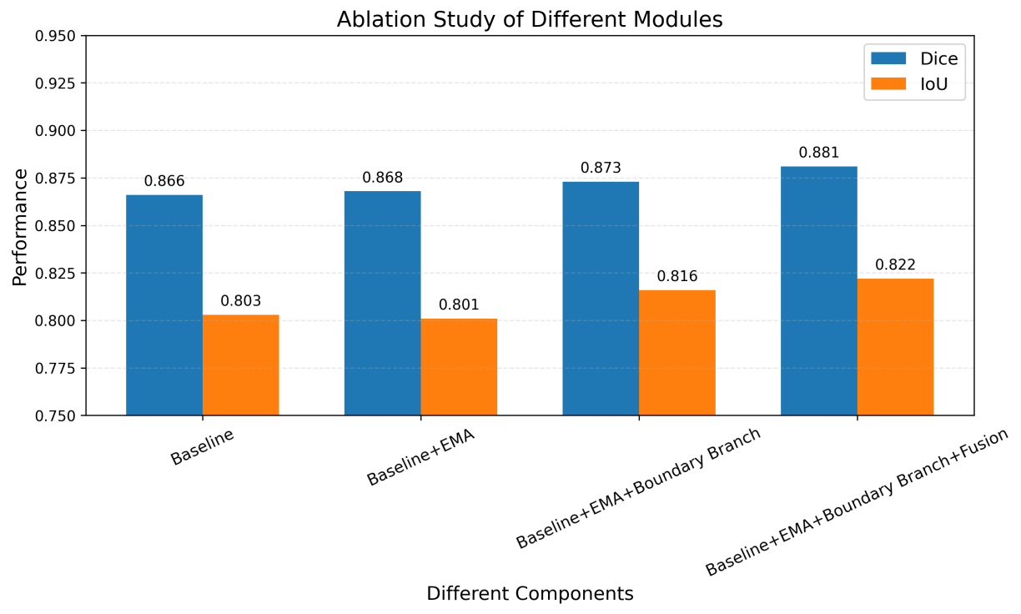
Fig. 6. Bar chart of module contributions
Table X and Fig. X show the average metrics of the model on five public datasets. The line/bar chart indicates that adding each module progressively improves performance. The baseline model (Baseline) achieves Dice and IoU scores of 0.866 and 0.803, respectively. After adding EMA, Dice increases slightly to 0.868, while IoU remains broadly stable at 0.801. This stable transition verifies that EMA focuses on target features through multi-scale attention modeling while suppressing background interference without harming structural overlap.
The most substantial improvement occurs after adding the Boundary Branch, with Dice and IoU reaching 0.873 and 0.816, respectively (a 1.5% increase in IoU). This demonstrates that explicit boundary modeling through the coordinated LDGA and LSCAB modules can substantially correct edge errors. Consistent with the qualitative boundary response maps discussed above, the module precisely recovers contours in blurred-edge, low-contrast, and complex anatomical settings, compensating for the main segmentation branch’s limited detail representation. Finally, the Fusion module combines boundary priors and semantic features at both feature and output levels, yielding the best average performance: Dice 0.881 and IoU 0.822. The quantitative ablation results agree closely with the qualitative visualizations, including feature heatmaps and boundary response maps, confirming the rationale of the proposed design and the effectiveness of each module.
4.4 Visualization Analysis
To further verify the role of each module, this section presents visual analyses of EMA feature responses, Boundary Branch boundary responses, the effectiveness of feature fusion by the Fusion module, and the final segmentation results. These visualizations qualitatively explain the performance improvements and, together with the preceding quantitative experiments, support the effectiveness of the proposed method.
4.4.1 Visualization of EMA Feature Responses
To visually verify the improvement in target focusing provided by EMA, we analyze feature responses on different datasets. Representative samples are selected from the highly challenging ETIS-LaribPolypDB dataset, Kvasir with complex illumination interference, and CVC-ColonDB with diverse polyp morphologies. We show heatmaps of feature responses before and after introducing EMA. Each heatmap is produced by average pooling a feature map across channels, normalizing the result, and overlaying it on the original image, with the ground-truth contour overlaid in white to show the regions attended to by the network. Comparing the spatial distributions of the responses before and after EMA allows its target-focusing capability in complex scenarios to be assessed.

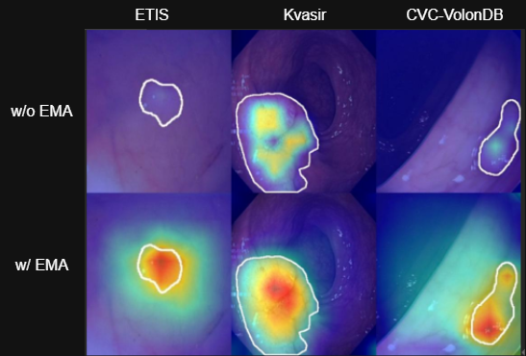
Fig. 7. EMA feature response heatmaps
As shown in Fig. 7, the first row presents heatmaps from the baseline network (without EMA, relying only on the PVTv2-B2 backbone for feature extraction), and the second row presents heatmaps after EMA is introduced.
Specifically, on ETIS (the first column of Fig. 7), the polyp is extremely small and the background contains severe noise. The baseline network’s feature responses are often diffuse, with highlighted regions easily shifting or being overwhelmed by the background, making the target difficult to capture accurately. After EMA is introduced, multi-scale attention enhances responses in the polyp region, causing the highlighted area in the heatmap to converge rapidly and localize precisely to the target. The response also shifts appropriately from the center of the region toward the target boundary and overall contour, effectively suppressing background interference. This demonstrates EMA’s increased sensitivity to small targets.
The Kvasir dataset (the second column of Fig. 7) contains relatively large polyps with irregular shapes. The baseline network’s responses tend to concentrate excessively in the polyp center, weakening responses at the edges and making boundary loss during segmentation likely. After EMA is added, spatial attention at different scales captures features from multiple dimensions, allowing the network to expand its attention dynamically across the entire polyp shape. Responses at the boundary increase substantially, indicating that EMA not only enhances responses in the target region but also promotes complete perception of the overall structure.
On CVC-ColonDB (the third column of Fig. 7), intestinal folds and complex specular reflections can readily mislead segmentation. The visualizations show clear false background activations in the baseline model under interference from intestinal texture, with diffuse response regions. By contrast, EMA establishes long-range contextual dependencies and effectively suppresses responses in non-target background regions. The highly focused areas in the heatmap cover the polyp and its edges, with almost no spurious activation in the background, confirming strong feature-focusing capability under complex interference.
In summary, the feature response heatmaps demonstrate the central role of EMA: it appropriately shifts the network’s attention from a single central point toward the target’s overall contour and edges, while substantially enhancing responses in the target region and suppressing background noise. This high-quality feature extraction provides a precise semantic foundation for subsequent boundary-branch modeling and feature fusion, thereby substantially improving overall segmentation performance.
4.4.2 Analysis of Boundary Branch Responses
To visually verify the boundary branch’s ability to recover contour details, we again select representative samples from ETIS, Kvasir, and CVC-ColonDB for visualization. The results show both predicted contours overlaid on the original images and boundary response maps from which the background texture has been removed (Fig. 8). The contour fit, continuity, and background interference in these pure boundary response maps provide an effective assessment of the module’s robustness in complex scenarios.

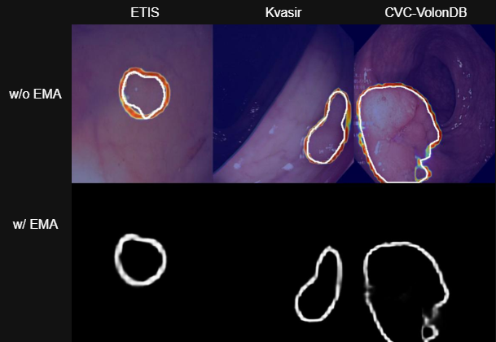
Fig. 8. Boundary Branch response heatmaps
Specifically, on ETIS (the first column of Fig. 8), despite the extremely small target and highly blurred edges, the pure boundary response map (second row) shows a clear, closed, high-precision contour and accurately captures weak edge signals that are difficult to discern visually. This verifies that the LDGA submodule combines multi-scale depthwise convolutions with gating to amplify local boundary responses in blurred regions and address boundary loss for small targets. On Kvasir (the second column of Fig. 8), despite highly irregular shapes with complex concavities and protrusions, the pure boundary response map (second row) closely follows and accurately recovers the complex topology. This reflects the LSCAB submodule’s fusion of cross-scale features along spatial and channel dimensions, which maintains boundary continuity in complex structures and substantially corrects missing edge details in the main branch. On CVC-ColonDB (the third column of Fig. 8), despite low-contrast background interference from intestinal folds and reflections, the pure boundary response map (second row) responds clearly only to the polyp itself, excluding background texture noise.
In summary, the visualizations confirm the effectiveness of the Boundary Branch: the coordinated LDGA and LSCAB modules enable precise contour recovery under blurred boundaries, complex structures, and low-contrast conditions. Explicit modeling of boundary priors compensates for the main segmentation branch’s limited detail representation and thereby improves overall segmentation performance.
4.4.3 Analysis of Feature Fusion by the Fusion Module
To visually verify the Fusion module’s interaction between boundary priors and semantic features, representative samples are again selected from ETIS, Kvasir, and CVC-ColonDB for analysis. The results show the main-branch semantic features and fused features before and after fusion, and a difference map directly illustrates feature changes introduced by the module, as shown in Fig. 9. Changes in the spatial distribution of features before and after fusion, together with high-response regions in the difference map, allow the specificity and effectiveness of multi-scale feature interaction to be assessed.

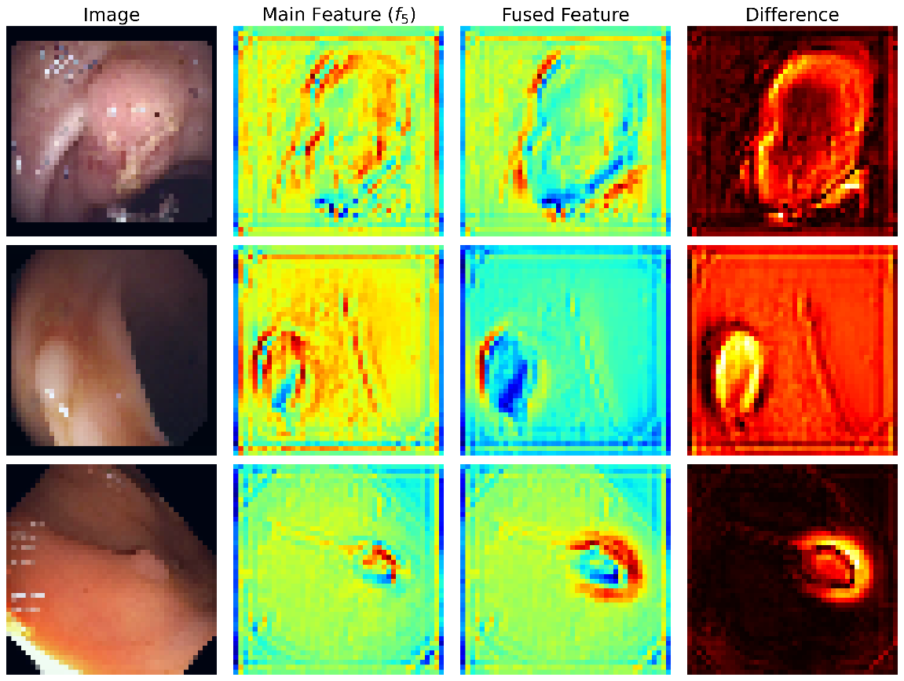
Fig. 9. Feature fusion heatmaps of the Fusion module
Specifically, on ETIS (the first row of Fig. 9), despite the extremely blurred boundary and small target, the main-branch semantic features (second column) can localize the polyp body, but responses at the boundary are diffuse. After processing by the Fusion module (third column), the fused features show a substantially enhanced high-response band near the polyp contour. The difference map (fourth column) shows that the changes due to fusion are concentrated mainly around the polyp boundary. This indicates that the module effectively injects boundary priors into the main branch’s semantic features, precisely compensating for boundary details without compromising the integrity of the semantic representation. On CVC-ColonDB (the second row of Fig. 9), for samples with highly irregular shapes and extremely low boundary contrast, main-branch features respond diffusely around the polyp contour. By contrast, the fused features introduce multi-scale contours extracted by the boundary branch, forming a clear and continuous response band at the target boundary. The highlighted regions in the difference map closely match the true polyp contour, indicating effective spatial alignment and complementarity between the cross-scale boundary features output by LSCAB and the main-branch semantic features. On Kvasir (the third row of Fig. X), despite low-contrast background interference from intestinal folds and reflections, the difference map shows a pronounced response only at the polyp boundary and minimal differences in the background, demonstrating the module’s strong resistance to background interference.
In summary, the visualizations confirm the effectiveness of the Fusion module. Through multi-scale feature interaction, it jointly models fine-grained spatial contour information extracted by the boundary branch and global semantic features from the main branch. The difference maps further show that feature changes introduced by fusion are concentrated precisely at polyp boundaries, achieving the design objective of “enhancing boundaries while preserving semantics.” This confirms the rationale of the module’s feature-level operation and provides a solid feature basis for improving final segmentation accuracy.
4.4.4 Visualization of Segmentation Results
Figure 9 presents a qualitative comparison between our model and eight mainstream segmentation methods. The four representative samples cover common clinical challenges, including multiple scales, complex shapes, low contrast, and strong background interference. In complex large-target scenarios (row 1 of Fig. 10), some comparison methods (e.g., PraNet and HarDNet-MSEG) exhibit edge overflow and internal holes. In the branched-structure scenario (row 2 of Fig. 10), the target is highly irregular, and methods such as UACANet-L show clear local omissions. Benefiting from the explicit boundary constraints of the Boundary Branch and semantic interaction of the Fusion module, our model effectively maintains the connectivity of complex topological structures.

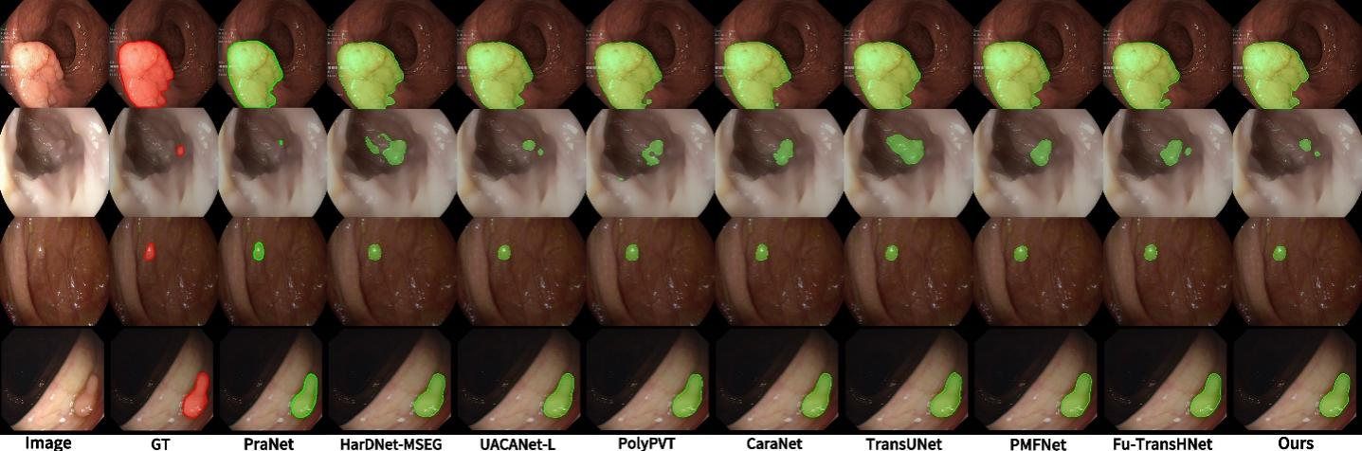
Fig. 10. Boundary Branch response heatmaps
For extremely small targets (row 3 of Fig. 10), the foreground occupies only a tiny portion of the image. Although existing mainstream methods can localize the target region, they show clear shortcomings in boundary delineation and internal completeness, often producing blurred edges or local omissions. With multi-scale attention focusing from EMA, our model accurately localizes tiny targets while maintaining more precise boundary representations and complete region filling. In low-contrast scenarios with interference from folds and reflections (row 4 of Fig. 10), several methods produce false background activations, whereas our model shows strong resistance to interference, precisely separates background noise, and generates masks with compact edges and filled interiors.
In summary, the qualitative visual comparisons demonstrate the structural robustness of our model. Through the focus provided by EMA, contour refinement from the Boundary Branch, and complementary information from the Fusion module, the model adapts to clinical challenges involving multiple scales, complex boundaries, and strong interference, achieving more precise, complete, and robust segmentation than current mainstream polyp segmentation networks.

Chapter 5 Conclusion
We propose a new Transformer network for polyp segmentation based on boundary awareness and multi-scale fusion. It introduces EMA attention and an explicit boundary branch to achieve high-precision segmentation of complex endoscopic images. Without costly edge annotations, we demonstrate that explicit boundary modeling based on LDGA and LSCAB effectively captures blurred edge information and supplements the detail representation of the main segmentation branch. We also propose a two-stage fusion strategy combining feature-level and output-level fusion, which strengthens complementarity between boundary priors and semantic features. Across a series of experiments, particularly on the highly challenging ETIS-LaribPolypDB dataset, our method outperforms several advanced segmentation networks in metrics including Dice, IoU, and Recall, demonstrating strong adaptability to complex scenarios.

References

- LOU A, GUAN S, LOEW M. CaraNet: context axial reverse attention network for segmentation of small medical objects[J]. Journal of Medical Imaging, 2023, 10(1): 014005. DOI: 10.1117/1.JMI.10.1.014005.
- BUI N T, HOANG D H, NGUYEN Q T, et al. MEGANet: multi-scale edge-guided attention network for weak boundary polyp segmentation[C]//Proceedings of the IEEE/CVF Winter Conference on Applications of Computer Vision. 2024: 7985-7994.
- HUANG C H, WU H Y, LIN Y L. HarDNet-MSEG: a simple encoder-decoder polyp segmentation neural network that achieves over 0.9 mean Dice and 86 FPS[EB/OL]. arXiv:2101.07172, 2021. DOI: 10.48550/arXiv.2101.07172.
- DU X, XU X, MA K. ICGNet: integration context-based reverse-contour guidance network for polyp segmentation[C]//Proceedings of the Thirty-First International Joint Conference on Artificial Intelligence. 2022: 877-883. DOI: 10.24963/ijcai.2022/123.
- KANG X, MA Z, LIU K, et al. Multi-scale information sharing and selection network with boundary attention for polyp segmentation[J]. Engineering Applications of Artificial Intelligence, 2025, 139(Pt B): 109467. DOI: 10.1016/j.engappai.2024.109467.
- DONG B, WANG W, FAN D P, et al. Polyp-PVT: polyp segmentation with pyramid vision transformers[J]. CAAI Artificial Intelligence Research, 2023, 2: 9150015. DOI: 10.26599/AIR.2023.9150015.
- FAN D P, JI G P, ZHOU T, et al. PraNet: parallel reverse attention network for polyp segmentation[C]//Medical Image Computing and Computer Assisted Intervention - MICCAI 2020. Cham: Springer, 2020: 263-273. DOI: 10.1007/978-3-030-59725-2_26.
- KIM T, LEE H, KIM D. UACANet: uncertainty augmented context attention for polyp segmentation[C]//Proceedings of the 29th ACM International Conference on Multimedia. 2021: 2167-2175. DOI: 10.1145/3474085.3475375.
- ZHANG Y, LIU H, HU Q. TransFuse: fusing transformers and CNNs for medical image segmentation[C]//Medical Image Computing and Computer Assisted Intervention - MICCAI 2021. Cham: Springer, 2021: 14-24. DOI: 10.1007/978-3-030-87193-2_2.
- LONG J, SHELHAMER E, DARRELL T. Fully convolutional networks for semantic segmentation[C]//Proceedings of the IEEE Conference on Computer Vision and Pattern Recognition. 2015: 3431-3440. DOI: 10.1109/CVPR.2015.7298965.
- RONNEBERGER O, FISCHER P, BROX T. U-Net: convolutional networks for biomedical image segmentation[C]//Medical Image Computing and Computer-Assisted Intervention - MICCAI 2015. Cham: Springer, 2015: 234-241. DOI: 10.1007/978-3-319-24574-4_28.
- LUO C, WANG Y, DENG Z, et al. Colonic polyp segmentation based on transformer-convolutional neural networks fusion[J]. Pattern Recognition, 2026, 170: 112116. DOI: 10.1016/j.patcog.2025.112116.
- LEWIS J, CHA Y J, KIM J. Dual encoder-decoder-based deep polyp segmentation network for colonoscopy images[J]. Scientific Reports, 2023, 13: 1183. DOI: 10.1038/s41598-023-28530-2.
- WANG W, XIE E, LI X, et al. PVT v2: improved baselines with Pyramid Vision Transformer[J]. Computational Visual Media, 2022, 8(3): 415-424. DOI: 10.1007/s41095-022-0274-8.
- LIN T Y, GOYAL P, GIRSHICK R, et al. Focal loss for dense object detection[C]//Proceedings of the IEEE International Conference on Computer Vision. 2017: 2999-3007. DOI: 10.1109/ICCV.2017.324.
- ZHAO H, SHI J, QI X, et al. Pyramid scene parsing network[C]//Proceedings of the IEEE Conference on Computer Vision and Pattern Recognition. 2017: 2881-2890. DOI: 10.1109/CVPR.2017.660.
- CHEN L C, PAPANDREOU G, SCHROFF F, et al. Rethinking atrous convolution for semantic image segmentation[EB/OL]. arXiv:1706.05587, 2017.
- D'ASCOLI S, TOUVRON H, LEAVITT M L, et al. ConViT: improving vision transformers with soft convolutional inductive biases[C]//Proceedings of the 38th International Conference on Machine Learning. 2021: 2286-2296.
- ZHENG S, LU J, ZHAO H, et al. Rethinking semantic segmentation from a sequence-to-sequence perspective with transformers[C]//Proceedings of the IEEE/CVF Conference on Computer Vision and Pattern Recognition. 2021: 6881-6890.
- XIE E, WANG W, YU Z, et al. SegFormer: simple and efficient design for semantic segmentation with transformers[C]//Advances in Neural Information Processing Systems. 2021, 34: 12077-12090.
- CHEN J, LU Y, YU Q, et al. TransUNet: transformers make strong encoders for medical image segmentation[EB/OL]. arXiv:2102.04306, 2021.
- WANG W, XIE E, LI X, et al. Pyramid vision transformer: a versatile backbone for dense prediction without convolutions[C]//Proceedings of the IEEE/CVF International Conference on Computer Vision. 2021: 568-578. DOI: 10.1109/ICCV48922.2021.00061.
- HU J, SHEN L, SUN G. Squeeze-and-excitation networks[C]//Proceedings of the IEEE/CVF Conference on Computer Vision and Pattern Recognition. 2018: 7132-7141. DOI: 10.1109/CVPR.2018.00745.
- WOO S, PARK J, LEE J Y, et al. CBAM: convolutional block attention module[C]//Proceedings of the European Conference on Computer Vision. 2018: 3-19.
- WANG Q, WU B, ZHU P, et al. ECA-Net: efficient channel attention for deep convolutional neural networks[C]//Proceedings of the IEEE/CVF Conference on Computer Vision and Pattern Recognition. 2020: 11534-11542.
- FU J, LIU J, TIAN H, et al. Dual attention network for scene segmentation[C]//Proceedings of the IEEE/CVF Conference on Computer Vision and Pattern Recognition. 2019: 3146-3154. DOI: 10.1109/CVPR.2019.00326.
- HE J, DENG Z, ZHOU L, et al. Adaptive pyramid context network for semantic segmentation[C]//Proceedings of the IEEE/CVF Conference on Computer Vision and Pattern Recognition. 2019: 7519-7528.
- ZHANG R, LAI P, WAN X, et al. Lesion-aware dynamic kernel for polyp segmentation[EB/OL]. arXiv:2301.04904, 2023.
- SHEN Z, ZHANG M, ZHAO H, et al. Efficient attention: attention with linear complexities[C]//Proceedings of the IEEE/CVF Winter Conference on Applications of Computer Vision. 2021: 3531-3539.
- HOU Q, ZHOU D, FENG J. Coordinate attention for efficient mobile network design[C]//Proceedings of the IEEE/CVF Conference on Computer Vision and Pattern Recognition. 2021: 13713-13722. DOI: 10.1109/CVPR46437.2021.01351.

