EcoSec
EcoSec is a comprehensive sustainability ontology designed to systematically assess and label the sustainability impact of security mechanisms and devices across their lifecycle or operational scope. By assigning sustainability labels ranging from A (most sustainable) to G (least sustainable), EcoSec provides a nuanced framework for evaluating the environmental and operational sustainability of various elements.
For security mechanisms, EcoSec assesses key aspects such as adoption, maintenance, and efficiency to understand their sustainability footprint.
In the context of devices, the ontology adopts a lifecycle approach, meticulously evaluating the sustainability performance at each stage (from raw material sourcing, manufacturing, and packaging, to transport, usage, spare parts availability, and end-of-life management).
*Reuses concepts from the OntoCarmen ontology and extends them with these sustainability aspects.

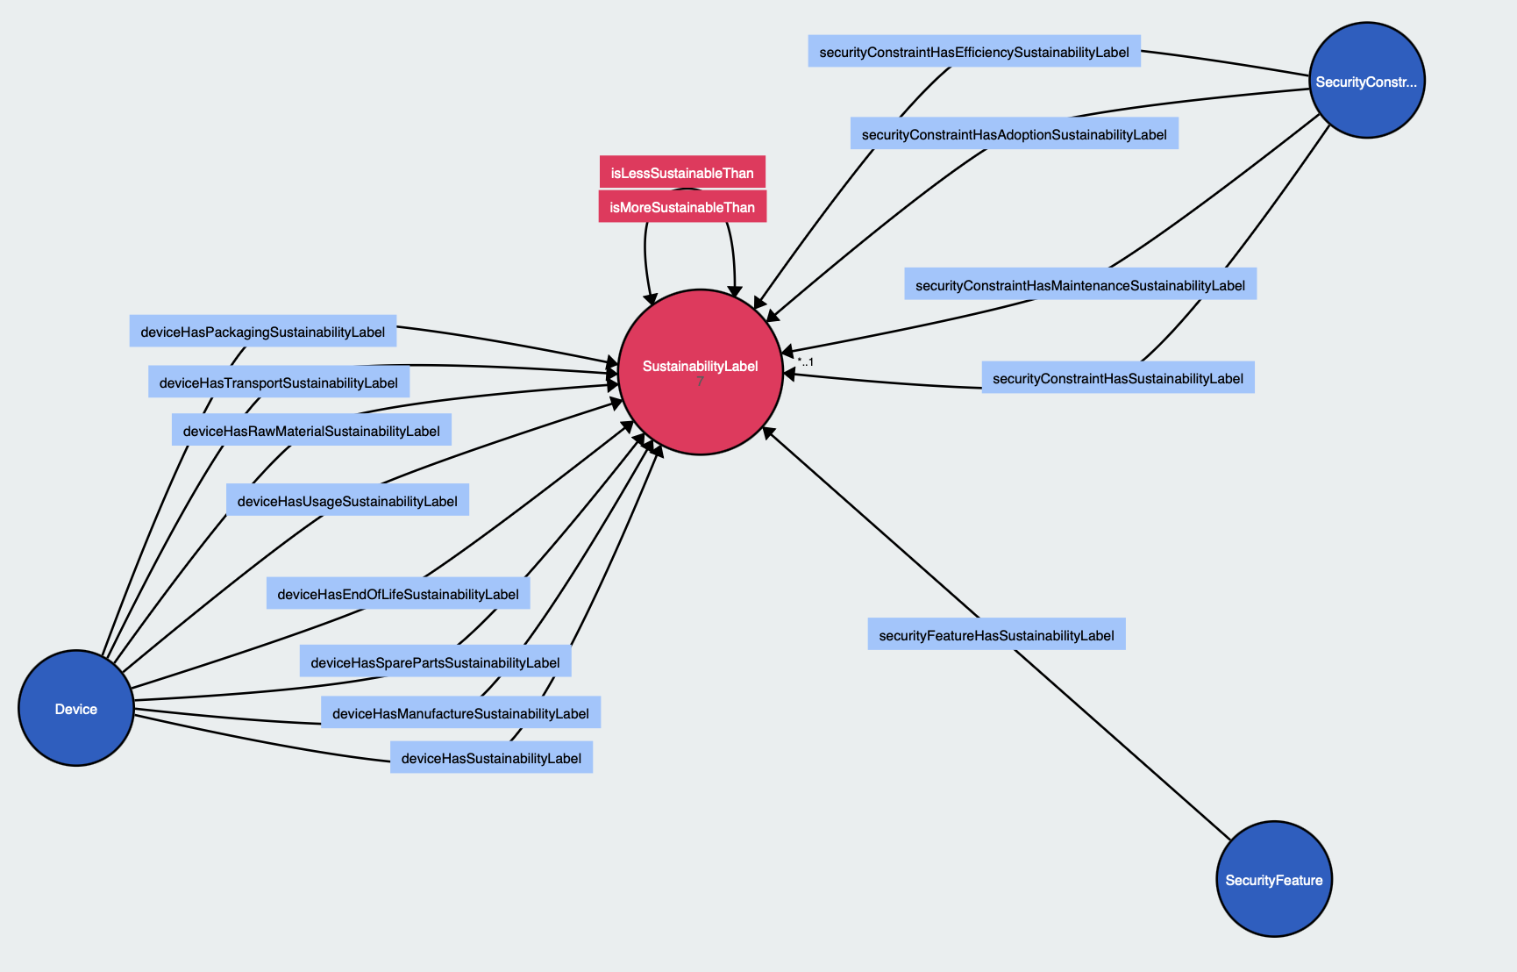

Sustainability Labels

Classifies the sustainability performance of devices and security mechanisms from A (most sustainable) to G (least sustainable).

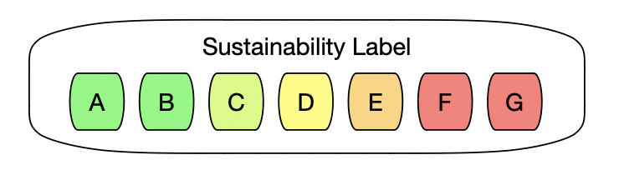

Class SustainabilityLabel

Represents the sustainability performance of various entities, including devices, security mechanisms, and other products, across their lifecycle or operational practices. Labels range from A (most sustainable) to G (least sustainable), providing a clear and standardized measure of environmental impact, resource efficiency, and overall sustainability.

Object property isLessSustainableThan

Indicates that one sustainability label denotes a lower level of sustainability compared to another. This hierarchical relationship helps in understanding and comparing the sustainability performance across different labels.

Object property isMoreSustainableThan

Indicates that one sustainability label represents a higher level of sustainability compared to another. It establishes a hierarchy among labels, facilitating comparison and decision-making based on sustainability criteria.

Individual ASustainabilityLabel

Represents the highest standard of sustainability. Products or practices with this label are considered to have the lowest environmental impact and highest efficiency and sustainability in their category.

Individual BSustainabilityLabel

Denotes a high level of sustainability, second only to A. Products or practices labeled B are highly sustainable with minor areas for improvement compared to A.

Individual CSustainabilityLabel

Reflects a moderate level of sustainability. C labeled entities offer a balanced sustainability performance but with significant room for improvement to reach higher standards.

Individual DSustainabilityLabel

Indicates a sustainability performance that is below average, with D being more sustainable than E, F, and G but less so than C, B, and A. As the labels progress to E, F, and G, they represent decreasing levels of sustainability, indicating increasing environmental impacts and lower efficiency.

Individual ESustainabilityLabel

Signifies a lower level of sustainability, indicating a need for significant improvements. Products or practices with an E label have a notable environmental impact and efficiency issues. This label suggests that while some sustainability measures may be in place, there are considerable areas for improvement to move towards a more sustainable outcome.

Individual FSustainabilityLabel

Represents a sustainability level that is second to last, highlighting substantial environmental impacts and a lack of efficiency. F labeled entities require major changes and enhancements in their sustainability practices and operations to reduce their negative environmental footprint.

Individual GSustainabilityLabel

Denotes the lowest level of sustainability, indicating the highest environmental impact and the least efficient use of resources. Entities with a G label are considered the least sustainable, underscoring an urgent need for comprehensive measures to significantly improve their sustainability performance.

Sustainability Requirements
Sustainability Requirements allow expressing sustainability-related expectations linked to existing security requirements.

A Security Requirement can be associated with one or more Security Features, which represent the security functionalities needed to satisfy that requirement.

Each Security Feature (inherited from OntoCarmen) includes the following properties:

- Security constraints.
- Security level.
- Sustainability label, added in EcoSec.

This sustainability label indicates the expected environmental and operational impact of the security functionality, independently of its specific implementation. In this way, security requirements can specify not only what security features are needed, but also the level of sustainability at which they should be implemented.

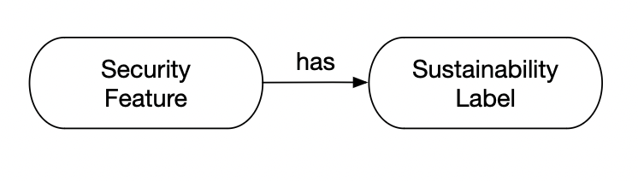

Object property securityFeatureHasSustainabilityLabel

Connects a security feature to a minimum sustainability label requirement, indicating the lowest acceptable level of sustainability across its associated security mechanisms. This label, which ranges from A to G, serves as a benchmark to ensure that all security constraints tied to the feature meet or exceed a specified standard of environmental, economic, and operational sustainability. It ensures that the security feature aligns with broader sustainability goals by aggregating the sustainability performance of its multiple constraints.

Sustainability of Security Mechanisms

This section associates sustainability labels with security mechanisms. Each Security Constraint has four sustainability labels:
- General label: overall sustainability of the mechanism.
- Adoption: reflects how easily the mechanism can be adopted and integrated.
- Efficiency: measures operational and computational efficiency.
- Maintenance: assesses long-term maintenance effort and impact.

The three partial labels (Adoption, Efficiency, Maintenance) are used to calculate the general sustainability label using simple aggregation rules.

Additionally, EcoSec defines a set of individuals representing typical security mechanisms, each pre-labeled with a sustainability score and accompanied by an explanation of the reasoning.
This allows these mechanisms to be reused directly, providing a library of pre-evaluated, sustainability-aware security components for design and analysis.

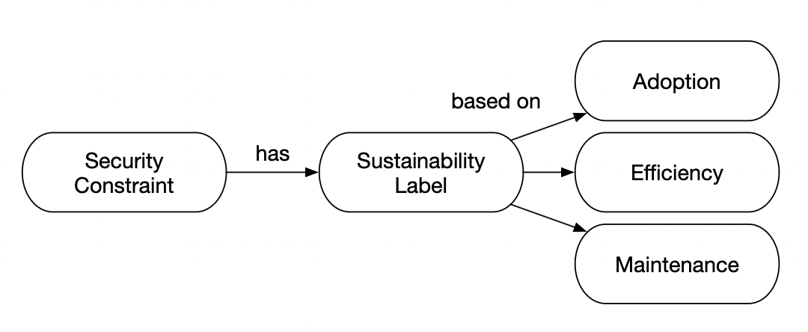

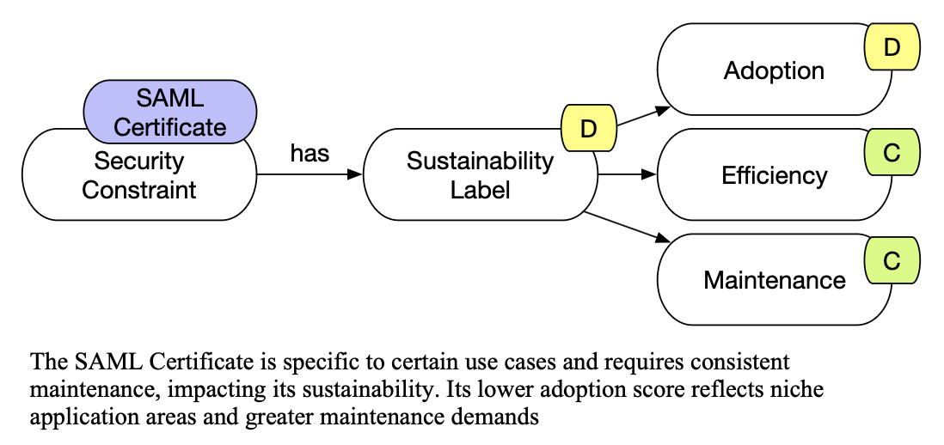

Object property securityConstraintHasSustainabilityLabel

Associates a security mechanism with its overall sustainability label, which represents a comprehensive evaluation of the mechanism's sustainability across three key dimensions: adoption, maintenance, and efficiency. This label, ranging from A to G, is calculated based on the combined assessments of the mechanism's adoption label, maintenance label, and efficiency label. The overall sustainability label provides a holistic view of the environmental, economic, and operational sustainability of the security mechanism, reflecting its long-term viability and impact.

Object property securityConstraintHasAdoptionSustainabilityLabel

Associates a security mechanism with its adoption label, reflecting the extent to which the technology has been accepted and adopted within the industry. This label, ranging from A to G, indicates the mechanism's prevalence and popularity among users and developers, providing insight into its widespread or limited adoption. The adoption label is a sustainability label, categorizing the mechanism's environmental and operational sustainability in terms of its adoption.

Object property securityConstraintHasEfficiencySustainabilityLabel

Links a security mechanism to its efficiency label, indicating the resource effectiveness and performance of the technology in operational environments. This label, which ranges from A to G, evaluates the mechanism's sustainability by measuring its computational efficiency, energy consumption, and the optimization of resources required for its functionality. The efficiency label is a sustainability label that underscores the environmental and economic impact of deploying and operating the security mechanism.

Object property securityConstraintHasMaintenanceSustainabilityLabel

Connects a security mechanism to its maintenance label, which quantifies the effort and resources required to keep the technology secure and up-to-date over time. This label, ranging from A to G, assesses the mechanism's sustainability in terms of ongoing support, frequency of updates needed, and overall lifecycle management. The maintenance label is a sustainability label that highlights the operational efficiency and long-term viability of the security mechanism.

This table defines basic rules for aggregating sustainability labels from sub-characteristics.
For example, if all sub-characteristics of a mechanism or device are rated A or B, the overall element is assigned an A.
These rules are applied both to security mechanisms and devices, providing a simple and consistent method to calculate general sustainability labels from partial evaluations.

Sustainability Rating | Rules
A | If all categories have at least one A or B label, then the device receives a sustainability label A.
B | If all categories have at least one B or C label, then the device receives a sustainability label B.
C | If all categories have at least one C or D label, then the device receives a sustainability label C.
D | If all categories have at least one D or E label, then the device receives a sustainability label D.
E | If all categories have at least one E or F label, then the device receives a sustainability label E.
F | If all categories have at least one F or G label, then the device receives a sustainability label F.
G | If all categories have at least one G label, then the device receives a sustainability label G.

Individual OpenPGPCertificateIndividual
- Sustainability Label: C
- Efficiency Label: C
- Maintenance Label: C
- Adoption Label: C
- Explanation: “This security mechanism is universal in its application but entails some complexity, which moderately impacts its overall sustainability rating. Its universality is tempered by complexities that moderate its efficiency, maintenance, and adoption scores, reflecting a balanced sustainability performance."

Individual OpenSSLCertificateIndividual
- Sustainability Label: B
- Efficiency Label: B
- Maintenance Label: B
- Adoption Label: B
- Explanation: "Efficiency and compatibility drive the OpenSSL Certificate to a 'B' sustainability rating across all aspects. It demonstrates high efficiency and broad compatibility, making it a sustainable choice for security implementations."

Individual SAMLCertificateIndividual
- Sustainability Label: D
- Efficiency Label: C
- Maintenance Label: C
- Adoption Label: D
- Explanation: "The SAML Certificate is specific to certain use cases and requires consistent maintenance, impacting its sustainability. Its lower adoption score reflects niche application areas and greater maintenance demands."

Individual X509CertificateIndividual
- Sustainability Label: A
- Efficiency Label: A
- Maintenance Label: A
- Adoption Label: A
- Explanation: "Broad adoption and interoperability grant the X.509 Certificate an 'A' rating in all sustainability categories. Its widespread acceptance and efficiency make it an exemplary model of sustainable security practice."

Individual HTTPSChannelIndividual
- Sustainability Label: A
- Efficiency Label: A
- Maintenance Label: A
- Adoption Label: A
- Explanation: "The universality and efficiency in the implementation of the HTTPS Channel secure it an 'A' rating across the board, showcasing optimal sustainability in secure communications."

Individual SSLTLSChannelIndividual
- Sustainability Label: B
- Efficiency Label: B
- Maintenance Label: B
- Adoption Label: B
- Explanation: "As the foundational technology for HTTPS, the SSL/TLS Channel exhibits high efficiency and broad version support, justifying its 'B' sustainability ratings."

Individual TunnelingChannelIndividual
- Sustainability Label: C
- Efficiency Label: C
- Maintenance Label: C
- Adoption Label: C
- Explanation: "The Tunneling Channel's sustainability is moderated by its type-dependent resource requirements, resulting in 'C' ratings across efficiency, maintenance, and adoption."

Individual AES128GCMCipherIndividual
- Sustainability Label: A
- Efficiency Label: A
- Maintenance Label: A
- Adoption Label: A
- Explanation: "Marked by its efficiency and broad adoption, the AES-128-GCM Cipher achieves 'A' ratings, highlighting its role as a sustainable cipher choice."

Individual CamelliaCipherIndividual
- Sustainability Label: C
- Efficiency Label: B
- Maintenance Label: C
- Adoption Label: C
- Explanation: "Though efficient, the Camellia Cipher's lower adoption and moderate maintenance requirements reflect its 'C' sustainability label, with room for broader acceptance."

Individual ChaCha20CipherIndividual
- Sustainability Label: B
- Efficiency Label: B
- Maintenance Label: B
- Adoption Label: B
- Explanation: "The ChaCha20 Cipher's good efficiency, particularly on mobile devices, secures it 'B' ratings, standing out for its performance and sustainable security approach."

Individual MultiFactorPasswordIndividual
- Sustainability Label: A
- Efficiency Label: A
- Maintenance Label: A
- Adoption Label: A
- Explanation: "Greater security and a reduced frequency of changes earn the Multi-Factor Password an 'A' rating in all categories, underscoring its exceptional sustainability in safeguarding access."

Individual StrongPasswordIndividual
- Sustainability Label: B
- Efficiency Label: B
- Maintenance Label: B
- Adoption Label: B
- Explanation: "The Strong Password balances security and usability well, achieving 'B' sustainability ratings. It represents a solid choice for secure yet user-friendly access controls."

Individual WeakPasswordIndividual
- Sustainability Label: G
- Efficiency Label: D
- Maintenance Label: D
- Adoption Label: D
- Explanation: "The frequent need for changes due to security vulnerabilities places the Weak Password at a 'G' sustainability rating, highlighting significant sustainability concerns."

Individual SHA2SecureHashingIndividual
- Sustainability Label: B
- Efficiency Label: B
- Maintenance Label: B
- Adoption Label: B
- Explanation: "Widely adopted yet transitioning towards SHA-3, SHA-2 Secure Hashing maintains 'B' ratings, reflecting its current relevance and sustainability in secure hashing."

Individual SHA3SecureHashingIndividual
- Sustainability Label: A
- Efficiency Label: A
- Maintenance Label: A
- Adoption Label: A
- Explanation: "The new, efficient design of SHA-3 Secure Hashing designed for longevity secures it an 'A' rating across all categories, marking it as a highly sustainable choice for secure hashing."

Individual PSKSignatureIndividual
- Sustainability Label: C
- Efficiency Label: C
- Maintenance Label: C
- Adoption Label: C
- Explanation: "The PSK Signature's niche application and specific use result in 'C' sustainability ratings, indicating moderate sustainability performance."

Individual SRPSignatureIndividual
- Sustainability Label: B
- Efficiency Label: B
- Maintenance Label: B
- Adoption Label: B
- Explanation: "Balancing efficiency with security, the SRP Signature achieves 'B' ratings, demonstrating its sustainable application in secure signature processes."

Sustainability of Devices

This section evaluates the sustainability of devices by extending the existing Device class with sustainability-related properties.

Each device is associated with a general sustainability label, which is calculated from partial labels corresponding to its lifecycle stages. These partial labels reflect the environmental and operational impact of each stage, enabling a fine-grained assessment.

It follows the life cycle of the product and evaluates the sustainability of each stage: raw material, manufacture, packaging, transport, usage, spare parts and end of life.

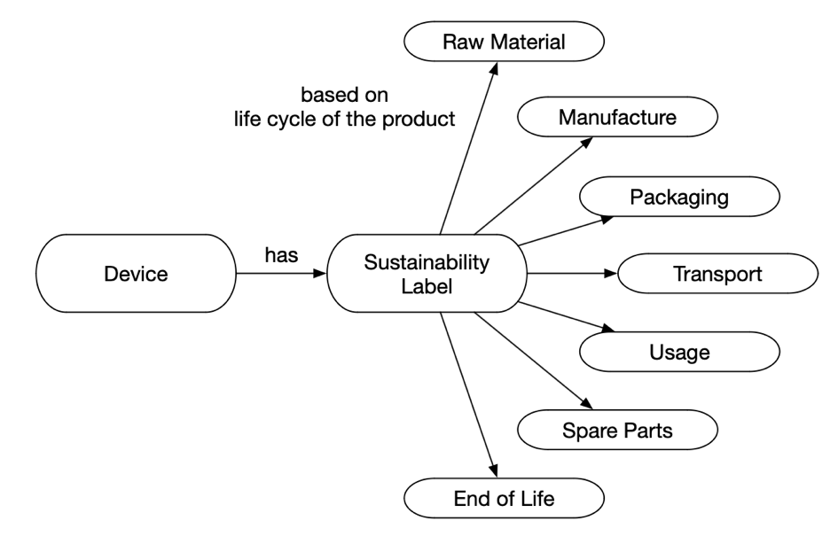

Object property deviceHasSustainabilityLabel

Associates a device with its overall sustainability label, calculated based on the sustainability labels of each stage in the device's lifecycle, including raw material acquisition, manufacture, packaging, transport, usage, spare parts, and end of life. This comprehensive label, ranging from A to G, encapsulates the device's total environmental impact, reflecting a holistic assessment of its sustainability performance across all lifecycle stages.

Object property deviceHasRawMaterialSustainabilityLabel

Associates a device with a sustainability label for the raw materials stage, evaluating material origin, extraction impacts, efficiency, recycled content, and compliance with hazardous substance regulations. This comprehensive assessment covers types of materials (recycled, renewable, conflict-free), environmental and social impacts of extraction, material usage efficiency, percentage of recycled materials, and adherence to standards like RoHS and REACH.

Object property deviceHasManufactureSustainabilityLabel

Links a device to a sustainability label for its manufacturing stage, considering CO2 emissions, water consumption, renewable energy usage, and waste treatment. Factors assessed include CO2 equivalent emissions, water usage efficiency, the percentage of renewable energy in manufacturing processes, and the effectiveness of production waste recycling and disposal.

Object property deviceHasPackagingSustainabilityLabel

Connects a device to a sustainability label for packaging, focusing on material types, efficiency, and sustainability information. Evaluates the use of recyclable, biodegradable, and reusable materials, optimization of packaging design to reduce waste, and the presence of labeling with recycling and disposal guidelines.

Object property deviceHasTransportSustainabilityLabel

Associates a device with a sustainability label for transport, assessing transport mode efficiency, logistics optimization, and transport packaging. Considers the efficiency of air, sea, and land transportation, measures to reduce transportation distances and consolidate shipments, and efforts to minimize volume and weight for transport efficiency.

Object property deviceHasUsageSustainabilityLabel

Links a device to a sustainability label for usage, covering energy efficiency, durability, repairability, and software updates. Reviews energy consumption, physical resistance, estimated lifespan, ease of repair, spare parts availability, and the impact of long-term software support on functionality and efficiency.

Object property deviceHasSparePartsSustainabilityLabel

Connects a device to a sustainability label for spare parts, evaluating availability, compatibility, and sustainability. Addresses ease of access to spare parts, their compatibility across different sources or models, and the environmental impact of materials and manufacturing processes for spare parts.

Object property deviceHasEndOfLifeSustainabilityLabel

Associates a device with a sustainability label for end-of-life management, focusing on recyclability, return programs, and reusability. Assesses the ease of device disassembly and material sorting, initiatives for device return to manufacturers or recycling points, and the potential for component or entire device reuse.

If we want to go to a higher level of detail in the sustainability of devices

Category | Subcategory | Description | Data Type
Raw Material | Material Origin | Types of materials used | Enumerated values: Recycled, Renewable, Conflict
 | Material Extraction | Environmental, social, and economic impact of material extraction. | Score: 0-100
 | Material Efficiency | Efficiency in material usage, design optimization for material use. | Score: 0-100
 | Recycled Material Content | Percentage of recycled materials used in the device. | Percentage: 0-100%
 | Use of Hazardous and Restricted Substances | Presence of hazardous substances, adherence to regulations like RoHS, REACH. | Enumerated values: Compliant, Non-Compliant
Manufacturing | CO2 Emissions | CO2 emissions during production. | Score: 0-100 based on CO2 equivalent
 | Water Consumption | Efficiency and sources of water used in production. | Score: 0-100 based on liters or cubic meters
 | Renewable Energy Usage | Percentage of renewable energy used in manufacturing processes. | Percentage: 0-100%
 | Waste Treatment | Recycling and disposal of production waste. | Score: 0-100 based on efficiency
Packaging | Packaging Materials | Types of packaging materials used | Enumerated values: Recyclable, Biodegradable, Reusable
 | Packaging Efficiency | Optimization of material and size to reduce waste. | Score: 0-100
 | Sustainability Information | Labeling with recycling and disposal information. | Score: 0-100 based on the presence of information
Transport | Transport Mode | Efficiency of transportation modes used. | Enumerated values: Air, Sea, Land
 | Logistics Optimization | Measures to reduce transportation distance, shipment consolidation. | Score: 0-100
 | Transport Packaging | Reduction in volume and weight for transport efficiency. | Score: 0-100
Usage | Energy Efficiency | Energy consumption during normal use. | Score: 0-100 based on watts or kilowatt-hours
 | Durability | Includes Physical Resistance and Estimated Life Span. | Score: 0-100 for Physical Resistance, Range in years for lifespan
 | Repairability | Ease of repair, availability of spare parts. | Score: 0-100
 | Software Updates | Long-term support impact on efficiency and functionality. | Score: 0-100
Spare Parts | Availability | Ease of access to spare parts. | Score: 0-100
 | Compatibility | Ability to use spare parts from various sources or models. | Score: 0-100
 | Sustainability of Spare Parts | Materials and manufacturing processes for spare parts. | Score: 0-100
End of Life | Recyclability | Ease of disassembly, material sorting. | Score: 0-100
 | Return Programs | Initiatives for returning the device to the manufacturer or recycling points. | Score: 0-100
 | Reusability | Potential for component or entire device reuse. | Score: 0-100

RAW MATERIAL
Sustainability Rating | Material Origin | Material Extraction Score | Material Efficiency Score | Recycled Material Content | Use of Hazardous and Restricted Substances
A | Renewable | 81-100 | 81-100 | >80% | Compliant
B | Recycled | 61-80 | 61-80 | 60-80% | Compliant
C | Recycled | 41-60 | 41-60 | 40-59% | Compliant
D | Recycled/Renewable | 21-40 | 21-40 | 20-39% | Compliant
E | Conflict | 11-20 | 11-20 | 10-19% | Non-Compliant
F | Conflict | 1-10 | 1-10 | 1-9% | Non-Compliant
G | Conflict | 0 | 0 | 0% | Non-Compliant

MANUFACTURING
Sustainability Rating | CO2 Emissions Score | Water Consumption Efficiency | Renewable Energy Usage | Waste Treatment Efficiency
A | Very Low (81-100) | Very Efficient (81-100) | >80% Renewable | Very Efficient (81-100)
B | Low (61-80) | Efficient (61-80) | 60-80% Renewable | Efficient (61-80)
C | Moderate (41-60) | Moderately Efficient (41-60) | 40-59% Renewable | Moderately Efficient (41-60)
D | Medium (21-40) | Average Efficiency (21-40) | 20-39% Renewable | Average Efficiency (21-40)
E | High (11-20) | Low Efficiency (11-20) | 10-19% Renewable | Low Efficiency (11-20)
F | Very High (1-10) | Very Low Efficiency (1-10) | 1-9% Renewable | Very Low Efficiency (1-10)
G | Extremely High (0) | No Efficiency (0) | 0% Renewable | No Efficiency (0)

PACKAGING
Sustainability Rating | Packaging Materials | Packaging Efficiency | Sustainability Information
A | Recyclable, Biodegradable, Reusable | Very Efficient (81-100) | Comprehensive (81-100)
B | Recyclable, Biodegradable, Reusable | Efficient (61-80) | Good (61-80)
C | Recyclable, Biodegradable, Reusable | Moderately Efficient (41-60) | Moderate (41-60)
D | Recyclable, Biodegradable, Reusable | Average Efficiency (21-40) | Minimal (21-40)
E | Recyclable, Biodegradable, Reusable | Low Efficiency (11-20) | Low (11-20)
F | Recyclable, Biodegradable, Reusable | Very Low Efficiency (1-10) | Very Low (1-10)
G | Non-Recyclable (0) | No Efficiency (0) | None (0)

TRANSPORT
Sustainability Rating | Transport Mode | Logistics Optimization | Transport Packaging
A | Land, Sea, Air | Highly Optimized (81-100) | Very Efficient (81-100)
B | Land, Sea, Air | Optimized (61-80) | Efficient (61-80)
C | Land, Sea, Air | Moderately Optimized (41-60) | Moderately Efficient (41-60)
D | Land, Sea, Air | Average Optimization (21-40) | Average Efficiency (21-40)
E | Land, Sea, Air | Low Optimization (11-20) | Low Efficiency (11-20)
F | Land, Sea, Air | Very Low Optimization (1-10) | Very Low Efficiency (1-10)
G | Land, Sea, Air | No Optimization (0) | No Efficiency (0)

USAGE
Sustainability Rating | Energy Efficiency | Durability | Repairability | Software Updates
A | High Efficiency (81-100) | Highly Durable (81-100) | Highly Repairable (81-100) | Comprehensive (81-100)
B | Efficient (61-80) | Durable (61-80) | Repairable (61-80) | Regular (61-80)
C | Moderate Efficiency (41-60) | Moderately Durable (41-60) | Moderately Repairable (41-60) | Occasional (41-60)
D | Average Efficiency (21-40) | Average Durability (21-40) | Average Repairability (21-40) | Infrequent (21-40)
E | Low Efficiency (11-20) | Low Durability (11-20) | Low Repairability (11-20) | Rare (11-20)
F | Very Low Efficiency (1-10) | Very Low Durability (1-10) | Very Low Repairability (1-10) | Minimal (1-10)
G | Inefficient (0) | Non-Durable (0) | Non-Repairable (0) | None (0)

SPARE PARTS
Sustainability Rating | Availability | Compatibility | Sustainability of Spare Parts
A | Highly Available (81-100) | Highly Compatible (81-100) | Highly Sustainable (81-100)
B | Available (61-80) | Compatible (61-80) | Sustainable (61-80)
C | Moderately Available (41-60) | Moderately Compatible (41-60) | Moderately Sustainable (41-60)
D | Limited Availability (21-40) | Limited Compatibility (21-40) | Limited Sustainability (21-40)
E | Rarely Available (11-20) | Rarely Compatible (11-20) | Unsustainable (11-20)
F | Very Rarely Available (1-10) | Very Rarely Compatible (1-10) | Very Unsustainable (1-10)
G | Not Available (0) | Not Compatible (0) | Not Sustainable (0)

END OF LIFE
Sustainability Rating | Recyclability | Return Programs | Reusability
A | Highly Recyclable (81-100) | Comprehensive (81-100) | Highly Reusable (81-100)
B | Recyclable (61-80) | Good (61-80) | Reusable (61-80)
C | Moderately Recyclable (41-60) | Moderate (41-60) | Moderately Reusable (41-60)
D | Limited Recyclability (21-40) | Minimal (21-40) | Limited Reusability (21-40)
E | Low Recyclability (11-20) | Rare (11-20) | Low Reusability (11-20)
F | Very Low Recyclability (1-10) | Very Rare (1-10) | Very Low Reusability (1-10)
G | Non-Recyclable (0) | None (0) | Not Reusable (0)

