VIETNAM NATIONAL UNIVERSITY OF HOCHIMINH CITY
THE INTERNATIONAL UNIVERSITY
SCHOOL OF COMPUTER SCIENCE AND ENGINEERING

Intelligent Fashion E-Commerce System with AI Chatbot and Scalable Architecture

By
Nguyen Hoang Giang – ITITIU21192

A thesis submitted to the School of Computer Science and Engineering
in partial fulfillment of the requirements for the degree of
Bachelor of Information Technology/Computer Science/Computer Engineering

Ho Chi Minh City, Vietnam
Year 2025

APPROVED BY: ________________________________ ,
Huynh Kha Tu, Assoc. Prof

THESIS COMMITTEE
(Whichever applies)

ACKNOWLEGMENTS

TABLE OF CONTENTS
Contents
ACKNOWLEGMENTS 3
TABLE OF CONTENTS 4
LIST OF FIGURES 6
LIST OF TABLES 8
ABSTRACT 9
CHAPTER 1 10
INTRODUCTION 10
1.1. Background 10
1.2. Problem Statement 10
1.3. Scope and Objectives 11
1.4. Assumption and Solution 11
1.5. Structure of thesis 12
CHAPTER 2 13
LITURATURE REVIEW/RELATED WORK 13
2.1. E-Commerce Systems in the Fashion Industry 13
2.1.1. Characteristics of Fashion E-Commerce Platforms 13
2.1.2. Challenges in Online Fashion Retail 13
2.2. AI-Powered Chatbots in E-Commerce 13
2.2.1 Natural Language Processing for Customer Support 13
2.2.2 Automated Customer Service and Its Limitations 13
2.3. Human–AI Collaboration in Customer Support 14
2.3.1. Chatbot-to-Human Escalation Mechanisms 14
2.3.2. Real-Time Communication Using Socket-Based Systems 14
2.4. Scalability in High-Traffic Web Applications 14
2.4.1. Monolithic vs Microservices Architecture 14
2.4.2. Scalability Challenges in Monolithic Systems 14
2.5. Message Queues and In-Memory Data Stores 14
2.5.1. Redis for Caching and Rate Limiting 15
2.5.2. RabbitMQ and Kafka for Asynchronous Processing 15
CHAPTER 3 16
METHODOLOGY 16
3.1. Overview 16
3.1.1. Key stakeholders Idenfication: 16
3.1.2. Requirement Elicitation 16
3.1.3. Requirement Documentation 16
3.1.4. Requirement Prioritization 17
3.2. Overall System Architecture 17
3.2.1. System Model Architecture 18
3.2.2. Datadase design 18
3.2.3. User Interface design 19
3.2.4. Use Case Design 22
3.2.5. Results 23
3.3. Functional Design Using Sequence Diagrams: 23
3.3.1. Login, Logout, Change-Password Processes 23
3.3.2. Sign-Up Process 25
3.3.3. Forget-Password 26
3.3.4. Product Browsing and Ordering Module 27
3.3.5. AI-Powered Customer Support Module 29
3.3.6. Scalability and Performance Support Module 29
3.4. Results 30
CHAPTER 4 30
IMPLEMENTS AND RESULTS 30
4.1. Implement 30
4.1.1. Software requirements 30
4.2. Results 31
4.2.1. Result 1 31
4.2.2. Result 2 31
CHAPTER 5 32
DISCUSSION AND EVALUATION 32
5.1. Discussion 32
5.2. Comparison 32
5.3. Evaluation 32
CHAPTER 6 33
CONCLUSION AND FUTURE WORK 33
6.1. Conclusion 33
6.2. Future work 33
REFERENCES 34
APPENDIX 35

LIST OF FIGURES
Figure 3.1 System Architecture Diagram. 18
Figure 3.2 Entity-Relationship Diagram (ERD) 19

LIST OF TABLES

ABSTRACT
The rapid growth of online fashion retail has increased the demand for intelligent, responsive, and scalable e-commerce systems. This project proposes the development of an Intelligent Fashion E-Commerce System that integrates an AI-powered chatbot capable of handling real-time customer support and automatically escalating complex queries to human staff through socket-based communication. The chatbot is designed to resolve common inquiries such as order tracking, product details, and return policies, while unresolved issues are redirected to staff who can view the entire conversation history and provide instant assistance.

To ensure stable performance during peak traffic periods, particularly in sale seasons, the system adopts scalable techniques using third-party tools such as Redis, RabbitMQ, or Kafka, allowing the monolithic backend to efficiently manage a large number of concurrent client requests. The proposed system aims to enhance user experience, improve customer support efficiency, and demonstrate an effective method for scaling monolithic architectures in high-demand fashion e-commerce environments. The project will be implemented using modern web technologies, including Node.js, Socket.io, and React.js, and evaluated based on performance, scalability, and user satisfaction.

CHAPTER 1

INTRODUCTION

Background
The rapid growth of fashion e-commerce has increased competition among online retailers and raised customer expectations for fast, responsive, and personalized services. Traditional e-commerce platforms often rely on manual customer support and static interfaces, which are insufficient to handle large volumes of user inquiries, especially during peak periods such as seasonal sales and promotional events. As a result, delays in customer support and system performance issues can negatively affect user experience and customer satisfaction.
Recent advancements in Artificial Intelligence (AI), particularly in natural language processing, have enabled the use of AI-powered chatbots to automate customer support tasks such as product inquiries, order tracking, and return policy assistance. When combined with scalable backend architectures and real-time communication mechanisms, these chatbots can significantly reduce the workload of human staff while maintaining service quality. This creates an opportunity to develop an intelligent fashion e-commerce system that integrates AI-driven interaction with scalable technologies to ensure reliable performance and enhanced user experience.

Problem Statement
Despite the rapid growth of fashion e-commerce platforms, several challenges remain unresolved in delivering efficient and reliable customer support and system performance. Many existing platforms rely heavily on human-operated customer service, leading to delayed responses and increased operational costs, particularly during peak traffic periods such as promotional campaigns and seasonal sales. This negatively impacts customer satisfaction and overall user experience.
In addition, while AI-powered chatbots are increasingly adopted, they often lack effective mechanisms to handle complex customer queries and seamlessly escalate unresolved issues to human staff. Furthermore, traditional monolithic backend systems struggle to scale efficiently under high concurrent request loads, resulting in performance degradation and service instability. These limitations highlight the need for an intelligent and scalable fashion e-commerce system that integrates AI-driven customer interaction with robust backend architecture.

Scope and Objectives
Scope
- Target users: Online fashion shoppers, customer support staff, and system administrators.
- Core features:
  - AI-powered chatbot for customer inquiries (product details, order tracking, return policies).
  - Real-time escalation of complex issues to human staff using socket-based communication.
  - Scalable backend architecture to handle high concurrent traffic..
- Technologies: Node.js, React.js, Socket.io, Gemini API, Redis, RabbitMQ/Kafka.
Objectives
- Design and develop an intelligent fashion e-commerce system integrating an AI-powered chatbot for customer support.
- Implement a real-time chatbot-to-human escalation mechanism with conversation history tracking.
- Apply scalable techniques to improve system performance during high-traffic periods.
- Evaluate the system based on performance, scalability, and user satisfaction.

Assumption and Solution
Assumptions
- Users have stable internet access and basic familiarity with online shopping platforms.
- Third-party AI services (e.g., Gemini API) provide sufficient accuracy for handling common customer inquiries.
- The backend infrastructure supports integration with caching and message queuing technologies.
Proposed Solutions
- For customer support automation: Integrate an AI-powered chatbot using the Gemini API to handle common inquiries efficiently.
- For complex queries: Implement real-time socket-based escalation to human support staff with full conversation context.
- For scalability: Utilize Redis for caching and rate limiting, and RabbitMQ/Kafka for asynchronous request processing to ensure stable system performance.

0Structure of thesis
This thesis presents the design, development, and evaluation of an Intelligent Fashion E-Commerce System with an AI-powered chatbot and scalable architecture.
- Chapter 1 introduces the background of the study, defines the problem statement, and outlines the objectives, scope, assumptions, and proposed solutions of the project. It also provides an overview of the overall structure of the thesis.
- Chapter 2 reviews related research and existing literature in the areas of fashion e-commerce systems, AI-powered chatbots, real-time customer support, and scalable system architectures. This chapter positions the proposed system within existing approaches and highlights gaps addressed by the study.
- Chapter 3 describes the methodology adopted in this research, including requirement analysis, system architecture design, AI chatbot integration, real-time escalation mechanisms, and database and user interface design.
- Chapter 4 focuses on the implementation of the proposed system and presents the results obtained. It details the technologies used, system components, and performance outcomes based on testing under different load conditions.
- Chapter 5 provides an in-depth discussion and evaluation of the system. It analyzes system performance, scalability, and user experience, and compares the proposed solution with existing fashion e-commerce platforms.
- Chapter 6 concludes the thesis by summarizing the key findings and contributions of the study. It also discusses limitations and suggests potential directions for future work and system enhancements.

CHAPTER 2

LITURATURE REVIEW/RELATED WORK

E-Commerce Systems in the Fashion Industry
Digital platforms and system characteristics shaping modern fashion e-commerce.
The Fashion e-commerce has grown rapidly due to changing consumer behavior and increased online accessibility. Unlike traditional retail, fashion platforms must manage dynamic inventories, seasonal trends, and high volumes of customer interaction. Research highlights that system responsiveness, customer support quality, and user experience are critical factors influencing customer satisfaction and purchase decisions in online fashion retail.

Characteristics of Fashion E-Commerce Platforms
Fashion e-commerce platforms typically feature visually rich product displays, frequent promotions, and personalized browsing experiences. Customers often require real-time information regarding product availability, order status, and return policies, placing high demand on customer support services. Efficient interaction mechanisms and fast response times are therefore essential characteristics of successful fashion e-commerce systems.

Challenges in Online Fashion Retail
A major challenge in online fashion retail is handling sudden spikes in user traffic during sales events, which can overwhelm traditional systems and customer support teams. In addition, customer inquiries are often complex and context-dependent, making them difficult to resolve using fully automated solutions. These challenges highlight the need for scalable architectures and intelligent customer support mechanisms.

AI-Powered Chatbots in E-Commerce
Enhancing customer interaction and service efficiency through artificial intelligence.
AI-powered chatbots are increasingly used in e-commerce to automate customer support and provide instant responses to common inquiries. Studies show that chatbots can effectively handle repetitive tasks such as product information requests and order tracking, reducing response time and operational workload. Recent advances in large language models have further improved chatbot capabilities in real-world e-commerce applications.

Natural Language Processing for Customer Support
Natural Language Processing (NLP) enables chatbots to understand user intent and generate appropriate responses in customer support scenarios. In e-commerce systems, NLP techniques are used to process customer queries related to products, orders, and policies. The availability of third-party AI language model APIs allows platforms to integrate advanced NLP capabilities without developing models from scratch.

Automated Customer Service and Its Limitations
Despite their benefits, AI-powered chatbots face limitations in handling complex, ambiguous, or emotionally sensitive customer issues. Automated systems may fail to fully understand context or provide satisfactory resolutions in such cases. Therefore, existing research emphasizes the importance of combining chatbot automation with human intervention to ensure reliable and high-quality customer support.

Human–AI Collaboration in Customer Support
Balancing automated intelligence and human intervention to ensure reliable customer service.
Human–AI collaboration has become a key approach in modern customer support systems, where AI handles routine tasks while humans resolve complex issues. Studies indicate that combining AI-driven automation with human oversight improves response efficiency while maintaining service quality. This hybrid approach is particularly important in e-commerce environments, where customer inquiries often require contextual understanding and flexible decision-making.

Chatbot-to-Human Escalation Mechanisms
Chatbot-to-human escalation mechanisms enable unresolved or complex customer queries to be transferred seamlessly from AI systems to human agents. Research highlights that effective escalation strategies reduce customer frustration and prevent service breakdowns caused by chatbot limitations. Providing human agents with full conversation history further improves resolution accuracy and continuity of customer support.

Real-Time Communication Using Socket-Based Systems
Real-time communication technologies, such as socket-based systems, allow instant interaction between customers and support staff. These systems are widely used to support live chat and immediate issue resolution in high-demand environments. Studies show that real-time communication enhances responsiveness and user satisfaction, particularly when handling time-sensitive customer inquiries.

Scalability in High-Traffic Web Applications
Ensuring system stability and performance under large volumes of concurrent users
Scalability is a critical requirement for web applications that experience fluctuating traffic levels, especially during peak usage periods. Research in web system design emphasizes the importance of architectural strategies that enable applications to handle increasing workloads without performance degradation. This is particularly relevant in e-commerce platforms that face sudden traffic spikes during promotions and seasonal sales.

Monolithic vs Microservices Architecture
Monolithic and microservices architectures represent two common approaches to web application design. While microservices offer flexibility and independent scaling, monolithic systems remain widely used due to their simplicity and ease of deployment. Recent studies suggest that with appropriate optimization techniques, monolithic architecture can still achieve effective scalability for many real-world applications.

Scalability Challenges in Monolithic Systems
Monolithic systems often face challenges related to resource contention, limited scalability, and performance bottlenecks under high traffic conditions. Research identifies issues such as inefficient request handling and lack of asynchronous processing as major constraints. Addressing these challenges requires the integration of caching, load management, and background processing mechanisms.

Message Queues and In-Memory Data Stores
Supporting scalable and efficient request handling in high-demand systems
Message queues and in-memory data stores are commonly used to enhance the scalability and performance of modern web applications. Existing literature highlights their effectiveness in managing asynchronous tasks, reducing system load, and improving response times. These technologies are particularly valuable in e-commerce environments that must handle large numbers of concurrent requests.

Redis for Caching and Rate Limiting
Redis is widely adopted as an in-memory data store for caching frequently accessed data and implementing rate-limiting mechanisms. Studies show that Redis significantly reduces database load and improves system responsiveness by serving data directly from memory. Rate limiting using Redis also helps protect backend systems from overload during traffic spikes.

RabbitMQ and Kafka for Asynchronous Processing
RabbitMQ and Kafka are message queue systems commonly used for asynchronous communication in distributed applications. Research indicates that these tools improve system reliability by decoupling request processing from real-time user interactions. By handling background tasks and event-driven workflows, message queues help maintain stable performance in high-traffic environments.

CHAPTER 3

METHODOLOGY

Overview
This chapter presents the methodology adopted for the design and development of the Intelligent Fashion E-Commerce System. The proposed system aims to address key challenges in modern online fashion retail, including high customer support demand, real-time communication requirements, and scalability during peak traffic periods. To achieve this, the system integrates an AI-powered chatbot capable of handling common customer inquiries and escalating complex issues to human support staff through socket-based communication.
The development process involves stakeholder identification, requirement analysis, and structured system design. Emphasis is placed on chatbot interaction flows, real-time messaging architecture, and scalable backend mechanisms using tools such as Redis and message queues. This chapter also outlines the system architecture, database design, and interaction diagrams that collectively ensure efficient request handling, improved user experience, and stable performance under high traffic conditions.

Key stakeholders Idenfication:
The development and operation of the Intelligent Fashion E-Commerce System involve multiple stakeholder groups:
- Customers (End Users): Online shoppers who use the platform to browse products, place orders, and interact with the AI chatbot for customer support.
- Customer Support Staff: Human agents who handle complex inquiries escalated from the AI chatbot and provide real-time assistance via socket-based communication.
- Store Administrators: Personnel responsible for managing products, orders, promotions, and monitoring system performance.
- Developers and System Engineers: The technical team responsible for designing, implementing, maintaining, and scaling the system.
- Business Owners / Management: Stakeholders interested in improving customer satisfaction, operational efficiency, and system scalability.

Requirement Elicitation
- Conducted a review of recent trends in fashion e-commerce systems and AI-powered customer support solutions.
- Collected insights from common user behaviors and expectations in online shopping, particularly regarding customer service responsiveness and order handling.
- Analyzed existing AI chatbot technologies and real-time communication tools (e.g., NLP-based chatbots, Socket.io) to identify suitable integration approaches.
- Studied scalability techniques and backend optimization strategies using tools such as Redis, RabbitMQ, and Kafka to support high-traffic scenarios.

Requirement Documentation
The requirements of the Intelligent Fashion E-Commerce System was divided into sections:
- Functional Requirements:
  - User registration, authentication, and profile management.
  - Product browsing, searching, and detailed product information display..
  - Automatic escalation of complex issues from chatbot to human support staff with full conversation history.
  - Real-time communication between customers and support staff using socket-based messaging.
  - Order management and tracking functionalities.
- Non-Functional Requirements:
  - Performance: the system must respond to chatbot queries and real-time messages with minimal latency.
  - Security: user data, chat logs, and transaction information must be securely stored and transmitted.
  - Usability: the interface must be intuitive and accessible for users with varying technical backgrounds.
  - Scalability: the system must support a large number of concurrent users during peak traffic periods without performance degradation.
- Constraints:
  - Budget: The system must utilize third-party tools and services within reasonable operational costs.
  - Time: Core functionalities such as chatbot support and real-time communication must be implemented within the project timeline, with advanced optimizations scheduled for later phases.

Requirement Prioritization
The system requirements were prioritized based on the following considerations:
- Importance, urgency, relevance, and possibility.
- Critical features: High priority was assigned to the AI-powered chatbot for handling common customer inquiries (e.g., order tracking, product information, return policies) and the ability to escalate unresolved issues to human staff with full conversation context.
- Performance and scalability: Ensuring fast response times and stable performance under high traffic conditions was a major priority. Scalability mechanisms such as caching, message queues, and asynchronous processing were prioritized to prevent performance degradation during peak shopping periods.
- Budget and time: To reduce development complexity and cost, the system prioritizes the use of existing AI services and third-party tools (e.g., Redis, RabbitMQ, Kafka) rather than building custom AI models or distributed systems from scratch.
- Usability: User-friendly interfaces for both customers and support staff were prioritized to ensure ease of use. Customers should be able to interact naturally with the chatbot, while staff should efficiently handle escalated conversations through a clear and intuitive dashboard.

Overall System Architecture
The proposed system follows a client–server architecture designed to support real-time interaction, AI-assisted customer support, and scalable request handling. The architecture is divided into several loosely coupled components to ensure maintainability and performance.
The frontend, built with React, provides user interfaces for browsing products, managing accounts, and interacting with the AI chatbot. The backend, developed using Node.js, handles core business logic, including user authentication, order processing, and API coordination.
Real-time communication is enabled through Socket.io, allowing instant message exchange between users, the AI chatbot, and human support staff. The system integrates Gemini API to power the AI chatbot, enabling automated handling of common customer inquiries.
To support scalability and high traffic conditions, Redis is used for caching and rate limiting, while message queues (such as RabbitMQ or Kafka) manage asynchronous tasks and distribute workload efficiently across the system.

System Model Architecture
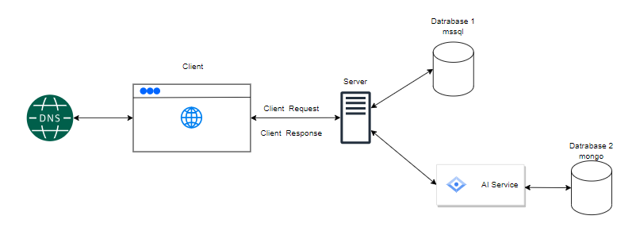
Figure 3.1 System Architecture Diagram.

Datadase design
The database design for the system follows a relational model, adhering to Boyce-Codd Normal Form (BCNF) principles to ensure data integrity and eliminate redundancy. The design process begins with a conceptual model, visualized through an Entity-Relationship Diagram (ERD), which outlines the key entities, their attributes, and the relationships between them.
- Conceptual Design:
The Entity-Relationship Diagram (ERD) illustrates the conceptual structure of the database, representing the essential data elements and their relationships. It serves as a blueprint for the subsequent logical and physical design phases.
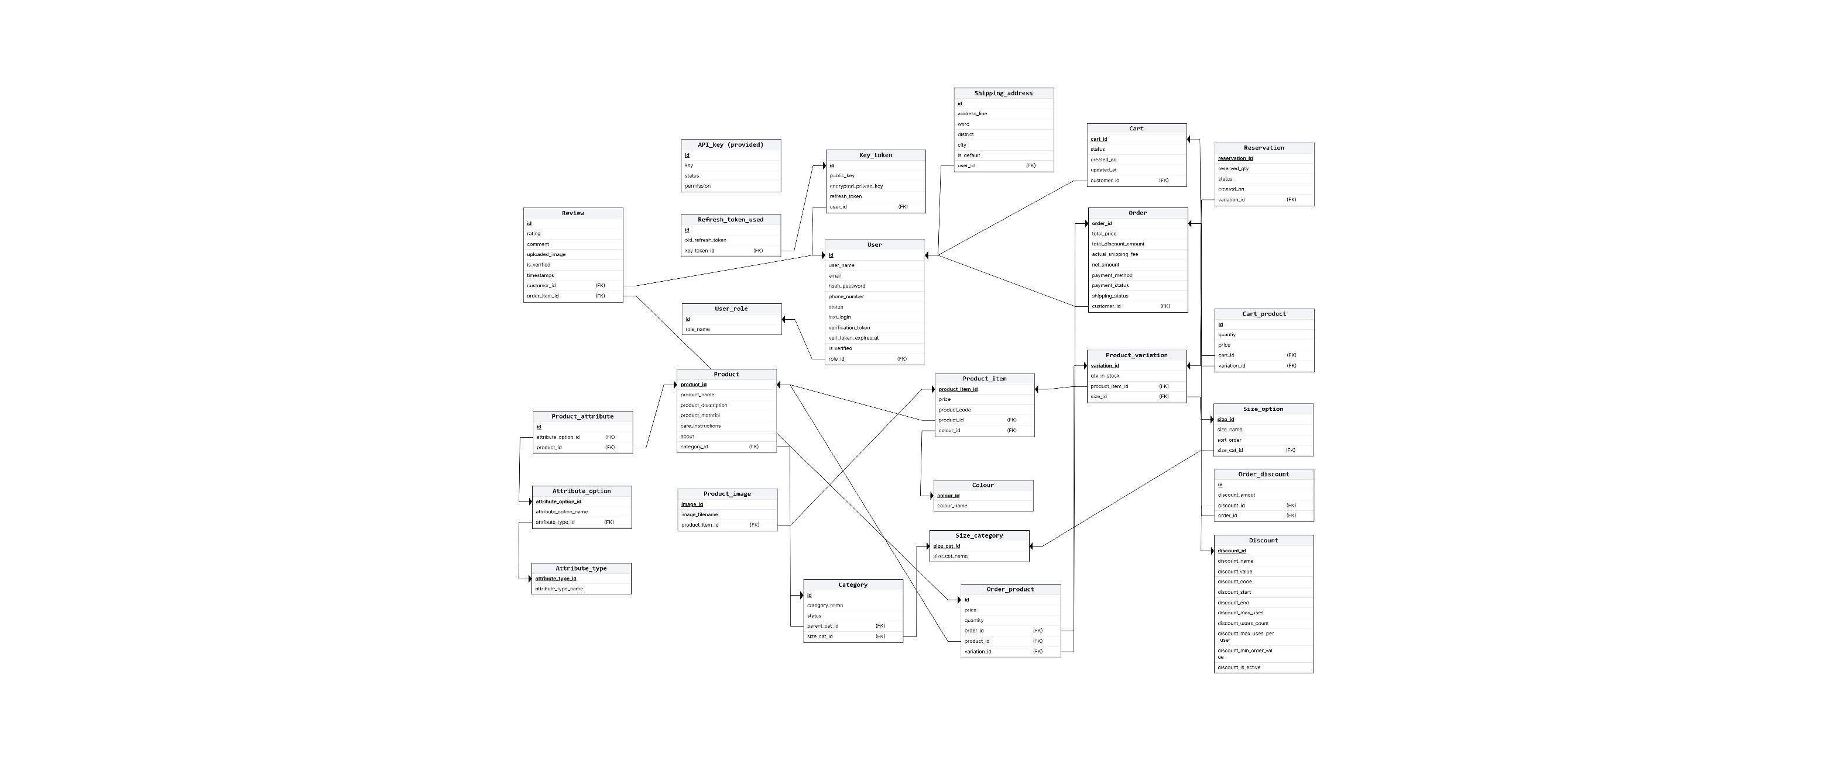
Figure 3.2 Entity-Relationship Diagram (ERD)

This conceptual model provides a comprehensive overview of the system's data requirements and serves as the foundation for the subsequent phases of database design, ensuring that the final system effectively captures and manages all relevant data to support the system's operations.

User Interface design
The user interface (UI) design prioritizes intuitiveness, user-friendliness, and efficiency, ensuring seamless interaction for all stakeholders. The UI development leverages modern web technologies and frameworks to create a responsive and accessible interface across various devices.
- Tools and Technologies:
- Frontend Framework: The UI is built using Reactjs, a popular JavaScript library for creating dynamic and interactive user interfaces. React’s component-based architecture allows for efficient development and maintenance of the UI.
- Styling: Tailwind CSS, a utility-first CSS framework, is employed for styling the UI elements. Tailwind CSS provides a wide range of pre-defined utility classes that can be combined to create custom designs quickly and efficiently. This approach eliminates the need for writing custom CSS from scratch, streamlining development, and ensuring a consistent visual style throughout the interface.
- State Management: Redux, a predictable state container for JavaScript apps, is used to manage the application's state efficiently, ensuring data consistency across different components.
- Data Visualization: Integrated Rechart to create interactive and informative charts and graphs for visualizing sales data, inventory trends, and other relevant metrics.
- UI/UX Design Tools: used Figma for prototyping and wireframing the UI before development, ensuring a user-centered design approach.

- Key UI Components:
The user interface of the Intelligent Fashion E-Commerce System is designed to be simple, responsive, and intuitive, ensuring efficient interaction for both customers and support staff. The key UI components include:
- Authentication Pages: Login and registration interfaces that allow users to securely access the system.
- Product Listing and Detail Pages: Screens displaying fashion products with images, prices, descriptions, and availability information.
- AI Chatbot Interface: A real-time chat box integrated into the platform, allowing users to interact with the AI chatbot for instant support.
- Human Support Dashboard: An interface for staff to receive escalated chatbot conversations, view full chat history, and respond in real time.
- Admin and Management Panels: Screens for managing products, orders, and system configurations.
- Notification and Feedback Components: UI elements such as alerts and messages that inform users about order updates, chatbot responses, and system actions.
- Sample Screens / Mockups:
To ensure a user-centered design, key user interface screens were prototyped using Figma prior to implementation. These mockups focus on the core user journeys of the system and serve as a visual reference for the final UI development. Rather than documenting every screen, only representative and critical interfaces are presented to illustrate system functionality and usability considerations.
- Login and Registration Screen:
IMAGES
This screen allows users to create an account or log in to the system securely. It includes input validation, error handling, and a clear call-to-action to guide users through authentication efficiently.

- Product Listing and Product Detail Screens:
IMAGES
The product listing screen displays fashion items with images, pricing, and filtering options to enhance product discovery. The product detail screen provides comprehensive information such as size options, descriptions, and availability, supporting informed purchasing decisions.

- Shopping Cart and Order Management Screen:
IMAGES
This screen enables users to review selected items, adjust quantities, and proceed with checkout. It is designed to minimize friction in the purchasing process and clearly present order summaries.

- AI Chatbot Interface:
IMAGES
The chatbot screen allows customers to interact with the AI-powered assistant in real time for inquiries such as order tracking or return policies. The interface also supports seamless escalation to human staff, where the full conversation history is preserved for efficient support.

- Admin / Staff Support Dashboard:
IMAGES
This interface enables staff to monitor chatbot escalations, view customer conversations, and respond instantly via real-time communication channels. It is designed to improve support efficiency and response time.

Use Case Design
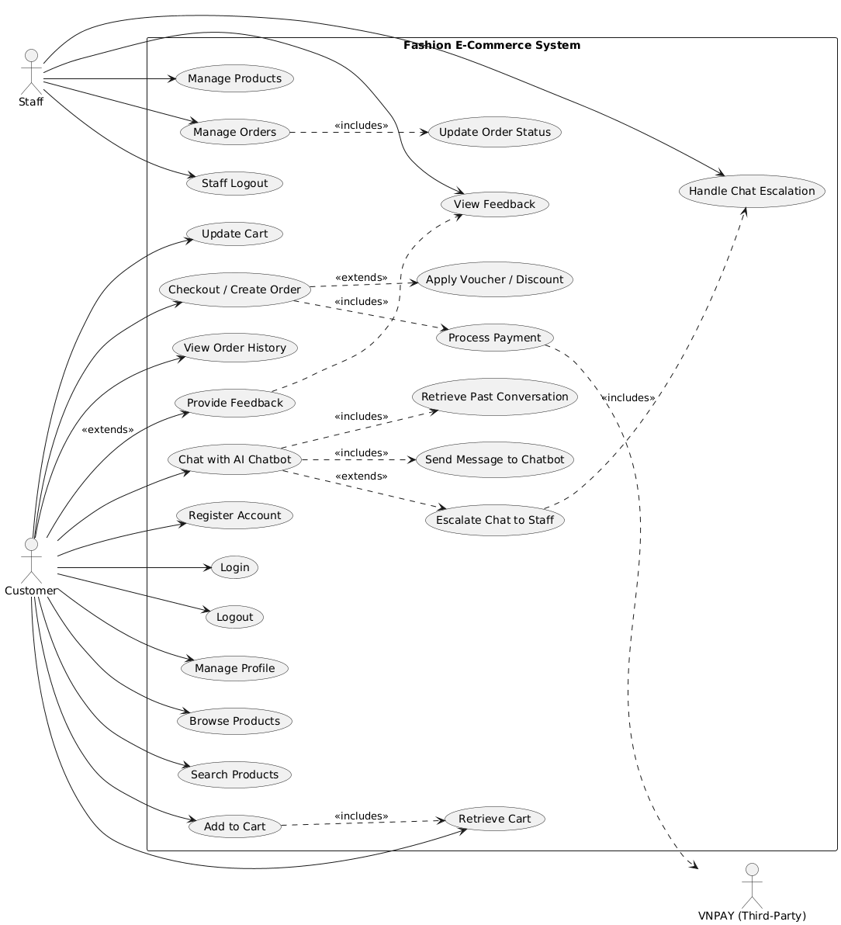
Figure 3.3 Use Case Diagram.
Actors:
- Customer
- Admin
- Support Staff
- AI Chatbot
- Third-Party Services (e.g., Payment Gateway)

Description:
The Use Case Diagram illustrates the high-level functional interactions between users, system components, and external services within the Intelligent Fashion E-Commerce System.
- Customer is the primary user who interacts with the system to browse products, manage accounts, place orders, make payments, view order history, provide feedback, and communicate with the AI chatbot for customer support.
- Admin is responsible for managing core system operations, including product management, order oversight, and monitoring user activity to ensure the platform operates correctly.
- Support Staff handles escalated customer inquiries that cannot be resolved by the AI chatbot. They can view conversation history and provide real-time assistance to customers.
- AI Chatbot acts as an intelligent intermediary, responding to common customer queries such as order tracking and product information, and escalating complex issues to support staff when necessary.
- Third-Party Services (such as payment gateways) interact with the system to securely process online payments during the checkout process. These services operate externally and do not directly interact with end users.

Results
Something else

Functional Design Using Sequence Diagrams:
Sequence diagrams are used to model the dynamic behavior of the system by illustrating interactions between system components over time. They show how users, system modules, and external services communicate through messages to complete specific functionalities. In this project, sequence diagrams are employed to clearly represent the execution flow of core features, including authentication, product ordering, AI-based customer support, and scalability mechanisms.

Login, Logout, Change-Password Processes

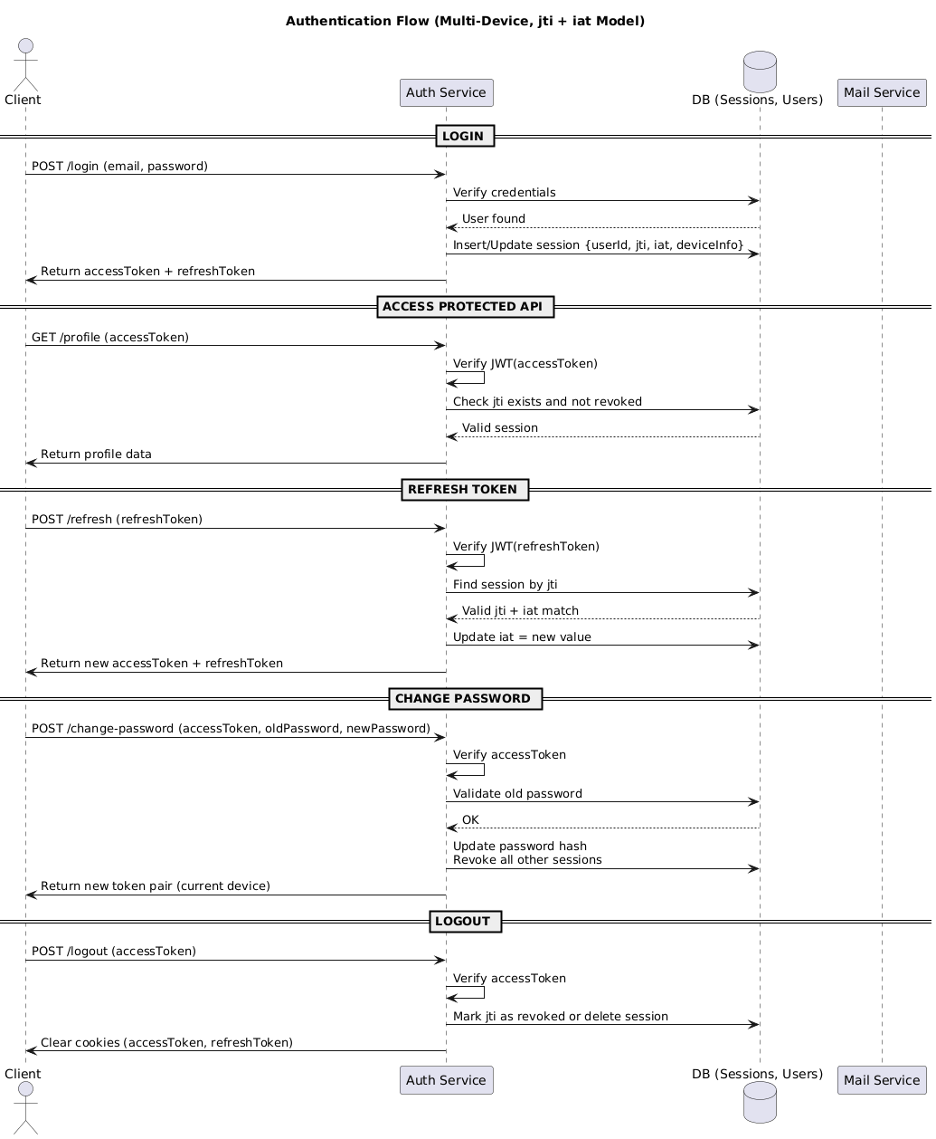
Figure 3.4
This sequence diagram illustrates the authentication-related processes of the system. It describes how a user submits credentials to the frontend, how the backend validates the information, and how authentication tokens are generated and managed. The diagram also demonstrates the logout flow and password update process, ensuring secure session handling and user account protection.
    - Sign-Up Process
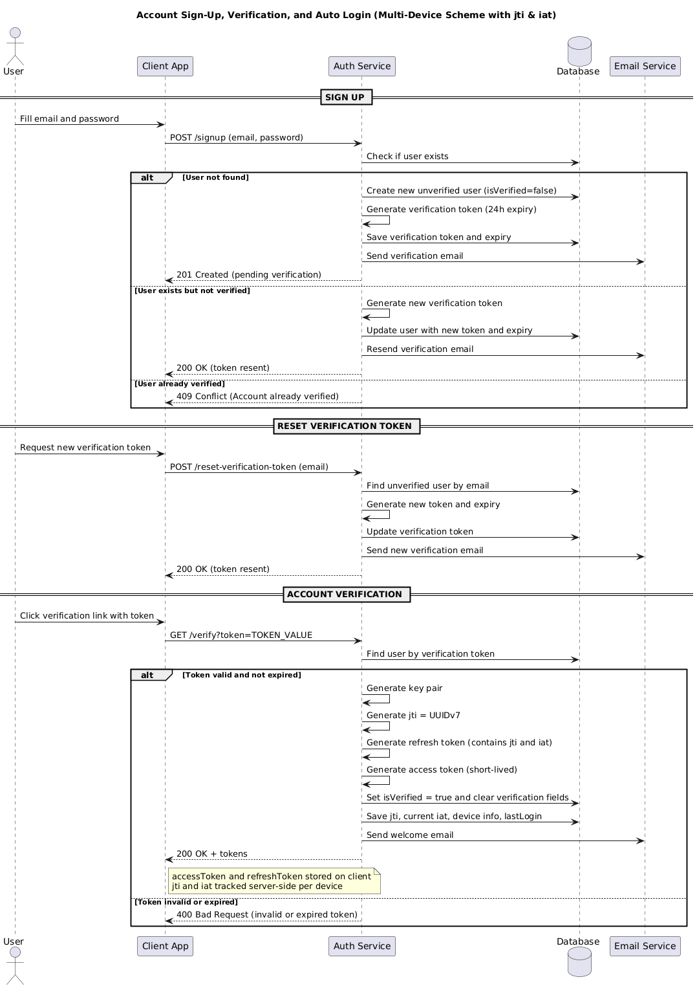
Figure 3.5
The sign-up sequence diagram presents the process of registering a new user account. It shows the interaction between the user interface, backend services, and the database for validating input data, creating user records, and confirming successful registration. This process ensures proper user onboarding while maintaining data integrity.

    - Forget-Password
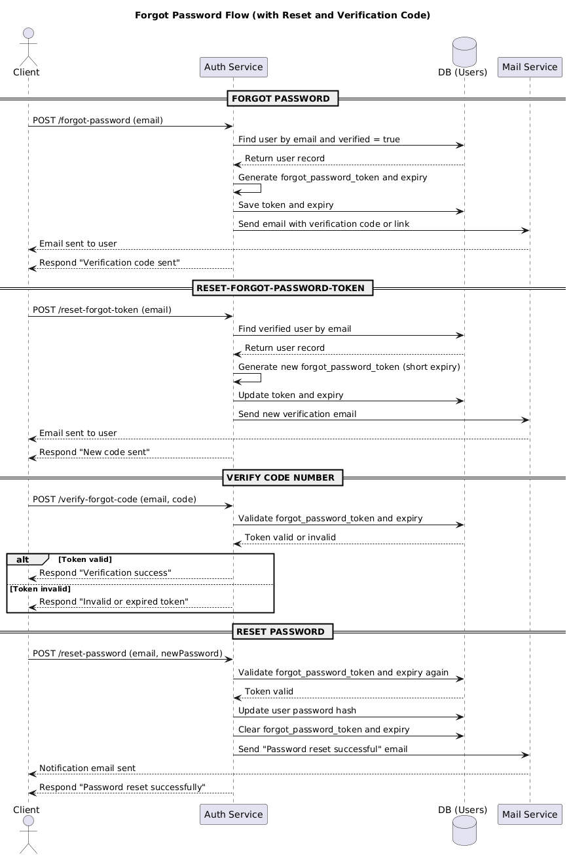
Figure 3.6
This diagram describes the password recovery workflow. It outlines how users request a password reset, how the system verifies user identity, and how reset credentials are securely generated and delivered. The sequence ensures that account recovery is both user-friendly and secure.

    - Product Browsing and Ordering Module
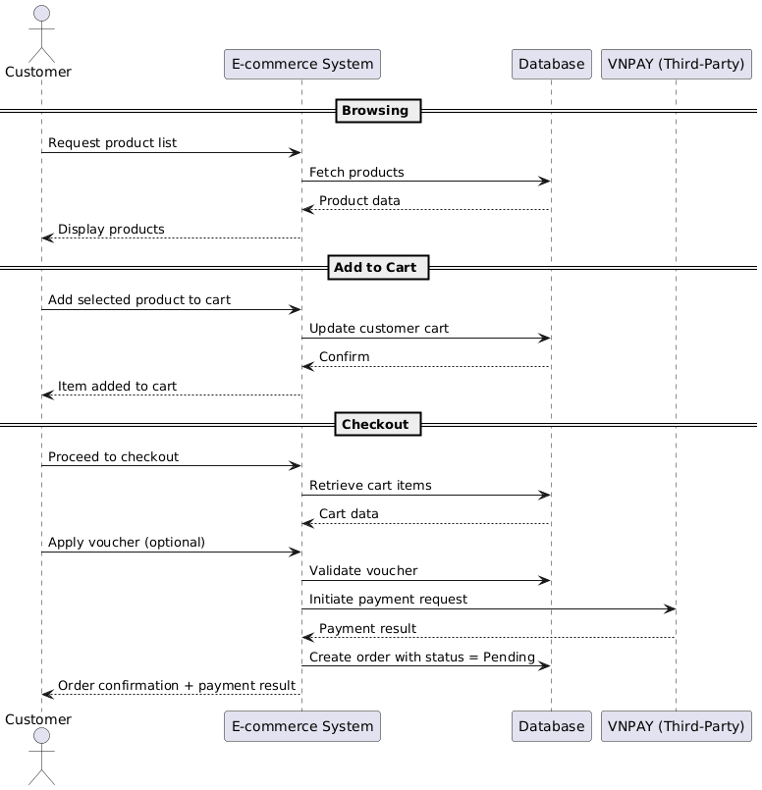
Figure 3.7
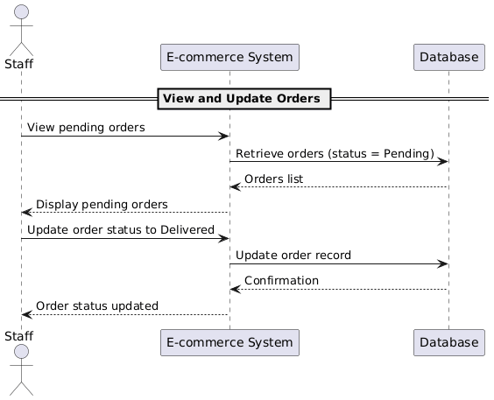
Figure 3.8
These sequence diagrams (3.7, 3.8) represent the core e-commerce functionality of the system. They demonstrate how customers browse products, manage shopping carts, apply discounts, and complete orders and how staff or admin accept those orders. The interaction with third-party payment services is also illustrated, highlighting how payment requests and confirmations are handled securely.
    - AI-Powered Customer Support Module
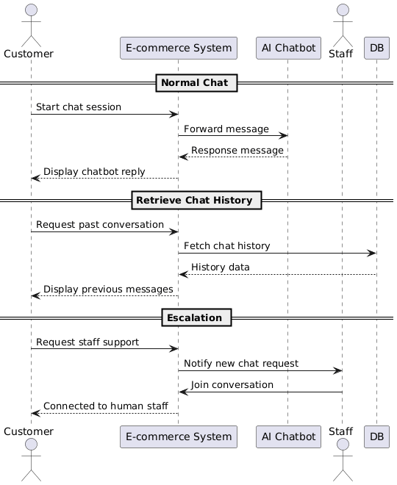
Figure 3.9
This sequence diagram illustrates the interaction between customers and the AI-powered chatbot through real-time communication. It shows how user messages are processed by the chatbot, how responses are generated using AI services, and how complex queries are escalated to human support staff via socket-based communication, with full conversation context preserved
    - Scalability and Performance Support Module
Something else
Figure 3.10
This diagram focuses on system scalability and performance optimization. It illustrates how technologies such as Redis and message queues are used to manage high volumes of concurrent requests, cache frequently accessed data, and process tasks asynchronously. These mechanisms ensure system stability and responsiveness during peak traffic periods.

Results

CHAPTER 4

IMPLEMENTS AND RESULTS

Implement
This chapter comprehensively describes the implementation process, including software and hardware requirements, code structure, and integration with autonomous vehicle systems. Specific algorithms and techniques employed in the implementation are discussed in detail.

Software requirements
- Database Management System (DBMS):
  - Main database: Postgres
  - Drawing tools: Lucid Chart, ERDPlus, Mermaid.live, PlantUML
- Web Server:
  - Backend deployment: 14.225.205.226
  - Frontend deployment: https://devit.website/
- Programming Languages and Frameworks
  - Backend: JavaScript with frameworks Node.js, Express.js, JSDoc, Vitest
  - Frontend: HTML, CSS, JavaScript with frameworks React and Vite
  - Database: module Faker from python to generate data
- Middleware and Tools:
  - Figma: UI/UX design
  - APIs: RESTful APIs for communication between frontend and backend
  - Version Control: GitHub
  - Development Tools: Visual Studio IDEs
- Security
  - Authentication: hash function to protect user sensitive data such as password
  - Public resource: secure information in .env file and hash image data
- Other Tools
  - Containerization: Docker (for environment consistency and easy deployment)

Results
Abc…

Result 1
Abc…

Result 2
Abc…

CHAPTER 5

DISCUSSION AND EVALUATION

Discussion
Abc…

Comparison
Abc…

Evaluation
Abc…

CHAPTER 6

CONCLUSION AND FUTURE WORK

Conclusion
Abc...

Future work
Abc…

REFERENCES

APPENDIX

