Databse table:

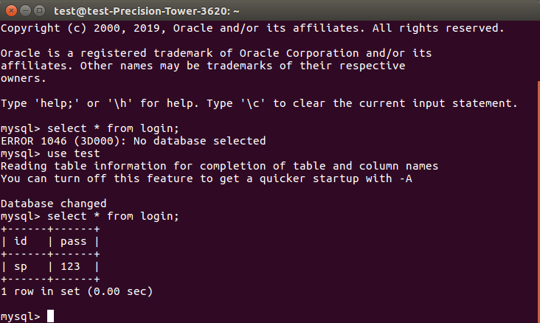

**JDBC code:**

**package** Mypackage;

**import** java.sql.*;

**public** **class** MysqlCon {

**public** **static** **void** main(String args[]){

System.*out*.println("Hi");

**try**{

Class.*forName*("com.mysql.jdbc.Driver");

Connection con=DriverManager.*getConnection*("jdbc:mysql://localhost:3306/test","root","root");

Statement stmt=con.createStatement();

ResultSet rs=stmt.executeQuery("select * from login");

**while**(rs.next())

System.*out*.println(rs.getString(1)+" "+rs.getString(2));

con.close();

}

**catch**(Exception e)

{

System.*out*.println(e);

}

}

}

