**Pre-requisites:**

We should have Java and Maven installed and configured to run the test cases. If not configured already, please see the steps given towards the end of this document.

Please run the suite on Mac OS, as the browser drivers used are particular to the Mac OS.

**Steps for execution:**

1. To view the source code, please open the project in Eclipse.
2. (Skip this step if Chrome browser is present in your machine). Tests are configured to run either on Chrome browser or Firefox browser. By default test suite is configured to run on Chrome browser. In order to change to Firefox, please change browser type in data.properties file. Steps are as follows.
3. Go to file ToDoApp/src/main/java/Celmatix/ToDoApp/data.properties
4. Change “Browser =FireFox “ for the FireFox Browser.
5. Go to terminal and change directory to the project folder.

Example: cd Users/Savitri /ToDoApp

1. Run the test cases by executing following command.

*mvn test*

1. With the above command, test case execution begins. Progress of test execution can be seen on the command prompt. Tests are executed by launching the browser, navigating to the website, executing all the requirements and ends by closing the browser. After successful execution, BUILD SUCCESS message is shown with execution summary as shown in the screenshot. 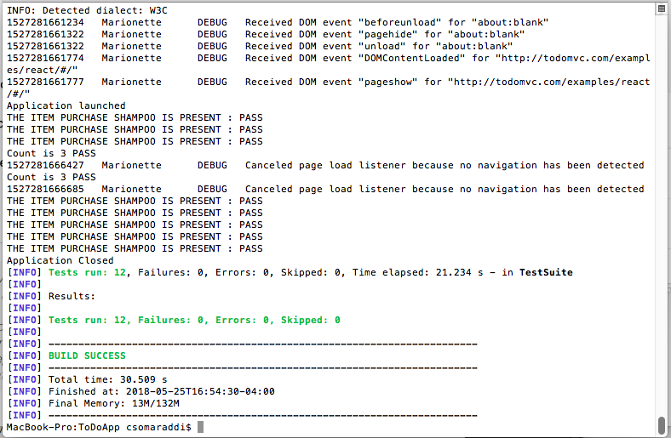
2. View Reports

To view reports please go to the following folder

projectpath/target/surefire-reports/ExtentReportTestNG.html

Note: projectpath for me is: Users/Savitri /ToDoApp

Open the ExtentReportTestNG.html file in the browser to view the detailed reports as shown in the screen shot below.

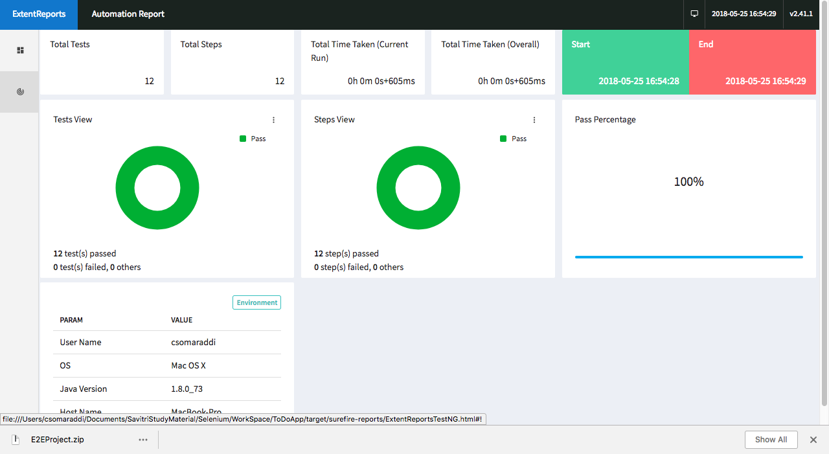

**Steps to Install and Configure Java on Mac Machine.**

1. Go to link <http://www.oracle.com/technetwork/java/javase/downloads/index.html>
2. Download the latest version of JDK for Mac machine.
3. Install Java by running the JDK.
4. Open Terminal.
5. Type: vim ~/.bash_profile
6. Press “i” in order to edit the bash_profile file.
7. Add this to the end of the bash.profile file:

Export JAVA_HOME = $(/usr/libexec/java_home)

1. Press :wq to save the file and exit .
2. Type : source .bash_profile

**Steps to Install and Configure Maven on Mac Machine:**

1. Go to link <https://maven.apache.org/download.cgi>
2. Download [apache-maven-3.5.3-bin.tar.gz](http://apache.mirrors.pair.com/maven/maven-3/3.5.3/binaries/apache-maven-3.5.3-bin.tar.gz) for the Mac machine.
3. Unzip the downloaded files.
4. Copy the path of the downloaded maven folder.
5. Open Terminal.
6. Type: vi ~/.bash_profile
7. Press “i” in order to edit the file.
8. Add maven folder directory path to the end of bash.Profile file:

For Example:

export PATH="/Users/ Savitri/Library/apache-maven-3.5.2/bin:$PATH"

1. Press :wq to save the file and exit .