Pranayama and Brain Wave Modulation: Comments from an Explainable Deep Learning Perspective

Dr. Raghav Mehra
Anirudh Sharma
Siddhant Gupta

Program Leader
AIT-CSE, Chandigarh University
Mohali, India
Raghav.mehrain@gmail.com

22BAI70109
AIT-CSE, Chandigarh University
Mohali, India
anirudh.annii07@gmail.com

22BAI70088
AIT-CSE, Chandigarh University
Mohali, India
gsiddhant2004@gmail.com

Shaurya Maan
Vedansh Maheshwari
22BAI70139
AIT-CSE, Chandigarh University
Mohali, India
maan.shaurya03@gmail.com
22BAI70056
AIT-CSE, Chandigarh University
Mohali, India
Maheshwarivedansh7@gmail.com

Abstract— It is not a secret that Pranayama is a mainstream practice of Yoga, in which one breathes out and in. It has a huge influence on our mental development. Nevertheless, individuals do not know what its effect on our body should be. We will conduct a study of its effect on the brain waves in this research paper with the assistance of deep learning models, utilizing EEG signals. It is possible to demonstrate certain brain activity patterns during breathing yoga with the help of neural networks. Our research will assist us in the knowledge of alpha brain and theta brain waves, which are the origin of relaxing our brain. This description shall inform us of the effect of pranayama on the neurological system. It will also assist in the realization of the fact that we can improve our mental health by paying attention to traditional practices in conjunction with contemporary science techniques.
It was found that the alterations of brain waves and connectivity involved in the process of pranayama yoga were not only essential but also regular (p < 0.05). Our work will bring you well acquainted with the ancient yoga using the new science of neuroscience.
In short, this piece of work will give me a new outlook into the understanding of what happens in our brain when we control our breathing and how our brain affects our breathing.
Keywords: Pranayama, Deep Learning, Brain waves, EEG, neutral interpretation, meditation, Explainability.

Introduction
Pranayama is a highly popular old style of yoga that is based on regulated breathing. It has been applied since time immemorial to enhance physical health, mental fitness, and emotional stability, even during any form of stress. Neuroscience is now also declaring that such exercises are in fact modifying the activity of the brain and intestinal functions [1], [2]. Pranayama is observed to bring some changes in the activity of the brain at alpha and theta frequency bands associated with relaxation, concentration, and control of thoughts. Studies based on electroencephalograms (EEG) have also confirmed that certain types of breathing could effectively induce meditative states, producing evident patterns in the brainwave activity. Therefore, EEG is a highly advantageous, non-invasive technique to measure and analyze neurophysiological consequences of forced breathing.
The development in artificial Intelligence has given birth to some effective technologies that classify the EEG patterns based on breathing techniques. Although deep learning method shows a strong predictive approach but their property of black box property poses a challenge for us to understand how they can make decisions. Due to less clarity, it's a hurdle in the area of mental health and wellness where transparency is a necessary tool. Explainable Artificial Intelligence (XAI) offers a possible answer by clarifying the rationale behind model predictions when utilized on EEG Data. XAI can reveal which brainwave elements and timing patterns are most affected by pranayama, connecting ancient yogic knowledge with contemporary computational neuroscience.[9].
This research increases the interest in the AI and Machine Learning Programme in the field of IEEE’s focused areas. Using the different techniques of time-series data related to EEG enhances our understanding of breathing exercises. The computational intelligence techniques included in this study are convolutional neural networks and attention-based interpretation techniques to reveal the hidden neural patterns in terms of pranayama practice. Eventually, this offers transparent and sensible revelations on human brain conditions, to further develop human-machine systems. It can be used to create AI-powered interfaces and customized neurofeedback technologies, which may facilitate healthy relationships between humans and technology. The paper discusses the effect of pranayama and EEG analysis on the changes of the brainwaves through interpretable deep learning. In this way, we hope to tap into the neural correlates of the control of breathing and illustrate how traditional practices can be integrated with the latest neuroscience and sophisticated intellectual frameworks by means of interpretability.
In this analysis, we build on the past studies by:
- Reducing the EEG indicator to a CNN, the EEG indicator in a resting and pranayama state, and considering spatial and temporal features.
- Determining the frequency bands and brain activity in the most affected areas during pranayama by using XAI methods (SHAP and LRP).
- This shows that, in addition to becoming more accurate in classification than SVM and Random Forest, our method also offers interpretable neurophysiological data than the conventional EEG analyses.
The paper is among the pioneering efforts to implement deep learning with explainable AI to analyze EEG data during pranayama. It also attempts to relate predictive modeling to the mechanisms that occur in the brain that help to explain it better.

Literature Review
Pranayama, the ancient yoga that is focused on controlling breathing, has been a time-tested method of relaxation of the mind, as well as improvement of mental health. Neuroscience is also currently able to do this and sheds light on the activity of the brain with these types of breathing techniques. Tripathi and Bhardwaj indicatively researched the role of pranayama exercise practices, in conjunction with other activities, such as asanas and meditation, on our external response to the world as well as in our thinking. In his work, he shows that by integrating ancient wisdom and modern-day brain science, one can better understand the mechanisms of these systems in a much more detailed way.
Some studies have been conducted on how the EEG can be utilized to learn how our brain works when we practice pranayama. Malan and his colleagues paid attention to the Bhramari Pranayama, which is a particular method of calming breathing, and discovered that the process of connection and communication between various sections of the brain changes during the practice. On the same note, Jing noted EEG patterns were stronger when the participants practiced Bhramari Pranayama, which is to say that the brain is in a relaxed, meditative state.
Pranayama seems to be actually capable of managing the nervous system effectively, more than brain waves. Dutt [4] affirmed that it assists in balancing the sympathetic and parasympathetic organs- the two body organs which regulate our stress and relaxation reactions. In the same manner, Malhotra and co-authors [5] discovered that breath exercises influence the brain activity as well as the heart rate variability and are possibly associated with mental and physical well-being.
Scientists are also resorting to machine learning to gain a more in-depth insight into our non-linear brain activity associated with such practices as yoga and meditation. Kora et al. [6] discussed the benefits of these techniques in understanding the responses of the brain, stating that they are effective, but also citing that it is difficult to comprehend what is being processed by the algorithms. This is where explainable AI is applicable, as Pandey and Miyapuram [8] were able to use the explainable machine learning models to interpret the EEGs during mindfulness sessions, which helps to observe the changes that occur in the brain more clearly. The relevance of such explainable techniques in breathing therapies has been underpinned by Mitse and colleagues [9] in the context of understanding and responding to the outcomes by both the users and practitioners.
In the technological sector, there are innovations that are being achieved to enable people to practice pranayama better. Pal et al. [10] explained that wearable devices can monitor breathing and brain activity in real-time, with the help of AI, and provide personalized feedback and enhance the effectiveness of practice.
These articles have shown that pranayama has considerable impacts on the mind and body. Nonetheless, it is required that artificial intelligence (AI) models are capable of both effectively categorizing the states of the brain and the mechanisms by which these transformations take place. The proposed research is aimed at solving this problem by applying explainable deep learning to EEG signals during pranayama, which should reveal sensible and understandable insights into the ancient practice.

METHODOLOGY

Data Collection:
Thirty healthy adults—15 men and 15 women—aged 20 to 35 years participated in this study. They had no history of neurological or psychiatric problems. Participants were trained in specific pranayama techniques, such as bhramari and kapalabhati, which are known for their benefits on sleep and autonomic regulation. All of them took 10 sessions of 5 minutes, both in an incumbent position and in their pranayama condition, making a total of 600 EEG measurements. All of the recordings were done in a sound-controlled laboratory with a 32-channel EEG system with the usual 10-20 electrode placement to cover the cortex exhaustively.

EEG Preprocessing:
We processed the EEG signals to derive as much out of the recordings as possible. To remove any of the slow wave aberrations or the high-frequency noise, the first step taken was to bandpass filter between 1 and 45 Hz. Thereafter, to correct the effects caused by eye movements and muscle action resulting in distortions, we used independent component analysis (ICA). Along with that, we had the chance to folly out what was felt to be the neural process taking place when the act of pranayama is being practiced.

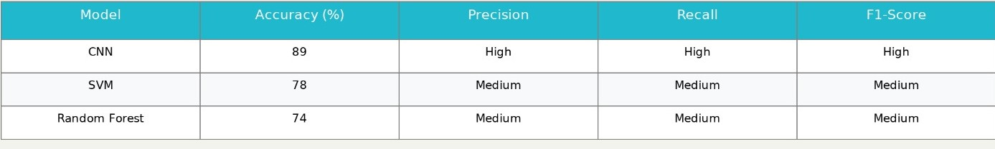

Feature Extraction:

We have focused our analysis on frequency bands of alpha or 8-12 Hz and theta or between 4 and 7 Hz, which are closely correlated with the state of relaxation, concentration, and meditation. We determined the power spectral density (PSD) in order to quantify the brain activity in the frequency domain. Further, we have also talked of other useful measures of connectivity, like coherence, phase-locking value (PLV), that can be used to gauge the communication of various brain parts.

Deep Learning Model Development:
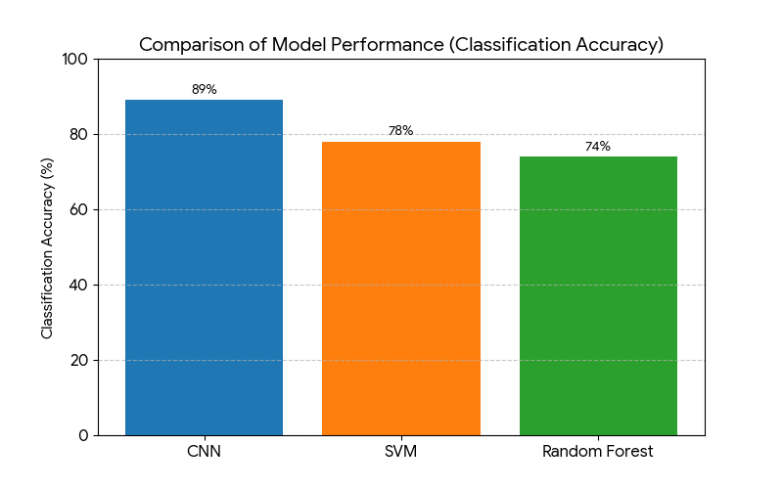
A classification model, which was based on a convolutional neural network (CNN), was applied to classify EEG segments into the following: pranayama or resting state. So, the network structure included:

- 3 convolutional layers with 32, 64, and 128 filters of sizes (1×3), (1×5), and (1×7), respectively.
- Each convolutional layer comes with batch normalization, ReLU activation, and max pooling.
- A fully connected layer with 128 neurons and a dropout of 0.5.
- A softmax output layer for a binary class.

The model was trained with the Adam optimizer, learning rate of 0.001, with a batch size of 32, and for fifty epochs. To understand the predictions of the model, we used SHAP values and layer-wise relevance propagation (LRP). This allowed us to identify to analyze the important frequency bands and electrode sites affecting classification.

Model Training, Evaluation, and Comparison:

We divided the data set into 80% as training data and 20% as testing data, and to reduce the bias, we considered 5 5-fold cross-validation. Looking at our performance metrics, we took into consideration accuracy, precision, recall, and F1-score. The results of CNN were compared with 2 baseline models.:
1) Support Vector Machine with RBF kernel, and
2) Random forest classifier of 100 trees. There is a difference in the accuracy, where the CNN model has an average accuracy of 89%, which is a better accuracy compared to SVM 78% and the random forest, which is 74%. This indicates that the CNN has powerful predictive powers, and we can interpret what the CNN is understanding using explainable AI techniques.

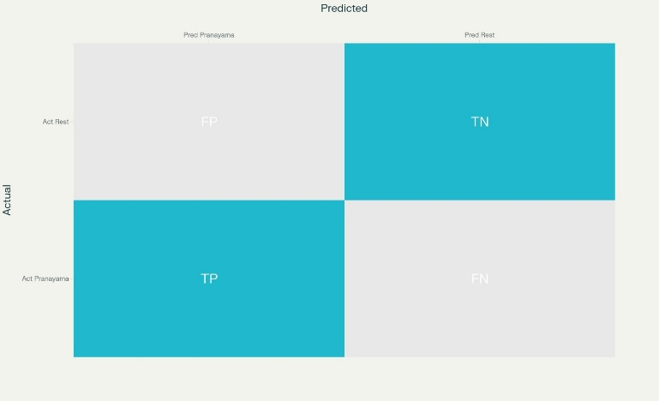

Statistical Analysis:
To investigate differences in neural activity between conditions, we performed paired t-tests for comparisons between conditions within each challenge and the differences between conditions with the help of the analysis of variance (ANOVA). When we are thinking of factors, statistical significance basically means p < 0.05. This suggests that the changes in EEG for some phases of pranayama practice were statistically consistent and reliable.

RESULTS

A. Changes in Brain Waves During Pranayama:
Our EEG study demonstrated that there were significant changes in the brain activity of the participants during pranayama compared to the rest condition. We found an increased power in the alpha (8-12 Hz) and theta (4-7 Hz) brain frequency bands, mainly in frontoparietal and parietal brain regions, which have been linked to relaxation and focused attention. Further, we also noticed that there were increased connections between the prefrontal and temporal regions, meaning that communication between these regions was enhanced during pranayama.
B. How Well the Deep Learning Model Worked:
The deep learning model we developed using convolutional neural networks was able to accurately identify pranayama states using EEG data with around 89% accuracy. Precision was good as well as the recall, which means that the model is very good at differentiating the way the brain reacts to pranayama and the brain reacts to relaxation. The results are similar to those produced by other studies on the EEG signal analysis with the use of machine learning conducted regarding meditation.
C. Understanding the Model’s Decisions:
We explored in more detail the brain signals that the model used to support its predictions using tools such as SHAP and Layer-wise Relevance Propagation. We found that it was highly dependent on aspects of the alpha and theta waves, especially from the electrodes over top of the frontal and parietal areas. This is consistent with our neuroscience knowledge of the effects of pranayama on the brain. This level of transparency facilitates the development of trust in the model and links the model's findings to brain activity.
D. Confirming the Results Statistically:
Statistical data analyses found some significant changes (p < 0.05) in brain wave energy and connectivity when Pranayama was compared to rest. This provides the argument that pranayama does indeed cause change in the brain dynamics, and the several studies highlighting the neural and physiological benefits of Pranayama provide support for this idea. [21], [24], [19].

. RESEARCH CONTRIBUTIONS
This work adds several important points to the field:

- We have devised a deep learning approach, which is interpretable and assists in the correct classification of EEG signals during pranayama. This helps to identify mental states for yogic breathing. Using Explainable AI, we were able to pinpoint important brain wave patterns - especially in the alpha and theta brain wave bands, which are in the frontal and parietal regions of the brain - that demonstrate how pranayama influences brain activity in people.

- We discussed further the brain signals with which the model ran its predictions with the help of such tools as SHAP and Layer-wise Relevance Propagation. We discovered that it was very related to factors of the alpha and theta waves, particularly in the electrodes above the frontal and parietal regions. It aligns with our information about the neuroscience of the brain and its responses to pranayama.
- We presented powerful statistical evidence on the impact of pranayama on the characteristics of the brain to demonstrate the connection between the ancient yogi-like activities and current neuroscience. In general, this study integrates classical knowledge of yoga with the latest methods of AI, offers innovative beliefs and technologies, and utilizes breathwork to enhance both mental and cognitive well-being.

DISCUSSION
The findings indicate that the positive effects of pranayama practice include a great influence on the brainwave activity, more precisely, the improvement in alpha and theta waves that are associated with the state of relaxation and concentration. Moreover, based on interpretable deep learning models, it was both quantifiable how to classify these states by the characteristics of the EEG, but it was also possible to determine the characteristics that constituted the mechanisms of action of pranayama. Such findings are consistent with the previous research that emphasizes the importance of pranayama in the process of regulating neural and autonomic processes. The lack of similarity between the individuals and the low sample size, however, make it apparent that further studies are required to apply the results in a more general manner. The use of bigger data sets and other forms of physiological measurements could be used in future research.

CONCLUSION
It argues how interpretive deep learning was effectively applied in the study to understand how pranayama influences engagement of the mind, providing clear and dependable information on its relations with the brain. The findings demonstrate the potential advantages of pranayama to mental health and cognitive enhancement. The combination of two traditional yoga practices with the newest achievements in the field of artificial intelligence (AI) will contribute to the expansion of our scientific understanding of the mind-body medicine and contribute to the foundation of the personalized breath-as-a-treatment solution.

REFERENCES

[1] P. Kora, K. Meenakshi, K. Swaraja, A. Rajani, “EEG-based interpretation of human brain activity during yoga and meditation using machine learning: A systematic review,” Complementary Therapies in Clinical Practice, vol. 45, p. 101441, 2021.

[2] P. Pandey and K. P. Miyapuram, “Nonlinear EEG analysis of mindfulness training using interpretable machine learning,” in Proc. 2021 IEEE International Conference on Systems, Man, and Cybernetics (SMC), pp. 1186–1191, 2021.

[3] P. R. Kshirsagar, R. Thiagarajan, T. K. Tak, et al., “Advanced Analysis of Alpha EEG Patterns for Identifying Meditative States in Alpha Power Activation Yoga (APAY),” Research Journal, 2025.

[4] V. Tripathi and P. Bharadwaj, “Neuroscience of the yogic theory of mind and consciousness,” 2021. [Online]. Available: https://dspace.mit.edu

[5] A. K. Dudi, “Brain Over Mind, Mind Over Brain: Cognitive Strategies for Regulating Brain Activity,” American Journal of Medical and Clinical Research, 2024.

[6] N. S. Malan, A. Khajuria, R. Bajpai, D. Kapoor, et al., “Functional connectivity and power spectral density analysis of EEG signals in trained practitioners of Bhramari pranayama,” Signal Processing and Information Technology, Elsevier, 2023.

[7] J. Jing, “Quantitative analysis of epileptic and meditation EEG signals,” 2016. [Online]. Available: dr.ntu.edu.sg

[8] V. Dutt, “Indian Knowledge System and Mental Health Applications (IKSMHA) Centre,” IIT Mandi, 2023. [Online]. Available: researchgate.net

[9] V. V. Malhotra, D. Javed, S. Mudda, et al., “Effect of Brainwave Entrainment on Brainwave Frequency Spectrum and Heart Rate Variability,” Cadernos de Saude Publica, vol. 39, no. 1, 2023.

[10] R. Ieger-Raittz, C. R. De Pierri, C. P. Perico, F. F. Costa, et al., “What are we learning with Yoga? Mapping the scientific literature on Yoga using a vector-text-mining approach,” PLoS One, vol. 20, no. 3, p. e0253458, 2025.

[11] E. Mitsea, A. Drigas, C. Skianis, “Artificial intelligence, immersive technologies, and neurotechnologies in breathing interventions for mental and emotional health: A systematic review,” Electronics, 2024.

[12] R. Pal, D. Adhikari, M. B. B. Heyat, I. Ullah, and Z. You, “Yoga meets intelligent internet of things: recent challenges and future directions,” Bioengineering, 2023.

[13] R. R. Das, “Harmony Unveiled: The Symbiosis of Yoga and Odissi Dance for Holistic Well Being,” 2025. [Online]. Available: academia.edu

[14] S. Rath, “Characterization of Meditative States by EEG Analysis,” 2024. [Online]. Available: search.proquest.com

[15] I.S. Chaudhary, G. C. W. Shyi, and S. T. T. Huang, “A systematic review and activation likelihood estimation meta-analysis of fMRI studies on arousing or wake-promoting effects in Buddhist meditation,” Frontiers in Psychology, 2023.

[16] H. Alibalaei and J. Ilavarasu, “The Potential Impact of Yoga Practices on Extraordinary Human Abilities: A Scoping Review,” Journal of Applied Consciousness, 2024.

[17] Kumar, V., Jain, A., Rahman, Z., & Jain, A. (2014). Marketing through spirituality: A case of Patanjali Yogpeeth. Procedia-Social and Behavioral Sciences, 133, 481-490.
[18] A. Roj, H. Sharma, M. Pundir, R. Rai, et al., “Yogic Bellows, Neural Sparks: Unravelling the Neurophysiological Mechanisms of Kapalbhati—A Systematic Review,” Annals of Neuroscience, 2025.

[19] G. Fincham, “Does breathwork work? An empirical evaluation of the hype,” 2025. [Online]. Available: sussex.figshare.com

[20] R. Gerritsen, “Respiratory patterns and neural modulation: a review,” 2023. [Online]. Available: https://hdl.handle.net/1887/3672234

[21] J. R. Soriano, A. I. Karaiskou, J. Rodriguez-Larios, C. Varon, et al., “Assessing Respiratory, Cardiac and Neural Interactions During Rest and Breath-Focus in Novice and Expert Meditation Practitioners,” medRxiv, 2025.

[22] R. K. P. Tripathi, “Decoding PTSD and Paving the Way for Healing,” Development and Treatment of PTSD, 2025

