Aluno: Gustavo Simas e Pedro Paulo
Matrícula: 16101076 e 16105771 Data: 26/10/2020

Resolução questões extra aula 4:

 |  |  |  |  |  |  |  |  | REG1 |  | REG2
Estado | B7 | B6 | B5 | B4 | B3 | B2 | B1 | B0 | (S1,S0) | Op | (S1,S0) | Op
E0 | 0 | 0 | 0 | 0 | 0 | 0 | 0 | 0 | 10 | SHR | 01 | SHL
E1 | 1 | 0 | 0 | 0 | 0 | 0 | 0 | 1 | 10 | SHR | 01 | SHL
E2 | 0 | 1 | 0 | 0 | 0 | 0 | 1 | 0 | 10 | SHR | 01 | SHL
E3 | 1 | 0 | 1 | 0 | 0 | 1 | 0 | 1 | 10 | SHR | 01 | SHL
E4 | 0 | 1 | 0 | 1 | 1 | 0 | 1 | 0 | 00 | D+Q | 00 | D+Q
E5 | 1 | 1 | 1 | 1 | 1 | 1 | 1 | 1 | 10 | SHR | 01 | SHL
E6 | 0 | 1 | 1 | 1 | 1 | 1 | 1 | 0 | 00 | D+Q | 00 | D+Q
E7 | 1 | 0 | 0 | 1 | 1 | 0 | 0 | 1 | 00 | D+Q | 00 | D+Q
E0 | 0 | 0 | 0 | 0 | 0 | 0 | 0 | 0 | 10 | SHR | 01 | SHL
E1 | 1 | 0 | 0 | 0 | 0 | 0 | 0 | 1 | 10 | SHR | 01 | SHL

Resolução questões extra aula 5:
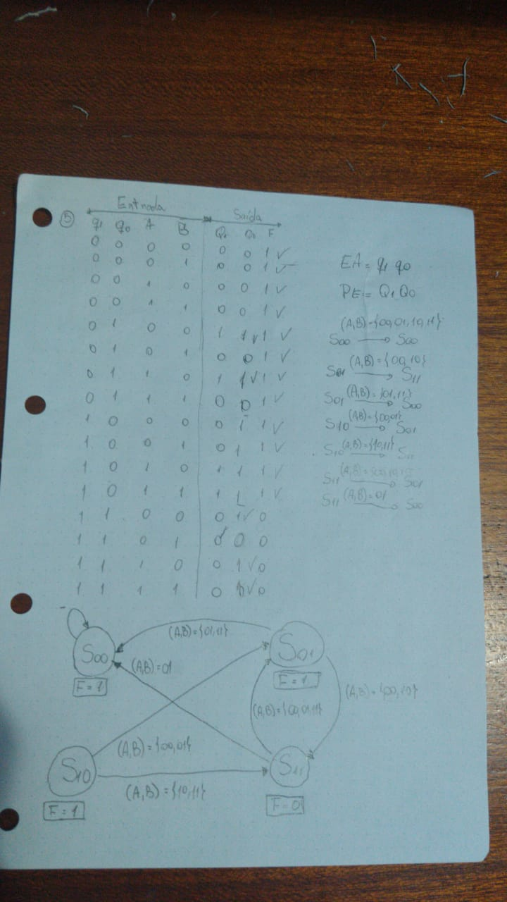

Dúvidas:

