# How to Import the GitHub java project to eclipse

## Clone the project from GitHub

1. Go to github.com
2. Sign up (Choose your own profile) and Sign into the account
3. Remember your username and password as with any other website
4. Download Git bash for Windows - (Google Git bash for windows)
5. Install - You may have to go thru multiple screens while installing, don’t change or choose any values - install with defaults
6. Open git bash
   1. it will open with the home directory
7. Create a new directory with the name of your choice (eg. javaselcode (remember no spaces allowed - preferable to have lower case)
   1. command to use - **mkdir javaselcode**
8. Change to that directory
   1. command to use - **cd javaselcode**
   2. Use the command. **pwd** to confirm the present working directory
9. Run the below command -
   1. **git clone https://github.com/avinashdj1979/VcentrySeleniumJava.git**
10. This will download the code repo (download)

## Import the GitHub project to eclipse

1. Once the git clone is successful, open Eclipse
2. Click on File -> New -> Java Project (if java project is not shown select project -> Java project)

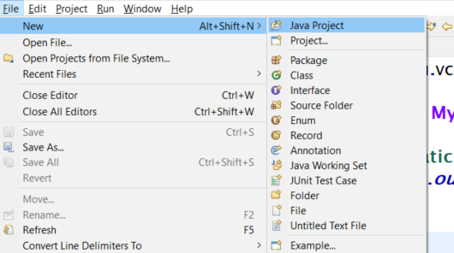

1. Provide a valid project Name without Spaces

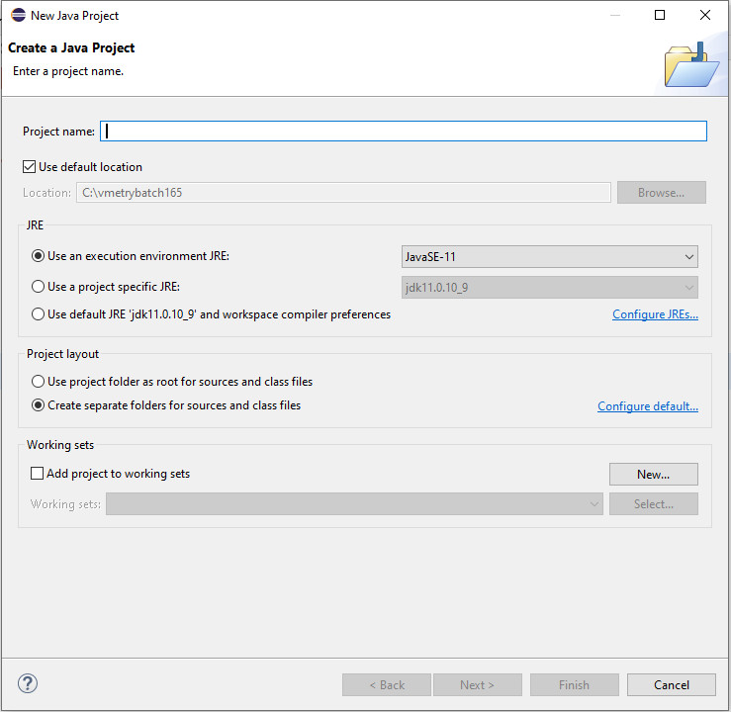

1. Uncheck the check box Use default location



1. Set the location field to the folder where you have cloned the project.

**-** In the case above it will be **C:/Users/<Username>/ javaselcode/VcentrySeleniumJava/ VcentrySeleniumJava**

1. Click on Next and Click on Finish.
2. **Please do not create a module. Skip creating a module.**
3. The project gets loaded in eclipse.

## How to pull the latest changes made to the GitHub Project to eclipse

### Using git bash

1. Open git hub
2. Change the directory the cloned project folder

* /c/Users/Username/javaselcode/VcentrySeleniumJava/VcentrySeleniumJava

1. Use the command – **git pull**.
2. The latest changes will be pulled

### Using Eclipse

1. Right Click on the Project Name
2. Select Team Menu from the context Menu
3. Select the Pull sub menu

