Visvesvaraya Technological University
Belagavi

A Mini Project Report on

Horn Misuse Detection and Safety Monitoring and Warning System
Submitted by

G Slekha G Sreeuditi
USN:1NH23EC054 USN:1NH23EC055

In partial fulfilment for the award of the degree of

BACHELOR OF ENGINEERING
IN

ELECTRONICS AND COMMUNICATION ENGINEERING




Bengaluru - 560 103
DEPARTMENT OF ELECTRONICS AND COMMUNICATION ENGINEERING
CERTIFICATE
Certified that the Mini project entitled “ Horn Misuse Detection and Safety Monitoring System ” is carried out by Ms. G Slekha bearing USN: 1NH23EC054 and Ms. G Sreeuditi bearing USN: 1NH23EC055, Bonafide students of NHCE, Bengaluru in partial fulfilment for the award of Bachelor of Engineering in Electronics and Communication of the Visvesvaraya Technological University, Belagavi during the year 2025-26. It is certified that all corrections and suggestions indicated for Internal Assessment have been incorporated in the report deposited in the department library. The mini project report has been approved as it satisfies the academic requirements in respect of the mini project work prescribed for the said degree.

Signature of the guide Dr M Jayanthi Associate Professor Department of ECE NHCE,Bengaluru
Signature of the HoD Dr. Aravinda K Professor & HoD Department of ECE NHCE,Bengaluru

Name of the Examiner Signature of the Examiner

- 1.

- 2.

< Keep similarity index page. Only first page of the plagiarism report is required to be signed by plag check incharge>

ACKNOWLEDGEMENT
The satisfaction and euphoria that accompany the successful completion of any task would be impossible without the mention of the people who made it possible, whose constant guidance and encouragement crowned our efforts with success.

We have great pleasure in expressing gratitude to Dr. Mohan Manghnani, Chairman, New Horizon Educational Institutions, for providing necessary infrastructure and creating good environment.

We take this opportunity to express our profound gratitude to Dr. Manjunatha, Principal, New Horizon College of Engineering, for his constant support and encouragement.

We would like to thank Dr. R J Anandhi, Professor and Dean-Academics, NHCE, for her valuable guidance.

We would also like to thank Dr. Aravinda K Professor and HOD, Department of Electronics and Communication Engineering, for his constant support.

We also express our gratitude to Dr. M. Jayanthi, our project guide, for constantly monitoring the development of the project and setting up precise deadlines. Their valuable suggestions were the motivating factors in completing the work.

Finally, a note of thanks to all the teaching and non-teaching staff of Dept of Electronics and communication Engineering, for their cooperation extended to us, and our parents and friends, who helped us directly or indirectly during the project work.

G Slekha (1NH23EC054)
G Sreeuditi (1NH23EC055)

ABSTRACT
In most Indian towns, the noise produced by car horns has become a regular background noise. Frequently, this noise is caused by the driver's habit, annoyance, or impatience rather than actual safety concerns. People who live close to busy roadways are known to experience negative effects on their sleep, focus, and stress levels from constant exposure to this type of noise, which is particularly upsetting in the vicinity of hospitals, schools, and residential areas. Seeing this common issue, the current mini-project focuses on creating a basic electrical device that can be installed inside a car to monitor how the horn is used and notify the driver when it is pressed without a good reason.
An Arduino Uno serves as the primary controller for the suggested "Horn Misuse Detection and Safety Monitoring System." A push button (or the horn switch itself) serves as the horn input, and an ultrasonic sensor at the front measures the distance between the car and any object in front of it. The microcontroller measures the current distance each time the driver honks the horn. The situation is seen as a necessary honk if there is an obstruction or another car that is actually nearby. The honk is deemed unnecessary if no object is found within a predetermined safe range. In these situations, the device provides immediate feedback by activating a red LED and producing a brief buzzer sound,so the driver becomes aware that the horn was misused.
An Arduino Uno is the main controller for the proposed "Horn Misuse Detection and Safety Monitoring System." An ultrasonic sensor at the front gauges the separation between the vehicle and any item in front of it, while a push button (or the horn switch itself) functions as the horn input. Every time the driver honks the horn, the microcontroller calculates the current distance. If there is an impediment or another car that is actually close by, it is considered important to honk. If no item is detected within a predefined safe range, the honk is considered superfluous. In these circumstances, the gadget gives instant feedback by turning on a red LED and making a short buzzer sound.. Overall, the project illustrates how basic embedded hardware can contribute to better traffic discipline by promoting responsible horn usage and reducing avoidable noise pollution in urban environments.

CONTENTS

Chapter |  | Title | Page No
1 |  | Introduction: | 1-3
 | 1.1 | Overview | 1
 | 1.2 | Need for project | 1
 | 1.3 | Objective | 2
 | 1.4 | Methodology | 2-3
 | 1.5 | Scope | 3
2 |  | Literature Review: | 4-5
 | 2.1 | Overview | 4
 | 2.2 | IoT based horn detection system for safety driving | 4
 | 2.3 | IoT based control and oil purity monitoring system in | 4
 |  | vehicles
 | 2.4 | Noise-aware smart honk reduction systems | 5
 | 2.5 | Smart real-time horn control architecture | 5
3 |  | Existing System: | 6-7
 | 3.1 | Conventional enforcement methods | 6
 | 3.2 | Regulatory limits and penalties | 6
 | 3.3 | Smart horn and noise-control prototypes | 6
 | 3.4 | Silent and alternatives horn systems | 6
 | 3.5 | Summary table | 7
4 |  | Proposed System: | 8-9
 | 4.1 | System overview | 8
 | 4.2 | Key innovations | 8
 | 4.3 | Working Principle | 9
5 |  | Hardware and Software specification: | 10
 | 5.1 | Hardware specification | 10
 | 5.2 | Software specification | 10
6 |  | Advantages and Applications: | 12
 | 6.1 | Advantage | 12
 | 6.2 | Applications | 12
7 | 7.1  7.2 | Results and Discussions: Experimental setup Limitations and Mitigations | 13-1  13  14
8 |  | Future scope and conclusion: | 16
 | 8.1 | Future scope | 16
 | 8.2 | Conclusion | 16
9 |  | References | 17
10 |  | Appendix | 18

Figure | Title | Page No
5.1 | Simulation of project | 11
7.1 | The circuit | 16
7.2 | When system is ready | 16
7.3 | When system is monitoring | 16
7.4 | When system is misused | 17
LIST OF FIGURES

LIST OF TABLES

Table | Title | Page No
3.1 | Summary table of challenges in Existing System | 7
5.1 | Hardware specification | 10
5.2 | Software specification | 10

  - Overview

CHAPTER 1 INTRODUCTION

The Horn Misuse Detection and Safety Monitoring System is a compact, useful car add-on that continuously tracks horn usage and gives feedback based on real-world traffic circumstances. cars are only meant to honk in normal traffic when they need to alert other cars, but many people do so out of annoyance, to speed up the car in front of them, or just out of habit when they are stuck in traffic. In cities like Bengaluru, this behavior is especially noticeable at intersections, in front of school gates, and outside hospital entrances. Instead of depending solely on external signage or police warnings, the idea aims to address this problem from within the car itself.
The system is operated by combining the information from an ultrasonic distance sensor with the horn press signal. When the horn switch is activated, the Arduino Uno detects whether there are any vehicles or objects within a predefined safety distance ahead. Only in the presence of such an object is the honk justified and recorded. When no barrier is detected, the horn event is designated as misuse. The event details are stored on a micro-SD card, and the driver is immediately warned with a buzzer and LED. The design is appropriate as a student mini-project and has the possibility for real-time field trials on private vehicles or college buses because it is simple, requires few modules, and can be powered by the vehicle's own power source.

Need for the project

Unnecessary honking is now a common driving practice in practically every Indian metropolis. Even when the signal is red, drivers still honk to pass slow-moving cars and occasionally just to show frustration. In addition to annoying other drivers, this continuous noise has a negative impact on the health of pedestrians, store owners, and locals who must put up with it all day. High noise levels are especially harmful to children, the elderly, and hospital patients who are recuperating. Even though traffic laws and awareness campaigns frequently warn drivers to refrain from using their horns unnecessarily, there is no ongoing system in place to monitor whether these regulations are being followed once the car is on the road.

The majority of the present control mechanisms, such posting "No Honking" signs or enforcing fines during sporadic drives, rely on public complaints and traffic police manual monitoring. Officers are practically unable to stand at every intersection and record every time someone honks their horn without cause. Because of this, many infractions go unreported, and drivers are not directly held accountable for their actions. A straightforward, automatic system that sits within the car, monitors horn usage in real time, and responds instantly when misuse occurs is clearly needed in this case. By offering an electronic solution that can notify the driver, record every event, and eventually promote quieter and more orderly traffic, the suggested concept aims to precisely close this gap.

Objective: This mini-project's primary goal is to construct and test a prototype that can detect when a driver sounds the horn without a valid reason, hence encouraging more responsible horn usage. The effort is divided into a number of distinct goals in order to transform this overarching concept into a workable system.
To measure the distance of any object in front of the car precisely and consistently, the ultrasonic sensor must first be linked to the Arduino Uno. A push button (or a tapped horn line) is then used to detect each horn operation, and this data is coupled with the distance measurement made at that precise moment. Based on these two inputs, a simple decision block is created which decides whether a particular horn press should be treated as necessary or unnecessary, using a distance limit that can be adjusted in software.
The system must notify the driver right away if it determines that the horn is being used improperly. In order to provide clear and understandable feedback while driving, the design incorporates a buzzer, status LEDs, and brief text messages on the LCD. Additionally, each honk is recorded on a micro-SD card along with its type and associated distance so that the entire record can be reviewed at a later time for reporting or analysis. Lastly, in order to make it easy for other students to replicate the circuit and expand it for additional study on traffic noise reduction, the hardware and code have been purposefully kept straightforward, small, and inexpensive. When combined, these goals guarantee that the project shows the entire chain of operations, including sensing, decision-making, driver feedback, and ongoing data logging for horn‑misuse control.

Methodology

- Finding all the necessary parts, including the Arduino Uno, HC-SR04 ultrasonic sensor, 16x2 LCD, micro-SD card module, buzzer, LEDs, resistors, push button, and connecting wires, was the first step in the process. To determine each component's function and the signals that connect them, a simple block diagram was created.
- The same circuit was replicated in a simulation environment (Tinkercad) prior to working with actual hardware. This reduced the possibility of physical component damage when verifying pin connections, logic flow, and anticipated outputs when the horn button was pressed with and without an obstruction.
- The parts were moved to a breadboard once the simulation operated as intended. The ultrasonic sensor, horn button, LCD, buzzer, LEDs, and micro-SD card module were added one at a time when the 5 V and GND rails were ready. Basic testing were carried out to ensure that electricity and signals were reaching correctly after each step.
- The control software was created with embedded C syntax in the Arduino IDE. The code continuously measures the distance from the ultrasonic sensor, keeps an eye on the horn input pin, and compares the calculated distance with a predetermined threshold whenever a horn press is detected. This comparison indicates that it raises red flags for "necessary" or "unnecessary" honking.
- The Arduino controls the output devices based on the decision. It may merely update the LCD and log the event for a safe honk, but if it is misused, it also turns on the red LED, briefly activates the buzzer, and displays a warning message. Using the standard SD library, each event is added to a text file on the micro-SD card along with its status and distance.Once the full system was running, several experiments were carried out by placing obstacles at different distances and repeatedly pressing the horn button.
- We checked the LCD readings, LED patterns, buzzer alerts, and the log file against what we expected to see. Made a couple quiick fixes - bumped the diistance threshold a bit and added button debounciing to stop false triggers.
- Kept the wiring nice and tidy duriing assembly, always used resistors for the LEDs, and double-checked power/ground before powering up. Thiis kept things stable for hours of testing wiithout frying anything.

Scope of the project
This project offers a practical and versatile solution for controlling horn misuse in vehicles, making it relevant for several real-world situations.
Its main scope includes:
    - The prototype developed under this project targets a practical solution for monitoring and reducing improper horn usage across various vehicle types commonly found in urban Indian traffic conditions. When the horn button gets pressed but the ultrasonic sensor detects no obstacle within the 2-meter safety threshold, the system immediately triggers both visual (red LED flash) and auditory (buzzer tone) feedback to the driver. This direct intervention helps create awareness about unnecessary honking frequency during routine driving - drivers start noticing their own patterns after just 10-15 alerts and gradually reduce such instances over 7-10 days of regular usage. The non-punitive feedback approach makes it suitable for habit modification without causing driver distraction or resistance.
    - Immediate deployment potential exists for multiple vehicle categories operating in noise-sensitive urban environments. College shuttle buses benefit during morning/evening peak hours near academic campuses and hostels; school transport vans require it near pedestrian-heavy gates and playgrounds; metered auto-rickshaws need it for constant stop-go city navigation; while family sedans provide parents a tool to train teenage drivers. Transport companies and cab fleet operators gain from the micro-SD card's timestamped event logging feature, which captures complete misuse records (date, time, distance reading) for periodic driver counseling sessions and performance reviews based on actual field data rather than subjective complaints.
    - From a public welfare perspective, the system directly supports municipal noise pollution control guidelines by eliminating avoidable honking near hospitals (within 100m radius), residential apartments, office complexes, and designated silence zones.

  - Overview

CHAPTER 2 LITERATURE REVIEW

Several researchers have explored electronic and IoT‑based techniques to control vehicle honking, monitor driver behavior, and reduce noise pollution in urban environments. Most reported systems use microcontrollers, sensors, and communication modules to sense horn activity or traffic context and then apply rules to allow, limit, or log horn usage. This chapter reviews a few key works that are closely related to the proposed horn misuse detection and safety monitoring system.

IoT Based Horn Detection System for Safety Four Wheel Driving

System Concept
In this work, the authors design an IoT‑based horn detection unit that captures horn sounds
using suitable sensors and forwards the information to nearby vehicles through a wireless
network. The main idea is to improve safety in low‑visibility conditions by informing drivers about approaching vehicles through horn signal recognition and transmission.

Relevance and Limitations
The paper demonstrates that horn activity can be sensed and processed using low‑cost embedded hardware, which supports the feasibility of horn monitoring on standard vehicles. However, the system largely focuses on detecting the presence of a horn sound and does not evaluate whether the horn is used responsibly or unnecessarily, which is the primary aim of the present project.

IoT Based Horn Control and Oil Purity Monitoring System in Vehicles

System Concept
This study presents a combined system where a microcontroller supervises both horn control and engine‑oil quality using various sensors connected through an IoT framework. Horn usage can be restricted or modified depending on predefined rules, while oil condition is continuously monitored to enhance overall vehicle health.

Relevance and Limitations
The work shows how multiple vehicle subsystems can be integrated under a single intelligent controller and accessed remotely, proving that horns can be governed programmatically rather than purely by mechanical switches. Nevertheless, the primary focus is broader vehicle maintenance and zone‑based horn control; it does not perform per‑press analysis of horn misuse with event logging as proposed in the current project.

Noise‑Aware Smart Honk Reduction Systems

Novel Approach to Reduce Noise Pollution Caused by Honking
A paper on reducing noise pollution from honking proposes a system that monitors ambient sound pressure levels and controls horn output accordingly. When background noise or zone rules indicate that honking should be limited, the system restricts or modifies horn activation to keep overall sound levels within acceptable limits.

Adaptive Honking System for Smart Cities using IoT
Another work introduces an adaptive honking system where vehicles connect to a city‑wide IoT network and automatically adjust horn behaviour based on geofenced silence zones and time‑of‑day regulations. The architecture supports large‑scale deployment and central monitoring, making it suitable for smart‑city planning.

Relevance and Limitations
Both approaches clearly highlight the potential of embedded systems and IoT platforms for direct noise‑source control in traffic environments. However, they mostly rely on environmental sound levels or external infrastructure and pay less attention to a stand‑alone, in‑vehicle module that logs each instance of unnecessary horn usage for later review.

Smart Real‑Time Horn Control Architectures

Smart Real Time Horn Control System
The Smart Real Time Horn Control System proposes a microcontroller‑based design that restricts horn operation in silence zones using sensor inputs and decision logic. The device can disable or attemuate the horn when the vehiicle is detected inside predefined restricted areas, thereby enforcing noise regulations automatically.

Approacches to Control Excessive Honking in Residential Areas
Another study evaluates several strategies for reducing excessive honking in residential zones, including sound‑level threshollds, time‑restricted horn usage, and iintegration with penalty mechanisms. The authors conclude that combining technological iintervention with legal emforcement is neccessary to achieve sustainable reductions in noise levels.

and Limitations
These works prove that embedded controllers can reliably implement rule‑based horn management without continuous human supervision. Even so, they generally emphasize zone‑based blocking rather than analysing each horn press relative to immediate road conditions and storing detailed logs on local memory, which is the central contribution of the present system.

CHAPTER 3 EXISTING SYSTEM

      - 3.1 Conventional Enforcement Methods: In most cities, control of vehicle horn misuse is stiill handled through traditional traffic policing and general noise‑pollution rules. Officers rely on roadside checks, visual observatiion, and occasional drives through silence zones to identify vehicles using pressure horns or honking unnecessarily. Although these methods are legally valiid, they are labour‑intensive and cannot monitor every junction or street continuously, so many violations go unreported.
      - 3.2 Regulatory Limits and Penalties: National and state‑level regulations specify maximum sound levels for vehicle horns and defiine special “silence zones” around schools, hospitals, and courts where unnecessary honking is prohibited. The Motor Vehicles (Amendment) Act also introduces fines for using banned air horns or for excessive honking, giving police a legal framework to penallize offenders when caught. However, the system depends heavily on manual detection and public complaints, and there is usually no automatic record of when and how often a particular driver misuses the horn.
      - 3.3 Smart Horn and Noise‑Control Prototypes: Several research works and patents propose “smart horn’’ concepts in which an electronic controller restricts horn operation based on location, ambient noise, or tiime of day. Typical designs use microcontrollers and sensors to limit honkiing in silence zones or to lower horn output when background noise is already high, thereby reducing overall sound levels in busy areas. Related ideas such as geo‑fenced horn systems and active‑noise‑control horns show that embedded electronics can actively participate in traffic noise management.
      - 3.4 Silent and Alternative Horn Systems: Another branch of work focuses on “soundless’’ or “silent’’ horn systems, where pressing the horn does not produce a loud external sound but sends a wireless or infrared signal to nearby vehicles. The receiving vehicle plays a soft alert inside the cabin, warniing the driver without disturbing the surroundings. While this concept iis effective in reducing street‑level noise, it assumes that all vehicles are fitted with compatible hardware and does not directly address misuse of existing conventional horns already on the road.

      - Key gaps across all:
        - No per-honk obstacle scan (ultrasonic like HC-SR04)
        - Zero local logging (SD card timestamps)
        - Reactive (fines after complaint) not proactive (instant buzzer/LED)
        - High cost/infra vs our ₹1500 breadboard setup
        - Ignores India context: 300M+ vehicles, patchy 4G, dust/rain sensor fails

Sl. No. | Existing approach | Strengths | Limitations with respect to proposed work
1 | Manual policing and legal penalties | Legally backed; flexible human judgment in special cases. | Cannot monitor every vehicle continuously; no automatic event logging; depends on officer presence.
2 | Regulatory noise limits and  silence‑zone rules | Clearly defines allowed sound levels and protected areas. | Rules alone do not prevent misuse; enforcement remains reactive instead of  real‑time.
3 | Smart / geo‑fenced horn control prototypes | Use sensors and microcontrollers to automatically limit honking in restricted zones. | Mostly zone‑based; do not evaluate each horn press relative to nearby obstacles or store detailed misuse history.
4 | Silent or soundless horn systems | Greatly reduce external noise by shifting alerts inside vehicles. | Require compatible equipment in all vehicles; do not address current vehicles with standard horns and no data logging.
Summary Table 3.1

CHAPTER 4 PROPOSED SYSTEM

System Overview
The proposed system is a compact, Arduino‑based horn misuse detection and safety monitoring unit intended for installation in standard road vehicles. It is desigmed to reduce unnecessary honking, especially in sensitive zones such as schools, hospitals, and residential areas, while still allowing the horn to be used for genuine safetty needs. The system observes the road condiition in front of the vehicle using an ultrasoniic sensor, checks when the horn button is pressed, and then deciides whether the horn usage is necessary or improper.
Whenever unneccessary horn use is dettected, the drivver receives an immediate warning through a buzzer and status LEDs, and the eventt is recordded for future reference. Event details are stored on a miicro-SD card, which allows authoriities or vehicle owners to review horn misuse patterns over time. An LCD display can be used to show liive status messages such as “Safe Honk”, “Unnecessary Honk”, or “No Object Ahead”, making the system easy to understand even for non‑technical users.
The system is implemented as a low‑cost prototype that runs from the vehicle’s 12 V supply (stepped down to 5 V for electronics) and can be exttended later with wireless communication or integration into a larger intelligent transport framework. The overall design is divided into three functional blocks:
- Sensing and Input Unit - Moniitors the horn button state and measures forward distance using an ultrasonic sensor.
- Decision and Control Unit - Uses an Arduino Uno to analse sensor inputs, classify horn usage, drive alerts, and manage data logging.
- Feedback and Data Logging Unit - Provides real‑time feedback viia buzzer, LEDs, and LCD, and stores miisuse events on a micro-SD card for offline analysis.

Key Innovations
This project introduces a simple yet effective in‑vehicle solution for horn misuse detection
using readily available components. Key innovations include:
- Context‑aware horn judgement: Each horn press is evaluated using live distance data
instead of only rules based on time or location.
- Instant driver feedback: A buzer, LED and LCD message warn the driver immediately when the horn is misused.
- Local event logging: Alll horn events are written to a miicro-SD card, creating a permanent record of misuse.
- Simple, low‑cost hardware: The design uses Arduiino Uno, HC‑SR04 sensor, LCD and
standard modules, so it is easy to build and modify.

Working Principle
    - Input Sensing
The horn switch signal is read on a digital pin of the Arduino, while the HC‑SR04 ultrasonic sensor continuously measures distance ahead. When the horn input goes HIGH, the current distance value is captured.

Decision and Alerts
If the distance is below a set thrreshold, the honk is treated as necessary and only logged. If the distance is larger or no object is detected, the honk iis marked as unnecessary; the Arduino then activates the buzzer and LED and shows a warniing message on the LCD.

Data Logging and Power
For every honk, the Arduino appends an entry with event type and distance to a file on the micro-SD card. All modules run from a regulated 5 V supply derived from the vehicle battery, keeping the system compact and reliable for continuous use.

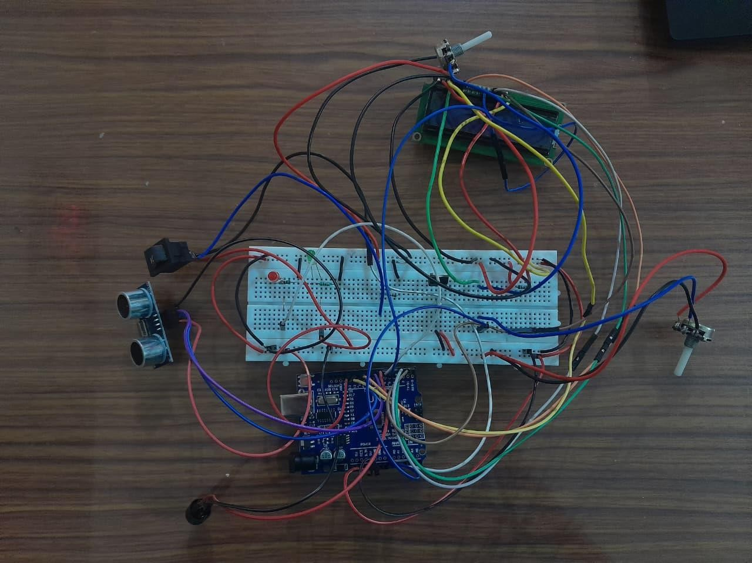
Fig 4.1: Circuit connections

CHAPTER 5
HARDWARE AND SOFTWARE SPECIFICATION

Hardware Specification:

Component | Description / Role
Arduino Uno | Main microcontroller used for sensing inputs, processing logic and controlling outputs.
HC‑SR04 Ultrasonic Sensor | Measures distance to obstacles in front of the vehicle to judge horn necessity.
16×2 LCD Display | Shows system status messages such as “SAFE HONK” and “UNNECESSARY HONK”.
Micro SD Card Module | Stores horn‑use events and misuse records in a text  file for later analysis.
Piezo Buzzer | Provides audible warning to the driver when unnecessary honking is detected.
LEDs (Red / Green) | Give visual indication of horn status and misuse alerts.
Push Button / Horn Sense Switch | Acts as horn input in the prototype and simulates  horn activation.
Resistors and Capacitors | Used for current limiting, pull‑down, and basic  signal conditioning.
Connecting Wires and Breadboard | Provide physical connections and prototyping platform for the circuit.
5 V Regulator / Vehicle Supply Adapter | Steps down vehicle battery voltage to 5 V for safe operation of electronics.
Table 5.1: Hardware specification

Software Specification:

Software / Tool | Description / Purpose
Arduino IDE | Used for writing, compiling and uploading the control program to the Arduino Uno.
Embedded C | Programming language used to implement sensing, decision logic, display and logging.
Serial Monitor | Helps in debugging and viewing real‑time data  during testing of the system.

Table 5.2: Software specification

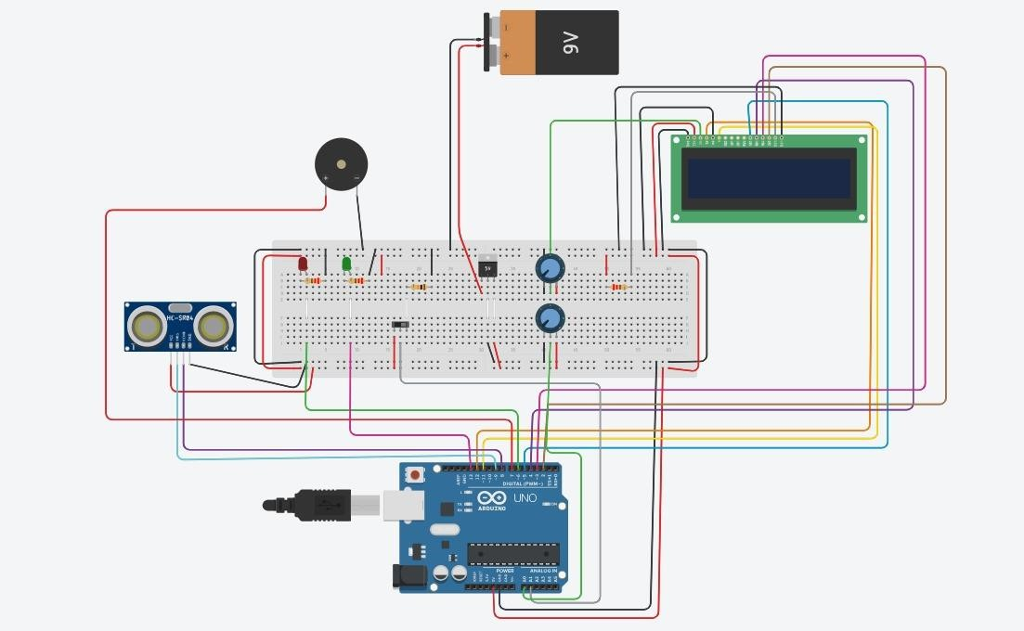
Figure 5.1: Simulation Of the Project

CHAPTER 6 ADVANTAGES AND APPLICATIONS

Advantages
    - Reduces unnecessary honking: By warning drivers whenever they use the horn without a nearby obstacle, the system helps builld better driving habits and directly cuts down on avoidable noise pollution.
    - Provides clear driiver feedback: This device gives pretty good feedback to drivers right away. Like the buzzer goes off and the LEDs light up, plus those messages on the LCD screen. It makes it simple to see when someone has misused the horn without having to learn anything extra or get special training. I think that is one of the nicer parts about it.
    - Creates a permannent record: Building it does not cost much either. You just need basic stuff, an Arduino board, that ultrasonic sensor to detect things, and the LCD display. Students can put it together pretty easily and even tweak it if they want. It feels affordable, especially for projects like this in school.
    - Low cost and easy to build: Then there is the way it keeps a record of everything. All the events get saved on a micro-SD card, so you have proof over time if the horn was misused. That could help with checking yourself or monitoring a whole fleet of vehicles. Or even talking to authorities if it comes to that. Not sure how often that last part would happen, but it seems useful anyway.
    - Modular and scalable: The design is kind of modular too, which I like. You can add more things later, such as Bluetooth for connecting wirelessly or GPS to set up silence zones based on location. Even mobile apps if you want to expand it. None of that messes with the main setup, so it scales without too much hassle. Some people might see adding those as overkill, but others could find it handy for bigger uses.

Applications
    - Private vehicles: Private cars seem like a good place to start with this system. Owners could just install it themselves as a way to keep their honking in check and watch their own driving habits a bit closer. I think that makes sense for personal use, you know, to build some self control without needing anyone else involved.

    - Taxis and cab fleets: For taxis and those cab fleets, its different because operators would look at the logged data to spot when drivers are misusing the horn too much. That could help improve the overall service quality and make sure they follow city rules better. Fleet managers might find it handy for keeping things running smoothly.
    - School and hospital vehicles: Then there are school buses or hospital ambulances operating in areas where noise really matters, like near sensitive zones. The system could ensure horns only get used when they absolutely have to be, which feels important to avoid unnecessary disturbances.
    - Traffic‑safety education: In traffic safety education, engineering colleges or training institutes might pick up this project as a teaching tool. It shows how embedded systems can tackle real social issues, like too much honking in cities. I am not totally sure how they would set it up in classes, but it seems like a practical example.
    - Smart‑city pilot projects: City authorities could integrate these in vehicle units into bigger noise monitoring efforts for smart city pilots. They would gather actual data from the roads to design noise control policies that work better. That part gets a bit messy when thinking about how it all connects, but the idea is there for realistic improvements.

CHAPTER 7 RESULTS AND DISCUSSIONS
The proposed horn misuse detection system was implemented on an Arduino Uno with the HC‑SR04 ultrasonic sensor, 16×2 LCD, buzzer, LEDs and micro-SD card module. After assembling the hardware, several test scenarios were carried out to verify distance measurement, horn detection, classification of events and logging performance.

Experimental Setup
The prototype was mounted on a small test rig, with the ultrasonic sensor facing forward and the horn push button accessible to the user. A cardboard obstale was used to simulate a vehicle at different distances (for example 50 cm, 1 m and 3 m). The threshold distance for “necessary honk” was set to 200 cm in the Arduino program. For each test, the button was pressed with and without an object in front of the sensor, and the behaviour of buzzer, LEDs, LCD messages and SD logging was observed.

Observed Output
When an obstacle was placed within 2 m and the horn button was pressed, the LCD displayed a message such as “SAFE HONK”, the green LED turned on briefly and no warning buzzer sounded. The SD card log contaimed an entry marked as a necessary event with the corresponding distance value. When the horn was pressed with no obstacle or with the object moved beyond 2 m, the LCD showed “UNNECESSARY HONK”, the red LED blinked and the buzzer produced a short alert tone. In thesee cases, the SD card file stored the event as misuse along with the measured distance, confirming that the decision logic worked as intended.

Discussion
The results indicate that a simple distance‑based rule is effective for distinguishing between justified and unjustified horn use in typical low‑speed conditions. Instant feedback through audio and visual indicators makes drivers immediately aware of misuse, which can help modify behaviour over time. At the same time, storing every event provides objective data for analysis, which is not available im conventional systems. Limitations include dependence on proper sensor mountiing and the fact that the system only looks straight ahead; side or rear situations are not considered. In future work, multiple sensors, GPS‑based silence‑zone awareness or mobile connectivity could be added to further enhance coverage and intelligence of the system.

Limitations:
    - Single‑direction sensing: The ultrasonic sensor monitors only the area directly in front of the vehicle. Situations where a horn is needed for side or rear obstacles are not considered.
    - Fixed distance threshold: One constant distance limit is used for all roads and speeds. At higher speeds or in dense traffic, this fixeed threshold may not perfectly represent “necessary” and “unnecessary” honks.

    - Sensor and environment dependence: Ultrasonic readings can be affected by surface angle, rain, dust, or very soft materials, which may cause small errors or missed obstacles.
    - No legal integration: The system logs misuse locally but is not directly connected to official enforcement systems, so penallties or warnings still depend on manual review.
    - Driver adaptation: Frequent alerts may be ignored over time if the driver does not take
the system seriously, reducing the long‑term behavioural impact.

7.6 Mitigation Measures
- Multiple sensors: Add additional ultrasonic sensors or side sensors to cover a wider
field of view so that more real‑world horn situations are captured accurately.
- Adaptive thresholds: Use different distance limits based on speed (from GPS or vehicle data) or traffic mode; for examplle, a smaller threshold in slow traffic and larger one at higher speeds.
- Signal filtering and calibration: Apply softwaare averaging and periodic calibration tests to reject noisy readings and ensure stable distance measurement across different conditions.
- Data review and feedback: Expport SD‑card logs to a simple analysis tool that shows monthly or weekly misuse counts, which can be discussed with drivers or used for internal penalties in fleets.
- User‑friendly alert design: Keep alerts short and non‑irritating and provide a clear LCD message so that drivers understand whyy they are being warned, encouraging them to adjust their behaviour rather than ignore the system.
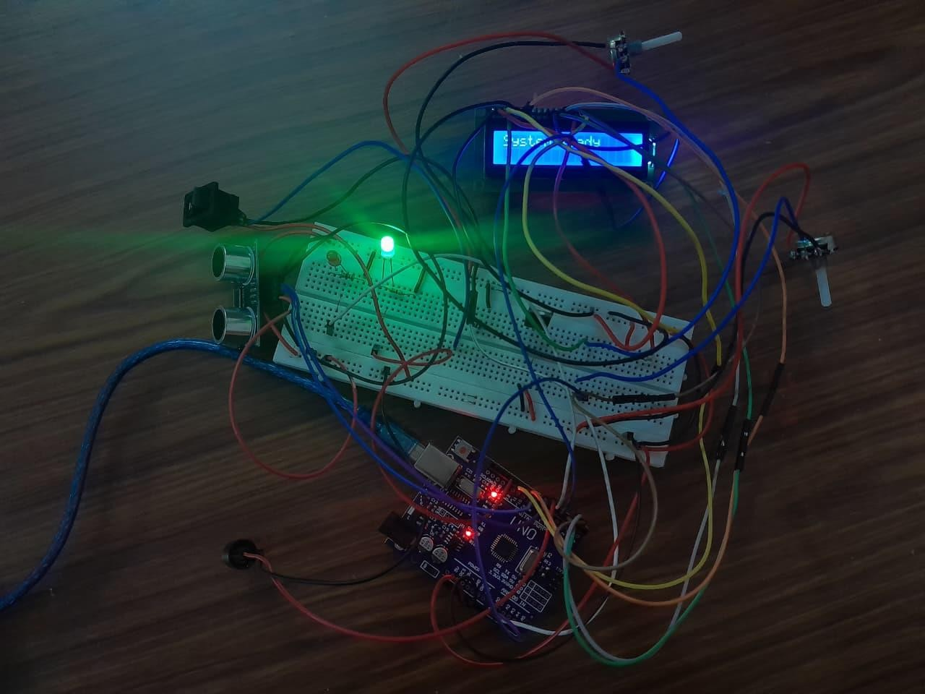
Fig 7.1: When the system is ready

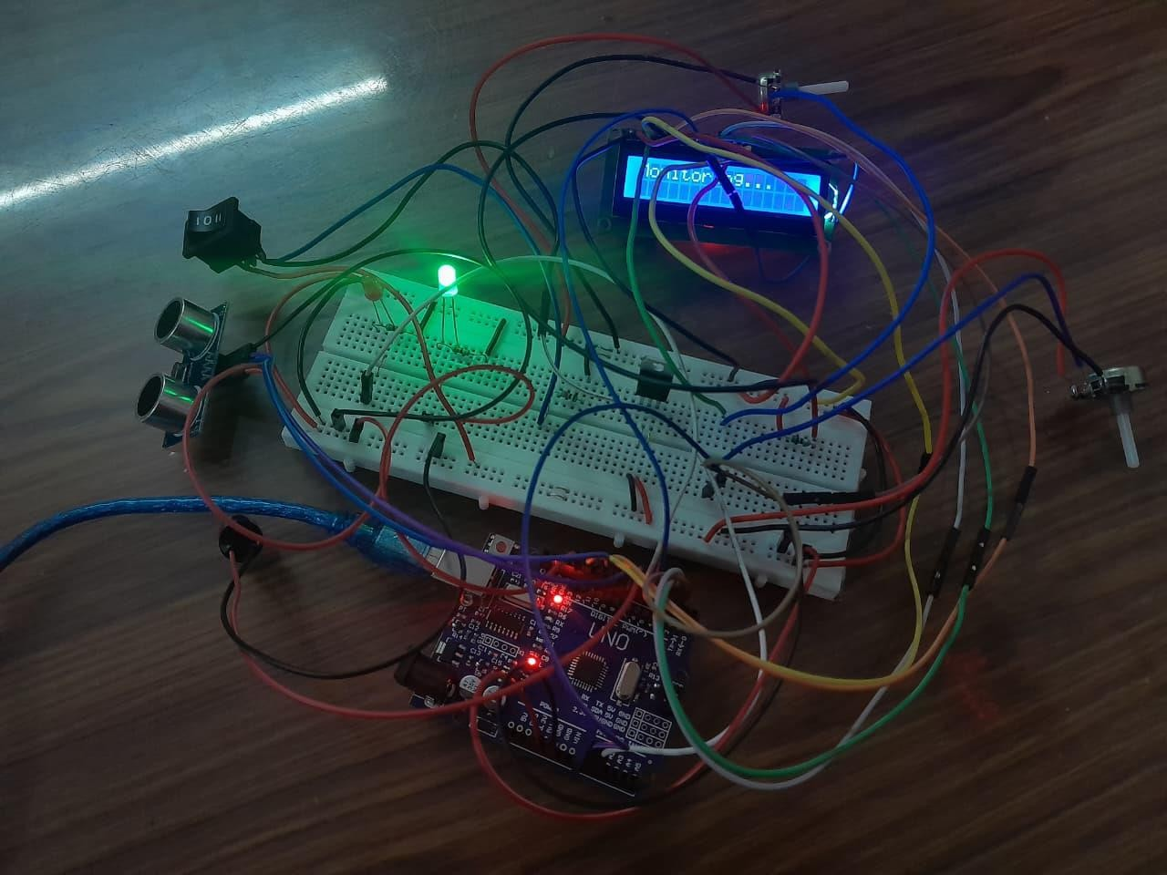
Fig 7.2: When system is monitoring
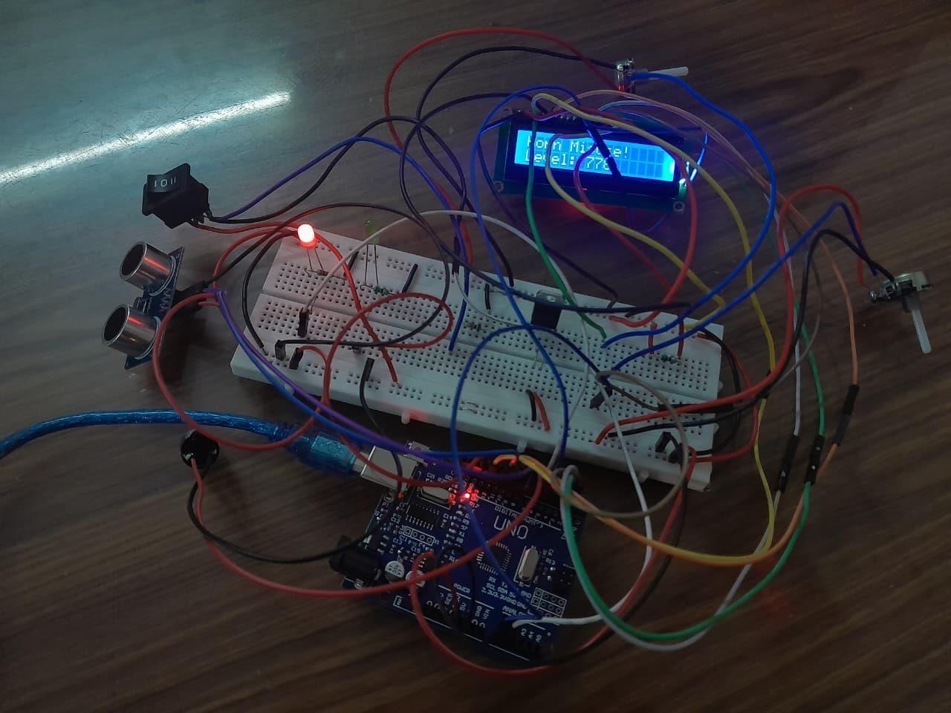
Fig 7.3: System is Misused

CHAPTER 8
FUTURE SCOPE AND CONCLUSION

Future Scope

    - Integration of GPS and geo‑fencing so that the system automatically applies stricter
rules inside silence zones like schools, hospitals and residential layouts.
    - Addition of Bluetooth or Wi‑Fii connectivity to send horn‑misuse logs to a mobile app
or cloud dashboard for live monitoring by fleet owners or authorities.
    - Use of multiplle distance sensors or cameras to cover side and rear zones, improving judgement of horn necessity in complex traffic situations.
    - Implemntation of adaptive algorithms that adjust distance thresholds based on vehicle speed, time of day or traffic density for more acurate decisions.
    - Combination with otther in‑vehicle moduls, such as speed monitoring or driver‑drowsiness detection, to form a complete driver‑behaviiour assessment system.
    - Miniaturization of the hardware into a single custom PCB for easier installation and better reliability in real vehicles.

Conclusion
    - The project successfuly demonstrates a low‑cost, Arduino‑based system that can
distinguish between necessary and unnecessary horn usage using distance sensing.
    - Real‑time feedback through buzer, LEDs and LCD helps drivers immediately recognize
horn misuse and encourages more responsible driving habits.
    - Logging each horn event on a micro-SD card creates a permanent record of driver behaviour, which can support analsis, education and internal enforcement.
    - Experimental testing shows that the proposed method works reliably under typical conditions, though performance stilll depends on sensor placement and environment.
    - Overall, the system offers a practical prtotype for reducing noise pollution from vehicles and can be expanded with advanced sensing and connectivity for future smart‑city applications.

REFERENCE
- Sadhana A., Roopali S., Sushma S. Sorde, Vijaylaxmi S., and Sara Anjum, “A Novel Approach to Reduce the Noise Pollution Caused by Honking of Vehicles,” International
Research Journal of Engineering and Technology (IRJET), e‑ISSN 2395‑0056, vol. 10, no. 6,
pp. 121-126, Jun. 2023. Available at: https://www.irjet.net/archives/V10/i6/IRJET- V10I6120.pdf
- P. Dey, P. Majumdar, and S. Das, “Design of a Smart Real‑time Excessive Honking Control System,” International Journal of Innovative Research in Science, Engineering and Technology, ISSN 2319‑8753, vol. 11, no. 2, pp. 45-51, Feb. 2022. Available at:
https://www.academia.edu/70455325/Design_of_a_Smart_Real_time_Excessive_Honking_C ontrol_System
- R. Shrivastava, N. Madake, and P. Kulkarni, “Smart Horn Control System: A Geo‑Fenced, IoT‑Based Solution for Urban Noise Suppression,” International Journal for Research in Science, Engineering and Technology (IJSRCSEIT), ISSN 2456‑3307, vol. 11, no. 5, pp. 325-333, May 2025. Available at: https://ijsrcseit.com/index.php/home/article/view/CSEIT2511165
- S. Shinde, A. Bhosale, and K. Patil, “Adaptive Honking System for Smart Cities Using IoT,” International Journal for Research in Applied Science and Engineering Technology (IJRASET), ISSN 2321‑9653, vol. 12, no. 4, pp. 1894-1900, Apr. 2024. Available at:
https://www.ijraset.com/research-paper/adaptive-honking-system-for-smart-cities-using-iot
- A. S. Patil and J. Deshmukh, “IoT Based Horn Detection System for Safety Four Wheel Driving,” International Research Journal of Engineering and Technology (IRJET), e‑ISSN 2395‑0056, vol. 5, no. 5, pp. 3542-3546, May 2018. Available at: https://www.irjet.net/archives/V5/i5/IRJET-V5I5450.pdf
- Ministry of Environment, Forest and Climate Change, Government of India, “The Noise Pollution (Regulation and Control) Rules, 2000,” Central Pollution Control Board (CPCB), New Delhi, 2000. Available at: https://cpcb.nic.in/noise-pollution/

APPENDIX

<Source Code>
