Build

* NuGet package (2.8.1 or above) or visual studio update (3 or above) needed

How to Add a Column

* BitcoinDataLayerAdoNet/Schema/Tables.sql
  + This is modifying the database scheme.
  + In the table, in which you would like to add a column, add a column name with a type.
* Recompile & Run ( /DropDb option)
  + This is for applying new database scheme with the new column added.
  + By running, it will apply the new "Table.sql" database scheme that you changed to the database.
* DataSets/[Table_where_new_column_added].xsd -> configure
  + Go to the table you modified.
  + Right click the name of the table.
  + Go to Configure…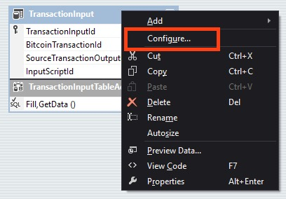
  + Select the database you are using. Next
  + Select "Use SQL statements". Next
  + Click "Query Builder…"
  + Tick the column you added. OK
  + Next, Next, Finish.
  + You have to be able to see the new column added on .xsd file.
* BitcoinDatabaseGenerator/SourceDataPipeline.cs
  + This is where actual data is transferred to the database.
  + The column you want to add should be coded here.
  + You might find useful to look at the given APIs to add a useful column in the db.  
    (~\BitcoinDatabaseGenerator-master\Sources\packages\BitcoinBlockchain.1.2.0.0\lib\net45\BitcoinBlockchain.XML)
* BitcoinDataLayerAdoNet/Data/[Table_where_new_column_added].cs
  + Add the new column to the constructor and add the method.