PES UNIVERSITY, BANGALORE
Department of Computer Science and Engineering
Jackfruit Phase-1
Software Requirements Specification
for
ChatSphere – Real-Time Direct & Group Messaging Platform
Version 1.0 approved
Prepared by Team 16 – Satvik L, Prithvi Aithal, Sourish Ganesh
PES University, Bangalore – Dept. of CSE, Section G
Team Members and SRNs
Sl. | Student Name | SRN | USN
1 | Satvik L | PES1UG24CS423 | PES1202400676
2 | Prithvi Aithal | PES1UG24CS909 | PES1202400699
3 | Sourish Ganesh | PES1UG25CS847 | PES1202503600
September 2026

Revision History
Name | Date | Reason For Changes | Version
Team 16 | Sep 2026 | Initial SRS baseline for Requirements submission | 1.0

Table of Contents
Right-click here and choose “Update Field” (or press F9) to generate the table of contents.

1. Introduction

1.1 Purpose
This document specifies the software requirements for Version 1.0 of ChatSphere, a real-time direct and group messaging web application built as the Level 3 Software Engineering mini-project (UE24CS341A) by Team 16. It covers the complete set of functional, non-functional and security requirements for the initial release and is the baseline against which the system's design, implementation and testing will be validated.

1.2 Intended Audience and Reading Suggestions
This SRS is intended for: the development team (Satvik L, Prithvi Aithal, Sourish Ganesh), who use it as the contract for design and implementation; the course faculty/evaluators, who use it to assess requirement quality and traceability; and the team members acting as testers, who derive test cases directly from Sections 5 and 6. Readers unfamiliar with the domain should first read Section 2 (Overall Description) before the detailed feature requirements in Section 5.

1.3 Product Scope
ChatSphere provides registered users with low-latency, one-to-one and group (room-based) text messaging over a persistent WebSocket connection, including real-time presence, typing indicators, delivery/read status and persisted, searchable message history. Its purpose is both to give a small community (e.g. a project team or campus group) a self-hostable communication tool, and to demonstrate the team's understanding of socket programming, event-driven architecture and the full software development life cycle.

1.4 References
- PES University, Dept. of CSE – “Jackfruit – Software Engineering Project Guidelines 2026” (UE24CS341A).
- PES University – “Software Engineering – Level 3 Student Submission Guide & Complete Exemplar” (Coffee Kiosk).
- Karl Wiegers – IEEE-style Software Requirements Specification template (structure followed by this document).
- Socket.IO official documentation – https://socket.io/docs/
- Express.js official documentation – https://expressjs.com/

2. Overall Description

2.1 Product Perspective
ChatSphere is a new, self-contained, three-tier web application; it is not a follow-on to an existing system. It consists of a React single-page-application client, a Node.js/Express + Socket.IO server that exposes both REST endpoints (for auth and history retrieval) and a WebSocket gateway (for real-time events), and a persistence tier composed of MongoDB (durable data – users, rooms, messages) and Redis (ephemeral presence/session state). The high-level flow is: Client ↔ REST API / WebSocket Gateway ↔ Service Layer ↔ MongoDB / Redis.

2.2 Product Functions
- User registration and secure (JWT-based) login.
- Real-time one-to-one direct messaging.
- Room creation, joining and leaving for group chat.
- Real-time group messaging within a room.
- Online/offline presence broadcasting.
- Real-time typing indicators.
- Persistent, paginated message history retrieval.
- Room administration – promoting or removing a member.
- Message delivery/read status tracking.

2.3 User Classes and Characteristics
User Class | Privileges | Characteristics
Registered User | Register/login; send & receive direct and group messages; create/join/leave rooms; view own conversation history; view presence | Non-technical, expects near-instant delivery; frequent short sessions from browser
Room Admin | All Registered User privileges, plus: promote another member to admin, remove a member from a room they administer | Same technical profile as Registered User; privilege is scoped only to rooms they created or were promoted in

2.4 Operating Environment
- Client: any evergreen desktop browser with WebSocket support (Chrome, Firefox, Edge).
- Server: Node.js 20 LTS runtime on Linux, packaged as a Docker container.
- Database: MongoDB 6+; Redis 7+ for presence/session pub-sub.
- Network: HTTPS for REST calls, WSS (WebSocket Secure) for the real-time channel.

2.5 Design and Implementation Constraints
- Must use WebSocket-based real-time communication (Socket.IO) per the course assignment – polling-only designs are not acceptable.
- Agile methodology is mandatory; work must be tracked as user stories/sprints on GitHub Projects (or Jira).
- Git/GitHub is the system of record for version control; individual Git commits are checked as evidence of contribution.
- A CI/CD pipeline, code reviews and security validation are mandatory course deliverables for later phases.
- Team of exactly 3 members; each member must own one complete functional feature end-to-end (Section 9 of the Synopsis).

2.6 Assumptions and Dependencies
- Users have a reasonably stable internet connection; brief disconnects (under ~60s) are expected to resume without message loss, but ChatSphere does not guarantee delivery over extended offline periods beyond queued-message retry.
- The project depends on third-party open-source libraries (Express, Socket.IO, Mongoose, JWT, bcrypt) remaining available and API-stable for the duration of the project.
- This phase targets a single-server deployment; multi-instance/horizontal scaling of the Socket.IO layer is out of scope (see Synopsis Section 7).

3. External Interface Requirements

3.1 User Interfaces
- Registration / Login screen – username, email, password fields, client-side validation and error messaging.
- Chat Dashboard – left panel listing direct conversations and joined rooms with unread counts and presence dots; right panel showing the active conversation.
- Message Composer – text input with a live typing indicator broadcast to the other participant(s), and per-message delivery/read ticks.
- Room Panel – member list with roles, and (for a Room Admin) controls to promote or remove a member.
- Search – a search box to find existing users or rooms to start a new conversation.

3.2 Software Interfaces
- REST API (JSON over HTTPS) – used for registration, login, and paginated history retrieval; implemented with Express.js.
- WebSocket API (Socket.IO over WSS) – used for all real-time events: message send/receive, typing, presence, room join/leave, room-admin actions.
- MongoDB via the Mongoose ODM – durable storage for User, Room, RoomMembership and Message documents.
- Redis – pub/sub channel for presence propagation and Socket.IO adapter for cross-instance event broadcast (forward-compatibility for future scaling).

3.3 Communications Interfaces
- All REST traffic is served over HTTPS; all real-time traffic is served over WSS (WebSocket Secure).
- Messages exchanged between client and server are JSON-encoded.
- Authentication uses JSON Web Tokens (JWT) sent as a Bearer token on REST calls and as an auth payload during the Socket.IO handshake.

4. Analysis Models
The use case diagram below identifies the two actors (Registered User and the more privileged Room Admin) and the major use cases they participate in.
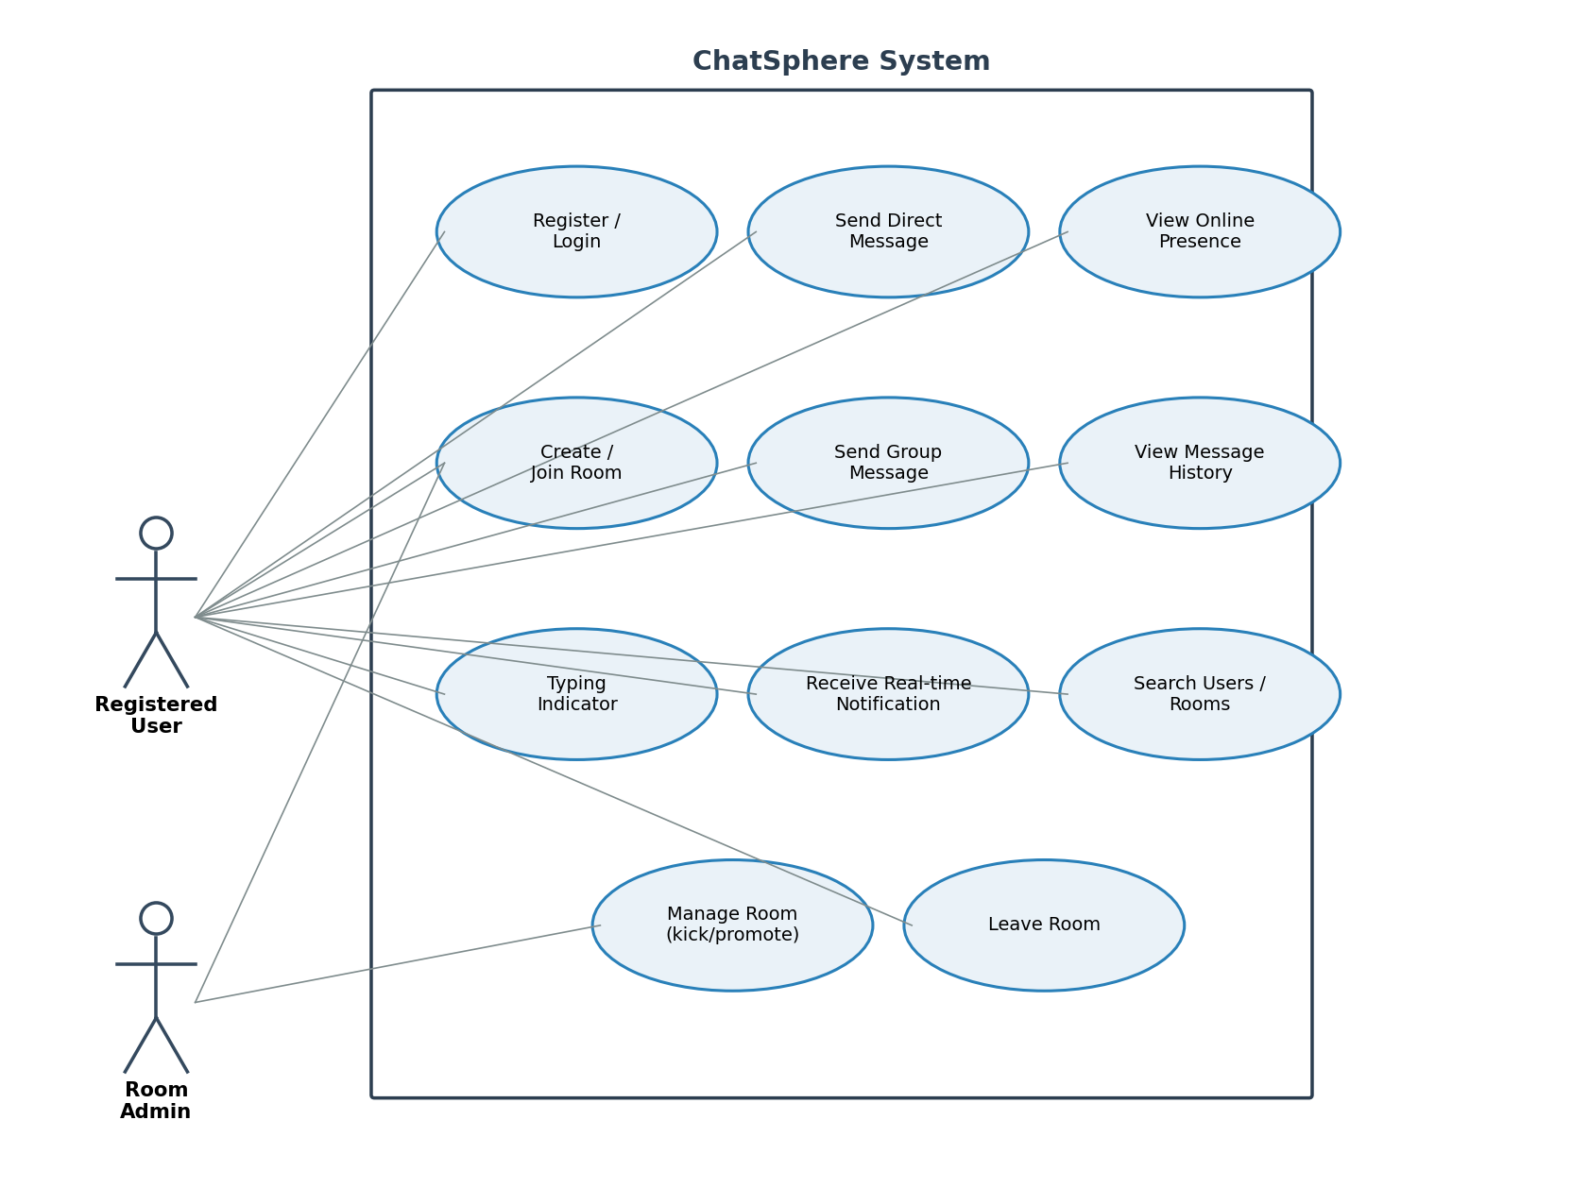
Figure 1 – Use Case Diagram for ChatSphere
The entity-relationship model below shows the core persisted entities – User, Room, RoomMembership (the join entity carrying each member's role) and Message – plus the ephemeral Session entity used to map a live socket connection back to a user.
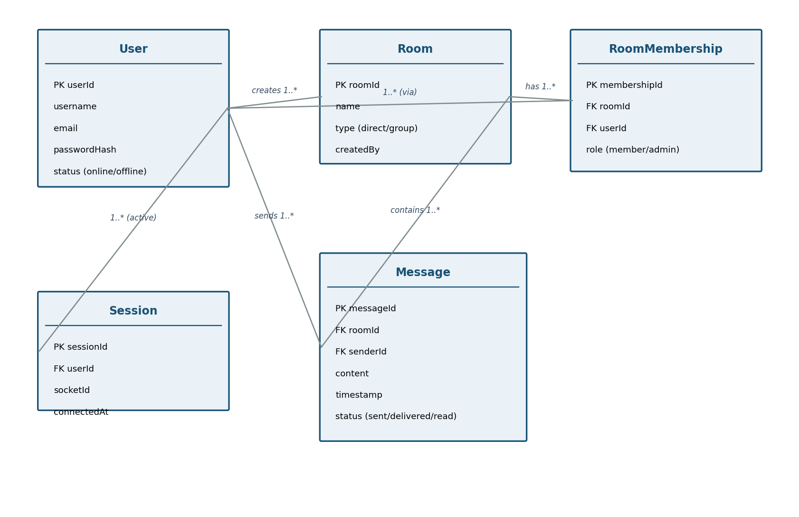
Figure 2 – Entity-Relationship Diagram for ChatSphere's data model

Use Cases
Use Case ID | Use Case | Primary Actor | Precondition | Outcome
UC-01 | Register / Login | Registered User | Application reachable | Authenticated session (JWT) issued
UC-02 | Send Direct Message | Registered User | Logged in | Message delivered (or queued if recipient offline)
UC-03 | Create / Join Room | Registered User | Logged in | Room membership created
UC-04 | Send Group Message | Registered User | Room member | Message broadcast to all online room members
UC-05 | View Message History | Registered User | Conversation/room exists | Paginated history returned
UC-06 | Manage Room | Room Admin | Admin authenticated | Member role updated / member removed
UC-07 | View Presence | Registered User | Logged in | Online/offline status of contacts shown

5. System Features
Requirements are organized by system feature. Each feature lists a description/priority, its stimulus/response behaviour, and its detailed, uniquely-tagged functional requirements. Each requirement is concise, unambiguous, verifiable and necessary, per the course's requirement-writing rule.

5.1 Authentication & Presence Management

Description and Priority
Lets a person register a ChatSphere account, log in to obtain a session, and lets the system reflect that user's connection state to others in real time. Priority: High – every other feature depends on it. Owned by Sourish Ganesh.

Stimulus/Response Sequences
- User submits the registration form → system creates the account or returns a validation error.
- User submits valid credentials → system returns a JWT and the client opens an authenticated socket connection.
- Client's socket connects/disconnects → system broadcasts the user's presence change to relevant contacts/rooms.

Functional Requirements
ID | Requirement | Priority | Verification
FR-001 | The system shall allow a new user to register using a unique username and a unique email address. | High | Functional test
FR-002 | The system shall hash user passwords (bcrypt) before storage; plaintext passwords shall never be persisted. | High | Code/config review
FR-003 | The system shall allow a registered user to log in with valid credentials and receive a signed JWT session token. | High | Functional test
FR-004 | The system shall authenticate the WebSocket handshake using the JWT issued at login and reject the connection if the token is missing, expired or invalid. | High | Security test
FR-005 | The system shall broadcast a user's online status to their direct contacts and room members immediately upon socket connection. | High | Integration test
FR-006 | The system shall broadcast a user's offline status to their direct contacts and room members within 5 seconds of socket disconnection. | Medium | Integration test

5.2 Direct Messaging

Description and Priority
Lets any two registered users exchange private, real-time text messages with typing and delivery-status feedback. Priority: High. Owned by Prithvi Aithal.

Stimulus/Response Sequences
- User selects a contact and sends a message → system delivers it instantly if the recipient is online, otherwise queues it.
- User starts typing in an open conversation → system notifies the other participant in real time; stops after a short idle period.
- Recipient's client acknowledges a message → system updates that message's status for the sender.

Functional Requirements
ID | Requirement | Priority | Verification
FR-007 | The system shall allow an authenticated user to send a direct text message to another registered user. | High | Functional test
FR-008 | The system shall deliver a direct message to the recipient's client in real time over WebSocket when the recipient is online. | High | Integration test
FR-009 | The system shall persist a direct message addressed to an offline recipient and deliver it automatically the next time that recipient connects. | High | Integration test
FR-010 | The system shall emit a typing-indicator event to the other participant while the sender is actively composing a message, and clear it after a short idle timeout. | Medium | Functional test
FR-011 | The system shall track and expose each direct message's status as one of: sent, delivered, or read. | High | Unit + integration test

5.3 Group / Room Chat

Description and Priority
Lets users organize into named rooms and exchange group messages broadcast to every connected member. Priority: High. Owned by Satvik L.

Stimulus/Response Sequences
- User requests to create a room with a unique name → system creates the room and makes the creator its first admin.
- User requests to join/leave a room → system updates room membership and notifies existing members.
- A room member sends a message → system broadcasts it to every other currently-connected member of that room.

Functional Requirements
ID | Requirement | Priority | Verification
FR-012 | The system shall allow an authenticated user to create a chat room with a unique room name, becoming that room's first admin. | High | Functional test
FR-013 | The system shall allow an authenticated user to join an existing room or leave a room they currently belong to. | High | Functional test
FR-014 | The system shall broadcast a group message in real time to every member of that room who is currently connected. | High | Integration test
FR-015 | The system shall allow only current members of a room to view or send messages within that room. | High | Negative/security test
FR-016 | The system shall require every room to retain at least one admin at all times, rejecting an action that would leave it with none. | Medium | Negative test

5.4 Message History & Status Tracking

Description and Priority
Persists every message and exposes it back to clients as searchable, paginated history so conversations survive reconnects and logouts. Priority: High/Medium. Jointly supported by Prithvi Aithal (direct) and Satvik L (group).

Functional Requirements
ID | Requirement | Priority | Verification
FR-017 | The system shall persist every direct and group message with its sender, timestamp, and conversation/room reference. | High | Integration test
FR-018 | The system shall allow a user to retrieve the message history of a conversation or room in reverse-chronological, paginated order. | High | Functional test

5.5 Room Administration

Description and Priority
Gives a room's admin(s) control over who belongs to the room and who else holds admin rights. Priority: Medium. Owned by Satvik L.

Functional Requirements
ID | Requirement | Priority | Verification
FR-019 | The system shall allow a room admin to promote another current member of that room to admin. | Medium | Functional test
FR-020 | The system shall allow a room admin to remove a member from that room. | Medium | Functional test
FR-021 | The system shall reject a room-administration action attempted by a member who does not hold the admin role for that room. | High | Authorization test

6. Other Nonfunctional Requirements

6.1 Performance Requirements
ID | Category | Measurable Requirement | Verification
NFR-001 | Performance | 95% of chat messages shall be delivered to an online recipient within 300 ms under the defined test load. | Latency/load test
NFR-002 | Performance | 95% of REST API responses (login, history) shall complete within 1 second under the defined test load. | Performance test

6.2 Safety Requirements
ChatSphere is a text-communication tool with no physical actuation, so conventional safety-of-life requirements do not apply. The only safety-adjacent concern is data safety: the system shall persist a message to the database before acknowledging it as ‘sent’ to the sender, so that a server crash immediately after send cannot silently lose an already-acknowledged message.

6.3 Security Requirements
ID | Security Requirement | Validation Approach
SEC-001 | Passwords shall never be stored in plaintext; only bcrypt password hashes shall be persisted. | Code/configuration review
SEC-002 | Role-based access control shall prevent a non-admin room member from performing room-administration actions. | Authorization tests
SEC-003 | All user-supplied message content shall be sanitized/escaped before storage and before rendering, to prevent stored XSS. | Negative/security tests
SEC-004 | REST endpoints and WebSocket connections shall reject expired or invalid JWTs. | Security test
SEC-005 | The system shall rate-limit message-send events per connection to mitigate spam/flood abuse. | Load/security test
SEC-006 | Security-relevant events (failed login attempts, unauthorized room-admin attempts) shall be logged. | System test

6.4 Software Quality Attributes
- Maintainability – business logic is separated into independent, unit-tested services (auth, messaging, room, presence).
- Reliability – a client that reconnects within 60 seconds of a dropped socket resumes without losing any queued message.
- Usability – a new user can register and send their first message within 3 primary screens.
- Testability – core socket event handlers expose a testable interface independent of the live Socket.IO transport, so they can be unit tested with mocked sockets.
- Portability – the server is packaged as a Docker image and configured entirely via environment variables.

6.5 Business Rules
- Only current members of a room may send or read messages in that room.
- Only a room's admin may promote/demote members or remove a member from that room.
- A direct-message conversation exists only between two distinct registered users.
- A password must satisfy a minimum complexity rule (at least 8 characters) before registration succeeds.
- A room must retain at least one admin at all times.
Also include Domain requirements here: message ordering within a single conversation/room must be strictly timestamp-consistent so history always renders in the order messages were actually sent.

7. Other Requirements
- Database: message history is retained indefinitely in this phase; a future release may add user-initiated deletion/retention limits.
- Legal/localization: no legal or localization requirements apply to this academic-project phase; UI text is English-only.
- Reuse: the project reuses open-source libraries (Express, Socket.IO, Mongoose, JWT, bcrypt, Redis client) under their respective permissive (MIT-style) licenses; no proprietary third-party components are used.

8. Validation Specification – Initial Planning
At the Requirements stage, this validation specification is planning-focused: it explains how each category of requirement above will eventually be validated, including planned security/penetration-style testing. It is not the final test report — concrete pass/fail results and the completed Requirement Traceability Matrix (Appendix C) will be produced once Deliverables 3 and 4 (Design, Implementation & Testing) are complete.
Requirement Category | Planned Validation Approach | Example | Timing / Owner
Functional | Black-box functional tests derived from each FR in Section 5 | Verify FR-008: message delivered in real time when recipient is online | Sprints 2–4, feature owner
Security | Authentication/authorization tests and negative/security tests derived from Section 6.3 | Verify SEC-002: non-admin member is rejected from room-admin actions | Sprint 5, Sourish Ganesh
Performance | Load/latency testing against the NFR-001/NFR-002 targets | Confirm 95% message delivery within 300 ms under defined concurrent load | Sprint 5, all members
Usability | Task-based walkthrough by a first-time user | New user registers and sends a first message within 3 primary screens | Sprint 4, all members
Reliability | Failure/retry and reconnect scenario testing | Client reconnecting within 60 s resumes without losing a queued message | Sprints 4–5, all members
Unit | Automated unit tests with coverage measurement per module (auth, messaging, room, presence) | Message status transition logic (sent → delivered → read) | Sprints 2–5, all members

Planned penetration-style checks: manual attempts to call room-admin REST/WebSocket actions with a non-admin JWT, an expired JWT and a tampered JWT, plus a check that message content is escaped before storage/render to rule out stored XSS. Results will be recorded in the System Validation Report at Deliverable 5.

9. Project Plan
The project follows an Agile (Scrum-style), sprint-based lifecycle across six two-week sprints, chosen because the feature set (auth, direct messaging, room chat, presence, admin) decomposes naturally into independently demoable increments that map to Section 10 of the Synopsis. Work is tracked as user stories/tasks on GitHub Projects (Jira-equivalent), with Git/GitHub commit history checked as evidence of individual contribution.

9.1 Work Breakdown Structure (WBS)
Work Package | Tasks | Owner | Effort (person-days) | Output
WP1 | Requirements gathering, use cases, SRS baseline | All | 4 | SRS
WP2 | High-level architecture + UML (use case, class, sequence, component) | Satvik L / Sourish Ganesh | 4 | Architecture / Design doc
WP3 | Authentication & Presence module | Sourish Ganesh | 6 | Working feature
WP4 | Direct Messaging module | Prithvi Aithal | 6 | Working feature
WP5 | Group / Room Chat module | Satvik L | 7 | Working feature
WP6 | Message history, status tracking, room administration | Prithvi Aithal / Satvik L | 6 | Working feature
WP7 | Testing + CI/CD + security validation | All | 6 | Test / validation evidence
WP8 | Final system validation + consolidated report | All | 4 | Final report

Total estimated effort: 43 person-days (~14 person-days per member) across a 12-week, six-sprint schedule.

9.2 Schedule (Sprint / Gantt Summary)
The table below is the text-form schedule; the team maintains the visual Gantt chart / burndown as a GitHub Projects board (screenshot attached as evidence in Deliverable 4).
Sprint | Weeks | Work Packages Active
Sprint 1 | Weeks 1–2 | WP1 (complete); WP2 (start)
Sprint 2 | Weeks 3–4 | WP2 (complete); WP3 (start)
Sprint 3 | Weeks 5–6 | WP3 (complete); WP4
Sprint 4 | Weeks 7–8 | WP5 (start); WP6 (start)
Sprint 5 | Weeks 9–10 | WP5, WP6 (complete); WP7
Sprint 6 | Weeks 11–12 | WP7 (complete); WP8

9.3 Tool Stack
Activity | Tool | Evidence to Submit
Version control | Git + GitHub | Repository URL, commit history
Agile planning | GitHub Projects (Jira-equivalent) | Backlog, user stories, sprint board
CI/CD | GitHub Actions | Workflow run screenshot/log
Containerization | Docker | Dockerfile + build/run evidence
Testing | Jest / Supertest (backend) | Test results
API testing | Postman | Collection / results
Static analysis | SonarQube or similar | Analysis report
Diagramming | draw.io / PlantUML | UML diagrams

Appendix A: Glossary
Term | Definition
Socket / WebSocket | A persistent, full-duplex TCP-based connection that lets the server push events to a client without the client polling.
Room | A named group conversation that one or more registered users can join to exchange group messages.
Presence | A user's real-time online/offline connection state, broadcast to their contacts and rooms.
JWT | JSON Web Token – a signed token used to authenticate a user on REST calls and the WebSocket handshake.
Typing Indicator | A transient real-time event shown to a conversation's other participant(s) while a message is being composed.
Read Receipt | A status update shown to a sender indicating the recipient has viewed their message.
RBAC | Role-Based Access Control – restricting an action based on a user's assigned role (e.g. room admin vs member).
ODM | Object-Document Mapper – here, Mongoose, which maps MongoDB documents to JavaScript objects/schemas.

Appendix B: Field Layouts
Derived from the entity-relationship model in Figure 2, the core persisted fields are:

User
Field | Length | Data Type | Description | Mandatory
user_id | 24 | ObjectId/String | Unique user identifier (primary key) | Y
username | 30 | String | Unique display/login handle | Y
email | 100 | String | Unique email address | Y
password_hash | 60 | String | bcrypt hash of the user's password | Y
status | 10 | Enum | online / offline | Y

Room
Field | Length | Data Type | Description | Mandatory
room_id | 24 | ObjectId/String | Unique room identifier (primary key) | Y
name | 50 | String | Unique room name | Y
type | 10 | Enum | direct / group | Y
created_by | 24 | ObjectId/String | FK → User who created the room | Y

RoomMembership
Field | Length | Data Type | Description | Mandatory
membership_id | 24 | ObjectId/String | Unique membership identifier (primary key) | Y
room_id | 24 | ObjectId/String | FK → Room | Y
user_id | 24 | ObjectId/String | FK → User | Y
role | 10 | Enum | member / admin | Y

Message
Field | Length | Data Type | Description | Mandatory
message_id | 24 | ObjectId/String | Unique message identifier (primary key) | Y
room_id | 24 | ObjectId/String | FK → Room (direct conversations use a 2-member room) | Y
sender_id | 24 | ObjectId/String | FK → User who sent the message | Y
content | 2000 | String | Message text body | Y
timestamp | – | DateTime | Server-assigned send time | Y
status | 10 | Enum | sent / delivered / read | Y

Appendix C: Requirement Traceability Matrix
At the Requirements stage this matrix carries requirement IDs only; the Architecture, Design, Code and Test-Case reference columns will be completed once Deliverable 3 (Design) and Deliverable 4 (Implementation & Testing) are finalized, per the course's stage-wise validation-specification flow.
Sl. No | Requirement ID | Brief Description | Architecture Ref | Design Ref | Code File Ref | Test Case ID | System Test Case ID
1 | FR-001 | Unique user registration | TBD | TBD | TBD | TBD | TBD
2 | FR-007 | Send direct message | TBD | TBD | TBD | TBD | TBD
3 | FR-012 | Create room | TBD | TBD | TBD | TBD | TBD
4 | FR-014 | Broadcast group message | TBD | TBD | TBD | TBD | TBD
5 | SEC-002 | Room-admin RBAC | TBD | TBD | TBD | TBD | TBD

