CAPM (Cloud application programming model) Project
This is the Schema.cds
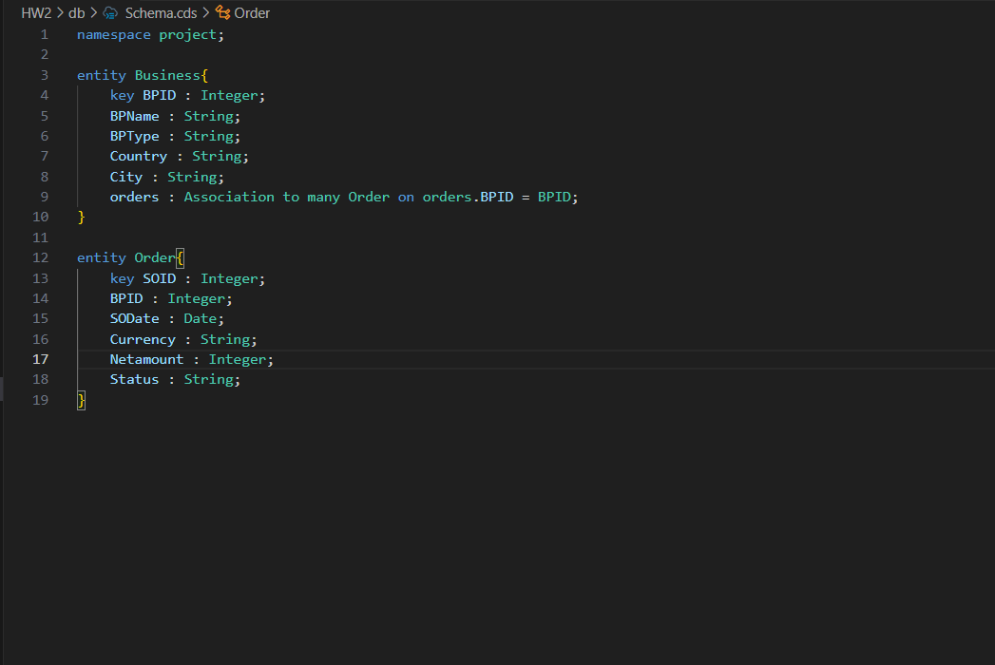
this is the service.cds
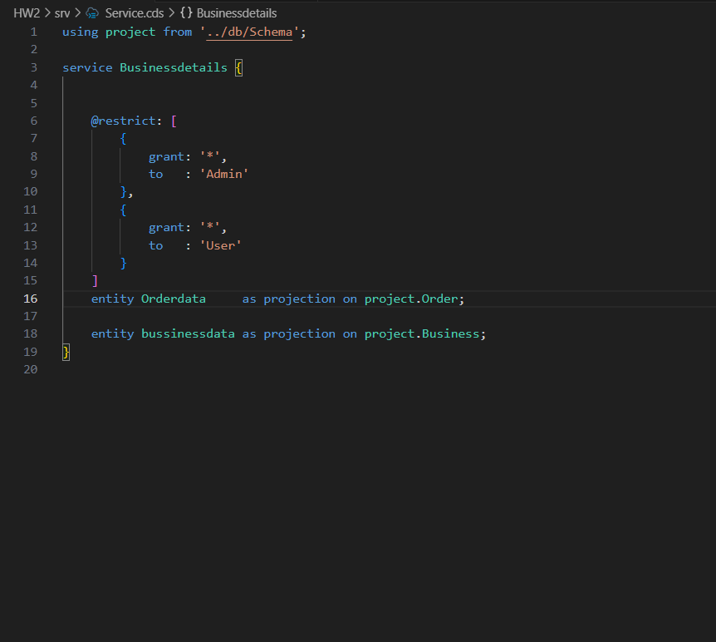
After that add the Fiori list report in the “SAP Fiori generator”
this will generate the annotations.cds file modify it to get the data as needed the output for this is as below

--List Page
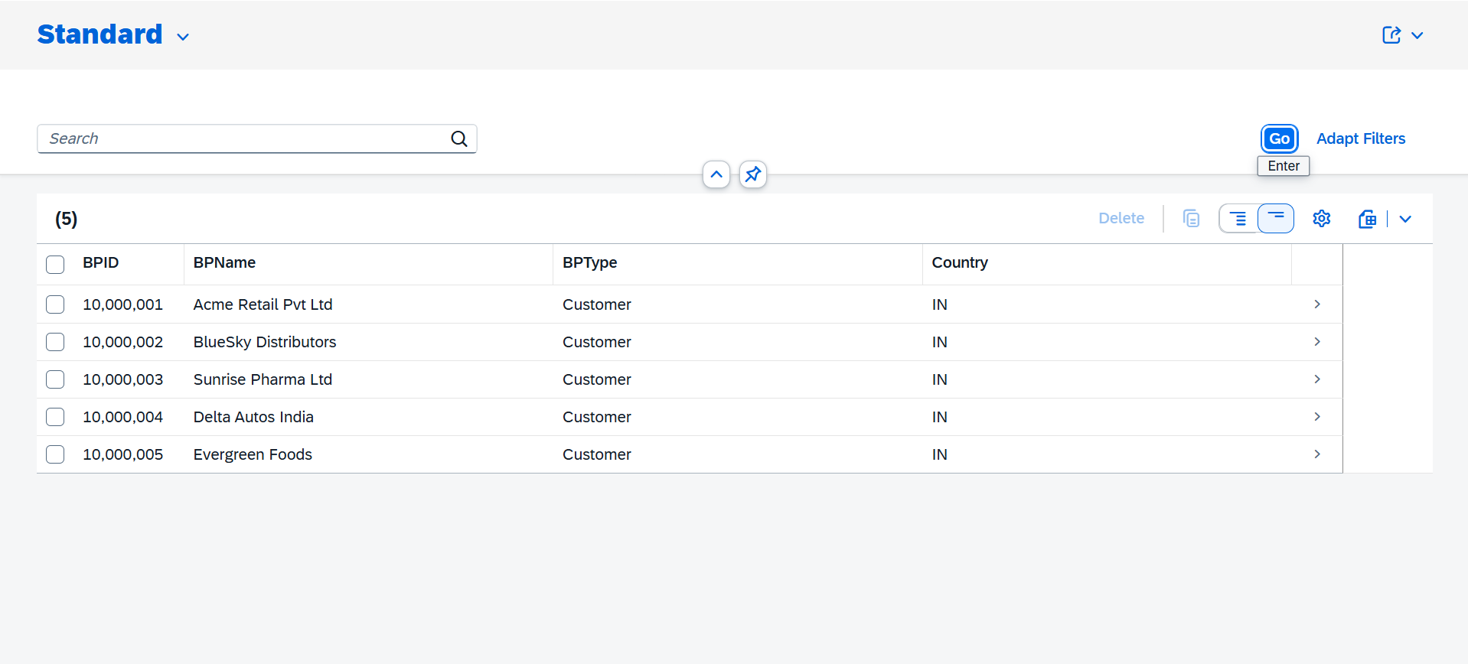

--Object Page
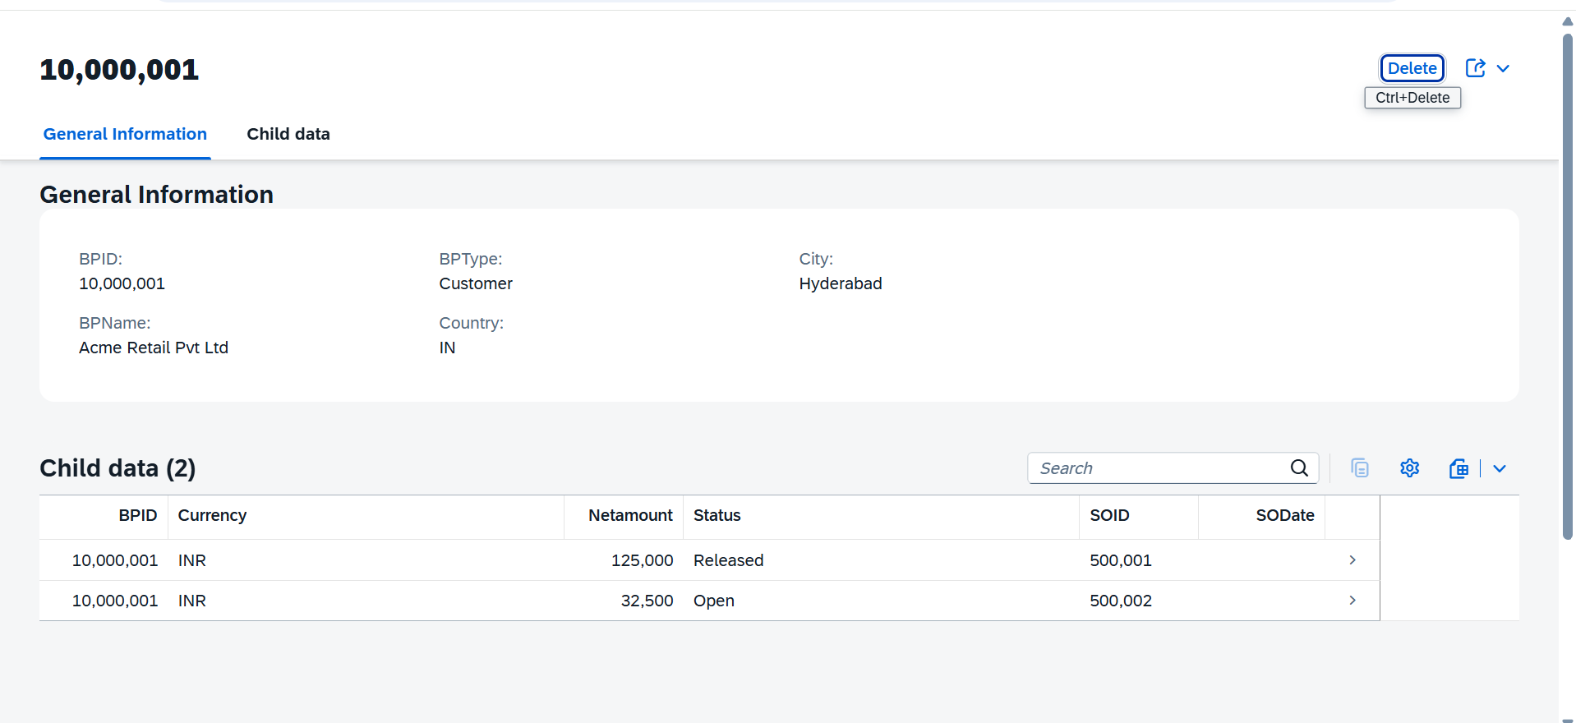

--3rd page
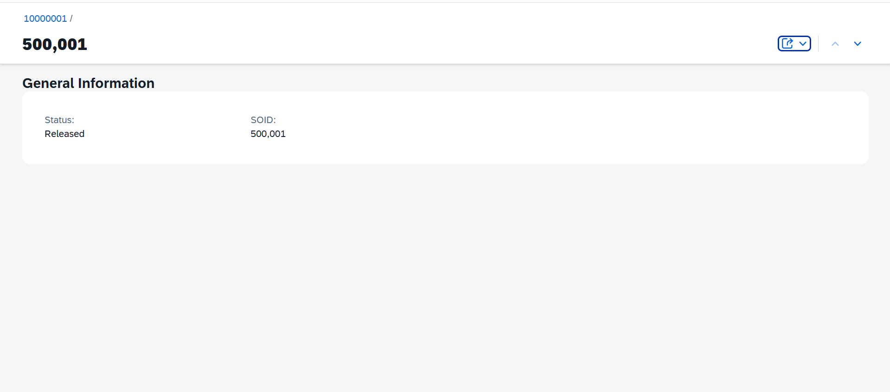

-Deployment Steps
- Cds add hana
- Cds add xusaa
- Cds add approuter
- Cds add mta
- Mta build -p cf
- Cf deploy mta_archives/*.mtar

After following the steps which are mentioned above get the deployed link of your srv to test in the POSTMAN
