MicrobialBiotechnology_Project_Markdown

2024-03-05

By George Strevens

#Install packages

options(repos = c(CRAN = "https://cran.rstudio.com/"))  
install.packages("dplyr")

## Installing package into 'M:/R/Win-Library/4.2'  
## (as 'lib' is unspecified)

## package 'dplyr' successfully unpacked and MD5 sums checked

## Warning: cannot remove prior installation of package 'dplyr'

## Warning in file.copy(savedcopy, lib, recursive = TRUE): problem copying  
## M:\R\Win-Library\4.2\00LOCK\dplyr\libs\x64\dplyr.dll to  
## M:\R\Win-Library\4.2\dplyr\libs\x64\dplyr.dll: Permission denied

## Warning: restored 'dplyr'

##   
## The downloaded binary packages are in  
## C:\Users\s2146807\AppData\Local\Temp\RtmpGEDx57\downloaded_packages

install.packages("lubridate")

## Installing package into 'M:/R/Win-Library/4.2'  
## (as 'lib' is unspecified)

## package 'lubridate' successfully unpacked and MD5 sums checked

## Warning: cannot remove prior installation of package 'lubridate'

## Warning in file.copy(savedcopy, lib, recursive = TRUE): problem copying  
## M:\R\Win-Library\4.2\00LOCK\lubridate\libs\x64\lubridate.dll to  
## M:\R\Win-Library\4.2\lubridate\libs\x64\lubridate.dll: Permission denied

## Warning: restored 'lubridate'

##   
## The downloaded binary packages are in  
## C:\Users\s2146807\AppData\Local\Temp\RtmpGEDx57\downloaded_packages

install.packages("ggplot2")

## Installing package into 'M:/R/Win-Library/4.2'  
## (as 'lib' is unspecified)

## package 'ggplot2' successfully unpacked and MD5 sums checked  
##   
## The downloaded binary packages are in  
## C:\Users\s2146807\AppData\Local\Temp\RtmpGEDx57\downloaded_packages

install.packages("tidyr")

## Installing package into 'M:/R/Win-Library/4.2'  
## (as 'lib' is unspecified)

## package 'tidyr' successfully unpacked and MD5 sums checked

## Warning: cannot remove prior installation of package 'tidyr'

## Warning in file.copy(savedcopy, lib, recursive = TRUE): problem copying  
## M:\R\Win-Library\4.2\00LOCK\tidyr\libs\x64\tidyr.dll to  
## M:\R\Win-Library\4.2\tidyr\libs\x64\tidyr.dll: Permission denied

## Warning: restored 'tidyr'

##   
## The downloaded binary packages are in  
## C:\Users\s2146807\AppData\Local\Temp\RtmpGEDx57\downloaded_packages

install.packages("scales")

## Installing package into 'M:/R/Win-Library/4.2'  
## (as 'lib' is unspecified)

## package 'scales' successfully unpacked and MD5 sums checked  
##   
## The downloaded binary packages are in  
## C:\Users\s2146807\AppData\Local\Temp\RtmpGEDx57\downloaded_packages

install.packages("MASS")

## Installing package into 'M:/R/Win-Library/4.2'  
## (as 'lib' is unspecified)

## package 'MASS' successfully unpacked and MD5 sums checked

## Warning: cannot remove prior installation of package 'MASS'

## Warning in file.copy(savedcopy, lib, recursive = TRUE): problem copying  
## M:\R\Win-Library\4.2\00LOCK\MASS\libs\x64\MASS.dll to  
## M:\R\Win-Library\4.2\MASS\libs\x64\MASS.dll: Permission denied

## Warning: restored 'MASS'

##   
## The downloaded binary packages are in  
## C:\Users\s2146807\AppData\Local\Temp\RtmpGEDx57\downloaded_packages

#library import

library(dplyr)

## Warning: package 'dplyr' was built under R version 4.2.3

##   
## Attaching package: 'dplyr'

## The following objects are masked from 'package:stats':  
##   
## filter, lag

## The following objects are masked from 'package:base':  
##   
## intersect, setdiff, setequal, union

library(lubridate)

## Warning: package 'lubridate' was built under R version 4.2.3

##   
## Attaching package: 'lubridate'

## The following objects are masked from 'package:base':  
##   
## date, intersect, setdiff, union

library(ggplot2)

## Warning: package 'ggplot2' was built under R version 4.2.3

library(tidyr)

## Warning: package 'tidyr' was built under R version 4.2.3

library(scales)

## Warning: package 'scales' was built under R version 4.2.3

library(MASS)

## Warning: package 'MASS' was built under R version 4.2.3

##   
## Attaching package: 'MASS'

## The following object is masked from 'package:dplyr':  
##   
## select

data <- read.csv ("datarecord.csv")  
head(data)

## Paper.No.  
## 1 1  
## 2 2  
## 3 3  
## 4 4  
## 5 5  
## 6 6  
## Title  
## 1 A metabolomic landscape of maize plants treated with a microbial biostimulant under well-watered and drought conditions  
## 2 Streamlined identifcation of strain engineering targets for bioprocess improvement using metabolic pathway enrichment analysis  
## 3 On-line untargeted metabolomics monitoring of an Escherichia coli succinate fermentation process  
## 4 A novel targeted/untargeted GC-Orbitrap metabolomics methodology applied to Candida albicans and Staphylococcus aureus biofilms  
## 5 Glycolysis and pyrimidine biosynthesis are required for replication of adherent–invasive escherichia coli in macrophages  
## 6 Substantial Extracellular Metabolic Differences Found Between Phylogenetically Closely Related Probiotic and Pathogenic Strains of Escherichia coli  
## DOI ResGrp.PI Type Institution  
## 1 10.3389/fpls.2021.676632 Karl Burgess IQB3 SBS   
## 2 10.1038/s41598-023-39661-x Karl Burgess IQB3 SBS   
## 3 10.1002/bit.28173 Karl Burgess IQB3 SBS   
## 4 10.1007/s11306-016-1134-2 Karl Burgess IQB3 SBS   
## 5 10.1099/mic.0.000289 Karl Burgess IQB3 SBS   
## 6 10.3389/fmicb.2019.00252 Karl Burgess IQB3 SBS   
## Journal Year AnalysisPgrm CodeArchived DAS  
## 1 Frontiers in Plant Science 2021 1 NA 1  
## 2 Scientific reports 2023 1 NA 1  
## 3 Biotechnology and Bioengineering 2022 1 NA 1  
## 4 Metabolomics 2016 1 NA NA  
## 5 Biotechnology and Bioengineering 2016 1 NA NA  
## 6 Frontiers in Microbiology 2019 1 NA 1  
## CorresAuthor Preprint Complete Reuse Access Licence Image Genomics  
## 1 1 0 2 3 4 4 NA NA  
## 2 1 0 4 4 4 4 NA NA  
## 3 1 0 3 4 4 4 NA NA  
## 4 1 0 4 4 2 4 NA NA  
## 5 1 0 2 2 2 4 0 NA  
## 6 1 0 4 4 4 4 NA NA  
## Proteometabolomic Data.Storage Funding.Source  
## 1 0 Supplementary material 1  
## 2 1 Supplementary material, MetaboLights 0  
## 3 0 Supplementary material, MetaboLights 0  
## 4 1 Supplementary material 0  
## 5 NA Supplementary material 1  
## 6 1 Supplementary material, GNPS repository 0  
## Number.of.times.cited.according.to.Google.Scholar CitationsPA  
## 1 40 13.33333  
## 2 2 2.00000  
## 3 6 3.00000  
## 4 56 7.00000  
## 5 5 0.62500  
## 6 29 5.80000  
## Competing.interests PIGroupLeader  
## 1 1 0  
## 2 0 1  
## 3 NA 1  
## 4 1 1  
## 5 NA 0  
## 6 0 0

#1 - Descriptive Statistics

#How many papers in each type

type_frequency <- table(data$Type)  
print(type_frequency)

##   
## IQB3 Other   
## 80 50

#frequency and percentage of paper in each year

total_counts_by_type <- data %>%  
 group_by(Type) %>%  
 summarise(Total = n(), .groups = "drop")  
  
# Calculate frequency and percentage for each Type and Year  
summarized_data <- data %>%  
 group_by(Year, Type) %>%  
 summarise(count = n(), .groups = "drop") %>%  
 left_join(total_counts_by_type, by = "Type") %>%  
 mutate(Percentage = (count / Total) * 100) # Removed the trailing %>%  
  
print(summarized_data)

## # A tibble: 20 × 5  
## Year Type count Total Percentage  
## <int> <chr> <int> <int> <dbl>  
## 1 2014 IQB3 8 80 10   
## 2 2014 Other 7 50 14   
## 3 2015 IQB3 7 80 8.75  
## 4 2015 Other 5 50 10   
## 5 2016 IQB3 5 80 6.25  
## 6 2016 Other 8 50 16   
## 7 2017 IQB3 9 80 11.2   
## 8 2017 Other 3 50 6   
## 9 2018 IQB3 7 80 8.75  
## 10 2018 Other 4 50 8   
## 11 2019 IQB3 9 80 11.2   
## 12 2019 Other 4 50 8   
## 13 2020 IQB3 7 80 8.75  
## 14 2020 Other 7 50 14   
## 15 2021 IQB3 8 80 10   
## 16 2021 Other 5 50 10   
## 17 2022 IQB3 11 80 13.8   
## 18 2022 Other 3 50 6   
## 19 2023 IQB3 9 80 11.2   
## 20 2023 Other 4 50 8

# Calculate the total number of papers for each year

yearly_totals <- data %>%  
 group_by(Year) %>%  
 summarise(Total = n(), .groups = "drop")  
  
# Calculate the grand total of all papers  
grand_total <- sum(yearly_totals$Total)  
  
# Add a column for the percentage of each year's total relative to the grand total  
yearly_totals <- yearly_totals %>%  
 mutate(Percentage = (Total / grand_total) * 100)  
  
# Print the yearly totals and percentages  
print(yearly_totals)

## # A tibble: 10 × 3  
## Year Total Percentage  
## <int> <int> <dbl>  
## 1 2014 15 11.5   
## 2 2015 12 9.23  
## 3 2016 13 10   
## 4 2017 12 9.23  
## 5 2018 11 8.46  
## 6 2019 13 10   
## 7 2020 14 10.8   
## 8 2021 13 10   
## 9 2022 14 10.8   
## 10 2023 13 10

#to categorize papers based on the year of publication compared to FAIR principles implementation 2016 (overall)

data <- data %>%  
 mutate(Period = ifelse(Year <= 2016, "Before or in 2016", "After 2016"))  
  
# Calculate the total number of papers for each period  
period_totals <- data %>%  
 group_by(Period) %>%  
 summarise(Total = n(), .groups = "drop")  
  
# Calculate the grand total of all papers  
grand_total <- sum(period_totals$Total)  
  
# Add a column for the percentage of each period's total relative to the grand total  
period_totals <- period_totals %>%  
 mutate(Percentage = (Total / grand_total) * 100)  
  
# Print the period totals and percentages  
print(period_totals)

## # A tibble: 2 × 3  
## Period Total Percentage  
## <chr> <int> <dbl>  
## 1 After 2016 90 69.2  
## 2 Before or in 2016 40 30.8

#to categorize papers based on the year of publication compared to FAIR principles implementation 2016 (depend on type)

#Frequency and Percantage of paper before and After FAIR principles (2016)  
total_counts_by_type <- data %>%  
 group_by(Type) %>%  
 summarise(Total = n(), .groups = "drop")  
  
# Categorize, calculate frequency and percentage for each Type based on year  
summarized_data <- data %>%  
 mutate(Category = ifelse(Year <= 2016, "On/Before 2016", "After 2020")) %>%  
 group_by(Category, Type) %>%  
 summarise(count = n(), .groups = "drop") %>%  
 left_join(total_counts_by_type, by = "Type") %>%  
 mutate(Percentage = (count / Total) * 100)  
  
print(summarized_data)

## # A tibble: 4 × 5  
## Category Type count Total Percentage  
## <chr> <chr> <int> <int> <dbl>  
## 1 After 2020 IQB3 60 80 75  
## 2 After 2020 Other 30 50 60  
## 3 On/Before 2016 IQB3 20 80 25  
## 4 On/Before 2016 Other 20 50 40

#to categorise papers based on the year of publication compared to COVID 19 - 2020 (overall)

data <- data %>%  
 mutate(Period = ifelse(Year <= 2020, "Before or in 2020", "After 2020"))  
  
# Calculate the total number of papers for each period  
period_totals <- data %>%  
 group_by(Period) %>%  
 summarise(Total = n(), .groups = "drop")  
  
# Calculate the grand total of all papers  
grand_total <- sum(period_totals$Total)  
  
# Add a column for the percentage of each period's total relative to the grand total  
period_totals <- period_totals %>%  
 mutate(Percentage = (Total / grand_total) * 100)  
  
# Print the period totals and percentages  
print(period_totals)

## # A tibble: 2 × 3  
## Period Total Percentage  
## <chr> <int> <dbl>  
## 1 After 2020 40 30.8  
## 2 Before or in 2020 90 69.2

#to categorise papers based on the year of publication compared to COVID 19 - 2020 (IQB3 vs Other)

total_counts_by_type <- data %>%  
 group_by(Type) %>%  
 summarise(Total = n(), .groups = "drop")  
  
# Categorize, calculate frequency and percentage for each Type based on year  
summarized_data <- data %>%  
 mutate(Category = ifelse(Year <= 2020, "On/Before 2020", "After 2020")) %>%  
 group_by(Category, Type) %>%  
 summarise(count = n(), .groups = "drop") %>%  
 left_join(total_counts_by_type, by = "Type") %>%  
 mutate(Percentage = (count / Total) * 100)  
  
print(summarized_data)

## # A tibble: 4 × 5  
## Category Type count Total Percentage  
## <chr> <chr> <int> <int> <dbl>  
## 1 After 2020 IQB3 28 80 35  
## 2 After 2020 Other 12 50 24  
## 3 On/Before 2020 IQB3 52 80 65  
## 4 On/Before 2020 Other 38 50 76

# Frequency and Percentage of the papers that share data (Data Sharing= Data Completeness score >1) Overall

data <- data %>%  
 mutate(Period = ifelse(Complete > 1, "Completeness > 1", "Completeness = 1"))  
  
# Calculate the total number of papers for each period  
period_totals <- data %>%  
 group_by(Period) %>%  
 summarise(Total = n(), .groups = "drop")  
  
# Calculate the grand total of all papers  
grand_total <- sum(period_totals$Total)  
  
# Add a column for the percentage of each period's total relative to the grand total  
period_totals <- period_totals %>%  
 mutate(Percentage = (Total / grand_total) * 100)  
  
# Print the period totals and percentages  
print(period_totals)

## # A tibble: 2 × 3  
## Period Total Percentage  
## <chr> <int> <dbl>  
## 1 Completeness = 1 6 4.62  
## 2 Completeness > 1 124 95.4

# Frequency and Percentage of the papers that share data (Data Sharing= Data Completeness score >1) by Type

total_counts_by_type <- data %>%  
 group_by(Type) %>%  
 summarise(Total = n(), .groups = "drop")  
  
# Categorize based on Completeness, calculate frequency and percentage for each Type  
summarized_data <- data %>%  
 filter(Complete == 1 | Complete > 1) %>%  
 mutate(Category = ifelse(Complete == 1, "Completeness = 1", "Completeness > 1")) %>%  
 group_by(Category, Type) %>%  
 summarise(count = n(), .groups = "drop") %>%  
 left_join(total_counts_by_type, by = "Type") %>%  
 mutate(Percentage = (count / Total) * 100)  
  
print(summarized_data)

## # A tibble: 4 × 5  
## Category Type count Total Percentage  
## <chr> <chr> <int> <int> <dbl>  
## 1 Completeness = 1 IQB3 3 80 3.75  
## 2 Completeness = 1 Other 3 50 6   
## 3 Completeness > 1 IQB3 77 80 96.2   
## 4 Completeness > 1 Other 47 50 94

#Chi square test to assess if there is any difference in data share between the two types (IQB3 vs Other)

# Create a contingency table  
table_completeness <- table(data$Type, data$Complete > 1)  
  
# Perform the Chi-square test  
result <- chisq.test(table_completeness)

## Warning in chisq.test(table_completeness): Chi-squared approximation may be  
## incorrect

#Print the chi-square results  
print(result)

##   
## Pearson's Chi-squared test with Yates' continuity correction  
##   
## data: table_completeness  
## X-squared = 0.027302, df = 1, p-value = 0.8688

# Get the expected values  
expected_values <- result$expected  
  
# Print the expected values  
print(expected_values) ##in order to check the assumption of chi square test: Each cell in the contingency table should have an expected count of 5 or more.

##   
## FALSE TRUE  
## IQB3 3.692308 76.30769  
## Other 2.307692 47.69231

#The assumptions of that test were met:  
  
#### Sample Size: Each cell in the contingency table has an expected count of 5 or more.   
#### Independence: The observations are independent of each other. This means that the selection of one observation should not influence or affect the selection of another observation.  
### Random Sampling: The data is a random sample.  
### Categorical Data: Both variables should be categorical (either nominal or ordinal).

#Frequency and percentage of Preprint

# Calculate frequency and percentage for each Preprint category, across all types  
Preprint_summary <- data %>%  
 group_by(Preprint) %>%  
 summarise(count = n(), .groups = "drop")   
  
# Calculate the overall total  
overall_total <- sum(Preprint_summary$count)  
  
# Add a column for the percentage of each Preprint category relative to the overall total  
Preprint_summary <- Preprint_summary %>%  
 mutate(percentage = (count / overall_total) * 100)  
  
# Print the summary  
print(Preprint_summary)

## # A tibble: 2 × 3  
## Preprint count percentage  
## <int> <int> <dbl>  
## 1 0 110 84.6  
## 2 1 20 15.4

# Frequency and Percentage of the papers with Preprint  
data %>%  
 group_by(Type, Preprint) %>%  
 summarise(count = n(), .groups = "drop") %>%  
 group_by(Type) %>%  
 mutate(total = sum(count),   
 percentage = (count/total)*100) %>%  
 ungroup() %>%  
 arrange(Type, Preprint)

## # A tibble: 4 × 5  
## Type Preprint count total percentage  
## <chr> <int> <int> <int> <dbl>  
## 1 IQB3 0 69 80 86.2  
## 2 IQB3 1 11 80 13.8  
## 3 Other 0 41 50 82   
## 4 Other 1 9 50 18

#Chi square test to assess if there is any difference in preprint between the two types (IQB3, Other)

# Create a contingency table  
table_preprint <- table(data$Type, data$Preprint)  
  
# Perform the Chi-square test  
result <- chisq.test(table_preprint)  
  
#Print the chi-square results  
print(result)

##   
## Pearson's Chi-squared test with Yates' continuity correction  
##   
## data: table_preprint  
## X-squared = 0.16287, df = 1, p-value = 0.6865

# Get the expected values  
expected_values <- result$expected  
  
# Print the expected values  
print(expected_values) ##in order to check the assumption of chi square test: Each cell in the contingency table should have an expected count of 5 or more.

##   
## 0 1  
## IQB3 67.69231 12.307692  
## Other 42.30769 7.692308

#The assumptions of that test were met:  
  
#### Sample Size: Each cell in the contingency table has an expected count of 5 or more.   
#### Independence: The observations are independent of each other. This means that the selection of one observation should not influence or affect the selection of another observation.  
### Random Sampling: The data is a random sample.  
### Categorical Data: Both variables should be categorical (either nominal or ordinal).

# Calculate frequency and percentage for DAS

DAS_summary <- data %>%  
 group_by(DAS) %>%  
 summarise(count = n(), .groups = "drop")   
  
# Calculate the overall total  
overall_total <- sum(DAS_summary$count)  
  
# Add a column for the percentage of each DAS category relative to the overall total  
DAS_summary <- DAS_summary %>%  
 mutate(percentage = (count / overall_total) * 100)  
  
print(DAS_summary)

## # A tibble: 3 × 3  
## DAS count percentage  
## <int> <int> <dbl>  
## 1 0 8 6.15  
## 2 1 48 36.9   
## 3 NA 74 56.9

data$DAS <- as.factor(data$DAS)  
  
# Frequency and Percentage of the papers with DAS in the publications  
data %>%  
 group_by(Type, DAS) %>%  
 summarise(count = n(), .groups = "drop") %>%  
 group_by(Type) %>%  
 mutate(total = sum(count),   
 percentage = (count/total)*100) %>%  
 ungroup() %>%  
 arrange(Type, DAS)

## # A tibble: 6 × 5  
## Type DAS count total percentage  
## <chr> <fct> <int> <int> <dbl>  
## 1 IQB3 0 6 80 7.5  
## 2 IQB3 1 28 80 35   
## 3 IQB3 <NA> 46 80 57.5  
## 4 Other 0 2 50 4   
## 5 Other 1 20 50 40   
## 6 Other <NA> 28 50 56

#Chi square test to assess if there is any difference in DAS between the two types (IQB3, Other)

# Create a contingency table  
table_das <- table(data$Type, data$DAS)  
  
# Perform the Chi-square test  
result <- chisq.test(table_das)

## Warning in chisq.test(table_das): Chi-squared approximation may be incorrect

#Print the chi-square results  
print(result)

##   
## Pearson's Chi-squared test with Yates' continuity correction  
##   
## data: table_das  
## X-squared = 0.25267, df = 1, p-value = 0.6152

# Get the expected values  
expected_values <- result$expected  
  
# Print the expected values  
print(expected_values) ##in order to check the assumption of chi square test: Each cell in the contingency table should have an expected count of 5 or more.

##   
## 0 1  
## IQB3 4.857143 29.14286  
## Other 3.142857 18.85714

#The assumptions of that test were met:  
  
#### Sample Size: Each cell in the contingency table has an expected count of 5 or more.   
#### Independence: The observations are independent of each other. This means that the selection of one observation should not influence or affect the selection of another observation.  
### Random Sampling: The data is a random sample.  
### Categorical Data: Both variables should be categorical (either nominal or ordinal).

# Calculate frequency and percentage for CorresAuthor

CorresAuthor_summary <- data %>%  
 group_by(CorresAuthor) %>%  
 summarise(count = n(), .groups = "drop")   
  
# Calculate the overall total  
overall_total <- sum(CorresAuthor_summary$count)  
  
# Add a column for the percentage of each category relative to the overall total  
CorresAuthor_summary <- CorresAuthor_summary %>%  
 mutate(percentage = (count / overall_total) * 100)  
  
print(CorresAuthor_summary)

## # A tibble: 2 × 3  
## CorresAuthor count percentage  
## <int> <int> <dbl>  
## 1 0 21 16.2  
## 2 1 109 83.8

# Frequency and Percentage of the papers with CorresAuthor being 0 or 1  
data %>%  
 group_by(Type, CorresAuthor) %>%  
 summarise(count = n(), .groups = "drop") %>%  
 group_by(Type) %>%  
 mutate(total = sum(count),   
 percentage = (count/total)*100) %>%  
 ungroup() %>%  
 arrange(Type, CorresAuthor)

## # A tibble: 4 × 5  
## Type CorresAuthor count total percentage  
## <chr> <int> <int> <int> <dbl>  
## 1 IQB3 0 14 80 17.5  
## 2 IQB3 1 66 80 82.5  
## 3 Other 0 7 50 14   
## 4 Other 1 43 50 86

*# Assuming 'data' is your DataFrame and has been loaded correctly*  
*# Transform the CorresAuthor variable*  
data <- data **%>%**  
  **mutate**(CorresAuthorStatus = **case_when**(  
    CorresAuthor **==** 1 **~** "Group Leader",  
    CorresAuthor **==** 0 **~** "Not Group Leader",  
    TRUE **~** **as.character**(CorresAuthor)  *# Fallback for unexpected values*  
  ))  
  
*# Check the class of the new variable*  
**class**(data**$**CorresAuthorStatus)

## [1] "character"

*# Convert the new Funding Source Status variable to a factor for plotting*  
data <- data **%>%**  
  **mutate**(CorresAuthorStatus = **factor**(CorresAuthorStatus, levels = **c**("Not Group Leader", "Group Leader")))  
  
*# Calculate frequency and percentage for each 'Complete' score and 'Funding Source Status'*  
CorresAuthor_frequency <- data **%>%**  
  **group_by**(Complete, CorresAuthorStatus) **%>%**  
  **summarise**(Frequency = **n**(), .groups = 'drop') **%>%**  
  **mutate**(Percentage = (Frequency **/** **sum**(Frequency)) **\*** 100)  
  
*# Define specific colors for the Funding Source status*  
colors <- **c**("Not Group Leader" = "#E5696F", "Group Leader" = "#50689B")  *# Correct the color names to match factor levels*  
  
*# Create the plot*  
CorresAuthor_plot <- **ggplot**(CorresAuthor_frequency, **aes**(x = **as.factor**(Complete), y = Frequency, fill = CorresAuthorStatus)) **+**  
  **geom_bar**(stat = "identity", position = "dodge") **+**  
  **geom_text**(**aes**(label = **paste0**(**round**(Percentage, 1), "% (", Frequency, ")")),  
            position = **position_dodge**(width = 0.9), vjust = **-**0.25, size = 3.5) **+**  
  **scale_fill_manual**(values = colors, name = "Corresponding Author Status") **+**  *# Ensure the name matches the legend*  
  **theme_bw**() **+**  
  **theme**(  
    axis.title = **element_text**(size = 10),  
    axis.text = **element_text**(size = 16),  
    legend.title = **element_text**(size = 14),  
    legend.text = **element_text**(size = 16),  
    legend.position = "bottom"  
  ) **+**  
  **labs**(x = "Completeness Score", y = "Frequency")  
  
*# Print the plot*

**print**(CorresAuthor_plot)

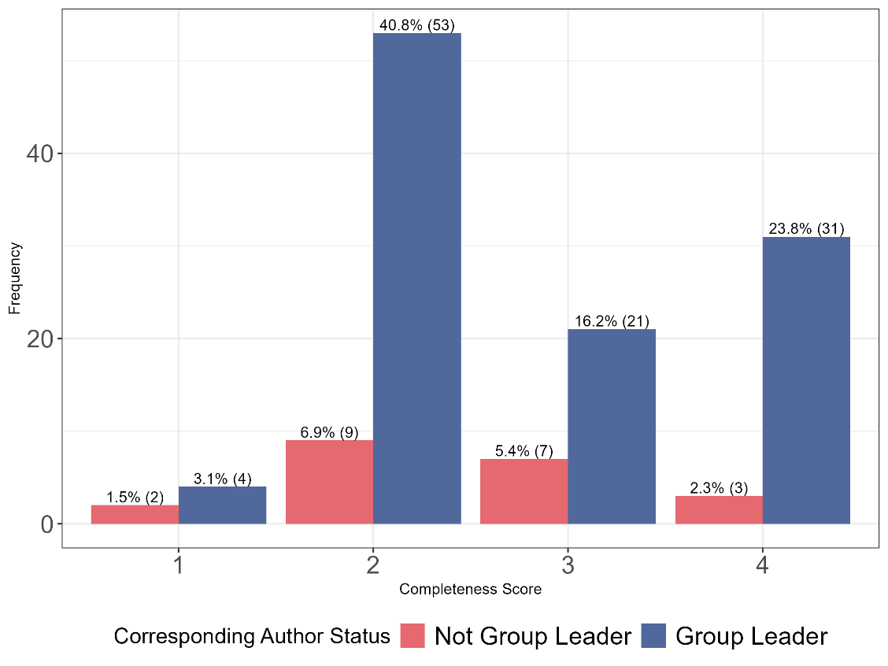

*# Save the plot to a file*

**ggsave**("CorresAuthor_status_distribution_plot.png", CorresAuthor_plot, width = 8, height = 6, bg = "white")

*# Assuming 'data' is your DataFrame and has been loaded correctly*  
**library**(dplyr)  
  
*# Transform the Completeness score into a binary variable (high vs. low)*  
data <- data **%>%**  
  **mutate**(CompletenessCategory = **case_when**(  
    Complete **%in%** 3**:**4 **~** "High",  
    Complete **%in%** 1**:**2 **~** "Low",  
    TRUE **~** NA_character_  *# Handle potential unexpected values*  
  ))  
  
*# Assuming CorresAuthor is already in a format that can be directly categorized*  
*# If not, you should transform CorresAuthor into categorical variable similar to CompletenessCategory*  
*# Example transformation is shown in the comment below. Adjust it based on your data structure.*  
*# data <- data %>%*  
*#   mutate(CorresAuthorCategory = case_when(*  
*#     CorresAuthor == some_condition ~ "Category1",*  
*#     CorresAuthor == another_condition ~ "Category2",*  
*#     TRUE ~ NA_character_  # Handle potential unexpected values*  
*#   ))*  
  
*# Drop rows with NA in either category if any exist due to unexpected values*  
data <- data **%>%**  
  **filter**(**!is.na**(CompletenessCategory) **&** **!is.na**(CorresAuthor))  
  
*# Create a contingency table*  
contingency_table <- **table**(data**$**CompletenessCategory, data**$**CorresAuthor)  
  
*# Conduct a Chi-square test of independence*  
chi_square_result <- **chisq.test**(contingency_table)  
  
*# Print the result of the Chi-square test*  
**print**(chi_square_result)

##  
##  Pearson's Chi-squared test with Yates' continuity correction  
##  
## data:  contingency_table

## X-squared = 4.6417e-31, df = 1, p-value = 1

# Calculate frequency and percentage for Code Sharing

CodeArchived_summary <- data %>%  
 group_by(CodeArchived) %>%  
 summarise(count = n(), .groups = "drop")   
  
# Calculate the overall total  
overall_total <- sum(CodeArchived_summary$count)  
  
# Add a column for the percentage of each Code Archived category relative to the overall total  
CodeArchived_summary <- CodeArchived_summary %>%  
 mutate(percentage = (count / overall_total) * 100)  
  
print(CodeArchived_summary)

## # A tibble: 3 × 3  
## CodeArchived count percentage  
## <int> <int> <dbl>  
## 1 0 3 2.31  
## 2 1 17 13.1   
## 3 NA 110 84.6

# Frequency and Percentage of the papers that shared the code used  
data %>%  
 group_by(Type, CodeArchived) %>%  
 summarise(count = n(), .groups = "drop") %>%  
 group_by(Type) %>%  
 mutate(total = sum(count),   
 percentage = (count/total)*100) %>%  
 ungroup() %>%  
  
 arrange(Type, CodeArchived)

## # A tibble: 6 × 5  
## Type CodeArchived count total percentage  
## <chr> <int> <int> <int> <dbl>  
## 1 IQB3 0 2 80 2.5  
## 2 IQB3 1 12 80 15   
## 3 IQB3 NA 66 80 82.5  
## 4 Other 0 1 50 2   
## 5 Other 1 5 50 10   
## 6 Other NA 44 50 88

#Chi square test to assess if there is any difference in Code Sharing between the two types (IQB3, Other)

# Create a contingency table  
table_code <- table(data$Type, data$CodeArchived)  
  
# Perform the Chi-square test  
result <- chisq.test(table_code)

## Warning in chisq.test(table_code): Chi-squared approximation may be incorrect

#Print the chi-square results  
print(result)

##   
## Pearson's Chi-squared test with Yates' continuity correction  
##   
## data: table_code  
## X-squared = 2.1717e-31, df = 1, p-value = 1

# Get the expected values  
expected_values <- result$expected  
  
# Print the expected values  
print(expected_values) ##in order to check the assumption of chi square test: Each cell in the contingency table should have an expected count of 5 or more.

##   
## 0 1  
## IQB3 2.1 11.9  
## Other 0.9 5.1

#The assumptions of that test were met:  
  
#### Sample Size: Each cell in the contingency table has an expected count of 5 or more.   
#### Independence: The observations are independent of each other. This means that the selection of one observation should not influence or affect the selection of another observation.  
### Random Sampling: The data is a random sample.  
### Categorical Data: Both variables should be categorical (either nominal or ordinal).

#Plot the 4 scoring criteria for all the papers

# Convert all relevant columns to factors first to avoid the error  
data <- data %>%  
 mutate(across(c(Complete, Reuse, Access, Licence), as.character), .groups = "drop")   
  
# Reshape data to long format  
long_data <- data %>%  
 pivot_longer(cols = c(Complete, Reuse, Access, Licence), names_to = "Category", values_to = "Value") %>%  
 mutate(Value = as.character(Value))   
  
# Rename and reorder categories  
long_data$Category <- recode(long_data$Category,   
 "Complete" = "Completeness",  
 "Reuse" = "Reusability",  
 "Access" = "Accessibility",  
 "Licence" = "Licence")  
long_data$Category <- factor(long_data$Category, levels = c("Completeness", "Reusability", "Accessibility", "Licence"))  
  
# Calculate counts and percentages ensuring percentages do not exceed 100%  
long_data <- long_data %>%  
 group_by(Category, Value) %>%  
 summarise(Count = n(), .groups = "drop") %>%  
 ungroup() %>%  
 group_by(Category) %>%  
 mutate(Total = sum(Count),  
 Percentage = pmin(Count / Total * 100, 100)) %>%  
 ungroup() %>%  
 arrange(Category, desc(Value)) %>%  
 group_by(Category) %>%  
 mutate(Label = ifelse(Percentage > 5, paste0(round(Percentage, 1), "%"), ""),  
 CumPercentage = pmin(cumsum(Percentage), 100)) %>%  
 ungroup()  
  
# Plot  
plot_all <- ggplot(long_data, aes(x = Category, y = Percentage, fill = Value)) +  
 geom_bar(stat = "identity", position = "stack") +  
 scale_fill_manual(values = c("#E5696F", "#50689B", "#36D0A1", "#D0A136")) +  
 labs(y = "Percentage", fill = "Score", title = "Scoring Criteria for Papers") +  
 theme_minimal() +  
 geom_text(aes(label = Label, y = pmin(CumPercentage - 0.5 * Percentage, 100)),   
 position = position_stack(vjust = 0.5), size = 6, check_overlap = TRUE) +  
 theme(  
 axis.title = element_text(size = 14),   
 axis.text = element_text(size = 18),  
 legend.title = element_text(size = 12),  
 legend.text = element_text(size = 14)  
 ) +  
 ylim(0, 100)  
  
# Ensure the values are factored in reverse order so that 4 is at the top of the stack  
long_data$Value <- factor(long_data$Value, levels = c("4", "3", "2", "1"))  
  
# Show the plot  
print(plot_all)

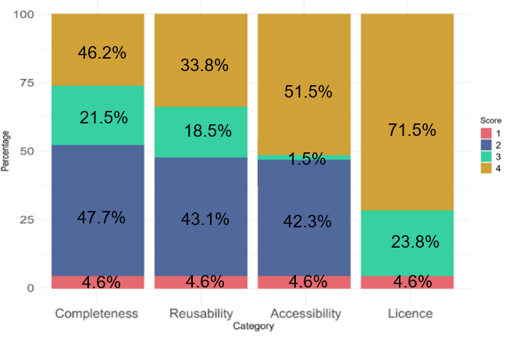## Warning: Removed 5 rows containing missing values or values outside the scale range  
## (`geom_text()`).

# Save the plot  
ggsave("plotall.png", plot_all, width = 10, height = 8, dpi = 300, bg="white")

## Warning: Removed 5 rows containing missing values or values outside the scale range  
## (`geom_text()`).

#Cluster bar chart fro the completeness criteria by the Type of the study

library(ggplot2)  
library(dplyr)  
  
# Reorder the levels of variables  
data$Complete <- factor(data$Complete, levels = c("4", "3", "2", "1"))  
  
# Summarize data  
summarized_data <- data %>%  
 group_by(Type, Complete) %>%  
 summarise(Count = n(), .groups = "drop") %>%  
 left_join(data %>% group_by(Type) %>% summarise(Total = n(), .groups = "drop"), by = "Type") %>%  
 mutate(Percentage = Count/Total * 100)  
# For cumulative percentages  
summarized_data <- summarized_data %>%  
 arrange(Type, desc(Complete)) %>%  
 group_by(Type) %>%  
 mutate(CumPercentage = cumsum(Percentage))  
  
# Create the stacked bar chart for Completeness with colors and annotations  
gcomp <- ggplot(summarized_data, aes(x = Type, y = Percentage, fill = as.factor(Complete))) +  
 geom_bar(stat = "identity", position = "stack") +  
 scale_fill_manual(values = c("#D0A136", "#36D0A1", "#50689B", "#E5696F")) +  
 labs(x = "Type", y = "Percentage", fill = "Completeness Score") +  
 theme_minimal() +  
 geom_text(aes(label = ifelse(Percentage > 5, paste0(round(Percentage, 1), "%"), ""),   
 y = pmin(pmax(ifelse(Complete == 1, Percentage / 2, CumPercentage - (0.5 * Percentage)), 0), 100)),  
 position = position_stack(vjust = 0.5), color = "Black", size = 5) +  
 theme(  
 axis.title = element_text(size = 14), # Increase axis titles  
 axis.text = element_text(size = 18), # Increase axis text  
 legend.title = element_text(size = 12), # Increase legend title  
 legend.text = element_text(size = 14) # Increase legend text  
 ) +  
 ylim(0, 100)   
  
print(gcomp)

## Warning: Removed 2 rows containing missing values or values outside the scale range  
## (`geom_text()`).

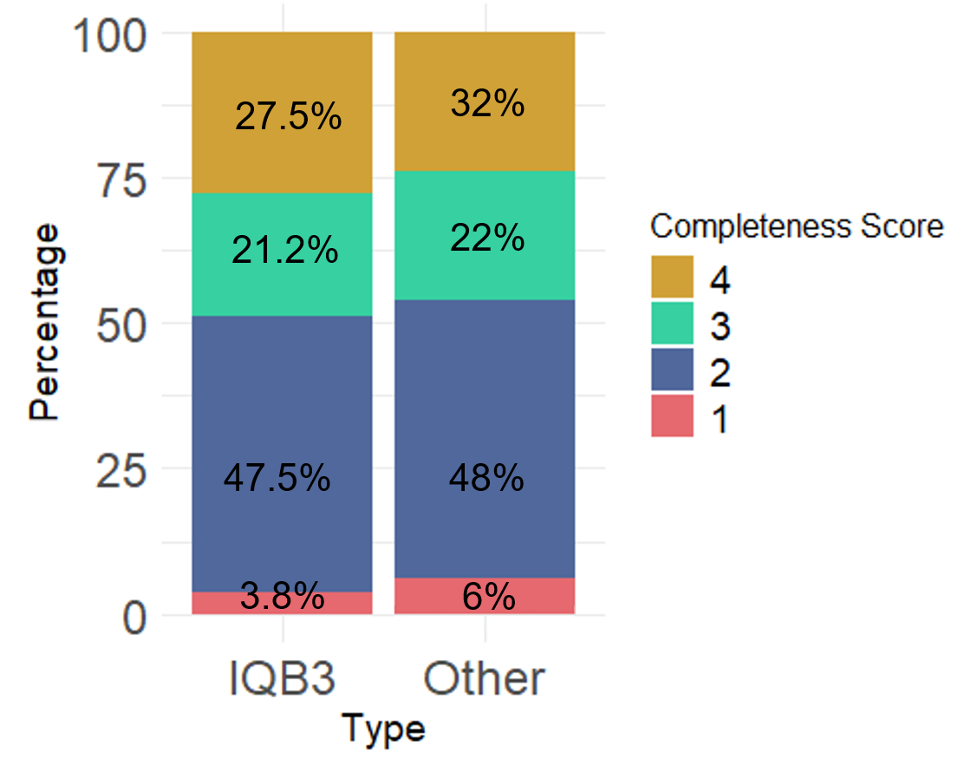

ggsave("gcomp.png", gcomp, width = 10, height = 8, dpi = 300)

## Warning: Removed 2 rows containing missing values or values outside the scale range  
## (`geom_text()`).

` ##Cluster bar chart for the Reuse criteria by the Type of the study

# Reorder the levels of variables  
data$Reuse <- factor(data$Reuse, levels = c("4", "3", "2", "1"))  
  
summarized_data_Reuse <- data %>%  
 group_by(Type, Reuse) %>%  
 summarise(Count = n(), .groups = "drop") %>%  
 left_join(data %>% group_by(Type) %>% summarise(Total = n(), .groups = "drop"), by = "Type") %>%  
 mutate(Percentage = Count/Total * 100)  
  
summarized_data_Reuse <- summarized_data_Reuse %>%  
 arrange(Type, desc(Reuse)) %>%  
 group_by(Type) %>%  
 mutate(CumPercentage = cumsum(Percentage))  
print(summarized_data_Reuse)

## # A tibble: 8 × 6  
## # Groups: Type [2]  
## Type Reuse Count Total Percentage CumPercentage  
## <chr> <fct> <int> <int> <dbl> <dbl>  
## 1 IQB3 1 3 80 3.75 3.75  
## 2 IQB3 2 37 80 46.2 50   
## 3 IQB3 3 10 80 12.5 62.5   
## 4 IQB3 4 30 80 37.5 100   
## 5 Other 1 3 50 6 6   
## 6 Other 2 19 50 38 44   
## 7 Other 3 14 50 28 72   
## 8 Other 4 14 50 28 100

colors <- c("#D0A136", "#36D0A1", "#50689B", "#E5696F")  
  
# Visualization  
gReuse <- ggplot(summarized_data_Reuse, aes(x = Type, y = Percentage, fill = as.factor(Reuse))) +  
 geom_bar(stat = "identity", position = "stack") +  
 scale_fill_manual(values = colors) +  
 labs(x = "Type", y = "Percentage", fill = "Reusability Score") +  
 theme_minimal() +  
 geom_text(aes(label = paste0(round(Percentage, 1), "%"),   
 y = CumPercentage - (0.5 * Percentage)),  
 position = position_stack(vjust = 0.5), color = "Black", size = 5) +  
 theme(  
 axis.title = element_text(size = 14), # Increase axis titles  
 axis.text = element_text(size = 18), # Increase axis text  
 legend.title = element_text(size = 12), # Increase legend title  
 legend.text = element_text(size = 14) # Increase legend text  
 ) +  
 ylim(0, 100)  
  
print(gReuse)

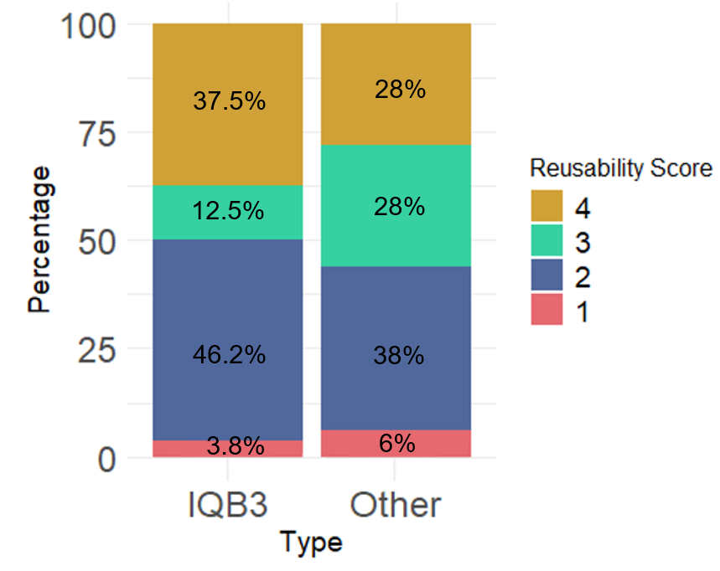## Warning: Removed 2 rows containing missing values or values outside the scale range  
## (`geom_text()`).

ggsave("gReuse.png", gReuse, width = 10, height = 8, dpi = 300)

## Warning: Removed 2 rows containing missing values or values outside the scale range  
## (`geom_text()`).

#bar chart for the Accessibility criteria by the Type of the study

# Reorder the levels of variables  
data$Access <- factor(data$Access, levels = c("4", "3", "2", "1"))  
  
summarized_data_Access <- data %>%  
 group_by(Type, Access) %>%  
 summarise(Count = n(), .groups = "drop") %>%  
 left_join(data %>% group_by(Type) %>% summarise(Total = n(), .groups = "drop"), by = "Type") %>%  
 mutate(Percentage = Count/Total * 100)  
  
summarized_data_Access <- summarized_data_Access %>%  
 arrange(Type, desc(Access)) %>%  
 group_by(Type) %>%  
 mutate(CumPercentage = cumsum(Percentage))  
print(summarized_data_Access)

## # A tibble: 8 × 6  
## # Groups: Type [2]  
## Type Access Count Total Percentage CumPercentage  
## <chr> <fct> <int> <int> <dbl> <dbl>  
## 1 IQB3 1 3 80 3.75 3.75  
## 2 IQB3 2 34 80 42.5 46.2   
## 3 IQB3 3 1 80 1.25 47.5   
## 4 IQB3 4 42 80 52.5 100   
## 5 Other 1 3 50 6 6   
## 6 Other 2 21 50 42 48   
## 7 Other 3 1 50 2 50   
## 8 Other 4 25 50 50 100

colors <- c("#D0A136", "#36D0A1", "#50689B", "#E5696F")  
  
# Visualization  
gaccess <- ggplot(summarized_data_Access, aes(x = Type, y = Percentage, fill = as.factor(Access))) +  
 geom_bar(stat = "identity", position = "stack") +  
 scale_fill_manual(values = colors) +  
 labs(x = "Type", y = "Percentage", fill = "Accessibility Score") +  
 theme_minimal() +  
 geom_text(aes(label = paste0(round(Percentage, 1), "%"),   
 y = CumPercentage - (0.5 * Percentage)),  
 position = position_stack(vjust = 0.5), color = "Black", size = 5) +  
 theme(  
 axis.title = element_text(size = 14), # Increase axis titles  
 axis.text = element_text(size = 18), # Increase axis text  
 legend.title = element_text(size = 12), # Increase legend title  
 legend.text = element_text(size = 14) # Increase legend text  
 ) +  
 ylim(0, 100)  
  
print(gaccess)

## Warning: Removed 2 rows containing missing values or values outside the scale range  
## (`geom_text()`).

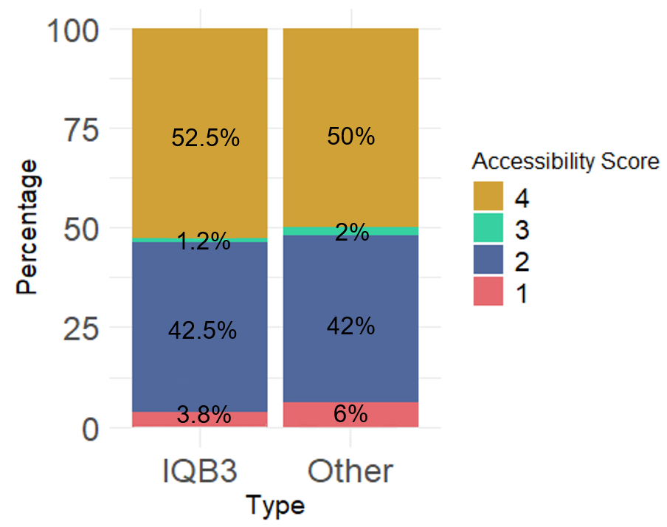

ggsave("gaccess.png", gaccess, width = 10, height = 8, dpi = 300)

## Warning: Removed 2 rows containing missing values or values outside the scale range  
## (`geom_text()`).

#bar chart for the Licence criteria by the Type of the study

# Reorder the levels of variables  
data$Licence <- factor(data$Licence, levels = c("4", "3", "2", "1"))  
  
summarized_data_Licence <- data %>%  
 group_by(Type, Licence) %>%  
 summarise(Count = n(), .groups = "drop") %>%  
 left_join(data %>% group_by(Type) %>% summarise(Total = n(), .groups = "drop"), by = "Type") %>%  
 mutate(Percentage = Count/Total * 100)  
  
summarized_data_Licence <- summarized_data_Licence %>%  
 arrange(Type, desc(Licence)) %>%  
 group_by(Type) %>%  
 mutate(CumPercentage = cumsum(Percentage))  
print(summarized_data_Licence)

## # A tibble: 6 × 6  
## # Groups: Type [2]  
## Type Licence Count Total Percentage CumPercentage  
## <chr> <fct> <int> <int> <dbl> <dbl>  
## 1 IQB3 1 3 80 3.75 3.75  
## 2 IQB3 3 21 80 26.2 30   
## 3 IQB3 4 56 80 70 100   
## 4 Other 1 3 50 6 6   
## 5 Other 3 10 50 20 26   
## 6 Other 4 37 50 74 100

colors <- c("#D0A136", "#36D0A1", "#E5696F")  
  
# Visualization  
glicence <- ggplot(summarized_data_Licence, aes(x = Type, y = Percentage, fill = as.factor(Licence))) +  
 geom_bar(stat = "identity", position = "stack") +  
 scale_fill_manual(values = colors) +  
 labs(x = "Type", y = "Percentage", fill = "Licence Score") +  
 theme_minimal() +  
 geom_text(aes(label = paste0(round(Percentage, 1), "%"),   
 y = CumPercentage - (0.5 * Percentage)),  
 position = position_stack(vjust = 0.5), color = "Black", size = 5) +  
 theme(  
 axis.title = element_text(size = 14), # Increase axis titles  
 axis.text = element_text(size = 18), # Increase axis text  
 legend.title = element_text(size = 12), # Increase legend title  
 legend.text = element_text(size = 14) # Increase legend text  
 ) +  
 ylim(0, 100)  
  
print(glicence)

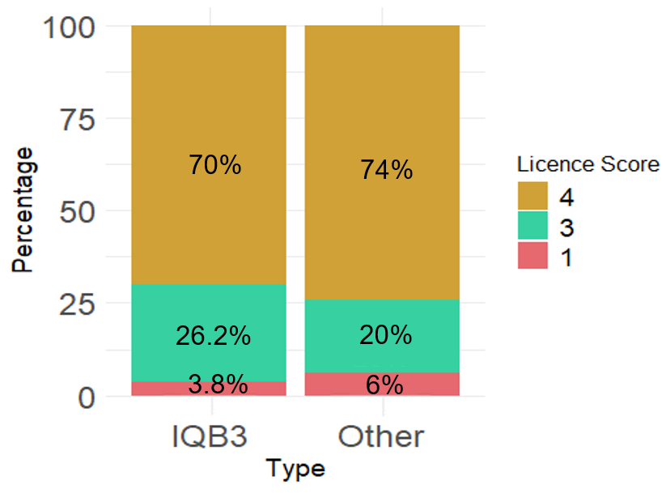

ggsave("glicence.png", glicence, width = 10, height = 8, dpi = 300)

## Warning: Removed 2 rows containing missing values or values outside the scale range   
## (`geom_text()`).

**library**(patchwork)

## Warning: package 'patchwork' was built under R version 4.3.3

##    
## Attaching package: 'patchwork'

## The following object is masked from 'package:MASS':   
##    
##     area

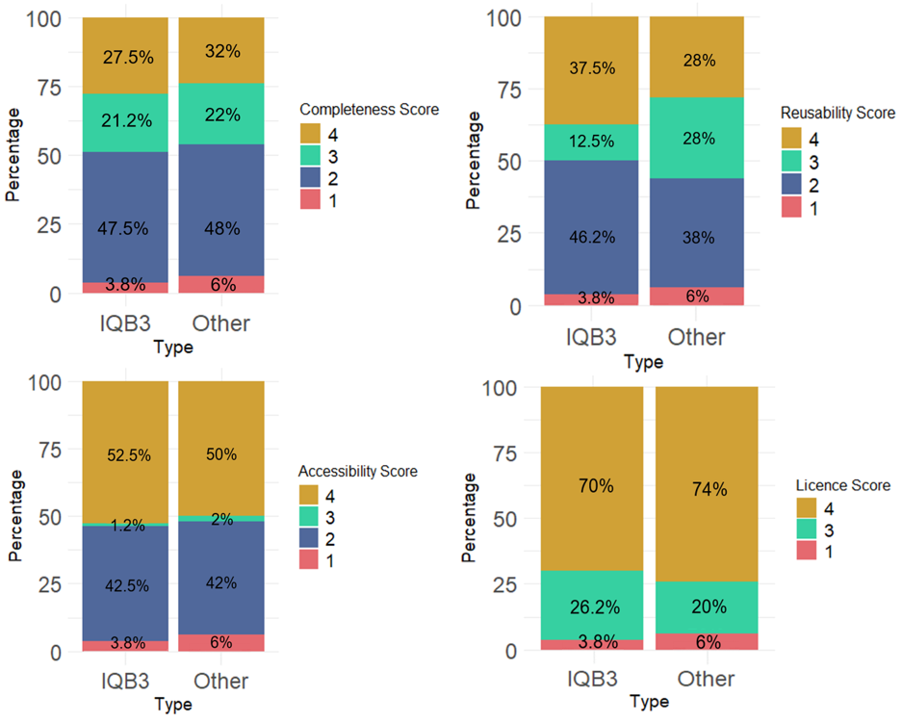combinedplot <- gcomp **+** greuse **+** gaccess **+** glicence **+**   
  **plot_layout**(   
    ncol = 2, heights = **c**(10, 10), widths = **c**(10, 10)   
  )   
**print**(combinedplot)

##Calculate the frequency and percentage for each 'Complete' score within each 'Year'  
long_data <- data %>%  
 count(Year, Complete) %>%  
 group_by(Year) %>%  
 mutate(Percentage = n / sum(n) * 100) %>%  
 mutate(Label = ifelse(Percentage > 5, paste0(round(Percentage, 1), "%"), "")) %>%  
 mutate(Cumulative_Percentage = cumsum(Percentage) - (0.5 * Percentage)) %>%  
 ungroup()  
  
# Custom colors  
colors <- c("#D0A136", "#36D0A1", "#50689B", "#E5696F")  
  
# Creating the stacked bar chart with percentage labels  
Compyear <- ggplot(long_data, aes(x = as.factor(Year), y = n, fill = as.factor(Complete))) +  
 geom_bar(stat = "identity", position = "fill") + # Scale the bar heights to proportions  
 scale_y_continuous(labels = percent_format()) + # Convert the y-axis to percentage  
 geom_text(  
 aes(label = Label, y = Percentage),   
 size = 4,   
 color = "black",   
 position = position_fill(vjust = 0.5)  
 ) +  
 scale_fill_manual(values = colors) +  
 labs(x = "Year",  
 y = "Percentage",  
 fill = "Completeness") +  
 theme(  
 axis.title = element_text(size = 14), # Increase axis titles  
 axis.text = element_text(size = 20), # Increase axis text  
 legend.title = element_text(size = 18), # Increase legend title  
 legend.text = element_text(size = 20) # Increase legend text  
 ) +  
 theme_minimal() +  
 scale_x_discrete(name = "Year", labels = unique(long_data$Year)) +  
 theme(axis.text.x = element_text(angle = 90, hjust = 1)) # Adjust text angle for readability  
  
# Print the plot  
print(Compyear)

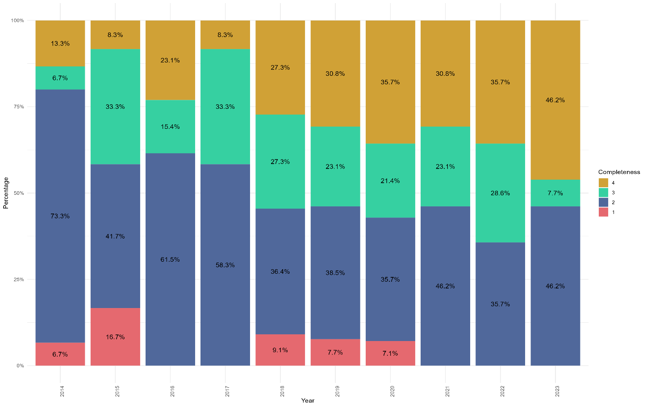

ggsave("Compyear.png", Compyear, width = 15, height = 10, units = "in", bg = "white")

# Calculate the frequency and percentage for each 'Reuse' score within each 'Year'  
long_data <- data %>%  
 count(Year, Reuse) %>%  
 group_by(Year) %>%  
 mutate(Percentage = n / sum(n) * 100) %>%  
 mutate(Label = ifelse(Percentage > 5, paste0(round(Percentage, 1), "%"), "")) %>%  
 mutate(Cumulative_Percentage = cumsum(Percentage) - (0.5 * Percentage)) %>%  
 ungroup()  
  
# Custom colors  
colors <- c("#D0A136", "#36D0A1", "#50689B", "#E5696F")  
  
# Creating the stacked bar chart with percentage labels  
Reuseyear <- ggplot(long_data, aes(x = as.factor(Year), y = n, fill = as.factor(Reuse))) +  
 geom_bar(stat = "identity", position = "fill") + # Scale the bar heights to proportions  
 scale_y_continuous(labels = percent_format()) + # Convert the y-axis to percentage  
 geom_text(  
 aes(label = Label, y = Percentage),   
 size = 4,   
 color = "black",   
 position = position_fill(vjust = 0.5)  
 ) +  
 scale_fill_manual(values = colors) +  
 labs(x = "Year",  
 y = "Percentage",  
 fill = "Reusability") +  
 theme(  
 axis.title = element_text(size = 14), # Increase axis titles  
 axis.text = element_text(size = 20), # Increase axis text  
 legend.title = element_text(size = 18), # Increase legend title  
 legend.text = element_text(size = 20) # Increase legend text  
 ) +  
 theme_minimal() +  
 scale_x_discrete(name = "Year", labels = unique(long_data$Year)) +  
 theme(axis.text.x = element_text(angle = 90, hjust = 1)) # Adjust text angle for readability  
  
# Print the plot  
print(Reuseyear)

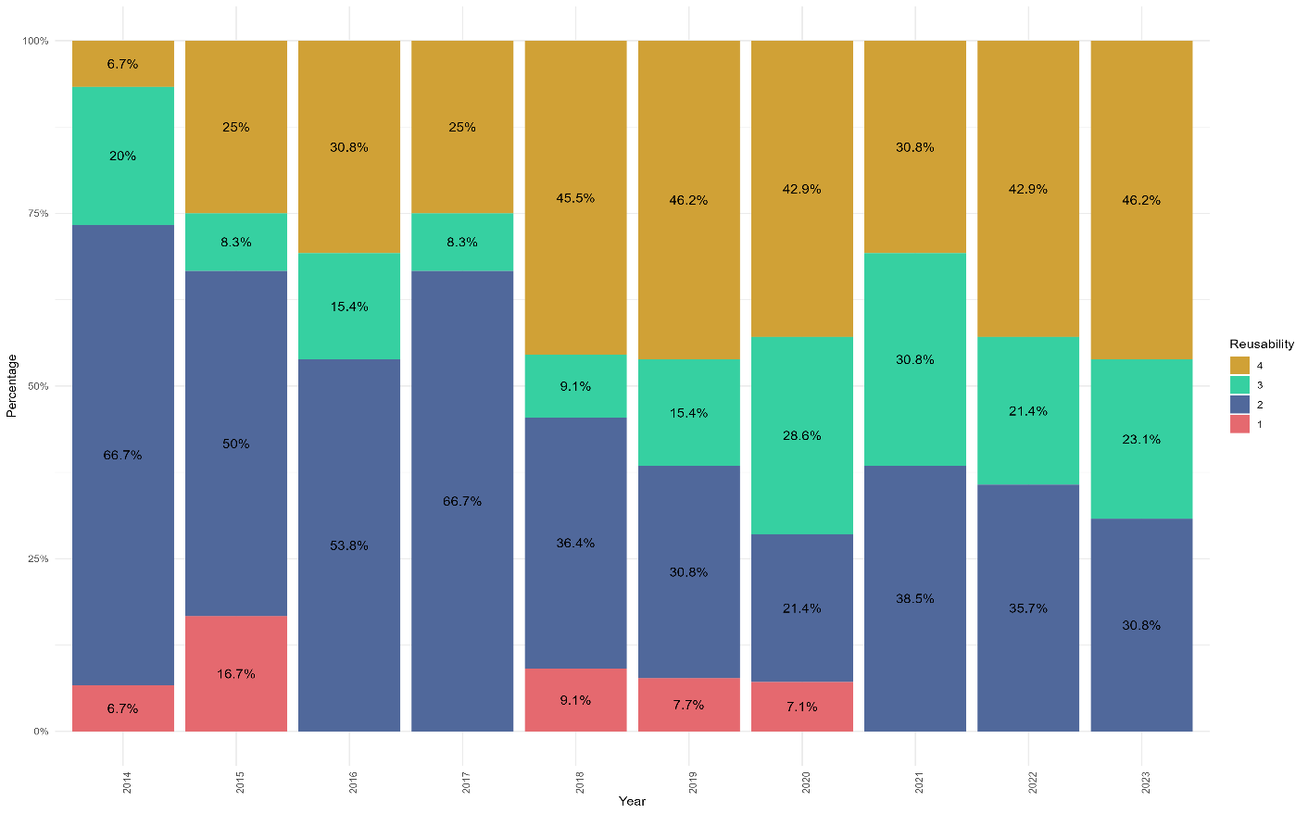

ggsave("Reuseyear.png", Reuseyear, width = 15, height = 10, units = "in", bg = "white")

# Calculate the frequency and percentage for each 'Access' score within each 'Year'  
long_data <- data %>%  
 count(Year, Access) %>%  
 group_by(Year) %>%  
 mutate(Percentage = n / sum(n) * 100) %>%  
 mutate(Label = ifelse(Percentage > 5, paste0(round(Percentage, 1), "%"), "")) %>%  
 mutate(Cumulative_Percentage = cumsum(Percentage) - (0.5 * Percentage)) %>%  
 ungroup()  
  
# Custom colors  
colors <- c("#D0A136", "#36D0A1", "#50689B", "#E5696F")  
  
# Creating the stacked bar chart with percentage labels  
accessyear <- ggplot(long_data, aes(x = as.factor(Year), y = n, fill = as.factor(Access))) +  
 geom_bar(stat = "identity", position = "fill") + # Scale the bar heights to proportions  
 scale_y_continuous(labels = percent_format()) + # Convert the y-axis to percentage  
 geom_text(  
 aes(label = Label, y = Percentage),   
 size = 4,   
 color = "black",   
 position = position_fill(vjust = 0.5)  
 ) +  
 scale_fill_manual(values = colors) +  
 labs(x = "Year",  
 y = "Percentage",  
 fill = "Accessibility") +  
 theme(  
 axis.title = element_text(size = 14), # Increase axis titles  
 axis.text = element_text(size = 20), # Increase axis text  
 legend.title = element_text(size = 18), # Increase legend title  
 legend.text = element_text(size = 20) # Increase legend text  
 ) +  
 theme_minimal() +  
 scale_x_discrete(name = "Year", labels = unique(long_data$Year)) +  
 theme(axis.text.x = element_text(angle = 90, hjust = 1)) # Adjust text angle for readability  
  
# Print the plot  
print(accessyear)

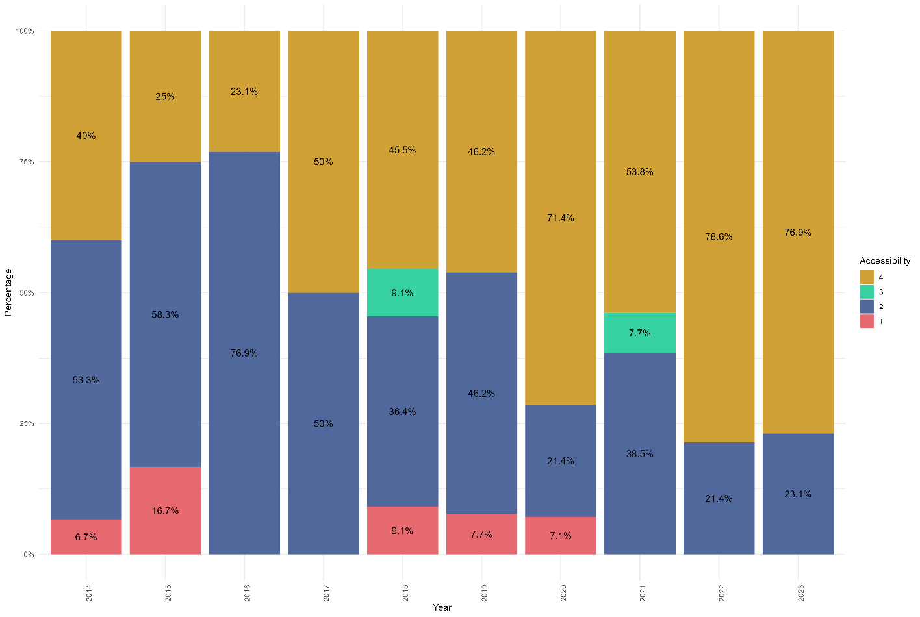

ggsave("accessyear.png", accessyear, width = 15, height = 10, units = "in", bg = "white")

# Calculate the frequency and percentage for each 'Licence' score within each 'Year'  
long_data <- data %>%  
 count(Year, Licence) %>%  
 group_by(Year) %>%  
 mutate(Percentage = n / sum(n) * 100) %>%  
 mutate(Label = ifelse(Percentage > 5, paste0(round(Percentage, 1), "%"), "")) %>%  
 mutate(Cumulative_Percentage = cumsum(Percentage) - (0.5 * Percentage)) %>%  
 ungroup()  
  
# Custom colors  
colors <- c("#D0A136", "#36D0A1", "#50689B", "#E5696F")  
  
# Creating the stacked bar chart with percentage labels  
licenceyear <- ggplot(long_data, aes(x = as.factor(Year), y = n, fill = as.factor(Licence))) +  
 geom_bar(stat = "identity", position = "fill") + # Scale the bar heights to proportions  
 scale_y_continuous(labels = percent_format()) + # Convert the y-axis to percentage  
 geom_text(  
 aes(label = Label, y = Percentage),   
 size = 4,   
 color = "black",   
 position = position_fill(vjust = 0.5)  
 ) +  
 scale_fill_manual(values = colors) +  
 labs(x = "Year",  
 y = "Percentage",  
 fill = "Licence") +  
 theme(  
 axis.title = element_text(size = 14), # Increase axis titles  
 axis.text = element_text(size = 20), # Increase axis text  
 legend.title = element_text(size = 18), # Increase legend title  
 legend.text = element_text(size = 20) # Increase legend text  
 ) +  
 theme_minimal() +  
 scale_x_discrete(name = "Year", labels = unique(long_data$Year)) +  
 theme(axis.text.x = element_text(angle = 90, hjust = 1)) # Adjust text angle for readability  
  
# Print the plot  
print(licenceyear)

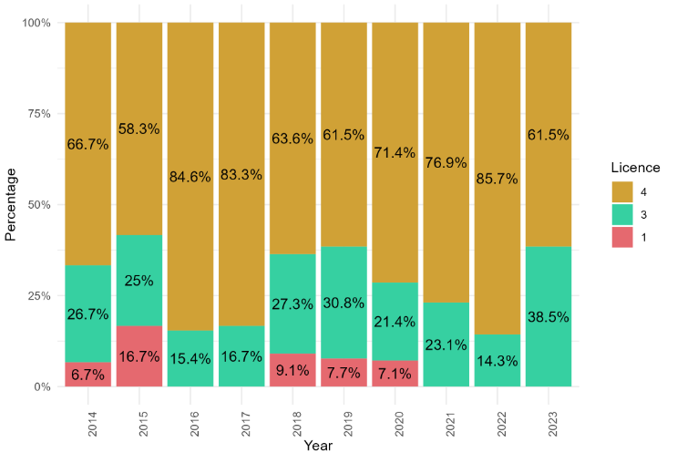

ggsave("licenceyear.png", licenceyear, width = 15, height = 10, units = "in", bg = "white")

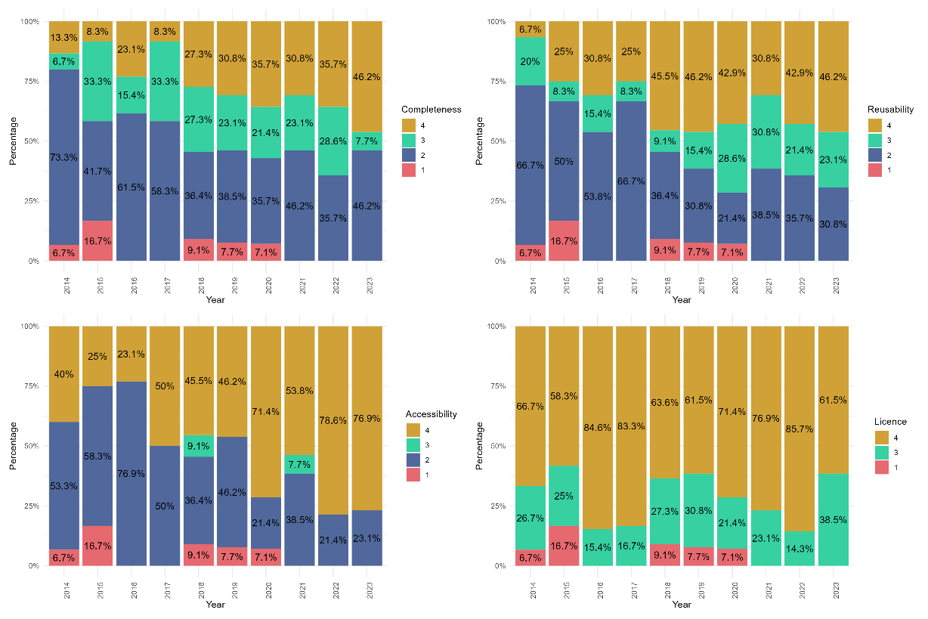plotyear <- Compyear **+** reuseyear **+** accessyear **+** licenceyear **+**   
  **plot_layout**(   
    ncol = 2, heights = **c**(10, 10), widths = **c**(10, 10)   
  )   
**print**(plotyear)

#study the significant difference between two type of the research for each scoring criteria

*# Convert scoring criteria to numeric (if not already)*   
data <- data **%>%**   
  **mutate**(**across**(**c**(Complete, Reuse, Access, Licence), **~as.numeric**(**as.character**(.))))   
   
*# Assumption checks for each criterion*   
**for** (criterion **in** **c**("Complete", "Reuse", "Access", "Licence")) {   
  *# Create and display a box plot to check the distribution shape and spread*   
  **print**(**ggplot**(data, **aes_string**(x = "Type", y = criterion, fill = "Type")) **+**   
    **geom_boxplot**() **+**   
    **ggtitle**(**paste**("Boxplot for", criterion)))   
     
  *# Print the median for a basic comparison*   
  **cat**(**paste**("Median of", criterion, "by Type:**\n**"))   
  **print**(**aggregate**(. **~** Type, data[**c**("Type", criterion)], median))   
     
  **cat**("**\n**")   
}

## Warning: `aes_string()` was deprecated in ggplot2 3.0.0.   
## ℹ Please use tidy evaluation idioms with `aes()`.   
## ℹ See also `vignette("ggplot2-in-packages")` for more information.   
## This warning is displayed once every 8 hours.   
## Call `lifecycle::last_lifecycle_warnings()` to see where this warning was   
## generated.

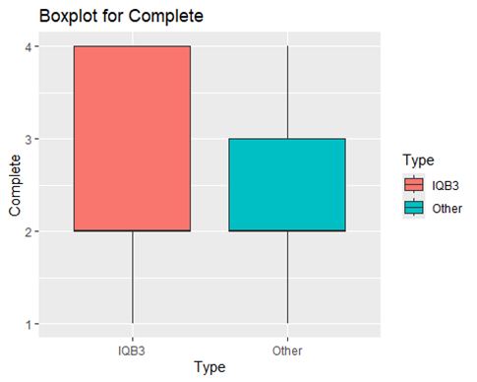

## Median of Complete by Type:   
##    Type Complete   
## 1  IQB3        2   
## 2 Other        2

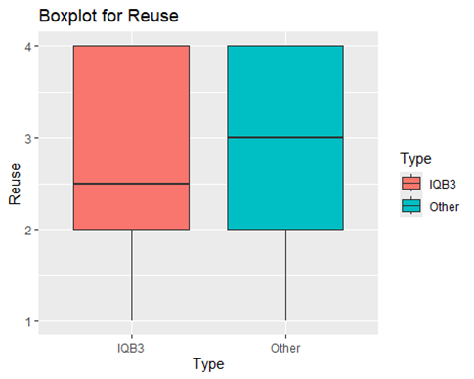

## Median of Reuse by Type:   
##    Type Reuse   
## 1  IQB3   2.5   
## 2 Other   3.0

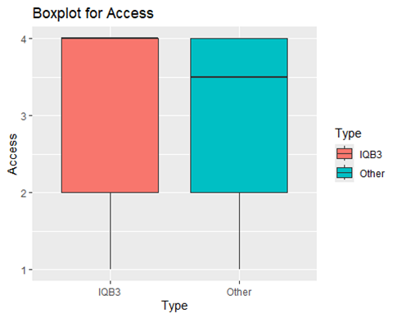

## Median of Access by Type:   
##    Type Access   
## 1  IQB3    4.0   
## 2 Other    3.5

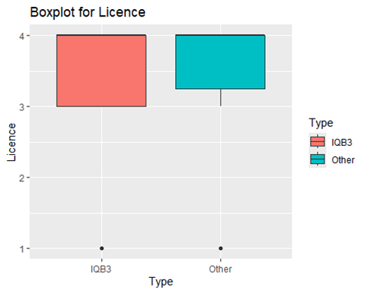

## Median of Licence by Type:   
##    Type Licence   
## 1  IQB3       4   
## 2 Other       4

*# Function to perform Mann-Whitney U test*   
perform_mann_whitney <- **function**(data, criterion) {   
  test_result <- **wilcox.test**(   
    **reformulate**("Type", response = criterion),    
    data = data,   
    exact = FALSE   
  )   
  **list**(criterion = criterion, p.value = test_result**$**p.value)   
}   
   
*# Perform the test for each criterion*   
mw_results <- **lapply**(**c**("Complete", "Reuse", "Access", "Licence"), **function**(criterion) {   
  **perform_mann_whitney**(data, criterion)   
})   
   
*# Convert the list of results to a dataframe*   
mw_results_df <- **do.call**(rbind, mw_results)   
   
**print**(mw_results_df)

##      criterion  p.value     
## [1,] "Complete" 0.6265178   
## [2,] "Reuse"    0.8119625   
## [3,] "Access"   0.7360586   
## [4,] "Licence"  0.7018642

*#The assumptions of the test were met:*   
***### Ordinal Data Check: The scoring criteria are ordinal variables***   
***### Similar Distribution Shapes: For each criterion, it creates a box plot to visually inspect the distribution shapes. This is crucial to check if the distributions are similar across groups.***   
***### Independence of Observations:the variables are independence observations.***

#Create variables for FAIR principles in 2016 and COVID-19 in 2020

data <- data %>%  
 mutate(Period2020 = ifelse(Year <= 2020, "Before 2020", "After 2020")) %>%  
 mutate(Period2016 = ifelse(Year <= 2016, "Before 2016", "After 2016"))#

#Study the significant difference before and afterCovid-19 2020 using Median and Mann Whitney U test

# Ensure the scoring criteria are numeric  
data <- data %>%  
 mutate(across(c(Complete, Reuse, Access, Licence), ~as.numeric(as.character(.))))  
  
# Function to generate box plots for distribution checks  
generate_boxplot <- function(data, score_var, period_var) {  
 ggplot(data, aes_string(x = period_var, y = score_var, fill = period_var)) +  
 geom_boxplot() +  
 labs(title = paste("Boxplot for", score_var, "across", period_var),  
 x = period_var,  
 y = score_var) +  
 theme_minimal()  
}  
  
# Generate and display box plots for each score with Period2020  
lapply(c("Complete", "Reuse", "Access", "Licence"), function(score_var) {  
 generate_boxplot(data, score_var, "Period2020")  
})

## Warning: `aes_string()` was deprecated in ggplot2 3.0.0.  
## ℹ Please use tidy evaluation idioms with `aes()`.  
## ℹ See also `vignette("ggplot2-in-packages")` for more information.  
## This warning is displayed once every 8 hours.  
## Call `lifecycle::last_lifecycle_warnings()` to see where this warning was  
## generated.

## [[1]]

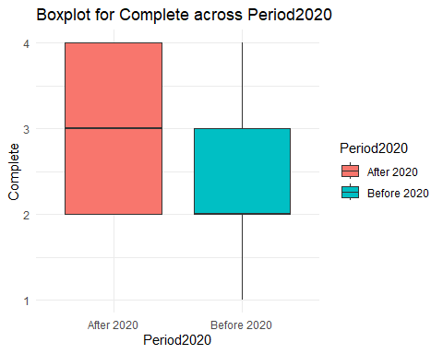

##   
## [[2]]

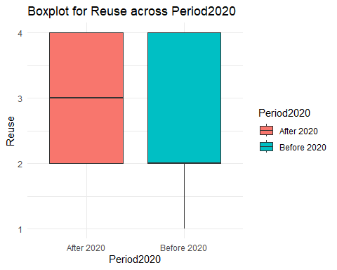

##   
## [[3]]

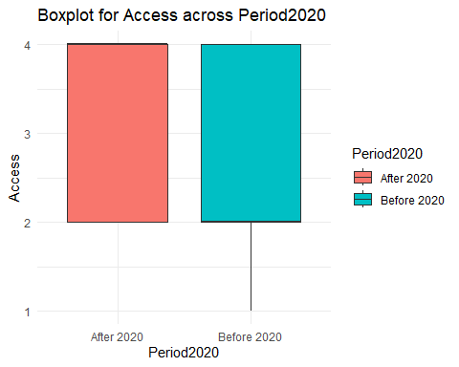

##   
## [[4]]

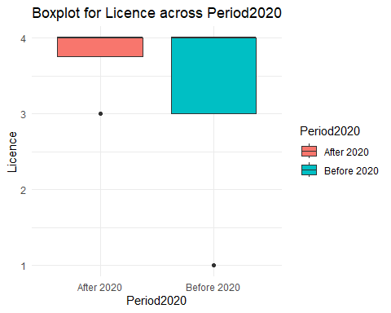

# Function to perform the Mann-Whitney test and calculate medians  
perform_analysis <- function(data, score_var, period_var) {  
 test_result <- wilcox.test(reformulate(period_var, score_var), data = data, exact = FALSE)  
   
 medians <- data %>%  
 group_by(!!sym(period_var)) %>%  
 summarise(median = median(!!sym(score_var), na.rm = TRUE), .groups = 'drop')  
   
 list(median = medians, p.value = test_result$p.value)  
}  
  
# Analysis for each score for 2020  
results_complete_2020 <- perform_analysis(data, "Complete", "Period2020")  
results_Reuse_2020 <- perform_analysis(data, "Reuse", "Period2020")  
results_access_2020 <- perform_analysis(data, "Access", "Period2020")  
results_licence_2020 <- perform_analysis(data, "Licence", "Period2020")  
  
# Print results  
print(results_complete_2020)

## $median  
## # A tibble: 2 × 2  
## Period2020 median  
## <chr> <dbl>  
## 1 After 2020 3  
## 2 Before 2020 2  
##   
## $p.value  
## [1] 0.0394013

print(results_Reuse_2020)

## $median  
## # A tibble: 2 × 2  
## Period2020 median  
## <chr> <dbl>  
## 1 After 2020 3  
## 2 Before 2020 2  
##   
## $p.value  
## [1] 0.0639665

print(results_access_2020)

## $median  
## # A tibble: 2 × 2  
## Period2020 median  
## <chr> <dbl>  
## 1 After 2020 4  
## 2 Before 2020 2  
##   
## $p.value  
## [1] 0.002491228

print(results_licence_2020)

## $median  
## # A tibble: 2 × 2  
## Period2020 median  
## <chr> <dbl>  
## 1 After 2020 4  
## 2 Before 2020 4  
##   
## $p.value  
## [1] 0.4440382

#The assumptions of the test were met:  
### Ordinal Data Check: The scoring criteria are ordinal variables  
### Similar Distribution Shapes: For each criterion, it creates a box plot to visually inspect the distribution shapes. This is crucial to check if the distributions are similar across groups.  
### Independence of Observations:the variables are independence observations.

#Study the significant difference before and afterCovid-19 2020 using Median and Mann Whitney U test for the IQB3 Papers

data_IQB3 <- data %>%   
 filter(Type == "IQB3")  
  
  
perform_analysis <- function(data_IQB3, score_var, period_var) {  
 test_result <- wilcox.test(reformulate(period_var, score_var), data = data_IQB3, exact = FALSE)  
   
 medians <- data_IQB3 %>%  
 group_by(!!sym(period_var)) %>%  
 summarise(median = median(!!sym(score_var), na.rm = TRUE), .groups = 'drop')  
   
 list(median = medians, p.value = test_result$p.value)  
}  
  
# Analysis for each score for 2020  
results_complete_2020_IQB3 <- perform_analysis(data_IQB3, "Complete", "Period2020")  
results_Reuse_2020_IQB3 <- perform_analysis(data_IQB3, "Reuse", "Period2020")  
results_access_2020_IQB3 <- perform_analysis(data_IQB3, "Access", "Period2020")  
results_licence_2020_IQB3 <- perform_analysis(data_IQB3, "Licence", "Period2020")  
  
# Print results  
results_complete_2020_IQB3

## $median  
## # A tibble: 2 × 2  
## Period2020 median  
## <chr> <dbl>  
## 1 After 2020 3  
## 2 Before 2020 2  
##   
## $p.value  
## [1] 0.3644481

results_Reuse_2020_IQB3

## $median  
## # A tibble: 2 × 2  
## Period2020 median  
## <chr> <dbl>  
## 1 After 2020 3  
## 2 Before 2020 2  
##   
## $p.value  
## [1] 0.268142

results_access_2020_IQB3

## $median  
## # A tibble: 2 × 2  
## Period2020 median  
## <chr> <dbl>  
## 1 After 2020 4  
## 2 Before 2020 2  
##   
## $p.value  
## [1] 0.01209852

results_licence_2020_IQB3

## $median  
## # A tibble: 2 × 2  
## Period2020 median  
## <chr> <dbl>  
## 1 After 2020 4  
## 2 Before 2020 4  
##   
## $p.value  
## [1] 0.7285709

#Study the significant difference before and after Covid-19 2020 using Median and Mann Whitney U test for the Other Papers

data_Other <- data %>%   
 filter(Type == "Other")  
  
  
perform_analysis <- function(data_Other, score_var, period_var) {  
 test_result <- wilcox.test(reformulate(period_var, score_var), data = data_Other, exact = FALSE)  
   
 medians <- data_Other %>%  
 group_by(!!sym(period_var)) %>%  
 summarise(median = median(!!sym(score_var), na.rm = TRUE), .groups = 'drop')  
   
 list(median = medians, p.value = test_result$p.value)  
}  
  
# Analysis for each score for 2020  
results_complete_2020_Other <- perform_analysis(data_Other, "Complete", "Period2020")  
results_Reuse_2020_Other <- perform_analysis(data_Other, "Reuse", "Period2020")  
results_access_2020_Other <- perform_analysis(data_Other, "Access", "Period2020")  
results_licence_2020_Other <- perform_analysis(data_Other, "Licence", "Period2020")  
  
# Print results  
results_complete_2020_Other

## $median  
## # A tibble: 2 × 2  
## Period2020 median  
## <chr> <dbl>  
## 1 After 2020 3.5  
## 2 Before 2020 2   
##   
## $p.value  
## [1] 0.03066192

results_Reuse_2020_Other

## $median  
## # A tibble: 2 × 2  
## Period2020 median  
## <chr> <dbl>  
## 1 After 2020 3   
## 2 Before 2020 2.5  
##   
## $p.value  
## [1] 0.1037424

results_access_2020_Other

## $median  
## # A tibble: 2 × 2  
## Period2020 median  
## <chr> <dbl>  
## 1 After 2020 4  
## 2 Before 2020 2  
##   
## $p.value  
## [1] 0.1016182

results_licence_2020_Other

## $median  
## # A tibble: 2 × 2  
## Period2020 median  
## <chr> <dbl>  
## 1 After 2020 4  
## 2 Before 2020 4  
##   
## $p.value  
## [1] 0.365762

#Study the significant difference before and after Fair 2016 using Median and Mann Whitney U for all the papers

data <- data %>%  
 mutate(Period2016 = ifelse(Year <= 2016, "Before 2016", "After 2016"))  
  
# Function to perform the Mann-Whitney test, calculate medians, and generate box plots  
perform_analysis <- function(data, score_var, period_var) {  
 test_result <- wilcox.test(reformulate(period_var, score_var), data = data, exact = FALSE)  
   
 medians <- data %>%  
 group_by(!!sym(period_var)) %>%  
 summarise(median = median(!!sym(score_var), na.rm = TRUE), .groups = 'drop')  
   
 # Generate a box plot  
 box_plot <- ggplot(data, aes_string(x = period_var, y = score_var, fill = period_var)) +  
 geom_boxplot() +  
 labs(title = paste("Boxplot for", score_var, "across", period_var),  
 x = period_var,  
 y = score_var) +  
 theme_minimal()  
   
 # Print the box plot  
 print(box_plot)  
   
 list(median = medians, p.value = test_result$p.value, plot = box_plot)  
}  
  
# Analysis for each score for 2016  
results_complete_2016 <- perform_analysis(data, "Complete", "Period2016")

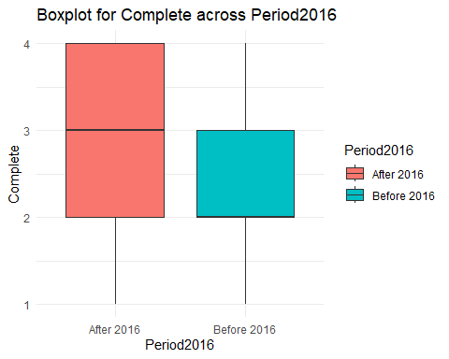

results_Reuse_2016 <- perform_analysis(data, "Reuse", "Period2016")

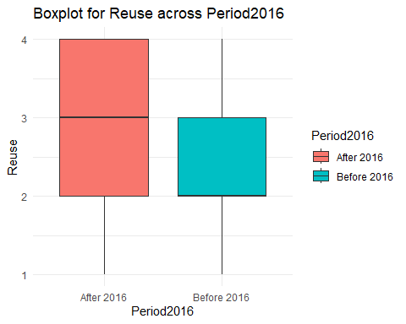

results_access_2016 <- perform_analysis(data, "Access", "Period2016")

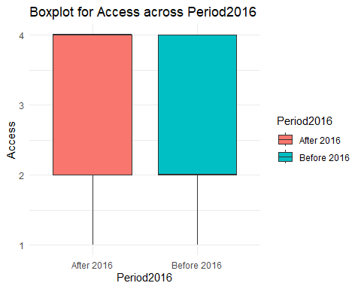

results_licence_2016 <- perform_analysis(data, "Licence", "Period2016")

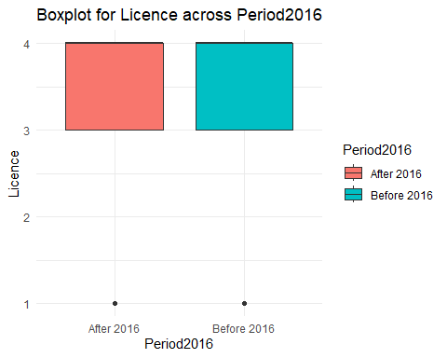

# Print results  
results_complete_2016

## $median  
## # A tibble: 2 × 2  
## Period2016 median  
## <chr> <dbl>  
## 1 After 2016 3  
## 2 Before 2016 2  
##   
## $p.value  
## [1] 0.01447046  
##   
## $plot



results_Reuse_2016

## $median  
## # A tibble: 2 × 2  
## Period2016 median  
## <chr> <dbl>  
## 1 After 2016 3  
## 2 Before 2016 2  
##   
## $p.value  
## [1] 0.006953216  
##   
## $plot



results_access_2016

## $median  
## # A tibble: 2 × 2  
## Period2016 median  
## <chr> <dbl>  
## 1 After 2016 4  
## 2 Before 2016 2  
##   
## $p.value  
## [1] 0.0007181409  
##   
## $plot



results_licence_2016

## $median  
## # A tibble: 2 × 2  
## Period2016 median  
## <chr> <dbl>  
## 1 After 2016 4  
## 2 Before 2016 4  
##   
## $p.value  
## [1] 0.7055106  
##   
## $plot

 #Study the significant difference before and after Fair 2016 using Median and Mann Whitney U test for the IQB3 Papers

perform_analysis <- function(data_IQB3, score_var, period_var) {  
 test_result <- wilcox.test(reformulate(period_var, score_var), data = data_IQB3, exact = FALSE)  
   
 medians <- data_IQB3 %>%  
 group_by(!!sym(period_var)) %>%  
 summarise(median = median(!!sym(score_var), na.rm = TRUE), .groups = 'drop')  
   
 list(median = medians, p.value = test_result$p.value)  
}  
# Analysis for each score for 2016  
results_complete_2016_IQB3 <- perform_analysis(data_IQB3, "Complete", "Period2016")  
results_Reuse_2016_IQB3 <- perform_analysis(data_IQB3, "Reuse", "Period2016")  
results_access_2016_IQB3 <- perform_analysis(data_IQB3, "Access", "Period2016")  
results_licence_2016_IQB3 <- perform_analysis(data_IQB3, "Licence", "Period2016")  
  
# Print results  
results_complete_2016_IQB3

## $median  
## # A tibble: 2 × 2  
## Period2016 median  
## <chr> <dbl>  
## 1 After 2016 3  
## 2 Before 2016 2  
##   
## $p.value  
## [1] 0.3265723

results_Reuse_2016_IQB3

## $median  
## # A tibble: 2 × 2  
## Period2016 median  
## <chr> <dbl>  
## 1 After 2016 3  
## 2 Before 2016 2  
##   
## $p.value  
## [1] 0.1311435

results_access_2016_IQB3

## $median  
## # A tibble: 2 × 2  
## Period2016 median  
## <chr> <dbl>  
## 1 After 2016 4  
## 2 Before 2016 2  
##   
## $p.value  
## [1] 0.004984167

results_licence_2016_IQB3

## $median  
## # A tibble: 2 × 2  
## Period2016 median  
## <chr> <dbl>  
## 1 After 2016 4  
## 2 Before 2016 4  
##   
## $p.value  
## [1] 0.5687401

#Study the significant difference before and after Fair 2016 using Median and Mann Whitney U test for the Other Papers

# Analysis for each score for 2016  
results_complete_2016_Other <- perform_analysis(data_Other, "Complete", "Period2016")  
results_Reuse_2016_Other <- perform_analysis(data_Other, "Reuse", "Period2016")  
results_access_2016_Other <- perform_analysis(data_Other, "Access", "Period2016")  
results_licence_2016_Other <- perform_analysis(data_Other, "Licence", "Period2016")  
  
# Print results  
results_complete_2016_Other

## $median  
## # A tibble: 2 × 2  
## Period2016 median  
## <chr> <dbl>  
## 1 After 2016 3  
## 2 Before 2016 2  
##   
## $p.value  
## [1] 0.01351854

results_Reuse_2016_Other

## $median  
## # A tibble: 2 × 2  
## Period2016 median  
## <chr> <dbl>  
## 1 After 2016 3  
## 2 Before 2016 2  
##   
## $p.value  
## [1] 0.01741414

results_access_2016_Other

## $median  
## # A tibble: 2 × 2  
## Period2016 median  
## <chr> <dbl>  
## 1 After 2016 4  
## 2 Before 2016 2  
##   
## $p.value  
## [1] 0.05851632

results_licence_2016_Other

## $median  
## # A tibble: 2 × 2  
## Period2016 median  
## <chr> <dbl>  
## 1 After 2016 4  
## 2 Before 2016 4  
##   
## $p.value  
## [1] 1

#plot the distribution of DAS for each completeness score

# Transform the DAS variable  
data <- data %>%  
 mutate(NewDAS = case_when(  
 is.na(DAS) ~ "Not present",  
 DAS == 1 ~ "Shared",  
 DAS == 0 ~ "Not shared",  
 TRUE ~ as.character(DAS))) # This line is just a fallback to handle unexpected values  
  
class(data$NewDAS)

## [1] "character"

# Convert the new DAS variable to a factor for plotting  
data$NewDAS <- factor(data$NewDAS, levels = c("Not present", "Not shared", "Shared"))  
  
# Calculate frequency and percentage for each combination of 'Complete' score and 'NewDAS' status  
das_frequency <- data %>%  
 group_by(Complete, NewDAS) %>%  
 summarise(Frequency = n(), .groups = 'drop') %>%  
 mutate(Percentage = (Frequency / sum(Frequency)) * 100)  
  
# Define specific colors for the new DAS values  
colors <- c("Not present" = "gray", "Not shared" = "#E5696F", "Shared" = "#50689B")  
  
# Create the plot  
das_plot <- ggplot(das_frequency, aes(x = as.factor(Complete), y = Frequency, fill = NewDAS)) +  
 geom_bar(stat = "identity", position = "dodge") +  
 geom_text(aes(label = paste0(round(Percentage, 1), "% (", Frequency, ")")),  
 position = position_dodge(width = 0.9), vjust = -0.25, size = 3.5) +  
 scale_fill_manual(values = colors, name = "DAS Status") +  
 theme_bw() + # Use theme_bw for a white background  
 theme(  
 axis.title = element_text(size = 10), # Increase axis titles  
 axis.text = element_text(size = 16), # Increase axis text  
 legend.title = element_text(size = 14), # Increase legend title  
 legend.text = element_text(size = 16) # Increase legend text  
 ) +  
 labs(x = "Completeness Score", y = "Frequency") +  
 theme(legend.position = "bottom")  
  
# Print and save the plot  
print(das_plot)

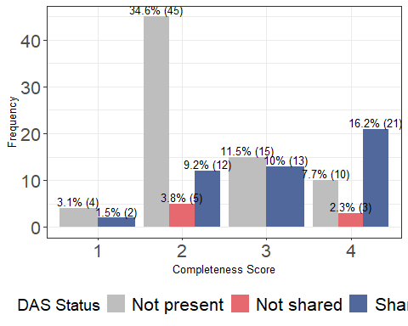

ggsave("new_das_distribution_plot.png", das_plot, width = 8, height = 6, bg = "white")

# Calculate the total count per year  
yearly_totals <- data %>%  
 group_by(Year) %>%  
 summarise(Total = n(), .groups = 'drop')  
  
# Join the totals back to the original data and calculate proportions  
proportion_data <- data %>%  
 left_join(yearly_totals, by = "Year") %>%  
 group_by(Year, NewDAS) %>%  
 summarise(Count = n(), .groups = 'drop') %>%  
 mutate(Proportion = Count / n())  
  
# Get all unique years for the x-axis  
all_years <- sort(unique(proportion_data$Year))  
  
colors <- c("Not present" = "gray", "Not shared" = "#E5696F", "Shared" = "#50689B")  
  
# Plot with every year on the x-axis  
DASyear <- ggplot(proportion_data, aes(x = Year, y = Proportion, color = NewDAS, group = NewDAS)) +  
 geom_line() +  
 geom_point() +  
 geom_vline(xintercept = 2016, linetype = "dashed", color = "black") +  
 geom_vline(xintercept = 2020, linetype = "dashed", color = "black") +  
 annotate("text", x = 2016, y = max(proportion_data$Proportion), label = "FAIR Principle", angle = 90, hjust = 1.5, vjust = -0.5, size = 3.5) +  
 annotate("text", x = 2020, y = max(proportion_data$Proportion), label = "COVID-19 Pandemic", angle = 90, hjust = 1.5, vjust = 1, size = 3.5) +  
 scale_x_continuous(breaks = all_years) +  
 labs(x = "Year", y = "Proportion", color = "Data Availability Statement") +  
 theme(  
 axis.title = element_text(size = 10), # Increase axis titles  
 axis.text = element_text(size = 16), # Increase axis text  
 legend.title = element_text(size = 14), # Increase legend title  
 legend.text = element_text(size = 16) # Increase legend text  
 ) +  
 theme_minimal() +  
 scale_color_manual(values = colors)  
   
print(DASyear)

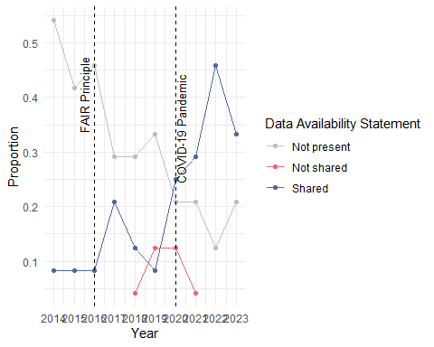

ggsave("DASyear.png", DASyear, width = 8, height = 6, bg = "white")

#Convert the Preprint numeric values to factor levels 'Yes' and 'No'  
data$Preprint <- factor(ifelse(data$Preprint == 1, "Yes", "No"))  
  
# Calculate the total count per year and proportion for Preprint  
proportion_data <- data %>%  
 group_by(Year) %>%  
 count(Preprint) %>%  
 mutate(Total = sum(n),   
 Proportion = n / Total)  
  
# Get all unique years for the x-axis  
all_years <- sort(unique(proportion_data$Year))  
  
# Define colors for 'Yes' and 'No'  
colors <- c("No" = "#E5696F", "Yes" = "#50689B")  
  
# Plot with every year on the x-axis for Preprint  
PreprintYear <- ggplot(proportion_data, aes(x = Year, y = Proportion, color = Preprint, group = Preprint)) +  
 geom_line() +  
 geom_point() +  
 geom_vline(xintercept = 2016, linetype = "dashed", color = "black") +  
 geom_vline(xintercept = 2020, linetype = "dashed", color = "black") +  
 annotate("text", x = 2016, y = max(proportion_data$Proportion), label = "FAIR Principle", angle = 90, hjust = 1.5, vjust = -0.5, size = 3.5) +  
 annotate("text", x = 2020, y = max(proportion_data$Proportion), label = "COVID-19 Pandemic", angle = 90, hjust = 1.5, vjust = 1, size = 3.5) +  
 scale_x_continuous(breaks = all_years) +  
 labs(x = "Year", y = "Proportion", color = "Preprint") +  
 theme(  
 axis.title = element_text(size = 10), # Increase axis titles  
 axis.text = element_text(size = 16), # Increase axis text  
 legend.title = element_text(size = 14), # Increase legend title  
 legend.text = element_text(size = 16) # Increase legend text  
 ) +  
 theme_minimal() +  
 scale_color_manual(values = colors)  
   
print(PreprintYear)

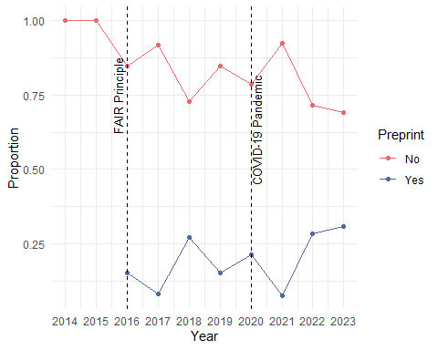

# Save the plot for Preprint  
ggsave("PreprintYear.png", PreprintYear, width = 8, height = 6, bg = "white")

#study if FAIR implementation and Covid19 have an effect on DAS and Preprint # 1- Fair implementataion

total_by_period <- data %>%  
 group_by(Period2016) %>%  
 summarise(Total = n(), .groups = "drop")  
  
# Join this total with the DAS and Preprint summaries and calculate the percentage  
Preprint_summary <- data %>%  
 group_by(Period2016, Preprint) %>%  
 summarise(Frequency = n(), .groups = "drop") %>%  
 left_join(total_by_period, by = "Period2016") %>%  
 mutate(Percentage = (Frequency / Total) * 100)  
  
# Print the Preprint summary table  
print(Preprint_summary)

## # A tibble: 4 × 5  
## Period2016 Preprint Frequency Total Percentage  
## <chr> <fct> <int> <int> <dbl>  
## 1 After 2016 No 72 90 80  
## 2 After 2016 Yes 18 90 20  
## 3 Before 2016 No 38 40 95  
## 4 Before 2016 Yes 2 40 5

Preprint_table <- table(data$Preprint, data$Period2016)  
  
# Perform the Chi-square test  
result <- chisq.test(Preprint_table)  
  
#Print the chi-square results  
print(result)

##   
## Pearson's Chi-squared test with Yates' continuity correction  
##   
## data: Preprint_table  
## X-squared = 3.7034, df = 1, p-value = 0.0543

# Get the expected values  
expected_values <- result$expected  
  
# Print the expected values  
print(expected_values) ##in order to check the assumption of chi square test: Each cell in the contingency table should have an expected count of 5 or more.

##   
## After 2016 Before 2016  
## No 76.15385 33.846154  
## Yes 13.84615 6.153846

#The assumptions of that test were met:  
  
#### Sample Size: Each cell in the contingency table has an expected count of 5 or more.   
#### Independence: The observations are independent of each other. This means that the selection of one observation should not influence or affect the selection of another observation.  
### Random Sampling: The data is a random sample.  
### Categorical Data: Both variables should be categorical (either nominal or ordinal).

total_by_period <- data %>%  
 group_by(Period2016) %>%  
 summarise(Total = n(), .groups = "drop")  
  
# Join this total with the NewDAS and Preprint summaries and calculate the percentage  
das_summary <- data %>%  
 group_by(Period2016, NewDAS)%>%  
 summarise(Frequency = n(), .groups = "drop") %>%  
 left_join(total_by_period, by = "Period2016") %>%  
 mutate(Percentage = (Frequency / Total) * 100)  
  
# Print the DAS summary table  
print(das_summary)

## # A tibble: 5 × 5  
## Period2016 NewDAS Frequency Total Percentage  
## <chr> <fct> <int> <int> <dbl>  
## 1 After 2016 Not present 40 90 44.4   
## 2 After 2016 Not shared 8 90 8.89  
## 3 After 2016 Shared 42 90 46.7   
## 4 Before 2016 Not present 34 40 85   
## 5 Before 2016 Shared 6 40 15

das_table <- table(data$NewDAS, data$Period2016)  
  
# Perform the Chi-square test  
result <- chisq.test(das_table)

## Warning in chisq.test(das_table): Chi-squared approximation may be incorrect

#Print the chi-square results  
print(result)

##   
## Pearson's Chi-squared test  
##   
## data: das_table  
## X-squared = 19.078, df = 2, p-value = 7.199e-05

# Get the expected values  
expected_values <- result$expected  
  
# Print the expected values  
print(expected_values) ##in order to check the assumption of chi square test: Each cell in the contingency table should have an expected count of 5 or more.

##   
## After 2016 Before 2016  
## Not present 51.230769 22.769231  
## Not shared 5.538462 2.461538  
## Shared 33.230769 14.769231

#The assumptions of that test were met:  
  
#### Sample Size: Each cell in the contingency table has an expected count of 5 or more.   
#### Independence: The observations are independent of each other. This means that the selection of one observation should not influence or affect the selection of another observation.  
### Random Sampling: The data is a random sample.  
### Categorical Data: Both variables should be categorical (either nominal or ordinal).

#2- Covid 19 # the impact of COVID-19 on Preprint

total_by_period <- data %>%  
 group_by(Period2020)%>%  
 summarise(Total = n(), .groups = "drop")  
  
# Join this total with the DAS and Preprint summaries and calculate the percentage  
Preprint_summary <- data %>%  
 group_by(Period2020, Preprint) %>%  
 summarise(Frequency = n(), .groups = "drop") %>%  
 left_join(total_by_period, by = "Period2020") %>%  
 mutate(Percentage = (Frequency / Total) * 100)  
  
# Print the Preprint summary table  
print(Preprint_summary)

## # A tibble: 4 × 5  
## Period2020 Preprint Frequency Total Percentage  
## <chr> <fct> <int> <int> <dbl>  
## 1 After 2020 No 31 40 77.5  
## 2 After 2020 Yes 9 40 22.5  
## 3 Before 2020 No 79 90 87.8  
## 4 Before 2020 Yes 11 90 12.2

Preprint_table <- table(data$Preprint, data$Period2020)  
  
# Perform the Chi-square test  
result <- chisq.test(Preprint_table)  
  
#Print the chi-square results  
print(result)

##   
## Pearson's Chi-squared test with Yates' continuity correction  
##   
## data: Preprint_table  
## X-squared = 1.5269, df = 1, p-value = 0.2166

# Get the expected values  
expected_values <- result$expected  
  
# Print the expected values  
print(expected_values) ##in order to check the assumption of chi square test: Each cell in the contingency table should have an expected count of 5 or more.

##   
## After 2020 Before 2020  
## No 33.846154 76.15385  
## Yes 6.153846 13.84615

#The assumptions of that test were met:  
  
#### Sample Size: Each cell in the contingency table has an expected count of 5 or more.   
#### Independence: The observations are independent of each other. This means that the selection of one observation should not influence or affect the selection of another observation.  
### Random Sampling: The data is a random sample.  
### Categorical Data: Both variables should be categorical (either nominal or ordinal)  
  
# the impact of COVID-19 on DAS  
  
total_by_period <- data %>%  
 group_by(Period2020) %>%  
 summarise(Total = n(), .groups = "drop")  
  
# Join this total with the NewDAS and Preprint summaries and calculate the percentage  
das_summary <- data %>%  
 group_by(Period2020, NewDAS)%>%  
 summarise(Frequency = n(), .groups = "drop") %>%  
 left_join(total_by_period, by = "Period2020") %>%  
 mutate(Percentage = (Frequency / Total) * 100)  
  
# Print the DAS summary table  
print(das_summary)

## # A tibble: 6 × 5  
## Period2020 NewDAS Frequency Total Percentage  
## <chr> <fct> <int> <int> <dbl>  
## 1 After 2020 Not present 13 40 32.5   
## 2 After 2020 Not shared 1 40 2.5   
## 3 After 2020 Shared 26 40 65   
## 4 Before 2020 Not present 61 90 67.8   
## 5 Before 2020 Not shared 7 90 7.78  
## 6 Before 2020 Shared 22 90 24.4

das_table <- table(data$NewDAS, data$Period2020)  
  
# Perform the Chi-square test  
result <- chisq.test(das_table)

## Warning in chisq.test(das_table): Chi-squared approximation may be incorrect

#Print the chi-square results  
print(result)

##   
## Pearson's Chi-squared test  
##   
## data: das_table  
## X-squared = 19.644, df = 2, p-value = 5.426e-05

# Get the expected values  
expected_values <- result$expected  
  
# Print the expected values  
print(expected_values) ##in order to check the assumption of chi square test: Each cell in the contingency table should have an expected count of 5 or more.

##   
## After 2020 Before 2020  
## Not present 22.769231 51.230769   
## Not shared 2.461538 5.538462   
## Shared 14.769231 33.230769

#The assumptions of that test were met:  
  
#### Sample Size: Each cell in the contingency table has an expected count of 5 or more.   
#### Independence: The observations are independent of each other. This means that the selection of one observation should not influence or affect the selection of another observation.  
### Random Sampling: The data is a random sample.  
### Categorical Data: Both variables should be categorical (either nominal or ordinal)

Image_summary <- data %>%  
 group_by(Image) %>%  
 summarise(count = n(), .groups = "drop")   
  
# Calculate the overall total  
overall_total <- sum(Image_summary$count)  
  
# Add a column for the percentage of each DAS category relative to the overall total  
Image_summary <- Image_summary %>%  
 mutate(percentage = (count / overall_total) * 100)  
  
print(Image_summary)

## # A tibble: 3 × 3  
## Image count percentage  
## <int> <int> <dbl>  
## 1 0 57 43.8   
## 2 1 11 8.46  
## 3 NA 62 47.7

data$DAS <- as.factor(data$DAS)  
  
# Frequency and Percentage of the papers with DAS in the publications  
data %>%  
 group_by(Type, Image) %>%  
 summarise(count = n(), .groups = "drop") %>%  
 group_by(Type) %>%  
 mutate(total = sum(count),   
 percentage = (count/total)*100) %>%  
 ungroup() %>%  
 arrange(Type, Image)

## # A tibble: 6 × 5  
## Type Image count total percentage  
## <chr> <int> <int> <int> <dbl>  
## 1 IQB3 0 32 80 40   
## 2 IQB3 1 2 80 2.5  
## 3 IQB3 NA 46 80 57.5  
## 4 Other 0 25 50 50   
## 5 Other 1 9 50 18   
## 6 Other NA 16 50 32

#plot the distribution of Image for each completeness score

# Transform the Image variable  
data <- data %>%  
 mutate(NewImage = case_when(  
 is.na(Image) ~ "Not used",  
 Image == 1 ~ "Shared",  
 Image == 0 ~ "Not shared",  
 TRUE ~ as.character(Image))) # This line is just a fallback to handle unexpected values  
  
class(data$NewImage)

## [1] "character"

# Convert the new DAS variable to a factor for plotting  
data$NewImage <- factor(data$NewImage, levels = c("Not used", "Not shared", "Shared"))  
  
# Calculate frequency and percentage for each combination of 'Complete' score and 'NewImage' status  
Image_frequency <- data %>%  
 group_by(Complete, NewImage) %>%  
 summarise(Frequency = n(), .groups = 'drop') %>%  
 mutate(Percentage = (Frequency / sum(Frequency)) * 100)  
  
# Define specific colors for the new Image values  
colors <- c("Not used" = "gray", "Not shared" = "#E5696F", "Shared" = "#50689B")  
  
# Create the plot  
Image_plot <- ggplot(Image_frequency, aes(x = as.factor(Complete), y = Frequency, fill = NewImage)) +  
 geom_bar(stat = "identity", position = "dodge") +  
 geom_text(aes(label = paste0(round(Percentage, 1), "% (", Frequency, ")")),  
 position = position_dodge(width = 0.9), vjust = -0.25, size = 3.5) +  
 scale_fill_manual(values = colors, name = "Image Status") +  
 theme_bw() + # Use theme_bw for a white background  
 theme(  
 axis.title = element_text(size = 10), # Increase axis titles  
 axis.text = element_text(size = 16), # Increase axis text  
 legend.title = element_text(size = 14), # Increase legend title  
 legend.text = element_text(size = 16) # Increase legend text  
 ) +  
 labs(x = "Completeness Score", y = "Frequency") +  
 theme(legend.position = "bottom")  
  
# Print and save the plot  
print(Image_plot)

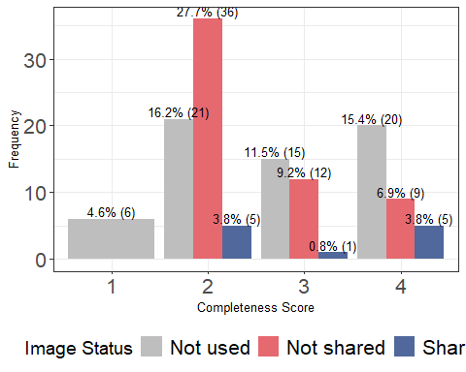

ggsave("new_Image_distribution_plot.png", Image_plot, width = 8, height = 6, bg = "white")

# Calculate the total count per year  
yearly_totals <- data %>%  
 group_by(Year) %>%  
 summarise(Total = n(), .groups = 'drop')  
  
# Join the totals back to the original data and calculate proportions  
proportion_data <- data %>%  
 left_join(yearly_totals, by = "Year") %>%  
 group_by(Year, NewImage) %>%  
 summarise(Count = n(), .groups = 'drop') %>%  
 mutate(Proportion = Count / n())  
  
# Get all unique years for the x-axis  
all_years <- sort(unique(proportion_data$Year))  
  
colors <- c("Not used" = "#828282", "Not shared" = "#E5696F", "Shared" = "#50689B")  
  
# Plot with every year on the x-axis  
Imageyear <- ggplot(proportion_data, aes(x = Year, y = Proportion, color = NewImage, group = NewImage)) +  
 geom_line() +  
 geom_point() +  
 geom_vline(xintercept = 2016, linetype = "dashed", color = "black") +  
 geom_vline(xintercept = 2020, linetype = "dashed", color = "black") +  
 annotate("text", x = 2016, y = max(proportion_data$Proportion), label = "FAIR Principle", angle = 90, hjust = 1.5, vjust = -0.5, size = 3.5) +  
 annotate("text", x = 2020, y = max(proportion_data$Proportion), label = "COVID-19 Pandemic", angle = 90, hjust = 1.5, vjust = 1, size = 3.5) +  
 scale_x_continuous(breaks = all_years) +  
 labs(x = "Year", y = "Proportion", color = "Image") +  
 theme(  
 axis.title = element_text(size = 10), # Increase axis titles  
 axis.text = element_text(size = 16), # Increase axis text  
 legend.title = element_text(size = 14), # Increase legend title  
 legend.text = element_text(size = 16) # Increase legend text  
 ) +  
 theme_minimal() +  
 scale_color_manual(values = colors)  
   
print(Imageyear)

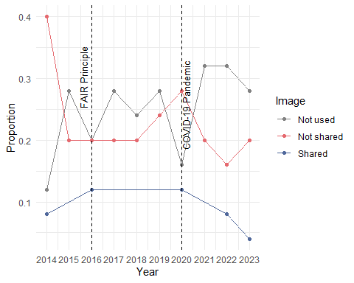

ggsave("Imageyear.png", Imageyear, width = 8, height = 6, bg = "white")

#Chi square test to assess if there is any difference in Image between the two types (IQB3, Other)

# Create a contingency table  
table_Image <- table(data$Type, data$Image)  
  
# Perform the Chi-square test  
result <- chisq.test(table_Image)  
  
#Print the chi-square results  
print(result)

##   
## Pearson's Chi-squared test with Yates' continuity correction  
##   
## data: table_Image  
## X-squared = 3.9043, df = 1, p-value = 0.04816

# Get the expected values  
expected_values <- result$expected  
  
# Print the expected values  
print(expected_values) ##in order to check the assumption of chi square test: Each cell in the contingency table should have an expected count of 5 or more.

##   
## 0 1  
## IQB3 28.5 5.5  
## Other 28.5 5.5

#The assumptions of that test were met:  
  
#### Sample Size: Each cell in the contingency table has an expected count of 5 or more.   
#### Independence: The observations are independent of each other. This means that the selection of one observation should not influence or affect the selection of another observation.  
### Random Sampling: The data is a random sample.  
### Categorical Data: Both variables should be categorical (either nominal or ordinal).

Genomics_summary <- data %>%  
 group_by(Genomics) %>%  
 summarise(count = n(), .groups = "drop")   
  
# Calculate the overall total  
overall_total <- sum(Genomics_summary$count)  
  
# Add a column for the percentage of each Genomics category relative to the overall total  
Genomics_summary <- Genomics_summary %>%  
 mutate(percentage = (count / overall_total) * 100)  
  
print(Genomics_summary)

## # A tibble: 3 × 3  
## Genomics count percentage  
## <int> <int> <dbl>  
## 1 0 27 20.8  
## 2 1 27 20.8  
## 3 NA 76 58.5

data$Genomics <- as.factor(data$Genomics)  
  
# Frequency and Percentage of the papers with Genomics in the publications  
data %>%  
 group_by(Type, Genomics) %>%  
 summarise(count = n(), .groups = "drop") %>%  
 group_by(Type) %>%  
 mutate(total = sum(count),   
 percentage = (count/total)*100) %>%  
 ungroup() %>%  
 arrange(Type, Genomics)

## # A tibble: 6 × 5  
## Type Genomics count total percentage  
## <chr> <fct> <int> <int> <dbl>  
## 1 IQB3 0 17 80 21.2  
## 2 IQB3 1 15 80 18.8  
## 3 IQB3 <NA> 48 80 60   
## 4 Other 0 10 50 20   
## 5 Other 1 12 50 24   
## 6 Other <NA> 28 50 56

#plot the distribution of Genomics for each completeness score

# Transform the Genomics variable  
data <- data %>%  
 mutate(NewGenomics = case_when(  
 is.na(Genomics) ~ "Not used",  
 Genomics == 1 ~ "Shared",  
 Genomics == 0 ~ "Not shared",  
 TRUE ~ as.character(Genomics))) # This line is just a fallback to handle unexpected values  
  
class(data$NewGenomics)

## [1] "character"

# Convert the new Genomic variable to a factor for plotting  
data$NewGenomics <- factor(data$NewGenomics, levels = c("Not used", "Not shared", "Shared"))  
  
# Calculate frequency and percentage for each combination of 'Complete' score and 'NewGenomics' status  
Genomics_frequency <- data %>%  
 group_by(Complete, NewGenomics) %>%  
 summarise(Frequency = n(), .groups = 'drop') %>%  
 mutate(Percentage = (Frequency / sum(Frequency)) * 100)  
  
# Define specific colors for the new Genomics values  
colors <- c("Not used" = "gray", "Not shared" = "#E5696F", "Shared" = "#50689B")  
  
# Create the plot  
Genomics_plot <- ggplot(Genomics_frequency, aes(x = as.factor(Complete), y = Frequency, fill = NewGenomics)) +  
 geom_bar(stat = "identity", position = "dodge") +  
 geom_text(aes(label = paste0(round(Percentage, 1), "% (", Frequency, ")")),  
 position = position_dodge(width = 0.9), vjust = -0.25, size = 3.5) +  
 scale_fill_manual(values = colors, name = "Genomics Status") +  
 theme_bw() + # Use theme_bw for a white background  
 theme(  
 axis.title = element_text(size = 10), # Increase axis titles  
 axis.text = element_text(size = 16), # Increase axis text  
 legend.title = element_text(size = 14), # Increase legend title  
 legend.text = element_text(size = 16) # Increase legend text  
 ) +  
 labs(x = "Completeness Score", y = "Frequency") +  
 theme(legend.position = "bottom")  
  
# Print and save the plot  
print(Genomics_plot)

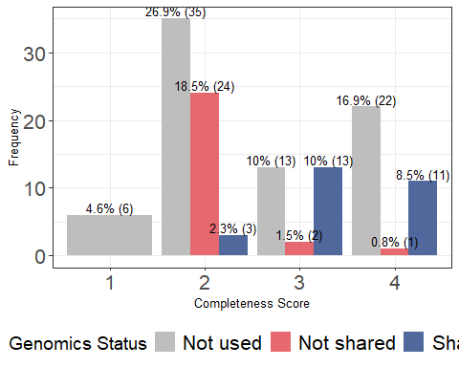

ggsave("new_Genomics_distribution_plot.png", Image_plot, width = 8, height = 6, bg = "white")

# Calculate the total count per year  
yearly_totals <- data %>%  
 group_by(Year) %>%  
 summarise(Total = n(), .groups = 'drop')  
  
# Join the totals back to the original data and calculate proportions  
proportion_data <- data %>%  
 left_join(yearly_totals, by = "Year") %>%  
 group_by(Year, NewGenomics) %>%  
 summarise(Count = n(), .groups = 'drop') %>%  
 mutate(Proportion = Count / n())  
  
# Get all unique years for the x-axis  
all_years <- sort(unique(proportion_data$Year))  
  
colors <- c("Not used" = "#828282", "Not shared" = "#E5696F", "Shared" = "#50689B")  
  
# Plot with every year on the x-axis  
Genomicsyear <- ggplot(proportion_data, aes(x = Year, y = Proportion, color = NewGenomics, group = NewGenomics)) +  
 geom_line() +  
 geom_point() +  
 geom_vline(xintercept = 2016, linetype = "dashed", color = "black") +  
 geom_vline(xintercept = 2020, linetype = "dashed", color = "black") +  
 annotate("text", x = 2016, y = max(proportion_data$Proportion), label = "FAIR Principle", angle = 90, hjust = 1.5, vjust = -0.5, size = 3.5) +  
 annotate("text", x = 2020, y = max(proportion_data$Proportion), label = "COVID-19 Pandemic", angle = 90, hjust = 1.5, vjust = 1, size = 3.5) +  
 scale_x_continuous(breaks = all_years) +  
 labs(x = "Year", y = "Proportion", color = "Genomics") +  
 theme(  
 axis.title = element_text(size = 10), # Increase axis titles  
 axis.text = element_text(size = 16), # Increase axis text  
 legend.title = element_text(size = 14), # Increase legend title  
 legend.text = element_text(size = 16) # Increase legend text  
 ) +  
 theme_minimal() +  
 scale_color_manual(values = colors)  
   
print(Genomicsyear)

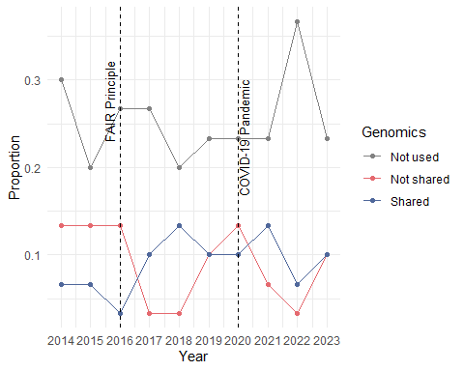

ggsave("Genomicsyear.png", Genomicsyear, width = 8, height = 6, bg = "white")

# Create a contingency table  
table_Genomics <- table(data$Type, data$Genomics)  
  
# Perform the Chi-square test  
result <- chisq.test(table_Genomics)  
  
#Print the chi-square results  
print(result)

##   
## Pearson's Chi-squared test with Yates' continuity correction  
##   
## data: table_Genomics  
## X-squared = 0.076705, df = 1, p-value = 0.7818

# Get the expected values  
expected_values <- result$expected  
  
# Print the expected values  
print(expected_values) ##in order to check the assumption of chi square test: Each cell in the contingency table should have an expected count of 5 or more.

##   
## 0 1  
## IQB3 16 16  
## Other 11 11

#The assumptions of that test were met:  
  
#### Sample Size: Each cell in the contingency table has an expected count of 5 or more.   
#### Independence: The observations are independent of each other. This means that the selection of one observation should not influence or affect the selection of another observation.  
### Random Sampling: The data is a random sample.  
### Categorical Data: Both variables should be categorical (either nominal or ordinal).

Proteometabolomic_summary <- data %>%  
 group_by(Proteometabolomic) %>%  
 summarise(count = n(), .groups = "drop")   
  
# Calculate the overall total  
overall_total <- sum(Proteometabolomic_summary$count)  
  
# Add a column for the percentage of each Proteometabolomic category relative to the overall total  
Proteometabolomic_summary <- Proteometabolomic_summary %>%  
 mutate(percentage = (count / overall_total) * 100)  
  
print(Proteometabolomic_summary)

## # A tibble: 3 × 3  
## Proteometabolomic count percentage  
## <int> <int> <dbl>  
## 1 0 34 26.2   
## 2 1 10 7.69  
## 3 NA 86 66.2

data$Proteometabolomic <- as.factor(data$Proteometabolomic)  
  
# Frequency and Percentage of the papers with Proteometabolomic in the publications  
data %>%  
 group_by(Type, Proteometabolomic) %>%  
 summarise(count = n(), .groups = "drop") %>%  
 group_by(Type) %>%  
 mutate(total = sum(count),   
 percentage = (count/total)*100) %>%  
 ungroup() %>%  
 arrange(Type, Proteometabolomic)

## # A tibble: 6 × 5  
## Type Proteometabolomic count total percentage  
## <chr> <fct> <int> <int> <dbl>  
## 1 IQB3 0 25 80 31.2  
## 2 IQB3 1 8 80 10   
## 3 IQB3 <NA> 47 80 58.8  
## 4 Other 0 9 50 18   
## 5 Other 1 2 50 4   
## 6 Other <NA> 39 50 78

#plot the distribution of Proteometabolomic for each completeness score

library(dplyr)  
library(ggplot2)  
  
# Transform the Proteometabolomic variable   
data <- data %>%  
 mutate(NewProteometabolomic = case_when(  
 is.na(Proteometabolomic) ~ "Not used",  
 Proteometabolomic == 1 ~ "Shared",  
 Proteometabolomic == 0 ~ "Not shared",  
 TRUE ~ as.character(Proteometabolomic)))   
  
# Convert the new New Proteometabolomic variable to a factor for plotting  
data$NewProteometabolomic <- factor(data$NewProteometabolomic, levels = c("Not used", "Not shared", "Shared"))  
  
# Calculate frequency and percentage for each combination of 'Complete' score and 'NewProteometabolomic' status  
Proteometabolomic_frequency <- data %>%  
 count(Complete, NewProteometabolomic) %>%  
 group_by(Complete) %>%  
 mutate(Percentage = (n / sum(n)) * 100) %>%  
 ungroup()  
  
# Define specific colors for the Proteometabolomic values  
colors <- c("Not used" = "gray", "Not shared" = "#E5696F", "Shared" = "#50689B")  
  
# Create the plot  
Proteometabolomic_plot <- ggplot(Proteometabolomic_frequency, aes(x = as.factor(Complete), y = n, fill = NewProteometabolomic)) +  
 geom_bar(stat = "identity", position = "dodge") +  
 geom_text(aes(label = paste0(round(Percentage, 1), "% (", n, ")")),  
 position = position_dodge(width = 0.9), vjust = -0.25, size = 3.5) +  
 scale_fill_manual(values = colors, name = "Proteometabolomic Status") +  
 theme_bw() +   
 theme(  
 axis.title = element_text(size = 10),   
 axis.text = element_text(size = 16),   
 legend.title = element_text(size = 14),   
 legend.text = element_text(size = 16)   
 ) +  
 labs(x = "Completeness Score", y = "Frequency") +  
 theme(legend.position = "bottom")  
  
# Print and save the plot  
print(Proteometabolomic_plot)

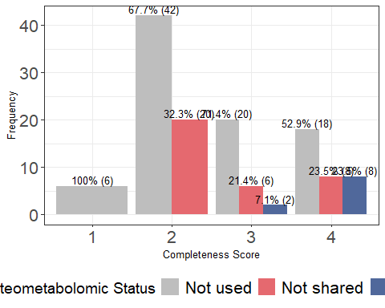

ggsave("new_Proteometabolomic_distribution_plot.png", Proteometabolomic_plot, width = 8, height = 6, bg = "white")

# Calculate the total count per year  
yearly_totals <- data %>%  
 group_by(Year) %>%  
 summarise(Total = n(), .groups = 'drop')  
  
# Join the totals back to the original data and calculate proportions  
proportion_data <- data %>%  
 left_join(yearly_totals, by = "Year") %>%  
 group_by(Year, NewProteometabolomic) %>%  
 summarise(Count = n(), .groups = 'drop') %>%  
 mutate(Proportion = Count / n())  
  
# Get all unique years for the x-axis  
all_years <- sort(unique(proportion_data$Year))  
  
colors <- c("Not used" = "#828282", "Not shared" = "#E5696F", "Shared" = "#50689B")  
  
# Plot with every year on the x-axis  
Proteometabolomicyear <- ggplot(proportion_data, aes(x = Year, y = Proportion, color = NewProteometabolomic, group = NewProteometabolomic)) +  
 geom_line() +  
 geom_point() +  
 geom_vline(xintercept = 2016, linetype = "dashed", color = "black") +  
 geom_vline(xintercept = 2020, linetype = "dashed", color = "black") +  
 annotate("text", x = 2016, y = max(proportion_data$Proportion), label = "FAIR Principle", angle = 90, hjust = 1.5, vjust = -0.5, size = 3.5) +  
 annotate("text", x = 2020, y = max(proportion_data$Proportion), label = "COVID-19 Pandemic", angle = 90, hjust = 1.5, vjust = 1, size = 3.5) +  
 scale_x_continuous(breaks = all_years) +  
 labs(x = "Year", y = "Proportion", color = "Proteometabolomic") +  
 theme(  
 axis.title = element_text(size = 10), # Increase axis titles  
 axis.text = element_text(size = 16), # Increase axis text  
 legend.title = element_text(size = 14), # Increase legend title  
 legend.text = element_text(size = 16) # Increase legend text  
 ) +  
 theme_minimal() +  
 scale_color_manual(values = colors)  
   
print(Proteometabolomicyear)

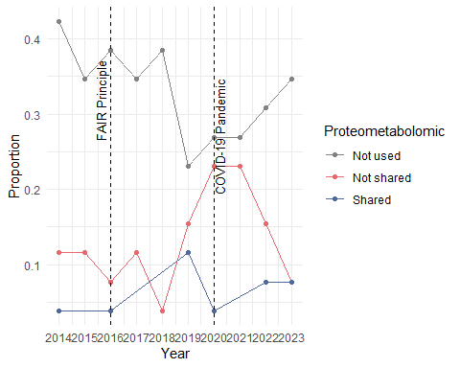

ggsave("Proteometabolomicyear.png", Proteometabolomicyear, width = 8, height = 6, bg = "white")

# Create a contingency table  
table_Proteometabolomic <- table(data$Type, data$Proteometabolomic)  
  
# Perform the Chi-square test  
result <- chisq.test(table_Proteometabolomic)

## Warning in chisq.test(table_Proteometabolomic): Chi-squared approximation may  
## be incorrect

#Print the chi-square results  
print(result)

##   
## Pearson's Chi-squared test with Yates' continuity correction  
##   
## data: table_Proteometabolomic  
## X-squared = 0, df = 1, p-value = 1

# Get the expected values  
expected_values <- result$expected  
  
# Print the expected values  
print(expected_values) ##in order to check the assumption of chi square test: Each cell in the contingency table should have an expected count of 5 or more.

##   
## 0 1  
## IQB3 25.5 7.5  
## Other 8.5 2.5

#The assumptions of that test were met:  
  
#### Sample Size: Each cell in the contingency table has an expected count of 5 or more.   
#### Independence: The observations are independent of each other. This means that the selection of one observation should not influence or affect the selection of another observation.  
### Random Sampling: The data is a random sample.  
### Categorical Data: Both variables should be categorical (either nominal or ordinal).

# Load the data  
data <- read.csv("datarecord.csv")  
  
# Plot using ggplot2  
ggplot(data, aes(x = Year, y = CitationsPA)) +  
 geom_point() + # Add points  
 geom_smooth(method = "lm", se = FALSE, color = "blue") + # Add a linear trend line without confidence interval  
 labs(title = "Average Citations Per Annum Over Years",   
 x = "Year",   
 y = "Average Citations Per Annum") +  
 theme_minimal()

## `geom_smooth()` using formula = 'y ~ x'

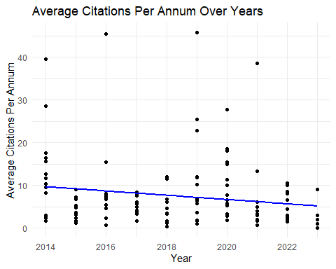 #add the difference between high and low completeness score

df <- read.csv("datarecord.csv")  
  
# Ensure the 'Complete' and 'CitationsPA' columns are correctly formatted  
# 'Complete' should be numeric or integer, and 'CitationsPA' should be numeric.  
# If not, you might need to convert them, for example:  
# df$Complete <- as.numeric(df$Complete)  
# df$CitationsPA <- as.numeric(df$CitationsPA)  
  
# Step 1: Split the data into two groups based on 'Complete' scores  
group1 <- df$CitationsPA[df$Complete %in% c(1,2)]  
group2 <- df$CitationsPA[df$Complete %in% c(3,4)]  
  
# Ensure that there are no NA values that could affect the t-test  
# This step is optional but recommended  
group1 <- na.omit(group1)  
group2 <- na.omit(group2)  
  
# Step 2: Conduct a T-test to compare the mean citation counts between the two groups  
t_test_result <- t.test(group1, group2)  
  
# Display the t-test results  
print(t_test_result)

##   
## Welch Two Sample t-test  
##   
## data: group1 and group2  
## t = -0.22511, df = 127.94, p-value = 0.8223  
## alternative hypothesis: true difference in means is not equal to 0  
## 95 percent confidence interval:  
## -3.232464 2.572094  
## sample estimates:  
## mean of x mean of y   
## 7.229044 7.559229

# Additional: Display mean citations for insight  
mean_group1 <- mean(group1)  
mean_group2 <- mean(group2)  
  
cat("Mean citation counts for Completeness 1-2:", mean_group1, "\n")

## Mean citation counts for Completeness 1-2: 7.229044

cat("Mean citation counts for Completeness 3-4:", mean_group2, "\n")

## Mean citation counts for Completeness 3-4: 7.559229

# Assuming 'data' is your DataFrame and has been loaded correctly  
# Transform the PI Group Leader variable  
data <- data %>%  
 mutate(PIGroupLeaderStatus = case_when(  
 PIGroupLeader == 1 ~ "Group Leader",  
 PIGroupLeader == 0 ~ "Not Group Leader",  
 TRUE ~ as.character(PIGroupLeader))) # Fallback for unexpected values  
  
# Check the class of the new variable  
class(data$PIGroupLeaderStatus)

## [1] "character"

# Convert the new PI Group Leader variable to a factor for plotting  
data <- data %>%  
 mutate(PIGroupLeaderStatus = factor(PIGroupLeaderStatus, levels = c("Not Group Leader", "Group Leader")))  
  
# Calculate frequency and percentage for each 'Complete' score and 'PIGroupLeaderStatus'  
pi_group_frequency <- data %>%  
 group_by(Complete, PIGroupLeaderStatus) %>%  
 summarise(Frequency = n(), .groups = 'drop') %>%  
 mutate(Percentage = (Frequency / sum(Frequency)) * 100)  
  
# Define specific colors for the PI Group Leader status  
colors <- c("Not Group Leader" = "#E5696F", " Group Leader" = "#50689B")  
  
# Create the plot  
pi_group_plot <- ggplot(pi_group_frequency, aes(x = as.factor(Complete), y = Frequency, fill = PIGroupLeaderStatus)) +  
 geom_bar(stat = "identity", position = "dodge") +  
 geom_text(aes(label = paste0(round(Percentage, 1), "% (", Frequency, ")")),  
 position = position_dodge(width = 0.9), vjust = -0.25, size = 3.5) +  
 scale_fill_manual(values = colors, name = "PI Group Status") +  
 theme_bw() +  
 theme(  
 axis.title = element_text(size = 10),  
 axis.text = element_text(size = 16),  
 legend.title = element_text(size = 14),  
 legend.text = element_text(size = 16)  
 ) +  
 labs(x = "Completeness Score", y = "Frequency") +  
 theme(legend.position = "bottom")  
  
# Print the plot  
print(pi_group_plot)

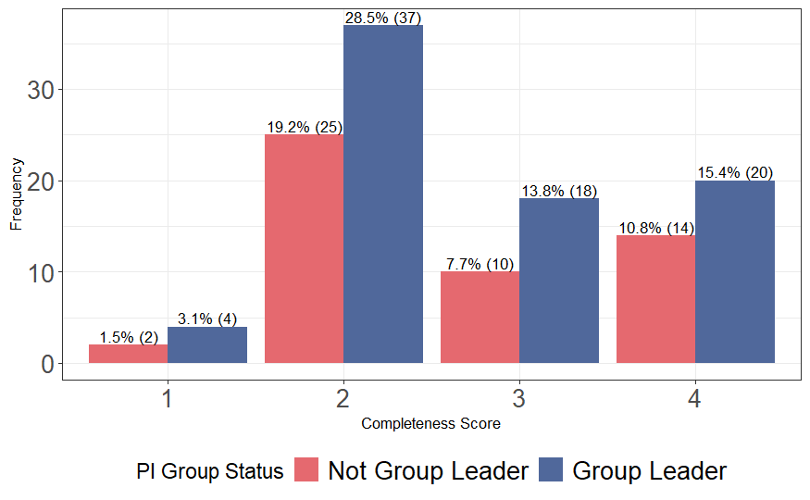

# Save the plot to a file  
ggsave("pi_group_status_distribution_plot.png", pi_group_plot, width = 8, height = 6, bg = "white")

#Convert the PIGroupLeader numeric values to factor levels 'Yes' and 'No'  
data$PIGroupLeader <- factor(ifelse(data$PIGroupLeader == 1, "Yes", "No"))  
  
# Calculate the total count per year and proportion for PIGroupLeader  
proportion_data <- data %>%  
 group_by(Year) %>%  
 count(PIGroupLeader) %>%  
 mutate(Total = sum(n),   
 Proportion = n / Total)  
  
# Get all unique years for the x-axis  
all_years <- sort(unique(proportion_data$Year))  
  
# Define colors for 'Yes' and 'No'  
colors <- c("No" = "#E5696F", "Yes" = "#50689B")  
  
# Plot with every year on the x-axis for PIGroupLeader  
PIGroupLeaderYear <- ggplot(proportion_data, aes(x = Year, y = Proportion, color = PIGroupLeader, group = PIGroupLeader)) +  
 geom_line() +  
 geom_point() +  
 geom_vline(xintercept = 2016, linetype = "dashed", color = "black") +  
 geom_vline(xintercept = 2020, linetype = "dashed", color = "black") +  
 annotate("text", x = 2016, y = max(proportion_data$Proportion), label = "FAIR Principle", angle = 90, hjust = 1.5, vjust = -0.5, size = 3.5) +  
 annotate("text", x = 2020, y = max(proportion_data$Proportion), label = "COVID-19 Pandemic", angle = 90, hjust = 1.5, vjust = 1, size = 3.5) +  
 scale_x_continuous(breaks = all_years) +  
 labs(x = "Year", y = "Proportion", color = "PIGroupLeader") +  
 theme(  
 axis.title = element_text(size = 10), # Increase axis titles  
 axis.text = element_text(size = 16), # Increase axis text  
 legend.title = element_text(size = 14), # Increase legend title  
 legend.text = element_text(size = 16) # Increase legend text  
 ) +  
 theme_minimal() +  
 scale_color_manual(values = colors)  
   
print(PIGroupLeaderYear)

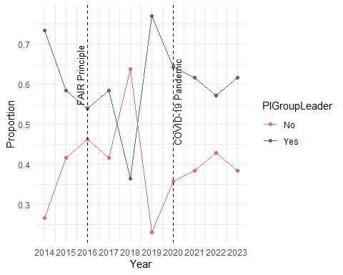

# Save the plot for PIGroupLeader  
ggsave("PIGroupLeader.png", PIGroupLeaderYear, width = 8, height = 6, bg = "white")

# Assuming 'data' is your DataFrame and has been loaded correctly  
# Transform the completeness score into a binary variable (high vs. low)  
data <- data %>%  
 mutate(CompletenessCategory = case_when(  
 Complete %in% 3:4 ~ "High",  
 Complete %in% 1:2 ~ "Low",  
 TRUE ~ NA_character_ # Handle potential unexpected values  
 ))  
  
# Drop rows with NA in CompletenessCategory if any exist due to unexpected values  
data <- data %>% filter(!is.na(CompletenessCategory))  
  
# Create a contingency table  
contingency_table <- table(data$PIGroupLeader, data$CompletenessCategory)  
  
# Conduct a Chi-square test of independence  
chi_square_result <- chisq.test(contingency_table)  
  
# Print the result of the Chi-square test  
print(chi_square_result)

##   
## Pearson's Chi-squared test with Yates' continuity correction  
##   
## data: contingency_table  
## X-squared = 6.4044e-31, df = 1, p-value = 1

# Calculate frequency and percentage for each Funding Source across all types  
FundingSource_summary <- data %>%  
 group_by(FundingSource) %>%  
 summarise(count = n(), .groups = "drop")   
  
# Calculate the overall total  
overall_total <- sum(FundingSource_summary$count)  
  
# Add a column for the percentage of each FundingSource category relative to the overall total  
FundingSource_summary <- FundingSource_summary %>%  
 mutate(percentage = (count / overall_total) * 100)  
  
# Print the summary  
print(FundingSource_summary)

## # A tibble: 2 × 3  
## FundingSource count percentage  
## <int> <int> <dbl>  
## 1 0 124 95.4   
## 2 1 6 4.62

# Frequency and Percentage of the papers with FundingSource  
data %>%  
 group_by(Type, FundingSource) %>%  
 summarise(count = n(), .groups = "drop") %>%  
 group_by(Type) %>%  
 mutate(total = sum(count),   
 percentage = (count/total)*100) %>%  
 ungroup() %>%  
 arrange(Type, FundingSource)

## # A tibble: 4 × 5  
## Type FundingSource count total percentage  
## <chr> <int> <int> <int> <dbl>  
## 1 IQB3 0 75 80 93.8   
## 2 IQB3 1 5 80 6.25  
## 3 Other 0 49 50 98   
## 4 Other 1 1 50 2

# Assuming 'data' is your DataFrame and has been loaded correctly  
# Transform the Funding Source variable  
data <- data %>%  
 mutate(FundingSourceStatus = case_when(  
 FundingSource == 1 ~ "Commercial",  
 FundingSource == 0 ~ "Not Commercial",  
 TRUE ~ as.character(FundingSource) # Fallback for unexpected values  
 ))  
  
# Check the class of the new variable  
class(data$FundingSourceStatus)

## [1] "character"

# Convert the new Funding Source Status variable to a factor for plotting  
data <- data %>%  
 mutate(FundingSourceStatus = factor(FundingSourceStatus, levels = c("Not Commercial", "Commercial")))  
  
# Calculate frequency and percentage for each 'Complete' score and 'Funding Source Status'  
FundingSource_frequency <- data %>%  
 group_by(Complete, FundingSourceStatus) %>%  
 summarise(Frequency = n(), .groups = 'drop') %>%  
 mutate(Percentage = (Frequency / sum(Frequency)) * 100)  
  
# Define specific colors for the Funding Source status  
colors <- c("Not Commercial" = "#E5696F", "Commercial" = "#50689B") # Correct the color names to match factor levels  
  
# Create the plot  
FundingSource_plot <- ggplot(FundingSource_frequency, aes(x = as.factor(Complete), y = Frequency, fill = FundingSourceStatus)) +  
 geom_bar(stat = "identity", position = "dodge") +  
 geom_text(aes(label = paste0(round(Percentage, 1), "% (", Frequency, ")")),  
 position = position_dodge(width = 0.9), vjust = -0.25, size = 3.5) +  
 scale_fill_manual(values = colors, name = "Funding Source Status") + # Ensure the name matches the legend  
 theme_bw() +  
 theme(  
 axis.title = element_text(size = 10),  
 axis.text = element_text(size = 16),  
 legend.title = element_text(size = 14),  
 legend.text = element_text(size = 16),  
 legend.position = "bottom"  
 ) +  
 labs(x = "Completeness Score", y = "Frequency")  
  
# Print the plot  
print(FundingSource_plot)

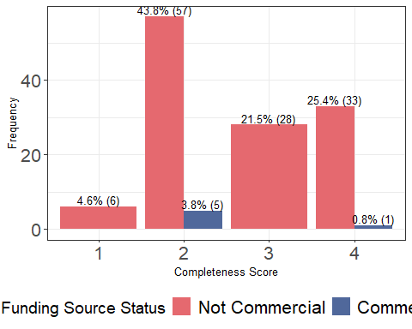

# Save the plot to a file  
ggsave("FundingSource_status_distribution_plot.png", FundingSource_plot, width = 8, height = 6, bg = "white")

# Assuming 'data' is your DataFrame and has been loaded correctly  
library(dplyr)  
  
# Transform the Completeness score into a binary variable (high vs. low)  
data <- data %>%  
 mutate(CompletenessCategory = case_when(  
 Complete %in% 3:4 ~ "High",  
 Complete %in% 1:2 ~ "Low",  
 TRUE ~ NA_character_ # Handle potential unexpected values  
 ))  
  
# Assuming FundingSource is already in a format that can be directly categorized  
# If not, you should transform FundingSource into categorical variable similar to CompletenessCategory  
# Example transformation is shown in the comment below. Adjust it based on your data structure.  
# data <- data %>%  
# mutate(FundingSourceCategory = case_when(  
# FundingSource == some_condition ~ "Category1",  
# FundingSource == another_condition ~ "Category2",  
# TRUE ~ NA_character_ # Handle potential unexpected values  
# ))  
  
# Drop rows with NA in either category if any exist due to unexpected values  
data <- data %>%   
 filter(!is.na(CompletenessCategory) & !is.na(FundingSource))  
  
# Create a contingency table  
contingency_table <- table(data$CompletenessCategory, data$FundingSource)  
  
# Conduct a Chi-square test of independence  
chi_square_result <- chisq.test(contingency_table)

## Warning in chisq.test(contingency_table): Chi-squared approximation may be  
## incorrect

# Print the result of the Chi-square test  
print(chi_square_result)

# Print the result of the Chi-square test  
print(chi_square_result)

##   
## Pearson's Chi-squared test with Yates' continuity correction  
##   
## data: contingency_table  
## X-squared = 1.2984, df = 1, p-value = 0.2545

#2 - Ordinal regression models (Scoring Criteria and year)

library(ordinal) # ordinal logistic regression: cumulative link mixed models, clm function is in this package; For a detailed explanation of the package and the functions available see: https://cran.r-project.org/web/packages/ordinal/vignettes/clm_article.pdf

## Warning: package 'ordinal' was built under R version 4.2.3

##   
## Attaching package: 'ordinal'

## The following object is masked from 'package:dplyr':  
##   
## slice

library(VGAM) # more ordinal regression

## Warning: package 'VGAM' was built under R version 4.2.3

## Loading required package: stats4

## Loading required package: splines

##   
## Attaching package: 'VGAM'

## The following objects are masked from 'package:ordinal':  
##   
## dgumbel, dlgamma, pgumbel, plgamma, qgumbel, rgumbel, wine

library(dplyr) # Data manipulation  
library(chisq.posthoc.test) # If needed

## Warning: package 'chisq.posthoc.test' was built under R version 4.2.3

library(gmodels) # For SPSS style chi-sq/ contingency tables

## Warning: package 'gmodels' was built under R version 4.2.3

library(emmeans)

## Warning: package 'emmeans' was built under R version 4.2.3

library(sure)

## Warning: package 'sure' was built under R version 4.2.3

data$Complete <- factor(data$Complete, ordered = TRUE)  
data$Reuse <- factor(data$Reuse, ordered = TRUE)  
data$Access <- factor(data$Access, ordered = TRUE)  
data$Licence <- factor(data$Licence, ordered = TRUE)  
data$Year <- as.numeric(data$Year)

#Ordinal regression model for the Completeness by year

m1a <- clm(Complete ~ Year, data = data)

## Warning in x$code == 0L || action == "silent": 'length(x) = 2 > 1' in coercion  
## to 'logical(1)'

## Warning: (2) Model is nearly unidentifiable: very large eigenvalue  
## - Rescale variables?   
## In addition: Absolute and relative convergence criteria were met

summary_m1a <- summary(m1a)   
  
# Extract coefficients and standard errors  
coefs <- summary(m1a)$coefficients  
OR <- exp(coefs[,1])  
lower_ci <- exp(coefs[,1] - 1.96 * coefs[,2])  
upper_ci <- exp(coefs[,1] + 1.96 * coefs[,2])  
  
# Calculate z-values and p-values  
z_values <- coefs[,1] / coefs[,2]  
p_values <- 2 * (1 - pnorm(abs(z_values)))  
  
# Combine everything into a data frame for easy viewing  
results <- data.frame(OR = OR, LowerCI = lower_ci, UpperCI = upper_ci, p_value = p_values)  
print(results)

## OR LowerCI UpperCI p_value  
## 1|2 1.622844e+151 2.282840e+50 1.153661e+252 0.003296030  
## 2|3 4.125302e+152 5.138138e+51 3.312117e+253 0.003032294  
## 3|4 1.117896e+153 1.334844e+52 9.362075e+253 0.002955632  
## Year 1.190114e+00 1.060719e+00 1.335293e+00 0.003038852

#Check the Assumptions   
nominal_test(m1a) # This is a test of the proportional odds assumption, odds are proportional in this case.

## Tests of nominal effects  
##   
## formula: Complete ~ Year  
## Df logLik AIC LRT Pr(>Chi)  
## <none> -148.39 304.78   
## Year

scale_test(m1a) # scale test checks for equal variance/ scale across year, assumptions are not violated here because p = 0.8386. If p is less than 0.05 then assumptions are violated

## Warning: (-1) Model failed to converge with max|grad| = 154.368 (tol = 1e-06)   
## In addition: iteration limit reached

## Tests of scale effects  
##   
## formula: Complete ~ Year  
## Df logLik AIC LRT Pr(>Chi)  
## <none> -148.39 304.78   
## Year

convergence(m1a) # This is another way to assess the model

## nobs logLik niter max.grad cond.H logLik.Error  
## 130 -148.39 7(0) 6.62e-10 6.3e+12 <1e-10   
##   
## Estimate Std.Err Gradient Error Cor.Dec Sig.Dig  
## 1|2 348.175 118.47952 -8.05e-14 -9.96e-11 9 12  
## 2|3 351.410 118.54160 4.79e-13 -9.97e-11 9 12  
## 3|4 352.407 118.56313 -7.34e-13 -9.97e-11 9 12  
## Year 0.174 0.05873 6.62e-10 -4.94e-14 13 13  
##   
## Eigen values of Hessian:  
## 1.484e+08 6.886e+01 8.253e+00 2.371e-05   
##   
## Convergence message from clm:  
## (2) Model is nearly unidentifiable: very large eigenvalue  
## - Rescale variables?   
## (3) Model is nearly unidentifiable: large eigenvalue ratio  
## - Rescale variables?   
## In addition: Absolute and relative convergence criteria were met

######## Graphically validate proportional odds using the sure package #######  
  
autoplot.clm(m1a, what = c("qq")) # most of the points fall along the line, so no violation of linearity

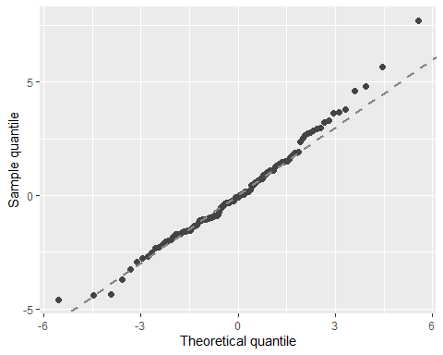

autoplot.clm(m1a, what = c("fitted")) # the residuals do not show a clear pattern or trend

## `geom_smooth()` using method = 'loess' and formula = 'y ~ x'

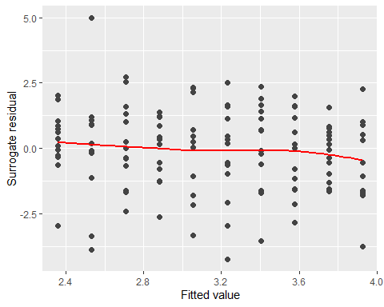

autoplot.clm(m1a, what = c("covariate"), x = data$Year) # scale test indicated no variance issues. This residual, covariate plots seems acceptable as well

## `geom_smooth()` using method = 'loess' and formula = 'y ~ x'

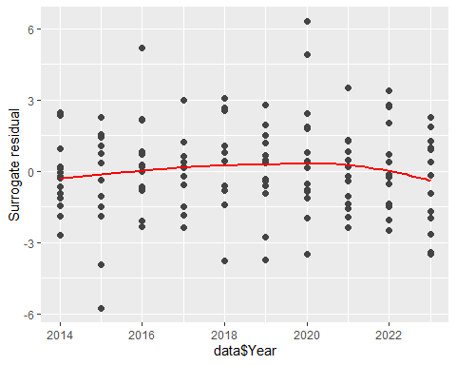

# N.B. - Interpreting residual plots is largely subjective!   
  
###plotting the model  
# Predict probabilities for each level of 'Complete'  
new_data <- data.frame(Year = sort(unique(data$Year)))  
pred_probs <- predict(m1a, newdata = new_data, type = "prob")  
  
# Add the 'Year' column to the predicted probabilities dataframe  
pred_probs_df <- cbind(new_data, as.data.frame(pred_probs))  
  
# Convert the predicted probabilities to a long format for ggplot  
library(reshape2)

## Warning: package 'reshape2' was built under R version 4.2.3

##   
## Attaching package: 'reshape2'  
##   
## The following object is masked from 'package:tidyr':  
##   
## smiths

pred_probs_long <- melt(pred_probs_df, id.vars = 'Year', variable.name = 'CompleteLevel', value.name = 'PredictedProbability')  
  
# Set the colors  
my_colors <- c("#E5696F", "#50689B", "#36D0A1", "#D0A136")  
  
# Modify ggplot command  
og1 <- ggplot(pred_probs_long, aes(x = Year, y = PredictedProbability, group = CompleteLevel, color = CompleteLevel)) +   
 geom_line(size = 2) + # Set size of the lines to make them thicker  
 scale_color_manual(values = my_colors) +  
 scale_x_continuous(breaks = unique(pred_probs_long$Year)) + # Show all years on x-axis  
 labs(x = "Year", y = "Probability", color = "Completeness Score") +  
 theme(  
 axis.title = element_text(size = 12), # Increase axis titles  
 axis.text = element_text(size = 14), # Increase axis text  
 legend.title = element_text(size = 12), # Increase legend title  
 legend.text = element_text(size = 14) # Increase legend text  
 )

## Warning: Using `size` aesthetic for lines was deprecated in ggplot2 3.4.0.  
## ℹ Please use `linewidth` instead.  
## This warning is displayed once every 8 hours.  
## Call `lifecycle::last_lifecycle_warnings()` to see where this warning was  
## generated.

print(og1)

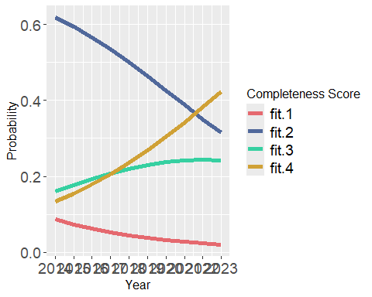

ggsave("og1.png", og1, width = 15, height = 10, units = "in", bg = "white")

#Ordinal regression model for the Reusibility by year

m1a <- clm(Reuse ~ Year, data = data)

## Warning in x$code == 0L || action == "silent": 'length(x) = 2 > 1' in coercion  
## to 'logical(1)'

## Warning: (2) Model is nearly unidentifiable: very large eigenvalue  
## - Rescale variables?   
## In addition: Absolute and relative convergence criteria were met

summary_m1a <- summary(m1a)   
  
  
# Extract coefficients and standard errors  
coefs <- summary(m1a)$coefficients  
OR <- exp(coefs[,1])  
lower_ci <- exp(coefs[,1] - 1.96 * coefs[,2])  
upper_ci <- exp(coefs[,1] + 1.96 * coefs[,2])  
  
# Calculate z-values and p-values  
z_values <- coefs[,1] / coefs[,2]  
p_values <- 2 * (1 - pnorm(abs(z_values)))  
  
# Combine everything into a data frame for easy viewing  
results <- data.frame(OR = OR, LowerCI = lower_ci, UpperCI = upper_ci, p_value = p_values)  
print(results)

## OR LowerCI UpperCI p_value  
## 1|2 1.068091e+156 2.411247e+57 4.731236e+254 0.001934390  
## 2|3 2.302380e+157 4.592835e+58 1.154179e+256 0.001778537  
## 3|4 5.188970e+157 9.966839e+58 2.701500e+256 0.001739712  
## Year 1.196679e+00 1.069257e+00 1.339285e+00 0.001773416

#Check the Assumptions   
nominal_test(m1a) # This is a test of the proportional odds assumption, odds are proportional in this case.

## Tests of nominal effects  
##   
## formula: Reuse ~ Year  
## Df logLik AIC LRT Pr(>Chi)  
## <none> -148.73 305.47   
## Year

scale_test(m1a) # scale test checks for equal variance/ scale across year, assumptions are not violated here

## Warning: (-1) Model failed to converge with max|grad| = 124.904 (tol = 1e-06)   
## In addition: iteration limit reached

## Tests of scale effects  
##   
## formula: Reuse ~ Year  
## Df logLik AIC LRT Pr(>Chi)  
## <none> -148.73 305.47   
## Year

convergence(m1a) # This is another way to assess the model

## nobs logLik niter max.grad cond.H logLik.Error  
## 130 -148.73 7(0) 6.29e-10 6.0e+12 <1e-10   
##   
## Estimate Std.Err Gradient Error Cor.Dec Sig.Dig  
## 1|2 359.2691 115.88860 -1.73e-13 1.13e-11 10 13  
## 2|3 362.3398 115.95172 1.92e-12 1.13e-11 10 13  
## 3|4 363.1524 115.97102 -2.06e-12 1.13e-11 10 13  
## Year 0.1796 0.05744 6.29e-10 5.60e-15 13 13  
##   
## Eigen values of Hessian:  
## 1.496e+08 8.699e+01 8.406e+00 2.480e-05   
##   
## Convergence message from clm:  
## (2) Model is nearly unidentifiable: very large eigenvalue  
## - Rescale variables?   
## (3) Model is nearly unidentifiable: large eigenvalue ratio  
## - Rescale variables?   
## In addition: Absolute and relative convergence criteria were met

######## Graphically validate proportional odds using the sure package #######  
  
autoplot.clm(m1a, what = c("qq")) # most of the points fall along the line, so no violation of linearity

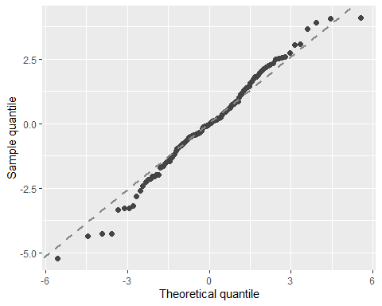

autoplot.clm(m1a, what = c("fitted")) # the residuals do not show a clear pattern or trend

## `geom_smooth()` using method = 'loess' and formula = 'y ~ x'

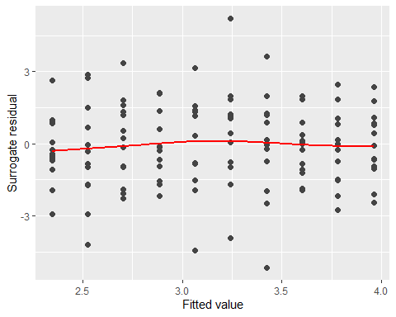

autoplot.clm(m1a, what = c("covariate"), x = data$Year) # scale test indicated no variance issues. This residual, covariate plots seems acceptable as well

## `geom_smooth()` using method = 'loess' and formula = 'y ~ x'

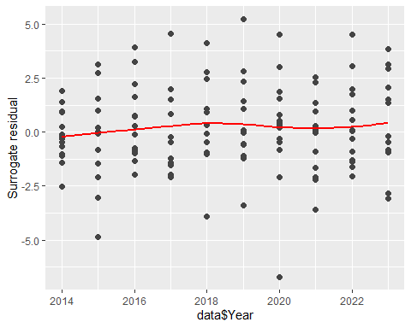

# N.B. - Interpreting residual plots is largely subjective!   
  
###plotting the model  
# Predict probabilities for each level of 'Complete'  
new_data <- data.frame(Year = sort(unique(data$Year)))  
pred_probs <- predict(m1a, newdata = new_data, type = "prob")  
  
# Add the 'Year' column to the predicted probabilities dataframe  
pred_probs_df <- cbind(new_data, as.data.frame(pred_probs))  
  
# Convert the predicted probabilities to a long format for ggplot  
library(reshape2)  
pred_probs_long <- melt(pred_probs_df, id.vars = 'Year', variable.name = 'Reuselevel', value.name = 'PredictedProbability')  
  
# Set the colors   
my_colors <- c("#E5696F", "#50689B", "#36D0A1", "#D0A136")  
  
# Modify ggplot command  
og2 <- ggplot(pred_probs_long, aes(x = Year, y = PredictedProbability, group = Reuselevel, color = Reuselevel)) +   
 geom_line(size = 2) + # Set size of the lines to make them thicker  
 scale_color_manual(values = my_colors) + # Use colors  
 scale_x_continuous(breaks = unique(pred_probs_long$Year)) + # Show all years on x-axis  
 labs(x = "Year", y = "Probability", color = "Reusability Score") +  
 theme(  
 axis.title = element_text(size = 12), # Increase axis titles  
 axis.text = element_text(size = 14), # Increase axis text  
 legend.title = element_text(size = 12), # Increase legend title  
 legend.text = element_text(size = 14) # Increase legend text  
 )   
print(og2)

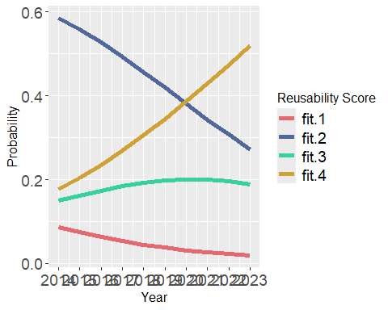

ggsave("og2.png", og2, width = 15, height = 10, units = "in", bg = "white")

m1a <- clm(Access ~ Year, data = data)

## Warning in x$code == 0L || action == "silent": 'length(x) = 2 > 1' in coercion  
## to 'logical(1)'

## Warning: (2) Model is nearly unidentifiable: very large eigenvalue  
## - Rescale variables?   
## In addition: Absolute and relative convergence criteria were met

summary_m1a <- summary(m1a)   
  
  
# Extract coefficients and standard errors  
coefs <- summary_m1a$coefficients[, 1] # Coefficients  
se_coefs <- summary_m1a$coefficients[, 2] # Standard errors  
  
# Extract coefficients and standard errors  
coefs <- summary(m1a)$coefficients  
OR <- exp(coefs[,1])  
lower_ci <- exp(coefs[,1] - 1.96 * coefs[,2])  
upper_ci <- exp(coefs[,1] + 1.96 * coefs[,2])  
  
# Calculate z-values and p-values  
z_values <- coefs[,1] / coefs[,2]  
p_values <- 2 * (1 - pnorm(abs(z_values)))  
  
# Combine everything into a data frame for easy viewing  
results <- data.frame(OR = OR, LowerCI = lower_ci, UpperCI = upper_ci, p_value = p_values)  
print(results)

## OR LowerCI UpperCI p_value  
## 1|2 2.193927e+208 1.045919e+98 Inf 0.0002143828  
## 2|3 4.895981e+209 2.007751e+99 Inf 0.0001967226  
## 3|4 5.246755e+209 2.142653e+99 Inf 0.0001963546  
## Year 1.270317e+00 1.120009e+00 1.440796 0.0001960819

#Check the Assumptions   
nominal_test(m1a) # This is a test of the proportional odds assumption, odds are proportional in this case.

## Tests of nominal effects  
##   
## formula: Access ~ Year  
## Df logLik AIC LRT Pr(>Chi)  
## <none> -110.95 229.9   
## Year

scale_test(m1a) # scale test checks for equal variance/ scale across year, assumptions are not violated here

## Warning: (-1) Model failed to converge with max|grad| = 301.489 (tol = 1e-06)   
## In addition: iteration limit reached

## Tests of scale effects  
##   
## formula: Access ~ Year  
## Df logLik AIC LRT Pr(>Chi)  
## <none> -110.95 229.9   
## Year

convergence(m1a) # This is another way to assess the model

## nobs logLik niter max.grad cond.H logLik.Error  
## 130 -110.95 8(2) 1.15e-09 6.4e+12 <1e-10   
##   
## Estimate Std.Err Gradient Error Cor.Dec Sig.Dig  
## 1|2 479.7234 129.60467 -2.94e-13 2.78e-11 10 13  
## 2|3 482.8287 129.68151 9.06e-12 2.79e-11 10 13  
## 3|4 482.8979 129.68364 -9.34e-12 2.79e-11 10 13  
## Year 0.2393 0.06425 1.15e-09 1.38e-14 13 13  
##   
## Eigen values of Hessian:  
## 1.276e+08 8.504e+02 8.325e+00 1.983e-05   
##   
## Convergence message from clm:  
## (2) Model is nearly unidentifiable: very large eigenvalue  
## - Rescale variables?   
## (3) Model is nearly unidentifiable: large eigenvalue ratio  
## - Rescale variables?   
## In addition: Absolute and relative convergence criteria were met

######## Graphically validate proportional odds using the sure package #######  
  
autoplot.clm(m1a, what = c("qq")) # most of the points fall along the line, so no violation of linearity

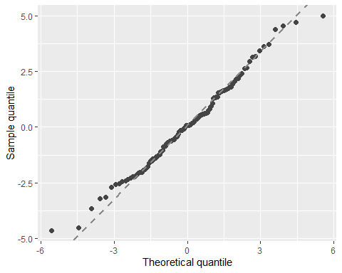

autoplot.clm(m1a, what = c("fitted")) # the residuals do not show a clear pattern or trend

## `geom_smooth()` using method = 'loess' and formula = 'y ~ x'

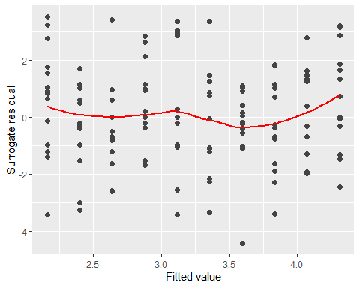

autoplot.clm(m1a, what = c("covariate"), x = data$Year) # scale test indicated no variance issues. This residual, covariate plots seems acceptable as well

## `geom_smooth()` using method = 'loess' and formula = 'y ~ x'

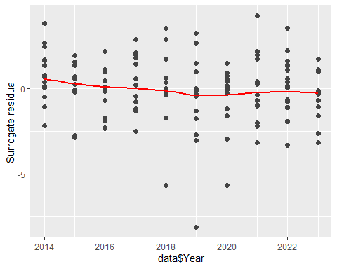

# N.B. - Interpreting residual plots is largely subjective!   
  
###plotting the model  
# Predict probabilities for each level of 'Complete'  
new_data <- data.frame(Year = sort(unique(data$Year)))  
pred_probs <- predict(m1a, newdata = new_data, type = "prob")  
  
# Add the 'Year' column to the predicted probabilities dataframe  
pred_probs_df <- cbind(new_data, as.data.frame(pred_probs))  
  
# Convert the predicted probabilities to a long format for ggplot  
library(reshape2)  
pred_probs_long <- melt(pred_probs_df, id.vars = 'Year', variable.name = 'AccessLevel', value.name = 'PredictedProbability')  
  
# Set the colors  
my_colors <- c("#E5696F", "#50689B", "#36D0A1", "#D0A136")  
  
# Modify ggplot command  
og3 <- ggplot(pred_probs_long, aes(x = Year, y = PredictedProbability, group = AccessLevel, color = AccessLevel)) +   
 geom_line(size = 2) + # Set size of the lines to make them thicker  
 scale_color_manual(values = my_colors) + # Use colors  
 scale_x_continuous(breaks = unique(pred_probs_long$Year)) + # Show all years on x-axis  
 labs(x = "Year", y = "Probability", color = "Accessibility Score") +  
 theme(  
 axis.title = element_text(size = 12), # Increase axis titles  
 axis.text = element_text(size = 14), # Increase axis text  
 legend.title = element_text(size = 12), # Increase legend title  
 legend.text = element_text(size = 14) # Increase legend text  
 )   
print(og3)

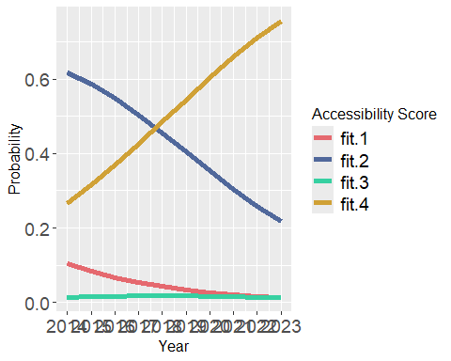

ggsave("og3.png", og3, width = 15, height = 10, units = "in", bg = "white")

m1a <- clm(Licence ~ Year, data = data)

## Warning in x$code == 0L || action == "silent": 'length(x) = 2 > 1' in coercion  
## to 'logical(1)'

## Warning: (2) Model is nearly unidentifiable: very large eigenvalue  
## - Rescale variables?   
## In addition: Absolute and relative convergence criteria were met

summary_m1a <- summary(m1a)   
  
  
# Extract coefficients and standard errors  
coefs <- summary_m1a$coefficients[, 1] # Coefficients  
se_coefs <- summary_m1a$coefficients[, 2] # Standard errors  
  
# Extract coefficients and standard errors  
coefs <- summary(m1a)$coefficients  
OR <- exp(coefs[,1])  
lower_ci <- exp(coefs[,1] - 1.96 * coefs[,2])  
upper_ci <- exp(coefs[,1] + 1.96 * coefs[,2])  
  
# Calculate z-values and p-values  
z_values <- coefs[,1] / coefs[,2]  
p_values <- 2 * (1 - pnorm(abs(z_values)))  
  
# Combine everything into a data frame for easy viewing  
results <- data.frame(OR = OR, LowerCI = lower_ci, UpperCI = upper_ci, p_value = p_values)  
print(results)

## OR LowerCI UpperCI p_value  
## 1|3 7.570575e+27 7.413337e-86 7.731148e+140 0.6287208  
## 3|4 6.239265e+28 6.046581e-85 6.438089e+141 0.6175010  
## Year 1.033865e+00 9.088113e-01 1.176126e+00 0.6126309

#Check the Assumptions   
nominal_test(m1a) # This is a test of the proportional odds assumption, odds are proportional in this case.

## Tests of nominal effects  
##   
## formula: Licence ~ Year  
## Df logLik AIC LRT Pr(>Chi)  
## <none> -93.915 193.83   
## Year

scale_test(m1a) # scale test checks for equal variance/ scale across year, assumptions are not violated here

## Warning: (-1) Model failed to converge with max|grad| = 33798.1 (tol = 1e-06)   
## In addition: iteration limit reached

## Tests of scale effects  
##   
## formula: Licence ~ Year  
## Df logLik AIC LRT Pr(>Chi)  
## <none> -93.915 193.83   
## Year

convergence(m1a) # This is another way to assess the model

## nobs logLik niter max.grad cond.H logLik.Error  
## 130 -93.92 6(0) 3.37e-10 3.9e+12 <1e-10   
##   
## Estimate Std.Err Gradient Error Cor.Dec Sig.Dig  
## 1|3 64.1941 132.76179 3.93e-14 -7.29e-12 10 12  
## 3|4 66.3032 132.76708 1.27e-13 -7.29e-12 10 12  
## Year 0.0333 0.06578 -3.37e-10 -3.62e-15 14 13  
##   
## Eigen values of Hessian:  
## 1.093e+08 1.282e+01 2.837e-05   
##   
## Convergence message from clm:  
## (2) Model is nearly unidentifiable: very large eigenvalue  
## - Rescale variables?   
## (3) Model is nearly unidentifiable: large eigenvalue ratio  
## - Rescale variables?   
## In addition: Absolute and relative convergence criteria were met

######## Graphically validate proportional odds using the sure package #######  
  
autoplot.clm(m1a, what = c("qq")) # most of the points fall along the line, so no violation of linearity

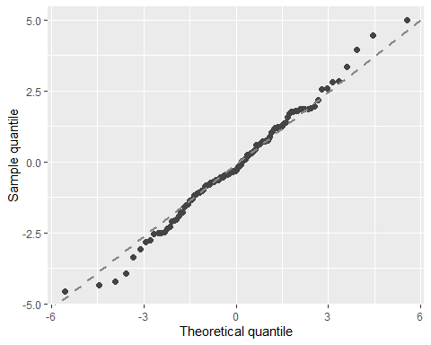

autoplot.clm(m1a, what = c("fitted")) # the residuals do not show a clear pattern or trend

## `geom_smooth()` using method = 'loess' and formula = 'y ~ x'

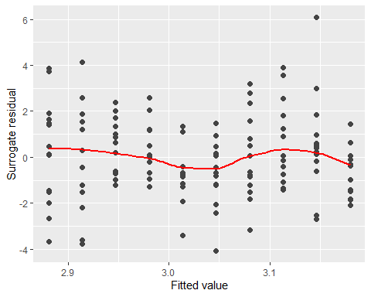

autoplot.clm(m1a, what = c("covariate"), x = data$Year) # scale test indicated no variance issues. This residual, covariate plots seems acceptable as well

## `geom_smooth()` using method = 'loess' and formula = 'y ~ x'

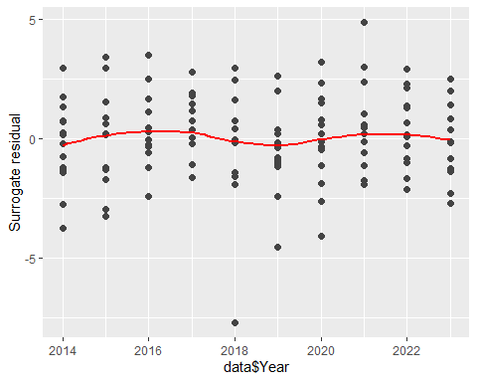

# N.B. - Interpreting residual plots is largely subjective!   
  
###plotting the model  
# Predict probabilities for each level of 'Complete'  
new_data <- data.frame(Year = sort(unique(data$Year)))  
pred_probs <- predict(m1a, newdata = new_data, type = "prob")  
  
# Add the 'Year' column to the predicted probabilities dataframe  
pred_probs_df <- cbind(new_data, as.data.frame(pred_probs))  
  
# Convert the predicted probabilities to a long format for ggplot  
library(reshape2)  
pred_probs_long <- melt(pred_probs_df, id.vars = 'Year', variable.name = 'Licencelevel', value.name = 'PredictedProbability')  
  
# Set the colors   
my_colors <- c("#E5696F", "#36D0A1", "#D0A136")  
  
# Modify ggplot command  
og4 <- ggplot(pred_probs_long, aes(x = Year, y = PredictedProbability, group = Licencelevel, color = Licencelevel)) +   
 geom_line(size = 2) + # Set size of the lines to make them thicker  
 scale_color_manual(values = my_colors) + # Use colors  
 scale_x_continuous(breaks = unique(pred_probs_long$Year)) + # Show all years on x-axis  
 labs(x = "Year", y = "Probability", color = "Licence Score") +  
 theme(  
 axis.title = element_text(size = 12), # Increase axis titles  
 axis.text = element_text(size = 14), # Increase axis text  
 legend.title = element_text(size = 12), # Increase legend title  
 legend.text = element_text(size = 14) # Increase legend text  
 )   
print(og4)

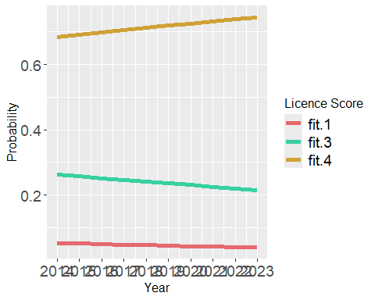

ggsave("og4.png", og4, width = 15, height = 10, units = "in", bg = "white")

install.packages("patchwork")

## Installing package into 'M:/R/Win-Library/4.2'  
## (as 'lib' is unspecified)

## package 'patchwork' successfully unpacked and MD5 sums checked  
##   
## The downloaded binary packages are in  
## C:\Users\s2146807\AppData\Local\Temp\RtmpGEDx57\downloaded_packages

library(patchwork)

## Warning: package 'patchwork' was built under R version 4.2.3

##   
## Attaching package: 'patchwork'

## The following object is masked from 'package:MASS':  
##   
## area

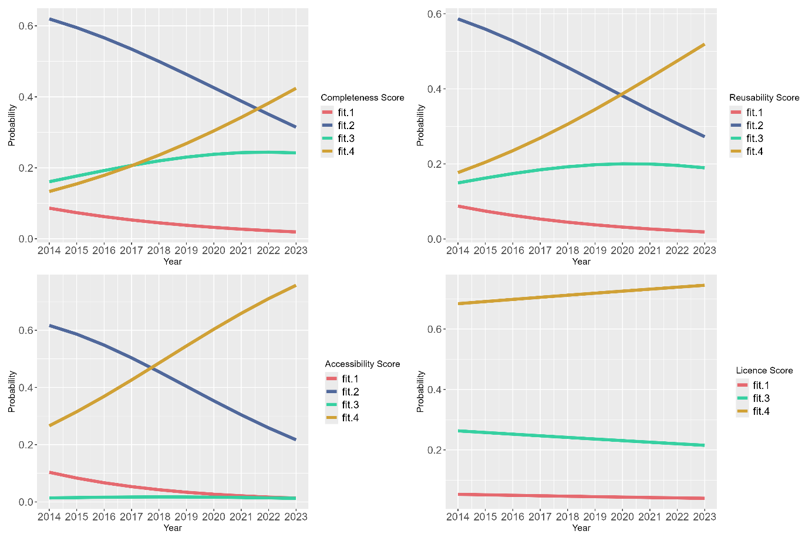ordinalplot <- og1 + og2 + og3 + og4 +  
 plot_layout(  
 ncol = 2, heights = c(10, 10), widths = c(10, 10)  
 )  
print(ordinalplot)

ggsave("ordinalplot.png", ordinalplot, width = 15, height = 10, units = "in", bg="white")

#Ordinal Regression models depending on the sharing projects

m1a <- clm(Complete ~ NewDAS + Preprint, data = data)   
summary_m1a <- summary(m1a)  
  
# Extract coefficients and standard errors  
coefs <- summary_m1a$coefficients[, 1] # Coefficients  
se_coefs <- summary_m1a$coefficients[, 2] # Standard errors  
  
# Extract coefficients and standard errors  
coefs <- summary(m1a)$coefficients  
OR <- exp(coefs[,1])  
lower_ci <- exp(coefs[,1] - 1.96 * coefs[,2])  
upper_ci <- exp(coefs[,1] + 1.96 * coefs[,2])  
  
# Calculate z-values and p-values  
z_values <- coefs[,1] / coefs[,2]  
p_values <- 2 * (1 - pnorm(abs(z_values)))  
  
# Combine everything into a data frame for easy viewing  
results <- data.frame(OR = OR, LowerCI = lower_ci, UpperCI = upper_ci, p_value = p_values)  
print(results)

## OR LowerCI UpperCI p_value  
## 1|2 0.08040527 0.03446409 0.1875867 5.481457e-09  
## 2|3 2.30928285 1.40274308 3.8016850 9.996808e-04  
## 3|4 6.98540751 3.86569749 12.6227979 1.201850e-10  
## NewDASNot shared 2.22062795 0.50650870 9.7356443 2.900738e-01  
## NewDASShared 4.43200155 2.15464581 9.1164115 5.207790e-05  
## Preprint 3.11203452 1.21055487 8.0002642 1.844070e-02

#Check the Assumptions   
nominal_test(m1a) # This is a test of the proportional odds assumption, odds are proportional in this case.

## Tests of nominal effects  
##   
## formula: Complete ~ NewDAS + Preprint  
## Df logLik AIC LRT Pr(>Chi)  
## <none> -141.46 294.91   
## NewDAS   
## Preprint 2 -140.60 297.20 1.706 0.4261

scale_test(m1a) # scale test checks for equal variance/ scale across year, assumptions are not violated here because p = 0.8386. If p is less than 0.05 then assumptions are violated

## Tests of scale effects  
##   
## formula: Complete ~ NewDAS + Preprint  
## Df logLik AIC LRT Pr(>Chi)  
## <none> -141.46 294.91   
## NewDAS 2 -141.06 298.12 0.78479 0.6754  
## Preprint 1 -141.39 296.78 0.12885 0.7196

convergence(m1a) # This is another way to assess the model

## nobs logLik niter max.grad cond.H logLik.Error  
## 130 -141.45 6(0) 2.36e-08 3.6e+01 <1e-10   
##   
## Estimate Std.Err Gradient Error Cor.Dec Sig.Dig  
## 1|2 -2.5207 0.4322 2.36e-08 4.00e-09 8 9  
## 2|3 0.8369 0.2543 -1.09e-08 -1.02e-10 9 9  
## 3|4 1.9438 0.3019 -5.49e-12 -9.47e-11 9 10  
## NewDASNot shared 0.7978 0.7541 -6.88e-10 -9.85e-11 9 9  
## NewDASShared 1.4889 0.3680 -9.83e-10 -9.04e-11 9 10  
## Preprint 1.1353 0.4817 -6.26e-10 -6.25e-11 9 10  
##   
## Eigen values of Hessian:  
## 58.846 25.507 6.644 5.242 3.748 1.627   
##   
## Convergence message from clm:  
## (0) successful convergence   
## In addition: Absolute and relative convergence criteria were met

######## Graphically validate proportional odds using the sure package #######  
  
autoplot.clm(m1a, what = c("qq")) # most of the points fall along the line, so no violation of linearity

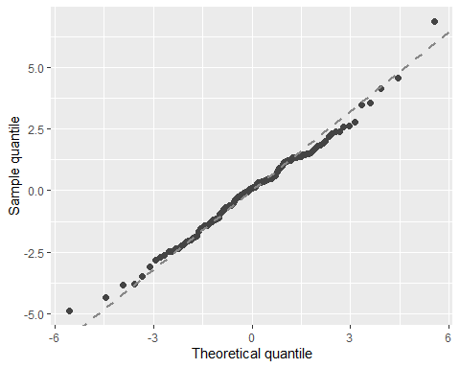

autoplot.clm(m1a, what = c("fitted")) # the residuals do not show a clear pattern or trend

## `geom_smooth()` using method = 'loess' and formula = 'y ~ x'

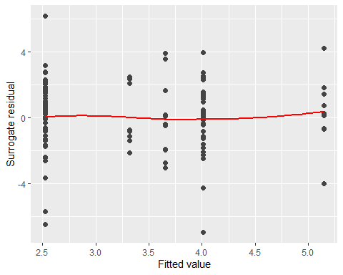

autoplot.clm(m1a, what = c("covariate"), x = data$NewDAS) # scale test indicated no variance issues. This residual, covariate plots seems acceptable as well

## Warning: The `<scale>` argument of `guides()` cannot be `FALSE`. Use "none" instead as  
## of ggplot2 3.3.4.  
## ℹ The deprecated feature was likely used in the sure package.  
## Please report the issue at <]8;;https://github.com/AFIT-R/sure/issueshttps://github.com/AFIT-R/sure/issues]8;;>.  
## This warning is displayed once every 8 hours.  
## Call `lifecycle::last_lifecycle_warnings()` to see where this warning was  
## generated.

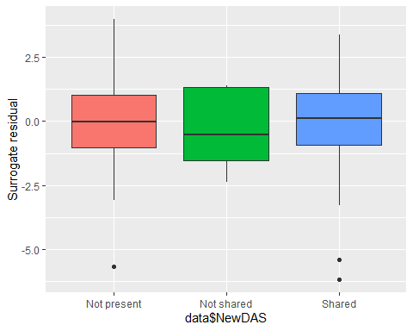

autoplot.clm(m1a, what = c("covariate"), x = data$Preprint)

## `geom_smooth()` using method = 'loess' and formula = 'y ~ x'

## Warning in simpleLoess(y, x, w, span, degree = degree, parametric = parametric,  
## : at -0.005

## Warning in simpleLoess(y, x, w, span, degree = degree, parametric = parametric,  
## : radius 2.5e-05

## Warning in simpleLoess(y, x, w, span, degree = degree, parametric = parametric,  
## : all data on boundary of neighborhood. make span bigger

## Warning in simpleLoess(y, x, w, span, degree = degree, parametric = parametric,  
## : pseudoinverse used at -0.005

## Warning in simpleLoess(y, x, w, span, degree = degree, parametric = parametric,  
## : neighborhood radius 0.005

## Warning in simpleLoess(y, x, w, span, degree = degree, parametric = parametric,  
## : reciprocal condition number 1

## Warning in simpleLoess(y, x, w, span, degree = degree, parametric = parametric,  
## : There are other near singularities as well. 1.01

## Warning in simpleLoess(y, x, w, span, degree = degree, parametric = parametric,  
## : zero-width neighborhood. make span bigger

## Warning: Failed to fit group -1.  
## Caused by error in `predLoess()`:  
## ! NA/NaN/Inf in foreign function call (arg 5)

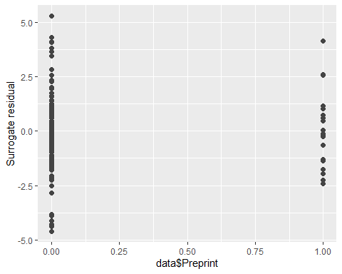

# N.B. - Interpreting residual plots is largely subjective!

m1a <- clm(Reuse ~ NewDAS + Preprint, data = data)   
summary_m1a <- summary(m1a)  
  
# Extract coefficients and standard errors  
coefs <- summary_m1a$coefficients[, 1] # Coefficients  
se_coefs <- summary_m1a$coefficients[, 2] # Standard errors  
  
# Extract coefficients and standard errors  
coefs <- summary(m1a)$coefficients  
OR <- exp(coefs[,1])  
lower_ci <- exp(coefs[,1] - 1.96 * coefs[,2])  
upper_ci <- exp(coefs[,1] + 1.96 * coefs[,2])  
  
# Calculate z-values and p-values  
z_values <- coefs[,1] / coefs[,2]  
p_values <- 2 * (1 - pnorm(abs(z_values)))  
  
# Combine everything into a data frame for easy viewing  
results <- data.frame(OR = OR, LowerCI = lower_ci, UpperCI = upper_ci, p_value = p_values)  
print(results)

## OR LowerCI UpperCI p_value  
## 1|2 0.08030323 0.03449122 0.1869638 4.945615e-09  
## 2|3 1.94089488 1.19689021 3.1473839 7.173334e-03  
## 3|4 4.95212549 2.84354848 8.6242760 1.584018e-08  
## NewDASNot shared 3.19798580 0.83340049 12.2715469 9.019262e-02  
## NewDASShared 6.37209386 3.00525060 13.5108800 1.367981e-06  
## Preprint 1.64953102 0.65229017 4.1713837 2.903525e-01

#Check the Assumptions   
nominal_test(m1a) # This is a test of the proportional odds assumption, odds are proportional in this case.

## Tests of nominal effects  
##   
## formula: Reuse ~ NewDAS + Preprint  
## Df logLik AIC LRT Pr(>Chi)  
## <none> -139.92 291.85   
## NewDAS 4 -138.18 296.36 3.4880 0.4797  
## Preprint 2 -139.22 294.43 1.4187 0.4920

scale_test(m1a) # scale test checks for equal variance/ scale across year, assumptions are not violated here because p = 0.8386. If p is less than 0.05 then assumptions are violated

## Tests of scale effects  
##   
## formula: Reuse ~ NewDAS + Preprint  
## Df logLik AIC LRT Pr(>Chi)  
## <none> -139.92 291.85   
## NewDAS 2 -138.55 293.11 2.7396 0.2542  
## Preprint 1 -139.28 292.57 1.2817 0.2576

convergence(m1a) # This is another way to assess the model

## nobs logLik niter max.grad cond.H logLik.Error  
## 130 -139.92 6(0) 4.40e-09 3.6e+01 <1e-10   
##   
## Estimate Std.Err Gradient Error Cor.Dec Sig.Dig  
## 1|2 -2.5219 0.4312 4.40e-09 7.42e-10 8 9  
## 2|3 0.6631 0.2466 -2.20e-09 -1.84e-11 10 10  
## 3|4 1.5998 0.2830 -1.29e-12 -1.65e-11 10 11  
## NewDASNot shared 1.1625 0.6861 -5.46e-11 -1.75e-11 10 11  
## NewDASShared 1.8519 0.3835 -1.05e-10 -1.57e-11 10 11  
## Preprint 0.5005 0.4733 -2.18e-10 -7.40e-12 10 10  
##   
## Eigen values of Hessian:  
## 68.197 24.184 6.638 5.094 4.107 1.915   
##   
## Convergence message from clm:  
## (0) successful convergence   
## In addition: Absolute and relative convergence criteria were met

######## Graphically validate proportional odds using the sure package #######  
  
autoplot.clm(m1a, what = c("qq")) # most of the points fall along the line, so no violation of linearity

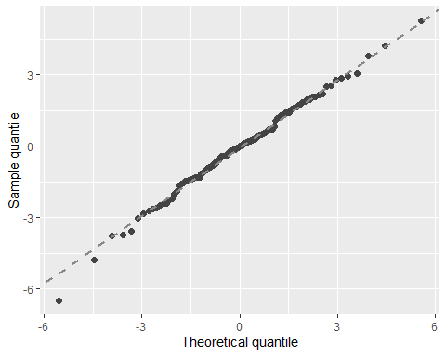

autoplot.clm(m1a, what = c("fitted")) # the residuals do not show a clear pattern or trend

## `geom_smooth()` using method = 'loess' and formula = 'y ~ x'

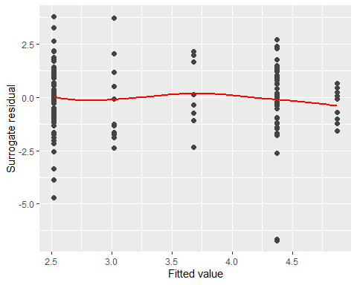

autoplot.clm(m1a, what = c("covariate"), x = data$NewDAS) # scale test indicated no variance issues. This residual, covariate plots seems acceptable as well

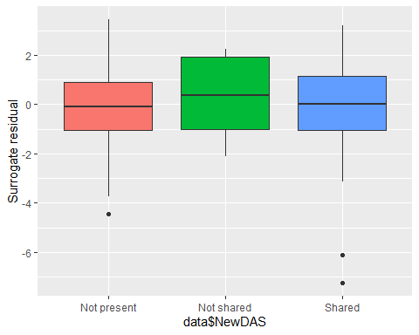

autoplot.clm(m1a, what = c("covariate"), x = data$Preprint)

## `geom_smooth()` using method = 'loess' and formula = 'y ~ x'

## Warning in simpleLoess(y, x, w, span, degree = degree, parametric = parametric,  
## : at -0.005

## Warning in simpleLoess(y, x, w, span, degree = degree, parametric = parametric,  
## : radius 2.5e-05

## Warning in simpleLoess(y, x, w, span, degree = degree, parametric = parametric,  
## : all data on boundary of neighborhood. make span bigger

## Warning in simpleLoess(y, x, w, span, degree = degree, parametric = parametric,  
## : pseudoinverse used at -0.005

## Warning in simpleLoess(y, x, w, span, degree = degree, parametric = parametric,  
## : neighborhood radius 0.005

## Warning in simpleLoess(y, x, w, span, degree = degree, parametric = parametric,  
## : reciprocal condition number 1

## Warning in simpleLoess(y, x, w, span, degree = degree, parametric = parametric,  
## : There are other near singularities as well. 1.01

## Warning in simpleLoess(y, x, w, span, degree = degree, parametric = parametric,  
## : zero-width neighborhood. make span bigger

## Warning: Failed to fit group -1.  
## Caused by error in `predLoess()`:  
## ! NA/NaN/Inf in foreign function call (arg 5)

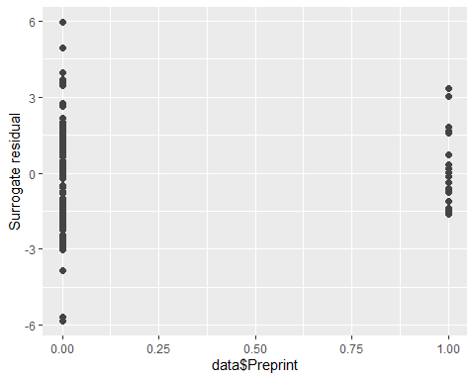

# N.B. - Interpreting residual plots is largely subjective!

m1a <- clm(Access ~ NewDAS + Preprint, data = data)   
summary_m1a <- summary(m1a)  
  
# Extract coefficients and standard errors  
coefs <- summary_m1a$coefficients[, 1] # Coefficients  
se_coefs <- summary_m1a$coefficients[, 2] # Standard errors  
  
# Extract coefficients and standard errors  
coefs <- summary(m1a)$coefficients  
OR <- exp(coefs[,1])  
lower_ci <- exp(coefs[,1] - 1.96 * coefs[,2])  
upper_ci <- exp(coefs[,1] + 1.96 * coefs[,2])  
  
# Calculate z-values and p-values  
z_values <- coefs[,1] / coefs[,2]  
p_values <- 2 * (1 - pnorm(abs(z_values)))  
  
# Combine everything into a data frame for easy viewing  
results <- data.frame(OR = OR, LowerCI = lower_ci, UpperCI = upper_ci, p_value = p_values)  
print(results)

## OR LowerCI UpperCI p_value  
## 1|2 0.08293078 0.03554014 0.193514 8.458039e-09  
## 2|3 2.17869399 1.30603472 3.634442 2.857815e-03  
## 3|4 2.37186800 1.41398150 3.978664 1.065660e-03  
## NewDASNot shared 1.94745782 0.49961942 7.590962 3.369174e-01  
## NewDASShared 11.85644530 4.63730330 30.314018 2.428559e-07  
## Preprint 1.94425820 0.64398445 5.869924 2.382481e-01

#Check the Assumptions   
nominal_test(m1a) # This is a test of the proportional odds assumption, odds are proportional in this case.

## Tests of nominal effects  
##   
## formula: Access ~ NewDAS + Preprint  
## Df logLik AIC LRT Pr(>Chi)   
## <none> -100.310 212.62   
## NewDAS   
## Preprint 2 -88.681 193.36 23.258 8.903e-06 ***  
## ---  
## Signif. codes: 0 '***' 0.001 '**' 0.01 '*' 0.05 '.' 0.1 ' ' 1

scale_test(m1a) # scale test checks for equal variance/ scale across year, assumptions are not violated here because p = 0.8386. If p is less than 0.05 then assumptions are violated

## Tests of scale effects  
##   
## formula: Access ~ NewDAS + Preprint  
## Df logLik AIC LRT Pr(>Chi)   
## <none> -100.310 212.62   
## NewDAS 2 -96.004 208.01 8.6128 0.01348 *  
## Preprint 1 -100.232 214.46 0.1562 0.69268   
## ---  
## Signif. codes: 0 '***' 0.001 '**' 0.01 '*' 0.05 '.' 0.1 ' ' 1

convergence(m1a) # This is another way to assess the model

## nobs logLik niter max.grad cond.H logLik.Error  
## 130 -100.31 7(2) 6.61e-08 3.2e+02 <1e-10   
##   
## Estimate Std.Err Gradient Error Cor.Dec Sig.Dig  
## 1|2 -2.4897 0.4323 6.61e-08 1.12e-08 7 8  
## 2|3 0.7787 0.2611 -3.06e-08 -3.35e-10 9 9  
## 3|4 0.8637 0.2639 -3.75e-11 -3.30e-10 9 9  
## NewDASNot shared 0.6665 0.6941 -1.80e-09 -3.29e-10 9 9  
## NewDASShared 2.4729 0.4789 -5.62e-10 -3.04e-10 9 10  
## Preprint 0.6649 0.5638 -2.73e-09 -2.63e-10 9 9  
##   
## Eigen values of Hessian:  
## 566.901 15.759 5.927 4.135 3.161 1.781   
##   
## Convergence message from clm:  
## (0) successful convergence   
## In addition: Absolute and relative convergence criteria were met

######## Graphically validate proportional odds using the sure package #######  
  
autoplot.clm(m1a, what = c("qq")) # most of the points fall along the line, so no violation of linearity

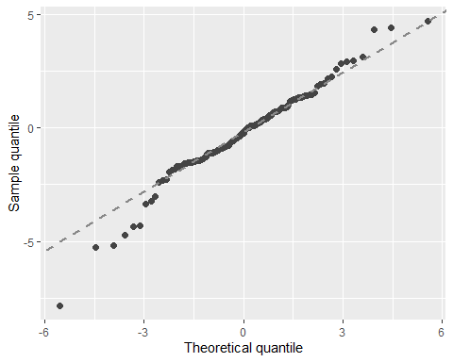

autoplot.clm(m1a, what = c("fitted")) # the residuals do not show a clear pattern or trend

## `geom_smooth()` using method = 'loess' and formula = 'y ~ x'

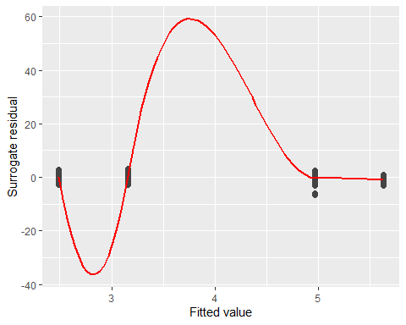

autoplot.clm(m1a, what = c("covariate"), x = data$NewDAS) # scale test indicated no variance issues. This residual, covariate plots seems acceptable as well

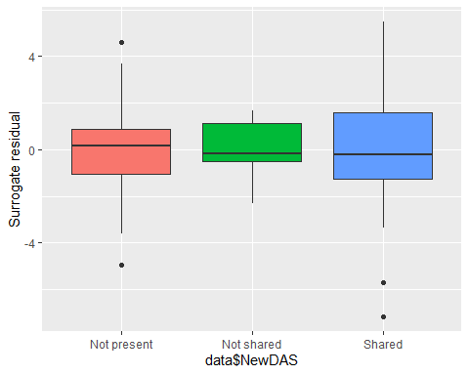

autoplot.clm(m1a, what = c("covariate"), x = data$Preprint)

## `geom_smooth()` using method = 'loess' and formula = 'y ~ x'

## Warning in simpleLoess(y, x, w, span, degree = degree, parametric = parametric,  
## : at -0.005

## Warning in simpleLoess(y, x, w, span, degree = degree, parametric = parametric,  
## : radius 2.5e-05

## Warning in simpleLoess(y, x, w, span, degree = degree, parametric = parametric,  
## : all data on boundary of neighborhood. make span bigger

## Warning in simpleLoess(y, x, w, span, degree = degree, parametric = parametric,  
## : pseudoinverse used at -0.005

## Warning in simpleLoess(y, x, w, span, degree = degree, parametric = parametric,  
## : neighborhood radius 0.005

## Warning in simpleLoess(y, x, w, span, degree = degree, parametric = parametric,  
## : reciprocal condition number 1

## Warning in simpleLoess(y, x, w, span, degree = degree, parametric = parametric,  
## : There are other near singularities as well. 1.01

## Warning in simpleLoess(y, x, w, span, degree = degree, parametric = parametric,  
## : zero-width neighborhood. make span bigger

## Warning: Failed to fit group -1.  
## Caused by error in `predLoess()`:  
## ! NA/NaN/Inf in foreign function call (arg 5)

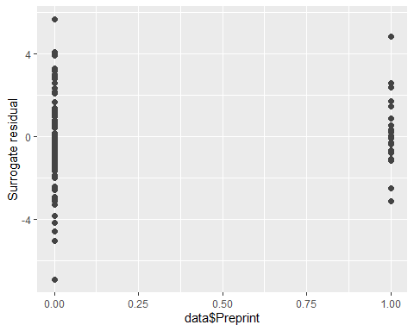

# N.B. - Interpreting residual plots is largely subjective!

m1a <- clm(Licence ~ NewDAS + Preprint, data = data)   
summary_m1a <- summary(m1a)  
  
# Extract coefficients and standard errors  
coefs <- summary_m1a$coefficients[, 1] # Coefficients  
se_coefs <- summary_m1a$coefficients[, 2] # Standard errors  
  
# Extract coefficients and standard errors  
coefs <- summary(m1a)$coefficients  
OR <- exp(coefs[,1])  
lower_ci <- exp(coefs[,1] - 1.96 * coefs[,2])  
upper_ci <- exp(coefs[,1] + 1.96 * coefs[,2])  
  
# Calculate z-values and p-values  
z_values <- coefs[,1] / coefs[,2]  
p_values <- 2 * (1 - pnorm(abs(z_values)))  
  
# Combine everything into a data frame for easy viewing  
results <- data.frame(OR = OR, LowerCI = lower_ci, UpperCI = upper_ci, p_value = p_values)  
print(results)

## OR LowerCI UpperCI p_value  
## 1|3 0.06281708 0.02618925 0.1506720 5.641767e-10  
## 3|4 0.56911004 0.34534082 0.9378742 2.699035e-02  
## NewDASNot shared 1.78733704 0.33990304 9.3984853 4.928701e-01  
## NewDASShared 4.46125540 1.67179567 11.9050432 2.824748e-03  
## Preprint 0.54460152 0.19750155 1.5017138 2.402780e-01

#Check the Assumptions   
nominal_test(m1a) # This is a test of the proportional odds assumption, odds are proportional in this case.

## Tests of nominal effects  
##   
## formula: Licence ~ NewDAS + Preprint  
## Df logLik AIC LRT Pr(>Chi)   
## <none> -88.207 186.41   
## NewDAS 2 -86.914 187.83 2.5854 0.27453   
## Preprint 1 -86.238 184.48 3.9372 0.04723 *  
## ---  
## Signif. codes: 0 '***' 0.001 '**' 0.01 '*' 0.05 '.' 0.1 ' ' 1

scale_test(m1a) # scale test checks for equal variance/ scale across year, assumptions are not violated here because p = 0.8386. If p is less than 0.05 then assumptions are violated

## Warning: (-1) Model failed to converge with max|grad| = 2.6247e-05 (tol = 1e-06)   
## In addition: iteration limit reached

## Tests of scale effects  
##   
## formula: Licence ~ NewDAS + Preprint  
## Df logLik AIC LRT Pr(>Chi)  
## <none> -88.207 186.41   
## NewDAS   
## Preprint 1 -87.174 186.35 2.0665 0.1506

convergence(m1a) # This is another way to assess the model

## nobs logLik niter max.grad cond.H logLik.Error  
## 130 -88.21 5(0) 4.39e-08 2.2e+01 <1e-10   
##   
## Estimate Std.Err Gradient Error Cor.Dec Sig.Dig  
## 1|3 -2.7675 0.4464 4.39e-08 6.85e-09 7 8  
## 3|4 -0.5637 0.2549 -3.38e-08 -1.62e-10 9 9  
## NewDASNot shared 0.5807 0.8468 -3.77e-10 -1.08e-10 9 9  
## NewDASShared 1.4954 0.5008 -6.23e-10 -2.03e-10 9 10  
## Preprint -0.6077 0.5175 -2.72e-09 2.21e-10 9 9  
##   
## Eigen values of Hessian:  
## 29.924 6.834 3.658 3.311 1.343   
##   
## Convergence message from clm:  
## (0) successful convergence   
## In addition: Absolute and relative convergence criteria were met

######## Graphically validate proportional odds using the sure package #######  
  
autoplot.clm(m1a, what = c("qq")) # most of the points fall along the line, so no violation of linearity

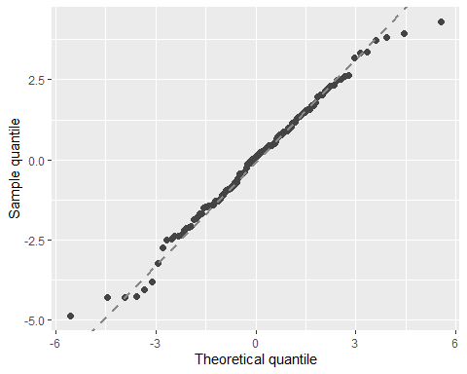

autoplot.clm(m1a, what = c("fitted")) # the residuals do not show a clear pattern or trend

## `geom_smooth()` using method = 'loess' and formula = 'y ~ x'

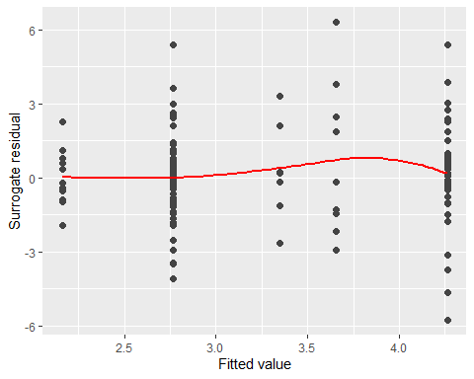

autoplot.clm(m1a, what = c("covariate"), x = data$NewDAS) # scale test indicated no variance issues. This residual, covariate plots seems acceptable as well

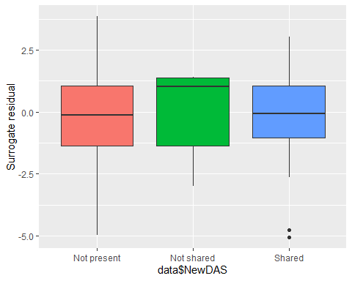

autoplot.clm(m1a, what = c("covariate"), x = data$Preprint)

## `geom_smooth()` using method = 'loess' and formula = 'y ~ x'

## Warning in simpleLoess(y, x, w, span, degree = degree, parametric = parametric,  
## : at -0.005

## Warning in simpleLoess(y, x, w, span, degree = degree, parametric = parametric,  
## : radius 2.5e-05

## Warning in simpleLoess(y, x, w, span, degree = degree, parametric = parametric,  
## : all data on boundary of neighborhood. make span bigger

## Warning in simpleLoess(y, x, w, span, degree = degree, parametric = parametric,  
## : pseudoinverse used at -0.005

## Warning in simpleLoess(y, x, w, span, degree = degree, parametric = parametric,  
## : neighborhood radius 0.005

## Warning in simpleLoess(y, x, w, span, degree = degree, parametric = parametric,  
## : reciprocal condition number 1

## Warning in simpleLoess(y, x, w, span, degree = degree, parametric = parametric,  
## : There are other near singularities as well. 1.01

## Warning in simpleLoess(y, x, w, span, degree = degree, parametric = parametric,  
## : zero-width neighborhood. make span bigger

## Warning: Failed to fit group -1.  
## Caused by error in `predLoess()`:  
## ! NA/NaN/Inf in foreign function call (arg 5)

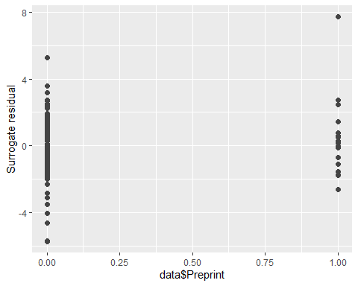

# N.B. - Interpreting residual plots is largely subjective

#Research Group figures (Internal)

# Calculate the frequency and percentage for each 'Complete' score among the research Group  
long_data <- data %>%  
 count(ResGrp, Complete) %>%  
 group_by(ResGrp) %>%  
 mutate(Percentage = n / sum(n) * 100) %>%  
 mutate(Label = ifelse(Percentage > 5, paste0(round(Percentage, 1), "%"), "")) %>%  
 mutate(Cumulative_Percentage = cumsum(Percentage) - (0.5 * Percentage)) %>%  
 ungroup()  
  
long_data <- long_data %>%  
 mutate(Complete = factor(Complete, levels = c("4", "3", "2", "1")))  
  
# Custom colors  
colors <- c("#D0A136", "#36D0A1","#50689B","#E5696F")  
  
# Creating the stacked bar chart with percentage labels  
internal1 <- ggplot(long_data, aes(x = as.factor(ResGrp), y = n, fill = as.factor(Complete))) +  
 geom_bar(stat = "identity", position = "fill") + # Scale the bar heights to proportions  
 scale_y_continuous(labels = percent_format()) + # Convert the y-axis to percentage  
 geom_text(  
 aes(label = Label, y = Percentage),   
 size = 4,   
 color = "black",   
 position = position_fill(vjust = 0.5)  
 ) +  
 scale_fill_manual(values = colors) +  
 labs(title = "Distribution of 'Completeness' Scores by ResGrp",  
 x = "ResGrp",  
 y = "Proportion",  
 fill = "Complete") +  
 theme_minimal() +  
 scale_x_discrete(name = "ResGrp", labels = unique(long_data$ResGrp)) +  
 theme(axis.text.x = element_text(angle = 90, hjust = 1)) # Adjust text angle for readability  
  
# Print the plot  
print(internal1)

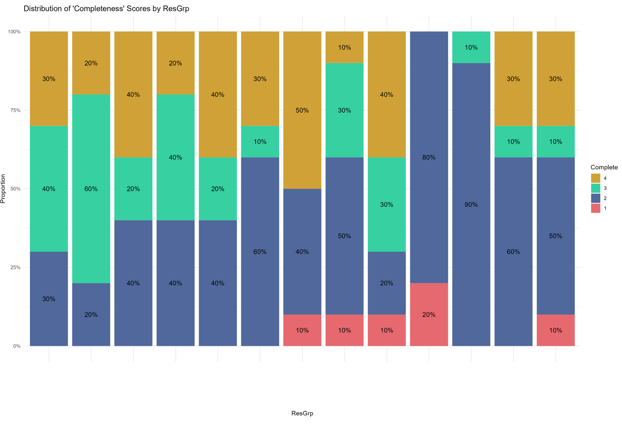

ggsave("internal1.png", internal1, width = 15, height = 10, units = "in", bg= "white")  
  
  
#these results were used for internal university meetings and presentations

# Calculate the frequency and percentage for each 'Reuse' score among the research Group  
long_data <- data %>%  
 count(ResGrp, Reuse) %>%  
 group_by(ResGrp) %>%  
 mutate(Percentage = n / sum(n) * 100) %>%  
 mutate(Label = ifelse(Percentage > 5, paste0(round(Percentage, 1), "%"), "")) %>%  
 mutate(Cumulative_Percentage = cumsum(Percentage) - (0.5 * Percentage)) %>%  
 ungroup()  
  
long_data <- long_data %>%  
 mutate(Reuse = factor(Reuse, levels = c("4", "3", "2", "1")))  
  
# Custom colors  
colors <- c("#D0A136", "#36D0A1","#50689B","#E5696F")  
  
# Creating the stacked bar chart with percentage labels  
internal2 <- ggplot(long_data, aes(x = as.factor(ResGrp), y = n, fill = as.factor(Reuse))) +  
 geom_bar(stat = "identity", position = "fill") + # Scale the bar heights to proportions  
 scale_y_continuous(labels = percent_format()) + # Convert the y-axis to percentage  
 geom_text(  
 aes(label = Label, y = Percentage),   
 size = 4,   
 color = "black",   
 position = position_fill(vjust = 0.5)  
 ) +  
 scale_fill_manual(values = colors) +  
 labs(title = "Distribution of 'Reusability' Scores by ResGrp",  
 x = "ResGrp",  
 y = "Proportion",  
 fill = "Reuse") +  
 theme_minimal() +  
 scale_x_discrete(name = "ResGrp", labels = unique(long_data$ResGrp)) +  
 theme(axis.text.x = element_text(angle = 90, hjust = 1)) # Adjust text angle for readability  
  
# Print the plot  
print(internal2)

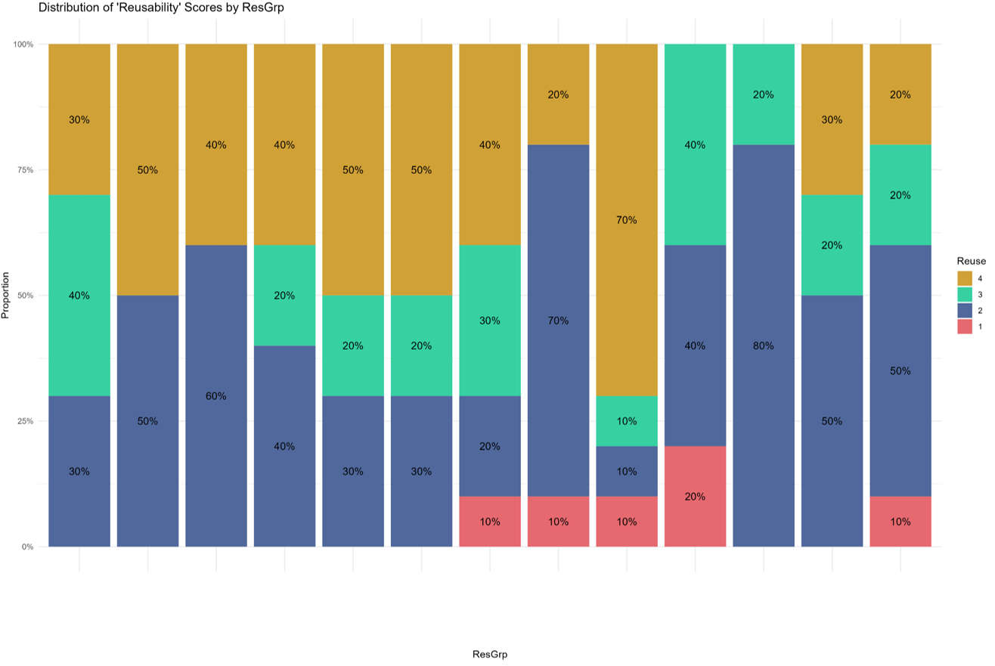

ggsave("internal2.png", internal2, width = 15, height = 10, units = "in", bg= "white")  
  
#these results were used for internal university meetings and presentations

# Calculate the frequency and percentage for each 'Access' score among the research Group  
long_data <- data %>%  
 count(ResGrp, Access) %>%  
 group_by(ResGrp) %>%  
 mutate(Percentage = n / sum(n) * 100) %>%  
 mutate(Label = ifelse(Percentage > 5, paste0(round(Percentage, 1), "%"), "")) %>%  
 mutate(Cumulative_Percentage = cumsum(Percentage) - (0.5 * Percentage)) %>%  
 ungroup()  
  
long_data <- long_data %>%  
 mutate(Access = factor(Access, levels = c("4", "3", "2", "1")))  
  
# Custom colors  
colors <- c("#D0A136", "#36D0A1","#50689B","#E5696F")  
  
# Creating the stacked bar chart with percentage labels  
internal3 <- ggplot(long_data, aes(x = as.factor(ResGrp), y = n, fill = as.factor(Access))) +  
 geom_bar(stat = "identity", position = "fill") + # Scale the bar heights to proportions  
 scale_y_continuous(labels = percent_format()) + # Convert the y-axis to percentage  
 geom_text(  
 aes(label = Label, y = Percentage),   
 size = 4,   
 color = "black",   
 position = position_fill(vjust = 0.5)  
 ) +  
 scale_fill_manual(values = colors) +  
 labs(title = "Distribution of 'Accessibility' Scores by ResGrp",  
 x = "ResGrp",  
 y = "Proportion",  
 fill = "Access") +  
 theme_minimal() +  
 scale_x_discrete(name = "ResGrp", labels = unique(long_data$ResGrp)) +  
 theme(axis.text.x = element_text(angle = 90, hjust = 1)) # Adjust text angle for readability  
  
# Print the plot  
print(internal3)

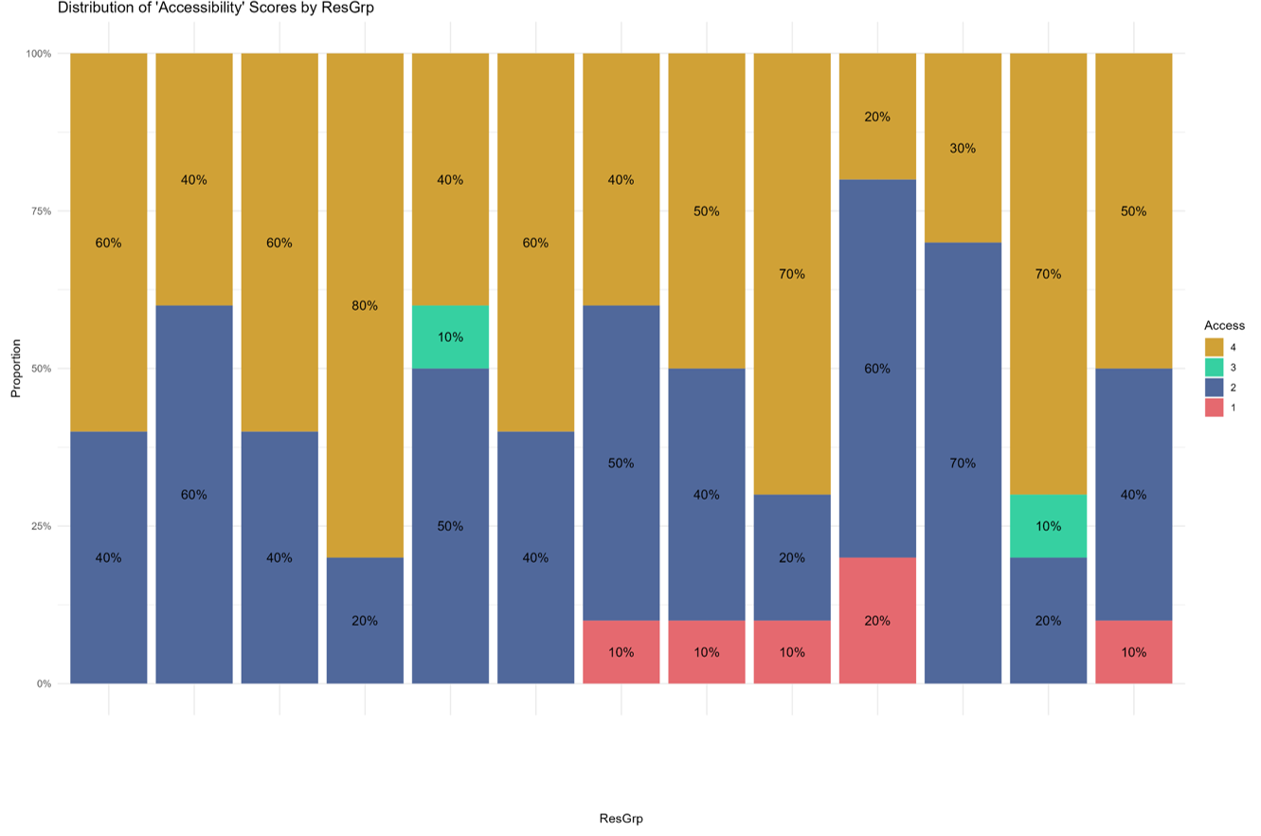

ggsave("internal3.png", internal3, width = 15, height = 10, units = "in", bg= "white")  
  
  
#these results were used for internal university meetings and presentations

# Calculate the frequency and percentage for each 'Licence' score among the research Group  
long_data <- data %>%  
 count(ResGrp, Licence) %>%  
 group_by(ResGrp) %>%  
 mutate(Percentage = n / sum(n) * 100) %>%  
 mutate(Label = ifelse(Percentage > 5, paste0(round(Percentage, 1), "%"), "")) %>%  
 mutate(Cumulative_Percentage = cumsum(Percentage) - (0.5 * Percentage)) %>%  
 ungroup()  
  
  
long_data <- long_data %>%  
 mutate(Licence = factor(Licence, levels = c("4", "3", "2", "1")))  
  
# Custom colors  
colors <- c("#D0A136", "#36D0A1","#50689B","#E5696F")  
  
# Creating the stacked bar chart with percentage labels  
internal4 <- ggplot(long_data, aes(x = as.factor(ResGrp), y = n, fill = as.factor(Licence))) +  
 geom_bar(stat = "identity", position = "fill") + # Scale the bar heights to proportions  
 scale_y_continuous(labels = percent_format()) + # Convert the y-axis to percentage  
 geom_text(  
 aes(label = Label, y = Percentage),   
 size = 4,   
 color = "black",   
 position = position_fill(vjust = 0.5)  
 ) +  
 scale_fill_manual(values = colors) +  
 labs(title = "Distribution of 'Licence' Scores by ResGrp",  
 x = "ResGrp",  
 y = "Proportion",  
 fill = "Licence") +  
 theme_minimal() +  
 scale_x_discrete(name = "ResGrp", labels = unique(long_data$ResGrp)) +  
 theme(axis.text.x = element_text(angle = 90, hjust = 1)) # Adjust text angle for readability  
  
# Print the plot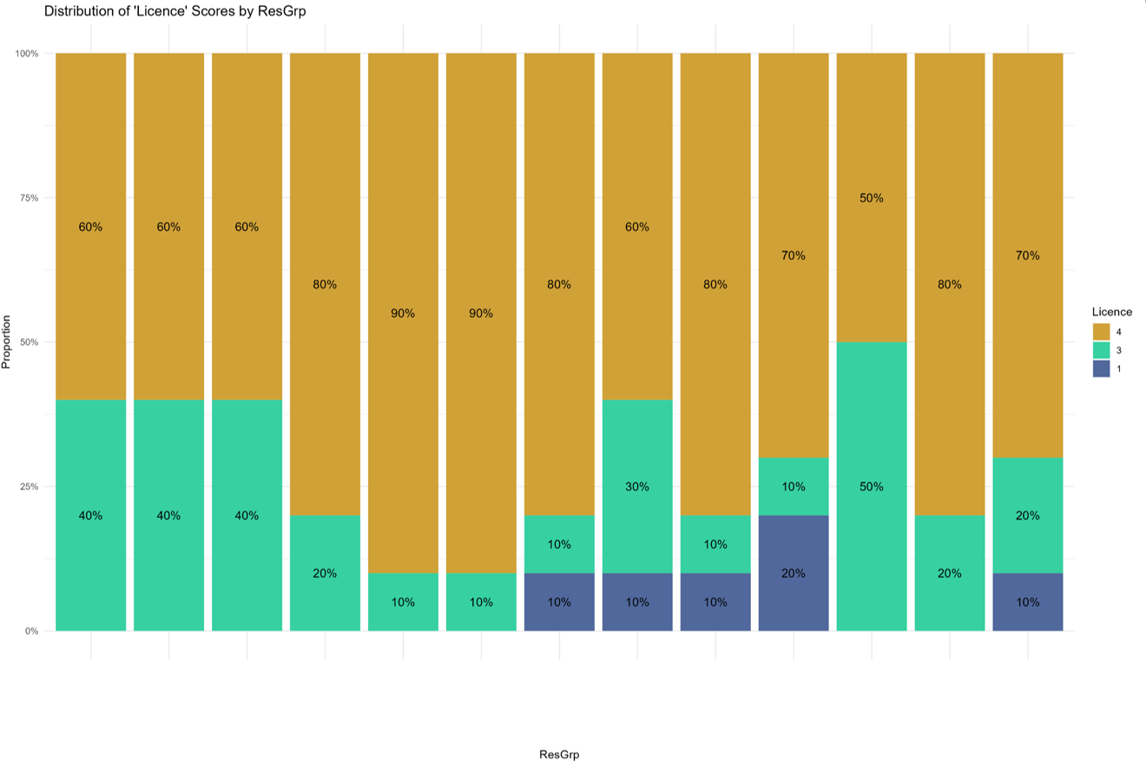  
print(internal4)