A
PROJECT REPORT
ON
“ Web Browser ”

Submitted to the Gondwana University, Gadchiroli in practical fulfillment of the requirement for Bachelor of Science (IT)III (Sem VI) Examination

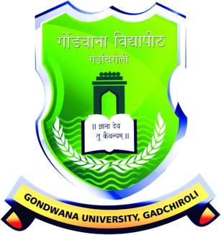

SUBMITTED BY

Mr.Gaurav S. Talodhikar (2014033700191813)
Miss. Komal M. Dhanorkar (2016033700056547)
Miss. Sujata M. Sonule (2016033700056474)

Guide

Dr. S. B. Kishor

DEPARTMENT OF COMPUTER STUDIES & RESEARCH
Sardar Patel Mahavidyalaya, Chandrapur
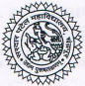
2018- 2019

Sardar Patel Mahavidyalaya Chandrapur
Department of Computer Studies & Research
CERTIFICATE

This is to certify that Mr. Gaurav S. Talodhikar, Miss.Komal M. Dhanorkar, Miss.Sujata Sonule are the bonafied students of B.SC(IT) III Year of this college for the session 2018 - 2019. They have completed their Project Work entitled
"Web Browser " approved by the Department.
This Project Work is being submitted to the Gondwana University, Gadchiroli in the fulfillment of the requirement for the award of B.SC(IT) III(Sem VI).
Date: / /
Place: Chandrapur.

Asst. Prof. Priyanka R. Yadav Dr. S. B. Kishor
(Co-Guide) ( Guide )

Internal Examiner External Examiner

DECLARATION
We, undersigned students of Department of Computer Studies and Reasearch here by declare that the project entitled “ Web Browser ” completed under guidance of Dr. S. B. Kishor
This project work is submitted for the partial fulfillment of B.SC(IT) III Year to the Department of Computer Studies and Research and Gondwana University, Gadchiroli
This report has not been submitted for any degree or diploma of any other university previously.

Date: - SUBMITTED BY

Place: - S. P. College Mr. Gaurav S. Talodhikar
Chandrapur. Miss. Komal M. Dhanorkar
Miss. Sujata M. Sonule

ACKNOWLEDGEMENT
We would like to express our deep sense of gratitude to our Guide Dr. S. B. Kishor for his able guidance and valuable advice during the course of our project.
We are also highly indebted to Prof. Priyanka Yadav, Prof. Nishant Shastrakar and Prof. Pravin Thakre the staff of "Department of Computer Studies and Research" for providing us all the facilities in college which we needed and encouraging us from time to time.
This acknowledges will remain incomplete without rendering impartial gratitude to all those helped us directly or indirectly in making this project success.
Last but not least, we would like to thank our parents who sacrificed their today for our tomorrow.

Mr. Gaurav S. Talodhikar
Miss. Komal M. Dhanorkar
Miss. Sujata M. Sonule

