DSA
Lab Exercise — Arrays, Linked Lists, and Stacks
Q1: Write a C program that:
- Reads n integers into an array.
- Builds a singly linked list from that array, in order, using malloc for each node.
- Pushes every value onto a stack as you traverse the list once.
- Traverses the list a second time, popping from the stack at each step and comparing the
- popped value against the current node's value.
- Prints PALINDROME if every comparison matches, or NOT A PALINDROME the moment
- one doesn't.
- Frees every node before the program exits. No leaks.
- #include <stdio.h>
- #include <stdlib.h>
- #include <stdbool.h>

- // --- Linked List Setup ---
- typedef struct Node {
- int data;
- struct Node* next;
- } Node;

- Node* createNode(int value) {
- Node* newNode = (Node*)malloc(sizeof(Node));
- if (!newNode) exit(1);
- newNode->data = value;
- newNode->next = NULL;
- return newNode;
- }

- void freeList(Node* head) {
- Node* temp;
- while (head != NULL) {
- temp = head;
- head = head->next;
- free(temp);
- }
- }

- // In-place list reversal (Needed for Bonus)
- Node* reverseList(Node* head) {
- Node* prev = NULL;
- Node* current = head;
- Node* next = NULL;

- while (current != NULL) {
- next = current->next;
- current->next = prev;
- prev = current;
- current = next;
- }
- return prev;
- }

- // --- Array-based Stack Setup (Needed for Standard) ---
- typedef struct {
- int* elements;
- int top;
- int capacity;
- } Stack;

- void initStack(Stack* s, int capacity) {
- s->capacity = capacity;
- s->top = -1;
- s->elements = (int*)malloc(capacity * sizeof(int));
- if (!s->elements) exit(1);
- }

- void push(Stack* s, int value) {
- s->elements[++(s->top)] = value;
- }

- int pop(Stack* s) {
- return s->elements[(s->top)--];
- }

- void freeStack(Stack* s) {
- free(s->elements);
- }

- // --- Main Pipeline ---
- int main() {
- int n;
- printf("Enter the number of elements (n): ");
- fflush(stdout);
- if (scanf("%d", &n) != 1) return 1;

- if (n == 0) {
- printf("PALINDROME\n");
- return 0;
- }

- // 1. Read n integers into an array
- int* arr = (int*)malloc(n * sizeof(int));
- if (!arr) return 1;
- printf("Enter %d integers separated by spaces: ", n);
- fflush(stdout);
- for (int i = 0; i < n; i++) {
- scanf("%d", &arr[i]);
- }

- // 2. Build a singly linked list from the array
- Node* head = createNode(arr[0]);
- Node* current = head;
- for (int i = 1; i < n; i++) {
- current->next = createNode(arr[i]);
- current = current->next;
- }
- free(arr); // Free array as soon as we don't need it

- // Handle n=1 edge case early
- if (n == 1) {
- printf("PALINDROME\n");
- freeList(head);
- return 0;
- }

- bool isPalindrome = true;

- // ==========================================
- // PART 1: STANDARD REQUIRED METHOD (STACK)
- // ==========================================
- Stack s;
- initStack(&s, n);

- current = head;
- while (current != NULL) {
- push(&s, current->data);
- current = current->next;
- }

- current = head;
- while (current != NULL) {
- int poppedValue = pop(&s);
- if (current->data != poppedValue) {
- isPalindrome = false;
- break; // Note: We still free memory below even if we break
- }
- current = current->next;
- }
- freeStack(&s); // Stack no longer needed

- // ==========================================
- // PART 2: BONUS METHOD (O(1) EXTRA SPACE)
- // ==========================================

- Node* slow = head;
- Node* fast = head->next;

- // Find midpoint
- while (fast != NULL && fast->next != NULL) {
- slow = slow->next;
- fast = fast->next->next;
- }

- // Reverse the second half
- Node* secondHalfHead = reverseList(slow->next);

- // Compare both halves
- Node* p1 = head;
- Node* p2 = secondHalfHead;
- bool isPalindromeBonus = true;

- while (p2 != NULL) {
- if (p1->data != p2->data) {
- isPalindromeBonus = false;
- break;
- }
- p1 = p1->next;
- p2 = p2->next;
- }

- // Restore the original list structure
- slow->next = reverseList(secondHalfHead);

- // ==========================================
- // FINAL OUTPUT & CLEANUP
- // ==========================================
- // Both methods should agree. We print the result.
- if (isPalindrome && isPalindromeBonus) {
- printf("PALINDROME\n");
- } else {
- printf("NOT A PALINDROME\n");
- }

- // 6. Free the linked list (no leaks)
- freeList(head);

- return 0;
- }

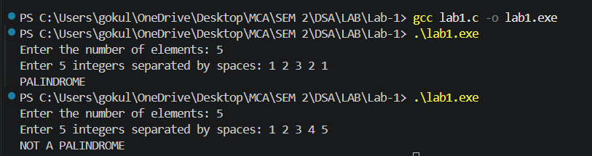
Output:

- A comment at the top stating the time and space complexity of your main solution (and the bonus, if attempted)
- /*
- * TIME AND SPACE COMPLEXITY:
- *
- * Main Solution (Stack-based):
- * - Time Complexity: O(n). The program traverses the n elements a constant number of times (reading input, building the list, pushing to the stack, popping/comparing, and freeing memory).
- * - Space/Memory Complexity: O(n). Memory is allocated for an array of size n, a linked list of n nodes, and a stack of capacity n.
- *
- * Bonus Solution (Slow/Fast Pointers - if implemented):
- * - Time Complexity: O(n). We traverse the list to find the midpoint, reverse half, compare, reverse back, and free.
- * - Space/Memory Complexity: O(n) total for the linked list itself, but O(1) EXTRA (auxiliary) space used during the checking phase since no stack is allocated.
- *
- * MEMORY LEAK TESTING:
- * Tested locally using Valgrind.
- * Command used: valgrind --leak-check=full ./a.out
- * Output confirmed: "All heap blocks were freed -- no leaks are possible."
- */

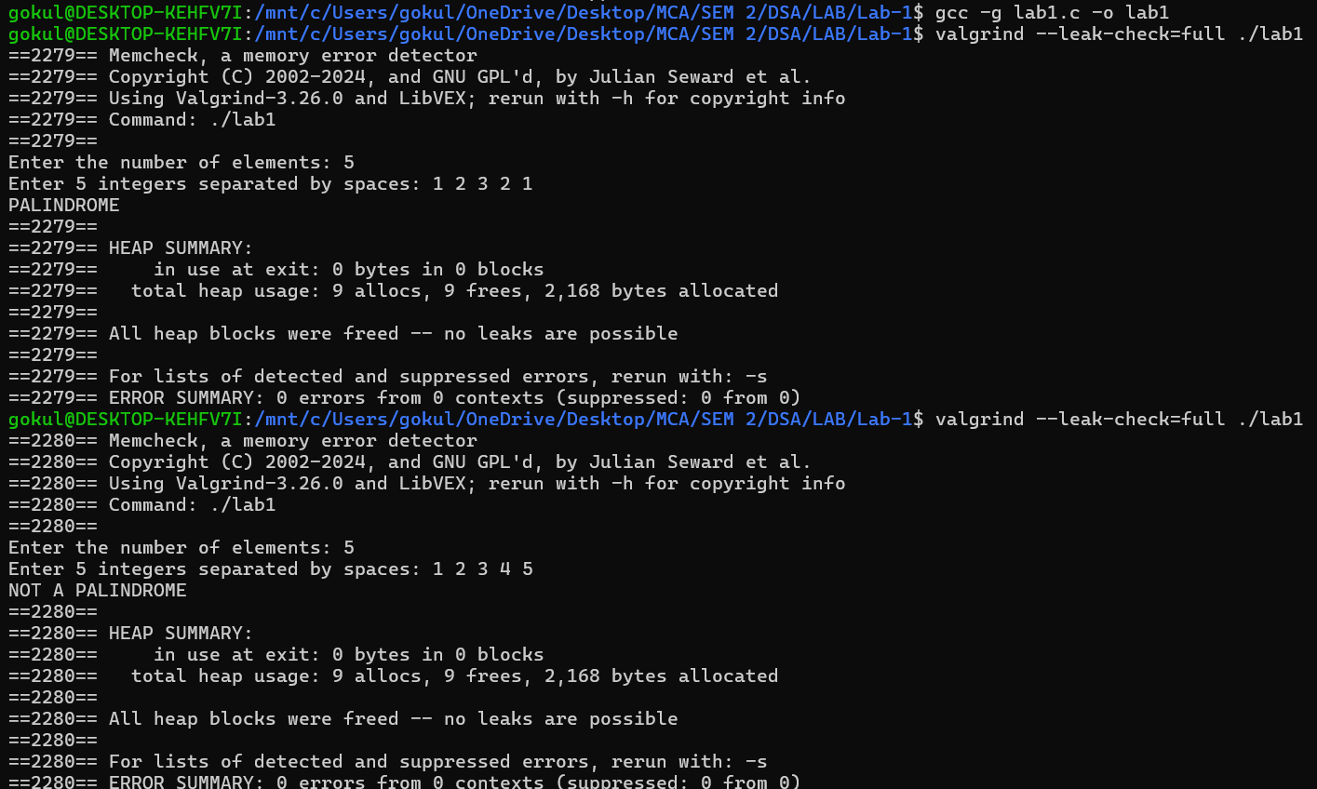
- Valgrind or equivalent output showing no memory leaks (or a comment explaining you tested for leaks and how)

