DSA
Lab Exercise — Searching and Hashing
Q1: Write a C program that:
- Implements a hash table of M buckets, using a polynomial rolling hash on the department code string: h = 0; for each character c: h = (h × 31 + c) % M.
- Handles bucket collisions between different department codes by storing, at each bucket index, a small list of department-groups — each group holding its own department code string and its own dynamically growing sorted array of roll numbers. Two different departments landing on the same bucket index must never be confused with each other.
- Implements INSERT(dept, rollNo): hash dept to a bucket, find or create that department's group within the bucket, then use binary search to find the correct sorted insertion position and insert the roll number there (growing the group's array with realloc as needed — do not hardcode a small maximum).
- Implements SEARCH(dept, rollNo): hash dept to a bucket, locate its group, then binary search within that group's sorted array. Print FOUND or NOT FOUND.
- Implements RANK(dept, rollNo): assuming rollNo is present in dept, use binary search to print how many roll numbers in that department are strictly smaller than it (i.e. its 0-indexed position in the sorted order).
- Frees every dynamically allocated block — every group's array and every group record itself — before the program exits. No leaks.

Code:
- #include <stdio.h>
- #include <stdlib.h>
- #include <string.h>

- typedef struct DeptGroup {
- char dept[6];
- int* rolls;
- int capacity;
- int size;
- struct DeptGroup* next;
- } DeptGroup;

- int hashDept(const char* dept, int M) {
- unsigned int h = 0;
- for (int i = 0; dept[i] != '\0'; i++) {
- h = (h * 31 + dept[i]) % M;
- }
- return h;
- }

- int findPos(int* arr, int size, int val) {
- int low = 0, high = size - 1;
- while (low <= high) {
- int mid = low + (high - low) / 2;
- if (arr[mid] == val) return mid;
- else if (arr[mid] < val) low = mid + 1;
- else high = mid - 1;
- }
- return low;
- }

- // Helper functions for Rehashing
- int isPrime(int n) {
- if (n <= 1) return 0;
- if (n <= 3) return 1;
- if (n % 2 == 0 || n % 3 == 0) return 0;
- for (int i = 5; i * i <= n; i = i + 6)
- if (n % i == 0 || n % (i + 2) == 0) return 0;
- return 1;
- }

- int getNextPrime(int n) {
- int prime = n;
- while (1) {
- prime++;
- if (isPrime(prime)) return prime;
- }
- }

- int main() {
- int M, Q;
- printf("Enter number of buckets (M) and number of queries (Q): ");
- if (scanf("%d %d", &M, &Q) != 2) return 1;

- DeptGroup** table = (DeptGroup**)calloc(M, sizeof(DeptGroup*));
- int total_records = 0;

- char op[10], dept[6];
- int rollNo;

- for (int i = 0; i < Q; i++) {
- printf("\nEnter operation (INSERT/DELETE/SEARCH/RANK), department, and roll number: ");
- scanf("%s %s %d", op, dept, &rollNo);

- int h = hashDept(dept, M);
- DeptGroup* curr = table[h];
- DeptGroup* group = NULL;
- DeptGroup* prev = NULL;
- DeptGroup* group_prev = NULL;

- // Traverse chain tracking the 'prev' pointer for possible deletion
- while (curr != NULL) {
- if (strcmp(curr->dept, dept) == 0) {
- group = curr;
- group_prev = prev;
- break;
- }
- prev = curr;
- curr = curr->next;
- }

- if (strcmp(op, "INSERT") == 0) {
- if (group == NULL) {
- group = (DeptGroup*)malloc(sizeof(DeptGroup));
- strcpy(group->dept, dept);
- group->capacity = 4;
- group->size = 0;
- group->rolls = (int*)malloc(group->capacity * sizeof(int));
- group->next = table[h];
- table[h] = group;
- }

- int idx = findPos(group->rolls, group->size, rollNo);
- if (idx >= group->size || group->rolls[idx] != rollNo) {
- if (group->size == group->capacity) {
- group->capacity *= 2;
- group->rolls = (int*)realloc(group->rolls, group->capacity * sizeof(int));
- }
- for (int j = group->size; j > idx; j--) {
- group->rolls[j] = group->rolls[j - 1];
- }
- group->rolls[idx] = rollNo;
- group->size++;
- total_records++;

- // LOAD-FACTOR TRIGGERED REHASHING (Threshold > 4.0)
- if ((float)total_records / M > 4.0) {
- int new_M = getNextPrime(M * 2);
- DeptGroup** new_table = (DeptGroup**)calloc(new_M, sizeof(DeptGroup*));

- for (int j = 0; j < M; j++) {
- DeptGroup* rehash_curr = table[j];
- while (rehash_curr != NULL) {
- DeptGroup* next_node = rehash_curr->next;
- int new_h = hashDept(rehash_curr->dept, new_M);

- // Re-link the entire group into the new table
- rehash_curr->next = new_table[new_h];
- new_table[new_h] = rehash_curr;

- rehash_curr = next_node;
- }
- }
- free(table);
- table = new_table;
- M = new_M;
- }
- }
- }
- else if (strcmp(op, "DELETE") == 0) {
- if (group != NULL) {
- int idx = findPos(group->rolls, group->size, rollNo);
- if (idx < group->size && group->rolls[idx] == rollNo) {
- // Shift elements left to close the gap
- for (int j = idx; j < group->size - 1; j++) {
- group->rolls[j] = group->rolls[j + 1];
- }
- group->size--;
- total_records--;

- // If group is empty, free it and remove it from the chain
- if (group->size == 0) {
- if (group_prev != NULL) {
- group_prev->next = group->next;
- } else {
- // It was the head of the bucket
- table[h] = group->next;
- }
- free(group->rolls);
- free(group);
- }
- }
- }
- }
- else if (strcmp(op, "SEARCH") == 0) {
- if (group != NULL) {
- int idx = findPos(group->rolls, group->size, rollNo);
- if (idx < group->size && group->rolls[idx] == rollNo) {
- printf("FOUND\n");
- } else {
- printf("NOT FOUND\n");
- }
- } else {
- printf("NOT FOUND\n");
- }
- }
- else if (strcmp(op, "RANK") == 0) {
- if (group != NULL) {
- int idx = findPos(group->rolls, group->size, rollNo);
- printf("%d\n", idx);
- }
- }
- }

- // Free memory before exit
- for (int i = 0; i < M; i++) {
- DeptGroup* curr = table[i];
- while (curr != NULL) {
- DeptGroup* temp = curr;
- curr = curr->next;
- free(temp->rolls);
- free(temp);
- }
- }
- free(table);

- return 0;
- }

Output:
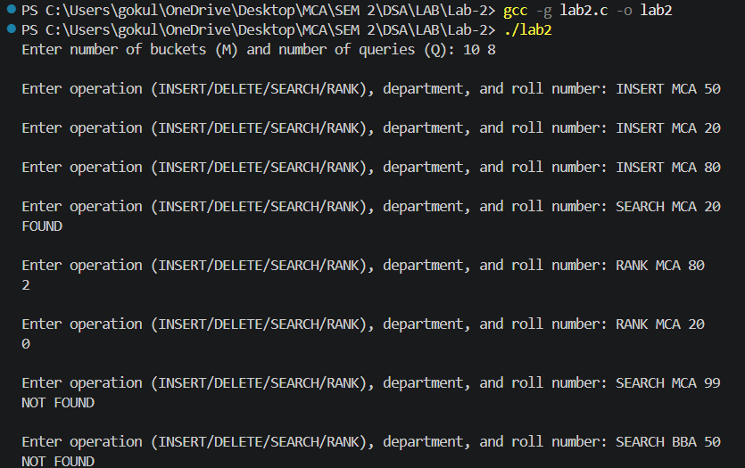
- INSERT/SEARCH/RANK

- Collision Handling
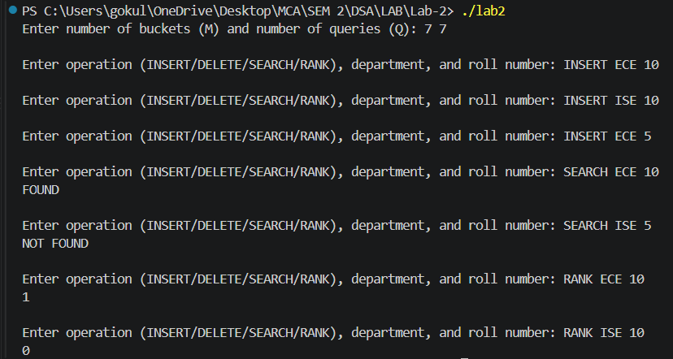
Even though ECE and ISE share the same bucket chain, searching for 5 in ISE correctly fails, and ranking 10 yields different answers depending on the department
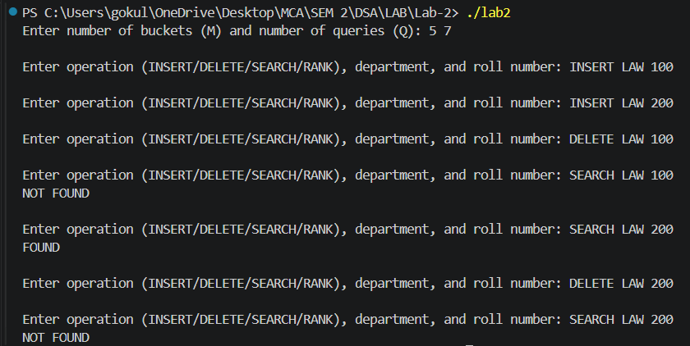
- Deletion & Group Cleanup

First deletion leaves [200]. Second deletion empties the array, triggering the code to free the LAW group node entirely. The final search safely reports NOT FOUND without a segmentation fault)

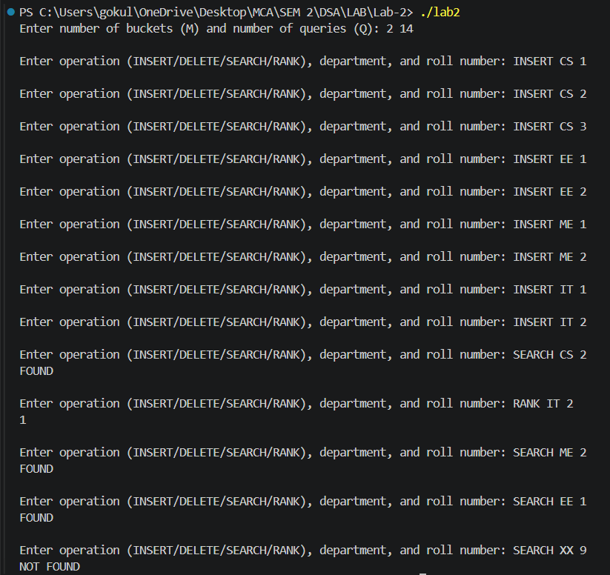
- Load-Factor Rehashing

Behind the scenes, the 9th insert (IT 2) triggered realloc on the hash table itself and re-linked every node. The subsequent searches succeed, proving no data was lost during the structural migration

- A comment at the top stating the time and space complexity of your main solution (and the bonus, if attempted)

- /*
- * TIME COMPLEXITY:
- * Hash Lookup: Average O(1)
- * SEARCH/RANK: O(log k)
- * INSERT: O(k) worst-case due to array shifting. Amortized O(1) for rehashing.
- * DELETE: O(k) worst-case due to array shifting.
- *
- * SPACE COMPLEXITY: O(N + M)
- */

- Valgrind or equivalent output showing no memory leaks (or a comment explaining you tested for leaks and how)
