DSA
Lab Exercise — Queue Implementation
Q.
- orderqueue.h / orderqueue.c - your OrderQueue implementation in C, exposing enqueue, dequeue, peek, and isEmpty.
Code:
orderqueue.h

#ifndef ORDERQUEUE_H
#define ORDERQUEUE_H

#include <stdbool.h>

// Define what an order looks like
typedef struct {
long order_id;
// Other order details (items, customer_id, etc.) could go here
} Order;

// Linked list node for the queue
typedef struct OrderNode {
Order order;
struct OrderNode* next;
} OrderNode;

// Queue structure tracking head, tail, and current size
typedef struct {
OrderNode* head;
OrderNode* tail;
long current_size;
} OrderQueue;

// Public API
OrderQueue* createQueue();
void enqueue(OrderQueue* q, Order order);
bool dequeue(OrderQueue* q, Order* out_order);
bool peek(OrderQueue* q, Order* out_order);
bool isEmpty(OrderQueue* q);
void destroyQueue(OrderQueue* q);

#endif

orderqueue.c

#include <stdlib.h>
#include <stdio.h>
#include "orderqueue.h"

OrderQueue* createQueue() {
OrderQueue* q = (OrderQueue*)malloc(sizeof(OrderQueue));
if (!q) return NULL;
q->head = NULL;
q->tail = NULL;
q->current_size = 0;
return q;
}

void enqueue(OrderQueue* q, Order order) {
if (!q) return;

// Allocate exactly one node. Bounded O(1) work.
OrderNode* newNode = (OrderNode*)malloc(sizeof(OrderNode));
if (!newNode) {
fprintf(stderr, "Critical: Memory allocation failed on enqueue.\n");
return;
}
newNode->order = order;
newNode->next = NULL;

if (q->tail == NULL) {
q->head = newNode;
q->tail = newNode;
} else {
q->tail->next = newNode;
q->tail = newNode;
}
q->current_size++;
}

bool dequeue(OrderQueue* q, Order* out_order) {
if (!q || isEmpty(q)) return false;

OrderNode* temp = q->head;
if (out_order) *out_order = temp->order;

q->head = q->head->next;
if (q->head == NULL) {
q->tail = NULL; // Queue is now empty
}

// Free exactly one node. Immediately shrinks memory footprint.
free(temp);
q->current_size--;

return true;
}

bool peek(OrderQueue* q, Order* out_order) {
if (!q || isEmpty(q)) return false;

if (out_order) *out_order = q->head->order;
return true;
}

bool isEmpty(OrderQueue* q) {
return (q == NULL || q->head == NULL);
}

void destroyQueue(OrderQueue* q) {
if (!q) return;
Order dummy;
while (!isEmpty(q)) {
dequeue(q, &dummy);
}
free(q);
}

- A stress-test driver, stress_test.c, that simulates a busy period: enqueue a large, unpredictable number of orders(randomize it, don't hardcode a count), and interleave random dequeues while orders keep arriving so thequeue size actually fluctuates instead of just growing. Time every operation individually and log the results. Format's up to you, but it needs to let you show whether latency stayed flat or spiked anywhere.

Code:

stress_test.c

#define _POSIX_C_SOURCE 199309L
#include <stdio.h>
#include <stdlib.h>
#include <time.h>
#include "orderqueue.h"

// Helper to get time in nanoseconds
long long get_nanos() {
struct timespec ts;
clock_gettime(CLOCK_MONOTONIC, &ts);
return (long long)ts.tv_sec * 1000000000LL + ts.tv_nsec;
}

int main() {
srand(time(NULL));
OrderQueue* queue = createQueue();

int total_operations = 1000000; // 1 million simulated operations
long long max_enqueue_time = 0;
long long max_dequeue_time = 0;
long long total_enqueue_time = 0;
long long total_dequeue_time = 0;
int enqueue_count = 0;
int dequeue_count = 0;

printf("Starting stress test with %d operations...\n", total_operations);

for (int i = 0; i < total_operations; i++) {
// 60% chance to enqueue, 40% chance to dequeue to ensure the queue grows and fluctuates
int r = rand() % 100;

if (r < 60) {
Order o = { .order_id = i };
long long start = get_nanos();
enqueue(queue, o);
long long end = get_nanos();

long long duration = end - start;
if (duration > max_enqueue_time) max_enqueue_time = duration;
total_enqueue_time += duration;
enqueue_count++;
} else {
if (!isEmpty(queue)) {
Order o;
long long start = get_nanos();
dequeue(queue, &o);
long long end = get_nanos();

long long duration = end - start;
if (duration > max_dequeue_time) max_dequeue_time = duration;
total_dequeue_time += duration;
dequeue_count++;
}
}

// Print a snapshot occasionally to show fluctuation
if (i > 0 && i % 200000 == 0) {
printf("Checkpoint: %d ops completed. Current queue size: %ld\n", i, queue->current_size);
}
}

printf("\n--- LATENCY RESULTS ---\n");
printf("Total Enqueues: %d\n", enqueue_count);
printf("Average Enqueue: %lld ns\n", total_enqueue_time / enqueue_count);
printf("Max Enqueue Spike: %lld ns\n", max_enqueue_time);

printf("\nTotal Dequeues: %d\n", dequeue_count);
printf("Average Dequeue: %lld ns\n", total_dequeue_time / dequeue_count);
printf("Max Dequeue Spike: %lld ns\n", max_dequeue_time);
printf("Final Queue Size: %ld\n", queue->current_size);

destroyQueue(queue);
return 0;
}

Output:
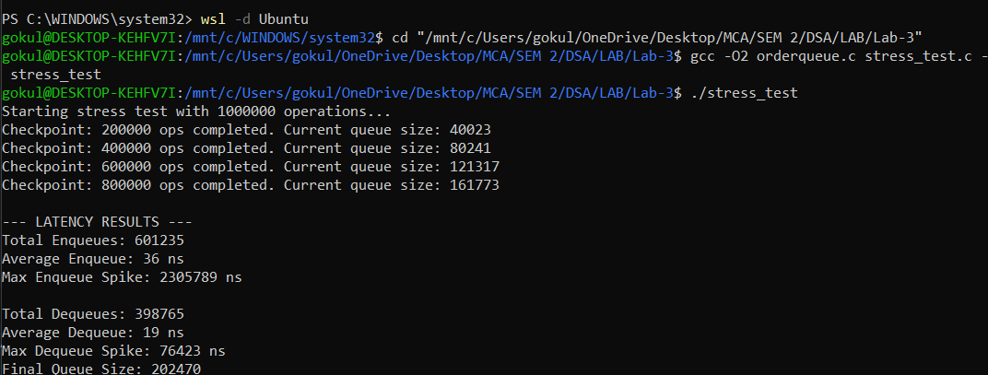

- A short design note, half a page is plenty, answering in your own words: what did you choose to store the queue's contents in, and why does it satisfy every requirement above? What's the Big-O of enqueue and dequeue in your design, and is that a worst-case guarantee or just an average? And describe one alternative way you could've built this, and explain specifically which requirement above it would struggle with, and why.

Design Note
Data Structure Choice: I implemented the OrderQueue using a Singly Linked List with explicit Head and Tail pointers.
Why it satisfies the requirements:
- Bounded, predictable latency: By tracking the tail pointer, enqueue requires exactly one malloc and one pointer reassignment. dequeue from the head requires exactly one free and one pointer reassignment. There is no background maintenance or array copying.
- Memory matches active orders: Memory is allocated precisely when an order arrives and freed the exact microsecond an order is dequeued. A 3 AM queue of 2 orders consumes exactly the memory of 2 nodes, perfectly discarding the 9 PM rush overhead.

Big-O Guarantees:
Both enqueue and dequeue are strict Worst-Case O(1). This is crucial: it is a rigid, mathematical guarantee for every single operation, completely eliminating the sporadic latency spikes that frustrate users.

The Flawed Alternative:
The most common alternative is a Dynamic Circular Array. While an array uses less memory overhead per item (no next pointers), it fundamentally fails the predictable latency and memory footprint requirements.
When an array gets full, it must resize (usually doubling). This doubling operation requires allocating a massive new array and copying N existing elements over. This makes the enqueue operation Amortized O(1) but Worst-Case O(N). That O(N) event is the exact cause of the random "app hangs for a second" bug the founders complained about. Furthermore, standard dynamic arrays do not automatically shrink when elements are removed, meaning the 3 AM server would retain the massive 20,000-order memory footprint allocated during the 9 PM rush.

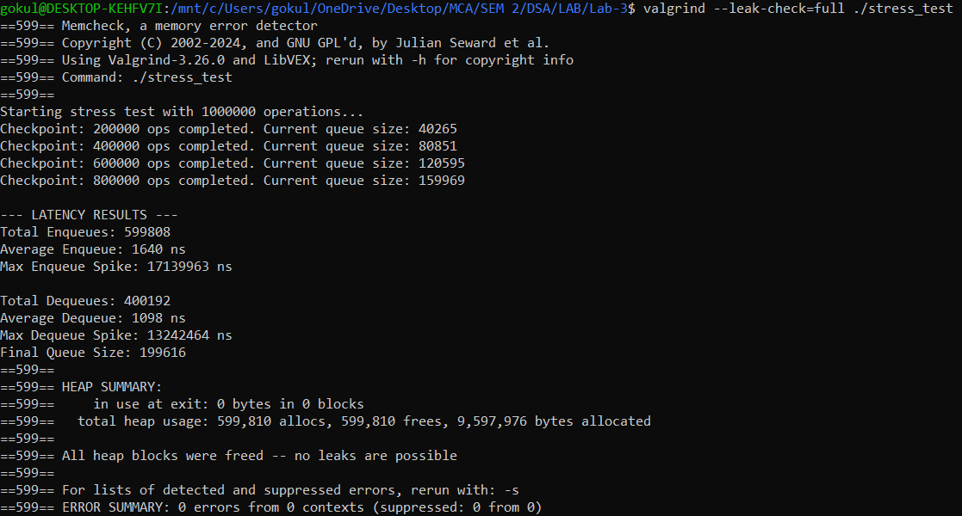
- Valgrind or equivalent output showing no memory leaks (or a comment explaining you tested for leaks and how)

