Python Programming
Lab Exercise 5
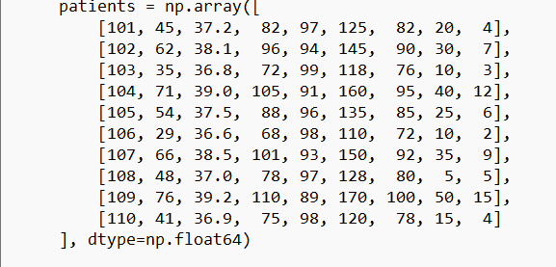
Q1: 1. Array Creation and Dataset Preparation: Create NumPy arrays for the patient dataset and use appropriate NumPy array-creation functions

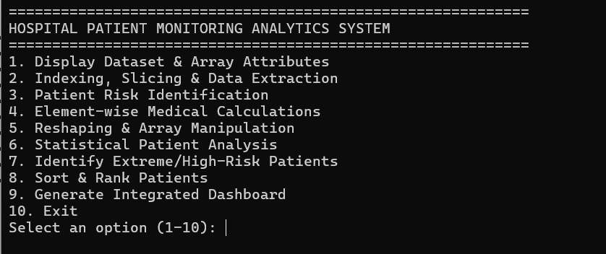
Menu:

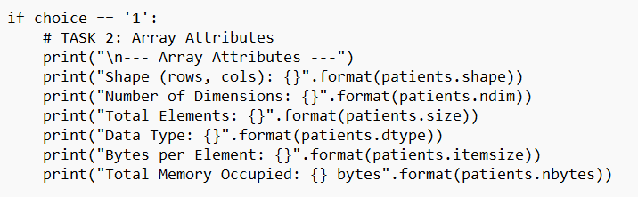
2. Array Attributes and Patient Data Exploration: Display and interpret the shape, number of dimensions, total number of elements, data type, bytes per element, and total memory occupied by the patient dataset using appropriate NumPy attributes.
Code:

Output:
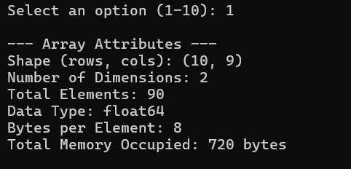

3. Indexing and Slicing: Extract the patient IDs, vital-sign columns, records of selected patients, the first five patients, and selected ranges of columns using indexing, negative indexing, slicing, and 2D indexing.
Code:
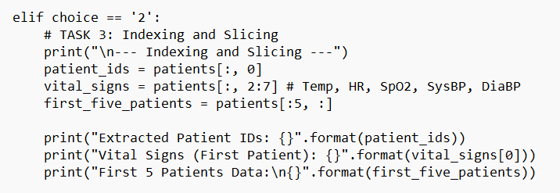

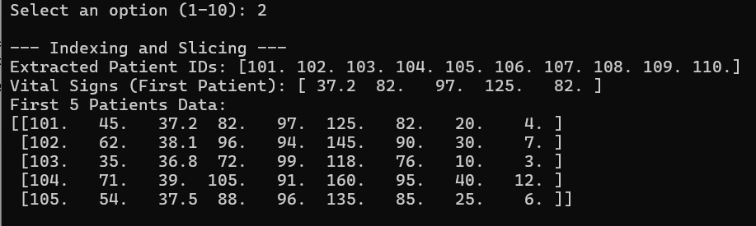
Output:

4. Patient Risk Identification: Use Boolean/Fancy indexing and np.where() to identify patients with temperature above 38°C, SpO2 below 95%, heart rate above 100 bpm, or systolic BP above 140 mmHg, and generate a list of patients requiring medical attention.
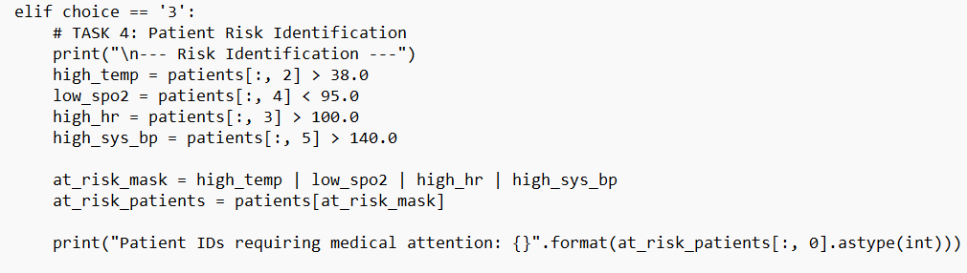
Code:

Output:
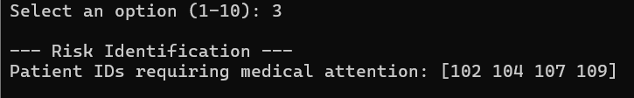

5. Element-wise Medical Calculations: Calculate pulse pressure, BMI-like derived measures where appropriate, medication-adjusted values, percentage changes, squared values, square roots, logarithmic/exponential transformations, and absolute differences
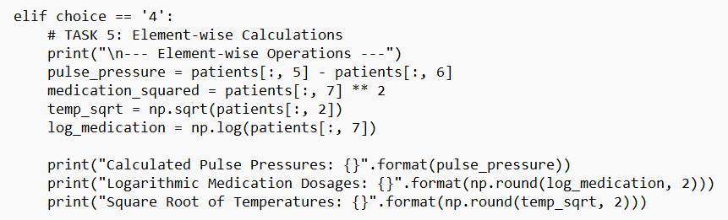
Code:

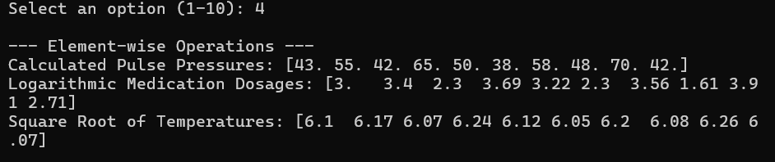
Output:

6. Reshaping and Manipulation: Reshape suitable patient-monitoring data into different dimensions, convert a multidimensional array into one dimension, transpose the dataset, concatenate patient records, vertically and horizontally stack related hospital data, split the dataset into suitable groups.
Code:
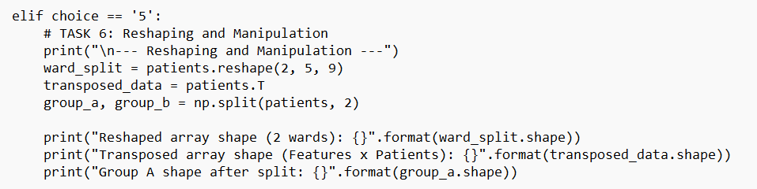

Output:
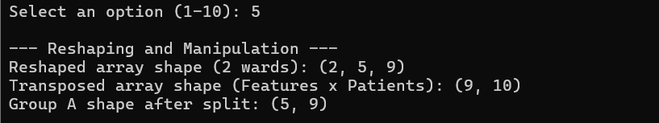
7. Statistical Patient Analysis: Calculate total, mean, standard deviation, variance, minimum, maximum, median, and selected percentiles for important patient parameters. Calculate cumulative medication dosage and cumulative hospital-stay information
Code:
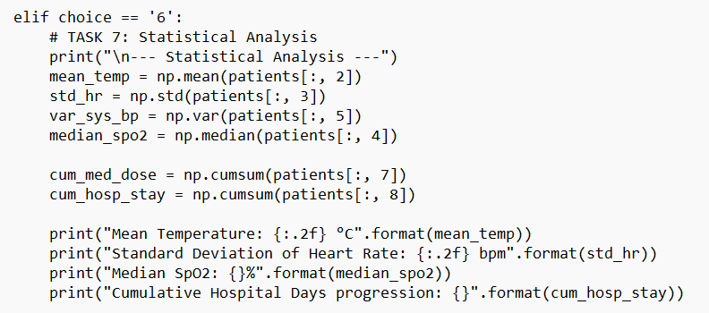
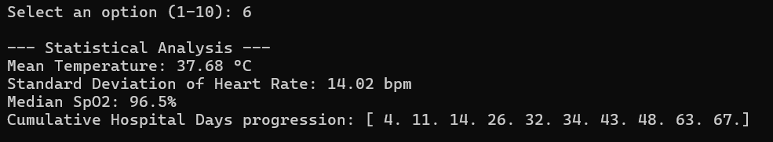
Output:

8. High-Risk and Best-Condition Patients: Identify the patient with the lowest SpO2, highest temperature, highest heart rate, and longest hospital stay. Clearly report the corresponding Patient IDs rather than only reporting array indices.
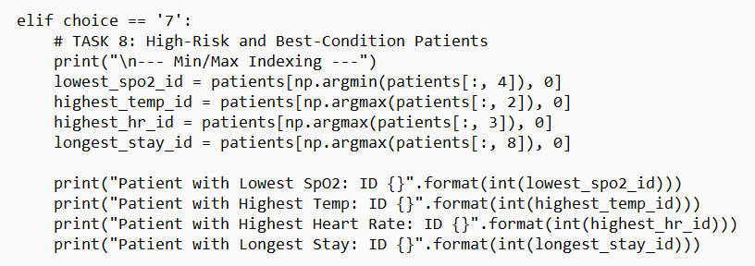
Code:

Output:
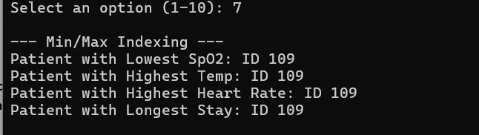

9. Sorting and Searching: Sort patients according to temperature, SpO2, heart rate, or hospital stay. Use argsort() to obtain the ranking of patients.
Code:
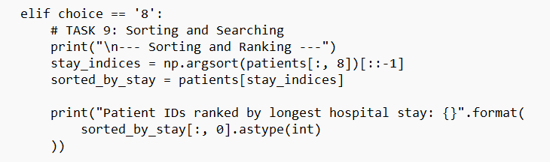

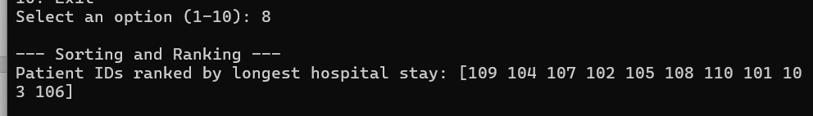
Output:

10. Integrated Hospital Dashboard: Finally, generate a concise NumPy-based report containing the number of patients, average vital signs, highest-risk patients, patients requiring immediate attention, highest and lowest values, patient rankings, cumulative statistics, and hospital resource requirements.
Code:
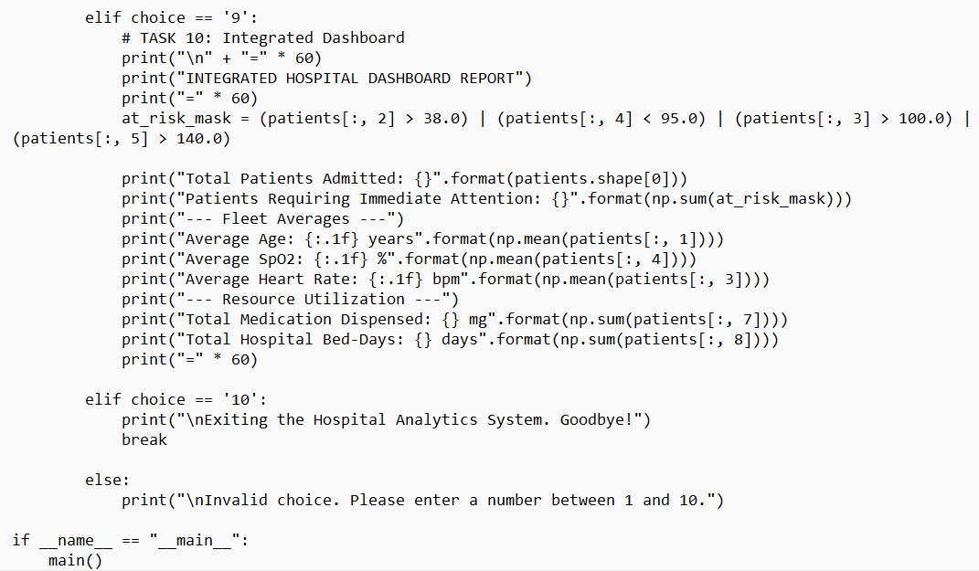
Output:
