Python Programming
Lab Exercise 2
Q1: Demonstrate Custom modules with functions
A. Create a custom Python module containing at least five reusable functions relevant to your selected domain.
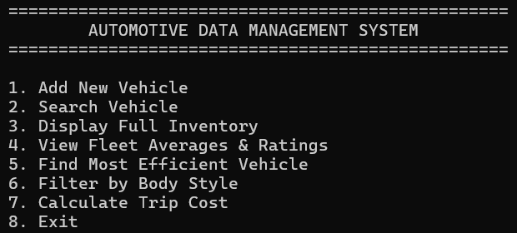
Menu: -

I. Add New Vehicle: -
Code:
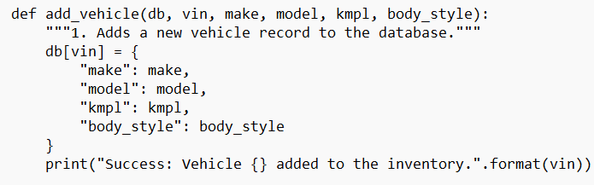
Output:
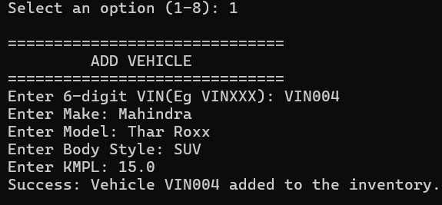

II. Search Vehicle: -
Code:
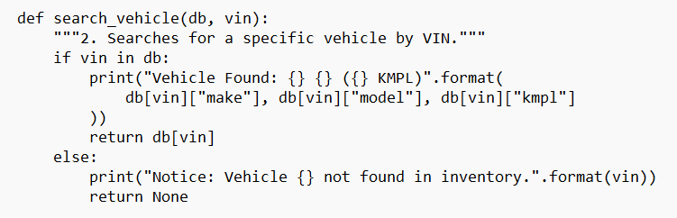
Output:
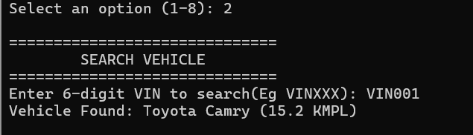

III. Display Full Inventory: -
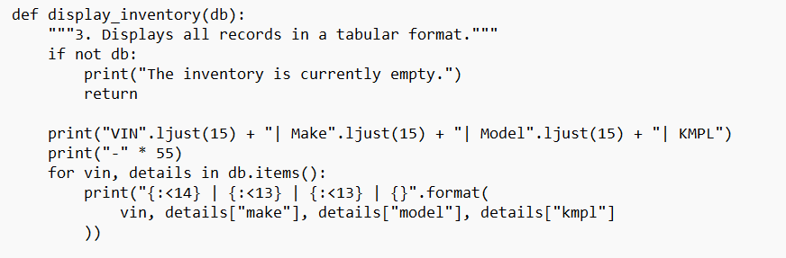
Code:

Output:
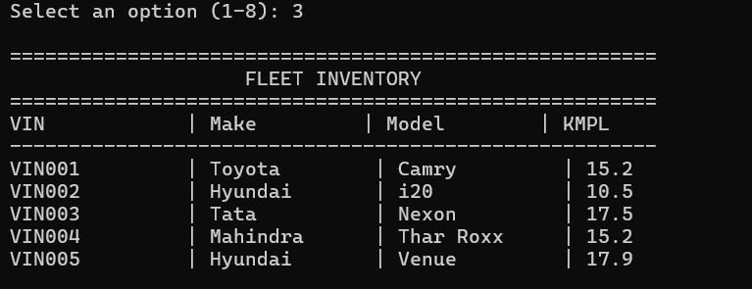
IV. View Fleet Averages & Ratings: -
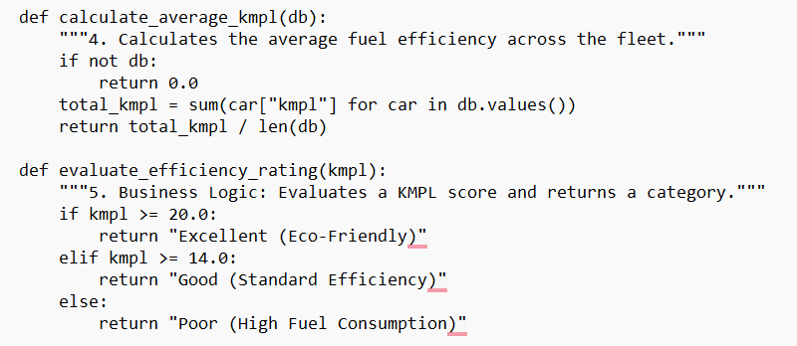
Code:

Output:
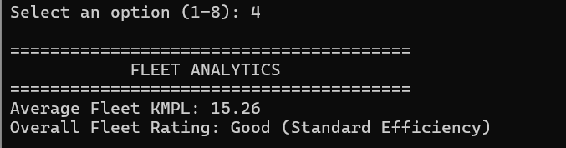

V. Find Most Efficient Vehicle: -
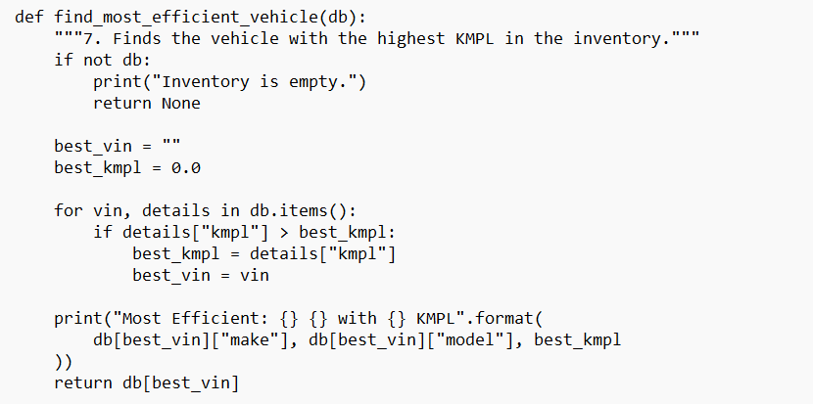
Code:

Output:
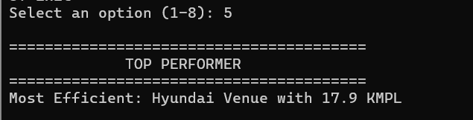
VI. Filter by Body Style: -
Code:
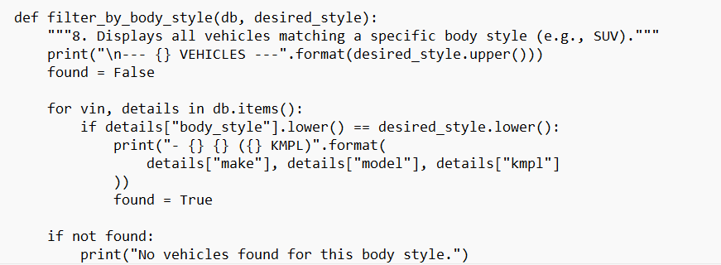

Output:
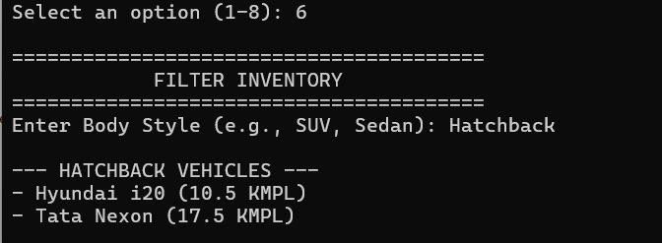
VII. Calculate Trip Cost
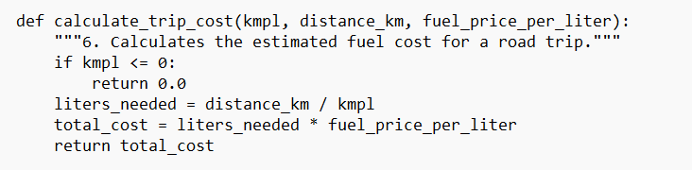
Code:

Output:
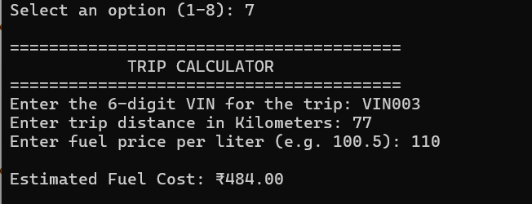

B. Design a reusable domain-independent utility modules and demonstrate its integration int your application.
I. Valid String: -
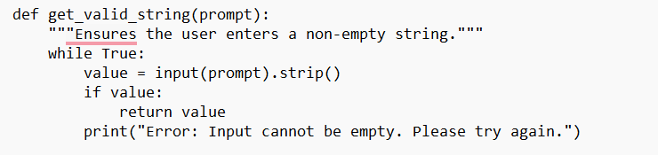
Code:
Output:
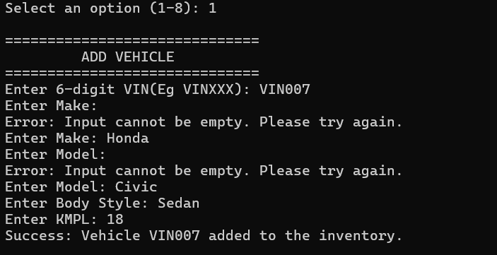
II. Valid Float: -
Code:
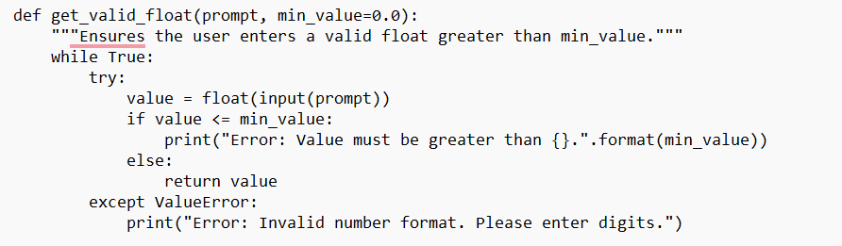

Output:
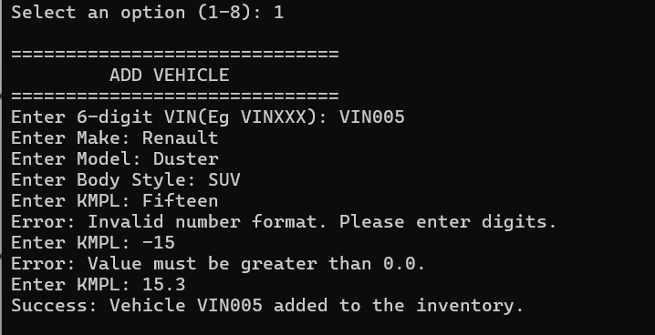
III. Alphanumeric String: -
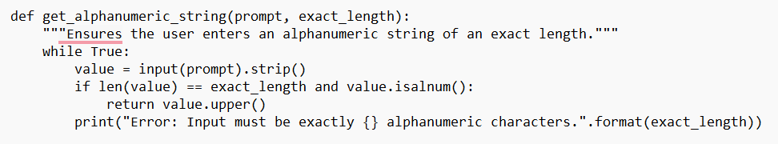
Code:

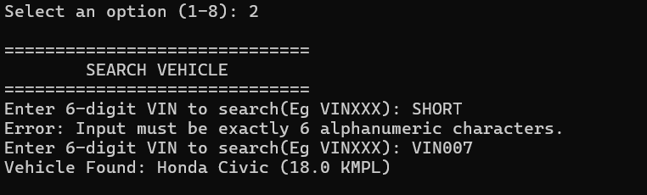
Output:

IV. Header: -
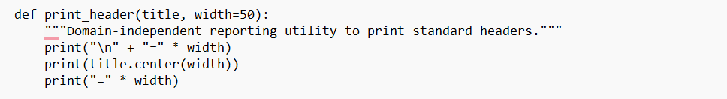
Code:

Output:
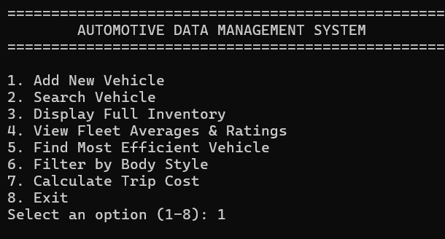

V. Unique Alphanumeric: -
Code:
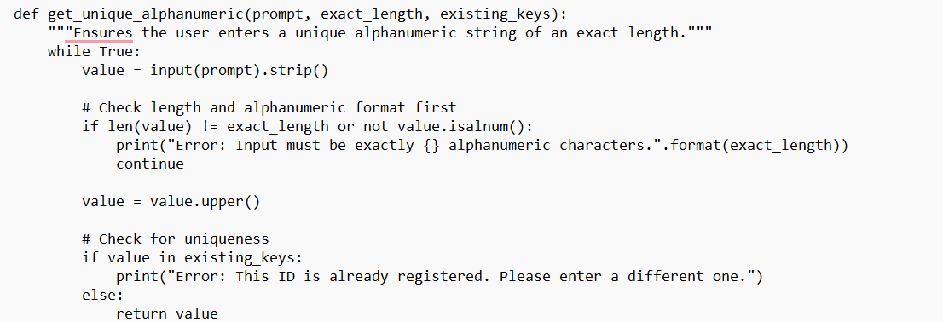
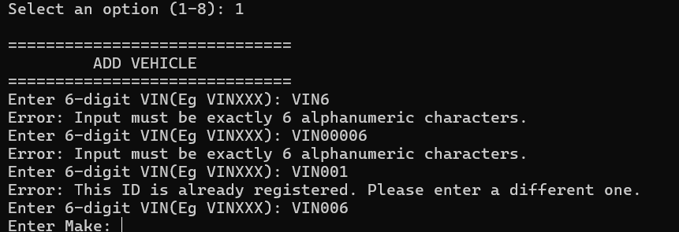
Output:

