Python Programming
Lab Exercise 6
Q1: Design a web application to explore the different graphs using layouts
Streamlit Application for Analysis
Develop an interactive web-based data analytics application using Python Streamlit to explore, analyse and visualize patterns in a domain-specific dataset identified and selected by you. The objective is to design a visually appealing, user-friendly and interactive dashboard that enables users to explore the dataset, identify meaningful patterns, interpret analytical results and support data-driven decision-making.
1. Title and Brief Description of the Selected Domain and Dataset
- Application Title: AutoDash · Automotive Fleet Analytics
- Selected Domain: Automotive & Fuel Efficiency Analysis (Fleet Management)
- Dataset & Preprocessing Description: The application analyses data.csv, a dataset containing 11,914 vehicle records across 16 attributes spanning model years 1990 to 2017. During ingestion (load_and_clean_data), missing values in Engine HP (69 rows) and Engine Cylinders (30 rows) are imputed using the median, Number of Doors (6 rows) is imputed using the mode, and missing categorical values in Engine Fuel Type and Market Category are filled with "Unknown" and "Standard", respectively. Two domain-specific metric columns—Highway KMPL and City KMPL—are derived using the conversion factor 1 MPG = 0.425144 KMPL.
2. Screenshots of the Customized Application
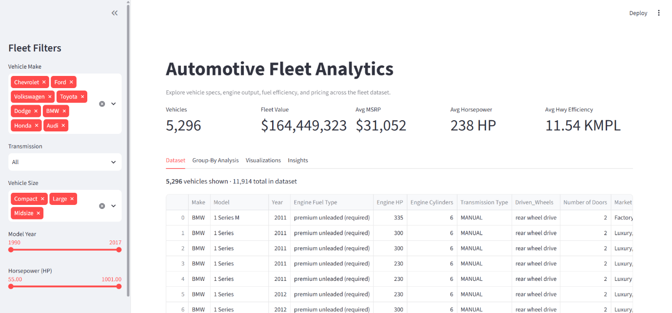
- Screenshot 1 — Header, Dynamic KPIs & Sidebar Filters (Fleet Filters):
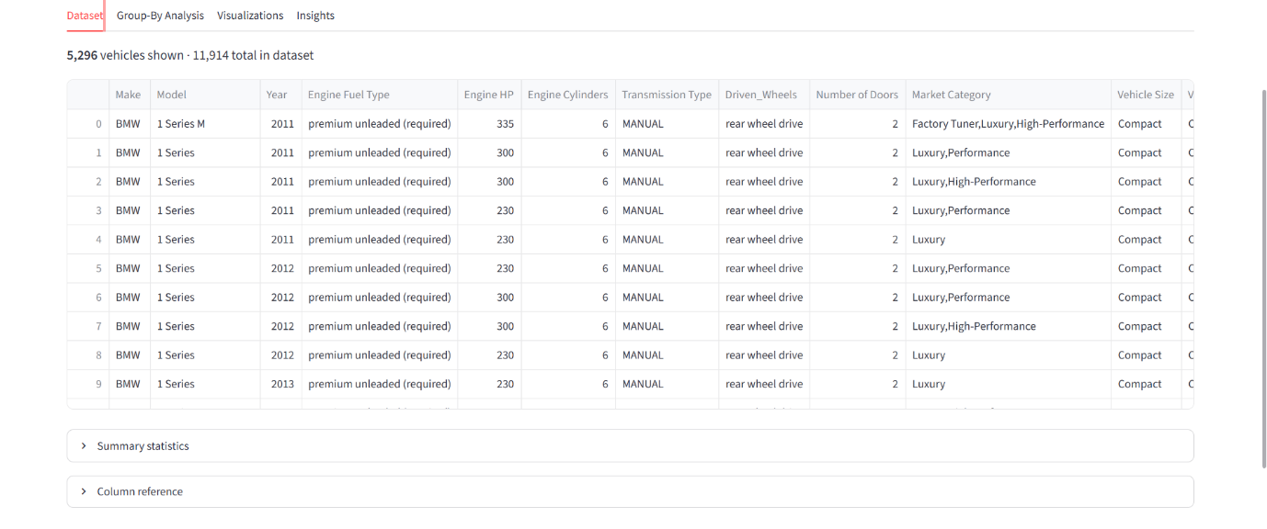
- Screenshot 2 — Tab 1 (Dataset):

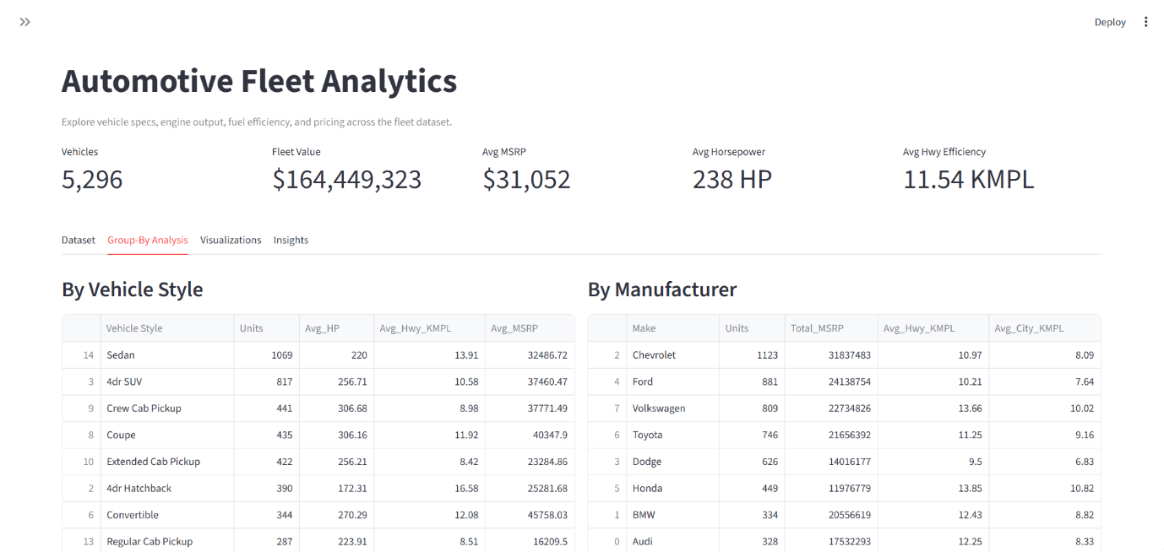
- Screenshot 3 — Tab 2 (Group-By Analysis):

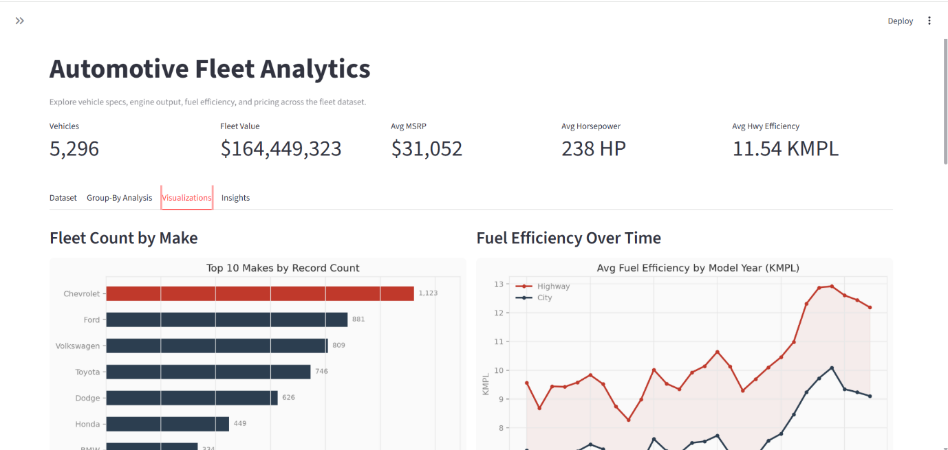
- Screenshot 4 — Tab 3 (Visualizations):

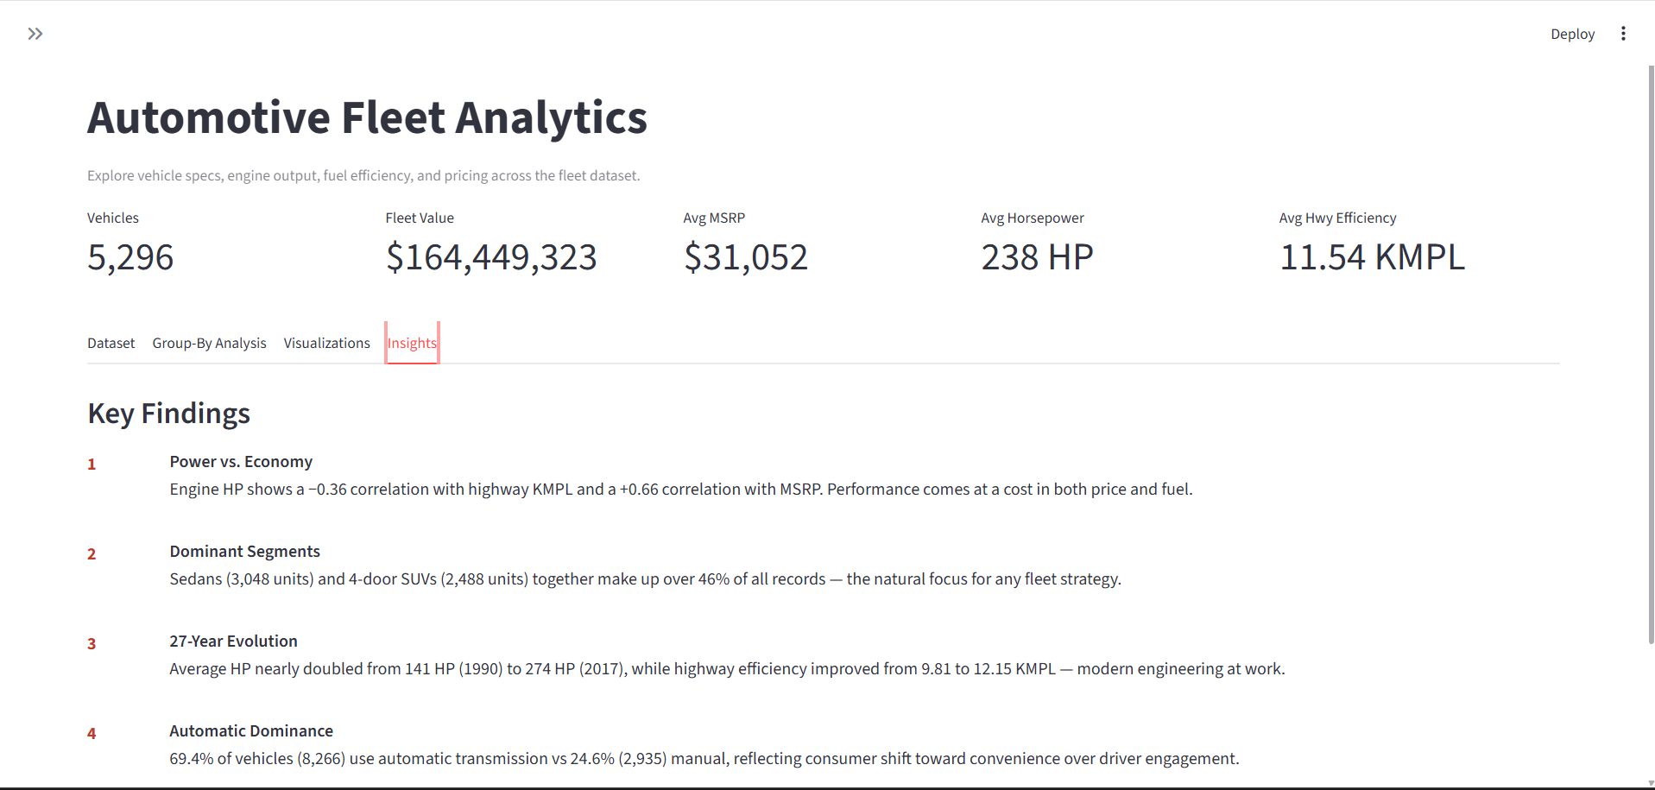
- Screenshot 5 — Tab 4 (Insights):

3. Key Observations and Insights Obtained from the Data Analysis
- Manufacturer Concentration (Bar Chart Analysis):
  - Observation: Chevrolet leads the inventory with 1,123 vehicles, followed by Ford at 881 vehicles—a gap of 242 units—followed by Volkswagen (809), Toyota (746), and Dodge (626).
  - Insight: Fleet inventory is heavily concentrated among mass-market manufacturers that offer wide trim and body-style variations, whereas luxury and niche brands maintain smaller production volumes.
- Longitudinal Fuel Efficiency Trends (Line Chart Analysis):
  - Observation: Across the default 8-brand fleet selection, average highway fuel efficiency improved by 30.7% between the first quartile of model years and the final quartile (and by 18.2% across all 48 brands in the full dataset, rising from 9.81 KMPL in 1990 to 12.15 KMPL in 2017). Meanwhile, average engine output nearly doubled from 141 HP (1990) to 274 HP (2017).
  - Insight: A consistent efficiency gap remains between highway cruising and stop-and-go city driving across all years, while the sharp post-2010 upward trajectory reflects stricter CAFE fuel regulations, hybrid powertrain adoption, and turbo-downsizing.
- Horsepower vs. Economy Trade-Off & EV Outliers (Scatter Plot Analysis):
  - Observation: Engine HP and Highway KMPL exhibit a statistically significant negative correlation ($r = -0.36$ across the full dataset; $r = -0.34$ in the 8-make default view), while Engine HP and MSRP show a strong positive correlation ($r = +0.66$). Vehicles exceeding 400 HP average just 9.0 KMPL (9.9 KMPL in the default selection), whereas vehicles under 150 HP average 13.7 KMPL (14.5 KMPL in the default selection). Additionally, 61 records in the full dataset (22 records in the default view) sit above 35 KMPL.
  - Insight: Compact vehicles dominate the upper-left high-efficiency cluster, muscle/performance cars occupy the lower-right high-power cluster, and electric vehicles (measured in MPGe) stand out clearly as upper-tier efficiency outliers.
- Body Style & Transmission Standardization (Group-By Analysis):
  - Observation: Sedans (3,048 units) and 4-door SUVs (2,488 units) represent over 46% of all vehicles in the dataset. Furthermore, automatic transmissions account for 69.4% (8,266 units) compared to 24.6% (2,935 units) for manual gearboxes.
  - Insight: Fleet procurement and maintenance standardization should prioritize automatic sedans and 4-door SUVs, as they represent the dominant market standard.

4. Public Deployment URL
- Streamlit Community Cloud URL: Automotive_FuelEfficiency

5. Conclusion Highlighting the Usefulness of the Developed Application
AutoDash provides an intuitive, real-time analytics environment for exploring 11,914 automotive records across 27 model years. By combining @st.cache_data performance optimization, custom-styled Matplotlib visualizations, multi-dimensional sidebar filters, and dynamic natural-language interpretation blocks (st.success) that recalculate automatically whenever filters change, the application enables fleet managers and analysts to evaluate vehicle pricing, horsepower trade-offs, and KMPL efficiency trends rapidly without writing code.

