Python Programming
Lab Exercise 1
Q1: Demonstrate use of Python data structures, Tuple, Set, List, and Dictionary.
A. Create a tuple, a list, a set, and a dictionary containing records/items from your selected domain. Demonstrate how to add, update, delete, and access elements.
Display the data appropriately.

I. Tuple: -
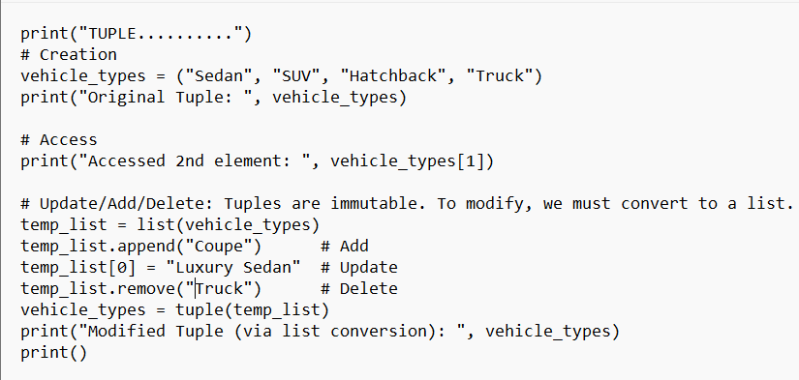
Code:
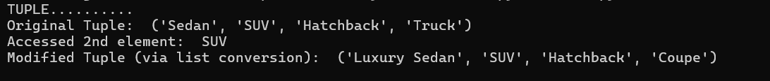
Output:

II. List: -
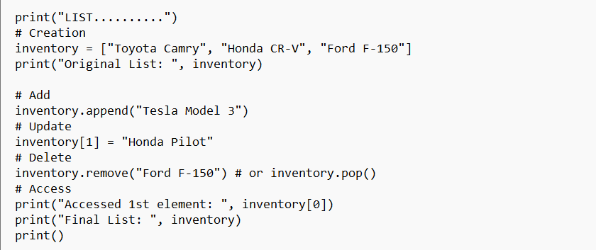
Code:
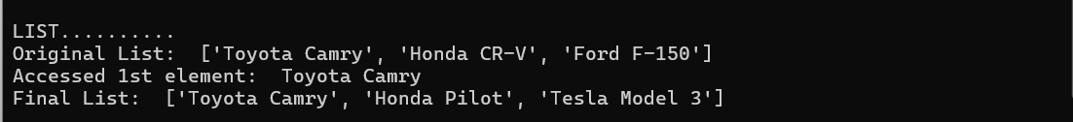
Output:

III. Set: -
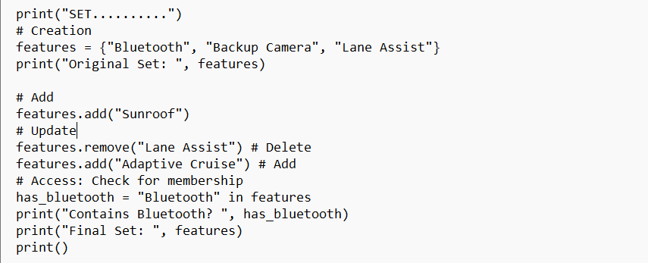
Code:
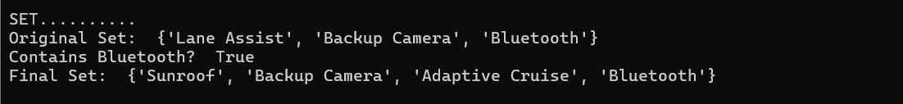
Output:

IV. Dictionary: -
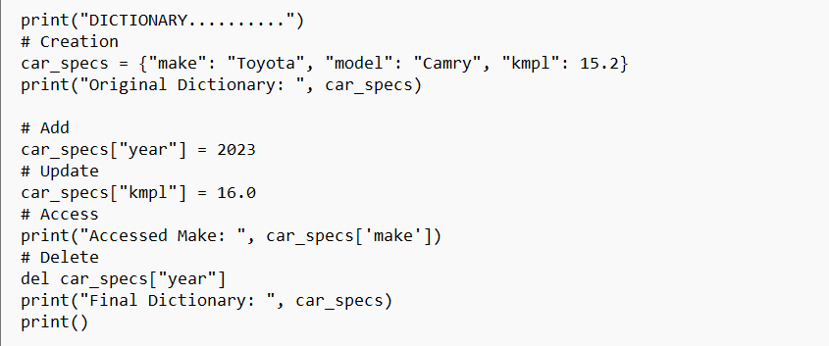
Code:
Output:

B. Design and develop a menu-driven data management system for a complete data-processing solution using combinations of lists, tuples, sets, and Dictionaries.
The program should demonstrate Nested data structures, Set operations, Dictionary operations, List comprehension, Set comprehension, Dictionary comprehension, sorting, searching, Aggregation, and data validation
Menu: -
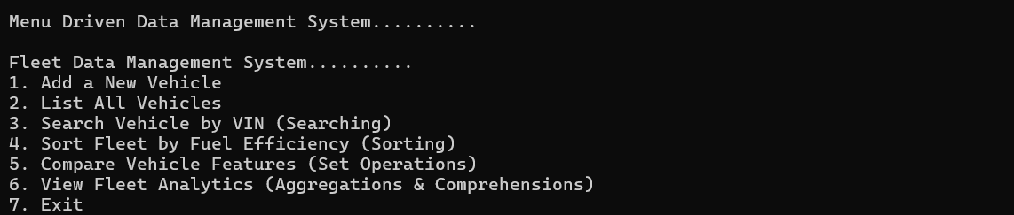
I. Nested data structures: -
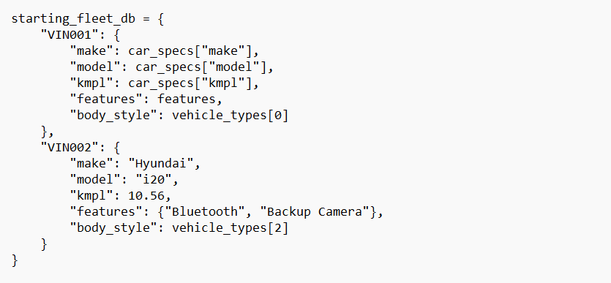
Code:
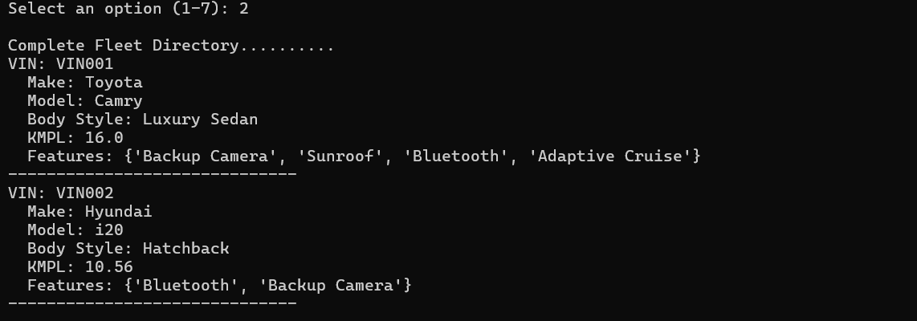
Output:
II. Set operations: -
Code:
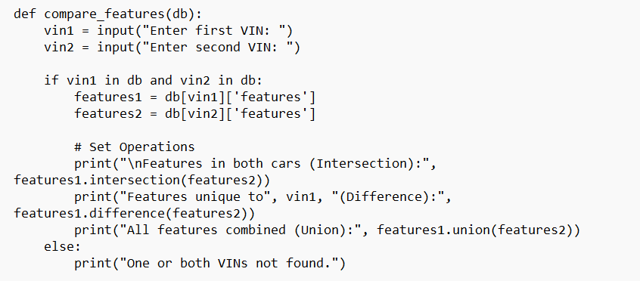
Output:
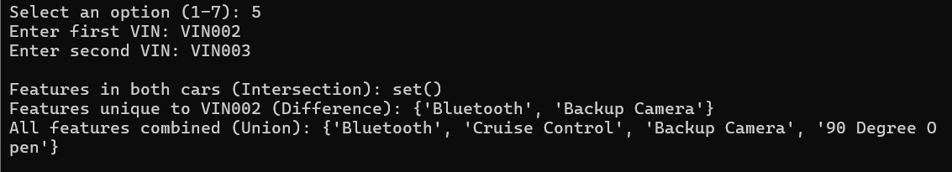
III. Dictionary operations: -
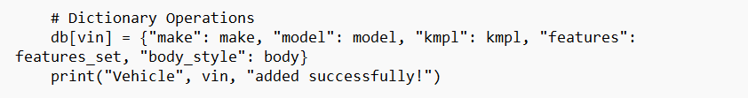
Code:

Output:
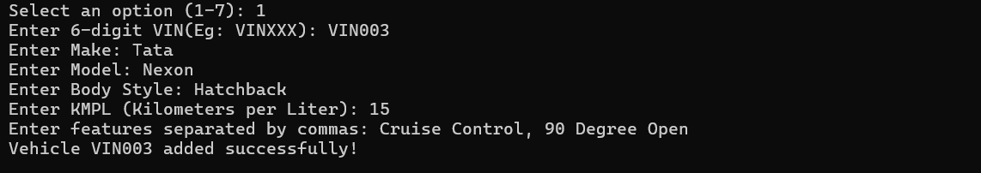

IV. List comprehension: -
Code:

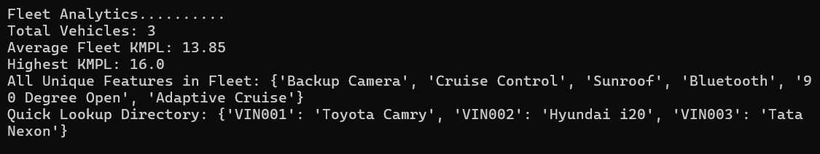
Output:

V. Set comprehension: -
Code:
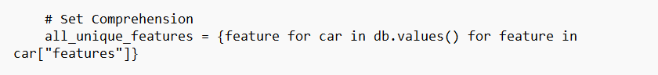
Output:
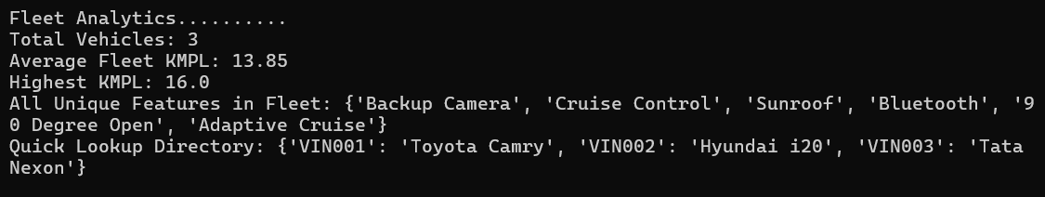

VI. Dictionary comprehension: -
Code:
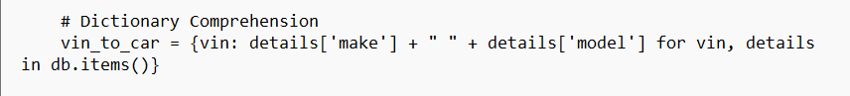
Output:
VII. Sorting
Code:
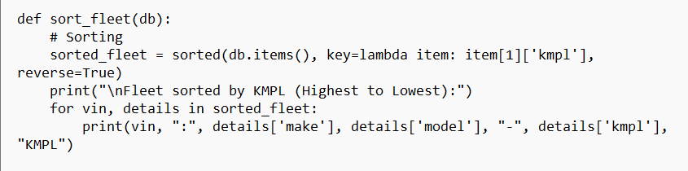
Output:
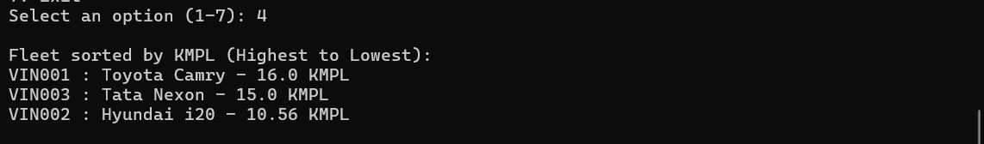

VIII. Searching: -
Code:
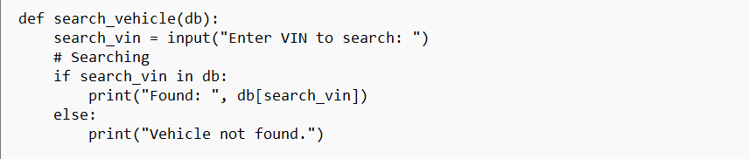
Output:
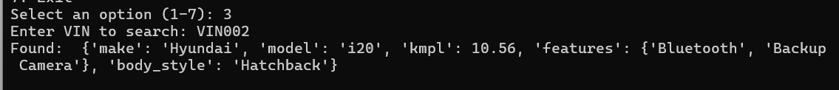
IX. Aggregation
Code:
Output:

X. Data validation
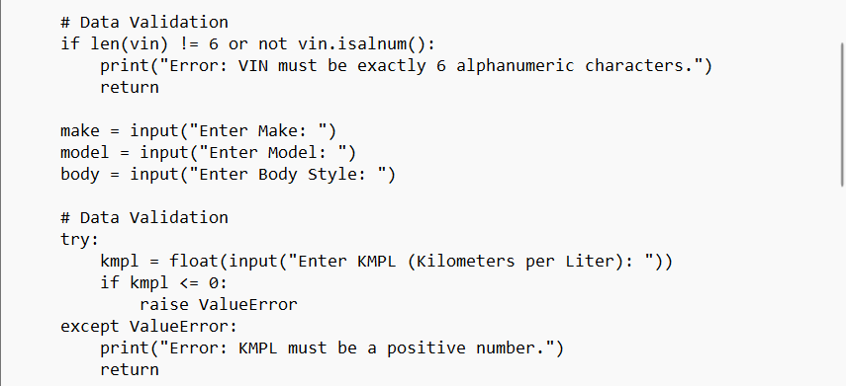
Code:

Output:

