Python Programming
Lab Exercise 3
Q1: Demonstrate use of object- oriented programming concepts
Develop a Python application for your domain by demonstrating the major Object-Oriented Programming (OOP) concepts. The program should be designed using a meaningful, real-world, domain-specific scenario and must demonstrate the following:
1. Class and Object – Create appropriate classes and instantiate objects.
2. Constructors – Use __init__() to initialize object attributes.
3. Encapsulation – Implement private/protected attributes with appropriate
getter/setter methods.
4. Inheritance – Demonstrate at least two levels or types of inheritance.
5. Polymorphism – Implement method overriding and method overloading-like
behaviour.
6. Abstraction – Use an abstract class and abstract methods where appropriate.
7. Class and Static Methods – Demonstrate the use of @classmethod and
@staticmethod.
8. Composition/Aggregation – Establish relationships between classes.
9. Special/Magic Methods – Implement suitable methods such as __str__(), __len__(), __eq__(), or __lt__().
A. Create a custom Python module containing at least five reusable functions relevant to your selected domain.
Menu: -
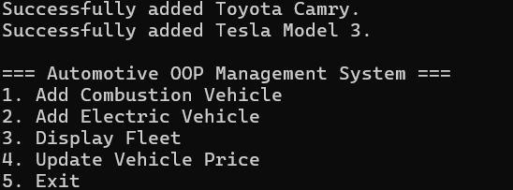

I. Program Start & Adding an Invalid Vehicle (Demonstrates Static Methods & Validation): -
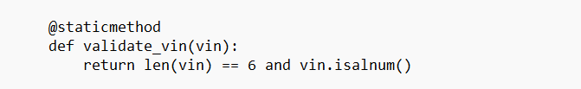
Code:
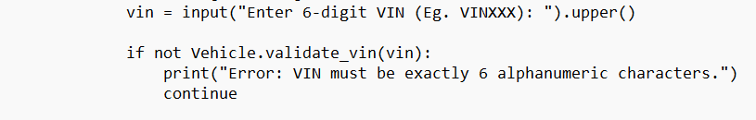

Output:
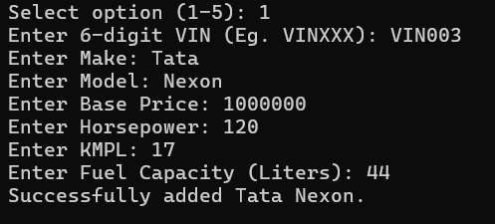

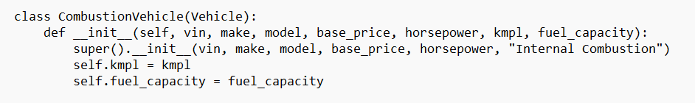
II. Adding a New Combustion Vehicle (Inheritance & Object Creation): -
Code:
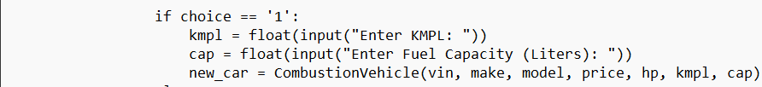

Output:
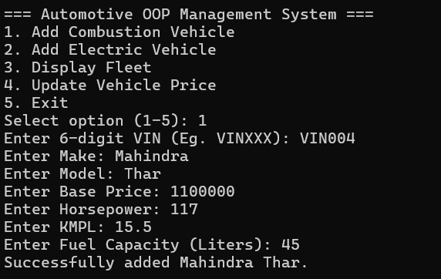

III. Searching a Vehicle(Objects): -
Code:
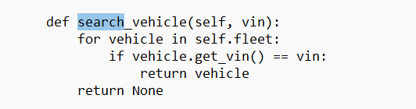

Output:
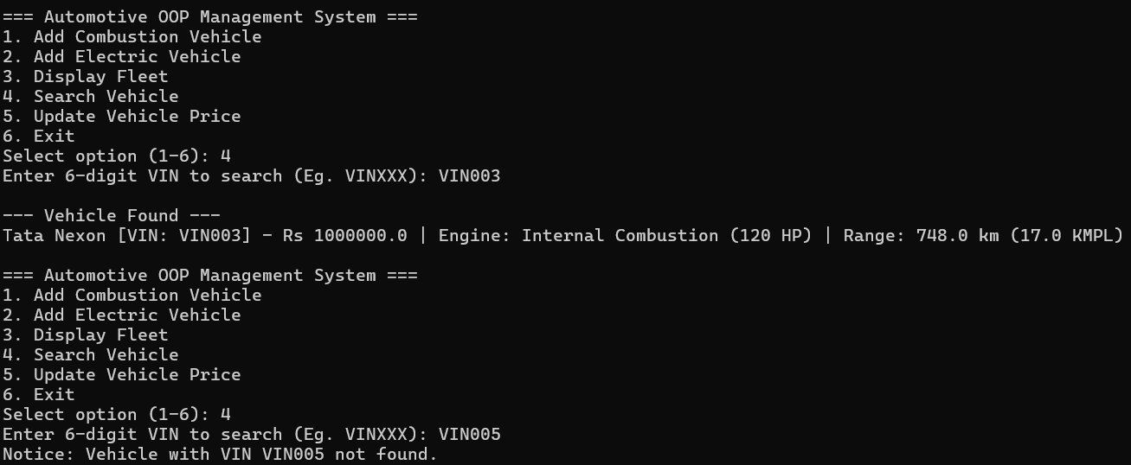

IV. Updating a Vehicle (Demonstrates Encapsulation & Method Overloading-like Behavior): -
Code:
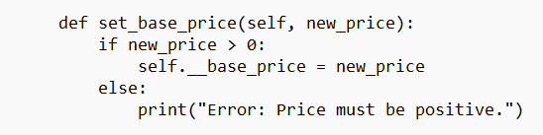
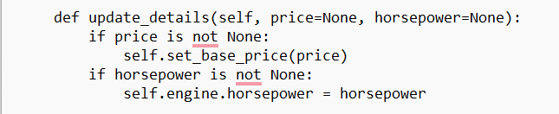

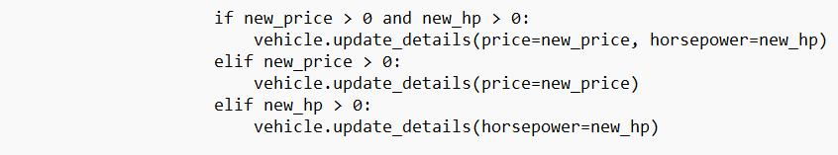

Output:
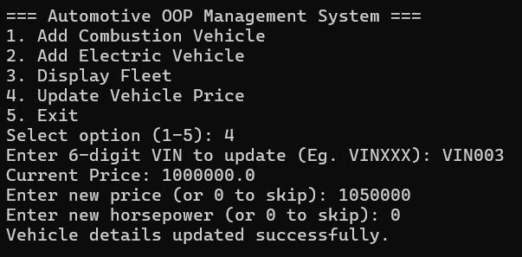

V. Displaying the Fleet (Polymorphism, Abstraction, and Class Methods): -
Code:
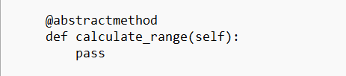

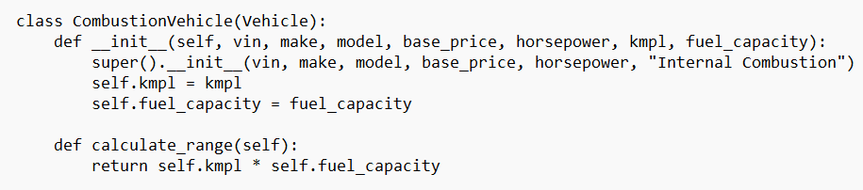
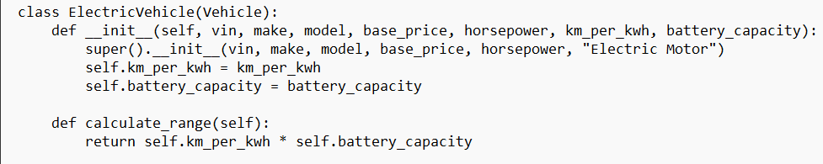
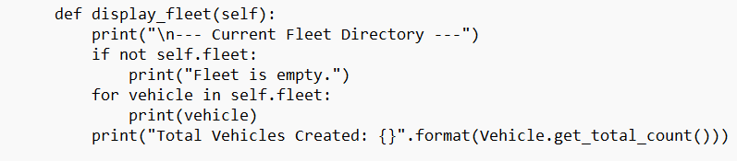

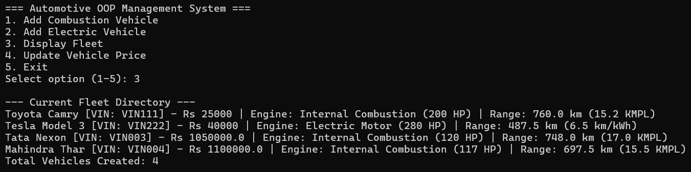
Output:

VI. The program must demonstrate at least 9 OOP concepts/features within an integrated, domain-specific application.
Class and Object: Created the Vehicle, CombustionVehicle, and FleetManager classes. Instantiated objects like car1 = CombustionVehicle(...).
Constructors: Used def __init__(self, ...): in all classes to set up the initial state of the objects.
Encapsulation: In Vehicle, the VIN and base price are private variables (self.__vin and self.__base_price). They are accessed safely using getters (get_vin()) and setters (set_base_price()).
Inheritance: Both CombustionVehicle and ElectricVehicle inherit from the parent Vehicle class using class CombustionVehicle(Vehicle):.
Polymorphism: Method overriding is used because both child classes write their own version of calculate_range(). Method overloading behavior is used in update_details(price=None, horsepower=None) where you can update one, both, or none.
Abstraction: Vehicle inherits from ABC (Abstract Base Class), and calculate_range uses the @abstractmethod decorator, meaning you cannot create a generic "Vehicle"—it must be a specific car type.
Class and Static Methods:
@staticmethod validate_vin() performs logic without needing a vehicle object.
@classmethod get_total_count() tracks the total_vehicles variable across all cars.
Composition / Aggregation: Inside the Vehicle constructor, it creates an Engine object (self.engine = Engine(...)). This is composition because a vehicle "has an" engine.
Special / Magic Methods: Used __str__(self) to format how the car prints, and __eq__(self, other) to define that two cars are "equal" if they have the exact same VIN.

