Python Programming
Lab Exercise 4
Q1: Implement exceptional handling. Apply a regular expression for string
manipulation
Develop a Python program to design a domain-specific data extraction and validation pipeline using Regular Expressions and Exception Handling. The program should accept a domain-related text/data record and perform the following:
1. Use at least 10 different Regular Expressions to extract and validate information such as:
- ID / Registration number, Date, Time, Email address, Contact number, Postal/PIN code, Alphanumeric code, URL, Numeric value, Decimal measurement, Any other relevant domain-specific pattern
2. Apply at least 10 different error/exception-handling cases, such as:
- ValueError, TypeError, IndexError, KeyError, ZeroDivisionError, AttributeError, NameError
- Exception / custom exception
3. The program must:
- Accept user/domain data.
- Validate the format using Regular Expressions.
- Validate the data type.
- Detect missing or empty values.
- Handle invalid inputs and exceptions appropriately.
- Generate meaningful error messages for each validation/error condition.
- Store only valid records in a suitable data structure.
- Display the extracted information and validation status.

Requirement: The program should demonstrate at least 10 Regular Expression patterns and at least 10 exception/error-handling cases within an integrated validation pipeline.

I. Accept user/domain data: -
Code:
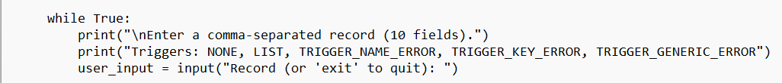
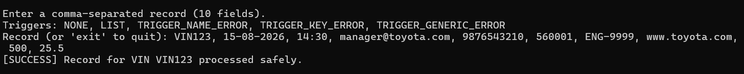
Output:

II. Validate the format using Regular Expressions: -
Code:
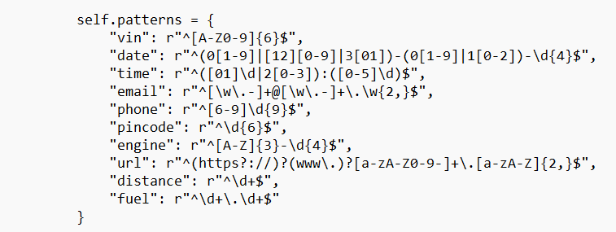
Output:
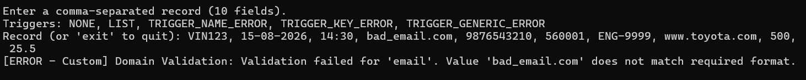

III. Validate the data type: -
Code:

Output:

IV. Detect missing or empty values: -
Code:

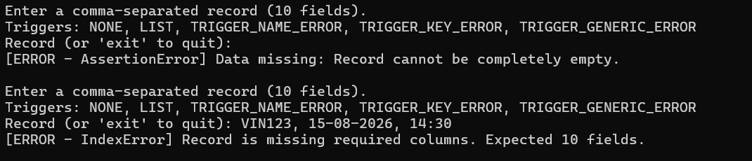
Output:

V. Handle invalid inputs/exceptions appropriately & Generate meaningful error messages: -
Code:

Output:
VI. Store only valid records in a suitable data structure.
Code:
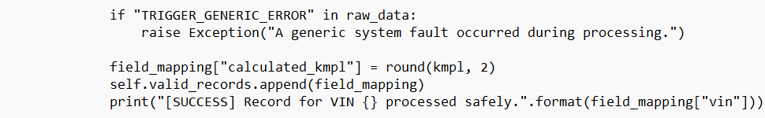
Output:

VII. Display the extracted information and validation status.
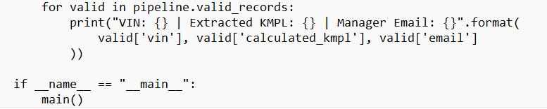
Code:

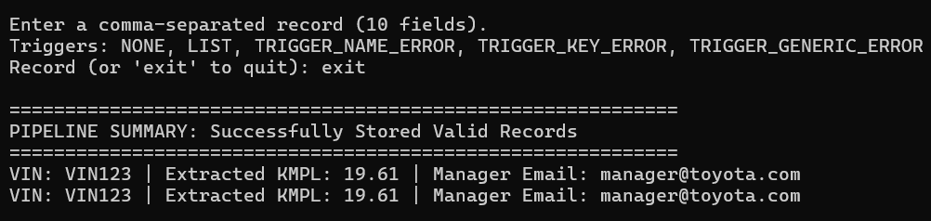
Output:

VIII. The program should demonstrate at least 10 Regular Expression patterns and at least 10 exception/error-handling cases within an integrated validation pipeline.

Code:
