**SUPPORT INFO AND RESOURCES FOR INTRO SQL WORKSHOP**

**Schema of the database we will be using**

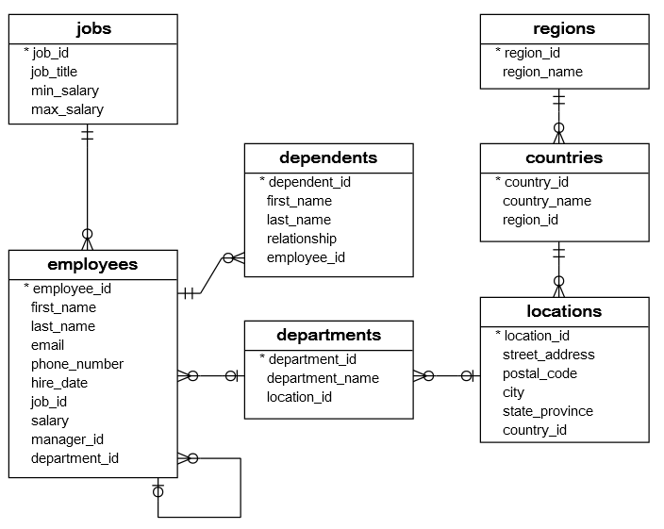

**Introduction to MySQL / SQL**

MySQL (pronounced S-Q-L or sequel) is a database management system for SQL, which stands for "Structured Query Language". SQL is designed for manipulation and storage of data in a **Relational Database Management System.**

**Why relational?**

In general, our brains can work when we organize things into categories, and understand the relationships between them. In real life, things are related to one another and things must be understood in context, and a relational model achieves that well.

A SQL database contains tables. Each column represents an attribute, and each row is one instance of whatever is represented in the table. We will take a closer look when we load up an SQL database in a few minutes.

Not all data is modeled relationally; examples of this are NoSQL DB's such as Amazon DynamoDB.

**Entity-relationship diagrams (ERDs or ER-diagrams)**

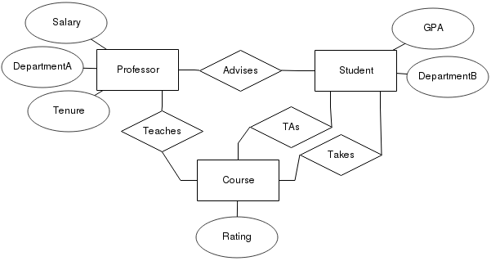

One of the easiest ways to understand a SQL database is through entity-relationship (ER) diagrams. In this typically-notated example ERD, a box represents an entity, which has attributes (represented by ovals) and connects to other entities through relationships (diamonds). ERD's become more complex than this but that is beyond the scope of the intro.

In short, if you are ever trying to understand a database the ERD is a quick way to see how it works. If you are ever trying to *create* a database, drawing an ERD beforehand is absolutely crucial or you will likely have structure problems.

**Join logic Venn Diagram**

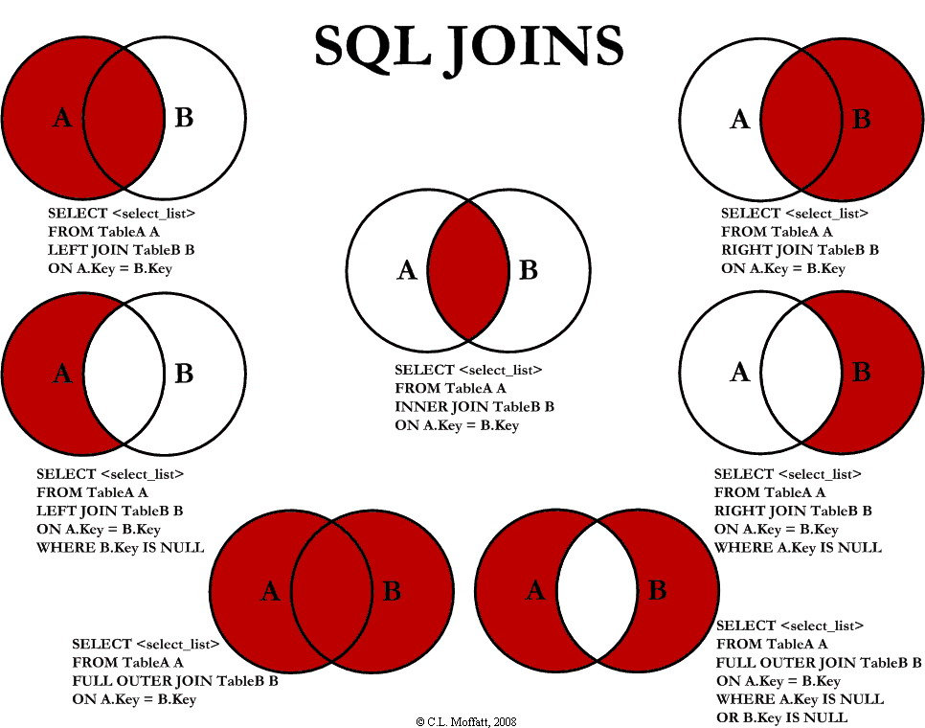

**Installing MySQL on your own device**

You will need two things to start querying in MySQL on your device:

* MySQL server
* MySQL workbench

We recommend using MySQL installer which will take care of everything you need in one go. <https://dev.mysql.com/downloads/installer>

You will then need to connect Workbench and Server. See this video for help:

<https://www.youtube.com/watch?v=u96rVINbAUI>