Admin milestones for OT’s or Contracts, in reality we have the phase level in most of our projects, but that is for you me and jon to discuss. This is the overview of progress rather than just the factory process tracking view. E.g. have we had approval, as the drawings been done, are the materials purchased etc, and then through to has production been started or completed? And has it been despatched

The window in the bottom right is what you get if you double click a cell

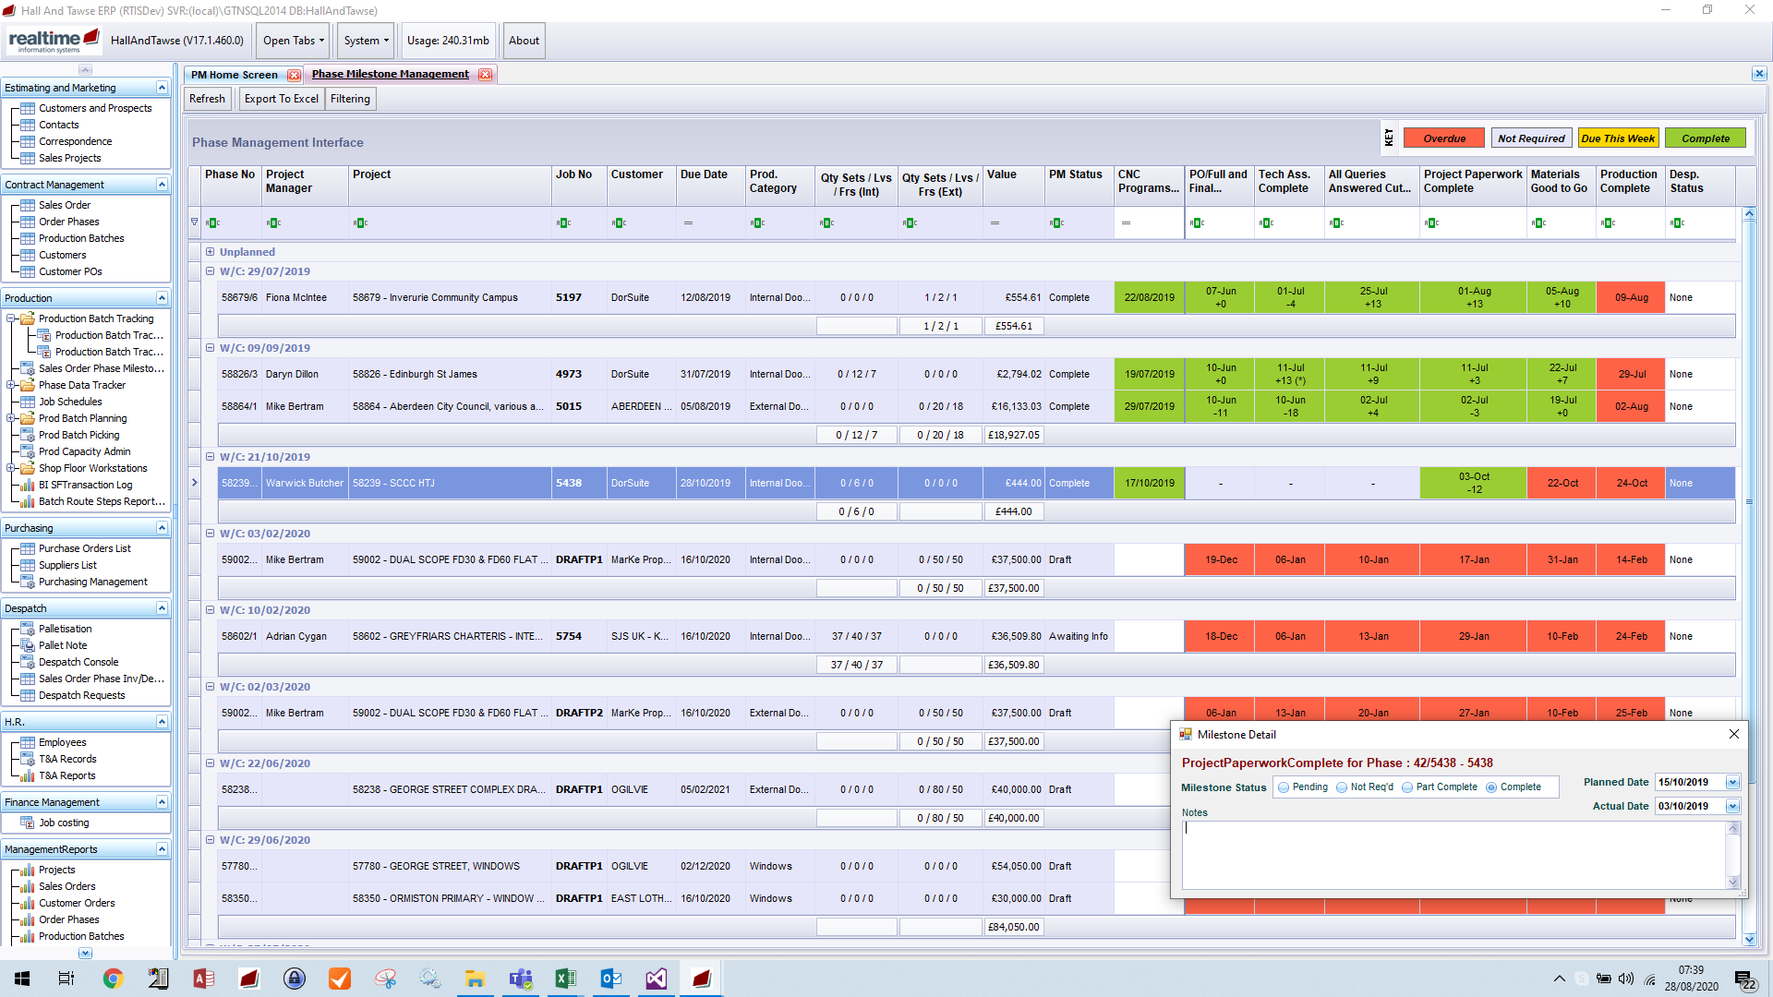

This one is very similar bur purely for the purchasing role. So for Hall And Tawse we have 3 similar screens

* over view of the progress of the jobs
* help purchasing make sure they have bought the various different material types for the jobs
* production process tracking

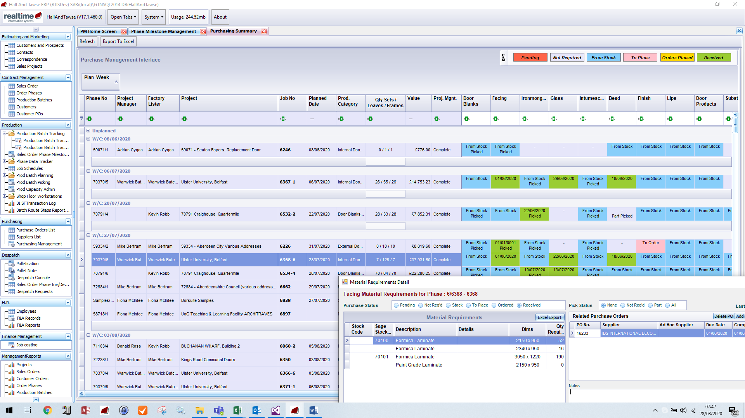

Saying how many hours available in the factory at different areas – the left is the standard pattern, then on the right you can override specific dates if you want

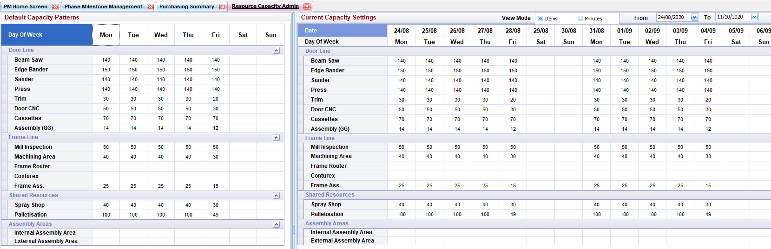

The planning management screen – this helps organise which jobs you want to try to do at each process on each day. It is very good for day to day juggling. It isn’t meant to be a medium term forecast

