Managing Your Off-Road Eagle Libraries

GT Off-Road Racing | Data Acquisitions

Ryan Chen

01/15/2021

Table of Contents

1.0 Overview/Function 2

2.0 Directions 3

Step #1: Get access to GitHub repositories 3

Step #2: Adding GTOREagleLib to Eagle library directory path 3

# 1.0 Overview/Function

Need help using or working with GTOR libraries? You’ve come to the right place! This guide will teach you about how to work on Autodesk Eagle schematics and boards using the Off-Road Eagle library.

The work flow in Off-Road when developing PCBs in Eagle will use two different Git repositories. The first repository is the [DAQ repository](https://github.com/GTOR-BajaSAE/DAQ), which is the main repository where all Off-Road work, projects, and resources will be located. The second repository is the [GTOREagleLib repository](https://github.com/GTOR-BajaSAE/GTOREagleLib), which will be used **exclusively for Off-Road Eagle libraries**.

When designing devices for your Off-Road project, make sure to pull from the GTOREagleLib repository before starting your work and pushing after adding a device to the library **immediately**. This way, we can avoid having to work with merge conflicts as much as possible.

# 2.0 Directions

## Step #1: Get access to GitHub repositories

Ask your team leads for access to the [DAQ repository](https://github.com/GTOR-BajaSAE/DAQ) and the [GTOREagleLib repository](https://github.com/GTOR-BajaSAE/GTOREagleLib).

## Step #2: Adding GTOREagleLib to Eagle library directory path

For Eagle to recognize the GTOREagleLib repository as a library, we need to change the directory for Eagle’s library in the settings.

On the control panel, navigate **Control Panel > Options > Directories**.

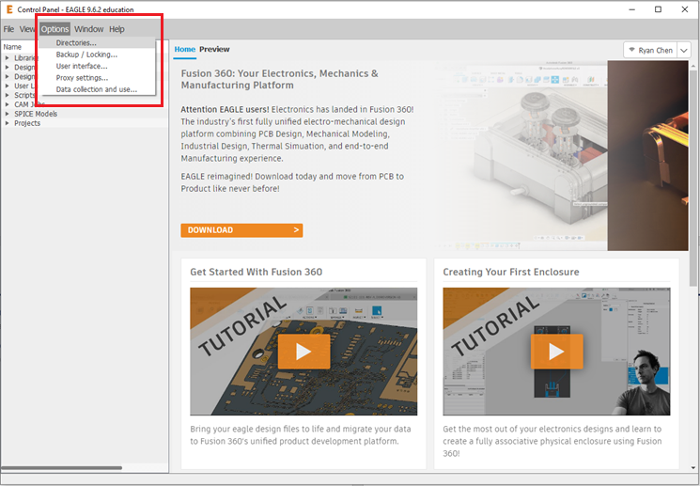

Then on the **Directories** window, click on the field next to libraries, and then click on **Browse…** to change the root directory of Eagle’s libraries.

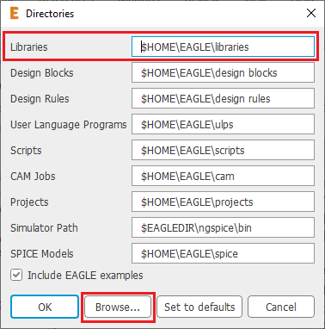

Next navigate to your home directory for the GTOREagleLib repository and then click **Select Folder**. In this case, the GTOREagleLib repository is in C:\Users\Ryan\Documents\1GitRepositories\GTOREagleLib. The GTOREagleLib repository will be added *in addition* to your existing library directories.

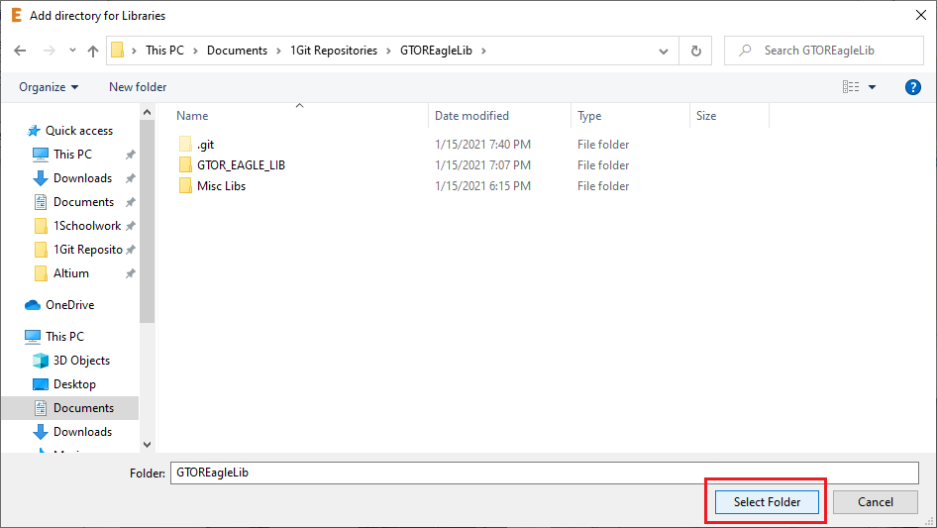

Now, you can look at your new GT Off-Road libraries in Eagle by returning to the **Control Panel** and looking under **Libraries > GTOREagleLib**.

