Polymorphic Encryption and Pseudonymisation



System Functional Design

Author: Bernard van Gastel, Jean Popma, Kai van Lopik, Hans Harmannij
Version: 1.56
Date: 2022-12-06

Change History
Date | Author | Version | Changes
2018-06-20 | JP | 1.0 | V1, after review by Radboudumc and Verily
2020-09-20 | JP | 1.1 | Revision towards 2.0 (publication version)
2020-11-19 | BVG | 1.2 | Added Revisions
2021-05-25 | JP | 1.41 | Revision #1 Using Data COLUMN instead of Data TYPE, Verify eliminated, 2 ways to replace a valid entry (re-upload and invalidate)
2022-02-15 | JP | 1.50 | Historical queries added
2022-04-07 | JP | 1.51 | Pseudonyms revised
2022-12-01 | JP | 1.55 | Minor revisions after first discussion in extended PEP-team
2022-12-06‍ | JBC | 1.56 | Minor revisions after second discussion in extende PEP-team

Distribution
Date | Version | To
2018-06-20 | 1.0 | Bas Bloem, Tessa vd Zande, Bart Jacobs, PEP development team

Contents
Change History 1
Distribution 1
Introduction 3
Structures 4
Data 4
Data Catalog 6
Pseudonyms 6
Access Rules 7
Workflow Processes 8
Defining an Authorization Context 8
Managing Data-COLUMNS 9
Exclusion of Participants 10
Requesting data from the repository 11
Uploading data to the repository 12
Invalidating data 14
Historical Queries 14
Use cases 16
Interfaces 17
Glossary 18

Introduction
In March 2017, a global description of all use cases has been drafted and agreed upon. The first use case was that of the Assessor. The Assessor Client was designed and implemented (and derived from that, the Monitor Client (for an external auditor), in order to support the first phase of the Personalized Parkinson’s Project (PPP).
Following that, parts of the core PEP system were technically redesigned / refactored based on gained insights during the first year of development. This resulted in increased stability and maintainability of the system. In addition, the system has been deployed to the designated production infrastructure.
This document describes the functional design of the current PEP-based research data repository. The last chapter is a Glossary describing terminology used.
The PEP repository supports the process of collecting, producing and sharing research data obtained from study-participants:
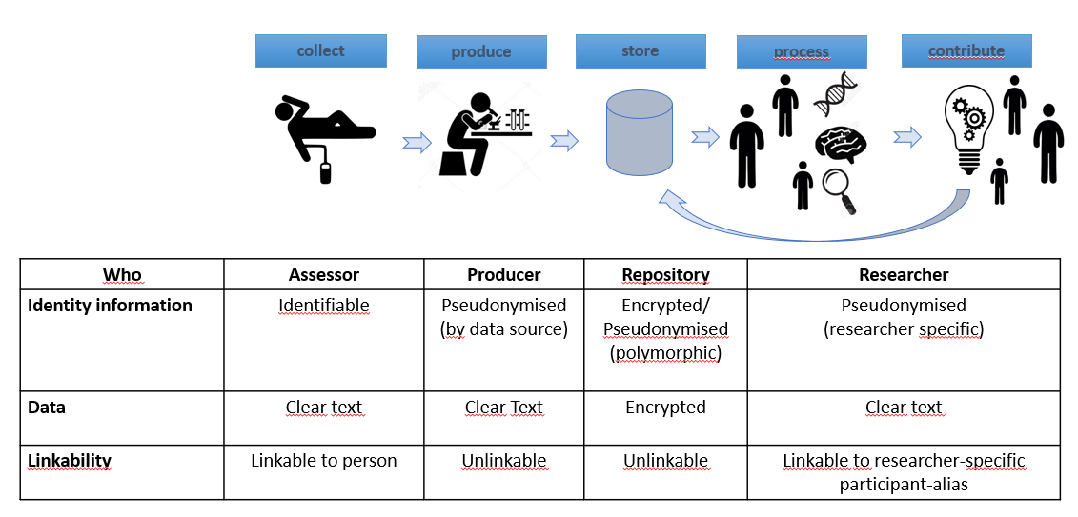
The following use cases have been implemented based on this functional design:
- Assessor
An Assessor is a person collecting data from participants. An Assessor must know the true identity of the participant, and knows all the (short) pseudonyms used in the data collection phase.
- Monitor (auditor)
A Monitor is a person who audits the data collection process. The monitor has access to all the (short) pseudonyms used in the data collection phase, but not to the identifying data.
- Data Contributor
A Data Contributor is a person who produces data from collected materials and tests, and who – after quality control and data pseudonymisation – uploads these data to the PEP data repository. A data producer has access to the (short) pseudonyms of the data involved, but not to the identifying information. Note: in case of derived data (data produced from data obtained from the repository) the Data Contributor can also have the role of Data analyst. In case of derived data the Data Contributor data is stored using the Participant Alias.
- Data Analyst (researcher)
A Data Analyst is a person who is granted access to (a subset of) data from the PEP-repository. A Data Analyst can download and decrypt data to an approved data processing environment.
- Data Administrator (DA)
A Data Administrator is a person responsible for managing data, the data catalog, columns, column groups, and participants and participant-groups in the PEP repository.
- Access Administrator (AA)
The Access Administrator is a person who manages users, user authentication, user-groups, and grants access for a user group to column-groups and participant groups based on formal requests by the data controller as defined by the GDPR.
- Participant
A participant is a person participating in a research project, providing personal data based on informed consent.
The interfaces have been designed on the basis on the use cases and feedback received from actual and potential users. Interfaces have been linked to basic structures and workflow processes in PEP. The description in this document is not the description of the technical implementation, but a conceptual description, with emphasis on the user view of the system.Structures

Data

On a conceptual level, PEP data can be envisioned as a two-dimensional table:
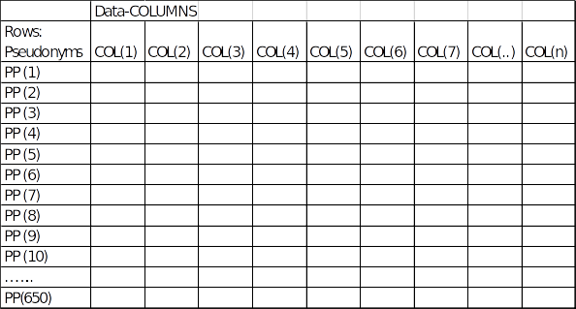

The rows of the table are participants, identified by a polymorph pseudonym (PP). During data download users (like data analysts) will get a participant alias as identifier for a row. This local pseudonym is unique for the research group the user belongs to (and can therefore not be exchanged with users from different research groups). A single participant has a stable identifier for the user(group) involved (does not change in a new PEP session). See also the section about pseudonyms below. A cell in this model does not represent a single value but single values, or single files (e.g. archives) of data.

For registration of a new participant (row) and data collection a specific PEP-ID is used. PEP-ID’s are generated by the system, in the form of a unique and unpredictable number (no serial number). During the data collection phase, this PEP-ID can be stored in a CRM system which can be used to manage the logistic process around participants. The PEP-ID is only used during data collection, to uniquely identify every study-participant, and never used afterwards nor in other parts of the system.
During registration of participants in PEP, also personally identifying information (i.e. name and date of birth) is recorded. This serves two purposes:
- It enables the assessors to verify the identity of the participant during the visits;
- It enables re-identification if this is required because of incidental findings.

The columns in the table are data-COLUMNS. A data-COLUMN is defined as a set of files that are always linked to each other. They have identical access rules. Examples of data-COLUMNS :
- Watch data Week 1, Watch data Week 2, Watch data Week 3, …. Watch data week 104.
- UPDRS OFF, UPDRS ON,
- ECG form,
- Home Questionnaire
- Bam file,
- MRI
- etc.

Data versioning
Newer versions of a cell can be uploaded, which will automatically become the active version. In other words, for a given cell only the last uploaded item is retrievable by a regular user. The content of a cell can be invalidated by replacing it with an empty cell. A cell in this table is not equivalent to a regular database cell, as each cell is in the fact a directory folder that can contain a number of versions.

Data content
One entry in a cell consists of the following data:
- PEP immutable metadata (unencrypted):
  - Local Storage Facility Pseudonym (LSFP)
  - Data-COLUMN-name
  - Uploaded end ( timestamp)
  - A hash of the Research Data file (unencrypted, uncompressed, for quick validation of downloaded data)
- PEP mutable metadata (unencrypted)
  - [DISCUSSION: is this category still necessary, and if so, what information is stored here?]
  - Changed by USER-ID (initially the uploading user)
- Research metadata (Encrypted immutable key values) consisting of
  - Placeholder for specific data formats (e.g. MRI)

  - Extension of the file
- Research Data (1 encrypted, immutable file)
  - May consist of an archive including several data files, belonging to the same observation.

Next to the data entries, metadata exist at the row (Participant) and column (Data-COLUMN) level:
- Participant metadata (in this case stored as special purpose Data COLUMNS: (mutable, encrypted))
  - Identification data (Name, Date of Birth) Restricted use: only for
    - Verification of identity during data collection visits
    - Reidentification following incidental findings.
  - Testparticipant (Boolean, Change User-ID). Shows whether a participant is a test-participant (Canary-participant). Restricted use by datamanager to maintain participant groups.
  - Consent (Boolean, Change User-ID). Shows whether consent is present or withdrawn. Restricted use by datamanager to maintain participant groups.

- Data COLUMN metadata; (mutable, unencrypted, unversioned)
  - Data-COLUMN descriptor (String, Change User-ID). Shows the name used for a data-COLUMN in representation to the user.
Note: while storing filenames in PEP it should be clear that original filenames (from the source system) of the Research Data are not retained. In PEP cells are identified by a combination of the Local pseudonym for Users and the Data-COLUMN . The standard representation to the user will contain a Participant Alias (a shortened version of the Local Pseudonym for Users) , the data-COLUMN, and an extension.

Data Catalog
The user view of the data takes the form of an authoritative data catalog describing the Data-COLUMNS. This is not hierarchical. The data catalog also contains hierarchies or groupings of Data –COLUMNS that are (often) used in conjunction (a COLUMN-Group). The Data-COLUMNS described in the Data Catalog are stored in PEP. These are the only Data-COLUMNS allowed in the repository.

Pseudonyms
Pseudonyms are identifiers for participants. In PEP a polymorphic pseudonym (PP) is used. Polymorphic pseudonyms can be randomized at every step, making a direct comparison of identifiers in different contexts impossible. However, they can be transformed to deterministic local pseudonyms that can be used to identify records.
- The PP is calculated, based on the PEP-ID of the participant (The Participant ID, also known as the PEP-ID, is randomly generated by PEP and is administered in the CRM).
- The thus generated PP is stored once at registration time on the Access Manager.
- At the time of participant registration, a set of Short Pseudonyms is generated. These are short –human readable –pseudonyms which are connected to a single data source. The Short Pseudonyms are stored as regular entries of a specific Data-COLUMN (and therefore encrypted) in the PEP storage facility. These pseudonyms have no additional cryptographic functionality.
- The PP is recalculated to produce a set of (encrypted) local pseudonyms, which are invariable (stable) once defined, and have a meaning only in the context where they are used (in a decrypted form), such as:
  - A Local Pseudonym for the User is produced at the time a user downloads data from PEP. This Local Pseudonym for the User identifies participants. The Local Pseudonym for the User is unique for the user-group, and it is static over multiple downloads. The Data Administrator has his own authorization context and therefore his own Local User Pseudonym.
  - A Participant Alias. The Local Pseudonym for the User is shortened for usability reasons, retaining its uniqueness. This shortened Local Pseudonym for the User is called the Participant Alias. Users of the PEP system downloading data or uploading derived data will only see and use this Participant Alias, and no other pseudonyms.
  - A Local Pseudonym for the Transcryptor, where it is stored and used to identify all data linked to the same participant.
  - A Local Pseudonym for the Storage facility, where it is stored and used to identify all data linked to the same participant.
  - A Local Pseudonym for the Access Manager is used to perform access control checks (matching the pseudonyms (participant-groups) and the user names to access rules).
At the time data need to be uploaded 2 different paths are available:
- Users uploading raw data, labeled by a Short Pseudonym, use this Short Pseudonym as an identifier. After uploading the data, the short pseudonym has no further use or significance within PEP.
- Users uploading derived data (derived from data they have obtained though the PEP system) use the Participant Alias as an identifier.

Access Rules
Access rules (authorizations) apply to User-Groups only. Users in a single User-Group have the same permissions and they share a pseudonymisation space (i.e. they obtain the same Participant Aliases).
Access Rules are defined as a permission to access data of a named list of participants (Participant-Group) and a named list of data-COLUMNS (Column-Group). All entries in a single cell in the above data model (i.e. all files that share the same data-COLUMN and PP) share the same access permissions.
There are 2 permissions that can be included in an access rule for Column-Groups: Read and Write.
There is 1 permission in an access rule for Participant-Groups: Access.
These rights are linked to a User Group:
- A named list of Data-COLUMNS (a Column-Group)
- A named list of Participants (a Participant-Group)

Workflow Processes

Defining an Authorization Context
An Authorization Context Is defined as a combination of a Participant-Group and a Column-Group that a specific User-Group has access to. The Authorization Context is therefore the combination of authorizations that enables a researcher to extract and decrypt data for which he is explicitly authorized by the Research Data and Sharing Review Board.
Taking the model of the two-dimensional table, an Authorization Context defines the authorization to access and decrypt a subset of the total data collection. In this example this is defined as access to Data Column(3) and Data-Column(6) for participants with PP 1, 4, 8, 9 and 650. The researcher is therefore authorized to download and decrypt the data pertaining to the blue cells. In the general case, this kind of access is based on a Column-Group and a Participant-Group.

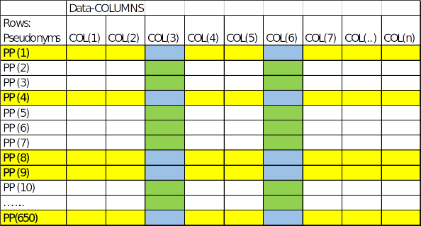

The process for defining an authorization context is described in table 1.

Table 1 Context Definition Workflow
# | Who | What | Where | Content | Fwd-to | NB
1 | RES | Context Request | Mail | - User-Group required  - Column-Group required  - Participant-Group required | DA | a
‍2 | PM | Forward approved request | Mail | - Column-Group  - Participant-Groep | DA
3 | DA | Context Definition | PEPCLI | - Define context:  - Participant-Group  - Column-Group | PM | b,c,d
4 | PM | Authorization Request | Mail | - Authorization Request:  - User-Group  - Participant-Group  - Column-Group (detailed list of Data-COLUMNS included | AA
5 | AA | Context Authorization | PEPCLI | - Access rules defined for User-Group |  | e
6 | AA | Inform | Mail | - User receives notification of access granted  - User receives names of Column-Group and Participant-Group | RES

NB
- Researcher (RES) requests authorization to access data, based on a formal decision of the Research and Data Sharing Review Board.
- Data Administrator (DA) defines a Participant-Group, and makes this list available in the Access Administrator (AA) for future reference (the list is drawn from a *-Participant list containing all Participants in the system). Likewise a Column-Group is defined.
- Named lists can be versioned (updated at regular intervals; as more participants are included in the study). PEPCLI contains
- Named lists can also be reused for multiple User-Groups.
- Access Administrator authorizes User-Group to access the data space defined by a Participant-Group and a Column-Group.

Managing Data-COLUMNS
Uploading of data should only be possible if the Data-COLUMN that is to be uploaded exists in the Data Catalog and in the PEP-system itself. This is to avoid pollution of the repository by erroneous or unauthorized uploads. The process to manage Data-Columns and to update the Data Catalog is documented in table 2. The process starts after a researcher or analyst has requested to upload data to a Data-COLUMN that is not listed in the catalog. The Data Catalog is not part of the PEP-system. The Data-catalog should be in sync with the contents of the PEP-system, in order to enable FAIR data use. Therefore the process of updating the Data-Catalog is included in this document.

Table 2 Catalog Update Workflow
# | Who | What | Where | Content | Fwd-to | NB
1 | DA | Update Data Catalog | External Data Catalog | - If a Data–COLUMN is new it should be added to the Data-Catalog and documented first | DA
2 | DA | Define Data- Column | PEPCLI | - The new Data-Column is defined in PEP | DA
3 | DA | Update Column-Group | PEPCLI | - Adjust Authorization contexts if necessary, by including the new data–COLUMN in Column-Groups. | PM

Exclusion of Participants
Participants have the right to withdraw their consent for the use of their personal data in the study. If they do so, all data concerning the participant must be blocked from further use. They may be used in historical queries for time-points before the withdrawal of the consent, but only for the purpose of scientific integrity or reporting of incidental findings. Exclusion of Participants is the responsibility of the Data Administrator. The process of exclusion is documented in table 3.
Table 3 Withdrawal of consent
# | Who | What | Where | Content | Fwd-to | NB
1 | PI | Notification |  | - Salesforce ID of participant to be excluded  - Date of Exclusion | DA
2 | DA | Exclude Participant |  | - Set Consent flag to untrue.  - No data concerning participant can be downloaded anymore, except in historical queries prior to the date the consent flag was set to untrue. |  | a
NB:
- Only the DA is allowed to set the consent flag to untrue. The timestamp of setting this attribute to untrue is leading for the selectability of the data.

Bespreking tot hier

Requesting data from the repository
A Data Request is an actual request that leads to downloaded and decrypted data, within the boundaries of the user’s Authorization Context.

The result of a Data Request is a subset of data a User-Group is authorized for. The user can apply restrictions in such a request, to reduce the amount of data received:
- Subset of participants: Pseudonym n only (Local User pseudonym, defaults to Participant-Group in the Authorization Context)
- Subset of Data-COLUMNS: Only a specific data-COLUMN(defaults to all data-COLUMNS in a Column-Group in the Authorization Context)
- Update download: Only data after verified -date (defaults to start of study =ALL) and not invalidated. Note: if performing an update user must be informed about changes in validation status in files before the ‘after verified-date’
- Historical query: Only data valid on -date (defaults to today =ALL). Valid is defined as having a Verified timestamp and not an Invalidated timestamp or a replay of an earlier ticket.

Each Data Request will produce the download and decryption of the defined subset, as well as a csv document of part of the metadata (TBD) for the participants that were authorized (the entire Authorization Context) to the user. The metadata overview produced will provide insight to the user in the total study population, the data that were invalidated at a certain point in time and the reason for invalidation (e.g. faulty equipment, withdrawal of consent, etc.). The overview also has a flag indicating which entries were included in the Data Request. The process of a Data Request is documented in table 4.
Table 4 Data Request Workflow
# | Who | What | Where | Content | Fwd-to | NB
1 | RES | Context request | Res Client | - Retrieve Authorization Context (named lists) including partly (TBD) metadata.
2 | RES | Data Request | Res Client | - Subset of participants  - Subset of Data COLUMNS  - Update download (verified after and not invalidated, notify of changes in invalidation)  - Historical query (Valid on) |  | a
3 | AM | Authorize | Access Manager | - Check if request is within auth. Context. If so:  - Provide tickets for download and  - Provide keys for decryption of data files | RES
4 | RES | Extract | Res client | - Download requested data  - Decrypt requested data.  - Download all metadata of Authorization Context.  - Participants are identified by a local end user pseudonym
NB
- Researcher (RES) requests data, within the bounds of his/her authorization context.

Uploading data to the repository
After data production/collection and sanitizing of data these can be uploaded to the PEP repository. There are two cases:
- Data are identified by a short pseudonym (for data extracted from initial sample streams)
- Data are identified by a Local User Pseudonym (for derived data constructed from data previously downloaded)
The upload using a Local User Pseudonym is the general case. If data are identified by a short pseudonym, the uploader will receive a translation table. For the sake of simplicity, both cases are regarded to be equal in the following process. The process used to upload data is documented in table 5.

Table 5 Data Upload Workflow
# | Who | What | Where | Content | Fwd-to | NB
1 | RES | PP request | Res Client | - Translation table Local end user Pseudonym / Short Pseudonym to PP
2 | RES | Upload Request | Res Client | - Specify Data COLUMN  - Specify participant | DA | a
3 | RES | Prepare Upload 1 | Workspace | - group research data in a predefined structure per participant | RES | b
4 | RES | Upload Check | Res Client | - Specify upload structure  - Test whether valid data exist (if so: DA must invalidate first) | DA | c
5 | RES | Upload | Res Client | - Specify upload structure  - Upload data | DA
6 | RES | Inform Verifier | Res Client | - Data Administrator or delegated verifier must be informed of successful upload. | DA

NB
- Researcher (RES) requests upload of data. List of participants is either in the form of short pseudonyms or in the form of a Local User Pseudonym. Data COLUMN must be specified.
- The folder should include all research data (research metadata and research data files), Data COLUMN and upload PP must also be included.
- Before uploading of data is allowed, a check must be performed to see whether valid data (for the specific combination of PP and Data COLUMN) are already present in the repository. If this is the case, these must be invalidated first, because only one valid copy of an entry may exist at any given time.
Note: for planning purposes there will be two different upload forms that will be included in consecutive versions:
- Batch upload of initial data, where it must be possible that verification is automated
- Upload of derived data by individual researchers.

Invalidating data
At any time a situation may occur that uploaded and verified data are considered to be invalid. For instance if it was discovered that a certain device generating data was proven to be faulty for some time, making the data collected during a certain period unreliable. Data can then be marked invalid, and will not be included anymore in later downloads, even if they are within the authorization context of a user. They will occur though in historical queries when they were still considered valid at the time-point when the original query was performed. Invalidation is the responsibility of the Data Administrator. The process of invalidation is documented in table 7.
Table 7. Invalidation Workflow
# | Who | What | Where | Content | Fwd-to | NB
1 | DA | Receives notice of invalidity |  | - Concerns Data -COLUMN and time when data are to be marked as invalid. | DA
2 | DA | Verify invalidation |  | - DA must verify that the data are indeed to be invalidated
3 | DA | Set Invalid Flag and reason. | Admin Client | - After setting flag and reason data cannot be downloaded anymore, except for historical queries.

Historical Queries

The PPP and HBS projects have in common that a wide variety of (personal) data is collected over a prolonged period of time. Data that become available over time can be added to the repository, and authorized users can then download and use the data they are entitled to. There are several reasons why such a repository is dynamic, in a sense that the contents may change over time, also after the initial data collection phase has been completed:
- Data may – with hindsight – be classified as being invalid, for instance because a measurement device produced faulty data within a certain timeframe, or because of protocol deviations that became clear after uploading of the data.
- Study participants can withdraw the consent given to use the data for scientific research. This means that their data may not be shared or used for new studies, after the moment of withdrawal.
- (Derived) data or additional data may be added later, or over a period of time.
Following the functional design of the PEP system, once uploaded, data cannot be deleted from the repository. They may however be marked as invalid, after which they are not available to new research projects or users of PEP. Users have the right to download valid data they’re authorized to use for as long as they are registered as a user. This means that a download of data from the PEP system, with exactly the same query can produce different results at different points in time. Researchers should be aware of this and take this into account when specifying which data they have obtained from the research data repository.

Historical queries use cases

Use cases for historical queries are linked to the purpose the serve. Five use cases are distinguished:

Use case | Data | Analysis | Purpose
Repetition | Original data used for publication | New techniques | Verify methods
Replication | New data | Original techniques, used for publication | Verify sample population
Research Integrity | Original data used for publication | Original techniques, used or publication | Detect fraud, misuse or error.
Publication of data | Original data used for publication | - | Enable data reuse
Archive function | Original data used before | - | Restore lost data

Note that publication of data can only be defined as an authoritative reference to the data, as the use of the data is restricted to legitimate users only, which requires a legally binding data use agreement to be in effect.
Following the terminology used in this table, in a strict sense, replication is not a PEP use case as it involves use of newly collected data. It is assumed that for the verification process an historical set of data may be required.
By default, a user does not have the right to perform historical queries. The authorization to perform historical queries should be explicit and must be bound by a specific data use agreement.
A historical query should return the data that were valid at the time the data were downloaded for the primary analysis of a specific study. A download from the PEP repository is identified by a combination of 4 parameters:
- The timestamp of the download
- The user-group the downloading user belongs to
- The column-groups the user-group was authorized for
- The participant-groups the user group was authorized for
Note: A dataset might be constructed by combining downloads performed at different points in time.

Functional design choices

- An authorization process designating a specific time frame to be queried must be available. By default historical queries are not allowed because multiple consecutive downloads can reveal time based information about the data themselves. This means that in order to obtain permission a specific request must be made and granted by the PI. The timeframe can be a specific moment in time or a time range (if for instance a user has constructed a dataset with information downloaded at different moments).
- There are two ways to identify and reproduce an historical query:
  - A time stamp based query. The user provides a timestamp, a user-group, a participant-group and a column –group. The user provides this information based on an estimate of the moment of download. Use of this query is recommended if a user has downloaded subsets of the dataset at different points in time, and there is no need for a formal proof.
  - A receipt based query. Every download produces a signed receipt containing the parameters used for the download. Such a receipt has the advantage that it can be used as a proof that this query was actually performed and repeating the query produces exactly the same dataset. Use of this type of query is recommended for producing authoritative references that can be used in publications (if such a reference is required). This could mean that a researcher is required to perform an extra (possibly lengthy) data download shortly before submitting a paper for publication. (given the fact that data are probably not downloaded all in one query…)

Use cases
Use cases are documented elsewhere (use_case_<version>.xlsx). They have been described regarding the following roles:
- Data subject
- Data controller
- Device (smartwatch)
- Data processor: Assessor
- Data processor: Verily data generation
- Data Processor: Researcher
- Data processor: Access Administrator
- Data processor: Data Administrator
- Data processor: Monitor
The first three roles / use cases are implemented in manual procedures, not in PEP. The documented use cases are aligned with the functional design as described in this document.

Interfaces
The PEP-system has a number of interfaces enabling the above-mentioned use cases.
The following interfaces are implemented:
Role | Command Line Interface | Graphical User Interface
Data Subject | - | -
Data controller | - | -
Device | - | -
Assessor | - | √
Verily data generation | √ | -
Researcher | √ | -
Access Administrator | √ | -
Data Administrator | √ | -
Monitor | - | √

Glossary
- Authorization Context: defined as a combination of a named list of polymorphic pseudonyms a user has access to and a named list of data COLUMNS a user has access to.
- Data Catalog: an authoritative inventory and description of valid data COLUMNS. No data can be uploaded or downloaded to/from PEP unless they refer to a Data-COLUMN listed in the data catalog. This is not hierarchical. The data catalog also contains hierarchies or groupings of data COLUMNS that are (often) used in conjunction. The data catalog is maintained by the Data Administrator.
- Data-COLUMN: a descriptor of a homogenous and by definition linked set of files.
- Named list
  - Column-Group: a collection of data-COLUMNS a User-Group or multiple User-Groups can be granted access to. This list is maintained by the Data Administrator. The Access Manager (server) hosts the named list. The list is used to authorize users to access specific Data-COLUMNS.
  - Participant-Group: a collection of Polymorphic Pseudonyms a User-Group, or multiple User-Groups can be granted access to. This list is maintained by the Data Administrator. The Access Manager (server) hosts the list. The list is used to authorize users to access data from specific participants. NOTE: a Participant-Group includes PP’s of participants that meet certain criteria (e.g. over 50, male etc. ) As the data repository grows over a period of several years, Participant-Groups need to be maintained regularly by the Data Administrator. Following authorization, the PP’s in the Participant-Group must be translated to the specific Local User Pseudonyms of the authorized users (actually groups).
  - User-Group: a group of users sharing the same access rights to Column-Groups and Participant-groups. Access rights are only attributed at the User-Group level, not to individual users.
- PEP metadata: describe the Research Data:
  - Local Storage Facility Pseudonym (immutable)
  - Data-COLUMN name (immutable)
  - Uploaded end -upload timestamp/USER-ID) (immutable)
  - Invalidated-Timestamp/USER-ID/Reason (mutable)
- Polymorphic Pseudonym (PP): the central identifier within PEP. The PP is used to derive specific pseudonyms for different users that can be used as an identifier only within a given context such as
  - The Local User Pseudonym is used as an identifier for participants within a user group.
  - The Participant Alias. For usability reasons this (long) Local User Pseudonym is shortened, retaining its uniqueness, and is presented to the user as the Participant Alias.
  - The Local Storage Facility Pseudonym is a unique identifier for participants at the storage facility.
  - The Local Access Manager Pseudonym is a unique identifier for participants used by the Access Manager.
  - The Local Transcryptor Pseudonym is a unique identifier for participants used by the central logger facility
The local pseudonyms can be derived from the PP at any given time, but cannot be translated back to the PP.
- Research metadata entry: Contains a HASH of the corresponding unencrypted and uncompressed Research data that can be used to uniquely identify a research data entry.
- Research data entry: a research data entry consist of a number of files, combined in a compressed archive to reduce storage space.
  - Research metadata (encrypted, compressed). These data give information about the data collection, quality checks, equipment settings etc.
  - Research data files (encrypted, compressed). These data files contain the actual measurements/study data.
- Short Pseudonym: short –human readable -pseudonyms are constructed by combining a random number, an ID for the study (POM), an ID for the visit (1, 2 or 3) and an ID for the sample/Data COLUMN (VS, HQ etc.). This supports and ensures the correct processing of the data, as opposed to the PP, which is not human-readable and does not fit to stickers used to identify samples. As an example: the short pseudonyms used during visit 1 for a test participant.
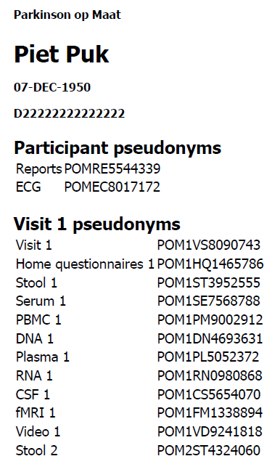

- PEP-ID: a unique Short Pseudonym for each participant, generated by PEP and stored in Salesforce. This ID is used as a seed to generate the PP, and as a main entry for lookup of data by an assessor.
- User: a user is an authenticated user (by 2FA). At the time of login a user is placed in a group. Within a group, all users are sharing authorizations and Participant Aliases. Examples of groups are:
  - Research team x contains researchers participating in a particular study
  - Data Administrator (DA). Group of users that define and maintains Authorization Contexts, verify uploaded data, invalidate data if they prove to be incorrect at a later stage. Under normal conditions this group contains 1 user.
  - Access Administrator (AA): Group of users who do not have access to any data in PEP. They administer access authorizations and permissions.
  - Data Contributor. A group of users of a research lab or facility that provide (and upload) a certain Data COLUMN
- User Interface:
  - PEPCLI: is the primary command line interface (CLI) application to interact with the PEP system. It is available for multiple platforms, and it is included in PEP's client Docker images and in the Windows client software installer. Among pepcli's functionalities are the ability to upload/download data and to administer the PEP system.
  - PEP-assessor client: A web interface providing research-assessor with all necessary information and access to resources required to support a participant-visit.
- User Roles:
  - Assessor
An Assessor is a person collecting data from participants. An Assessor must know the true identity of the participant, and knows all the (short) pseudonyms used in the data collection phase.
  - Monitor (auditor)
A Monitor is a person who audits the data collection process. The monitor has access to all the (short) pseudonyms used in the data collection phase, but not to the identifying data.
  - Data Contributor
A Data Contributor is a person who produces data from collected materials and tests, and who – after quality control and data pseudonymisation – uploads these data to the PEP data repository. A data producer has access to the (short) pseudonyms of the data involved, but not to the identifying information. Note: in case of derived data (data produced from data obtained from the repository) the Data Contributer can also have the role of Data analyst. In case of derived data the Data Contributor data is stored using the Participant Alias.
  - Data Analyst (researcher)
A Data Analyst is a person who is granted access to (a subset of) data from the PEP-repository. A Dat Analyst can download and decrypt data to an approved data processing environment.
  - Data Administrator
A Data Administrator is a person responsible for managing data, the data catalog, columns, column groups, and participants and participant-groups in the PEP repository.
  - Access Administrator
The Access Administrator is a person who manages users, user authentication, user-groups, andgrants access for a user group to column-groups and participant groups based on formal requests by the data controller.
  - Participant
A participant is a person participating in a research project, providing personal data based on informed consent.

This information is only available to the assessors who need to be in contact with the participants, and the PI (principal investigator) with special permission.
Immutable metadata are only stored once at the time of file creation. –Data COLUMN name and upload end timestamp are used as a base for encryption (of the AES key).
Mutable in this context means: can be added after creation of the entry. Once added it cannot be changed anymore. Changes take the form of new versions of mutable metadata.
In a future release the PP will be used only once, initially, to avoid risks involved with storing and reusing the PP. This means that a translation mechanism between different local pseudonyms will replace the central function of the PP.
Short Pseudonyms are constructed by combining a random number, an ID for the study (POM), an ID for the visit (1, 2 or 3) and an ID for the sample/Data COLUMN (VS, HQ etc.). The last 2 digits contain an integrity check of the Short Pseudonym. This supports and ensures the correct processing of the data, as opposed to the PP, which is not human-readable and does not fit to stickers used to identify samples.
Note that, if a User-Group gets access to multiple Authorization Contexts, this may imply access that is broader then intended because Participant-Groups are not exclusively linked to a Column-Group in an Authorization Context. Because applying such a tight link would result in a great deal of complexity for the end user, and because the incidence of such combinations is expected to be very low, the decision was made not to implement this tight linkage.
This implies that any user in a group can exercise any historical query for that group, irrespective of the date the user was added to the group.

