Equity BOT

## Instructions

App version 2.0

Instructions for “Equity BOT”

**Please read and follow all the instructions for a proper use of application!**

## Prerequisites:

1. TB template – should be made on the template presented down below:



In the TB Template, map the information from the Trial Balance provided by the client, onto the Template shown here accordingly. (Account, Description, Opening Balance, Movement Debit & Credit and Closing Balance,)

|  |  |  |  |  |  |
| --- | --- | --- | --- | --- | --- |
| Account | Description | OB | DM | CM | CB |
| 401 | Vendors | 2.341 | 34.325 | 5.353 | 31.313 |

## Instructions:

1. Open the app:

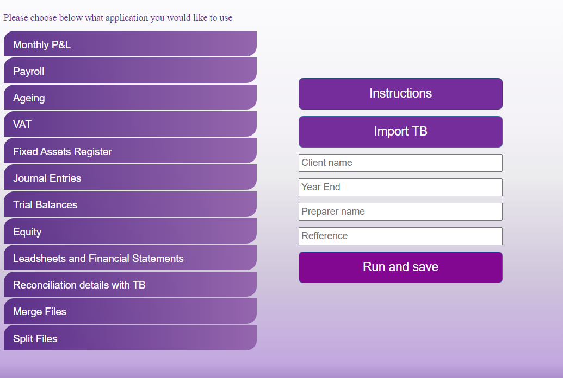

1. Click “Import TB” button and select the TB template.
2. In the “Client name”, “Year End”, “Preparer name” and “Refference” introduce the information accordingly.
3. Click “Run and save”. Once clicking that, the robot will process your request and exit the application.
4. Finally, you should obtain an Excel document named “Equity + client name”

Note: Please do not modify any of the templates provided!

If you encounter any issues or if you have any other questions or suggestions, please contact:

Cristian Iordache, [cristian.iordache@ro.gt.com](mailto:cristian.iordache@ro.gt.com)

Bogdan Constantinescu, bogdanconstantinescu@ro.gt.com