Cuba’s CENESEX leads
the way on sexual rights
Cuba’s National Center for Sex Education (Centro Nacional de Educación Sexual) carries out its important collective labor — including combating what remains of pre-revolutionary prejudice against same-sex love — in what was once a privately owned Havana mansion.
Mariela Castro Espín, director of CENESEX, stressed that sexologists have a “scientific, social and political responsibility” to help raise understanding and consciousness in the whole population. (havanajournal.com, April 1, 2003)
CENESEX’s goal, Castro Espín explained, is to contribute to “the development of a culture of sexuality that is full, pleasurable and responsible, as well as to promote the full exercise of sexual rights.” (Reed)
Since she and CENESEX are part of the revolution, they don’t have to do this work alone.
“Historically speaking,” Castro Espín stated, “changing mentality is one of the most difficult things to do, one of the slowest processes in society. Even though we’ve made substantial political and legislative strides, we’re still bound by aspects of roles defined long ago. This subjectivity begins early, in the way children are raised, in how they’re taught to play.
“We have to learn to recognize which elements of the traditional masculinity or femininity are actually doing us damage. What parts of the picture actually take away from our freedom, fulfillment and dignity. We have to take a hard look at these things, or else we’ll keep passing them down from generation to generation.” (Reed)
She offered a concrete example about AIDS safer-sex education. “We have to include a gender perspective — promotion of new constructs of masculinity and femininity — and not just take an epidemiological approach.”
She said an epidemiological approach to prevent AIDS transmission might simply suggest, “Use a condom.”
But the system of male chauvinism imposed on Cuba for centuries created a mindset in which some males feel that condoms may be a sensation barrier to full sexual enjoyment, to which they are entitled. Castro Espín emphasized, “So, for him to use a condom, he has to begin to construct and define his masculinity in a different way, that doesn’t put a premium only on his own pleasure. In the end, this stereotype is very dangerous to his own health as well as his partner’s — and this can be true for homosexual as well as heterosexual couples, whenever a relationship defines that one partner has hegemony over the other.
“So you need to combine both an epidemiological and a gender approach to these very intimate issues. This is why, for example, our posters and other materials emphasize that protection of your partner against HIV and STIs in general is a sign of caring, and that means it’s a responsibility of both partners in a relationship.”
Castro Espín told MEDICC Review interviewer Gail A. Reed regarding CENESEX, “We work with groups who promote safe sex among their peers: men who have sex with men [MSM], transvestites and transsexuals, adolescents and young people in general and then more broadly with medical students. In each medical school, there’s a department of Sexology and Education for Sexuality.”
All education in Cuba, it bears repeating — including medical school — is free.
Castro Espín observed in 2006, “Regarding attitudes towards MSM and bisexuals as well, there have been positive changes — I say empirically, since we are still studying this. But at our conferences and workshops that we hold with people from the whole country, it’s clear that participants are more able now than 10 years ago to understand and respect another sexual orientation. I think the work that’s been done over the decade in health and by the Cuban Women’s Federation has helped to bring about that change, and we’ve done it reaching out to people’s sensitivity as human beings.
“In essence, our view is that any kind of prejudice or discrimination is damaging to health.” (Reed)

‘Modifying the social imagination’
As a revolutionary worker, Castro Espín demonstrates in every interview that she has already rolled up her sleeves to do the next job that needs to be done.
She talked about the revolutionary labor that is still required to make progress in overcoming old prejudices about same-sex love. “First,” she told Reed, “I think we have to work more and better in the schools. We’ve worked with the Ministry of Education, but I’m still not satisfied we’ve made enough progress, and so we need to deepen understanding among teachers and other school staff; we need to carry more on educational TV and so on.
“And this also has to do with a gender focus, of course. In the 70s and 80s, we found a lot of fear and resistance to a national program for sex education with such a gender focus. The program was finally accepted in 1996, and now it’s taught throughout the country; since then it has reduced school dropouts from early marriages and childbirth by one half.”
Castro Espín elaborated, “The country now has policies that legitimize sexual orientations and also has brought laws in line with a gender perspective. But on the legislative front, there is still a lot to be done.”
She has proposed that when the Cuban Constitution of the Republic is next revised, the category of “sexual orientation” be added. Castro Espín said homosexual Cubans are protected, but “when something like that is made explicit, it is official recognition that there is a need to avoid any type of discrimination, like racism or sexism.”
Such a legal measure, she pressed, would make this protection even more evident. And, she added, it’s important to protect against discrimination, not just in public institutions “but also in the space of the family, because it is often there that a homosexual is first insulted or rejected.”
No Cuban of any sex has to marry in order to have economic support, a job, a home, health care or other rights that are guaranteed to every person. Castro Espín pointed out, though, that although homosexuals live within the law in consensual relationships, “gay marriage is not recognized, so you have many issues such as inheritance that aren’t fully resolved. We need changes in the family code itself related to these and other questions, including domestic violence. CENESEX has now presented two bills in Parliament before the education and children’s commissions that have to do with gender,” she noted, “and these have been well received.”
Unofficial same-sex marriages have taken place on the island. For example, four local young males ranging in ages from 17 to 22 held a double same-sex ceremony outdoors, in front of loved ones and neighbors, in the working-class suburb of San Miguel del Padrón, southeast of Havana, in 2001. (Berkowitiz, Cabral)
Castro Espín summed up, “By the 1970s, reforms to the penal code excluded the classification of homosexuals as criminals (because of their sexual orientation); any word that discriminated against homosexuals was modified.
“However,” she stressed, “that is not enough because I think our laws should better reflect the respect that homosexuals deserve. Greater and more professional work is needed at the micro-social level, because what this is about is trying to change perceptions, modifying the social imagination.” (Garcia)
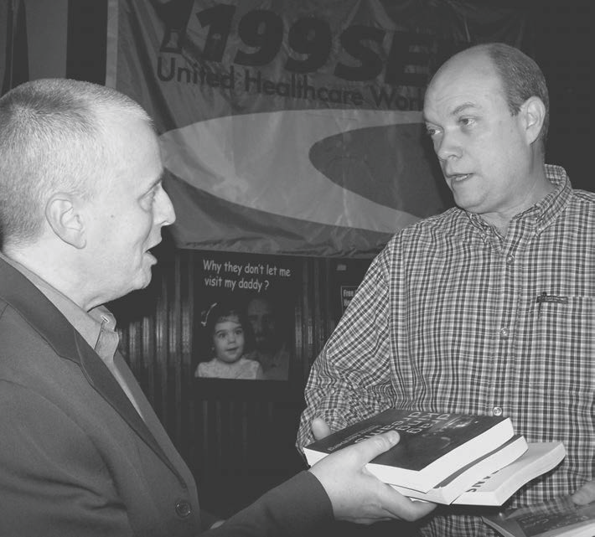
Teresa Gutierrez
Leslie Feinberg, shortly after initiating the Rainbow Solidarity for the Cuban Five Campaign, presents Cuban Ambassador Rodrigo Malmierca Díaz with copies of her books.

FIDEL CASTRO BACKS EFFORT

