Postscript
Cuba surpasses world on
same-sex, trans rights
The Communist Party of Cuba has welcomed an update of the revolutionary Family Code to include same-sex and trans rights, reported National Center for Sexual Education (CENESEX) Director Mariela Castro Espín at the 5th International Culture and Development Congress held in Havana on June 11-14, 2007.
Journalist Dalia Costa reported from Havana on June 18, “If the initiative is approved, gay and lesbian couples would enjoy the same civil, patrimonial, inheritance, housing and adoption rights as heterosexual couples.” (caribbean360.com)
Costa added, "Norma Guillart, an expert involved in the work of a group of lesbians in CENESEX, told IPS that the reform would also recognize the right of any woman to assisted reproduction services, which are currently limited to married couples."
Castro Espín said that in expectation of the legal changes, a request has already been filed with the Ministry of Public Health to provide reproductive assistance to three lesbian couples. (Cuban News Agency)
The amendment to the Family Code, Costa stated, would also "stipulate that the family has the responsibility and duty to accept and care for all of its members, regardless of their gender identity or sexual orientation."
The planned reform, drafted by the Federation of Cuban Women (FMC) and backed by CENESEX, will be introduced to the people's parliament as a draft law.

Same-sex marriage
Currently in the U.S., efforts by Republicans and Democrats — both political parties of capitalist big business — have pushed for reactionary legislation defining marriage as "between a man and a woman" solely to block the rights of same-sex couples.
But in Cuba, Article 36 of the Family Code of the revolutionary workers' state was defending the rights of women emerging from colonial and imperialist patriarchal enslavement when it codified in 1975 that "marriage is the voluntary union between a man and a woman."
In Cuba today, common law couples enjoy the same rights as married couples. And children all have the same rights, whether born to single women, couples who are unmarried, married, living together, separated or divorced. (caribbean360.com)
Ricardo Alarcón, president of Cuba’s National Assembly, stated in the spring, “We have to abolish any form of discrimination” against homosexuality. He explained, “We are trying to see how to do that, whether it should be to grant them the right to marry or to have same-sex unions. We have to redefine the concept of marriage. Socialism should be a society that does not exclude anybody.”
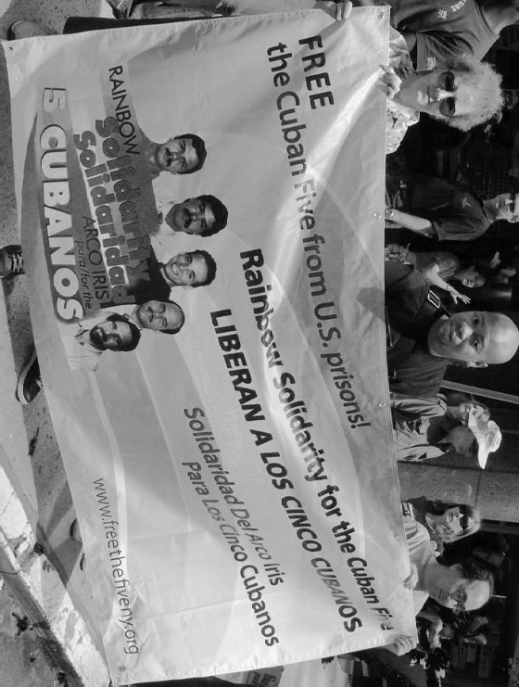
G. Dunkel
Activists brought Rainbow Solidarity for the Cuban Five and defense of the Cuban Revolution to Pride 2007 events in N.Y., L.A., Boston, Atlanta, Buffalo, San Diego and other cities. Above, Rainbow Solidarity signers Bev Hiestand (left) and Imani Henry (center).
Castro Espín said that the proposal to add same-sex marriage to the Cuban Constitution will be taken up when that charter is next amended. “For now,” she added, “it is sufficient to reform the Family Code, which is recognized as a branch of Cuban law.”
In her presentation on the last day of the international congress, Castro Espín emphasized, “The political will exists to eliminate all forms of discrimination in our laws.”
“Laws by themselves are not sufficient for achieving real change,” she noted, but they are necessary to achieve forward momentum.

Trans rights moving forward
The proposed reforms to the Family Code also serve to bolster CENESEX’s 2004 national strategy to support the needs of transsexual and transgender Cubans. This plan, Castro Espín explained, “is already being put into effect.” (caribbean360.com)
The plan involves winning greater acceptance in the educational system and consciousness-raising among the revolutionary security forces.
Sex reassignment surgery — cost-free, like all forms of health care in Cuba — will be more available on request.
Twenty-four transsexual Cubans, who have won support from CENESEX since 1979, have applied for surgery. Many of them have already had their identity documents amended. Some 40 other Cubans have applied for sex-reassignment.
“Nearly everything is ready,” Castro Espín concluded. “An internal Public Health Ministry regulation has authorized the performance of this surgery by the specialized health services, and work has been carried out in training staff and acquiring technology, medical supplies and prosthetics.”

