Colonialism: the real ‘Apocalypto’
From Indigenous oral histories, passed down through millennia, to the hostile accounts kept by colonial record keepers, a great deal of evidence exists to show that sex/gender variance and homosexuality were part of the fabric of early cooperative societies in the Americas — from pole to pole.
What is significant about the abundant European colonial records — whether military, missionary or anthropological — is not their perceptivity, objectivity or accuracy in describing life among the diverse Native societies in this hemisphere. It’s that these observations by the Europeans and their reactions to homosexuality and gender/sex variance in Native cultures — reflected in characterizations like “devilish,” “sinful,” “perverted,” “abominable,” “unnatural,” “heinous,” “disgusting,” “lewd” — reveal how different the European societies were.
The “observed” were peoples who lived in societies that were either communal or were in the early stages of class division.
The “observers” came as military, commercial or intellectual servants of entrenched European ruling classes that were expanding beyond their own hemisphere to steal gold, land and other resources.
In Europe, where most communal lands had been seized by slave-owners and then feudal landlords, state laws and repression against same-sex love and sex/gender variance had been part of this centuries-old class warfare.

From south to north
Colonial observations about same-sex love and sex/gender variance in Indigenous societies in the Western hemisphere are copious. Those with imperial aspirations studied the peoples they sought to militarily conquer and enslave.
When a European colonial expedition in 1576 reached the lands of the Tupinamba people in what is now northeastern Brazil, they found female-bodied hunters and warriors who were accepted by the other Native men. Recalling the Greek Amazon warriors, the Europeans dubbed the river that flowed through that area the “River of the Amazons.” (Magalhães)
Narrating his first trip down another river, now called the Mississippi, Jesuit Jacques Marquette described in the 17th century how, among the Illinois and Nadouessi, he found people who today would be referred to as Two-Spirit. Marquette wrote that they were “summoned to the Councils, and nothing can be decided without their advice. Finally, through their profession of Leading an Extraordinary life, they pass for Manitous — That is to say, for Spirits — or persons of Consequence.” (Marquette)
French missionary Joseph François Lafitau condemned the Two-Spirit people he found in societies along the western Great Lakes, Louisiana and Florida, but these Native peoples did not share his prejudice. He wrote in 1724 that “they participate in all religious ceremonies, and this profession of an extraordinary life causes them to be regarded as people of a higher order.” (Lafitau)
But where Indigenous ruling classes had emerged and consolidated their territory, sometimes after the violent overturn of neighboring communal societies, these attitudes had changed.
Historian Max Mejía wrote, “In the Aztec culture of pre-Hispanic Mexico, the dominant culture at the time the Spanish arrived, the treatment of sodomy was not exactly favorable. On the contrary, the Aztecs had very harsh laws against it, punishing the practice severely with public execution for those who were caught. Punishment affected mainly males, but women were not exempt.” (Mejía)
Friar Bartolomé de las Casas noted that among the Aztecs, “The man who dressed as a woman, or the woman found dressed with men’s clothes, died because of this.”
“However,” Mejía explained, “there were exceptions to the Aztecs’ rules against homosexuality. Most historians agree that the practice was tolerated when it took place in religious rituals.”
Mejía added, “[T]he Aztecs ruled over a vast array of peoples, who had different cultural histories. Several of these did not necessarily share the Aztecs’ vision of homosexuality and its practice. Some even showed signs of singular tolerance towards it in their communities. One of these was the Zapotec culture, derived from the Mayans and located in what is now the state of Oaxaca.”
He emphasized, “[W]hat I am trying to show is that in pre-Hispanic Mexico, alongside the rigid Aztecs, there existed — and there exist still today — other, more flexible cultures more tolerant of homosexuality.”
When it came to sexuality, Mejía stated: “[T]he Mayans had a more favorable view of diversity within the community, which suggests greater tolerance of homosexuality, above all when it concerned religious rituals and artistic practices.”

The real “Apocalypto”
In 2006, director Mel Gibson made a movie called “Apocalypto” about the Mayan empire, as experienced by a family from a nearby hunting-gathering society being chased by its warriors.
Gibson’s movie ideologically serves those in the U.S. who yearn for a Fourth Reich, much as Leni Riefenstahl’s films did for imperialist Nazi capital.
“Apocalypto,” which depicts the Mayans as inherently bloodthirsty, is being screened in the citadel of the most bloodthirsty imperialist power in history. It arrives in chain theaters in the U.S. at a time when Lou Dobbs and other white-supremacist propagandists are pitching classic fascist appeals to the middle-class in this country to view Mexican immigrants as “the enemy within.”
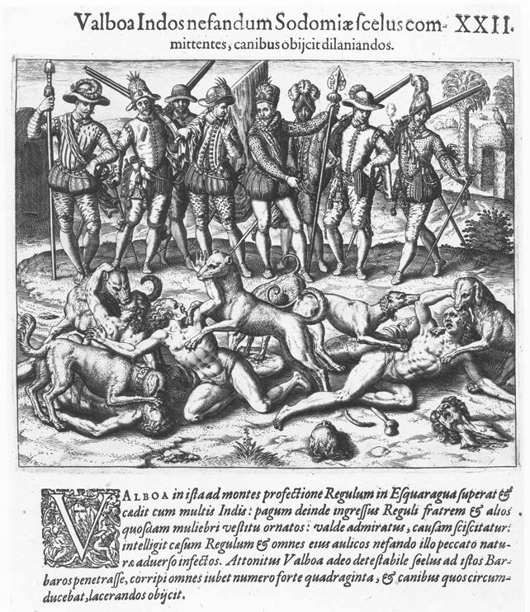
Rare Books and Manuscripts Division, the New York Public Library; Astor, Lenox and Tilden Foundations.
Antonio de la Calancha, a Spanish official in Lima, wrote that during Vasco Núñez de Balboa’s incursion across Panama, “he saw men dressed like women; Balboa learnt that they were sodomites and threw the king and forty others to be eaten by his dogs, a fine action of an honorable and Catholic Spaniard.” (Guerra)
It also screens as U.S. finance capital has unleashed its war machine to recolonize Iraq and Afghanistan under the banner of a “war on terror.”
“Apocalypto” is pro-imperialist propaganda, making colonialism synonymous with salvation. The film ends with the Spanish fleet appearing on the horizon to save the day.
But when the lights come up, it is colonialism and imperialism that are the real historical “Apocalyptos.”

Colonialism brings Inquisition
The patriarchs of colonial power violently restructured the Indigenous societies they militarily conquered — in economic organization, kinship, family/community organization, sexualities, gender and sex roles — in order to best facilitate enslavement, exploitation and oppression.
Mejía stated that with the arrival of the Spanish conquistadors, “An absolutist discourse enveloped homosexuality in the concepts of ‘infamous sin,’ ‘sin against nature,’ corruption of the soul and alliance with the devil. They punished the practice without distinctions, among both lay people and clerics.”
This religious ideology and the ethos of male supremacy, he said, corresponded to the war-driven European social order.
“Furthermore,” Mejía concludes, “the conquerors treated ‘sodomy’ as a special Indian sin and hunted it down and punished it as such on a grand scale. They orchestrated crusades like the Holy Inquisition, which began burning sodomites at the stake as a special occasion, as in the memorable auto-da-fé of San Lázaro in Mexico City.”
This bloody crusade of terror is confirmed in the colonizers’ own words.
Antonio de la Calancha, a Spanish official in Lima, wrote that during Vasco Núñez de Balboa’s incursion across Panama, he “saw men dressed like women; Balboa learnt that they were sodomites and threw the king and forty others to be eaten by his dogs, a fine action of an honorable and Catholic Spaniard.” (Guerra)
When the Spanish invaded the Antilles and Louisiana, “[T]hey found men dressed as women who were respected by their societies. Thinking they were hermaphrodites, or homosexuals, they slew them.” (Green)
Native peoples throughout this hemisphere fought back.
Conquistador Nuño de Guzmán noted in 1530 that after one battle the last Indigenous person taken prisoner, who had “fought most courageously, was a man in the habit of a woman.” (Burton)
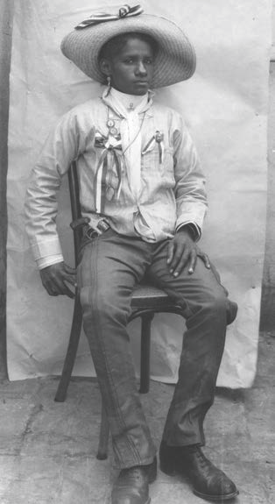
Fondo Casaola, Fototeca del Instituto Nacional de Anthropologia e Historia
C. Robles was a one of a number of female-bodied Mexican revolutionaries who enlisted as males and fought for national independence from Spain. Robles and at least four others rose to the rank of colonel. (suppressedhistories.net).

