‘Cuba: Estamos contigo!’:
Rainbow Solidarity for
Cuban Five circles globe

A multi-national, multi-lingual group of lesbian, gay, bisexual and trans (LGBT) activists in the United States — the belly of the beast — issued a call in Spanish and English for Rainbow Solidarity for the Cuban Five in mid-January 2007.
The five political prisoners — Gerardo Hernández, Antonio Guerrero, Ramón Labañino, Fernando González and René González — are collectively serving four life sentences and 75 years in far-flung U.S. penitentiaries. The “crime” they were convicted of is having infiltrated CIA-backed fascist commando groups in order to halt terror attacks against Cuba from U.S. soil.
The Rainbow Solidarity call demands a new trial and freedom for these political prisoners, defense of Cuban sovereignty and self-determination and a halt to the illegal U.S. acts of war against Cuba — including the economic blockade and CIA trained, funded and armed attacks by mercenary “contra” armies operating from this country.
This initiative was consciously issued by LGBT and other activists battling oppression based on sexuality, gender expression and sex — one of the progressive movements targeted by the imperialist campaign to vilify Cuba.
This was not the first act of solidarity with Cuba by left-wing LGBT activists in the United States — not by a long shot. But the response to the Rainbow Solidarity initiative — swift and dramatic — signals a new day for LGBT support worldwide for Cuba.
Within hours and days after the call went out over the Internet, hundreds of individuals and organizations signed on to the call, posted on the www.freethefiveny.org web site (look for the rainbow).
Most exciting was how many of the signers immediately began forwarding the call to their e-mail lists.
Volunteers from around the world translated the introduction and call for Rainbow Solidarity to free the Cuban Five into simplified and traditional Chinese, Tagalog, Farsi, Turkish, Greek, Croatian, Portuguese, Italian, Danish, Japanese, French and German. More translations in the works or planned include Swahili, Urdu, Indonesian, Arabic, Korean, Bengali and a streaming video in ASL (American Sign Language).
International endorsements flooded in from Argentina, Australia, Austria, Belgium, Brazil, Canada, Costa Rica, Croatia, Cuba, Cyprus, Denmark, England, Finland, France, Germany, Greece, India, Iran, Ireland, Italy, Japan, Luxemburg, Mexico, Montenegro, New Zealand, occupied Palestine, Philippines, Portugal, Puerto Rico, Romania, Scot-land, Serbia, Spain, Sweden, Switzerland, Turkey, United Arab Emirates, Wales and other countries and nations and from Hong Kong and Taiwan.
Individuals and groups from every state in the continental U.S. signed on as well — from southern Florida to the Pacific Northwest, Southern California to Maine.
All told, they form an extraordinary and broad arc of a united front. A frequently updated list of signers is posted at www.freethefiveny.org.
Many names on the growing list will be recognizable as well-known LGBT activists and others battling oppression based on sexuality, gender and sex, including women’s liberationists.
This roster also reveals that many of these activists are also some of the hardest-working organizers in movements here and around the world against imperialist war, neo-liberalism, neo-colonialism, national oppression, racism, police brutality, prison and death penalty abolition, sweatshops and capitalist globalization.
These are also leading activists in the struggle for immigrant rights; women’s liberation, including reproductive rights; jobs; labor union, tenant and community organizing; education; health care and affordable housing; freedom for all U.S. political prisoners and for prisoner rights; liberation of oppressed nations; support for Cuba, and the revolutionary movement to overturn capitalism and build an economy based on planning to meet peoples’ needs.

Expansive political spectrum
Early signers include Teresa Gutierrez, a long-time leader in the struggle to free the Cuban Five; former political prisoner and leading prison abolitionist Angela Y. Davis; Leslie Cagan, national coordinator of United for Peace and Justice; LeiLani Dowell, national coordinator of FIST (Fight Imperialism, Stand Together); Stephen Funk, the U.S. Marine who was the first imprisoned Iraq War conscientious objector; Bev Tang, organizer for Anakbayan, the youth group of Bayan; Gerry Scoppettuolo, co-founder of GALLAN (Pride At Work, Boston); Lani Ka’ahumanu, BiNET USA; anti-imperialist activist Joo-Hyun Kang; Atlanta community activist Pat Hussain; Camille Hopkins, director of NYTRO (New York Transgender Rights Organization) of Western New York; transgender activist Moonhawk River Stone; and Jesse Lokahi Heiwa, Queer People Of Color Action.
Rauda Morcos, general coordinator of Aswat-Palestinian Gay Women, signed on. The Puerto Rican Alliance of Los Angeles and its coordinator Lawrence Reyes have endorsed.
Activists Barbara Smith and Margo Okazawa-Rey signed. The two were among the founders of the Combahee River Collective, a group of Black feminists of all sexualities who issued a historic 1977 statement against the “interlocking” system of “racial, sexual, heterosexual and class oppression.”
Former political prisoners Laura Whitehorn and Linda Evans added their names.
Louisville, Ky., filmmaker and activist Sonja de Vries, director of the documentary “Gay Cuba,” and Walter Lippmann, editor-in-chief of CubaNews, signed on. Other activists and organizations working in defense of Cuba also added weight to the call, including Cuba Education Tours, Vancouver, B.C., Canada; Fairness Campaign, Louisville, Ky.; Simon McGuinness, secretary of the Free the Miami Five Campaign, Ireland; Brigitte Oftner, coordinator of the Austrian Free the Five committee; Viktor Dedaj, webmaster of the Cuba Solidarity Project; the Cuba Edmonton Solidarity Committee in Alberta, Canada; the Swiss Cuba Association; Deutsche Kommunistische Partei Cuba Arbeitsgruppe, Germany; and No War on Cuba, Washington, D.C.
Groups include the national organization Pro-Gay Philippines; Audre Lorde Project — a Lesbian, Gay, Bisexual, Two Spirit and Transgender People of Color center for community organizing, focusing on the New York City area; FIERCE! — a community organization for Transgender, Lesbian, Gay, Bisexual, Two Spirit, Queer, and Questioning (TLGBTSQQ) youth of color in New York City; QUIT! (Queers Undermining Israeli Terrorism); LAGAI-Queer Insurrection; Stonewall Warriors, Boston; Greek Homosexual Community, Athens, Greece; Queertoday.com, Boston, Mass.; and Queers Without Borders, Hartford, Conn.
The Queer Caucus of the National Lawyers Guild; Stephen Whittle, professor of equalities law and the British organization Press for Change at the School of Law at Manchester Metropolitan University, endorsed. So did Barbara Findlay, co-chair of the Lesbian Gay Bisexual and Transgender Issues Section, BC Branch, Canadian Bar Association; and the law office of Lenore Rae Shefman, San Francisco, Calif.
Many transgender and transsexual organizations and individuals strengthened the initiative, including Trans Action Canada; three national Italian trans groups: Coordinamento Nazionale Trans FTM, Movimento Identità Transessuale and Crisalide Azione Trans; playwrite and performer Imani Henry; Matt/ilda a.k.a. Matt Bernstein Sycamore, editor “Nobody Passes,” San Francisco, Calif.; Cianán Russell, chair of the Indiana Transgender Rights Advocacy Alliance; and the Winona Gender Mutiny Collective.
Endorsers include The National Lavender Green Caucus; Doug Barnes and the Freedom Socialist Party; Starlene Rankin, Green National Committee delegate of the Lavender Caucus of the Green Party of the United States; Orange County Peace & Freedom Party, Anaheim, Calif; and the LGBT Caucus of Workers World Party.
Among the signers are individuals and organizations whose activist work includes the struggle against women’s oppression: Brenda Stokely, a leader of the Million Worker March Movement and NYCLAW; transnational feminist theorist Chandra Talpade Mohanty; Sara Flounders, co-director of the International Action Center; Women’s Fightback Network, Boston, Mass.; Melinda Clark, local co-founder of Code Pink in Willits, Calif.; Welfare Warriors, Milwaukee, Wis.; League of Women Voters in Montenegro; and Women’s International League for Peace and Freedom (WILPF) chapters in Washington, D.C.; Rome, Italy; and the Canadian Section in British Columbia.
Many LGBT labor activists have added their names and/or the endorsement of their unions, including the Pride at Work/GALLAN (Gay and Lesbian Labor Action Network), Boston, Mass, AFL-CIO; Bus Riders Union/Labor Community Strategy Center, Los Angeles, Calif.; and from Canada: Canadian Union Of Postal Workers, Calgary, Alberta; Canadian Union of Public Employees, Toronto, Ont.; and Hospital Employees’ Union, Burnaby, B.C.
There’s no end in sight to this rainbow.

Grassroots diplomacy
The Rainbow Solidarity for the Cuban Five initiative is also giving voice to individuals who, living in capitalist democracies, have little political input.
The Rainbow Solidarity call has become a poll that reveals a new grassroots sentiment as signers eloquently register their outrage at the continued imprisonment of the five Cubans and at Washington’s economic and political blockade of Cuba and other illegal and covert acts of war.
Rebecca writes from San Diego, Calif., “Free the Cuban Five!! No more political prisoners!”
David from New York State stresses how biased the trial venue was for the Five: “[The] Five Cubans were trying to stop the ultra-right terrorist groups in Miami from carrying out violent actions against the people of Cuba. Miami is the one city in the U.S. where the Five certainly could not receive a fair trial.”
Paul says: “As a gay man in South Florida who calls for freedom for our brothers, the Five, I am delighted to see this initiative. THEY MUST BE FREE!”
Tighe supports the five as “those most important defenders of everyone’s right to live without fear of terrorism. The patriotic Cuban Five [are] illegally held political prisoners in a country with the most of its own people behind bars.”
Barry, who grew up in Miami, adds the need to organize to close down the U.S. prison at Guantanamo and free all those held there.
“T.” from California comments, “These five men, fighting against terrorism, have been imprisoned by the U.S. government — ‘MY’ government! Jailing heroes and supporting terror, while pretending to do the opposite, is sadly all the public can count on from ‘our’ hypocritical, double-speaking, global corporate-run excuse for a ‘by and for the people’ government.”
Brian states from Newport, Ore., “I am enraged by the hypocrisy of five innocent men being held in prison under harsh circumstances while known terrorist Luis Posada Carriles goes scot-free. While Bush and cronies spout off that no nation that harbors terrorists will be tolerated with one face, they set a convicted terrorist murderer of at least 73 innocents free with the other, while holding five innocent men in prison.”
Adela, from the Zig Zag Young Women’s Resource Centre Inc. in Queensland, Australia, states, “I want to express my solidarity with the Cuban Five and the Cuban people and Fidel.”
Richard, from Madera, Calif., says succinctly, “It’s way past time to change our policy toward Cuba and the Cuban people.”
Jerry, from Athletes United for Peace, U.S.-El Salvador Sister Cities, Nicaragua Solidarity Committee, writes: “These people were trying to prevent an act of terrorism. The country that claims to lead the ‘War On Terror’ is imprisoning them.”
Marcos writes from Bielefeld, Germany, “Free the Five Cubans now, stop the war on Cuba and the rest of the world!”
Richard, in Jacksonville, Ill., says, “Close Guantánamo, human rights are for humans everywhere.”
Ray from Farmington, Conn., suggests, “Put Cheney and Bush in jail instead of the Cuban Five.”
Yancy, from the LGBTQI Desk of Bayan USA, affirms: “Mabuhi ang panaghiusang international!!! Long live international solidarity!!”

Solidarity is not charity
Eric from Milwaukee reminds, “Ah, the things we gain from solidarity.”
It is in the interests of LGBT activists and organizations in the U.S. and other imperialist countries to break with their own ruling classes and extend their own unilateral declaration of peace to a socialist country. And by rejecting anti-communism, the movement against sexual, gender and sex oppression can combat capitalist ideology — a giant step towards liberation.
Cuba has much to teach those who yearn for the right to live and love without fear or censure about what it takes to begin the process of literally eradicating white supremacy, patriarchy and prejudice against same-sex love and gender/sex diversity; what it takes to create a new woman, a new man, a new human being, and new forms of communist comradeship.
The Cuban people fought back against enslavement for half a millennium. For the last half century they have resisted the most powerful slave-master in history, just 90 miles from their shores.
The famous labor union song poses the question sharply: Which side are you on?
Rainbow Solidarity answers: “Cuba, estamos contigo. Cuba we are with you.”
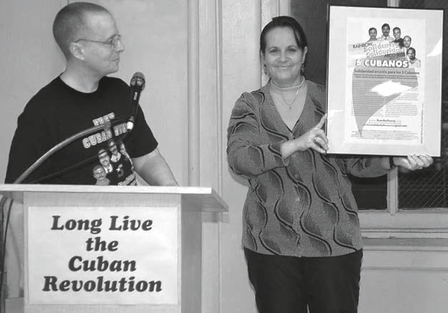
Roberto Mercado
Alicia González of the Federation of Cuban Women (Federación de Mujeres Cubanas, FMC) holds up gift of first Rainbow Solidarity for the Cuban Five poster presented by Leslie Feinberg at a Workers World Party International Women's Day commemoration meeting March 9, 2007 in New York City.
Tami Starlight, director of Trans Action Canada: “I support this fully!”
Lynda, from Elk, Calif.: “Please add my name to the call to free the Cuban 5 (I am a lesbian).”
Tim: “My partner and I are with you 100 percent.”
Joan, from Brooklyn, N.Y.: “I have long been outraged by the terrible injustice of their situation.”
Larry of the Scottish Socialist Freedom Movement: “It is time these Cubans had a fair trial and it is recognized they were protecting their homeland from U.S.-sponsored terrorism.”
Richard from Wappingers Falls, N.Y., states, “It is wrong, it is immoral and unjust what the U.S. is doing to these five men.”
Jay, from Shrewsbury, England, emphasizes, “It’s about time they were out of there and back home.”
Sandy, from Paterson, N.J., says, “This is a miscarriage of justice.”
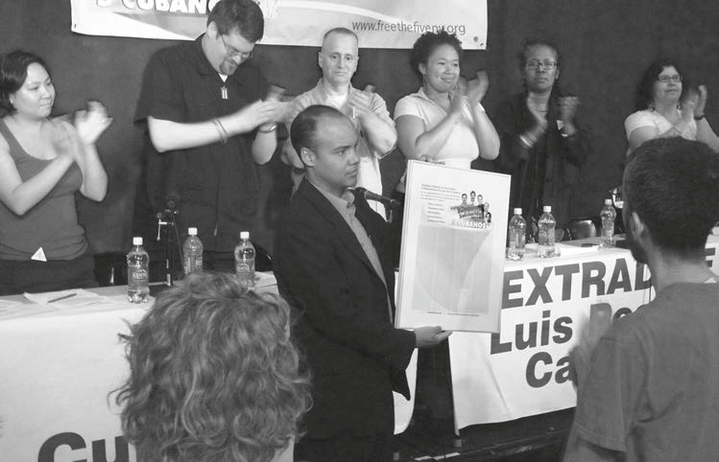
G. Dunkel
First public event for Rainbow Solidarity for the Cuban Five at the New York City LGBT Community Center on June 2, 2007. From left: Helena Wong, Benjamin Ramos, Leslie Feinberg, LeiLani Dowell, Joan Gibbs, Teresa Gutierrez and Yancy Mark Gandionco (not seen in this photo) applauded Secretary Jorge Luis Dustet from the United Nations Cuban Mission as he holds up poster with the names of the first 1,000 signers of the call for Rainbow Solidarity with the Cuban Five.
You can make the call for Rainbow Solidarity for the Cuban Five more powerful by adding your name at: www.freethefiveny.org. Please help circulate the call far and wide, on the Internet, at your campus, community organization, local Pride events and other activities.
Translations, downloadable leaflets, posters and buttons are available online.
Rainbow Solidarity organizers stress that to make this call even more powerful, your signature is needed. To become a part of Rainbow Solidarity to Free the Cuban Five, sign on at: www.freethefiveny.org/rainboweng.htm.
For ideas about how to deepen this initiative, e-mail: rainbowsolidarity4cuban5@gmail.com
For more information about the case of the Cuban Five, visit freethefiveny.org or freethefive.org.
Barry Morley, secretary-treasurer of the Community Business and Professionals Association of Canada, states, “It is time for the Bush administration to stop the hypocrisy and make terrorism against Cuba illegal.”
Chien San Feng, professor in the Department of Journalism, National Cheng Chi University, in Taipei, Taiwan, sends this message: “The U.S. should lift the embargo.”
Dale Pfeiffer, author of “Eating Fossil Fuels,” writes from Irvine, Ky.: “It is long past time for the U.S. to recognize Cuba’s right to determine its own form of government. In the years to come, U.S. respect for Cuba will be extremely important to the welfare of the U.S. public, as industrialized, U.S.-style agriculture results in a food crisis for which Cuba has pioneered the only possible solution. It is time to honor Cuba, not vilify it. Let this honor begin with the freedom of the Cuban Five.”
Adela, counselor at the Zig Zag Young Women’s Resource Centre Inc. in Brisbane, Australia: “As a citizen of the world, I demand the U.S. government to free the five Cubans who have not committed any crime. I also demand the U.S. government to lift the economic embargo against the Cuban people.”
Joan, from St. Paul, Minn.: “I have written Fernando Gonzáles approximately twice a week since March of 2003. I have learned so much from him. The Five are examples for the world, just as the Cuban Revolution has always been an example for the world. I greatly appreciate your work in supporting the Five, and I know the Five and their families also greatly appreciate your beautiful efforts. Thank you!!!!!!”
Melinda, a local co-founder of Code Pink in Willits, Calif., says of the Cuban Five: “Thank you to all who have been fighting for their survival and publicity. They will be freed.”
Robert Taylor, from the Bus Riders Union/Labor Community Strategy Center, writes from Los Angeles, “Let’s keep the fight on to free the Cuban Five from jail!”
Monty, from Jamul, Calif., stresses, “Please get the word out to keep up the pressure.”
David, from New State, concludes: “To all justice-loving people in the U.S. and around the world, we appeal to you to join the struggle to free Fernando, René, Antonio, Ramón and Gerardo. Help us in outreach, education and organizing, because once people know the facts of the case, we are sure they will call for their freedom as well.”

