Bibliografia
Cuban strategy in the struggle against AIDS. Granma, 18 de setembro, 1988.
Spotlight on Cuba’s strategy against HIV/AIDS. 2001. MEDICC review II (1,2).
World Sexology Congress in Havana: Treading the path of human development. 2003.
Granma International, 19 de março.
Cuban parliamentary committees conclude 2005 review. Granma, December, 2005
Cuban soap opera with gay story lines draws to an end; some see show as increased acceptance. Advocate.com/Miami Herald 2006 [cited November 8. Available from http://216.239.51.104/search?q=cache:AHKe5lKjbx0J:www.globalgayz.com/cuba-news03-06.html+Advocate+%22Now,+as+the+show+draws+to+an+end,:%22&hl=en&ct=clnk&cd=1&gl=us&client=firefox-a.
Cuban parliament to discuss free sex-changes. Diversity (Diversidad), February 13, 2007.
Acosta, Dalia. A long-closed door opens for sexual diversity in Cuba. Inter Press Service (IPS) News Agency. 2004 [cited July 3. Available from http://mostlywater.org/rights_cuba_door_opens_for_sexual_diversity.
Aguilera, Elizabeth. AIDS: Cuba’s low HIV rate belies the stigma, ignorance many face. Denver Post, February 10, 2003.
Arreola, Gerardo. Cuba divided on the issue of bisexuality. La Jornada, May 8, 2006.
———. Plans to authorize sex change operations and modifications in identity documents: Cuban Parliament considers legal recognition of the rights of transsexuals; Total endorsement from two commissions, says main promoter Mariela Castro. La Jornada, Jan. 9, 2006.
Bejel, Emilio. 2001. Gay Cuban Nation. Chicago: The University of Chicago Press
Berkowitz, Bill. Viva gay Cuba! Out and married in the increasingly tolerant Communist island. Workingforchange.com 2001 [cited July 13. Available from http://www.workingforchange.com/article.cfm?ItemID=11550.
Betancourt, José Luis Estrada. 2006. Unseen faces (The hidden side of the moon). Juventud Rebelde, newspaper of the Unión de Jóvenes Comunistas (Union of Young Communists).
Bjorklund, Eva. 2000. Homosexuality is not illegal in Cuba, but like elsewhere, homophobia persists. Swedish Cuba magazine quarterly, published by the Swedish-Cuban Association, Summer.
Borge, Tomas. 1992. Face to Face with Fidel Castro: A Conversation with Tomás Borge: Ocean Press.
Buchanan, Patrick. AIDS disease: it’s nature striking back. New York Post, May 24, 1983.
Burton, Richard. 1886. The Book of the Thousand Nights and a Night, Vol. I.
Cabral, Juan Pérez. Gays wed in Cuba: the second revolution. theGully.com 2001 [cited June 21. Available from http://216.239.51.104/search?q=cache:ofJMmdKcg2IJ:www.thegully.com/essays/cuba/010621gay_cuba.html+Cabral+Gays+wed+in+Cuba%3F&hl=en&ct=clnk& cd=1&gl=us&client=firefox-a.
Cardenal, Ernesto. 1974. In Cuba. New York: New Directions Publishing Corporation.
Cookson, Clive. Cuba praised for its AIDS programme. Financial Times, February 16, 2003.
Eaton, Tracey. Sex conference in Cuba covers everything from implants to abuse. The Dallas Morning News, April 1, 2003.
Editors. 2001. Cuba’s HIV-AIDS rate: Lowest in the Americas. MEDICC review II (1,2).
———. 2001. Cuba’s strategy against HIV/AIDS. MEDICC review II (1,2).
Fee, Elizabeth. 1988. Sex education in Cuba: An interview with Dr. Celestino Alvarez Lajonchere. International Journal of Health Services 18 (2).
Feinberg, Leslie. 1996. Transgender Warriors: Making History from Joan of Arc to Ru Paul. Hardcover ed. Boston: Beacon Press.
———. Bobbi Campbell calls for solidarity in fight against AIDS. Workers World, October 13, 1983
———. Demonstrators in 7 cities demand gov’t funds to fight AIDS. Workers World, 1983..
———. ‘The government didn’t care if I lived or died’: Workers World interviews Michael Callen who has AIDS. Workers World, August 25, 1983.
Fuente, Alejandro de la. 2004. Slave law and claims-making in Cuba: The Tannenbaum debate revisited. Law and History Review 22 (2).
Garcia, Eduardo Jimenez. Gay rights in Cuba: How much has changed? Green Left Weekly.
Gilpin, Margaret and Luis Felipe Bernaza. 1995. Mariposas en el Andamio (Butterflies on the Scaffold).
González, Fernán. Mariela Castro: ‘I am proud of my father.’ BBC Mundo, September 18, 2006.
Green, Richard. 1974. Historical and Cross-Cultural Survey. In Sexual Identity Conflict in Children and Adults, New York: Basic Books.
Guerra, Francisco. 1971. The Pre-Columbian Mind. London: Seminar Press.
Hatch, Marcel and Leonardo Hechavarría. 2001. Gays in Cuba, from the Hollywood school of falsification. Review of reviewed item. (October), http://www.walterlippmann.com/lgbt-cuba-003.html.
Hillson, Jon. 2001. The Sexual Politics of Reinaldo Arenas: Fact, Fiction and the Real Record of the Cuban Revolution.
Israel, Esteban. Castro’s niece fights for new revolution. Reuters, July 3, 2006.
Iznaga, Diana. 1986. Introduction in Los negros curros, by Fernando Ortiz. Havana: Editorial de Ciencias Sociales.
Lafitau, Joseph François. 1724. Moeurs des sauvages ameriquains, compares aux moeurs des premiers temps. 2 vols. Vol. 1:52 Paris: Saugrain.
Lamey, Mary. Mariela Castro speaks out for Cuba’s gay minority. The Gazette, July 29, 2006.
Levin, Julia. 2003. Tomás Gutiérrez Alea. Senses of cinema.
López, Marlon Brito. Art and Love vs. AIDS: Part 1. 2006 [cited. Available from http://216.239.51.104/search?q=cache:NQ3tPk4Q4r8J:www.walterlippmann.com/docs669.html+Marlon+Brito+Lopez+%22The+main+goals%22&hl=en&ct=clnk&cd=1&gl=us& client=firefox-a.
Lumsden, Ian. 1996. Machos, Maricones, and Gays. Philadelphia: Temple University Press.
Magalhães, Pedro de. 1922. The Histories of Brazil. New York: The Cortes Society.
Manago, Cleo. 1994. Cuba, from a Black, Male, Same-Gender-Loving Perspective. Sonoma County Free Press, August.
Marcy, Sam. The U.S.-Cuba immigration accord. Workers World, September 22, 1994.
Marquette, Jacques. 1896-1901. Of the First Voyage Made by Father Marquette Toward New Mexico, and How the Idea Thereof Was Conceived. Edited by R. G. Thwaites. Vol. 59, The Jesuit and Allied Documents. Cleveland: Burrows.
Marx, Gary. Helping Cubans realize ‘what it means to be gay’, June 4, 2006.
Marx, Karl. 1970. The German Ideology, New York: International Publishers.
McCubbin, Bob. Gay Cuba: Problems of building socialism. Workers World, April 26, 2001.
McKinley, James C. Jr. Cuba counters prostitution with AIDS programs. New York Times, December 26, 2004.
Mejía, Max. 2000. Mexican Pink. In Different Rainbows, edited by P. Drucker: Gay Men’s Press.
Mutti, Joseph. ‘Repression’ Saved Lives. Resource Center of the Americas.org 1999 [cited. Available from http://www.americas.org/item_260.
Oberg, Larry R. 2006. The status of gays in Cuba: myth and reality. Cuban Libraries Solidarity Group.
Pratt, Minnie Bruce. ‘Gay Cuba’: Revolution within the revolution. Workers World, July 12, 2001.
Puyol, Johanna. Interview with Rafael Cheíto González: An open message. La Jiribilla, April 28, 2006.
Ramonet, Ignacio. 2006. Cien Horas Con Fidel. Translated by e. b. W. L. CubaNews translation: Cuban Council of State.
Reed, Gail A. 2006. MR Interview: Mariela Castro, MS — Director, National Center for Sex Education. MEDICC review VIII (No. 1).
Rich, Lourdes Arguelles and B. Ruby. 1989. Homosexuality, homophobia, and revolution: notes toward an understanding of the Cuban lesbian and gay male experience. In Hidden from History: Reclaiming the Gay & Lesbian Past, edited by M. V. a. G. C. Martin Bauml Duberman, Jr. New York: New American Library. Original edition, Signs, A Journal of Women in Culture and Society, Summer 1984.
Rodriguez, Andrea. Cuba’s transsexuals get powerful new friend. Associated Press, September 5, 2004. [cited Sept. 5. Available from http://www.ap.org.
Vries, Sonja de. Gay Cuba: Frameline Distribution.
———. N. California queers help celebrate: a gay May Day in Havana. News for a Peoples World, May 26, 1995.
Wald, Karen. Health official details drastic approach to AIDS. Guardian, October 28, 1987.
West, Dennis. 1995. ‘Strawberry and Chocolate,’ ice cream and tolerance: Interview with Tomás Gutiérrez Alea. Cineaste 21 (1-2):16-20.
Williams, Walter. 1986. The Spirit and the Flesh: Sexual Diversity in American Indian Culture. Boston: Beacon Press.
Wills, Stephen J. and Randolph E. Risch. Positive views of gays. Gay Insurgent, Summer, 1980.
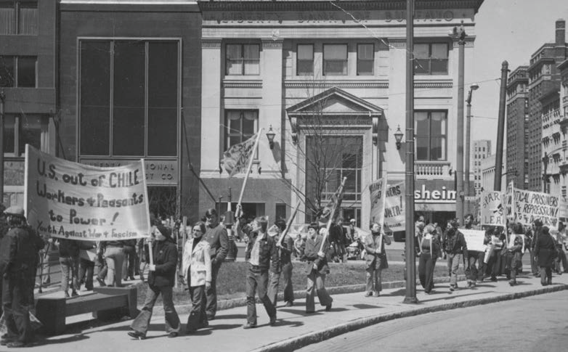
Feinberg, hoisting flag aloft, at Buffalo, N.Y., Youth Against War & Fascism (YAWF) protest against 1973 CIA-engineered counter-revolution in Chile.
ABOUT THE AUTHOR
Leslie Feinberg is a long-time activist and award-winning author of the novels Stone Butch Blues and Drag King Dreams, and the non-fiction works Transgender Warriors: Making History from Joan of Arc to Dennis Rodman, and Trans Liberation: Beyond Pink or Blue. Feinberg’s web-book-in-progress — Lavender & Red — can be read online at: www.workers.org.
Feinberg is in the national leadership of Workers World Party; a managing editor of Workers World newspaper; member of the LGBT Caucus of the National Writers Union/UAW; Pride At Work, AFL-CIO; and associate member of the Steelworkers Union. Feinberg is also a founder of Rainbow Flags for Mumia and a national organizer for the International Action Center. Feinberg is an initiator of Rainbow Solidarity for the Cuban Five and takes the demand to free the Five, and defense of the Cuban Revolution, to campuses, rallies, community events and youth groups across the U.S. and internationally. For more information about the Rainbow Solidarity call, look for the rainbow at: www.freethefiveny.org.
Leslie Feinberg is at home in cyberspace at www.transgenderwarrior.org and can be emailed at leslie@workers.org.

