CloudPulse
Complete technical guide: every component, algorithm, decision, result and mistake
Experiment-validated PostgreSQL query regression remediation
Repository: github.com/GTX-Pradeep/cloudpulse
Generated from the repository on 2026-11-03

Contents

1. How to use this guide
This document explains everything in the CloudPulse repository: what problem it solves, every component, every algorithm and formula, every SQL statement that matters, every design decision and its alternatives, every mistake found along the way, every result and where it came from, and how to explain all of it in an interview.
Read it in this order the first time:
- Chapter 2 (one page): what CloudPulse is and the single result that makes it interesting.
- Chapter 4 (concepts): the PostgreSQL and statistics ideas the rest depends on. Do not skip it; every interview question starts here.
- Chapter 5 (architecture): the three databases, the end-to-end flow, the module map.
- Chapters 6–13 (components): one chapter per part of the system, in the order data flows through it, with the real code.
- Chapters 14–15 (results and mistakes): what was measured, how stable it is, and what went wrong. This is your interview story.
- Chapters 16–17: testing, CI, reproducibility and honest limitations.
- Chapter 18 (interview preparation): pitches, a demo script and a 31-question drill.
Conventions: code is a name in the code or SQL; bold marks the idea to remember. Code excerpts are copied automatically from the repository when this document is generated, so they always match the code. Every number in the results chapters is read from a committed results file, and the file is named next to it.
Honest limitation: All measurements in this guide come from the development cloud sandbox: 2 virtual CPUs, 7.8 GB RAM, PostgreSQL 16.15. Every results file is labelled dev-cloud-sandbox (not official). CI runs the tests on the pinned PostgreSQL 17 image. Re-run scripts/reproduce.sh on your own machine to produce your own numbers.

2. CloudPulse in one page

The problem
A query that used to take 0.3 ms now takes 180 ms. Most tools stop at it is slow, maybe add an index. That leaves the hard questions unanswered:
- Is this a real regression or normal variation?
- What in the execution plan explains it?
- Does the proposed fix actually make the query faster, by how much, and how sure are we?
- Does the fix make any other query slower? An index that helps one query can hurt another, and it always adds work to every write.
- Given the evidence, should a human apply it: yes, no, or we cannot tell?

The idea
CloudPulse treats every proposed fix as a hypothesis to be tested, not an answer. Its pipeline is:
Regression -> Evidence -> Diagnosis -> Candidate fix -> Controlled A/B experiment
-> Statistical verdict -> Workload-wide guardrail -> SUPPORTED / REJECTED / INCONCLUSIVE
- Detect a regression by comparing each query with its own history (from pg_stat_statements).
- Explain it by capturing the real execution plan (EXPLAIN ANALYZE) and extracting evidence from it.
- Hypothesise a small set of fixes with explainable rules (an index, ANALYZE, a scoped work_mem).
- Pre-filter with HypoPG: would the planner even use the index, and which other queries would change plan?
- Experiment on two byte-identical copies of the database (never the monitored one), alternating between them.
- Decide with a paired block bootstrap confidence interval and a rule written down before any experiment ran.
- Guard the rest of the workload: if any other tracked query gets confidently worse by more than 10%, veto the fix.

The result that makes it interesting
Scenario S5: the index on orders(created_at) is dropped and the recent-orders feed becomes thousands of times slower. CloudPulse proposes re-creating the index, and the experiment confirms it makes the feed 99.7% faster. But the guardrail finds that, with that index, PostgreSQL answers latest 10 orders of customer X by walking the created_at index backwards and filtering. For heavy customers whose orders are all old, that walk reads most of the table: up to 56× slower for one customer, 5.66× slower for that query overall. Verdict: REJECTED, with the reason written out, even though total workload time would drop by 82%.
Key idea: An optimisation that is excellent for one query can be harmful for the workload. CloudPulse finds that out by measurement, before anyone applies the change to production.

What is real and what is synthetic
Real | Synthetic or limited
PostgreSQL itself: real planner, real execution, real pg_stat_statements, real HypoPG and pgvector | The main dataset is generated (2 M orders, 100 k customers) with deliberate skew
Every latency is a real measurement; every execution is stored in raw.csv | The 7 faults were designed by the same author who wrote the rules
TPC-H validation uses the official benchmark schema, data generator and queries | Measurements come from a 2-vCPU cloud VM (noisy), not production hardware
Bugs and wrong results were found, fixed and kept on record | Telemetry intervals are rounds of a workload replay, not wall-clock minutes

3. How the project was built
The project started as a written brief and a guide. The first step was a review of the plan for real technical problems; the main ones found, and how the build addressed each, were:
Problem found in the original plan | How the build resolved it
BEGIN; CREATE INDEX; benchmark; ROLLBACK on the monitored database takes a SHARE lock that blocks writes for the whole benchmark, and warms caches for arm B | Experiments run only on a separate lab server, on twin databases cloned from a template (D-003)
A read-only workload can never show the main cost of an index (write maintenance, lost HOT updates) | The tracked workload includes an UPDATE; scenario S4 measures the HOT-update cost
pg_stat_statements min/max/stddev are cumulative and cannot be differenced; no per-interval percentiles | Detector works on interval means from differenced sums (D-012)
auto_explain writes to logs and, with log_analyze, instruments every query (perturbs benchmarks) | On-demand EXPLAIN ANALYZE in a read-only transaction with a timeout (D-020)
Bootstrapping single executions understates uncertainty; testing many queries inflates false alarms | Paired block bootstrap; Bonferroni-adjusted guardrail (D-010, D-011)
Core contribution (experiments) scheduled late in the roadmap | Built first: measurement bench and statistics before detection and UI

Everything was then built, tested and evaluated in one long session, with several rounds of finding and fixing problems in the results. The commit history, in order (14 further "checkpoint" commits only saved in-progress result files and are omitted):
Commit | When (UTC) | What changed
5fd61f2 | 02-Nov-18:39 | Core engine: data generator, A/B harness, statistics, plans, diagnosis, telemetry, pipeline
d56ba89 | 02-Nov-18:40 | Index incidents for similarity search after evaluation; add similarity benchmark command
c19cdc7 | 02-Nov-18:43 | Add web UI, API, CI workflow, lint config, similarity search and example experiment specs
099fa4a | 02-Nov-18:47 | Docs (decision log, architecture, learning notes), reproduce script, license, UI polish, similarity tests
2e9a6bf | 02-Nov-18:49 | Add PROGRESS.md handoff file
c2b5e8c | 02-Nov-18:52 | Report measured fault effect per scenario; warn on confident sub-threshold guardrail slowdowns
6bb7c6c | 02-Nov-18:54 | Guardrail benchmarks the exact parameters whose plan changes under HypoPG (F-7)
58423f1 | 02-Nov-18:57 | Fix query mapping across target databases (F-8); mark first evaluation run superseded
25384c5 | 02-Nov-18:59 | Add A/A calibration and similarity benchmark results (dev sandbox); update F-5 with committed numbers
a53137f | 02-Nov-19:12 | Include heavy-hitter parameter values in HypoPG what-if checks (F-9)
49f548d | 02-Nov-19:16 | Fix detection-delay off-by-one (F-10) and correct recorded evaluation summaries
743e818 | 02-Nov-19:19 | S2 supplementary (16 fault rounds) results with delay correction
1d3c328 | 02-Nov-19:25 | Final README with measured results, results index, trap example with heavy customers
245ca6a | 03-Nov-01:46 | Add replication of candidate verdicts; extract build_candidate_spec
ba2df76 | 03-Nov-01:50 | Workload packs: generalise the engine; add the TPC-H benchmark pack
7806806 | 03-Nov-02:01 | Replication: consolidated stability verdict (UNSTABLE when runs disagree); checkpoint results
22ec4b6 | 03-Nov-02:02 | Replication results with consolidated verdicts; D-023 and F-11 in the decision log
09e342d | 03-Nov-02:04 | README: replication results; add the guide generator (docs/guide)
c9a76b6 | 03-Nov-02:06 | Fix hotspot shares in parallel plans (F-12); worked-example data export for the guide
c875c05 | 03-Nov-02:07 | Guide: worked-example chapter; checkpoint TPC-H results

4. Concepts you must know first
This chapter is a primer. Each concept is explained in plain terms, then connected to where CloudPulse uses it.

4.1 How PostgreSQL runs a query
- Parse the SQL text into a tree, then rewrite (views, rules).
- Plan: the planner enumerates ways to execute the query (which table to scan how, which join method, in which order) and estimates a cost for each, using table statistics. It picks the cheapest estimated plan.
- Execute the plan: a tree of nodes (Seq Scan, Index Scan, Hash Join, Sort, Aggregate, Limit...). Each node pulls rows from its children.
The planner never runs anything to decide; it estimates. When its row-count estimates are wrong, it can choose a plan that is orders of magnitude slower. Most query regressions are a plan choice that stopped being right.

4.2 EXPLAIN and EXPLAIN ANALYZE
- EXPLAIN shows the chosen plan with estimated rows and costs. It does not run the query.
- EXPLAIN (ANALYZE, BUFFERS) runs the query and adds actual rows, loops, time per node, and buffer (page) hits, reads and temp writes.
- FORMAT JSON gives the same as a nested JSON tree, which CloudPulse parses (chapter 7).
- Buffer counts and times are inclusive of children: a parent's numbers include everything below it. CloudPulse subtracts children to get per-node values (F-2).

4.3 Indexes, scans and the cost model
- A B-tree index keeps keys sorted with pointers to table rows. It makes =, ranges and ORDER BY on its leading column(s) fast.
- Seq Scan reads the whole table. Cheap per page (sequential I/O), but it reads everything.
- Index Scan walks the index and fetches matching rows (random I/O per row). Bitmap Index/Heap Scan first collects matching row locations, then reads pages in physical order. That is a middle ground for medium selectivity.
- The planner chooses using seq_page_cost, random_page_cost, CPU costs, estimated rows, and the correlation between index order and physical row order.
- Composite index (a, b): usable for filters on a, and for a = ? ORDER BY b without sorting.
- Every index must be updated on INSERT and on any UPDATE that cannot be HOT (4.6). Indexes are never free.

4.4 Statistics, ANALYZE and cardinality estimation
- ANALYZE samples rows and stores per-column statistics in pg_statistic: null fraction, number of distinct values, a most-common-values (MCV) list with frequencies, and a histogram.
- From these the planner estimates how many rows a predicate matches (cardinality or selectivity).
- q-error = max(estimated/actual, actual/estimated). 1 is perfect; 10 or more is a serious misestimate.
- Statistics go stale when much data changes and ANALYZE has not run (autovacuum normally runs it). pg_stat_user_tables.n_mod_since_analyze counts changed rows since the last analyze.
- The planner assumes columns are independent and values are evenly spread. Correlated data (heavy customers whose orders are all old) breaks this. That is the root of scenario S5.

4.5 Join methods and why nested loops can explode
- Nested Loop: for each outer row, look up matching inner rows. Excellent for few outer rows with an index on the inner side; disastrous for many.
- Hash Join: build a hash table on one side, probe it with the other. Good for large unsorted inputs.
- Merge Join: both inputs sorted on the join key, merged.
- When the planner under-estimates outer rows (estimates 1, gets 300,000) it picks a nested loop and does 300,000 index probes. That is scenario S2 (stale statistics).

4.6 MVCC, VACUUM and HOT updates
- PostgreSQL never updates a row in place. An UPDATE writes a new row version and marks the old one dead (MVCC). VACUUM later reclaims dead versions.
- Normally every index on the table gets a new entry pointing to the new version.
- A HOT (heap-only tuple) update avoids that: if no indexed column changes and the new version fits on the same page, no index is touched. This is much cheaper.
- fillfactor (CloudPulse uses 90 for orders) leaves free space on each page so HOT updates have room.
- Consequence: adding an index on a column that updates modify (like updated_at) turns every such update from HOT into a full update. Verified in this project: 100% HOT without the index, 0% with it (scenario S4, finding F-6).
- VACUUM (FREEZE) after loading data sets hint bits and the visibility map, so the first benchmark reads do not pay that one-off cost.

4.7 work_mem and spills
work_mem is the memory one sort or hash operation may use per operation, per session. If the data does not fit, the operation spills to temporary files (external sort, hash batches). A spill is not automatically slow: spilled files often sit in the operating-system page cache. Finding F-1 shows this: removing a spill did not make the query faster. Raising work_mem globally is risky under concurrency (each of N sessions may use it several times), so CloudPulse only ever proposes it for one query's session.

4.8 pg_stat_statements and queryid
- An extension loaded at server start (shared_preload_libraries) that keeps one row per normalised statement: constants are replaced by $1, $2...
- Counters are cumulative since the last reset: calls, total_exec_time, rows, shared_blks_hit/read, temp_blks_written... You must snapshot and difference them to learn about an interval.
- min/max/stddev_exec_time are cumulative too and cannot be differenced. That is why CloudPulse works on interval means.
- queryid is a hash of the parsed query tree, including table OIDs and parameter types. The same text sent with int2 vs int8 parameters becomes two entries (F-4, D-019).
- pg_stat_statements_info reports stats_reset (time of last reset) and dealloc (entries evicted because pg_stat_statements.max was exceeded).
- EXPLAIN (VERBOSE) prints the statement's Query Identifier, the same queryid. CloudPulse uses it to map entries to its templates.

4.9 Prepared statements and generic plans
A prepared statement is planned once and executed many times. After 5 executions PostgreSQL may switch to a generic plan that ignores parameter values. psycopg 3 prepares automatically after 5 executions, so a benchmark could silently change plan halfway through. CloudPulse sets prepare_threshold=None to disable that (D-006).

4.10 HypoPG, pgvector, template databases, advisory locks, SKIP LOCKED
- HypoPG: creates hypothetical indexes visible only to the planner in one session. EXPLAIN (without ANALYZE) then shows whether the planner would use them. It cannot run the query, so it never proves a speed-up.
- pgvector: a vector(n) column type with distance operators (<=> is cosine distance). Used for similar-incident search.
- Template databases: CREATE DATABASE x TEMPLATE y STRATEGY FILE_COPY copies y's files. The copy has the same physical row layout and the same planner statistics. This is how CloudPulse makes twin databases.
- Advisory locks: application-defined locks (pg_advisory_lock(n)). CloudPulse uses one to run one experiment at a time on the lab server.
- FOR UPDATE SKIP LOCKED: lock rows you select, skipping rows another transaction has locked. Concurrent workers each grab a different job instead of waiting.

4.11 The statistics you need
- Median and MAD (median absolute deviation): robust centre and spread. One huge outlier barely moves them, unlike mean and standard deviation. 1.4826 × MAD estimates the standard deviation for normal data.
- Robust z-score = (x − median) / (1.4826 × MAD): how unusual a value is.
- Log ratio: log(B/A). Ratios are multiplicative: 2× faster and 2× slower are symmetric around 0 in log space (−0.69 and +0.69), so averaging log ratios is correct where averaging ratios is not.
- Bootstrap: estimate uncertainty by resampling your data with replacement many times and recomputing the statistic. The spread of the recomputed values gives a confidence interval.
- Block (paired) bootstrap: resample whole blocks, not single executions, because executions within a block are correlated. Resampling single executions would give falsely narrow intervals.
- Confidence interval (CI): a range that, under the method's assumptions, contains the true value with the stated frequency (e.g. 95%).
- Multiple comparisons and Bonferroni: testing m queries at 95% each gives about m × 5% chance of at least one false alarm. Bonferroni uses 1 − 0.05/m per query to keep the overall rate near 5%.
- A/A test: run the experiment with two identical arms. Any difference you see is the method's noise, so this calibrates how far you can trust A/B results.
- Practical significance: a difference can be statistically real yet too small to matter. CloudPulse requires at least 5% improvement, and vetoes only regressions confidently above 10%.

5. Architecture

5.1 Three PostgreSQL servers
Server | Port | Role | What runs there
target-db | 5433 | The monitored "production" database | The application workload. pg_stat_statements records it. CloudPulse only reads here: telemetry, and EXPLAIN ANALYZE of read queries in read-only transactions. Never experiments.
lab-db | 5434 | Experiments | Base databases (the target's state rebuilt), twin databases A and B, HypoPG what-if sessions.
meta-db | 5435 | Evidence store | Snapshots, incidents, plans, diagnoses, candidates, experiments, every raw timing, verdicts, the job queue, pgvector embeddings.

Why three: experiments must never touch the monitored database (index builds take locks and use I/O), and CloudPulse's own writes must not compete with the workload it measures. In Docker Compose the target and lab servers are capped at 2 CPUs / 2 GB with fixed settings (shared_buffers=256MB, jit=off, track_io_timing=on, pg_stat_statements preloaded), so measurement conditions are explicit (D-001).
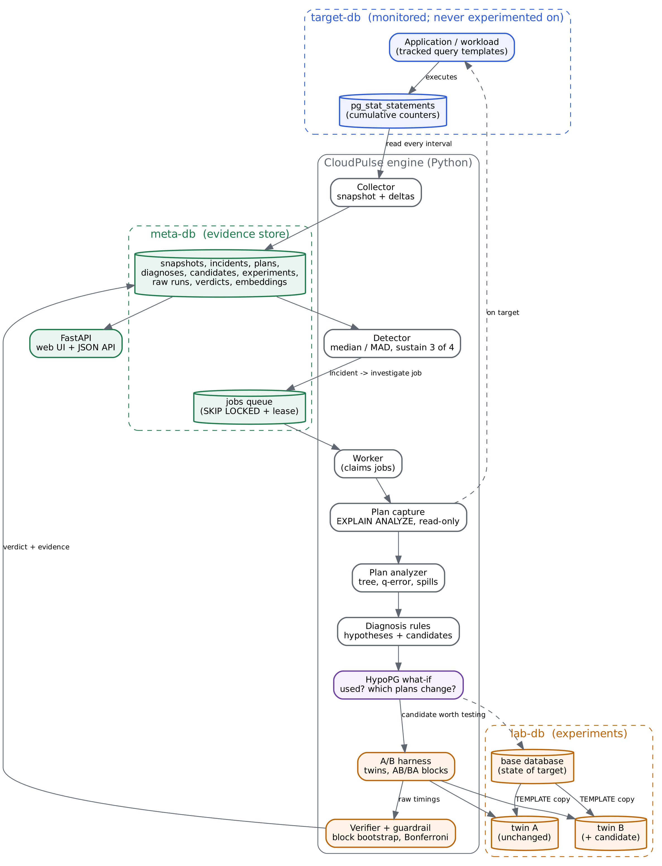
Figure 5.1: System architecture: where each component runs and how data flows.

5.2 The lifecycle of one regression, end to end
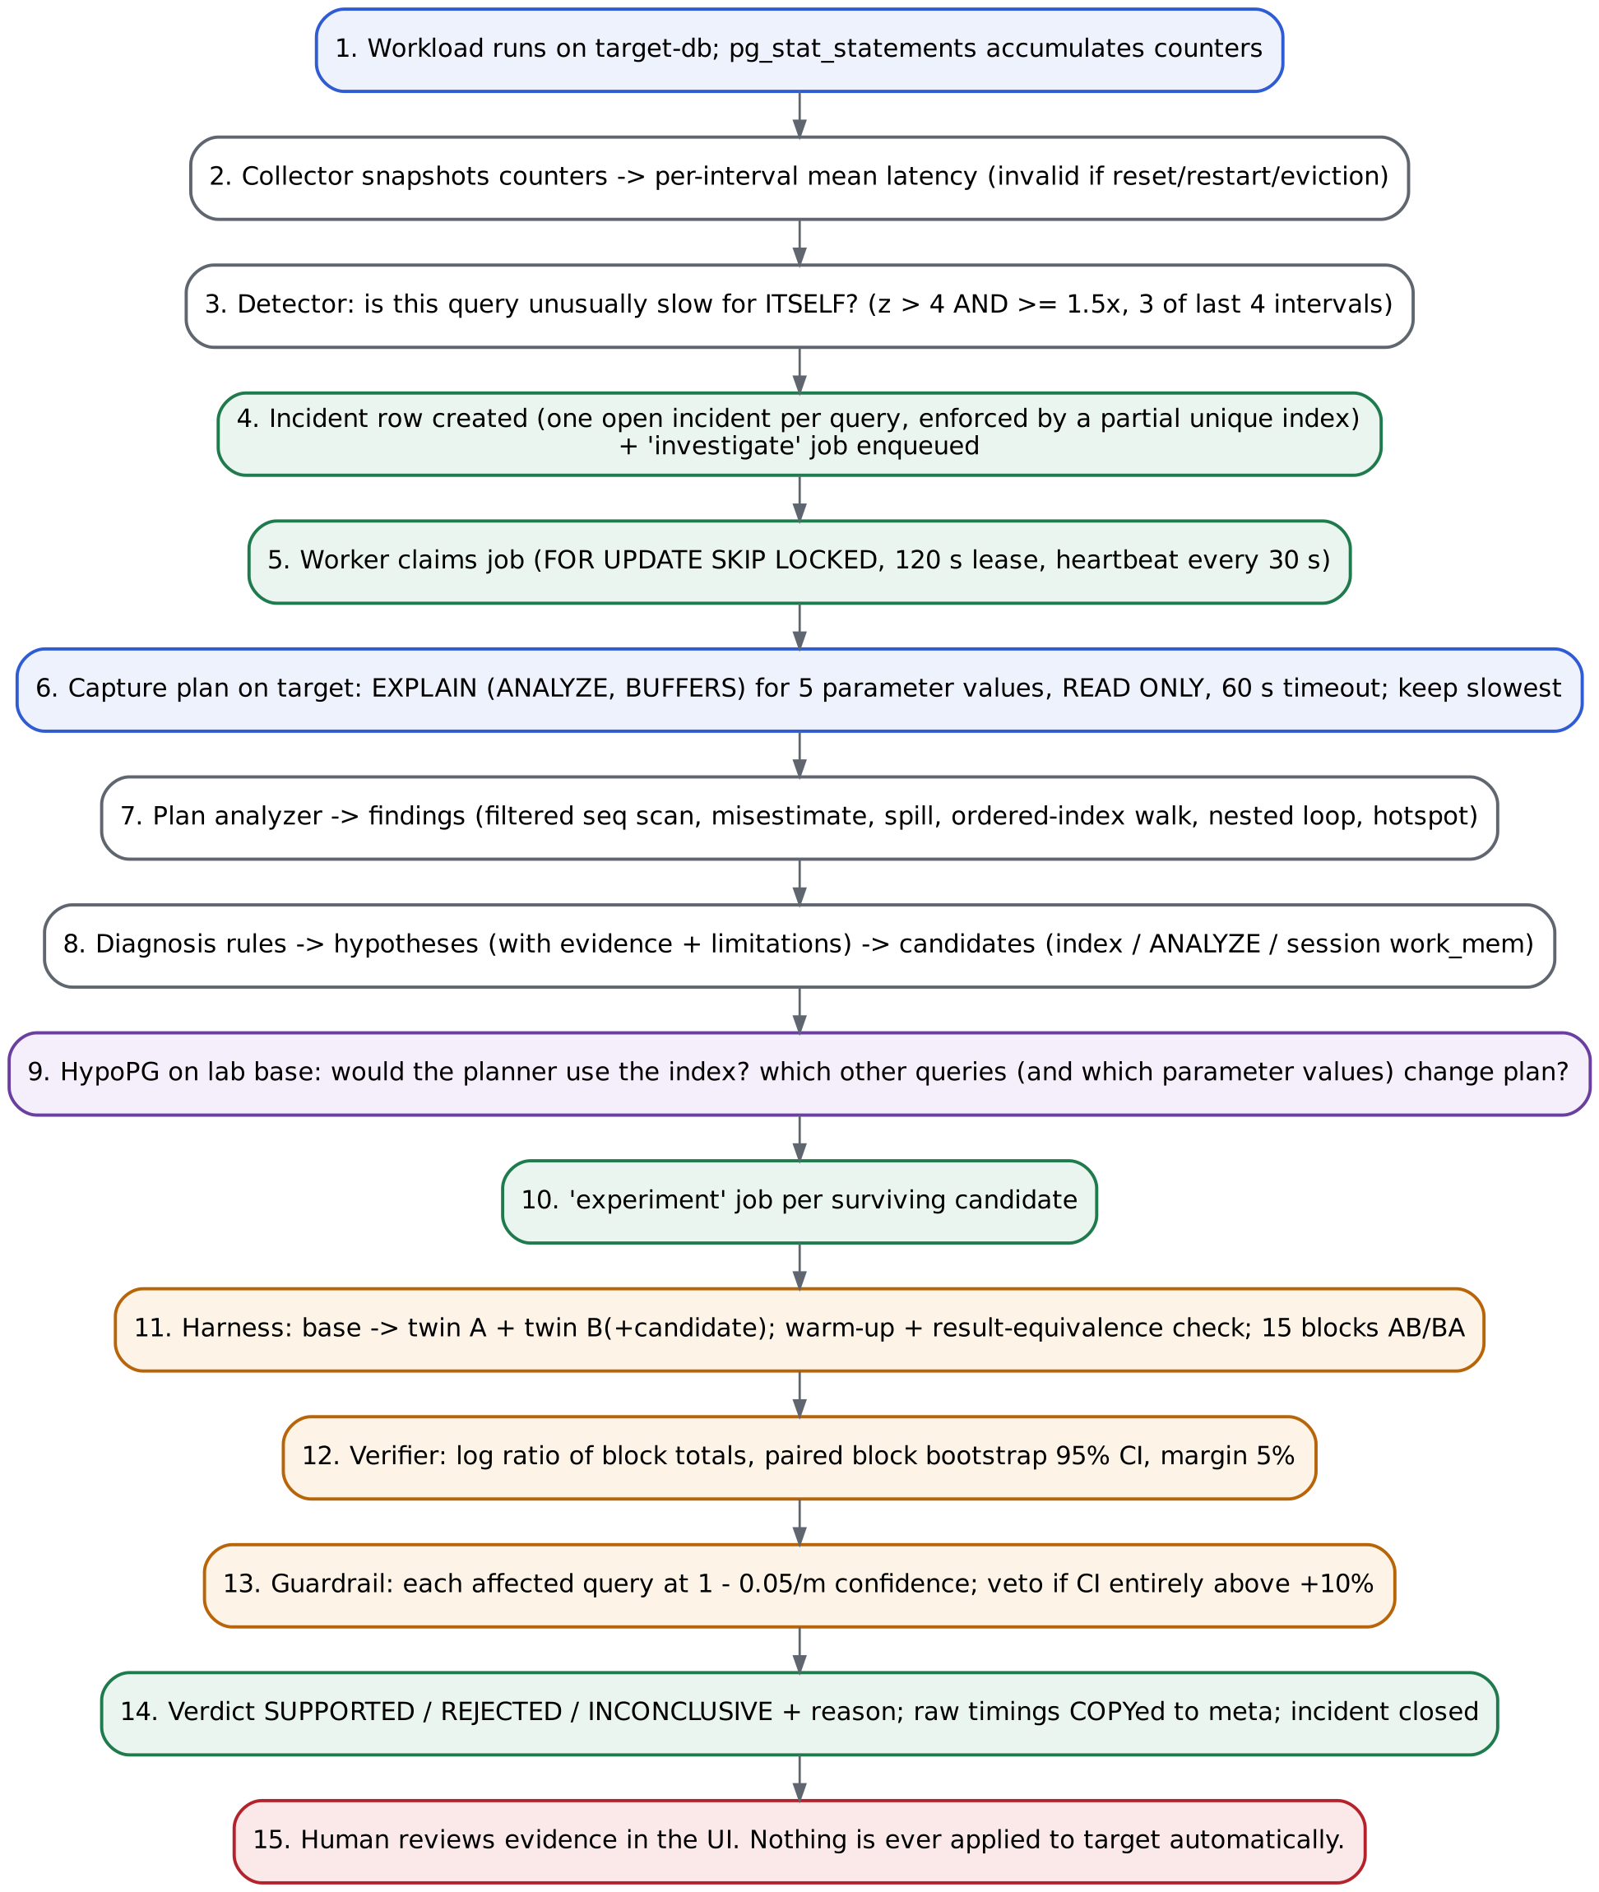
Figure 5.2: From a slow query to a reviewed verdict, in 15 steps.

5.3 Module map
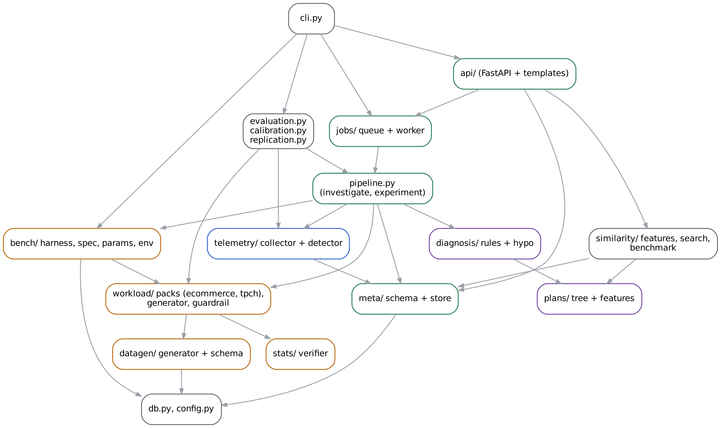
Figure 5.3: Python packages and their dependencies (arrows point to what a module uses).
Package / file | Responsibility
config.py, db.py | Settings from environment / .env; connections with benchmark-safe options; database admin helpers; the safety guard that refuses experiments on the target.
datagen/ | Deterministic, skewed e-commerce data generated inside PostgreSQL; content fingerprint.
workload/pack.py, packs.py | The pack abstraction (schema+data, workload, baseline, faults) and registry.
workload/suite.py, tpch.py | The e-commerce pack and the TPC-H pack.
workload/generator.py | Replays the tracked workload on the target in rounds; the noisy-neighbour load.
workload/guardrail.py | Collateral-regression check and final verdict.
bench/ | Experiment specs, deterministic parameter samplers, environment capture, the twin-database A/B harness.
stats/verifier.py | Effect estimate, paired block bootstrap, decision rule.
telemetry/ | pg_stat_statements collector and the regression detector.
plans/ | EXPLAIN JSON parsed into a typed tree; evidence findings; plan fingerprints.
diagnosis/ | Rules that turn findings into hypotheses and candidates; HypoPG what-if analysis.
pipeline.py | Orchestration: open incidents, investigate, run candidate experiments, close incidents.
meta/ | Evidence schema (tables, constraints, view) and data access.
jobs/ | PostgreSQL job queue (SKIP LOCKED + leases) and worker.
similarity/ | Structural feature vectors, pgvector search, retrieval benchmark.
api/ | FastAPI app and server-rendered HTML pages.
evaluation.py, calibration.py, replication.py | Ground-truth scenarios, A/A calibration, verdict replication.
cli.py | The cloudpulse command.

6. Foundations: configuration, connections, data

6.1 Configuration
config.load_settings() reads four values from the environment (or .env): CP_TARGET_DSN, CP_LAB_DSN, CP_META_DSN (PostgreSQL connection strings) and CP_ENV_LABEL (written into every results file, e.g. dev-cloud-sandbox (not official) or official-<hostname>).

6.2 Every connection is created the same way
src/cloudpulse/db.py: connect()
def connect(dsn: str, autocommit: bool = True) -> psycopg.Connection:
"""Open a connection with settings the benchmarks rely on.

prepare_threshold=None disables psycopg's automatic server-side prepared
statements. Otherwise, after 5 executions PostgreSQL may switch to a generic
plan and silently change what we are measuring (see decisions D-006).
"""
conn = psycopg.connect(
dsn, autocommit=autocommit, prepare_threshold=None, options="-c TimeZone=UTC"
)
# psycopg sends a Python int as int2/int4/int8 depending on its *value*.
# pg_stat_statements' queryid includes parameter types, so one query would be
# split into several entries (id=5 vs id=500000). Always send int8 (D-019).
conn.adapters.register_dumper(int, Int8Dumper)
return conn
- prepare_threshold=None: no automatic server-side prepared statements, so no silent switch to a generic plan during a benchmark (D-006).
- TimeZone=UTC: timestamps and fingerprints are identical everywhere.
- Int8Dumper for Python int: psycopg would otherwise send small numbers as int2 and large ones as int8, and because queryid includes parameter types, one query would be split into several pg_stat_statements entries (F-4, D-019).

6.3 The safety guard
src/cloudpulse/db.py: assert_not_target()
def assert_not_target(settings, dsn: str) -> None:
"""Refuse to run experiments against the monitored target server."""
if settings.server_identity(dsn) == settings.server_identity(settings.target_dsn):
raise SafetyError(
"refusing to run an experiment on the monitored target server "
f"{settings.server_identity(dsn)}; experiments must use the lab server"
)
Every experiment calls this first. It compares host and port (normalising 127.0.0.1 to localhost) of the lab connection with the target connection and raises SafetyError if they are the same server. A unit test and an integration test check it. Identifiers that become SQL (database names) are validated with a strict regular expression (check_ident) to rule out SQL injection.

6.4 The e-commerce dataset
Two tables, generated inside PostgreSQL in one session after setseed(), so the same (scale, seed) always produces identical rows and 2 million orders load in about 16 seconds.
src/cloudpulse/datagen/schema.sql
-- Synthetic e-commerce schema used for every CloudPulse experiment.
-- Deliberately minimal: two tables are enough to produce selective filters,
-- skewed joins, top-N queries, aggregation spills and update-heavy traffic.

CREATE TABLE customers (
id bigint PRIMARY KEY,
name text NOT NULL,
country text NOT NULL,
segment text NOT NULL,
signup_at timestamptz NOT NULL,
-- end of the customer's activity window; customers "churn" at different times
last_active_at timestamptz NOT NULL,
CHECK (last_active_at >= signup_at)
);

-- fillfactor 90 leaves free space on each page so that updates which do not
-- touch an indexed column can be HOT (heap-only tuple) updates. Without it,
-- full pages would make HOT impossible and hide the cost of extra indexes.
CREATE TABLE orders (
id bigint PRIMARY KEY,
customer_id bigint NOT NULL,
status text NOT NULL,
amount numeric(10,2) NOT NULL CHECK (amount >= 0),
created_at timestamptz NOT NULL,
updated_at timestamptz NOT NULL,
CHECK (updated_at >= created_at)
) WITH (fillfactor = 90);
Built-in property | How it is generated | Why (which scenario it enables)
Power-law customer popularity | customer_id = 1 + floor(C × u³), u uniform in [0,1). P(id ≤ k) = (k/C)^(1/3), so low ids are hot. Measured: the top 1% of customers own 21.6% of orders; the largest has 43,114. | WHERE customer_id = ? ranges from 3 rows to 40,000 rows: one template, very different costs
Activity windows | Each customer has signup_at uniform over 700 days and last_active_at = signup + 30 days + u² × 700 days (capped). Orders fall inside the window. | Some heavy customers have only old orders: time and customer are correlated, which the planner assumes they are not (S5 trap)
Status depends on age | < 2 days before the end: 70% pending / 30% shipped; < 7 days: 80% shipped; else 95% delivered, 4% cancelled, 1% returned | status = 'pending' matches 0.3% of rows: a highly selective predicate
Append order | Rows are numbered and inserted in created_at order | id and created_at are physically correlated, like a real append-only table
fillfactor 90 on orders | 10% free space per page | HOT updates are possible, so the cost of extra indexes on writes is visible (S4)
Fixed clock | EPOCH_START 2024-01-01, EPOCH_END 2026-01-01 | Queries use constants instead of now(), so results never depend on the day you run them

src/cloudpulse/datagen/generate.py: the orders generator (exact SQL)
GENERATE_ORDERS = """
INSERT INTO orders (id, customer_id, status, amount, created_at, updated_at)
SELECT row_number() OVER (ORDER BY created_at, customer_id, rs),
customer_id,
CASE
WHEN %(end)s::timestamptz - created_at < interval '2 days'
THEN CASE WHEN rs < 0.7 THEN 'pending' ELSE 'shipped' END
WHEN %(end)s::timestamptz - created_at < interval '7 days'
THEN CASE WHEN rs < 0.8 THEN 'shipped' ELSE 'delivered' END
ELSE CASE WHEN rs < 0.95 THEN 'delivered'
WHEN rs < 0.99 THEN 'cancelled' ELSE 'returned' END
END,
round((5 + ra * ra * 495)::numeric, 2),
created_at,
created_at + interval '1 hour'
FROM (
SELECT d.customer_id, d.rs, d.ra,
c.signup_at + d.rt * (c.last_active_at - c.signup_at) AS created_at
FROM (
SELECT 1 + floor(%(customers)s * (random() ^ %(skew)s))::bigint AS customer_id,
random() AS rt, random() AS rs, random() AS ra
FROM generate_series(1, %(orders)s)
) d
JOIN customers c ON c.id = d.customer_id
) x
"""
After loading: the foreign key is added, a cloudpulse_dataset table records scale and seed, and VACUUM (FREEZE, ANALYZE) sets hint bits, the visibility map and statistics. fingerprint() returns row counts plus sum(hashtextextended(row::text, 0)) over each table. Two databases with the same fingerprint hold the same data. Scales: tiny (2,000 customers / 40,000 orders, for tests), small (20k / 400k), default (100k / 2M, about 240 MB).

7. Workload packs
The engine knows nothing about any schema. A pack supplies everything application-specific:
src/cloudpulse/workload/pack.py: the Pack contract
class Pack:
name: str
workload: list[QuerySpec]
baseline_sql: list[str]
baseline_db_settings: dict[str, str]
scenarios: dict[str, Scenario]
tables: list[str]
scales: list[str]
# (admin_dsn, dbname, scale, seed) -> dsn of a freshly built, frozen database
build: Callable[[str, str, str, int], str]
# dsn -> content fingerprint proving two databases hold the same data
fingerprint: Callable[[str], dict]
# text that changes whenever the data generator changes (part of the lab base key)
code_fingerprint: Callable[[], str]
noisy_sql: str

@property
def by_name(self) -> dict[str, QuerySpec]:
return {q.name: q for q in self.workload}

7.1 The e-commerce tracked workload
Nine query templates. Weight = relative frequency; the guardrail and the load generator both use it.
Template | SQL (abridged) | Parameters | Weight
orders_by_customer | SELECT id, amount, created_at FROM orders WHERE customer_id = $1 | customer mix (40) | 30
latest_orders_for_customer | … WHERE customer_id = $1 ORDER BY created_at DESC LIMIT 10 | customer mix (40) | 20
recent_orders_feed | … WHERE created_at > $1 ORDER BY created_at DESC LIMIT 50 | 1–48 h before end (20) | 5
order_by_id | … WHERE id = $1 | random ids (100) | 30
customer_profile | SELECT … FROM customers WHERE id = $1 | customer mix (40) | 10
segment_revenue_for_status | orders JOIN customers WHERE status = $1 GROUP BY segment | backordered / returned / cancelled | 1
monthly_revenue_top_customers | GROUP BY customer, month over 2025, ORDER BY revenue DESC LIMIT 20 | none | 0.2
recently_updated_orders | … WHERE updated_at > $1 ORDER BY updated_at DESC LIMIT 100 | 1–24 h before end (20) | 2
touch_order (write) | UPDATE orders SET updated_at = updated_at + interval '1 second' WHERE id = $1 | random ids (200) | 20

Healthy baseline: indexes on orders(customer_id), orders(created_at), orders(updated_at), then ANALYZE; database setting work_mem = 64MB.

7.2 The e-commerce fault scenarios
Scenario | Fault injected | Query expected to regress | Expected diagnosis
s0_control | none | — | —
s1_dropped_fk_index | DROP INDEX orders_customer_id_idx | orders_by_customer | selective_seq_scan
s2_stale_statistics | autovacuum off on orders; bulk-insert 300,000 'backordered' orders; no ANALYZE | segment_revenue_for_status | stale_statistics
s3_work_mem_lowered | ALTER DATABASE … SET work_mem = '4MB' | monthly_revenue_top_customers | work_mem_spill
s4_updated_at_index_dropped | DROP INDEX orders_updated_at_idx | recently_updated_orders | selective_seq_scan
s5_created_at_index_dropped | DROP INDEX orders_created_at_idx | recent_orders_feed | selective_seq_scan
s6_noisy_neighbor | 2 background threads running a full-table hash on orders | — (contention) | none (cause unclear)

Only the expected diagnosis is ground truth. The expected verdict is never asserted: the experiment decides, and the evaluation reports what happened.

7.3 The TPC-H pack (external validation)
TPC-H is the industry-standard decision-support benchmark. Its data is defined by the specification, and tpchgen-cli (an implementation of the official dbgen) produces identical data for a scale factor. CloudPulse's rules, thresholds and decision rule were all written for the e-commerce pack and are used on TPC-H unchanged.
- Schema: the 8 standard tables with primary keys (tpch_schema.sql). Data loaded with COPY … FORMAT csv.
- Workload: order lookup, customer's recent orders, order lines, official queries Q3, Q4, Q6, Q14 with substitution parameters drawn as the specification describes, and an UPDATE on lineitem.
- Healthy baseline: indexes on orders(o_custkey), orders(o_orderdate), lineitem(l_shipdate).
- Faults: t1 drops the l_shipdate index (Q14 reads one month), t2 drops o_custkey (customer's recent orders), t3 drops o_orderdate (Q4 reads a quarter), t0 control.

7.4 Parameter samplers
A template has no single latency; it has a latency per parameter value. Samplers produce a fixed, seeded list, and both arms see the same values in the same order.
Sampler | What it returns
customer_mix | Stratified customers: 20% from the top 1% by order count, 40% from the rest of the top half, 40% from the bottom half (numpy default_rng(seed))
order_ids | Uniform random ids between min(id) and max(id)
hours_before_end | Timestamps 1–48 h (or max_hours) before EPOCH_END
values | An explicit list
sql | Any query using random(), run after setseed(seed) in the same session (used by TPC-H)
heavy_hitters | The k heaviest values (e.g. the 20 customers with most orders), see F-9
union | A base sample plus required extra values and/or other samplers, de-duplicated

7.5 The load generator
WorkloadRunner replays the tracked workload in rounds: each template runs max(1, round(weight × 0.5)) times with a random parameter, shuffled and split over 2 concurrent connections. Each round opens fresh connections so ALTER DATABASE … SET changes apply. Telemetry is snapshotted after each round. Rounds instead of wall-clock intervals keep a scenario to minutes, and guarantee a rare report query appears in every interval (D-014). NoisyNeighbor runs a full-table hashtext scan in 2 threads to create CPU/IO contention.

8. The experiment engine

8.1 Experiment specification
An ExperimentSpec has a name, pack, scale, seed, baseline_sql (the state to rebuild), a list of QuerySpecs (name, SQL with %s placeholders, read/write, parameter sampler, weight, compare_results), two ArmSpecs (setup SQL + session settings) and a Protocol (blocks = 20 by default and 15 in the pipeline, 1 warm-up round, seed, 60 s statement timeout, synchronous_commit=off for lab sessions). Specs can be JSON files (experiments/*.json).

8.2 Base and twin databases
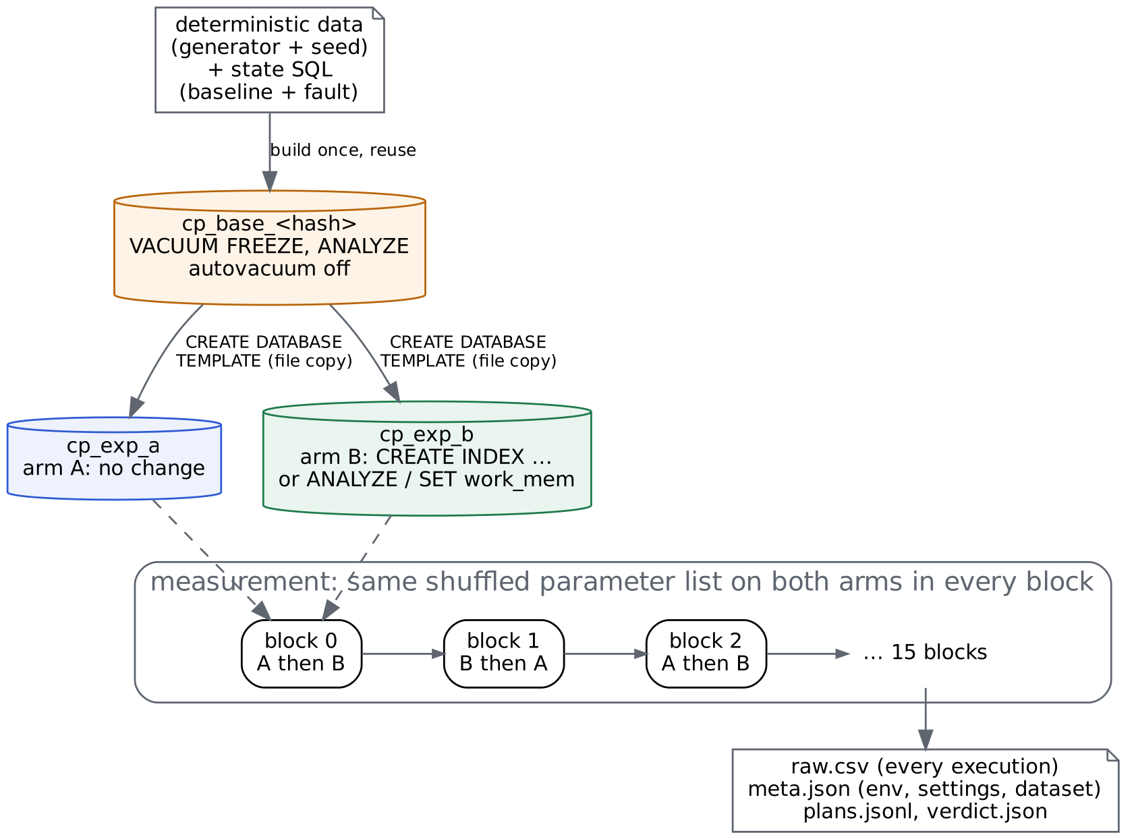
Figure 8.1: The A/B harness: one base, two identical twins, alternating blocks.
src/cloudpulse/bench/harness.py: ensure_base()
def ensure_base(
lab_admin_dsn: str, scale: str, seed: int, baseline_sql: list[str], rebuild: bool = False,
pack: str = "ecommerce",
) -> str:
"""Build (or reuse) the lab base database for a given state. Returns its name.

The base is keyed by a hash of (generator code, scale, seed, state SQL), so a
changed scenario or generator can never silently reuse a stale base."""
key = base_key(scale, seed, baseline_sql, pack)
p = packs.get(pack)
name = f"cp_base_{key}"
if not rebuild and db.database_exists(lab_admin_dsn, name):
with db.cursor(db.with_database(lab_admin_dsn, name)) as cur:
cur.execute("SELECT value FROM cloudpulse_dataset WHERE key = 'ready'")
if cur.fetchone():
return name
dsn = p.build(lab_admin_dsn, name, scale, seed)
with db.cursor(dsn) as cur:
cur.execute("CREATE EXTENSION IF NOT EXISTS hypopg")
# Lab databases must not change underneath an experiment (D-008).
for table in p.tables:
cur.execute(f"ALTER TABLE {db.check_ident(table)} SET (autovacuum_enabled = false)")
for stmt in baseline_sql:
cur.execute(stmt)
cur.execute("CHECKPOINT")
cur.execute("INSERT INTO cloudpulse_dataset VALUES ('base_key', %s), ('ready', 'yes')", (key,))
return name
- The base is named cp_base_<hash>; the hash covers the generator code, scale, seed and state SQL, so a changed scenario or generator can never reuse a stale base.
- Autovacuum is disabled on lab tables so an ANALYZE cannot change one twin's plans mid-experiment (D-008).
- Twins are created with CREATE DATABASE cp_exp_a TEMPLATE cp_base_… STRATEGY FILE_COPY: a file copy with identical layout and statistics (D-003).
- Arm B then gets the candidate: CREATE INDEX …, ANALYZE …, or session settings such as work_mem. Setup time and index sizes are recorded.
- One experiment at a time per lab server: pg_advisory_lock(7346001) (D-015). Twins are dropped in a finally block.

8.3 Warm-up and the result-equivalence check
Before measuring, every parameter runs once on each arm. For read queries the arms must return the same multiset of rows (an md5 of the sorted row representations). If not, the harness raises EquivalenceError: a faster candidate that changes results is a bug, not an optimisation. Queries whose results legitimately change under concurrent writes opt out (compare_results=False). The plan each arm chooses for up to 12 parameters is saved to plans.jsonl.

8.4 Measurement
src/cloudpulse/bench/harness.py: execute_timed()
def execute_timed(conn: psycopg.Connection, q: QuerySpec, p: tuple) -> tuple[float, str, int, str | None]:
"""Run one execution. Returns (latency_us, status, rowcount, result_hash)."""
with conn.cursor() as cur:
t0 = time.perf_counter_ns()
try:
cur.execute(q.sql, p)
rows = cur.fetchall() if cur.description is not None else None
t1 = time.perf_counter_ns()
except errors.QueryCanceled:
return float("nan"), "timeout", -1, None
n = len(rows) if rows is not None else cur.rowcount
h = _result_hash(rows) if (rows is not None and q.compare_results) else None
return (t1 - t0) / 1000.0, "ok", n, h
src/cloudpulse/bench/harness.py: arm order and parameter order per block
def block_order(block: int) -> tuple[str, str]:
"""Counterbalanced arm order: AB, BA, AB, BA, ..."""
return ("A", "B") if block % 2 == 0 else ("B", "A")

def block_permutation(n: int, seed: int, query_idx: int, block: int) -> list[int]:
import numpy as np

rng = np.random.default_rng([seed, query_idx, block])
return [int(i) for i in rng.permutation(n)]
- Latency is measured on the client: perf_counter_ns around execute plus fetch-all, which is what an application experiences (D-007).
- Each block runs the same shuffled parameter list on both arms; the arm order alternates AB, BA, AB… so drift (caches, CPU frequency, bloat from writes) hits both arms equally (D-004).
- Read queries are measured first, then writes, because writes change what reads see.
- Every execution becomes one row of raw.csv: query, kind, block, arm, position, seq, param_index, latency_us, status (ok/timeout), rows.
- meta.json captures host (OS, CPU model, cores, memory, Python, psycopg), PostgreSQL version and key settings, extension versions, git commit, environment label, dataset fingerprint, both arms' setup reports, and the exact parameter lists.

9. Statistics: from timings to a verdict

9.1 The effect estimate
For query q and block b, sum the latencies of all parameters on each arm and take the log ratio:
d_b = ln( Σ latency_B(b) / Σ latency_A(b) ) one number per block
ratio = exp( mean_b d_b ) 0.25 = B takes 25% of A's time
change % = (ratio − 1) × 100
Using total time over the parameter mix weights each parameter by its real cost, which is what the workload pays. Pairing inside a block cancels drift. The per-execution median of each arm is reported too, but only as a description.
src/cloudpulse/stats/verifier.py: block_log_ratios() and bootstrap_ci()
def block_log_ratios(rows: list[dict], query: str) -> tuple[np.ndarray, dict]:
"""Per-block log(sum_B / sum_A) for one query, plus descriptive info."""
sums: dict[tuple[int, str], float] = {}
lat = {"A": [], "B": []}
timeouts = {"A": 0, "B": 0}
for r in rows:
if r["query"] != query:
continue
arm = r["arm"]
if r["status"] != "ok":
timeouts[arm] += 1
continue
v = float(r["latency_us"])
lat[arm].append(v)
sums[(int(r["block"]), arm)] = sums.get((int(r["block"]), arm), 0.0) + v
blocks = sorted({b for (b, _) in sums})
d = np.array(
[math.log(sums[(b, "B")] / sums[(b, "A")]) for b in blocks if (b, "A") in sums and (b, "B") in sums]
)
info = {
"median_us_a": float(np.median(lat["A"])) if lat["A"] else float("nan"),
"median_us_b": float(np.median(lat["B"])) if lat["B"] else float("nan"),
"timeouts_a": timeouts["A"],
"timeouts_b": timeouts["B"],
}
return d, info

def bootstrap_ci(d: np.ndarray, confidence: float, n_boot: int, seed: int) -> tuple[float, float]:
rng = np.random.default_rng(seed)
idx = rng.integers(0, len(d), size=(n_boot, len(d)))
means = d[idx].mean(axis=1)
alpha = 1.0 - confidence
lo, hi = np.quantile(means, [alpha / 2, 1 - alpha / 2])
return float(lo), float(hi)

9.2 Uncertainty: the paired block bootstrap
- Take the n block values d_1 … d_n (15 in the pipeline).
- 10,000 times: draw n blocks with replacement and compute their mean.
- The 2.5th and 97.5th percentiles of those 10,000 means, exponentiated, form the 95% CI of the ratio.
Resampling whole blocks keeps the correlation between executions in a block; resampling single executions would produce intervals that are far too narrow. The method is tested by simulation (tests/test_stats.py): with a known true ratio of 0.8, the 95% interval covers it in at least 88% of 200 simulations; identical arms are wrongly SUPPORTED in at most 3% of simulations.

9.3 The decision rule (fixed before any scenario ran)
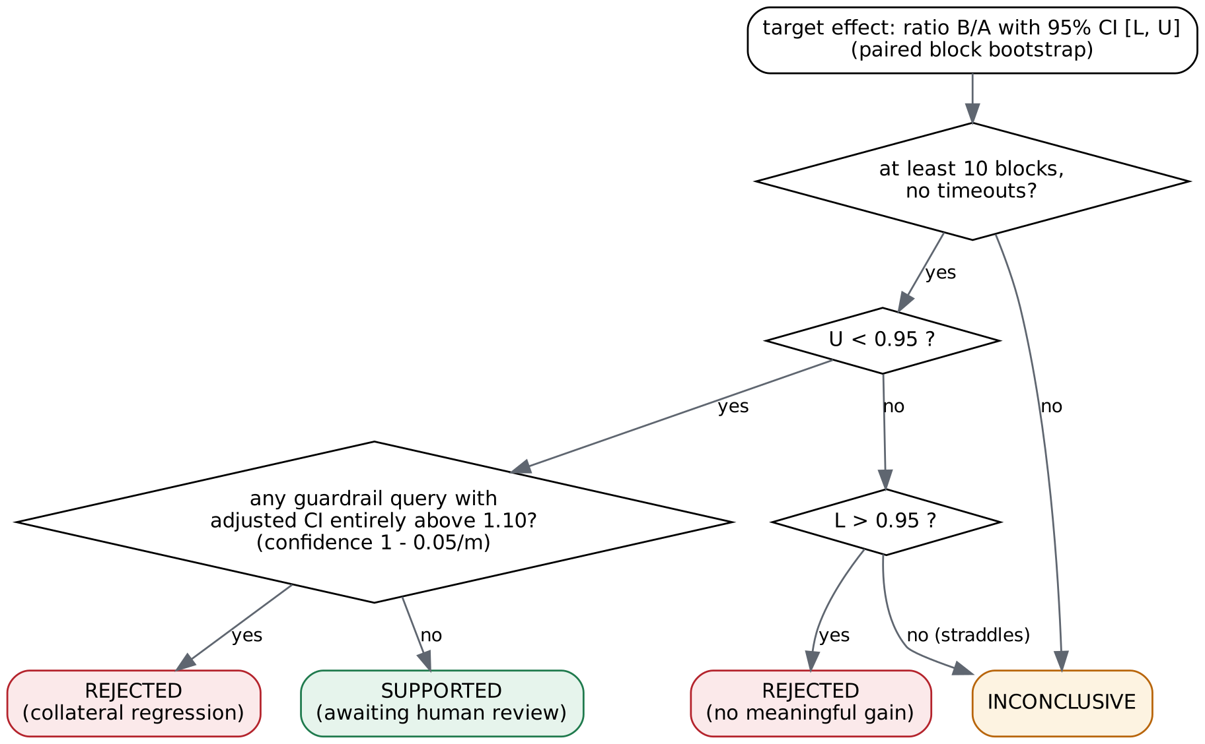
Figure 9.1: Target verdict and guardrail veto.
src/cloudpulse/stats/verifier.py: decide_target()
def decide_target(effect: Effect, margin: float = 0.05, min_blocks: int = 10) -> Verdict:
if effect.n_blocks < min_blocks:
return Verdict(INCONCLUSIVE, f"only {effect.n_blocks} valid blocks (< {min_blocks})", effect)
if effect.timeouts_b > 0 and effect.timeouts_a == 0:
return Verdict(REJECTED, f"candidate arm hit {effect.timeouts_b} statement timeouts", effect)
if effect.timeouts_a or effect.timeouts_b:
return Verdict(INCONCLUSIVE, "timeouts in both arms; latency is censored", effect)
thr = 1.0 - margin
ci = f"{effect.confidence:.0%} CI of time ratio B/A = [{effect.ci_low:.3f}, {effect.ci_high:.3f}]"
if effect.ci_high < thr:
return Verdict(SUPPORTED, f"{ci} lies entirely below {thr:.2f} (>= {margin:.0%} faster)", effect)
if effect.ci_low > thr:
return Verdict(REJECTED, f"{ci} lies entirely above {thr:.2f}: no meaningful improvement", effect)
return Verdict(INCONCLUSIVE, f"{ci} straddles the {thr:.2f} threshold", effect)
Interview angle: Three outcomes, not two. INCONCLUSIVE ("the interval straddles the threshold") is a feature: a tool that recommends database changes must be able to say it does not know.

9.4 The workload guardrail
- Which queries: for an index, the reads whose plan HypoPG says would change (plus the parameter values that change, F-7/F-9), plus every write on the indexed table (writes always pay index maintenance). For ANALYZE: every read on the table. For a session-scoped work_mem: none (only that query's session is affected).
- Multiple comparisons: each guardrail query's CI uses confidence 1 − 0.05/m (Bonferroni). With m = 2, that is 97.5%.
- Collateral regression: the adjusted CI lies entirely above 1.10 (+10%), or the candidate arm times out more often.
- Final verdict: SUPPORTED only if the target is SUPPORTED and no collateral regression exists; a single collateral regression vetoes it (REJECTED, naming the worst query).
- Warnings: a guardrail query that is confidently slower (CI above 1.0) but below the veto margin is listed as a warning. Added after the first evaluation; it does not change verdicts.
- Weighted change: Σ weight × median_A × (ratio − 1) / Σ weight × median_A. Informational: in S5 it was −82% while the veto rejected the index. Whether that trade is acceptable is a human decision.
src/cloudpulse/workload/guardrail.py: evaluate()
def evaluate(
rows: list[dict],
target: QuerySpec,
guardrail_queries: list[QuerySpec],
harm_margin: float = HARM_MARGIN,
target_margin: float = TARGET_MARGIN,
min_blocks: int = 10,
) -> GuardrailReport:
t_eff = verifier.estimate(rows, target.name, confidence=0.95)
t_ver = verifier.decide_target(t_eff, margin=target_margin, min_blocks=min_blocks)

m = max(len(guardrail_queries), 1)
adj_conf = 1 - 0.05 / m
g_out, collateral, warnings = [], [], []
weighted_num = weighted_den = 0.0
for q in [target, *guardrail_queries]:
eff = t_eff if q is target else verifier.estimate(rows, q.name, confidence=adj_conf)
if eff.n_blocks and eff.median_us_a == eff.median_us_a: # not NaN
base_cost = q.weight * eff.median_us_a
weighted_num += base_cost * (eff.ratio - 1)
weighted_den += base_cost
if q is target:
continue
reg = verifier.is_collateral_regression(eff, harm_margin)
if reg:
collateral.append(q.name)
elif eff.n_blocks and eff.ci_low > 1.0:
warnings.append(q.name)
g_out.append({**eff.to_dict(), "weight": q.weight, "collateral_regression": reg})

weighted = round(100 * weighted_num / weighted_den, 2) if weighted_den else None
if t_ver.label == verifier.SUPPORTED and collateral:
worst = max((g for g in g_out if g["collateral_regression"]), key=lambda g: g["ratio"])
label = verifier.REJECTED
reason = (
f"target improved ({t_ver.reason}) but {len(collateral)} tracked quer"
f"{'y' if len(collateral) == 1 else 'ies'} regressed beyond +{harm_margin:.0%}: "
f"worst is {worst['query']} at {worst['ratio']:.2f}x "
f"(adjusted CI [{worst['ci_low']:.2f}, {worst['ci_high']:.2f}])"
)
else:
label, reason = t_ver.label, t_ver.reason
if t_ver.label == verifier.SUPPORTED:
reason += f"; no collateral regression across {len(guardrail_queries)} guardrail queries"
return GuardrailReport(label, reason, t_ver.to_dict(), g_out, collateral, weighted, warnings)

10. Telemetry and regression detection

10.1 Mapping statistics entries to templates
src/cloudpulse/telemetry/collector.py: template_queryids()
def template_queryids(target_dsn: str, templates: list[QuerySpec]) -> dict[int, str]:
"""Map queryid -> template name.

pg_stat_statements replaces constants with $n, so comparing query text with
our templates is fragile. Instead we ask PostgreSQL itself: EXPLAIN (VERBOSE)
reports the "Query Identifier" it computes for the statement, which is the
same queryid pg_stat_statements uses.
"""
out: dict[int, str] = {}
with db.connect(target_dsn) as conn, conn.cursor() as cur:
for q in templates:
p = paramsmod.sample({**q.params, "n": 1}, target_dsn, 0)[0]
cur.execute("EXPLAIN (VERBOSE, FORMAT JSON) " + q.sql, p)
plan = cur.fetchone()[0][0]
qid = plan.get("Query Identifier")
if qid is not None:
out[int(qid)] = q.name
return out
Comparing query text is fragile, because pg_stat_statements replaces every constant (including LIMIT 10 and interval '1 second') with $n. Instead CloudPulse asks PostgreSQL: EXPLAIN (VERBOSE) reports the same Query Identifier that pg_stat_statements uses.

10.2 Snapshots and intervals
Each snapshot stores raw cumulative counters plus stats_reset, dealloc and pg_postmaster_start_time(). Deltas are never stored; a view computes them, so a bug in delta logic can be fixed and replayed:
src/cloudpulse/meta/schema.sql: the query_intervals view
CREATE OR REPLACE VIEW query_intervals AS
SELECT q.query_id,
s.id AS snapshot_id,
s.taken_at,
prev_s.taken_at AS prev_taken_at,
q.calls - p.calls AS calls,
q.total_exec_time_ms - p.total_exec_time_ms AS exec_time_ms,
CASE WHEN q.calls > p.calls
THEN (q.total_exec_time_ms - p.total_exec_time_ms) / (q.calls - p.calls) END
AS mean_ms,
q.shared_blks_read - p.shared_blks_read AS blks_read,
q.temp_blks_written - p.temp_blks_written AS temp_written,
(q.calls < p.calls
OR s.postmaster_start <> prev_s.postmaster_start
OR s.stats_reset IS DISTINCT FROM prev_s.stats_reset) AS invalid
FROM query_stats_snapshots q
JOIN stat_snapshots s ON s.id = q.snapshot_id
JOIN LATERAL (
SELECT p.* FROM query_stats_snapshots p
WHERE p.query_id = q.query_id AND p.snapshot_id < q.snapshot_id
ORDER BY p.snapshot_id DESC LIMIT 1
) p ON true
JOIN stat_snapshots prev_s ON prev_s.id = p.snapshot_id;
Event | How it shows up | Handling
pg_stat_statements_reset() | stats_reset changes | interval invalid, skipped
Server crash / restart | postmaster start time changes | interval invalid
Entry evicted and re-added | calls go backwards | interval invalid
Collector restart | nothing special | next delta uses the last stored snapshot (longer interval)
Query not run in an interval | calls delta = 0 | mean is NULL; skipped by the detector

10.3 The detector
src/cloudpulse/telemetry/detector.py: detect()
def detect(series: list[dict], cfg: DetectorConfig = DEFAULT_CONFIG) -> Detection:
"""series: dicts with keys mean_ms, calls, invalid (from query_intervals)."""
valid: list[tuple[int, float]] = []
flags: list[bool] = []
state = Detection("insufficient_data")
for i, pt in enumerate(series):
if pt.get("invalid") or pt.get("mean_ms") is None or (pt.get("calls") or 0) < cfg.min_calls:
continue
x = float(pt["mean_ms"])
base = [v for (j, v), f in zip(valid, flags) if not f][-cfg.window:]
if len(base) < cfg.min_baseline:
valid.append((i, x))
flags.append(False)
continue
med = statistics.median(base)
mad = _mad(base, med)
scale = max(1.4826 * mad, cfg.rel_floor * med, cfg.abs_floor_ms)
z = (x - med) / scale
anomalous = z > cfg.z_threshold and x / max(med, 1e-9) >= cfg.min_ratio
valid.append((i, x))
flags.append(anomalous)
recent = flags[-cfg.sustain_n:]
if anomalous and sum(recent) >= cfg.sustain_k:
pts = [valid[-len(recent) + k][0] for k, f in enumerate(recent) if f]
cur = statistics.median([valid[-len(recent) + k][1] for k, f in enumerate(recent) if f])
return Detection("regression", i, med, mad, cur, cur / med, z, pts)
state = Detection("ok", None, med, mad, x, x / med if med else None, z)
return state
Parameter | Value | Meaning
window | 20 | baseline = last 20 valid, non-anomalous intervals
min_baseline | 8 | fewer -> insufficient_data, never "fine"
z_threshold | 4.0 | robust z must exceed 4
min_ratio | 1.5 | and the value must be ≥ 1.5 × the baseline median (practically large)
rel_floor / abs_floor_ms | 5% / 0.05 ms | scale = max(1.4826 × MAD, 5% × median, 0.05 ms): a flat baseline (MAD = 0) cannot produce infinite z-scores
sustain_k / sustain_n | 3 / 4 | regression only when 3 of the last 4 valid intervals are anomalous

Anomalous intervals are excluded from future baselines, so a regression does not teach the detector that slow is normal. Unit tests check: no flags on 100 stable noisy series (≤ 2 allowed), a step detected exactly 3 intervals after it, a single spike ignored, a 30% change ignored, a flat baseline not exploding, invalid intervals skipped.

11. Plans, diagnosis and candidates

11.1 Capturing the plan
src/cloudpulse/pipeline.py: capture_incident_plan()
def capture_incident_plan(settings: Settings, q: QuerySpec) -> tuple[dict, tuple]:
"""Run EXPLAIN (ANALYZE, BUFFERS) on the target for a few parameter values and
keep the slowest. Reads run in a READ ONLY transaction with a timeout; writes
are only EXPLAINed (never executed) because ANALYZE would modify data."""
plist = paramsmod.sample(q.params, settings.target_dsn, 99)[:PLAN_CAPTURE_PARAMS]
best, best_p, best_ms = None, None, -1.0
with db.connect(settings.target_dsn, autocommit=False) as conn, conn.cursor() as cur:
for p in plist:
if q.kind == "read":
cur.execute("BEGIN READ ONLY")
cur.execute(f"SET LOCAL statement_timeout = {PLAN_CAPTURE_TIMEOUT_MS}")
cur.execute("EXPLAIN (ANALYZE, BUFFERS, FORMAT JSON) " + q.sql, p)
else:
cur.execute("BEGIN")
cur.execute("EXPLAIN (FORMAT JSON) " + q.sql, p)
plan = cur.fetchone()[0][0]
conn.rollback()
ms = plan.get("Execution Time", 0.0)
if ms > best_ms:
best, best_p, best_ms = plan, p, ms
return best, best_p
Reads are executed with EXPLAIN (ANALYZE, BUFFERS) inside BEGIN READ ONLY with a 60-second statement_timeout, then rolled back. Writes are only EXPLAINed, because ANALYZE would modify data. Five parameter values are tried and the slowest plan is kept. The incident also records whether the plan shape differs from the healthy baseline plan captured at startup.

11.2 The plan tree and derived metrics
src/cloudpulse/plans/tree.py: derived metrics on PlanNode
def q_error(self) -> float | None:
"""max(est/act, act/est), both floored at 1 row. 1.0 = perfect estimate."""
if self.actual_rows is None:
return None
est = max(self.plan_rows, 1.0)
act = max(self.actual_rows, 1.0)
return max(est / act, act / est)

def self_time_ms(self) -> float | None:
"""Exclusive time of this node across all loops (children subtracted)."""
if self.actual_total_ms is None:
return None
total = self.actual_total_ms * (self.actual_loops or 1)
for c in self.children:
if c.actual_total_ms is not None and c.node_type not in ("InitPlan", "SubPlan"):
total -= c.actual_total_ms * (c.actual_loops or 1)
return max(total, 0.0)

def self_temp_written(self) -> int | None:
"""Temp blocks written by this node itself. EXPLAIN's buffer counters are
inclusive of children, so a spill deep in the tree would otherwise make
every ancestor look like it spilled too."""
if self.temp_written is None:
return None
return max(self.temp_written - sum(c.temp_written or 0 for c in self.children), 0)
Plan fingerprint: a SHA-1 of the plan shape only (node types, tables, index names, join types, recursively). It changes when the planner picks a structurally different plan, never when costs, row counts or constants change. A golden-file test checks both properties.

11.3 Findings: evidence extracted from a plan
Finding | Condition | Detail recorded
filtered_seq_scan | Seq Scan with a Filter | rows examined (actual + removed by filter, × loops), rows kept, selectivity, filter columns, equality columns
misestimate | scan of a table, q-error ≥ 10 and ≥ 1000 rows | estimated, actual, loops, q-error, over/under
spill | external sort, batches > 1, disk usage, or temp blocks written by this node | sort method/space, batches, disk kB, temp blocks
repeated_inner_work | Nested Loop whose inner side runs ≥ 1000 loops | inner node type, loops, total inner time, inner filter
index_scan_heavy_filter | Index scan examining ≥ 10,000 rows and keeping < 1% | index name, examined, kept, filter
workers_not_launched | parallel workers planned > launched | planned, launched
hotspot | a node holding ≥ 50% of execution time | self time, share

Filter columns are extracted from PostgreSQL's filter text (e.g. (customer_id = '42'::bigint)) with a regular expression; tests cover qualified names, AND-combined filters and $n parameters.

11.4 Diagnosis rules
Rule | Fires when | Candidate | Limitation it records
selective_seq_scan | filtered seq scan, ≥ 10,000 rows examined, ≤ 5% kept | index on (first equality column, first range column), skipped if an index with those leading columns exists | selectivity from one captured execution; write cost unmeasured
stale_statistics | misestimate on a table AND ≥ 5% of rows modified since last ANALYZE | ANALYZE table | random sampling can still miss rare values
estimation_limit | misestimate but statistics fresh | none | needs extended statistics or a rewrite
work_mem_spill | spill in a sort/hash | SET work_mem for this query's session: next power of two ≥ 1.5 × (peak memory + disk), capped at 256 MB | only helps if disk is the bottleneck; never global
ordered_index_walk | index walked in order, ≥ 99% of rows filtered (ORDER BY … LIMIT trap) | composite index (filter column, index column) | depends on parameter values; correlated data
nested_loop_inner_scan | ≥ 1000 inner loops over a Seq Scan | index on the inner join key | join key inferred from filter text
cause_unclear | no rule fired | none | contention, locks, checkpoints, bloat or an unsupported cause

src/cloudpulse/diagnosis/rules.py: rule_selective_seq_scan()
def rule_selective_seq_scan(f: Finding, ctx: Context) -> Diagnosis | None:
d = f.detail
if f.kind != "filtered_seq_scan" or not f.relation:
return None
if d["rows_examined"] < MIN_SCAN_ROWS or (d["selectivity"] or 1) > MAX_SELECTIVITY:
return None
eq = d["equality_columns"]
rng = [c for c in d["filter_columns"] if c not in eq]
cols = (eq[:1] + rng[:1]) if eq else rng[:1]
if not cols:
return None
diag = Diagnosis(
rule="selective_seq_scan",
hypothesis=(
f"Seq Scan on {f.relation} examined {d['rows_examined']:,.0f} rows to keep "
f"{d['rows_kept'] or 0:,.0f} ({(d['selectivity'] or 0):.2%}). An index on "
f"{f.relation}({', '.join(cols)}) could let PostgreSQL read only matching rows."
),
evidence=d,
limitations=(
"Selectivity comes from one captured execution and its parameters; other "
"parameter values may be less selective. An index also costs storage and "
"write maintenance, which the guardrail must measure."
),
)
if _covered(ctx, f.relation, cols):
diag.limitations += " An index with these leading columns already exists but was not used."
else:
diag.candidates.append(index_candidate(f.relation, cols))
return diag

11.5 HypoPG what-if analysis
- In one session on the lab base: hypopg_reset(); EXPLAIN the target query and every tracked read query for its sample of parameters (up to 60: the workload sample plus the 20 heaviest values).
- hypopg_create_index(<candidate DDL>).
- EXPLAIN them all again. The candidate survives only if some target plan now uses the hypothetical index (its name starts with <).
- Any other read whose plan fingerprint changed for some parameter goes into the guardrail, together with those exact parameter values (up to 10).
- Every write on the indexed table goes into the guardrail.
src/cloudpulse/bench/params.py: heavy_hitters()
def heavy_hitters(spec: dict[str, Any], dsn: str, k: int = 20) -> Params:
"""The k heaviest parameter values for a sampler (F-9).

Plan flips concentrate on the most frequent values, which the planner treats
specially (most-common-values statistics) and which a random sample rarely
contains. What-if checks always include them. Empty for samplers without a
notion of "heavy"."""
if spec.get("type") != "customer_mix":
return []
with db.cursor(dsn) as cur:
cur.execute(
"SELECT customer_id FROM orders GROUP BY customer_id "
"ORDER BY count(*) DESC, customer_id LIMIT %s", (k,)
)
return [(int(r[0]),) for r in cur.fetchall()]

12. Orchestration, storage and jobs

12.1 The evidence schema
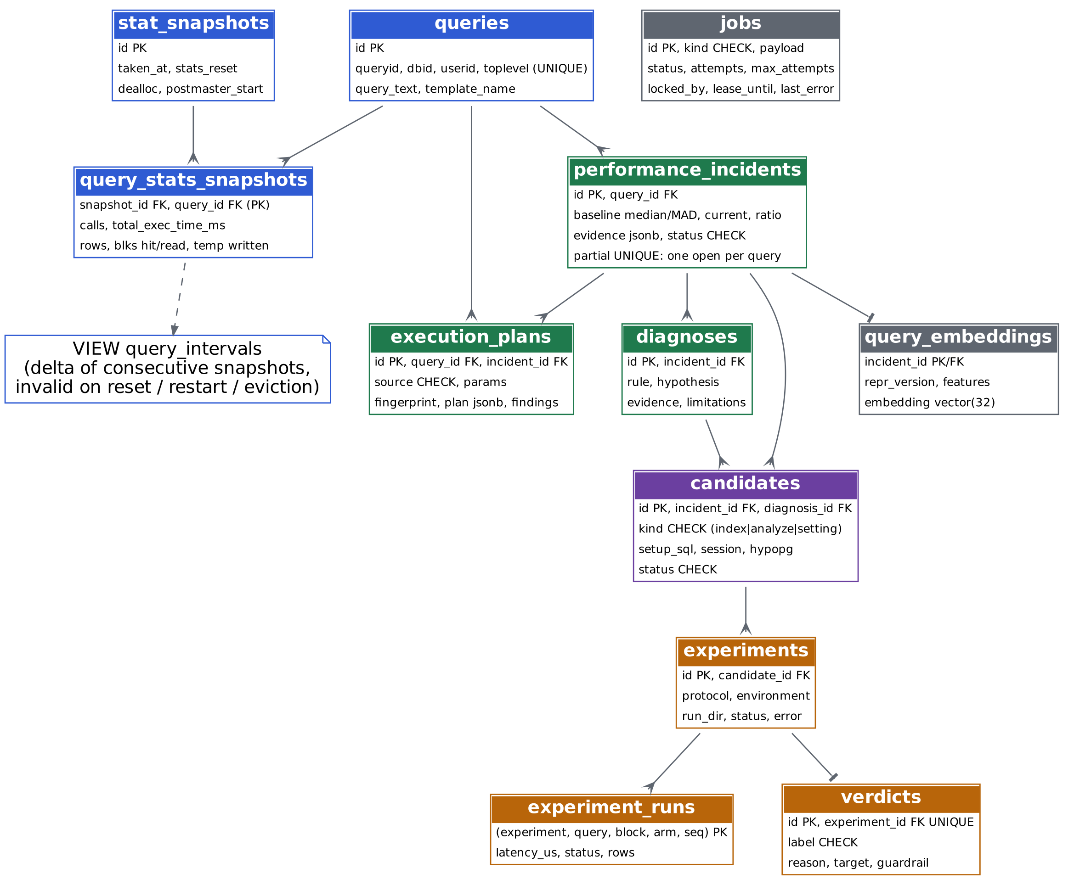
Figure 12.1: Evidence schema in meta-db.
- CHECK constraints on every status and label, so a bug cannot write a state that does not exist.
- Partial unique index one_open_incident_per_query ON performance_incidents(query_id) WHERE status IN ('open','investigating'): at most one open incident per query, enforced by the database even with concurrent detectors.
- The `query_intervals` view computes deltas with a LATERAL join to the previous snapshot.
- COPY bulk-loads thousands of raw timings per experiment into experiment_runs (primary key: experiment, query, block, arm, seq).
- ON DELETE CASCADE keeps the evidence tree consistent when an investigation is retried.
- pgvector column embedding vector(32) in query_embeddings.

12.2 The job queue
src/cloudpulse/jobs/queue.py: the claim statement
CLAIM_SQL = """
UPDATE jobs SET status = 'running', locked_by = %(worker)s, attempts = attempts + 1,
lease_until = now() + make_interval(secs => %(lease)s), updated_at = now()
WHERE id = (
SELECT id FROM jobs
WHERE attempts < max_attempts
AND (status = 'queued' OR (status = 'running' AND lease_until < now()))
ORDER BY id
FOR UPDATE SKIP LOCKED
LIMIT 1
)
RETURNING id, kind, payload, attempts
"""
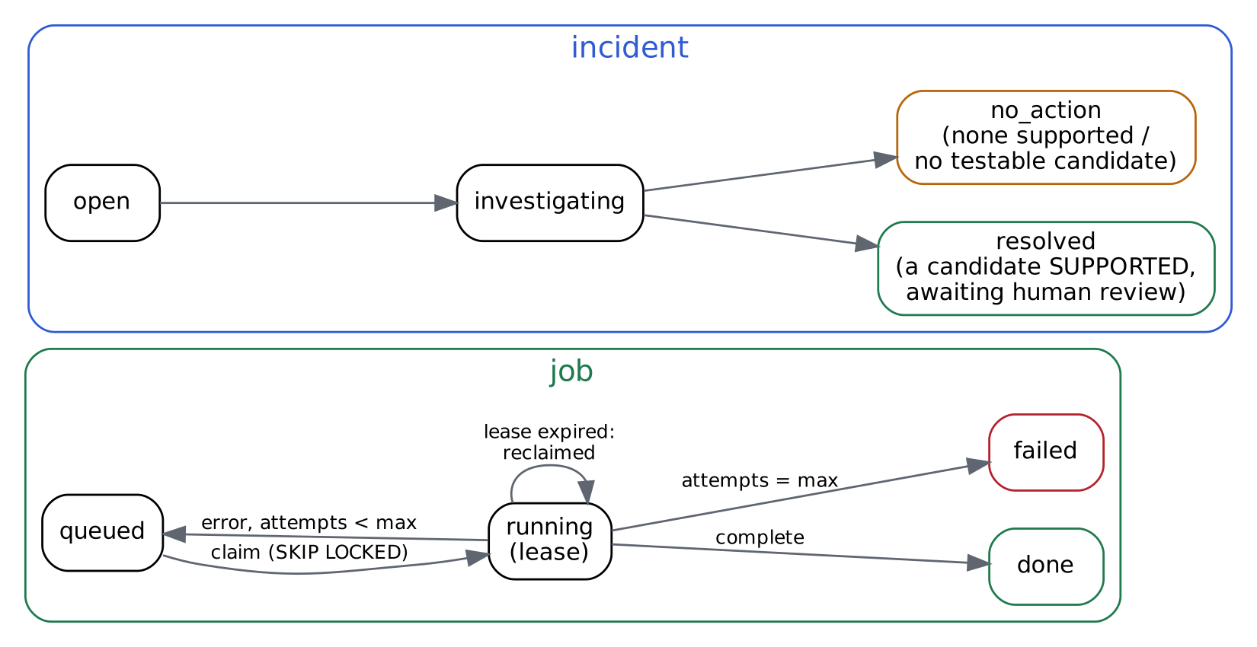
Figure 12.2: Job and incident states.
- SKIP LOCKED: concurrent workers skip rows another worker has locked, so each gets a different job (tested with 4 threads).
- Lease: 120 s, renewed every 30 s by a heartbeat thread. If a worker crashes, its lease expires and another worker reclaims the job; the old worker's heartbeat then fails because the job is no longer its own.
- fail() re-queues until max_attempts (3); sweep() marks jobs whose lease expired on their last attempt as failed.
- Idempotent jobs: an investigation deletes its earlier diagnoses, candidates and plans first; an experiment rebuilds its twins. Retrying is always safe.
- Why not Kafka or Redis: a few jobs that take minutes each, needing durability and transactions with the evidence. PostgreSQL already provides all of that (D-017).

12.3 Investigate and experiment
investigate(incident) runs steps 6–10 of Figure 5.2 and enqueues one experiment job per surviving candidate. run_candidate_experiment(candidate) builds the spec (target query + guardrail queries, parameter lists capped at 20), runs the harness, evaluates the guardrail, COPYs every timing into experiment_runs, stores the verdict, and closes the incident: resolved if any candidate was SUPPORTED ("awaiting human review"), otherwise no_action.
src/cloudpulse/pipeline.py: build_candidate_spec()
def build_candidate_spec(
cand: dict, lab_state: LabState, protocol: Protocol, name: str
) -> tuple[ExperimentSpec, QuerySpec, list[QuerySpec]]:
"""Turn a stored candidate into an A/B experiment: target query + guardrail."""
target = _cap(packs.template(cand["template_name"]))
guard = [g if g.params.get("type") == "union" else _cap(g)
for g in guardrail_queries(cand, target)]
spec = ExperimentSpec(
name=f"{name}_{target.name}",
description=cand["description"],
scale=lab_state.scale, seed=lab_state.seed, baseline_sql=lab_state.sql,
queries=[target, *guard],
arm_a=ArmSpec("A", [], dict(lab_state.db_settings)),
arm_b=ArmSpec("B", list(cand["setup_sql"]), {**lab_state.db_settings, **cand["session"]}),
protocol=protocol, target_query=target.name, pack=lab_state.pack,
)
return spec, target, guard

13. Interfaces: UI, API, CLI, similarity

13.1 Web UI and JSON API
FastAPI with server-rendered Jinja2 pages and inline SVG charts (no JavaScript build). The incident page has five sections: (1) regression evidence: baseline vs current, robust z, plan-changed flag, latency chart with anomalous intervals in red; (2) the captured plan as an indented table with estimated/actual rows, q-error and self time highlighted; (3) diagnoses with limitations; (4) candidates with HypoPG result, verdict reason, effect, CI, per-block ratio strip, guardrail table; (5) structurally similar past incidents.
Route | Purpose
GET / | incident list
GET /incidents/{id} | incident evidence page
GET /api/incidents, /api/incidents/{id} | JSON
GET /api/experiments/{id}/runs | every raw timing
POST /api/incidents/{id}/investigate | enqueue an investigation (202)
GET /api/jobs | queue state
GET /healthz | health

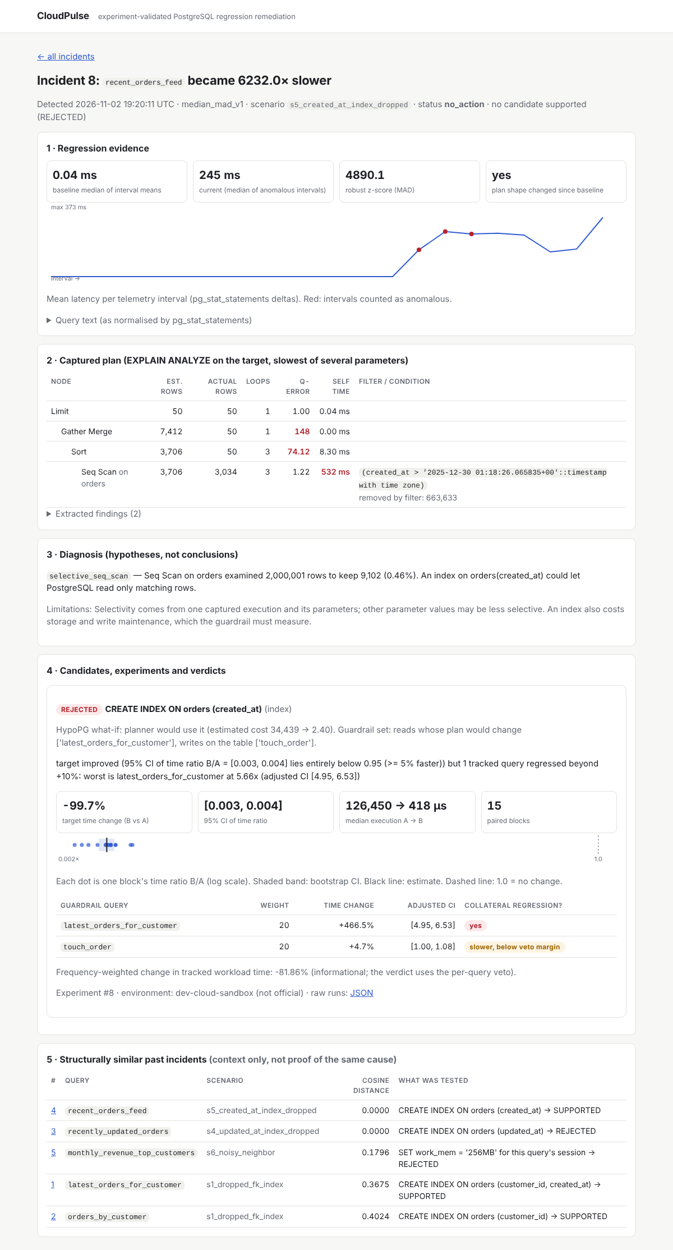
Figure 13.1: The UI page for the rejected created_at index (real evaluation data).

13.2 Command line
Command | What it does
cloudpulse init-meta [--reset] | create the evidence schema
cloudpulse bench <spec.json> [--blocks N] [--rebuild] | run one A/B (or A/A) experiment with guardrail
cloudpulse calibrate [--repeats 10 --blocks 12] | A/A calibration
cloudpulse evaluate [--pack ecommerce|tpch] [--scenario …] [--fault-rounds N] [--keep-meta] [--label …] | ground-truth scenario suite
cloudpulse replicate [--repeats 3] | re-run every tested candidate to check verdict stability
cloudpulse similarity-benchmark | retrieval benchmark
cloudpulse worker | process jobs forever
cloudpulse serve | web UI on :8000

13.3 Similarity search (secondary feature)
Each incident gets a 32-dimensional vector whose dimensions have meanings: 15 SQL-structure counts from the real PostgreSQL parser (pglast: tables, joins, comparison predicates, equality/range predicates, aggregates, GROUP BY, ORDER BY, LIMIT, subqueries, statement type, SET columns), 12 plan node-type counts, and 5 finding flags. Values are log1p-scaled and L2-normalised, stored as pgvector, and searched exactly with cosine distance (<=>). Results are shown as context ("last time something shaped like this regressed, this was tested and rejected"), never as a diagnosis. Exact search, because a scan of a few thousand 32-dimensional vectors takes milliseconds (D-018).

14. Results

14.1 Where the numbers come from
Item | Value
Environment label | dev-cloud-sandbox (not official)
Host (main evaluation, calibration) | Intel(R) Xeon(R) Processor @ 2.80GHz, 2 vCPU, 7.8 GB RAM, Linux 6.18.44-fc-v185
Host (replication, TPC-H) | Intel(R) Xeon(R) Processor @ 2.30GHz, 2 vCPU: the sandbox restarted on different hardware between sessions. Each results file records its own host.
PostgreSQL | 16.15 (Ubuntu 16.15-0ubuntu0.24.04.1); shared_buffers 327688kB, jit off, max_parallel_workers_per_gather 2
Dataset | e-commerce pack, scale "default" (100,000 customers, 2,000,000 orders), seed 42
Protocol | 14 pre-fault + 8 post-fault telemetry intervals per scenario; experiments: 15 blocks, ≤ 20 parameters per query, 1 warm-up round
Main evaluation | results/evaluation/20261102T185926Z
Supplementary runs | …_supplementary-16-rounds (S2), …_supplementary-after-F9 (S5)
Calibration / replication / similarity | results/calibration/20261102T185543Z / results/replication/20261103T014630Z / results/similarity/20261102T185917Z_benchmark.json

14.2 Headline: the tempting index that is rejected
In S5 the target query (recent_orders_feed) became 6144× slower after the fault; it was detected at interval 3 after the fault and diagnosed as a selective sequential scan. The candidate CREATE INDEX ON orders (created_at) made the target −99.7% faster, but:
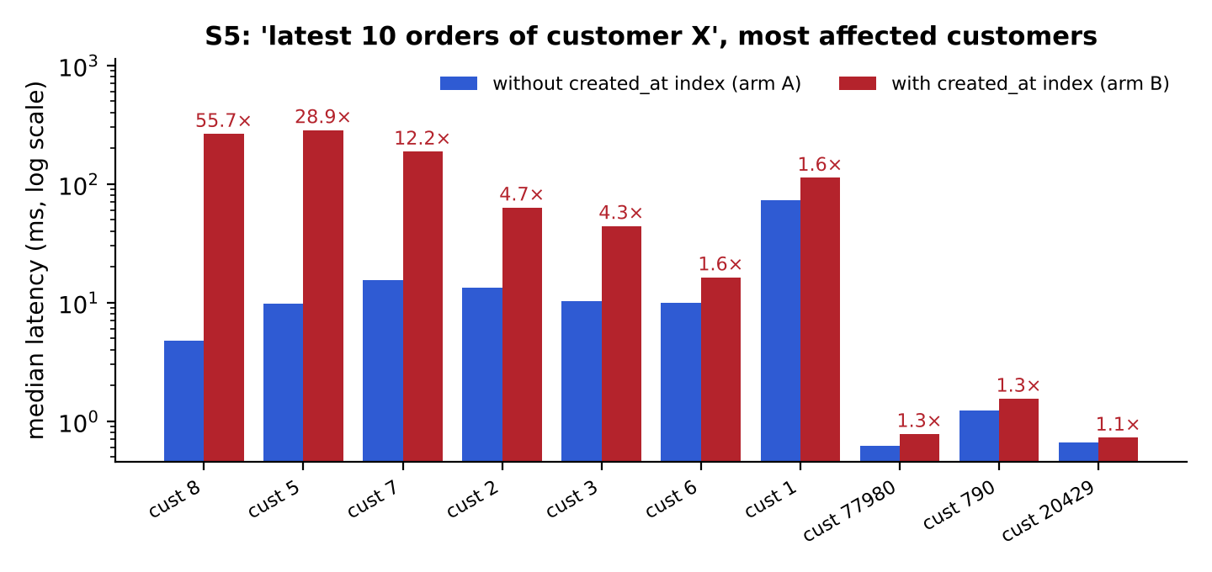
Figure 14.1: Per-customer medians in the guardrail benchmark (results/runs/20261102T192017Z_cand8_recent_orders_feed). 13 of 30 customers got faster, 7 got more than 1.5× slower.
CREATE INDEX ON orders (created_at) → REJECTED; target −99.7% (CI 0.003–0.004); collateral: latest_orders_for_customer 5.66× [4.95, 6.53]. Weighted workload change: -81.86% (informational).
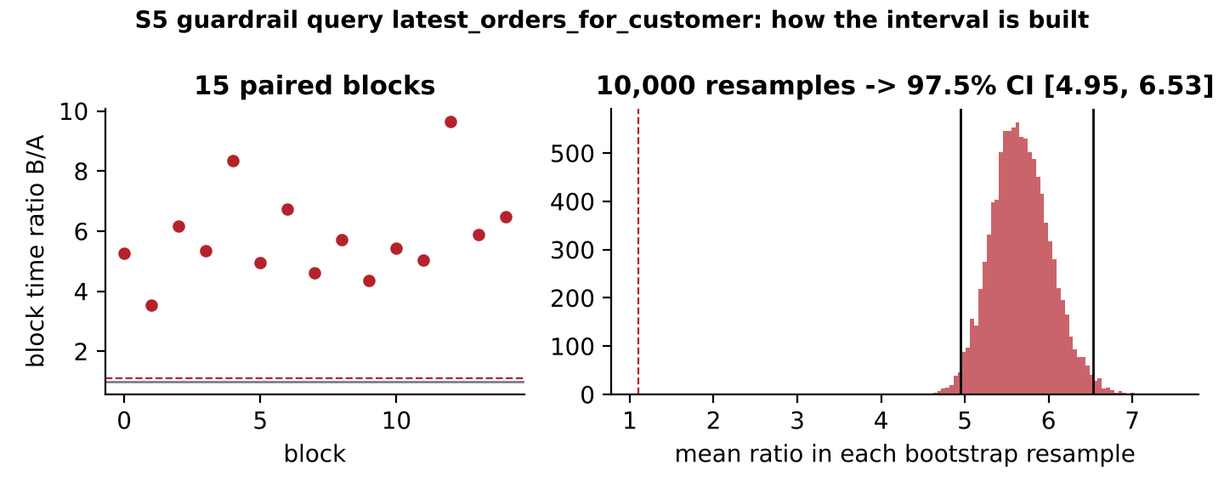
Figure 14.2: How the guardrail interval for latest_orders_for_customer is built: 15 block ratios, then 10,000 bootstrap resamples. The whole interval lies far above the 1.10 veto line.
Interview angle: This is the story to tell: the obvious fix is excellent for the query that regressed and terrible for a few big customers on another query. CloudPulse caught it because it benchmarks the parameter values where the plan changes, including the heaviest ones. Two earlier runs missed it, which is how F-7 and F-9 were discovered.

14.3 Worked example: one incident, every step, real values
Incident 8 (scenario s5_created_at_index_dropped, after fix F-9). Every value below is read from the evidence database; this is exactly what CloudPulse stored.

Step 1. Telemetry and detection
The statement as pg_stat_statements normalised it (constants became $n)
queryid -2728112807911579600
SELECT id, customer_id, amount FROM orders WHERE created_at > $1 ORDER BY created_at DESC LIMIT $2
- Baseline: median of interval means 0.039 ms, MAD 0.0096 ms (from up to 20 healthy intervals).
- After the fault, intervals 14, 15, 16 were anomalous (3 of the last 4 → regression declared). Current value: 244.5 ms, i.e. 6,232× the baseline, robust z = 4,890.
- A row was inserted into performance_incidents (the partial unique index guarantees it is the only open one for this query) and an investigate job was queued.

Step 2. Plan capture on the target
EXPLAIN (ANALYZE, BUFFERS) was run in a READ ONLY transaction for 5 parameter values; the slowest used parameter ["2025-12-30 01:18:26.065835+00:00"] and took 194.2 ms. Plan fingerprint 699f9e4a77eed669; plan shape changed since the healthy baseline: yes (the healthy plan used the created_at index).
Node | Est. rows | Actual rows | Loops | Time ms | Filter / detail
Limit | 50 | 50 | 1 | 194.2
Gather Merge | 7412 | 50 | 1 | 194.2
Sort | 3706 | 50 | 3 | 180.1 | sort: created_at DESC
Seq Scan on orders | 3706 | 3034 | 3 | 177.4 | (created_at > '2025-12-30 01:18:26.065835+00'::timestamp with time zone) (removed 663,633 per loop)

Step 3. Findings
- filtered_seq_scan on orders: 2,000,001 rows examined, 9,102 kept (selectivity 0.46%), filter columns created_at
- hotspot on orders: self time 532.083 ms, stored share 2.739. A share above 1 is the parallel-plan bug F-12, found while writing this guide and fixed since.

Step 4. Diagnosis
Note: [selective_seq_scan] Seq Scan on orders examined 2,000,001 rows to keep 9,102 (0.46%). An index on orders(created_at) could let PostgreSQL read only matching rows. Limitations: Selectivity comes from one captured execution and its parameters; other parameter values may be less selective. An index also costs storage and write maintenance, which the guardrail must measure.

Step 5. Candidate and HypoPG what-if
- Candidate: CREATE INDEX cp_orders_created_at_idx ON orders (created_at).
- HypoPG: the planner would use it; estimated cost of the target query 34,439 → 2.40.
- Of up to 60 parameter values checked per tracked read, 21 values of latest_orders_for_customer changed plan; the first 10 (customers 23, 1, 2, 3, 4, 5, 6, 7, 8, 9) were forwarded to the guardrail.
- Writes on the table: touch_order, added to the guardrail (index maintenance).

Step 6. Experiment
Twin databases were cloned from the lab base; arm B got the index. 15 blocks, 2,100 timed executions stored (20261102T192017Z_cand8_recent_orders_feed).
Query | Role | Time ratio B/A | CI | Median A → B (µs) | Outcome
recent_orders_feed | target | 0.003 | 95%: [0.003, 0.004] | 126,450 → 418 | ≥ 5% faster: yes
latest_orders_for_customer | guardrail | 5.665 | 97.5%: [4.95, 6.53] | 969 → 838 | collateral regression (veto)
touch_order | guardrail | 1.047 | 97.5%: [1.00, 1.08] | 363 → 385 | slower, below veto margin (warning)

Interview angle: Look at latest_orders_for_customer: the median execution got slightly faster, yet the total time ratio is several times worse. Most customers benefit a little; a few heavy customers become dramatically slower and dominate the total. A median-based comparison would have approved this index. Using the total over the parameter mix, which is what the workload actually pays, is a deliberate design choice (D-010).

Step 7. Verdict and outcome
Key idea: REJECTED: target improved (95% CI of time ratio B/A = [0.003, 0.004] lies entirely below 0.95 (>= 5% faster)) but 1 tracked query regressed beyond +10%: worst is latest_orders_for_customer at 5.66x (adjusted CI [4.95, 6.53])

Incident status: no_action: no candidate supported (REJECTED). Nothing was applied to the target; a person reviews this evidence in the UI.

14.4 All scenarios
Scenario | Measured effect on its query | Detected | False alarms before fault | Diagnosis | Candidate → verdict
S0 | — | no alarms | 0 | — | —
S1 | 817.10× | yes, interval 2 after fault | 0 | selective_seq_scan (correct) | CREATE INDEX ON orders (customer_id) → SUPPORTED; target −99.5% (CI 0.005–0.006); 2 guardrail queries clean
S2 | 1.83× | no (within window) | 0 | — | —
S2 (16-int.) | 1.84× | yes, interval 9 after fault | 0 | stale_statistics (correct) | ANALYZE orders → SUPPORTED; target −54.9% (CI 0.427–0.473); 6 guardrail queries clean
S3 | 1.03× | nothing to detect (effect < 1.5×) | 0 | — | —
S4 | 2635.15× | yes, interval 3 after fault | 0 | selective_seq_scan (correct) | CREATE INDEX ON orders (updated_at) → REJECTED; target −99.6% (CI 0.004–0.005); collateral: touch_order 1.23× [1.14, 1.31]
S5 | 4752.46× | yes, interval 3 after fault | 0 | selective_seq_scan (correct) | CREATE INDEX ON orders (created_at) → SUPPORTED; target −99.6% (CI 0.003–0.004); 2 guardrail queries clean
S5 (after F-9) | 6143.67× | yes, interval 3 after fault | 0 | selective_seq_scan (correct) | CREATE INDEX ON orders (created_at) → REJECTED; target −99.7% (CI 0.003–0.004); collateral: latest_orders_for_customer 5.66× [4.95, 6.53]
S6 | — | flagged: monthly_revenue_top_customers, segment_revenue_for_status | 0 | — | SET work_mem = '256MB' for this query's session → REJECTED; target +7.7% (CI 1.039–1.128)  CREATE INDEX ON orders (status) → SUPPORTED; target −66.8% (CI 0.308–0.359); 1 guardrail query clean

- False alarms: 0 regressions declared in 954 query-intervals with no fault active (7 scenarios × 14 pre-fault intervals × 9 queries, plus S0's 8 post-fault intervals).
- Detection: S1, S4, S5 caught 2–3 intervals after the fault. S2 (1.83× on the template mean, because only one of its three parameter values regressed) was missed in 8 intervals and caught at interval 9 in a 16-interval run. S3's fault had no measurable effect (1.03×) and was correctly ignored.
- Diagnosis: the expected rule fired for every detected scenario.
- S6 (contention): the report queries were flagged; the work_mem candidate was REJECTED (no gain), and an index on status was SUPPORTED. It genuinely speeds that query in isolation but does not address the actual cause. A SUPPORTED verdict is about the candidate, not a root-cause claim.
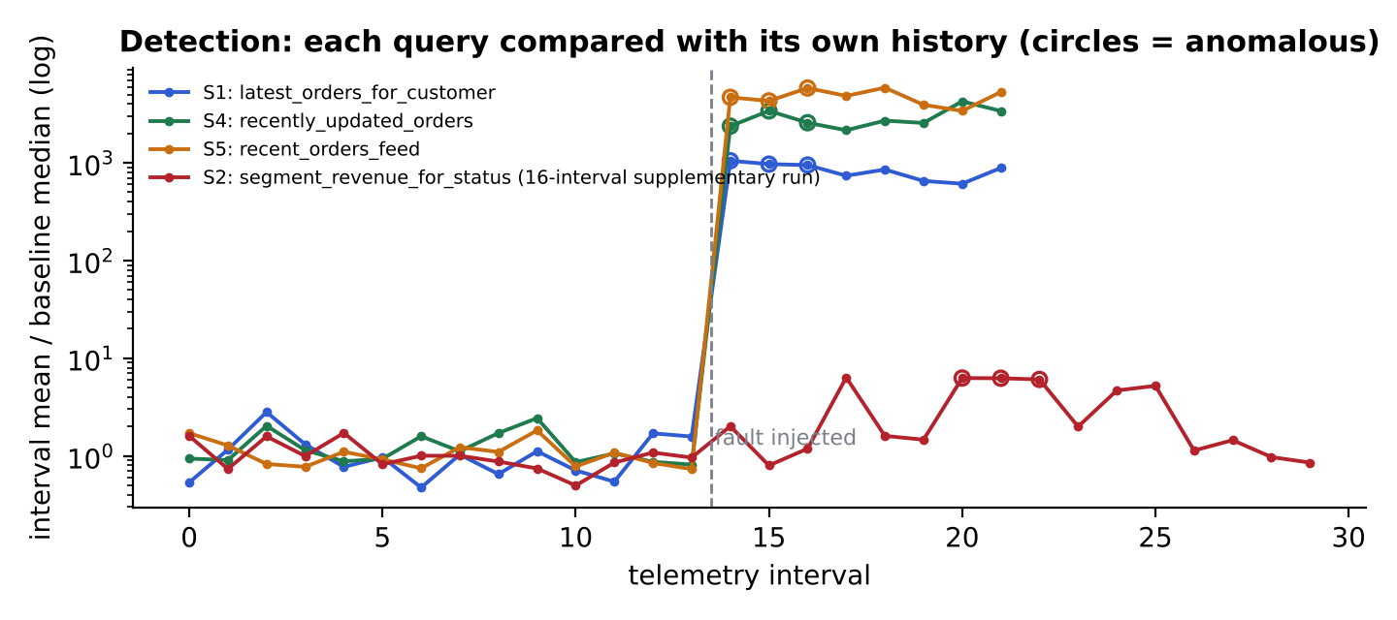
Figure 14.4: Interval means relative to each query's own baseline median; circles mark intervals counted as anomalous.

14.5 A/A calibration: can the method be trusted?
10 repeats × 5 queries with identical arms and fresh twins (results/calibration/20261102T185543Z/summary.json). False SUPPORTED: 0/50. False collateral flags: 0/50. 95% CI contains 1.0: 45/50 (nominal 95%). Largest A/A difference: 17.65% (on the UPDATE). Verdict counts: SUPPORTED 0, REJECTED 13, INCONCLUSIVE 37.
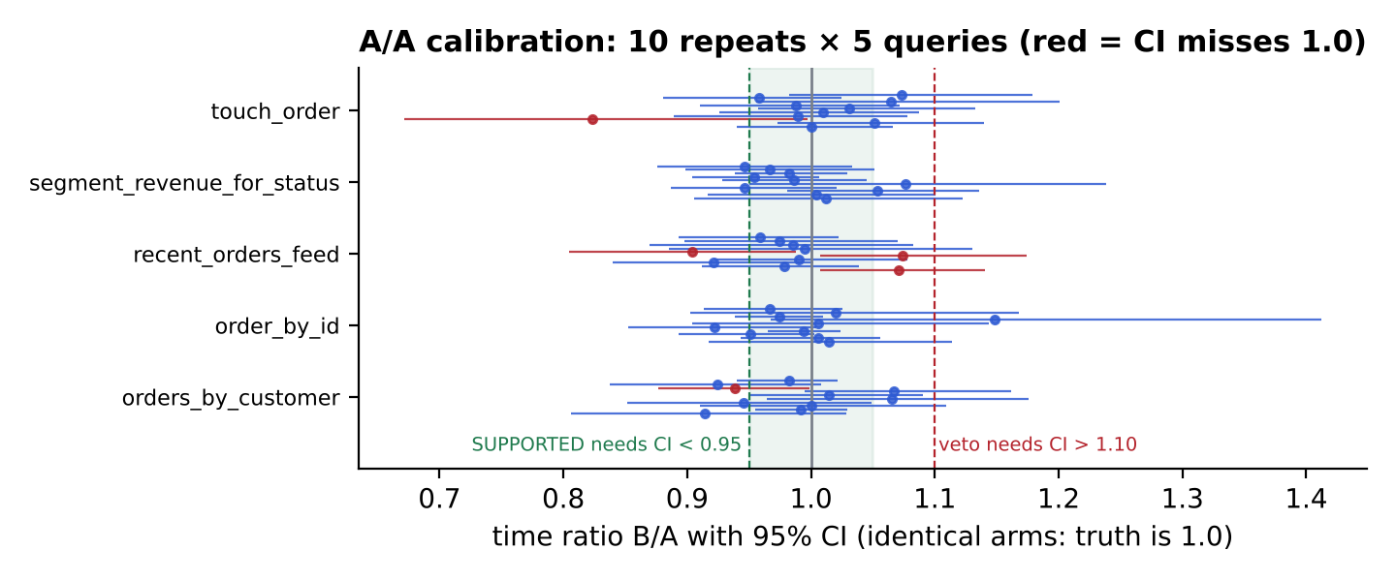
Figure 14.5: Every A/A estimate with its 95% CI. None reaches the SUPPORTED or veto lines with its whole interval.

14.6 Replication: are single-run verdicts stable?
Each tested candidate was re-run 3 more times with fresh twin databases and new shuffle seeds (results/replication/20261103T014630Z). The consolidated verdict is the common label if all runs agree, otherwise UNSTABLE (D-023). In the table, S = SUPPORTED, R = REJECTED, I = INCONCLUSIVE; "vetoed by" names the query with a collateral regression.
Scen. | Candidate | Original (target ratio) | Replications (target ratio) | Consolidated
S1 | CREATE INDEX ON orders (customer_id) | SUPPORTED (0.005) | R 0.005 vetoed by touch_order  S 0.005  S 0.004 | UNSTABLE
S1 | CREATE INDEX ON orders (customer_id, created_at) | SUPPORTED (0.003) | S 0.002  S 0.002  S 0.001 | SUPPORTED
S2 | ANALYZE orders | SUPPORTED (0.451) | S 0.434  S 0.440  S 0.447 | SUPPORTED
S4 | CREATE INDEX ON orders (updated_at) | REJECTED (0.004) | S 0.003  S 0.003  S 0.003 | UNSTABLE
S5 | CREATE INDEX ON orders (created_at) | REJECTED (0.003) | R 0.003 vetoed by latest_orders_for_customer  R 0.002 vetoed by latest_orders_for_customer  R 0.003 vetoed by latest_orders_for_customer | REJECTED
S6 | CREATE INDEX ON orders (status) | SUPPORTED (0.332) | S 0.352  S 0.350  S 0.372 | SUPPORTED
S6 | SET work_mem = '256MB' for this query's session | REJECTED (1.077) | R 1.051  R 1.050  R 1.057 | REJECTED

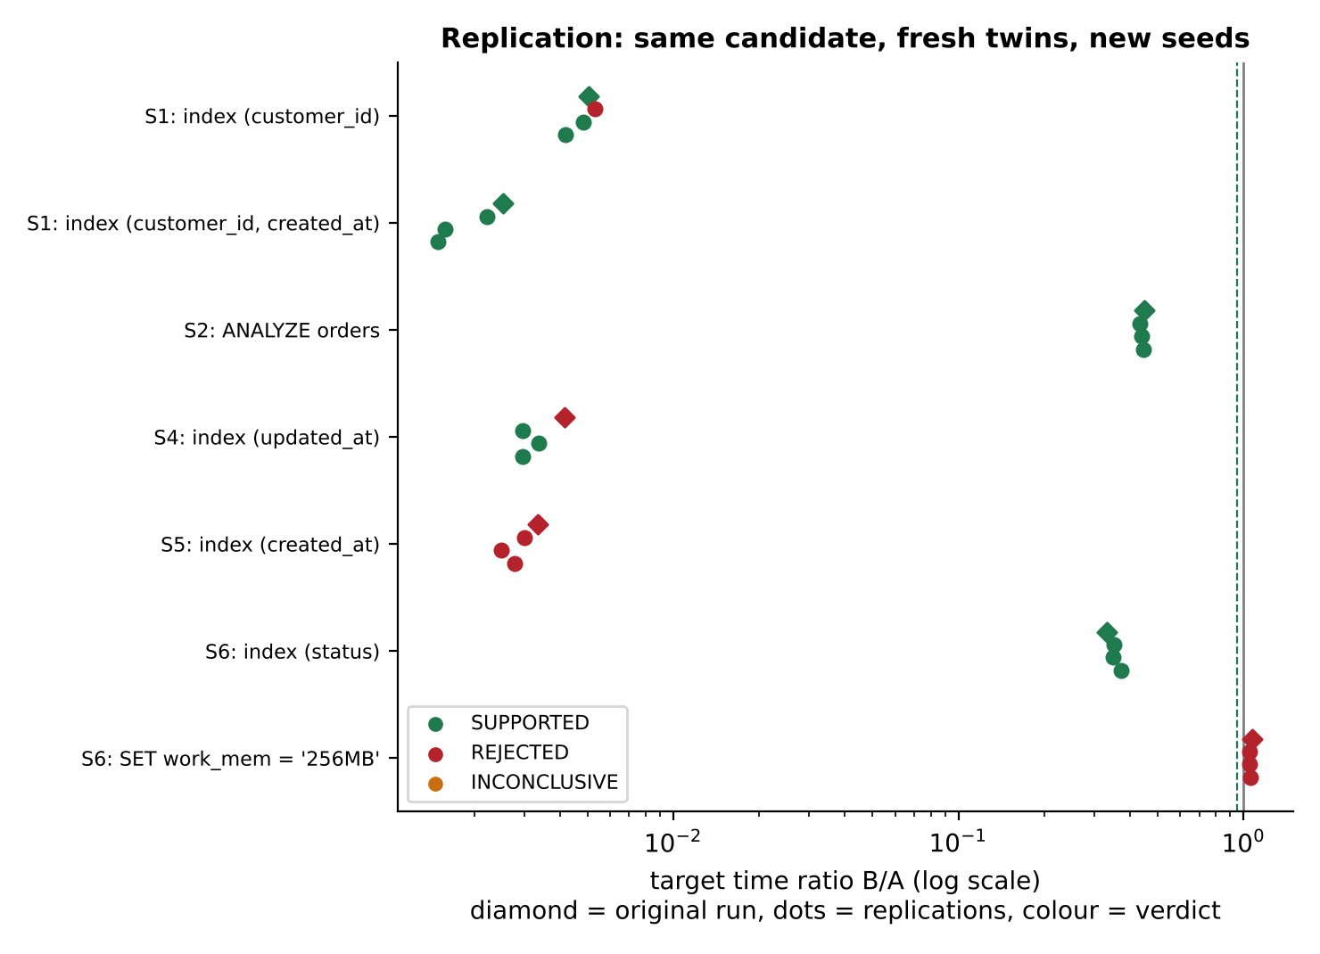
Figure 14.6: Target time ratio per run; colour is the verdict of that run.
Key idea: Verdicts far from a decision margin replicate perfectly. Verdicts that depend on an effect close to a margin (a ~10–25% write slowdown against a 10% veto) flip between runs. Report those as UNSTABLE and let a human decide, or pool more runs. Never present one run's verdict as settled.

14.7 External validation on TPC-H
Same engine, same rules, same thresholds, applied to the TPC-H benchmark (tpch-sf1, data from tpchgen-cli; results/evaluation/20261103T020258Z_tpch-sf1). Nothing was tuned for TPC-H.
Scenario | Measured effect on its query | Detected | False alarms before fault | Diagnosis | Candidate → verdict
T0 | — | no alarms | 0 | — | —
T1 | 2.50× | yes, interval 4 after fault | 0 | selective_seq_scan (correct) | CREATE INDEX ON lineitem (l_shipdate) → SUPPORTED; target −43.8% (CI 0.539–0.583); 1 guardrail query clean
T2 | 761.45× | yes, interval 3 after fault | 1 (tpch_q3_shipping_priority) | selective_seq_scan (correct) | CREATE INDEX ON orders (o_custkey) → SUPPORTED; target −99.7% (CI 0.002–0.003)
T3 | 0.77× | nothing to detect (effect < 1.5×) | 2 (tpch_q14_promotion_effect, tpch_q3_shipping_priority) | — | —

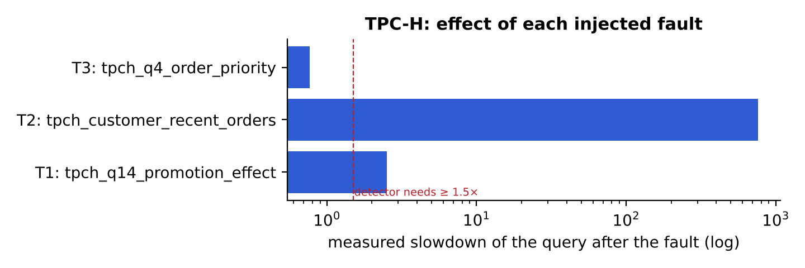
Figure 14.7: Measured effect of each TPC-H fault on its query.
Reading it: both faults that really slowed their query (t1, t2) were detected, correctly diagnosed and fixed with a SUPPORTED index. Dropping the o_orderdate index (t3) made Q4 faster, so there was nothing to detect. The weakness: 3 false alarms before any fault, on Q3 and Q14. These run once per interval with parameters whose cost differs about 2×, so one interval's mean is one random draw (F-13). Each false alarm was investigated and closed as no action (HypoPG filtered the index out, or the cause was unclear): no wrong recommendation was made.

14.8 Similarity search
On 30 hand-written queries in 6 structural families: recall@1 1 vs 0.633 for a text baseline (token Jaccard); recall@4 1 vs 0.683. The families were written by the same author as the features, so this shows the features behave as designed, not that they generalise.

14.9 The superseded first run
The first full evaluation (20261102T184027Z) is kept for the record. It differed because of two bugs found in it: F-7 (S5 guardrail sampling gap → S5 SUPPORTED) and F-8 (queries mapped to an earlier scenario's database → fake "false positives" in S5 and S6). It also measured S4's write slowdown at +13% (SUPPORTED with a warning), where the corrected run measured +23% (REJECTED). That disagreement is what motivated replication.

15. What went wrong, and what it taught
Every failed hypothesis, bug and wrong result found during the project, verbatim from docs/decisions.md. These are the most valuable interview stories: each one shows how a problem was noticed, diagnosed from evidence, fixed, and documented without rewriting history.

F-1 · "The aggregate spills, so more work_mem will make it faster": false here
While building scenario S3, raising work_mem from 4 MB to 64 MB and 256 MB removed the spill but did not reduce runtime (about 2.0–2.5 s in every setting). The spilled data stayed in the OS page cache, so disk was never the bottleneck. This is why rules produce hypotheses that are tested, not answers.

F-2 · False spill findings on parent nodes
EXPLAIN's buffer counters are inclusive of children, so a hash aggregate that wrote temp files made its Sort and Limit parents look like they spilled too. Fixed by computing per-node temp blocks (self_temp_written). Caught by the golden-file tests.

F-3 · Misestimates reported where they are inherited
Aggregates and joins above a badly estimated scan also show huge q-errors. The misestimate finding is now emitted only on table scans, where the error originates.

F-4 · queryid split by parameter types
See D-019. Found by the collector integration test, which could not match a template to its pg_stat_statements entry.

F-5 · The A/A confidence intervals are somewhat too narrow on a noisy VM
Committed calibration (results/calibration/20261102T185543Z): 10 repeats × 5 queries, with identical arms and fresh twins each repeat.
- 0 / 50 false SUPPORTED verdicts and 0 / 50 false collateral flags.
- The 95% CI contained 1.0 in 45 / 50 cases (90%, nominal 95%).
- Identical arms differed by up to 17.7% (touch_order, a single-row UPDATE). Read queries stayed within about ±15%, mostly within ±8%.
Variation between runs (fresh twins, background activity on a shared VM) is larger than the variation within a run that the block bootstrap sees, so single-run intervals are optimistic. The 5% target margin and the 10% Bonferroni-adjusted harm margin absorbed this: no wrong verdicts. An earlier, uncommitted calibration run that overlapped with other heavy work on the same machine gave 42/50 coverage; it was discarded because the machine was not idle. Consequence: single-run write-latency effects around ±10–15% (such as S4's +13% on touch_order) need replication before being trusted. In S4 the mechanism is independently confirmed: HOT updates go from 100% to 0% with the index. Possible improvements: repeat whole experiments, or derive margins from A/A data.

F-6 · A misleading HOT-update probe
A first check updated a contiguous range of ids and reported 0% HOT updates even without the extra index. Contiguous rows share pages, and the 10% free space per page filled up immediately. Random single-row updates (what the workload actually does) showed 100% HOT without the index and 0% with it.

F-7 · The guardrail missed the ORDER BY … LIMIT trap: sampling gap
In the first full evaluation, scenario S5 (re-adding an index on created_at) came back SUPPORTED with no collateral regression, although manual probing had shown that the index makes "latest 10 orders of customer X" 15–60× slower for heavy customers whose orders are old.
- Cause: only a few customers trigger the bad plan. HypoPG checked 6 parameter values and saw a plan change for 1 of them, so it correctly put the query into the guardrail set. But the benchmark then drew its own 20-customer sample, which contained no trap customer. Every plan recorded for both arms used the customer_id index, so the guardrail measured only the harmless cases.
- Fix: HypoPG now checks the whole 40-value workload sample and records the specific parameter values whose plan changes. The guardrail benchmark always includes those values (union sampler). On the S5 lab database, 1 of 40 customers (customer 23) changes plan.
- Trade-off: those values are over-represented in the guardrail sample compared with real traffic. The verdict asks "does any parameter regress badly?", which is the conservative question for a change applied in production.
- The original run is kept in results/evaluation/ as recorded. The re-run after the fix is a separate, labelled result.

F-8 · Bookkeeping bug: incidents attributed to an earlier scenario's query
The first full evaluation (results/evaluation/20261102T184027Z, kept but marked superseded) showed "false positives before the fault" in S5 and S6. They were not real. Each scenario recreates the target database, so the meta database holds one queries row per template per target database. tracked_query_pks selected by template name without filtering by database and without an ORDER BY, so it sometimes returned a previous scenario's row. S4's genuine regression was therefore re-reported in S5 and S6, and two extra incidents were opened. Their investigations ran against the correct, current database and ended in "no action", so no verdict was wrong, but the detection bookkeeping was.
- Fix: filter by the current target's dbid (pipeline.target_dbid), with an integration test. The full evaluation was re-run with the fix.
- Lesson: an identifier that is unique only within a scope (here queryid per database) needs that scope in every lookup, and the test suite needs a case with two scopes.

F-9 · A random parameter sample never contains the customers who suffer
After the F-7 fix, the corrected run still returned S5 = SUPPORTED. The plan-changing value HypoPG found in its random 40-customer sample (customer 23) was benchmarked, and for that customer the new plan was actually faster (4.3 ms → 0.8 ms). The customers who really suffer, heavy customers whose orders are all old (e.g. customer 7: about 15 ms → 166 ms in manual probing), were in neither sample.
- Why: the planner treats the most frequent values specially (most-common-values statistics give them large row estimates), so plan flips concentrate there, but a random sample of 40 out of ~100k customers almost never draws them.
- Fix: the what-if check always adds the 20 heaviest parameter values (params.heavy_hitters). On the S5 lab database, HypoPG then reports 21 plan changes, including customers 1–9, and those are benchmarked by the guardrail.
- Lesson: "test the workload" means testing the parameter distribution's tails, not only its typical values. Both earlier S5 results are kept as recorded.

F-10 · Detection delay reported one interval too low
The first workload round has no earlier snapshot to diff against, so each query's series has one interval fewer than the number of rounds. The evaluation counted the fault's position from the round count and reported delays one interval too early. Fixed by counting from the end of the series. Results recorded before the fix are corrected explicitly (delay_offset_corrected in summary.json).

F-11 · Verdicts near a decision margin flip between runs
Replication (results/replication/20261103T014630Z, run on a 2.30 GHz host after the sandbox restarted; the main evaluation ran on a 2.80 GHz host) re-ran the seven tested candidates three times each.
- Stable (4 of 4 runs agree): S5's created_at index REJECTED every time (collateral 4.4×–5.7×); ANALYZE orders SUPPORTED (target 0.43–0.45); the composite index SUPPORTED; the S6 status index SUPPORTED; work_mem REJECTED.
- UNSTABLE: S4's updated_at index: the UPDATE was consistently +17% to +23% slower in all four runs, but the lower end of its adjusted CI landed at 1.09–1.15, straddling the 1.10 veto line, so the verdict flipped (1 REJECTED, 3 SUPPORTED). S1's customer_id index: UPDATE +15% to +44% (one run vetoed).
- Lesson: the effect was reproducible; its classification was not, because it sits on a threshold. Report the stability of a verdict, not only the verdict.

F-12 · Hotspot shares above 100% in parallel plans
Found while writing the worked example for the guide: the S5 incident's plan reported its Seq Scan as a "hotspot" holding 274% of execution time (532 ms of self time in a 194 ms query). Self time is per-loop time × loops, and parallel workers count as loops, so in a parallel plan it measures process time summed over workers, not wall-clock time. Dividing it by wall-clock execution time is meaningless.
- Fix: shares are now computed against the sum of all nodes' self times (always a proper fraction), in both the findings and the UI. A test asserts every hotspot share in the golden plans lies in (0, 1].
- Impact: hotspot findings are descriptive only (no rule creates a candidate from them), so no diagnosis or verdict was affected. Stored findings from earlier runs keep their old share values.

F-13 · False alarms on TPC-H's heavy analytic queries
On TPC-H (results/evaluation/20261103T020258Z_tpch-sf1), the detector declared three regressions before any fault: Q3 in two scenarios and Q14 in one. The e-commerce workload had none in 954 fault-free query-intervals.
- Cause: these queries run once per telemetry interval with randomly drawn substitution parameters, and their cost depends strongly on the draw (Q3: about 550 ms or about 950 ms depending on market segment and date). With one call per interval, the "interval mean" is a single draw from a two-peaked distribution. Three high draws in four intervals satisfy the sustain rule. This is the same root cause as the S2 miss (F-5 area, D-012), in the other direction: averaging over parameters with very different costs.
- Harm: none. Each false alarm was investigated; HypoPG filtered the proposed index out (the planner would not use it) or the diagnosis was cause_unclear, so the incidents closed as no_action without any experiment or recommendation.
- Not fixed by re-tuning: raising thresholds after seeing this result would overfit to it. The principled fix is per-parameter-group detection (or more calls per interval), listed as future work.

16. Testing, CI and reproducibility
Test suite: 75 tests collected in 0.28s. Unit tests run without a database; tests marked db use the three servers and their own scratch databases (cp_test_*), never the real ones.
File | What it proves
tests/test_stats.py | Effect recovery; block drift cancels; CI coverage ≥ 88% by simulation; A/A false-SUPPORTED ≤ 3%; decision rule cases; timeouts; collateral detection
tests/test_detector.py | No flags on stable noise; exact delay on a step; spike ignored; small change ignored; flat baseline; invalid and empty intervals; config respected
tests/test_plans.py | Golden files (real EXPLAIN JSON from PostgreSQL): parsing, selectivity, misestimate only on scans, spill detected once, index walk, healthy plan, estimate-only plan, non-negative self time, fingerprint stability and sensitivity, filter-column extraction
tests/test_rules.py | Each rule on golden plans; existing index not re-proposed; ANALYZE only when stale; scoped work_mem capped; composite index for the walk; cause_unclear; DDL format
tests/test_harness_units.py | Arm alternation; deterministic permutations; base-key sensitivity; spec parsing; safety guard; identifier guard; guardrail veto/pass/warning; union sampler; plan-changing params in guardrail; replication consolidation
tests/test_similarity.py | Structural features; arithmetic is not a predicate; surface changes do not change the vector; unit length; beats text baseline
tests/test_db_integration.py | Deterministic generation and skew; harness records every execution and cleans up; result-changing candidate rejected; target refused; collector deltas and reset handling; SKIP LOCKED gives distinct jobs; lease expiry, reclaim, max attempts; requeue on failure; schema CHECKs; dbid scoping (F-8); heavy hitters; TPC-H pack builds and samples deterministically
tests/test_api.py | Health; pages render real plan, candidate, guardrail and percentage; JSON API and 404; investigate endpoint enqueues a job

CI (GitHub Actions, every push): build the PostgreSQL 17 + HypoPG + pgvector image, start the three servers with docker compose up -d --build --wait, install, ruff check, pytest -q, run the similarity benchmark. Reproduce everything on your machine with ./scripts/reproduce.sh (labels results official-<hostname>; --quick for a short run).

17. Limitations and future work
- Hardware and version: results are from a noisy 2-vCPU VM running PostgreSQL 16; official numbers should come from your machine on PostgreSQL 17.
- Self-designed scenarios: the e-commerce faults and the rules share an author. TPC-H reduces but does not remove this (the faults on TPC-H were still chosen by the same author).
- Run-to-run noise: single-run CIs are optimistic (90% A/A coverage); verdicts near a margin flip between runs (S1, S4). Use replication and treat UNSTABLE as "needs a human".
- Detector on means: a regression that affects only some parameter values is diluted (S2). Fix: detect per parameter group or on per-call latency samples.
- Lab state: rebuilt from generator + SQL; real deployments need snapshot restore (and ANALYZE, since statistics are not dumped before PostgreSQL 18).
- Not diagnosable: locks, I/O or CPU saturation, checkpoints, bloat, generic-plan flips, network.
- Candidate space: no extended statistics, partial or expression indexes, or query rewrites yet.
- Guardrail weighting: the veto ignores frequency; heavy-hitter parameters are over-represented on purpose (the conservative question).
Natural next steps: pooled analysis across replications; per-parameter-group detection (fixes S2); extended statistics as a candidate for estimation_limit; generic-plan regressions as a scenario; snapshot-based lab provisioning; auto_explain ingestion for plans captured at the moment of slowness.

18. Interview preparation

18.1 The 30-second pitch
"CloudPulse is a PostgreSQL performance tool I built that treats every index or tuning suggestion as a hypothesis. When a query regresses, it captures the real plan, proposes a fix, and benchmarks it on two identical copies of the database with alternating trials and bootstrap confidence intervals. Crucially, it checks the rest of the workload too. In one case the obvious index made the regressed query 99.7% faster but made a customer-lookup query 5.7 times slower for heavy customers, so the tool rejected it."

18.2 The 2-minute version
- Problem: tools say "add an index"; nobody checks whether it helps, how sure we are, or what it breaks.
- Detection: pg_stat_statements is cumulative, so I snapshot and difference it, handle resets and restarts, and compare each query with its own history using median/MAD with a sustain rule.
- Diagnosis: I parse EXPLAIN ANALYZE JSON into a tree, compute q-errors and spills, and explainable rules produce hypotheses plus candidates.
- Experiment: template-copied twin databases so layout and statistics are identical; alternating blocks; a result-equivalence check; a paired block bootstrap; a decision rule fixed in advance.
- Guardrail: HypoPG finds which other queries, and which parameter values, would change plan; those plus writes are benchmarked with Bonferroni correction and a 10% veto.
- Honesty: A/A calibration, replication, TPC-H validation, and thirteen documented mistakes, including two runs where the headline result was wrong and how I found out.

18.3 How to demo it
- docker compose up -d --build --wait, then pip install -e .
- cloudpulse bench experiments/ab_created_at_index_trap.json: shows REJECTED with the collateral query, live.
- cloudpulse evaluate --scale small --scenario s5_created_at_index_dropped then cloudpulse serve and open the incident page: walk through the five sections.
- Open results/runs/<run>/raw.csv to show that every number is backed by raw data.

18.4 Question drill
Q1. Why not just run EXPLAIN on the slow query and add the index it suggests?
EXPLAIN shows estimates, and the planner's estimates are what went wrong. An index's benefit, its cost to writes, and its effect on other queries' plans can only be known by measuring. HypoPG and EXPLAIN are filters, not proof.
Q2. Why are pg_stat_statements counters cumulative and what does it force you to do?
Cheap running sums in shared memory. You must snapshot and difference them, and detect resets (stats_reset), restarts (postmaster start time) and evictions (calls going backwards) so you never compute a fake negative delta.
Q3. Why can't you get p95 latency per interval from pg_stat_statements?
Only sums can be differenced. min/max/stddev are cumulative since reset. So the detector uses interval means, and its weakness is parameter mix (S2).
Q4. Why median/MAD instead of mean and standard deviation?
One extreme interval inflates mean and standard deviation, hiding later anomalies. Median and MAD resist a minority of outliers. Floors stop a flat baseline from producing infinite z-scores.
Q5. Why require 3 of the last 4 intervals?
A single slow interval is usually noise (a checkpoint, a cold cache). A sustained shift is a regression. The cost is detection delay (2–3 intervals here).
Q6. Why can a later EXPLAIN ANALYZE differ from the slow execution?
Different parameters, cache state, statistics (autovacuum may have analysed), or concurrency. CloudPulse tries several parameters, keeps the slowest, and records whether the plan shape changed since a healthy baseline.
Q7. What is q-error and why does it matter?
max(estimate/actual, actual/estimate). Join methods and orders are chosen from estimates; estimating 1 row instead of 300,000 picks a nested loop with 300,000 probes (S2).
Q8. How does PostgreSQL choose between a seq scan and an index scan?
Estimated cost: estimated rows × per-row CPU costs plus pages × page costs (sequential vs random), adjusted by the correlation between index order and physical order. Wrong row estimates mean wrong choices.
Q9. Why can adding an index make another query slower?
It changes the planner's options. In S5 the planner walks the created_at index for ORDER BY … LIMIT, assuming matching rows are spread evenly; for heavy customers with only old orders it reads most of the table. Indexes also add work to every insert and non-HOT update.
Q10. What is a HOT update, and how did the project show its cost?
An update that changes no indexed column and fits on the same page writes no index entries. Indexing updated_at turned touch_order from 100% HOT to 0% HOT; the guardrail measured roughly +13–23% on that update.
Q11. Why two databases instead of BEGIN; CREATE INDEX; ROLLBACK?
A plain CREATE INDEX holds a SHARE lock blocking writes for the whole benchmark; the build warms the cache for one side; CONCURRENTLY can't run in a transaction. Twins from a template are identical in layout and statistics and can be alternated.
Q12. Why alternate AB, BA instead of A then B?
Time-dependent effects (cache warming, CPU frequency, bloat from writes) would systematically favour one arm. Alternating spreads them over both, and pairing within blocks cancels them.
Q13. Why bootstrap over blocks rather than executions?
Executions within a block are correlated; resampling them as if independent understates uncertainty. Blocks are the paired, more independent unit.
Q14. Why log ratios?
Ratios are multiplicative: 2× faster and 2× slower are symmetric in log space. Averaging raw ratios is biased.
Q15. Why a confidence interval rather than a p-value?
The decision depends on effect size relative to a practical margin (5%), not only on whether the effect differs from zero.
Q16. Why INCONCLUSIVE?
Forcing yes/no on noisy data creates confident wrong answers. A tool that recommends schema changes must be able to say "not enough evidence".
Q17. What does Bonferroni do here and what does it cost?
Checking m guardrail queries at 95% each gives ~m×5% chance of a false alarm; using 1 − 0.05/m per query keeps the family rate near 5%. The cost is power: small real regressions are harder to flag.
Q18. Your A/A intervals covered 1.0 only 90% of the time. Is the method broken?
Single-run intervals are optimistic because run-to-run variance exceeds within-run variance. The 5%/10% margins absorbed it (zero false verdicts). The fix is replication or margins calibrated from A/A data, which is what the replication step does.
Q19. A verdict flipped between runs. What do you conclude?
The true effect is near a decision margin (S4: a write slowdown of ~10–25% against a 10% veto). Report UNSTABLE and let a human weigh it; do not pick the run you like.
Q20. What does HypoPG tell you and what doesn't it?
Whether the planner would use a hypothetical index and which plans would change, cheaply. Not runtime, cache effects, or write cost. It's a pre-filter and a scoping tool.
Q21. How did the guardrail miss the trap at first?
It benchmarked a random sample of customers; only a few heavy customers trigger the bad plan. F-7 added the exact plan-changing parameter values; F-9 added the heaviest values to the what-if check, because plan flips concentrate on most-common values.
Q22. Why work_mem only per session?
work_mem is per operation per session; raising it globally multiplies across concurrent sessions and operations and can exhaust memory. Also, removing a spill may not help at all (F-1, S6).
Q23. How does the job queue survive a worker crash?
Claim with FOR UPDATE SKIP LOCKED and a 120 s lease renewed every 30 s. A crashed worker stops renewing; the lease expires; another worker reclaims the job (attempts+1). Jobs are idempotent. After max_attempts the job is failed with its last error.
Q24. Why PostgreSQL as a queue instead of Kafka/Redis?
A handful of minute-long jobs needing durability and transactional consistency with the evidence. PostgreSQL already provides that; another system adds operations without a measured need.
Q25. How do you prevent duplicate incidents?
A partial unique index on performance_incidents(query_id) WHERE status IN ('open','investigating'). The second insert fails and is ignored.
Q26. How did you map pg_stat_statements entries to your templates?
Not by text (constants become $n). EXPLAIN (VERBOSE) prints the same Query Identifier pg_stat_statements uses. Integers are always sent as int8, because queryid includes parameter types (F-4).
Q27. What bug produced fake false positives?
F-8: the helper looked up a template's query row without scoping to the current database, so an earlier scenario's regression was re-reported. Fix: filter by dbid; add a two-database test.
Q28. Why pgvector with exact search and hand-designed features?
Explainable, reproducible dimensions; tens to thousands of rows make a sequential scan instant and exact. ANN indexes trade recall for speed that isn't needed.
Q29. What can CloudPulse not do?
Diagnose locks, saturation, checkpoints, bloat, generic-plan flips; propose rewrites or extended statistics; know production traffic shape beyond the tracked workload; apply anything automatically, by design.
Q30. How do you know your results aren't just noise?
A/A calibration on the same machine; decision margins; result-equivalence checks; replication with consolidated verdicts; raw data for every number; TPC-H as a workload not designed around the rules.
Q31. What would you do with another month?
Per-parameter-group detection; pooled multi-run analysis; extended statistics candidates; snapshot-based lab provisioning; run on real production-like traces.

19. Glossary
Term | Meaning
A/A test | Experiment with two identical arms; measures the method's own noise
Arm | One side of an experiment (A = unchanged, B = with candidate)
Block | One pass of the full parameter list on both arms; the unit of pairing
Bonferroni | Per-test confidence 1 − α/m to control false alarms across m tests
Candidate | A concrete proposed change (index, ANALYZE, session setting)
Cardinality | Number of rows a plan step produces
Collateral regression | Another query confidently slower by more than 10% under the candidate
Fingerprint (plan) | Hash of a plan's shape: node types, tables, indexes, join types
Guardrail | The check of other tracked queries for collateral regressions
Heavy hitter | One of the most frequent parameter values (e.g. biggest customers)
HOT update | Heap-only tuple update: no index entries written
HypoPG | Extension for hypothetical indexes visible only to the planner
Incident | A detected regression of one query
Lease | Time-limited ownership of a job by a worker
MAD | Median absolute deviation, a robust measure of spread
MCV list | Most-common values and their frequencies in planner statistics
Pack | Schema + data + workload + baseline + faults for one application
q-error | max(estimated/actual, actual/estimated) rows
Spill | A sort/hash that exceeded work_mem and wrote temp files
Twin databases | Two file-level copies of the same base database
UNSTABLE | Consolidated verdict when replications disagree

Appendix A. Decision log (verbatim)
Every design decision, the alternatives considered, and what was learned when something did not work. Code comments refer to these IDs (D-0xx, F-x).

Environment

D-001 · Three pinned PostgreSQL servers with fixed resources
- Decision: docker-compose.yml runs target-db (monitored), lab-db (experiments) and meta-db (evidence), all from one image based on postgres:17.6-bookworm plus HypoPG and pgvector. Target and lab are capped at 2 CPUs / 2 GB; shared_buffers=256MB; jit=off; track_io_timing=on.
- Why: the monitored database must never be used for experiments, and CloudPulse's own writes must not compete with the workload it measures. Fixed resource limits make "the conditions of the measurement" explicit. JIT is off because compilation time adds variance to short OLTP queries.
- Alternatives: one server with three databases (simpler, but experiments and telemetry would share CPU with the monitored workload).
- Limitations: Docker on a laptop is still noisy (other apps, CPU frequency scaling, thermal limits). The A/A calibration measures how noisy.

D-002 · Development sandbox ran PostgreSQL 16, not 17
- Context: the cloud sandbox used to build this project cannot pull from Docker Hub or apt.postgresql.org. It has Ubuntu's PostgreSQL 16 with HypoPG 1.4 and pgvector 0.6.
- Decision: develop against three local PG16 clusters with the same settings; CI and scripts/reproduce.sh use the pinned PG17 image.
- Consequence: every committed result is labelled dev-cloud-sandbox (not official) and records server_version. Official numbers come from re-running on your own machine.

Measurement (the bench)

D-003 · Twin databases cloned from a template, not toggling an index
- Decision: build a base database once, then create two physically identical copies with CREATE DATABASE … TEMPLATE … STRATEGY FILE_COPY. Arm A's copy stays as is; arm B's copy gets the candidate change.
- Why: a file-level copy has identical row layout, visibility map and planner statistics, so the only difference between the arms is the candidate. Both arms exist at the same time, so the harness can alternate between them cheaply.
- Alternatives considered:
  - BEGIN; CREATE INDEX; benchmark; ROLLBACK on the monitored database: rejected. A plain CREATE INDEX holds a SHARE lock that blocks writes for the whole benchmark, and the build itself warms the cache in favour of arm B.
  - One database, building and dropping the index between blocks: every switch costs a full index build and re-warms the cache.
  - Re-running data generation for each arm: ANALYZE samples randomly, so the two copies would have slightly different statistics and possibly different plans.
- Limitation: the twins share shared_buffers and the OS cache. With two ~240 MB databases and 256 MB of shared buffers, one arm can evict the other's pages. Alternating arms spreads this effect over both.

D-004 · Counterbalanced blocks; the block is the unit of pairing
- Each block runs the same shuffled parameter list on both arms, in order AB, BA, AB, … Slow drift (cache warming, CPU frequency, bloat from writes) therefore affects both arms equally, and the statistics compare arms within a block.

D-005 · Result-equivalence check before measuring
- During warm-up, read queries must return the same rows on both arms (multiset hash). A "faster" candidate that changes results is a bug, not an optimisation. Queries whose results legitimately change under concurrent writes opt out (compare_results=False).

D-006 · No automatic server-side prepared statements
- psycopg 3 prepares a statement after 5 executions; PostgreSQL may then switch to a generic plan that ignores parameter values. That changes what is being measured part-way through a run. prepare_threshold=None keeps one plan per execution (custom plans). Generic-plan regressions are a real problem, but they are out of scope for v1.

D-007 · Latency measured on the client
- perf_counter_ns around execute plus fetchall, on a persistent connection. This includes protocol and result transfer, which is what an application sees. EXPLAIN ANALYZE timing was rejected for benchmarks: it adds per-node instrumentation overhead and does not send rows to the client.

D-008 · Lab tables have autovacuum disabled; data is frozen after load
- Autovacuum could ANALYZE one twin halfway through an experiment and change its plans, so it is disabled on lab tables (not on the target). After generation, VACUUM (FREEZE, ANALYZE) sets hint bits and the visibility map, so the first benchmark reads do not pay that one-off cost.

D-009 · synchronous_commit=off in lab sessions
- Commit latency on a laptop is dominated by fsync variance. Turning it off for lab sessions keeps write measurements focused on the work an index adds (heap and index maintenance, HOT vs non-HOT updates).
- Limitation: any extra WAL volume caused by an index shows up only partly in latency.

Statistics

D-010 · Effect measure and pre-registered decision rule
- Effect: for each block, d_b = log(sum_B / sum_A) over the whole parameter mix; the estimate is exp(mean d_b) (0.25 = four times faster). Using total time weights each parameter by its real cost.
- Uncertainty: paired block bootstrap (resample whole blocks, 10,000 times), percentile interval. Resampling single executions would ignore the correlation between neighbouring executions and give falsely narrow intervals.
- Rule (fixed before any scenario was run): margin 5%, at least 10 blocks.
  - SUPPORTED if the upper end of the CI is below 0.95.
  - REJECTED if the lower end is above 0.95 (confidently not a meaningful gain).
  - Otherwise, or with too few blocks or timeouts on both sides: INCONCLUSIVE.
  - Timeouts only on the candidate arm: REJECTED.
- Alternatives: a t-test on per-execution latencies (assumes independence and normality; neither holds); Mann-Whitney (answers "is one distribution shifted", not "by how much").

D-011 · Guardrail rule: Bonferroni-adjusted veto
- Each guardrail query gets a CI at 1 − 0.05/m. It counts as a collateral regression if that CI lies entirely above +10%.
- Final verdict: SUPPORTED only if the target is SUPPORTED and there is no collateral regression. Otherwise REJECTED, with the regressing query named.
- The frequency-weighted change in total workload time is reported but does not decide the verdict. The veto is deliberately conservative; a person may decide that a regression on a rare query is an acceptable trade.

Telemetry and detection

D-012 · Detect on interval means with median/MAD and a sustain rule
- pg_stat_statements only allows differencing cumulative sums. min, max and stddev are cumulative since reset, so per-interval percentiles are not available, and the detector works on interval mean latency.
- Baseline: the last 20 valid intervals that were not themselves anomalous; at least 8 are needed, otherwise the result is insufficient_data.
- Anomaly: robust z > 4 using scale = max(1.4826·MAD, 5%·median, 0.05 ms), and at least 1.5× the median. The floors stop a perfectly flat baseline (MAD = 0) from turning tiny wobbles into infinite z-scores.
- Regression: at least 3 of the last 4 valid intervals are anomalous.
- Resets, restarts, eviction: the interval is marked invalid and skipped. The baseline itself is kept, because a statistics reset is a telemetry event, not a change in performance.
- Known limitation: a template's mean mixes cheap and expensive parameter values, so a shift in the parameter mix looks like a regression.

D-014 · Round-based telemetry in the evaluation
- The scenario runner snapshots after each workload round (every template runs at least once, in proportion to its weight) instead of every N seconds. That keeps a scenario to minutes and ensures rare report queries appear in every interval. The collector and detector do not depend on how intervals are defined; a deployment would snapshot on a timer.

D-019 · Integers are always sent as bigint
- Found while testing: psycopg sends a Python int as int2, int4 or int8 depending on its value, and pg_stat_statements includes parameter types in the queryid. WHERE id = $1 with id=5 and with id=500000 therefore became two separate entries, splitting the query's history. Every connection now registers an int8 dumper for int.

D-020 · Plans captured with on-demand EXPLAIN ANALYZE, not auto_explain
- When an incident opens, CloudPulse runs EXPLAIN (ANALYZE, BUFFERS) on the target for 5 parameter values inside a READ ONLY transaction with a 60 s timeout, and keeps the slowest. Writes are only EXPLAINed, never executed.
- Why not auto_explain: it writes to the server log, so it would need log shipping and parsing. With log_analyze it instruments every query, which would also perturb the benchmarks.
- Limitation: the plan is captured after detection, so cache state, statistics or concurrency may differ from the moment the slowdown happened. The incident also records whether the plan shape differs from the healthy baseline plan.

Diagnosis and candidates

D-013 · A deliberately small candidate space
- Supported candidates: btree indexes with one or two columns, ANALYZE <table>, and work_mem raised for the affected query's session only (capped at 256 MB). No SQL rewriting, no global configuration changes, and no extended statistics yet.

D-022 · HypoPG as a pre-filter and guardrail-scoping tool
- A hypothetical index is created in one lab session. If the planner would not use it for the target query, the candidate is filtered out without an experiment.
- The same what-if run lists which other tracked read queries would change plan; only those, plus writes on the indexed table (which always pay maintenance), go into the guardrail.
- HypoPG never proves a speed-up; it only says what the planner thinks.

System

D-015 · One experiment at a time per lab server
- pg_advisory_lock on the lab server serialises experiments. Twins have fixed names, and two experiments sharing a 2-CPU machine would measure each other.

D-016 · Lab state is rebuilt deterministically
- The lab reproduces the target's current state from (generator, scale, seed, state SQL). A real deployment would restore a snapshot instead (e.g. a pg_dump restore or a storage snapshot), which would also need ANALYZE because statistics are not dumped before PostgreSQL 18.

D-017 · Job queue in PostgreSQL (FOR UPDATE SKIP LOCKED + leases)
- The workload is a handful of jobs that each take minutes, not a high-volume message stream. PostgreSQL already gives transactions, durability and row locks. Leases plus max_attempts handle worker crashes. Redis or Kafka would add another system to operate without a measured need.

D-018 · Deterministic structural vectors, exact search
- 32-dimensional vectors where each dimension has a meaning: SQL structure from the PostgreSQL parser (pglast), plan node counts and finding flags. Exact cosine search, because at this scale (tens to thousands of incidents) a sequential scan is fast and returns exact neighbours. An HNSW or IVFFlat index would add recall loss and tuning for no measured benefit.

D-021 · Server-rendered UI instead of Next.js
- FastAPI + Jinja2 templates + inline SVG. The UI displays evidence; it is not the technical core. A separate JavaScript toolchain would double the build and test surface for no functional gain.

D-023 · Replicate verdicts; report UNSTABLE when runs disagree
- Decision: cloudpulse replicate re-runs every tested candidate (3 extra runs, fresh twins, new shuffle seeds). The consolidated verdict is the shared label if all runs agree, otherwise UNSTABLE, which means a human should decide.
- Why: the A/A calibration showed that noise between runs exceeds what a single run's interval reflects (F-5), and two runs of the same S4 experiment had already disagreed (F-11).
- Alternatives: majority vote (hides the disagreement); pooling all blocks into one interval (treats runs as interchangeable and ignores run-level variance; a hierarchical model would be the principled version).

Appendix B. Configuration reference
Setting | Value | Where
Target improvement margin | 5% (CI upper < 0.95) | workload/guardrail.py TARGET_MARGIN
Collateral veto margin | 10% (adjusted CI lower > 1.10) | guardrail.py HARM_MARGIN
Guardrail confidence | 1 − 0.05/m | guardrail.evaluate
Minimum blocks for a verdict | 10 | verifier.decide_target
Bootstrap resamples | 10,000 | verifier.estimate
Pipeline protocol | 15 blocks, 1 warm-up, ≤ 20 params/query | pipeline.py
Statement timeout in lab | 60 s | bench/spec.py Protocol
Plan capture | 5 parameters, READ ONLY, 60 s timeout | pipeline.py
Detector | window 20, min baseline 8, z > 4, ≥ 1.5×, floors 5% / 0.05 ms, 3 of 4 | telemetry/detector.py
Selective scan rule | ≥ 10,000 rows examined, ≤ 5% kept | diagnosis/rules.py
Stale statistics rule | q-error ≥ 10, ≥ 1000 rows, ≥ 5% rows modified | plans/features.py, rules.py
Index-walk finding | ≥ 10,000 examined, < 1% kept | plans/features.py
work_mem cap | 256 MB, session only | rules.py
HypoPG parameters checked | up to 60 (sample + 20 heavy hitters); ≤ 10 changed values forwarded | diagnosis/hypo.py, bench/params.py
Job lease / heartbeat / attempts | 120 s / 30 s / 3 | jobs/queue.py, worker.py
Server settings (compose) | shared_buffers 256MB, jit off, track_io_timing on, pg_stat_statements max 5000, 2 CPU / 2 GB | docker-compose.yml

Appendix C. Repository file map
File | Lines
.env.example | 12
.github/workflows/ci.yml | 41
.gitignore | 13
LICENSE | 21
PROGRESS.md | 48
README.md | 283
docker-compose.yml | 71
docker/postgres/Dockerfile | 14
docs/architecture.md | 58
docs/decisions.md | 369
docs/guide/README.md | 14
docs/guide/builder.js | 202
docs/guide/charts.py | 249
docs/guide/diagrams.py | 207
docs/guide/img/architecture.png | 1847
docs/guide/img/chart_bootstrap.png | 291
docs/guide/img/chart_calibration.png | 351
docs/guide/img/chart_detection.png | 603
docs/guide/img/chart_info.json | 59
docs/guide/img/chart_replication.png | 454
docs/guide/img/chart_s5_customers.png | 269
docs/guide/img/decision.png | 698
docs/guide/img/harness.png | 665
docs/guide/img/lifecycle.png | 1136
docs/guide/img/modules.png | 948
docs/guide/img/schema.png | 1043
docs/guide/img/states.png | 381
docs/guide/img/walkthrough.json | 455
docs/guide/main.js | 9
docs/guide/part1.js | 159
docs/guide/part2.js | 288
docs/guide/part3.js | 355
docs/img/incident-s5-rejected.png | 1174
docs/img/incidents.png | 541
docs/learn/01-measurement-bench.md | 68
docs/learn/02-statistics-and-guardrail.md | 68
docs/learn/03-plans-and-diagnosis.md | 68
docs/learn/04-telemetry-and-detection.md | 62
docs/learn/05-system-design.md | 68
experiments/aa_orders_by_customer.json | 38
experiments/ab_created_at_index_trap.json | 66
experiments/ab_customer_id_index.json | 43
pyproject.toml | 44
scripts/reproduce.sh | 65
src/cloudpulse/__init__.py | 3
src/cloudpulse/api/__init__.py | 0
src/cloudpulse/api/app.py | 179
src/cloudpulse/api/templates/base.html | 60
src/cloudpulse/api/templates/incident.html | 120
src/cloudpulse/api/templates/index.html | 28
src/cloudpulse/bench/__init__.py | 0
src/cloudpulse/bench/env.py | 95
src/cloudpulse/bench/harness.py | 299
src/cloudpulse/bench/params.py | 117
src/cloudpulse/bench/spec.py | 77
src/cloudpulse/calibration.py | 78
src/cloudpulse/cli.py | 143
src/cloudpulse/config.py | 51
src/cloudpulse/datagen/__init__.py | 0
src/cloudpulse/datagen/generate.py | 158
src/cloudpulse/datagen/schema.sql | 27
src/cloudpulse/db.py | 103
src/cloudpulse/diagnosis/__init__.py | 0
src/cloudpulse/diagnosis/hypo.py | 105
src/cloudpulse/diagnosis/rules.py | 260
src/cloudpulse/evaluation.py | 337
src/cloudpulse/jobs/__init__.py | 0
src/cloudpulse/jobs/queue.py | 92
src/cloudpulse/jobs/worker.py | 78
src/cloudpulse/meta/__init__.py | 0
src/cloudpulse/meta/schema.sql | 201
src/cloudpulse/meta/store.py | 50
src/cloudpulse/pipeline.py | 392
src/cloudpulse/plans/__init__.py | 0
src/cloudpulse/plans/features.py | 161
src/cloudpulse/plans/tree.py | 183
src/cloudpulse/replication.py | 132
src/cloudpulse/similarity/__init__.py | 0
src/cloudpulse/similarity/benchmark.py | 96
src/cloudpulse/similarity/features.py | 110
src/cloudpulse/similarity/search.py | 65
src/cloudpulse/stats/__init__.py | 0
src/cloudpulse/stats/verifier.py | 165
src/cloudpulse/telemetry/__init__.py | 0
src/cloudpulse/telemetry/collector.py | 103
src/cloudpulse/telemetry/detector.py | 88
src/cloudpulse/workload/__init__.py | 0
src/cloudpulse/workload/generator.py | 98
src/cloudpulse/workload/guardrail.py | 96
src/cloudpulse/workload/pack.py | 54
src/cloudpulse/workload/packs.py | 45
src/cloudpulse/workload/suite.py | 185
src/cloudpulse/workload/tpch.py | 221
src/cloudpulse/workload/tpch_schema.sql | 35
tests/__init__.py | 0
tests/conftest.py | 61
tests/test_api.py | 79
tests/test_db_integration.py | 212
tests/test_detector.py | 65
tests/test_harness_units.py | 114
tests/test_plans.py | 105
tests/test_rules.py | 75
tests/test_similarity.py | 33
tests/test_stats.py | 86

Appendix D. Evidence schema (full SQL)
-- CloudPulse metadata / evidence store (runs on the META server, never on target).
-- Every table maps to one step of:
-- telemetry -> regression -> plan evidence -> diagnosis -> candidate
-- -> experiment -> raw runs -> verdict
-- Constraints encode the rules the code relies on, so a bug cannot silently
-- write an impossible state (e.g. a verdict label that does not exist).

CREATE EXTENSION IF NOT EXISTS vector;

-- Query identity. One row per pg_stat_statements entry we have seen.
-- queryid is only unique together with dbid/userid/toplevel.
CREATE TABLE IF NOT EXISTS queries (
id bigserial PRIMARY KEY,
queryid bigint NOT NULL,
dbid oid NOT NULL,
userid oid NOT NULL,
toplevel boolean NOT NULL DEFAULT true,
query_text text NOT NULL,
template_name text, -- matching tracked-workload template, if any
first_seen_at timestamptz NOT NULL DEFAULT now(),
UNIQUE (queryid, dbid, userid, toplevel)
);

-- Raw cumulative counters, exactly as read. Deltas are derived, never stored
-- in place of the raw values, so a bug in delta logic can be fixed and replayed.
CREATE TABLE IF NOT EXISTS stat_snapshots (
id bigserial PRIMARY KEY,
taken_at timestamptz NOT NULL DEFAULT now(),
stats_reset timestamptz, -- pg_stat_statements_info.stats_reset
dealloc bigint, -- pg_stat_statements_info.dealloc
postmaster_start timestamptz NOT NULL -- detects server restarts
);

CREATE TABLE IF NOT EXISTS query_stats_snapshots (
snapshot_id bigint NOT NULL REFERENCES stat_snapshots(id) ON DELETE CASCADE,
query_id bigint NOT NULL REFERENCES queries(id),
calls bigint NOT NULL,
total_exec_time_ms double precision NOT NULL,
rows bigint NOT NULL,
shared_blks_hit bigint NOT NULL,
shared_blks_read bigint NOT NULL,
temp_blks_written bigint NOT NULL,
PRIMARY KEY (snapshot_id, query_id)
);
CREATE INDEX IF NOT EXISTS query_stats_snapshots_query_idx
ON query_stats_snapshots (query_id, snapshot_id);

-- Per-interval view derived from consecutive snapshots of the same query.
-- An interval is invalid (no delta) when counters went backwards, the server
-- restarted, or pg_stat_statements was reset in between.
CREATE OR REPLACE VIEW query_intervals AS
SELECT q.query_id,
s.id AS snapshot_id,
s.taken_at,
prev_s.taken_at AS prev_taken_at,
q.calls - p.calls AS calls,
q.total_exec_time_ms - p.total_exec_time_ms AS exec_time_ms,
CASE WHEN q.calls > p.calls
THEN (q.total_exec_time_ms - p.total_exec_time_ms) / (q.calls - p.calls) END
AS mean_ms,
q.shared_blks_read - p.shared_blks_read AS blks_read,
q.temp_blks_written - p.temp_blks_written AS temp_written,
(q.calls < p.calls
OR s.postmaster_start <> prev_s.postmaster_start
OR s.stats_reset IS DISTINCT FROM prev_s.stats_reset) AS invalid
FROM query_stats_snapshots q
JOIN stat_snapshots s ON s.id = q.snapshot_id
JOIN LATERAL (
SELECT p.* FROM query_stats_snapshots p
WHERE p.query_id = q.query_id AND p.snapshot_id < q.snapshot_id
ORDER BY p.snapshot_id DESC LIMIT 1
) p ON true
JOIN stat_snapshots prev_s ON prev_s.id = p.snapshot_id;

CREATE TABLE IF NOT EXISTS performance_incidents (
id bigserial PRIMARY KEY,
query_id bigint NOT NULL REFERENCES queries(id),
detected_at timestamptz NOT NULL DEFAULT now(),
detector text NOT NULL,
baseline_median_ms double precision NOT NULL,
baseline_mad_ms double precision NOT NULL,
current_ms double precision NOT NULL,
ratio double precision NOT NULL,
evidence jsonb NOT NULL,
status text NOT NULL DEFAULT 'open'
CHECK (status IN ('open', 'investigating', 'resolved', 'no_action', 'failed')),
outcome text,
scenario text -- set by the evaluation harness only
);
-- at most one open incident per query
CREATE UNIQUE INDEX IF NOT EXISTS one_open_incident_per_query
ON performance_incidents (query_id) WHERE status IN ('open', 'investigating');

CREATE TABLE IF NOT EXISTS execution_plans (
id bigserial PRIMARY KEY,
query_id bigint NOT NULL REFERENCES queries(id),
incident_id bigint REFERENCES performance_incidents(id) ON DELETE CASCADE,
captured_at timestamptz NOT NULL DEFAULT now(),
source text NOT NULL CHECK (source IN ('baseline_explain', 'incident_explain_analyze', 'lab')),
params jsonb,
fingerprint text NOT NULL,
plan jsonb NOT NULL,
findings jsonb NOT NULL DEFAULT '[]'
);
CREATE INDEX IF NOT EXISTS execution_plans_query_idx ON execution_plans (query_id, captured_at);

CREATE TABLE IF NOT EXISTS diagnoses (
id bigserial PRIMARY KEY,
incident_id bigint NOT NULL REFERENCES performance_incidents(id) ON DELETE CASCADE,
rule text NOT NULL,
hypothesis text NOT NULL,
evidence jsonb NOT NULL,
limitations text NOT NULL
);

CREATE TABLE IF NOT EXISTS candidates (
id bigserial PRIMARY KEY,
incident_id bigint NOT NULL REFERENCES performance_incidents(id) ON DELETE CASCADE,
diagnosis_id bigint REFERENCES diagnoses(id) ON DELETE CASCADE,
kind text NOT NULL CHECK (kind IN ('index', 'analyze', 'setting')),
description text NOT NULL,
setup_sql jsonb NOT NULL DEFAULT '[]',
session jsonb NOT NULL DEFAULT '{}',
hypopg jsonb, -- what-if result, null if not applicable
status text NOT NULL DEFAULT 'proposed'
CHECK (status IN ('proposed', 'filtered_out', 'queued', 'tested', 'failed')),
UNIQUE (incident_id, description)
);

CREATE TABLE IF NOT EXISTS experiments (
id bigserial PRIMARY KEY,
candidate_id bigint NOT NULL REFERENCES candidates(id) ON DELETE CASCADE,
started_at timestamptz NOT NULL DEFAULT now(),
finished_at timestamptz,
protocol jsonb NOT NULL,
environment jsonb,
run_dir text,
status text NOT NULL DEFAULT 'running'
CHECK (status IN ('running', 'done', 'failed')),
error text
);

-- Every timed execution. This is the raw evidence behind every verdict.
CREATE TABLE IF NOT EXISTS experiment_runs (
experiment_id bigint NOT NULL REFERENCES experiments(id) ON DELETE CASCADE,
query_name text NOT NULL,
block int NOT NULL CHECK (block >= 0),
arm char(1) NOT NULL CHECK (arm IN ('A', 'B')),
position smallint NOT NULL,
seq int NOT NULL,
param_index int NOT NULL,
latency_us double precision,
status text NOT NULL CHECK (status IN ('ok', 'timeout')),
rows bigint,
PRIMARY KEY (experiment_id, query_name, block, arm, seq)
);

CREATE TABLE IF NOT EXISTS verdicts (
id bigserial PRIMARY KEY,
experiment_id bigint NOT NULL UNIQUE REFERENCES experiments(id) ON DELETE CASCADE,
label text NOT NULL CHECK (label IN ('SUPPORTED', 'REJECTED', 'INCONCLUSIVE')),
reason text NOT NULL,
target jsonb NOT NULL,
guardrail jsonb NOT NULL,
decided_at timestamptz NOT NULL DEFAULT now()
);

-- Work queue. Workers claim rows with FOR UPDATE SKIP LOCKED and hold a lease;
-- a crashed worker's lease expires and the job becomes claimable again.
CREATE TABLE IF NOT EXISTS jobs (
id bigserial PRIMARY KEY,
kind text NOT NULL CHECK (kind IN ('investigate', 'experiment')),
payload jsonb NOT NULL,
status text NOT NULL DEFAULT 'queued'
CHECK (status IN ('queued', 'running', 'done', 'failed')),
attempts int NOT NULL DEFAULT 0,
max_attempts int NOT NULL DEFAULT 3,
locked_by text,
lease_until timestamptz,
last_error text,
created_at timestamptz NOT NULL DEFAULT now(),
updated_at timestamptz NOT NULL DEFAULT now()
);
CREATE INDEX IF NOT EXISTS jobs_claimable_idx ON jobs (created_at) WHERE status IN ('queued', 'running');

-- Structural vectors for similarity search (secondary feature).
CREATE TABLE IF NOT EXISTS query_embeddings (
incident_id bigint PRIMARY KEY REFERENCES performance_incidents(id) ON DELETE CASCADE,
repr_version int NOT NULL,
features jsonb NOT NULL,
embedding vector(32) NOT NULL
);

CREATE OR REPLACE VIEW incident_overview AS
SELECT i.id, i.detected_at, i.status, i.outcome, i.ratio, i.scenario,
q.template_name, q.query_text,
(SELECT count(*) FROM candidates c WHERE c.incident_id = i.id) AS n_candidates,
(SELECT string_agg(v.label, ',' ORDER BY v.id)
FROM verdicts v JOIN experiments e ON e.id = v.experiment_id
JOIN candidates c ON c.id = e.candidate_id WHERE c.incident_id = i.id) AS verdicts
FROM performance_incidents i JOIN queries q ON q.id = i.query_id;

