Data Structures & Algorithms

Encryption/Decryption Project

Cian Gannon

G00337022

Interface:

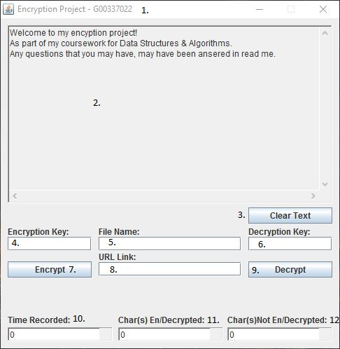

1. Header
2. Display Text Area
3. Clear Text Button
4. Encryption Key Input Area
5. File Name Input Area
6. Decryption Key Input Area
7. Encrypt Button
8. URL Link Input Area
9. Decrypt Button
10. Time Recorded Text Area
11. Characters Encrypted/Decrypted Text Area
12. Characters Not Encrypted/Decrypted Text Area

1.Header

The Header is used to display the program name and my student ID.

Very simple and not much to explain.

2.Display Text Area

This area is used to display information to the user such as progress of the codeC:\Users\lego\AppData\Local\Microsoft\Windows\INetCache\Content.Word\progress.jpg

As you can see above it shows what state it is currently in. It has finished Initialising Variables but is still in the Encryption process.

The text area also display errors to the user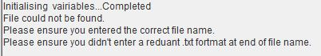

As you see above it has told the user it is unable to find the file specified.

The text are displays all this information to the user so they understand what is going on and that the program is working as it should.

3.Clear Text Button

This button clears up previously output information by the text area. This is useful when the program has become very cluttered and hard for the user to go back to more relevant information that was previously entered.

Before:

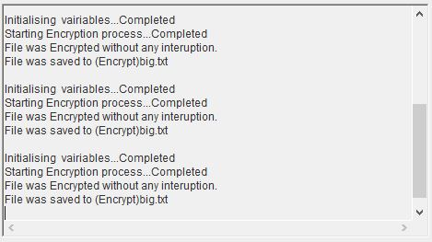

As you see above the scroll bar has started to show and the information shown may no longer be useful to the user anymore. So you click the Clear Text button.

After:

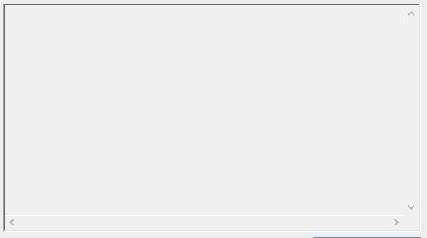

As you see above the scroll bar has retracted and is no longer visible and that there is no longer any text in the Text Area anymore.

4.Encyption Key Input Area

C:\Users\lego\AppData\Local\Microsoft\Windows\INetCache\Content.Word\key.jpg

The Key input Area is used to encrypted data using the porta cypher as reference.

Without a key the program will not runC:\Users\lego\AppData\Local\Microsoft\Windows\INetCache\Content.Word\blank.jpg

As you see above if key is black the program will tell the user.

5.File Name Input Area

The file name input area is used to find a file the user wishes to encrypt of decryptC:\Users\lego\AppData\Local\Microsoft\Windows\INetCache\Content.Word\filename.jpg

With the file name and key the program can begin to encrypt a file.

If the file name is left blank the user will be informed.C:\Users\lego\AppData\Local\Microsoft\Windows\INetCache\Content.Word\blank.jpg

6.Decryption Key Input Area

C:\Users\lego\AppData\Local\Microsoft\Windows\INetCache\Content.Word\dekey.jpg

This input box is used to decrypt a file the user wishes to enter.

7.Encrypt Button

The Encrypt Button is responsible for running the Encypt.java file to encrypt files and websites that the user inputs.

File:

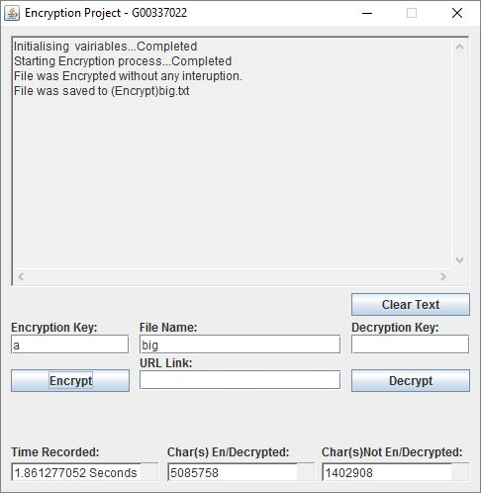

As you see above the file called “big” was encrypted in 1.85 seconds and was saved to a file called (Encrypted)big.txt. But the program also shows how many characters were encrypted and how many were unable to be encrypted. As you see 5 Million characters were successfully encrypted and 1.4 million characters were unsuccessfully encrypted.

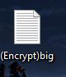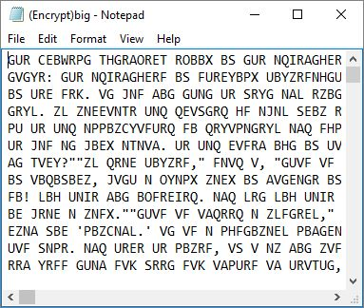

8.URL Link Input Area

C:\Users\lego\AppData\Local\Microsoft\Windows\INetCache\Content.Word\link.jpg

The URL input area is used by the user to select a website to encrypt.

9.Decypt Button

C:\Users\lego\AppData\Local\Microsoft\Windows\INetCache\Content.Word\debuttion.jpg

The Decrypt Button is used to decrypt files by the user.

It only decrypts files as websites aren’t encrypted. But it can still decrypt website that the user has encrypted as they are saved in a txt file after encryption.

As a test we will decrypt the big file which was encrypted with a key of “a”

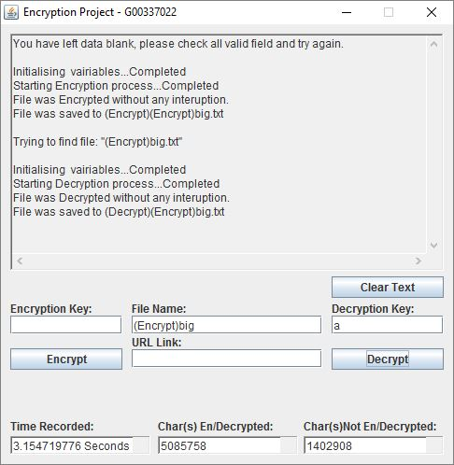

As the picture above shows the file was decrypted in 3.1 seconds and the stats show the same amount of characters were encrypted and decrypted as the file when it was encrypted.

Before:



As you see above the file (Encrypt)big.txt is unreadable.

After:

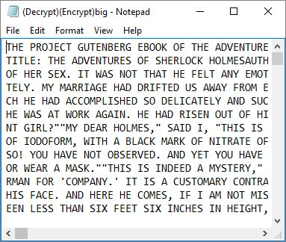

But once the process is finished it is in readable English.

10.Time Taken Text Area

C:\Users\lego\AppData\Local\Microsoft\Windows\INetCache\Content.Word\taken.jpg

The above picture displays exactly what this text box does.

It shows the calculation of how long it took to encrypt/decrypt.

11. Characters Encrypted/Decrypted Text Area

C:\Users\lego\AppData\Local\Microsoft\Windows\INetCache\Content.Word\c.jpg

The above picture shows the Text Box in action showing how many characters could be processed successfully (a,b,c) any character that is inside the porta cypher.

12. Characters Encrypted/Decrypted Text Area

C:\Users\lego\AppData\Local\Microsoft\Windows\INetCache\Content.Word\u.jpg

This picture shows the files which could not be encrypted this happens when the characters are not in the porta cypher.

(;’./.,&^%$£”!) All these characters that could occur in a file are skipped