PO Annex template

ITEA 3 Call 3

Foreword

Do not remove or modify in any way the sections having these notations,

All guidelines in the template appear in this “boxed” format. These instructions, as well as the preceding title page (“PO Annex template”) and this foreword, should never be removed manually from the submitted files: they are automatically removed by the merging function of the ITEA Community website. Potential layout issues appearing when removing the instructions (e.g. a large image leaving half a page blank) will be adjusted by the ITEA Office, between the proposal submission and the transfer of the generated PO/FPP to the reviewers.

NB: all texts between “<” and “>” symbols (incl. on the front page and in the headers) should be replaced or removed.

It is highly recommended that you carefully read all the instructions provided: they indicate for each chapter and subchapter what is expected, and must be carefully taken into account.

It is crucial that proposal writers comply with the pre-defined formatting and styling rules: breaking these rules may create errors when inserting the auto-generated sections and thus cause the merge process to fail. Complying with formatting rules can be achieved by adhering to the following guidelines:

* do not remove any predefined title and do not add headers, incl. annexes, that are not supposed to be defined according to this template, at any level of the hierarchy (e.g. do not add a §5 after §4 Rationale for public funding); in particular, for references or publications, as additional annexes are forbidden, please rely on footnotes; you are, however, free to add subsections when there is no subsection yet defined (e.g. you can define a subsection §2.2.1.1 within §2.2.1 Market analysis);
* do not modify the predefined styles, except for standard “emphasis” effects (i.e. underlined or bold text) – we recommend using the underlined and bold formatting in a consistent and prudent way throughout the document, and on body text exclusively;
* only use the pre-defined styles that start with “ITEA_”: the most relevant ones are “ITEA_BodyText” for standard paragraphs (Arial 10 with a line spacing factor of 1.2 pt), “ITEA_BodyBullets” for bullet points within standard paragraphs and “ITEA_Figure”; for captions, you can use the standard “Insert Caption” function from Word, as it will automatically use the “ITEA_Caption” styling; these styles are accessible in the “Quick Styles Gallery” of the “Home” tab;
* do not remove the instructions (both green and orange ones), and do not remove the auto-generated sections, incl. the annexes;
* do not overload the document with uncompressed / excessively large images; a proposal should ideally fit in less than 10 MB.

It is in the interest of consortia to ensure that a merged document (i.e. including auto-generated sections) can be generated and downloaded before the submission deadline so that all the relevant information is provided in the project proposal document.

Items that need to be filled in exclusively via the ITEA Community website will have the following notation:

Auto-generated section: input to be provided only on the Community website.

Do not remove or modify in any way the sections having these notations throughout the whole Annex template since they are needed to automatically merge the information provided via the ITEA Community website with your uploaded Annex document.

Unless otherwise specified, section length recommendations (in pages) are only provided as suggestions to help the editing. However, the overall length of the final merged document up to section §4 excluded must not exceed 45 pages for a PO and 75 pages for an FPP, which roughly corresponds to an uploaded file of 55 pages for a PO, and of 85 pages for an FPP (all sections included, i.e. including comments and empty auto-generated sections).

Project Outline Annex

OPTIMUM

OPTimised Industrial IoT and Distributed Control Platform for Manufacturing and Material Handling

Edited by: Giuliano Persico, Thomas Bangemann, Matthias Riedl

Date: 2016-10-27

Apart from the State-of-the-Art-dedicated text (§2.3.1) which is handled by the ITEA Office as public information, unless otherwise specified by the consortium, this document will be treated as strictly confidential.

Project key data

Auto-generated section: input to be provided only on the Community website. Do not edit or remove this box and do not provide any text within this annex in this chapter, but provide the requested information directly on the ITEA Community website.

The inserted key data will contain (among others) the acronym, full title, time frame, the respective countries and partners per country, the coordinator, as well as a short description which should include the project idea, the main expected market impact and the main technological objective.

Table of Contents

Project key data 2

Project acronyms 2

1. Project one-page description 2

2. Project overview 2

2.1. Rationale of the project 2

2.1.1. Problem statement and market value chain 2

2.1.2. Project innovations and technology value chain 2

2.2. Targeted impact 2

2.2.1. Market analysis 2

2.2.2. Consortium market access 2

2.2.3. Impact on quality of life 2

2.3. Technology 2

2.3.1. State-of-the-Art (SotA) analysis 2

2.3.2. Proposed technological innovation and novelty in relation to the SotA 2

2.3.3. Expected project outputs 2

2.3.4. Quantified objectives and quantification criteria 2

2.4. Consortium overview 2

2.4.1. Cooperation added value: business level 2

2.4.2. Cooperation added value: technology level 2

3. Work description 2

3.1. Project structure 2

3.2. Main milestones 2

4. Rationale for public funding 2

Annex A: Summary of costs & effort breakdown 21

Project acronyms

|  |  |
| --- | --- |
| CPS | Cyber Physical Systems |
| CPPS | Cyber Physical Production Systems |
| HW | Hardware |
| IoT | Internet of Things |
| IIoT | Industrial Internet of Things |
| SW | Software |
|  |  |
|  |  |
|  |  |
|  |  |
|  |  |
|  |  |
|  |  |
|  |  |
|  |  |
|  |  |
|  |  |

1. Project one-page description

(Mandatory length: 1 page)

Provide, within one page maximum, a strategic description of your proposed project addressing:

* the context and goals of the proposal;
* the business relevance and the targeted market impact;
* the innovative aspects and the major expected technical outcomes;
* the consortium relevance.

The proposed project aims to support innovative concepts for engineering, commissioning, control and supervision of smart manufacturing and material handling. It will be in line with European, National and international initiatives towards digital manufacturing, closely related to on-going activities in working groups around the German initiative Industry 4.0. Taking the results from ongoing architectural, component and ontology discussions, OPTIMUM’s major goals are: improvement of the aspects of distributed control, adaptation of IIoT technologies to real industrial needs, enhancement of control and applications by context and location awareness as well as application design and common-model based 3D engineering and supervision.

Today’s control of industrial processes is done in a highly centralized and hierarchical (S95 / IEC 62264) manner. Future concepts like component based and collaborative automation, as alongside the 4th industrial revo-/evolution, require much more distributed functionalities. Related technologies allow companies to innovate their industrial products like cranes - in the case of TEREX - reducing their HW variety of crane control modules and increasing software capabilities and modularity. Context and location awareness will further enhance assistance functions offered for these products and thus, due to increased efficiency, comfort and safety of resulting applications, allowing companies like TEREX being more competitive on the market and gaining additional market shares.

Companies like Bosch-Rexroth, that are offering classical centralized control solutions, will get ready for new challenges of component based distributed industrial control. OPTIMUM developments will complement the current developments within Industry 4.0 working groups, where Bosch is playing a driving role. Thus, synchronization with and feedback to the standardizations initiatives, increasing sustainability of project results, is guaranteed.

The main goals will be achieved by addressing innovation aspects like

Replacing centralized control of manufacturing and material handling components by intelligent components based on distributed control software,

Enhancing control SW of material handling components with context/location awareness,

Replacement of HW diversity by SW modularity,

Design of an open platform supporting interoperability with third-party control and application software,

Increasing safety, performance and flexibility based on context/location awareness and secure communication between distributed control modules,

3D-based engineering, virtual commissioning and supervision based on common models.

The consortium is representing the overall business and technological value chains needed for reaching the project goals and, after having completed the project successfully, transferring the results into the domains of smart manufacturing, material handling, with the potential of influencing standardization activities, towards digital manufacturing / Industry 4.0. The domains covered by OPTIMUM are represented by key players alongside the business value chains (like Bosch-Rexroth, ERMETAL, TEREX, TRIMEK), innovative SMEs and research partners complementing all innovation aspects addressed.

1. Project overview
   1. Rationale of the project
      1. Problem statement and market value chain

(Recommended length: 1-2 pages)

Introduce here the problem the project aims to solve. Explain the current issues, limitations or bottlenecks of what currently exists, explain the needs you plan to satisfy or to create.

Describe the societal, economic and/or technological challenges addressed by the proposed project.

Also introduce the market value chain(s). The market value chain is a representation of the various processes involved in producing products or services and delivering them to the market. It indicates where and how value is considered and created, and how the market actors in their respective markets can be profitable. It also describes the actors’ strategies and relative positioning: it must show all the actors involved in designing, producing, distributing the products and/or services and the relationships among them. All the peripheral actors who can influence the market(s), through regulations, recommendations, indirect suggestions, etc., must also be included. Describe clearly the interfaces between these actors and define the customer – provider relationship(s) wherever relevant.

This subsection describes the context and background relevant to the project, in terms of technological and market status, not the project itself. It should convince evaluators that the project partners have a good understanding of the context in which they will be evolving, both technology- and business-wise.

Manufacturing goods is playing central rules at National, European or world markets. It contri­butes more than 75% to the exportation in EU area (see Figure 1).

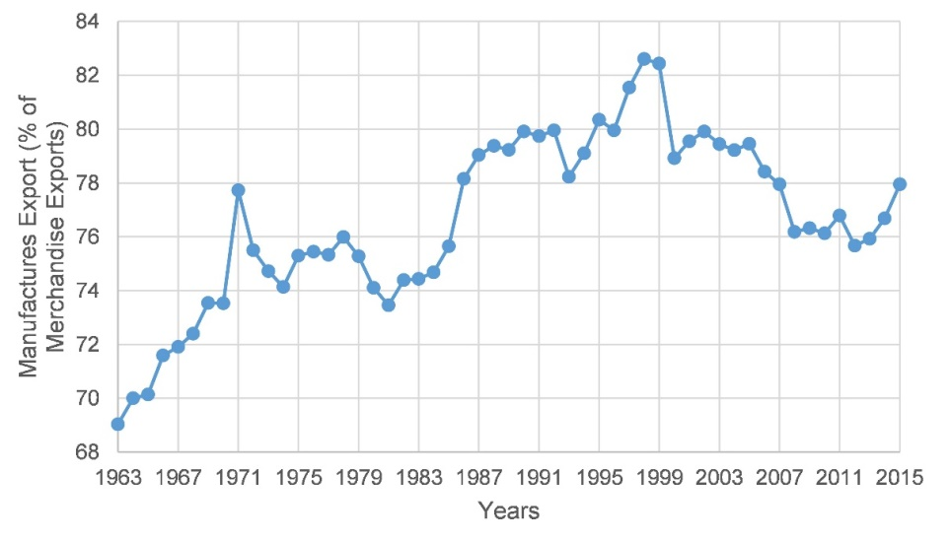

Figure 1: European manufacturers export volume [Source:http://data.worldbank.org/indicator/ TX.VAL.MANF.ZS.UN?end=2015&locations=XC&start=1962&view=chart]

Industrial production processes are moving towards a new dimension characterized by “Digital Manufacturing” or “Industry 4.0” like initiatives. Several European initiatives are playing central roles towards that direction. In that context, supply chain optimization and integration into the overall workflow is a key issue towards efficient and flexible production satisfying individual customer’s needs. One of the key partners of the OPTIMUM consortium – TEREX – is among the world’s leading manufacturers of material handling components (cranes). Currently cranes play a crucial role within the supply chain as they are mainly operated manually to provide material at the right time to the right place. Common control coordinated with other material handling components like forklifts or floor conveyors is rarely implemented. Within factory workshops many cranes have to be operated in parallel or even in a synchronized manner, which is also mostly done by human operators today, causing security and safety issues. Summarizing, integration of cranes in standard applications and into overall automatic control procedures is rarely achieved so far, but it is an elementary precondition for operating flexible plants and autonomous production components as needed for future Industry 4.0 applications. The more integrated production processes are planned and operated, the more competitive goods may be produced. This applies to all branches, including those addressed by OPTIMUM.

Considering these issues, OPTIMUM addresses the following problems:

***Problem 1: Efficient programming of industrial control application requires interoperable tools and application frameworks***

Industrial control applications are typically developed in a closed, vertically arranged market. The manufacturers of PLCs provide development environments (e.g. SIEMENS Step7, Phoenix Contact PC WORX…) that should be used for programming their own brands controllers. Within inhomogeneous PLC environments, many different programming environments have to be operated and different brands are used. Third party’s applications have either to be developed using the right development environment or, while complying with the right interface and protocol standards and then being integrated into the overall system architecture again using branded engineering tools.

***Problem 2: Material handling components are either individually manually operated or by a central controller***

Most of the material handling components are individually and manually operated. Process cranes are integrated into the overall control strategy of the production system, equipped with centralized PLCs. The variety and performance of electronics integrated into crane solutions is of high diversity. This requires enormous development and production costs. There is a strong demand for reducing HW diversity and to increase SW modularity for efficiency and cost reasons.

***Problem 3: Seamless industrial real-time communication on wired and wireless networks is not achieved today***

Industrial communication architectures are characterized to be composed of a variety of different communication protocols with components for bridging the gap between them. Industrial wireless communication is rarely supporting hard real-time control requirements. Therefore the platform OPTIMUM must be able to make the devices communicate on wired and wireless networks seamlessly, being a huge challenge considering all the different industrial requirements. In consequence, suitable Information and Communication Technologies (ICT) are crucial for the success and implementation of the platform. The communication must occur in real time, and must permit the devices to collaborate to fulfill challenging Industry 4.0 enabled applications.

***Problem 4: Safety and precise positioning of material handling components mainly belongs to the responsibility of the human operator***

The safety of and positioning precision of manually operated cranes is solely dependent on the operator itself. There is rarely support by automated functions. Fully integrated logistics solutions are equipped with sensors like proximity initiators, cameras or others that provide position information to the central system controller. Safety and comfort functions are key selling points on this competitive market. As more than 90% of the solutions are manually operated, there is an enormous potential for additional support functions based on context and location awareness. Systematic context and location awareness are enablers for advanced applications.

***Problem 5: Security and safety of industrial applications are fundamental aspects for the acceptance of application related “self”-functions and collaborated work***

Along with productive application and management functions, proper security and safety concepts and techniques need to be developed in order to protect applications, data, systems and services – while still fulfilling real-time requirements of the industrial domain.

***Problem 6: Engineering, commissioning and operation of distributed applications must be kept easy and comfortable***

Distributed control generates a lot of new challenges compared to today’s centralized setups. To avoid acceptance problems from end users, system integrators and alike, the introduction of this new technology must be supported by user friendly and comfortable support applications. 🡪 We have to meet the customer at the place he is today and support the migration.

The OPTIMUM proposal addresses the following challenges:

* **Societal:** Production processes must be highly efficient considering consumption of natural resources. Thus production and logistic processes must become optimized. While this shall be achieved, safety and security issues shall be guaranteed regarding personnel and equipment. 3D based engineering will increase acceptance for the newly introduced technology of distributed control and enhance the comfort of the overall engineering process.
* **Economic:** Economic success and positioning on the international market depend on efficiency and high product quality, competitive product functionalities, separation from the mass market and efficient production and logistic processes. These characteristics are addressed by the innovations foreseen alongside the OPTIMUM value chain. Replacing HW diversity by SW modularity will reduce development costs and allow more intelligent component functions.
* **Technological:** Control functions distributed to individual manufacturing and material handling components will drastically increase the capabilities of formerly basic, low-level components. This will allow implementing comfort functions, providing more flexibility and increasing safety at application level. Collaborative operation of individual components will become possible based on common communication platform and control framework.

The market value chain addressed by the OPTIMUM proposal can be illustrated as follows:

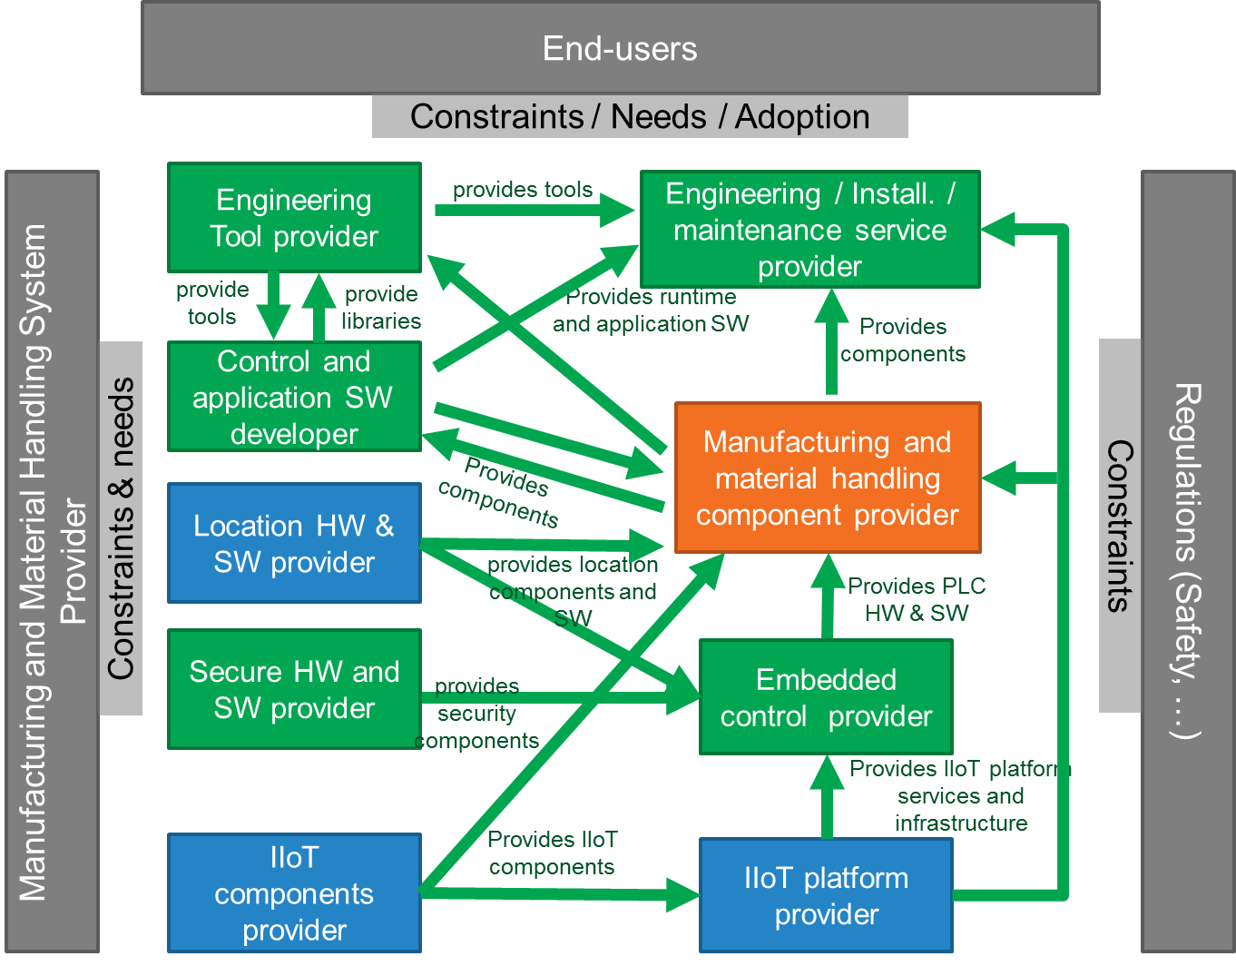

Figure 2: Business value chain.

Figure 2 illustrates the expected situation after the OPTIMUM project will have finished. Today’s market value chain is quite similar, except the technological background, participants in the business value chain have to bring in. OPTIMUM will introduce an IIoT platform, whereas today’s components are not able to communicate, or are equipped with classical fieldbus technology. Location and context awareness is also introduced by OPTIMUM – bringing new participants to this value chain. The expected OPTIMUM influence is described in section 2.2.2.

* + 1. Project innovations and technology value chain

(Recommended length: 1-2 pages)

Present here a brief view of the project innovations you are introducing: focus the description on novelty in terms of the state-of-the-art. Innovation can include both technological, process, usage and business model innovations. Explain what the project brings to the table, how it differs from existing results and previous or current projects, products and services, how partners will be able to differentiate themselves from existing market actors and become competitive (or how they can create or reimagine a market). Remain concise in this section (cf. §2.2 and §2.3).

Describe in a few words what the project aims to achieve and how it backs the broader goals of the main partners.

Introduce also the technological value chain(s): it is a kind of modular architecture comprising the main functions and building blocks required to create the solution, as well as their interactions.

This subsection should convince evaluators of the novelty of the project proposal.

The OPTIMUM proposal aims to support new concepts of engineering, commissioning, controlling and supervision of Digital Manufacturing / Industry 4.0 like distributed production and logistics components and systems, or even systems of systems. This will be achieved while introducing several innovations for solving the problems introduced above in section 2.1.1:

* ***Application development within an application eco-system (addressing problem 1)***

Using the capabilities provided by a distributed control and application environment on top of an IIoT based communication infrastructure will allow innovative application design and will be a foundation for increasing safety for operators and equipment. This will be facili­tated by the development of an IIoT and control platform concept, standardized interfaces for plugging applications, and a development and deployment environment for distributed and assistance functions as well as 3D-enabled engineering and supervision tools.

* ***Development of a distributed control platform (addressing problem 2)***

The distributed control platform will be constituted of 1) a runtime environment enabling fine-grained control and application modules and 2) an application development framework for comfortable application design and distribution to runtime components. Application distribution and operational message transfer will benefit from implicit, IIoT platform based seamless communication.

* ***IIoT based platform for real-time communication (addressing problem 3)***

Existing and upcoming (I)IoT platforms and protocol extension will be analysed with regards to the requirements introduced from the domains addressed by the OPTIMUM proposal. Research and developments will end-up with a platform solution targeting these requirements and being the basis for distributed control and applications.

* ***Integrating location and context awareness into control (addressing problem 4)***

Integrated context and location awareness are enablers for advanced applications (control and assistance). It will allow collaborative actions between control elements (e.g. tandem operation of cranes) as well as assistance functions that e.g. will only run in a certain position of the shop floor or if certain external conditions are fulfilled.

* ***Security and safety in industrial environments (addressing problem 5)***

The goal is to create an end-to-end security solution that uses a new security paradigm moving from the `walled garden’ concept that tries to isolate systems in which reaction to attacks occurs after the event to the resilient systems with distributed security control.

* ***3D based engineering, commissioning and supervision based on common models (addressing problem 6)***

OPTIMUM will enhance the design processes, validation of solutions by simulation and also use 3D-technologies for supervision particularly for interoperation of cranes with conveyor technology, folk-lifts or machinery. During the phases of layout planning, simu­lation, virtual commissioning and supervision the same pool of 3D models will be used.

Figure 3 illustrates the technological value chain of the intended OPTIMUM solution. The main end user partners (e.g. TRIMEK, ERMETAL) will become more competitive by adopting the overall technological value chain – using IIoT based distributed control components for material handling. TRIMEK will benefit from these technologies in more flexible production application design and operation. ERMETAL will also benefit from the 3D-enabled engineering, virtual commissioning and supervision technologies. Thus ERMETAL will have more efficient and effective planning ability in production lines where costs can be reduced and work safety of the lines can be enhanced using 3D based engineering and IIoT technologies. Moreover, this project triggering the other investments according to Industry 4.0 will be a milestone for ERMETAL and its sub-industries. In any case, these partners will move their production sites towards smart Industry 4.0 enabled factories. TEREX will enhance their crane control by OPTIMUM technologies and thus being able of reducing hardware diversity of controllers and gaining flexibility and comfort functions based on modular software. Other partners will attract additional market shares based on the innovative solutions developed in OPTIMUM.

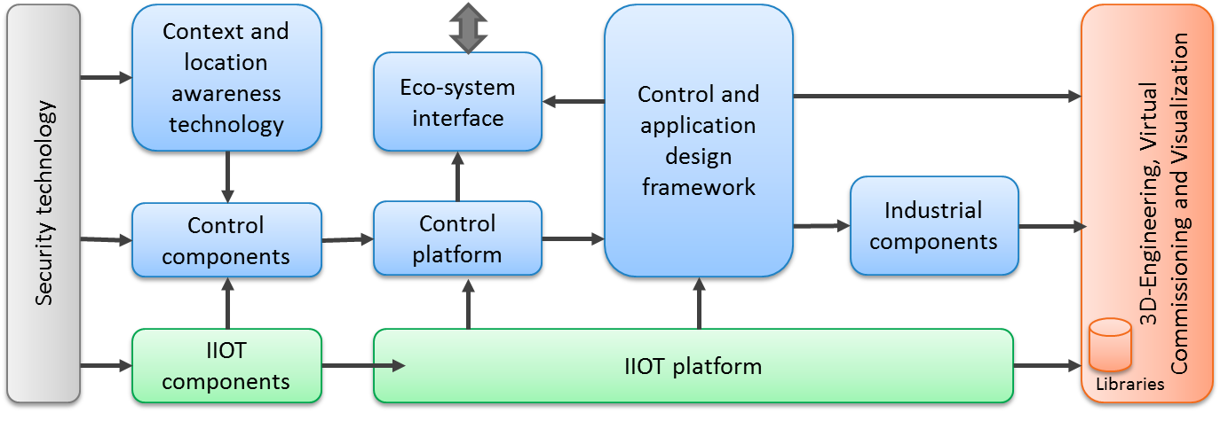

Figure 3: Technological value chain

OPTIMUM technologies will boost competitive solutions of all project partners. The open OPTIMUM eco-system will allow third parties participating from the project achievements while exploiting common interface as well as development and deployment environments for designing specific applications.

* 1. Targeted impact
     1. Market analysis

(Recommended length: up to 5 pages)

Present here a detailed market analysis that is focused on the actual markets targeted by the project partners. Present market trends (e.g. graphics and figures), main products, describe the landscape in terms of competing or alternative solutions (companies, products…), the situation in Europe vs. US and Asia, etc.; provide figures whenever possible. Use up-to-date data or comment on outdated information (e.g. forecasts of several years ago). Do not rely solely on current market situations but consider also predictions and estimates of future growth from the latest studies.

Describe the existing or announced industrial products or services in the project domain. Explain which competitive advantages the market leaders have and how differentiation could be achieved towards them. Detail why smaller actors are restricted to low market share (e.g. targeting niche markets or competitiveness issue) and how volatile the market currently is (are there more and more actors or is it the opposite? In the latter case, does it derive from market consolidation or from competitors dying out?).

Present existing and potential and/or forecasted competitors (e.g. Google in the car industry or satellites). Do not hesitate to introduce Porter’s five forces model of competition to describe (on top of the current industry competitors) not only suppliers and buyers, but also potential new entrants as well as threat of substitutes.

This subsection should convince evaluators that the project partners have a clear and detailed understanding of the market they are targeting, including not only the current situation but also the current trends, forecasted evolutions and potential threats.

**Material handling market**

***Market description and segmentation***

Material handling as a segment of the Intra-logistics defines the logistic material and product flows that take place inside a workshop or inside a factory site. Inside this segment all industrial infrastructure, which allows moving goods or products by lifting is defined as the sub-segment of hoisting solutions. Hoisting solutions infrastructure shows a wide range of complexity in their products: from very simple equipment for lifting loads (e.g. electrical chain hoists) up to various types of electrically driven overhead (EOT) cranes (see the Figure 4).

***Estimated market volume***

The majority of products inside this segment of Hoisting Solutions are manually controlled hoists or cranes. `Manually controlled` means that the hoist units or cranes are controlled by an operator, either via cable or wirelessly via a radio remote control system. Only app. 3% of all cranes are fully automated as part of a complete intra-logistic material flow process: these ‘process cranes’ are represented in the table below in the column `special`. Those types of cranes are sophisticated and expensive, especially due to their expensive centralized control system.

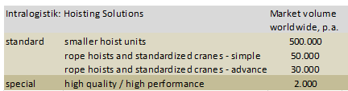

***Competitive situation***

The market of industrial cranes and hoisting components manufacturers is segmented into a smaller group of worldwide acting companies and several hundred locally (often national wide) acting smaller companies. Smaller crane building companies often buy hoisting components from these worldwide acting companies mentioned – and build customized cranes or individually `tailor made` hoisting solutions from these components. This fact forces a situation where standard products and components are affected by high price pressure. Consequently, TEREX-Material Handling tries to distinguish their products and services from those of other competitors. Most important product features for `product differentiation` are `Safety` and performance resp. productivity.

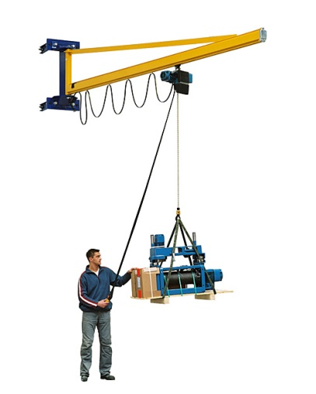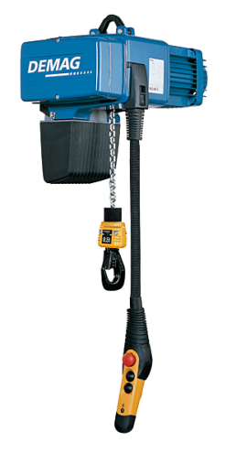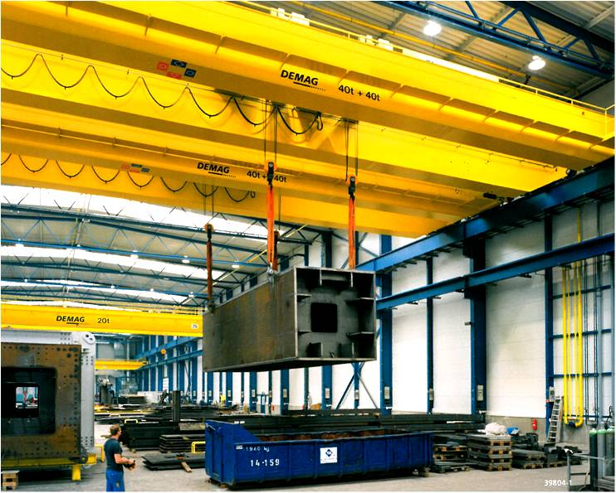

Figure 4: DEAMG Chain hoist DC (left) as a part of a jib crane (middle). Right: Process crane: either manually controlled or as a part of automated production chain.

The important keywords in this context are variant-management and variant-reduction, meaning, that the number of theoretical variants drastically influences the process costs of the components – in all their different phases of the product lifetime (development, validation, setting into operation, troubleshooting, maintenance and service). Consequently, TEREX as a component manufactures is highly interested to simplify and unify the control interfaces. Distributed control systems with highly standardized control interfaces (wired or wireless) therefore are assumed to offer best conditions for future industrial products that combine flexibility in application and cost efficiency in design.

***Competitive products and services on the market***

Competitors such as KONECRANES, KITO, ABUS have a similar product range of cranes, components and services. For TEREX, it is strategically important to invest in new technologies for a products and services differentiation.

***Vision and market outlook***

The vision is that of a stronger automation and integration of location awareness of the standard segments of manually driven hoists and standard EOT cranes. The expectation is that those kinds of hoisting solution will become equipped with more intelligent control functions that allow increasing the safety and / or the productivity of the operator. These functions will `guide and assist` the actions of the operator.

Feedback from customers showed TEREX, that their customers highly value those product features that increase productivity and / or safety. TEREX foresees that these `guiding and assisting` functionalities of upcoming products are crucial for future selling propositions and, will significantly influence the customer`s buying decision.

Flexible control capabilities and location awareness, supported by assistance functions, 3D simulation and virtual commissioning as part of the engineering process will enhance today’s “standard” crane modules becoming part of so-called “special” solutions. Those crane components may be flexibly integrated into complete intra-logistic material flow solutions or even become an integrated part of highly flexible but complex production processes as they are foreseen for future Industry 4.0 compliant production sites. This will then allow increasing the market shares of “special” solutions.

**Manufacturing market**

***Market description and segmentation***

Manufacturing is one of the main industries worldwide covering from the textile or food and beverages markets to the aerospace market and in the whole cycle of a product developing chain such as manipulating or transporting materials to the very assembling and packaging of the product. Manufacturing components and system, as done by ERMETAL, is seriously supporting automotive industry, that plays an important role in employment and export across Europe and is growing every year.

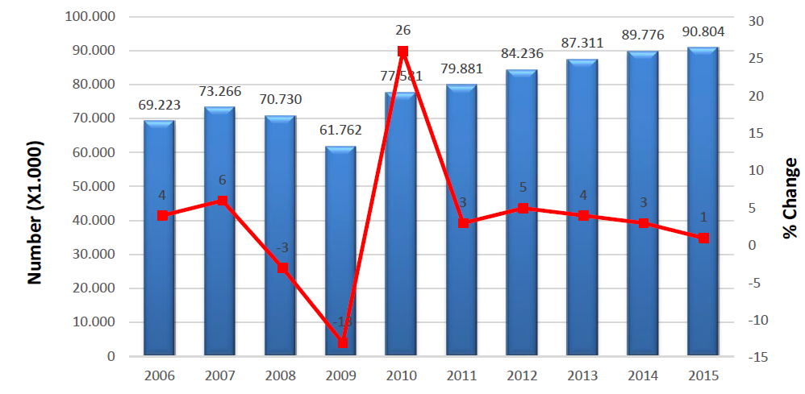

Figure 5: Automotive market growth [Source: OICA, http://www.oica.net/category/production-statistics/]

Companies are forced to manufacture their products in more efficient and safe way ensuring sustainable quality due to global scale competition that causes some production shift to Far East region where labour costs are very low. This issue can be overcome by increasing efficiency in manufacturing processes. IIoT and Industry 4.0 technology and tools are seen as enabler for improving the rate of capacity utilization. Tools combined with optimisation methods may lessen the production costs in automotive industry significantly - therefore sector reaches to more competitive position in the global market. In addition, the costumers demand for customized products that are challenging for many sectors, using a large number and different sizes of materials. Various materials usage makes it harder to control transportation, storage and orders for both, key and sub-industries. Industry 4.0 involves a high level of automation and digitalization of power plants and factories. Using Internet and cyber-physical systems, or through virtual networks with possibilities of controlling physical objects, the manufacturing plants can be upgraded into intelligent plants characterized by instantaneous and continuous inter-communication between the different workstations that form the chains of production, procurement, packing and shipping. Industry 4.0 technology is the instrument that supports current industrial changes, this being the origin of innovation, where the traditional models are transformed to accommodate the market and is precisely this niche where potential customers are to be found.

***Estimated market volume***

‘Manufacturing’ was the second highest economic activity in terms of share of the GVA in the EU-28 and in six other G20 members. ‘Manufacturing’ represented more than one fifth of the economies of South Korea, China and Indonesia and between 14.0 % and 20.0 % in Japan, Turkey, India, the EU-28 and Argentina. With the exception of Australia, where ‘manufacturing’ represented 7.2 % of the economy’s GVA, in all other G20 members, it equated to at least 10.0 %.

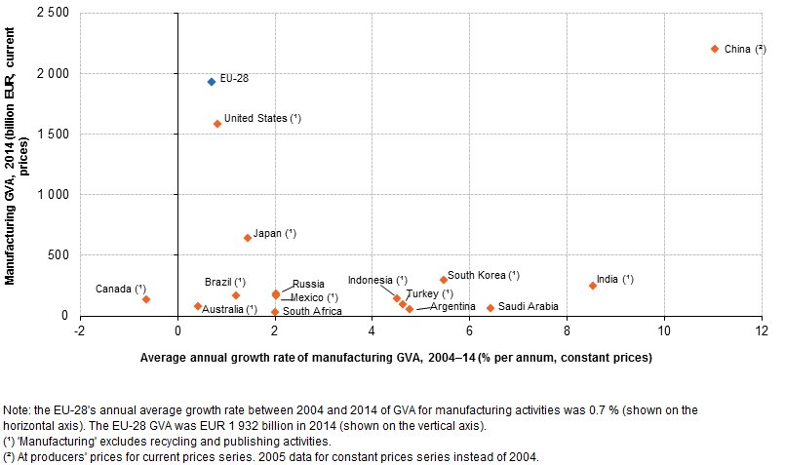

Figure 6: Average annual growth rate of manufacturing [source: http://ec.europa.eu/eurostat/statistics-explained/index.php/The_EU_in_the_world_-_industry,_trade_and_services]

***Competitive situation***

Industry 4.0 arises as the perfect solution to solve the problems of the phenomenon of relocation of factories (for Eastern Europe), or the closure of companies that are losing the ability to pay its daily operating costs. In Europe, only a few companies offer high added value and innovative products. Just a few countries, as well have managed to preserve a solid manufacturing structure since the new millennium began.

***Competitive products and services on the market***

All major automation suppliers offer control components and systems for manufacturing and material handling processes. Typically the control components within in manufacturing are connected by field busses or Ethernet based communication - each of them engineered separately. There is a need of a control platform which is dedicated for distributed applications. IIoT Interfaces for converging the communication networks of information technology and operational technology are missing in today`s control solutions.

The Industry 4.0 concept is being driven by several European projects, where innovation ecosystems are being consolidated. Within this innovation ecosystems initiatives like I4MS (ICT for Manufacturing SME Innovation Ecosystems) or SAE (Smart Anything Everywhere) are boosting the development of products that integrate digital technology inside, and aim at accelerating the design, development and uptake of advanced digital technologies by European Industry. In the United States, the project "Smart Manufacturing Leadership Coalition (SMLC)", focussing also on the modalities of the future industrial manufacturing and aims at developing an open Smart Manufacturing Platform that integrates existing and future plant-level data, simulations and systems across manufacturing seams to orchestrate business real-time enterprise-wide.

***Vision and market outlook***

The concept of industry 4.0 is relatively recent and refers to the fourth industrial revolution consisting in the introduction of digital technologies in the industry. The typology of current market makes it necessary to give an evolutionary change to the re-industrialization of the processes adapted to the customer’s needs, placing customer at the center of the process. So, the means of the production turn on lathe to the needs of the client, adapting to the expectations and needs of it, being more flexible to the demand and integrating the industrial physical world and the virtual one, where the elements are connected and communicate among themselves using the IoT and where every movement it transferred as Big Data and Deep learning.

* + 1. Consortium market access

(Recommended length: up to 10 pages)

Describe how the introduced innovation will help achieve competitive advantage. Explain the expected business impact of the project with respect to the competition (see §2.2.1). Each of the partners (except for the academics and research centres) should clearly identify its markets, opportunities and how it intends to profit from them.

Detail how the partners will exploit the actual project results after the project end (e.g. integration in future products or services, third-party licensed software, published APIs, life-cycle maintenance through an SME, open source software, integration in in-house software tools ...). When possible, briefly discuss a timeline for commercialising the project outcome (keeping in mind that funded projects may not directly develop products or services): indicate the most relevant technology deployment time range, i.e. short-term (less than two years after project closure), mid-term (two to four years) or long-term (five years or more) that can be expected.

NB: while ambition is at the core of competitiveness, it is also important to remain realistic and credible with regards to the partner targets and capabilities.

Detail also in this section the global strategy deployed towards achieving the exploitation goals, for instance (and when relevant) through:

* Standardisation:
* Standardisation includes de jure/de facto standards, published APIs, open source repositories and associated communities, etc. Standardisation should be seen as a way to enable exploitation plans, e.g. by enabling a market to take off, by helping integrators to embrace the proposed technology, by counterbalancing proprietary solutions of leading competitors, etc.
* When relevant, define a standardisation strategy consistent with the project and document its implementation. Projects having software- or system-engineering related activities should, whenever applicable, identify the open source strategy or the tools interoperability strategy.
* When Open Source Software is considered, explain how the project intends to build (on) a large, lively and strong community around the open source software and how the impact from the project will be quantified.
* Dissemination:
* Consider here dissemination towards customers, communities (industrial, scientific, etc.), incl. communications, seminars, workshops, conferences, papers, courses, etc. Dissemination must be seen as a tool to make potential customers or partners aware of the project achievements and results, within and outside the organisations participating in the project.
* Define and justify a dissemination strategy actually supporting and having impact on the project, i.e. justify the choices made (e.g. why selecting given workshops rather than others). Indicate how the project results will be disseminated in the course and at the end of the project, i.e. by means of (e.g.) which presentations in workshops and conferences, publications, etc.

If fast exploitation is expected, explain what exactly is targeted, and how the consortium intends to achieve these goals.

This subsection should convince evaluators that the consortium is credible, legitimate and relevant to address the market and to exploit the project results (if successful) to generate business (i.e. that it can have an impact on the market). This subsection should be market oriented and should only focus on the long-term goals of the project (i.e. what is expected to be achieved thanks to the project outcomes, i.e. after the project closure).

The business value chain for manufacturing and material handling is illustrated in Figure 2. The following descriptions provide a rough vision how participants in the business value chain may benefit from OPTIMUM results and may finally foster their position on the market.

* **IIoT components provider:** IoT components provider will improve their position in the market especially if they are dedicated to develop single components that work inde­pen­dently, but also can be part of a large network of components. The platform proposed al­lows the users to manage all the devices together regardless of the device character­istics (e.g., communication methods, the data it provides, the manufacturer). In conse­quence, a component provider would not need to build a set of devices, it can focus only on building specific devices where it can provide added value, as long as it sticks to the standards and protocols used. The components provider will benefit from this project to expand its potential market, for example in the use of a single device model in different environments.
* **IIoT platform provider:** IoT platform providers will benefit from OPTIMUS due to the innovative characteristics of the platform. There is no platform in the market with appro­priate characteristics and the industry is eager to use this kind of solutions because the industry 4.0 and the use of IoT is still in an early stage and there is a growing interest in this market.

**Secure HW and SW provider:** Industrial automation and smart manufacturing are relatively new market segments for secure HW and SW provider. Approaches like industry 4.0 bring digitization and IP connectivity to manufacturing sites and significantly increase their attack surface for security breaches. Manufacturers of industrial control systems have started to understand the need to provide suitable solutions to their customers and therefore interest in and demand for secure HW and SW is starting to increase. OPTIMUM will provide the conceptual framework to make suitable solutions available off the shelf.

**Location HW & SW provider:** Most of the material handling operations in warehouses are based under a SISO strategy (single-Input, Single-Output), not considering the actual position of the conveyor vehicle. Hence, localization systems will have a large impact on material handling processes in the near future. Therefore, the Location HW & SW provider will largely benefit from the OPTIMUM project with well-defined use cases, new technology platforms, products and standardized interfaces.

**Embedded control provider:** Existing controllers, like PLC or specific embedded hardware may be enhanced by OPTIMUM based concepts and functionalities to offer new application functionalities on top of the embedded controller hardware and IIoT like communication. Providers of embedded controllers, such as BREX or THORSIS offer such components starting from flexible gateways, remote IO systems or dedicated small embedded controllers. OPTIMUM will enable embedded controller in automation domain to be an integral part of flexible network infrastructures.

**Manufacturing and material handling component manufacturers:** In the material handling industry many competitors are active with a similar range of products. Based on OPTIMUM results, component manufacturers will achieve competitive advantage and reach differentiation through: distributed applications running between logistics systems and crane components; specific assistance functions and their potential to be integrated in future solutions; maintenance, remote service and auto-configuration; future functions may also be – at least partially - location sensitive or even dependent; industrial automation environ­ments application modules will have the capability of being running on different communica­tion protocols (e.g. wired and wireless) without cutbacks for aspects like security, engineering applications will support design, simulation and commissioning of new systems.

**Control and application SW developer:** Software development based on new concepts introduced by CPPS or IIoT will be adapted in OPTIMUM to use it in automation domain. Thus different application design criteria have to be considered and prototypical implement­ted in engineering systems, in order to be able to design the overall control application by means of predefined Function Blocks or object-oriented and download specific parts of the application on dedicated devices, e.g. based on CPPS or IIoT platforms. In addition, the communication relations between the objects running on different hardware components have to be re-assigned automatically with respect to real-time constraints. Furthermore, the design of ad-hoc interactions of devices, often required for interaction of devices in material handling, will be possible.

**Engineering tool provider:** Engineering tool providers like TARAKOS may, based on OPTIMUM concepts, improve the market position of their software-tools for layout and process planning, visualization and simulation. New tool functions will assist users to plan innovative processes in IoT-context and give users the chance to validate their solutions easily. Furthermore, e.g. TARAKOS will support animated 3D-layouts designed in an early project phase later on for simulation and supervision.

**Engineering / installation / maintenance service provider:** Engineering companies will benefit from 3D-based modelling, simulation and virtual commissioning functionalities of engineering tools based on OPTIMUM engineering strategies. They will benefit from shortened engineering times with simultaneous consideration of higher quality regarding the request for proposal and thus being able to provide more competitive offerings. Installation, operational support and maintenance tasks may be more efficient.

**Exploitation and Dissemination**

The following table summarizes the exploitation and dissemination potential and activities of each OPTIMUM partner.

|  |  |
| --- | --- |
| OPTIMUM Partner |  |
| TEREX | **Exploitation**  Results of OPTIMUM will immediately run into a TEREX-intern major product development project called `new unified control system architecture`, which describes TEREX`s approach to replace the complete today`s used heterogeneous control portfolio. TEREX awaits internal benefits (like cost reductions due to the intended `minimalistic hardware designs`) - paired with innovative new features in their products (assistance functions). Internal- and customer- benefits will strengthen TEREX`s market position in a significant and sustainable manner. In mid-term view the results of OPTIMUM will affect yearly around 50.000 chain hoists and more than 10.000 industrial cranes.  **Dissemination**  A part of OPTIMUM project is to build a `Demonstrator`, which means a real hoisting solution application based on the results of OPTIMUM. TEREX will show this to their customers – furthermore TEREX will do efforts to communicate and propagate the results in form of publications, house exhibitions and other promotional activities. As member in the VDMA organisation TEREX-MH will present contents of this project at suitable VDMA meetings and platforms. |
| BREX | **Exploitation**  Today’s control solutions will be enabled to fulfil the requirements in distributed collaborating applications. Bosch Rexroth will improve knowhow concerning control components, operating environments,, control engineering and transactions between distributed components. This know­how will flow into future generations of control products, which are exploited in the market of transportation solutions as well as in the general automation market.  **Dissemination**  Bosch Rexroth will exhibit project results on fairs, make presentations on congresses, contribute to specialist publications and inform members of professional associations, like VDMA. |
| NXP | **Exploitation**  Industrial automation and smart manufacturing will open up a complete new market segment for NXP where strong growth is expected in Europe during the next decade, but also worldwide. This area is currently gaining high strategic import­ance for the European industry. NXP will derive new dedicated solutions and products in close cooperation with partners from the industrial automation area. The consolidated findings of this project will enable NXP to support new architect­tures and platforms to satisfy the starting demand. Early market introduction is mandatory to be successful for an early positioning in this future market. The addressed area of smart industrial automation has already today a value of several hundred million Euros. First commercial solutions based on the new concepts and expertise gained within the project could be expected within the coming 4-5 years.  **Dissemination**  NXP is actively driving scientific deployment of relevant research and development results in the form of scientific presentations, publications in technical and scientific journals or in the form of patent applications. The results generated within this project will be opened up in consultation with the project partners to an interested public in the form of conference papers, scientific talks, articles and publications. The results of the project will have strong influence on these activities and help to further deepen the cooperation with universities, institutes and research centers. NXP is actively engaged in the German “Platform Industry 4.0” in several working groups as well as in BitKom and ZVEI. |
| TARAKOS | **Exploitation**  Make our products more efficient and expand into the crane industry with material flow applications, especially for production logistics applications.  **Dissemination**  A base for the next generation of tarakos Virtual Reality software tools the results of the projects will be used also in the scientific space where tarakos is working with research institutes to continuously publish the publicly available knowledge in the area of 3D simulation for production environments. |
| COMNOVO | **Exploitation**  Comnovo is interested in extending the Know-how for industrial localization systems with new applications in the crane industry. The results of the project will be integrated in the new product development process for new location-based assistance- and safety system.  **Dissemination**  Part of the results will be used in the scientific community of Comnovo, where results will be also made available by scientific presentations and publications at international conferences. |
| THORSIS | **Exploitation**  Fieldbus systems will exist in parallel to Field-Ethernet-Technology on the market for the foreseeable future as most sensor devices don´t need the high-speed (and in turn higher costs) associated with Ethernet. Thus there will be an increasing demand for gateways. Further with the use of distributed components the consideration of security aspects becomes of steadily growing significance as the linking of wide range distributed production points increases the potential for threads of the production. The hardware and software platforms developed within the OPTIMUM project can provide as base for distributed control devices for the required intelligent and secure crosslinking.  **Dissemination**  Thorsis will promote the OPTIMUM results of distributed devices among its existing customer base. Thorsis will organize in house demonstrations and promote the system on several industrial fairs e.g. Hannover Fair, SPS / IPC / Drives and Meorga Fairs. Further Thorsis might contribute to academic publications on this topic as well as support the standardization of the OPTIMUM project results using our participation in the relevant working groups of FDT, OPC, FDI, PI and FieldComm Group. |
| IFAK | **Exploitation**  Based on work done within the OPTIMUM project, IFAK is interested in a con­tinued co-operation with the German and European industrial partners. Speci­fically, IFAK intends to support TEREX in the further introduction of project results, like communication, distributed control functions, assistance functions or integra­tion components for legacy systems for their material handling components. IFAK as research and development institution will exploit the results of the project to reinforce research co-operations, strengthen the integration of OPTIMUM related topics into lectures, and establish research activities complementing the OPTIMUM project results. IFAK offers knowledge transfer (presentations, seminars, work­shops, development support, etc.), technical guidance regarding introduction of advanced methods and technologies to improve automation system’s capabilities and prototype tools/software to customers and project partners.  **Dissemination**  IFAK will support the dissemination activities by writing publications to be sub­mitted to national and international conferences and journals. Further on, IFAK will prepare presentations to working groups focused on topics like "Industry 4.0” under the hood of large associations like VDI/VDE/GMA or Platform Industry 4.0. IFAK is organizing a series of colloquia presenting project and research results. Participation to these workshops is free of charge for the public audience. The workshops are announced publicly, among others via the infrastructure of the regional VDI group, the German Society of Engineers. |
| URO | **Exploitation**  Results will be used to build the ground for new business ideas, which will potentially result in founding new SME.  **Dissemination**  URO will actively drive dissemination by means of publishing the research results on well-known conferences, in journals, through talks, as well as presentation at exhibitions like Embedded World. URO will proceed in organizing the established SOCNE workshop on Service-oriented Cyber-Physical Systems in Converging Networked Environments as well as the WS4D workshop series. |
| ABALIA | **Exploitation**  ABALIA will use the context-aware technology developed to generate new services for the manufacturing market and for the IoT industry as well. This, along with the expertise of the company in systems monitoring will help the company to deploy the IIoT platform in new and old factories.  **Dissemination**  ABALIA will participate in the dissemination of the project by showing the IIoT platform for the Industry 4.0 in national congresses and conferences, in journals, websites and well-known forums. |
| VISUALTIS | **Exploitation**  Visualtis is interested in improving its beacon-based location system to other devices. Its platform is currently used in the stone industry enabling supply chain departments to save costs. It is also interested in improve the platform adding context awareness system.  **Dissemination**  Visualtis is part of CENTIC, a tech-innovation center which is integrated with other industry clusters. The results of this project can be showed up in different wokshops managed by them. |
| NIMBEO | **Exploitation**  Nimbeo builds, designs, implements and move to market high added-value tech solutions focused on EdTech, telecommunications and Smart Grids, encompassed by the Smart Big Data paradigm. Nimbeo will exploit the project by including the innovative outcomes of the project and the systems that secure the smart grid into the portfolio. Nimbeo collaborates with big players in the energy market. These players are a potential target for the exploitation of the project outcomes. Nimbeo is currently providing tools to analyze and control the smart grids; hence, the project is completely aligned with the strategy of the company.  **Dissemination**  NIMBEO will participate in the dissemination of OPTIMUM by showing the results in terms of IoT in national and international congresses, conferences and workshops. |
| ANSWARE | **Exploitation**  Answare will provide the project with its experience in real-time monitoring and control acquired in the Space sector and also its expertise in decision support systems (Control and application SW designer)  **Dissemination**  Answare is part of CENTIC, the Technology Centre of the Region of Murcia (50 companies). CENTIC is involved in IoT and will disseminate the project results to its members and community. |
| SQS | **Exploitation**  The testing solution will be commercialized as a software framework (license) and as a service. SQS has the following strategic channels for its commercialization: a) Current customers of SQS related with the CPS field will be contacted from the beginning of the project and invited to presentations and test of the testing solution, b) New customers gained by means of different channels: participation to fairs or conferences, distribution of brochures and guides, publication of articles in specialized magazines, newsletters, and social media. Moreover, SQS organizes the QA&Test international conference, and its QA Breakfasts meetings for discussion about current specific problems. c) Corporate partnerships, like the Eclipse Foundation focused on developing an open source community and an ecosystem of complementary products and services.  **Dissemination**  SQS estimates these marketing activities for the dissemination of project results: participation in 2-3 fairs/ conferences per year like Mobile World Congress, World Manufacturing Forum, etc.; distribution of brochures and guides; publication of articles; publication of newsletters; free on-line marketing (social media, blogs) and organization of workshops. |
| KUMO | **Exploitation**  KUMO Technologies will incorporate the results of the project as part of their 3D KUMO suite (scanning-cloud storage-3D model digital marketplace-comparison framework) and will exploit the results of the project developing support services dedicated to the manufacturing industries to allow their customers accessing 3D models. Moreover we will explore other application fields for the visualization technologies developed in the project, with the aim to extend their portfolio of services to companies. |
| TRIMEK | **Exploitation**  Trimek will use the results of OPTIMUM as part of their innovation strategy and adaption to the Industry 4.0, which will allow them to develop new services based on the platform and set the basics to boost their position in the upcoming markets based on IoT services.  **Dissemination**  Dissemination activities aim at sharing the research outputs with the technical communities, research communities and academic environments, through publications and events. Publications consist of academic papers that will be prepared by the research and academic partners as well as the technical articles and whitepapers that will be prepared by the industrial and SME partners. Besides the papers, workshops will be organized to share the project results with relevant bodies. Trimek will also participate in related seminars, conferences and workshop during the project. For example, they will participate actively and aim to present OPTIMUM results in the main manufacturing and metrology conferences and exhibitions around the world, for example, Metromeet (Bilbao), Control Fair (Stuttgart), Industrial Technologies, World Manufacturing Forum, and International Technical Fair (Bucharest) |
| INNOVALIA | **Exploitation**  Innovalia will develop tools to improve the integration of the technologies in terms of interoperability. Furthermore, it will develop solutions for the IoT platform, allowing efficient communication. Lastly, it will generate new algorithms that improve data fusion and processing, whatever the origin.  **Dissemination**  Innovalia will actively disseminate the outputs of OPTIMUM through the participation in events, such as international fairs such as Metromeet, Control Messe or the World Manufacturing Forum. Moreover, it will participate in national and international scientific congresses, such as IEEE symposium and conferences, CAiSE conferences, ER conference or the DEXA conference |
| SOTEC | **Exploitation**  SOTEC will use the results of OPTIMUM to extend their expertise and accelerate propagations of Industry 4.0, generating new services for the market and helping the company to increase the knowledge in IoT systems.  **Dissemination**  SOTEC is actually involved in many projects related with the IoT where devices, sensors and data are analyzed. Hence SOTEC is a company with an important number of partners related with technologies that OPTIMUS project is based on. |
| BOR | **Exploitation**  BOR aims to quickly transfer its experience on IoT technologies to the IIoT domain in a short term. In this respect, our further developments in IoT is expected to be focused on IIoT, and empowered by both - the outputs of our previous R&D projects such as our Mobile Device Management Platform (www.mobivisor.com) and our current works based on potential customer requests. Our plan for exploitation of OPTIMUM project outputs is also similar; merging them with our current products in order to generate higher valued applications and tailoring them according to potential customer’s needs.  **Dissemination**  Project outputs are going to be presented to both local industrial associations and relevant special interest groups of the different techno-parks in Ankara. We are plan­ning to share outputs with relevant departments of the universities in Ankara. |
| DIA | **Exploitation**  Our flagship product is DIA Enterprise Management System, which is an ERP system consisting of many horizontal and vertical modules running on a large number of clients in Turkey. In fact, we are aware through our current research activities that IIoT and Industry 4.0 are very emerging topics even in the local market. Respecting to the both topics, we already searched for potential requirements of end users through our customer portfolio. Our exploitation plan of OPTIMUM outputs is; tailoring them according to potential customer’s needs.  **Dissemination**  Project outputs are going to be presented to both local industrial associations and relevant special interest groups of the different techno-parks in Istanbul. We are also planning to share outputs with the departments of the universities in Istanbul. |
| GALATA24 | **Exploitation**  GALATA24 is interested in installation of OPTIMUM platform and services in the GALATA24’s network of SMEs with support from Turkey trade and industrial associations. As a member of the OPTIMUM consortium the partner would make contributions to development of the work intended in the manufacturing and material handling component manufacturers’ aspects of the project.  **Dissemination**  GALATA24 will be disseminating the project in Professional institutions, Manufacturing, IT and international conferences for professionals. GALATA24 will also disseminate the project for national, European and international stakeholders and policymakers, including through Turkish Government departments, International Maritime Organization as well as other key policy makers and stakeholders in particular the major local and international awarding, accrediting and licensing bodies. GALATA24 has a strong relationship with number universities in Turkey e.g. BAU. It will work with its contacts in universities to disseminate OPTIMUM project among universities’ business network. |
| ERMETAL | **Exploitation**  Many cranes and forklifts used frequently in production lines are utilized in Ermetal where productivity and costs are crucial for competitiveness. Process efficiency will be improved by performing effective production plan including heavy loads transportation and visualization of the working area in production lines and stocks. Using IIoT and Industry 4.0 tools, unexpected activities can be manageable during manufacturing process.  **Dissemination**  Benefits of the project outputs will share not only key industry but also sub-industries and keep informed about applications based on IIoT and Industry 4.0. Project outputs will be presented to shareholders in local symposiums and conferences with the aim of dissemination. |
| C4FF | **Exploitation**  C4FF is interested in exploiting OPTIMUM platform and services in the UK SMEs. The main exploitation route will be targeting our industrial SME members, local, regional and national (as well as their European network), ManuFuture and IMS to promote OPTIMUM and its results and further development and commercialization. The other interests and exploitation routes includes providing consultancy, developing new RTD projects and integration of project outputs with our existing software systems.  **Dissemination**  C4FF possesses large national and international industrial networks and has gained vast experience on previous and ongoing LLP, TSBs (now known as InnovateUK) and other EU projects has instigated two major European platforms developing programme and supporting research and innovation in industrial sector, ExtremeFactories (www.extremefactories.eu); ManuFuture (www.manufuture.org); IMS (intelligent Manufacturing System www.ims.org), maritime sector, MariFuture (www.marifuture.org) and MarEdu (www.maredu.co.uk). The project will be promoted in the aforementioned platforms, through its networks, as well as in various International publications and events in the form of press releases, news publications, articles, papers etc. C4FF will be disseminating the project in Professional institutions, Manufacturing, IT and international conferences. |
| HANDYSOFT | **Exploitation**  Results of the OPTIMUM project will be used to extend HANDYSOFT’s IoT platform called HANDYPIA to Industrial IoT Platform. This will accelerate propagations of industry 4.0.  **Dissemination**  HANDYSOFT will implement IIoT platform with ETRI and supporting demonstration of the OPTIMUM in international exhibition. |
| ETRI | **Exploitation**  Through the OPTIMUM project, ETRI introduces the concept of IIoT and Industry 4.0 to industry in Korea. The ETRI investigates and extends existing IIoT technologies and defines specifications of IIoT platforms and develop IIoT core technologies. Results of OPTIMUM will support and help SMEs in Korea via technology transfers by ETRI.  **Dissemination**  ETRI will support the dissemination activities by publications and international exhibitions. |
| BEIA | **Exploitation**  BEIA will exploit tools and software libraries developed in the project in order to provide IIoT solutions to customers that are managing logistics environments. Also, this project will help BEIA to develop the existing IoT/telemetry platform for the industrial domain. The project is designed to lead BEIA into a new business segment for IIoT services. The main purpose for our company is to integrate and exploit our knowledge on sensors and tele-monitoring.  **Dissemination**  BEIA will disseminate the results of the project to the Romanian ICT & IoT industry through various channels - participation at the “International Fair of Inventions, Scientific Research and New Technologies”, ”International Technical Fair Bucharest” and “Telecommunication Day Romania” events, research papers published at different conferences and workshops organized by universities. We will also disseminate the projects results at different industrial events, especially organized by the Romanian Association for Electronics and Software (ARIES. Also, we envision dissemination to students with innovative ideas related to the use cases of the project, and also we will use all specific on line dissemination tools where these results could be implemented and demonstrated, so that organi­zations or people that want to invest in IIoT research would have access to them. |

Standardization is seen as a powerful means for supporting exploitation. The partners of the OPTIMUM proposal are actually considering the following standardization activities.

|  |  |
| --- | --- |
| OPTIMUM Partner |  |
| TEREX | TEREX will introduce the results and new OPTIMUM-knowledge or approaches in the discussion of standardization bodies and is already involved in the following organizations and groups DKE/AK 225.0.3, NA 060-22-10,11,12,15 AA, FEM EOT: Cranes and Hoists, ZVEI - German Electrical and Electronic Manufacturers' Association, EN, ISO Standardisation-Bodies like EN 14492-2 – Cranes - Power driven winches and hoists, EN 15011 - Cranes - Bridge and Gantry Cranes. |
| NXP | NXP is active in several ongoing standardization bodies and activities focusing on security and wireless communication (e.g. CEN, ETSI, ISO-IEC-JTC1 SC6 / SC17 / SC27 / SC31, Ecma International, etc.). Relevant results will be introduced into the according standardization body. Especially for wireless industrial applications standardization is still in its beginnings and will be a key aspect of success. NXP can also contribute to standardisation drafts in security related aspects. |
| TARAKOS | tarakos sees great benefits in creating the foundation for standard workflows that could be available as building blocks in the future to realize 3D simulations of production environments at significantly lower costs. |
| COMNOVO | Comnovo sees great benefits by creating standardized protocols for location-based services and control applications to enable the interoperability of different sub-systems. Comnovo will support the activities of URO in that field. |
| THORSIS | Thorsis Technologies is active on standardization for FDT Group and FieldComm Group especially FDI. Here we see a big opportunity to forward OPTIMUM project results into industrial and process automation standards. |
| IFAK | IFAK is active in several working groups of German associations like ZVEI or VDI/VDE/GMA and even in some working groups of the Platform Industry 4.0 and National Standardization Committee (DKE). During the course of this project, IFAK will monitor and discuss with project partners what innovations can be pushed to the respective working groups IFAK is working with. |
| URO | URO will monitor activities within various standardization committees especially with respect to IoT related technologies. As a member of Bluetooth SIG URO will monitor Bluetooth Low Energy (BLE) technology as part of Bluetooth standard. Based on its own experiences within IETF and OASIS URO will support and consult partners to help finding the right place for their standardization activities. Some new frameworks, protocols and tools are currently under development within Eclipse Foundation to establish an open IoT/M2M platform and will be evaluated by URO. |
| ABALIA | ABALIA expects to contribute to standardization for context and location awareness protocol in IoT platforms. |
| VISUALTIS | Visualtis expects a great advance on standardization for context and location based protocols, specially related to IoT environments that can use BLE. Therefore, Visualtis will work with URO/COMNOVO in that part. |
| NIMBEO | NIMBEO expects to contribute to the analysis and use of standardized protocols for communication and location of IoT elements in the project |
| ANSWARE | Answare plans to make benefits of the standards oriented to IoT platforms and more specifically the monitoring and control aspects |
| SQS | SQS will be in continuous contact with standardization bodies such as open62541, PROCESSNET “Data Exchange for Process Industry (DEXPI)”; in order to help to meet the corresponding standards or regulation. |
| KUMO | KUMO will follow the standardization activities within the acquisition, storage and visualization of digital 3D models. It will also be considered the possibility to contribute to 3D visualization standards such as LOTAR, X3D or KML. |
| TRIMEK | Trimek will ensure that OPTIMUM developments are fully compliant with the manufacturing and quality control standards, well as applicable to the EU and key strategic markets directives. |
| BOR | BOR will closely follow the relevant standardization activities and promote project outputs in the open source domain. We believe, considering the dynamics of the open source environment; a quick and easy adoption by interested institutions will clearly enhance the impact and further consolidation. |
| DIA | DIA will follow the relevant standardization activities, especially in the domains of its’ expertises, and regularly share the collected information with all the project partners. |
| GALATA24 | GALATA24 will work with C4FF to support interaction with CEN standards’ committee and also ensure compliance with the Turkish industrial standards and requirements. |
| ERMETAL | Project outputs will be implemented in every department where cranes play an important role in manufacturing of Ermetal. Ermetal will evaluate the integration of IIoT technology and its standards in new investments. |
| C4FF | C4FF through its Factories of the Future initiatives will support GALATA24 interactions with CEN and also the UK standards’ requirements. |
| HANDYSOFT | HANDYSOFT have ISO/IEC 30128 standard based IoT platform technology and oneM2M standard based IoT Platform technology. Via the OPTIMUM project, HANDYSOFT will implement technology following International Standard on IIoT. |
| ETRI | The Protocol Engineering Center (PEC) in ETRI is responsible for ICT standardization. ETRI will focus on the regulatory aspects of national ICT standards and international standards via PEC. |
| BEIA | BEIA is actively involved in Technical Committee 6 (Telecommunications, Radio-communications) of the Romanian Standards Association (ASRO) and will promote standard updates resulted from the project. |

* + 1. Impact on quality of life

(Recommended length: up to 1 page)

Describe here the expected impact on the quality of life (e.g. improved wellbeing, enhanced healthcare, increased crowd security, extended social connection, better working conditions with less physical burden and fatigue, more reliable products, broader access to knowledge, etc.).This subsection should only mention the (potential) societal relevance of / added-value or benefit from the project.

Industry 4.0, and Digital Manufacturing initiatives at all, are seen as enablers for innovative, competitive solutions in industry and economic growth in general. It has also to be noticed, that, the more complex production processes are, the more essential it is to encapsulate complexity and to care about limited human capabilities for mastering engineering and operation of these processes. OPTIMUM is addressing both: The demand for distributed application intelligence and collaboration between production and material handling components is addressed by the distributed OPTIMUM control platform. On the other side, to keep the resulting systems manageable by the human operators, developments are undertaken towards 3D engineering and supervision support. Sophisticated software solutions will allow comfortable handling of processes and equipment.

Easy use of 3D-models for engineering, simulation of process and control strategies and the same style of supervision will allow engineers and operators being more efficient and productive. They may concentrate on the essential parts of work, so that work will become more comfortable. 3D models will reduce stress caused by working high visual basis and improved wellbeing due to increased comfort.

Within the shop floor, distributed and collaborative applications, enhanced by context and location awareness will reduce accidents and improve the general safety. The users/operators will be supported with assistance functions – i.e. collision avoidance, load positioning assistance, coordinated movements of machines and so on - to make their work safer and faster. Application of advanced 3D virtual commissioning capabilities will allow optimization of applications before they are installed in reality (Potential errors may be detected within the virtual commissioning phases so that iterative engineering cycles help avoiding accidents during real operation.) thus again increasing operator’s safety and reducing commissioning effort. Collaborative control and assistance applications can provide a feeling of connectedness and raising awareness on presence and activity levels or overall energy consumption.

3D virtual commissioning, collaborative control and optimized individual operation, as addressed by OPTIMUM will lead to more energy efficient processes.

* 1. Technology
     1. State-of-the-Art (SotA) analysis

(Recommended length: 5 pages)

Describe the current technological situation in the project domain with a detailed technical state-of-the-art, with regard to current products, prototypes and research results and trends, both on the industrial and academic sides.

For the research state-of-the-art (SotA), also document how your proposed project relates to, and/or builds on results of, and differentiates from, other (past or running) cooperative (e.g. ITEA, H2020, or national) projects or national ICT clusters tackling related issues: we recommend filling in, for each of such projects or national ICT clusters, a short description thereof in the suggested table below, focusing on the aspects related to the proposed project and a short description of how the proposed project relates to, and/or builds on and differentiates from it. Please note that in this table below, the last column, “Relationship”, should explain:

* which input modules will be reused from the mentioned project;
* and/or what will be transferred from this proposal to the mentioned project;
* or the reasons why the consortium does not intend to reuse/transfer results from/to the mentioned project (i.e. why the results already achieved are not useful for this proposal).

NB1: The ITEA Living Roadmap (accessible through the ITEA Community website) provides a rich source of information with regard to the existing SotA. Use it but go also beyond its content to extend the known SotA (e.g. with the very latest products, achievements, publications, etc.).

NB2: For each past or running ITEA project, a two-page description ("Leaflet") is available on the ITEA public website.

The state-of-the-art described in the project proposal will have to be updated / extended in the course of the project and integrated in a public deliverable. Except for specific cases, the state-of-the-art section of the project proposals will be considered by the ITEA Office as a public document which could be added to the Living Roadmap.

This subsection should convince evaluators that the project partners have detailed knowledge of the technological background (and evolution) in the targeted field. ITEA considers the State-of-the-Art analysis as a key tool to clearly understand and steer innovation all along the project lifespan.

***Application development within a runtime eco-system***

In recent years in various industrial domains some integrated frameworks have been developed, e.g. for the railway domain openETCS framework [5] and Amalthea [6] for the automotive domain. The results of Amalthea are available as Eclipse project APP4MC [7] that is a platform for engineering embedded multi- and many-core software systems. The platform enables the creation and management of complex tool chains including simulation and validation. While there exist various solutions in the industrial domain, a comprehensive framework that fits the needs of OPTIMUM is still missing. But some emerging software frameworks exists that solve partly some needs, and needs to be elaborated in more detail in the context of the project.

4DIAC [1, 2] is based on Eclipse and provides an industrial-grade open source infrastructure for distributed industrial process measurement and control systems based on the IEC 61499 standard. IEC 61499 defines a domain specific modelling language for developing distributed industrial control solutions.

The Eclipse IoT universe [8] is a collection of various state-of-the art software components and networking stacks that are not applied in the industrial domain but needs to be treated. It incorporates libraries that can be deployed to constrained devices, open stacks for gateways, stacks for IoT cloud platforms and open software for cross-stack functionality. Besides 4DIAC [2], Kura [3, 4] is part of the gateway software libraries. Kura provides a general purpose middleware and application container for IoT gateway services.

A runtime eco-system requires substantial amount of technology, especially because the industrial domain will have a wide variety of sensors and gateways. The big gaps in the aforementioned frameworks are 1) the interaction between the libraries is not established, 2) the integration of context information (like localization information) is missed and 3) the provisioning of distributed control algorithms are not available. All this is necessary to form an IIoT ecosystem for Industry 4.0 aware applications.

[1] Strasser, Thomas et al. “4DIAC - Ein Open Source Framework für verteilte industrielle Automatisierungs- und Steuerungssysteme.” GI Jahrestagung (2010).

[2] 4DIAC - The Open Source Environment for Distributed Industrial, Eclipse Foundation, http://www.eclipse.org/4diac/

[3] KURA- Framework for IoT gateways, Eclipse Foundation, http://www.eclipse.org/kura/

[4] N. Pazos, M. Muller, M. Aeberli, and N. Ouerhani, “ConnectOpen - automatic integration of IoT devices,” Internet of Things (WF-IoT), 2015 IEEE 2nd World Forum on 2015, pp. 640–644.

[5] Mahlmann, Peter et. al; openETCS Concluding Report (Schlussbericht), 2016 github.com/openETCS/Dissemination/blob/master/Schlussbericht/openETCS Schlussbericht.pdf

[6] C. Wolff et al., “AMALTHEA: Tailoring tools to projects in automotive software development,” Intelligent Data Acquisition and Advanced Computing Systems: Technology and Applications (IDAACS), IEEE 8th International Conference on, 2015, pp. 515–520.

[7] APP4MC- Platform for engineering embedded multi- and many-core software systems, Eclipse Foundation, https://www.eclipse.org/app4mc/

[8] Benjamin Cabé, The Three Software Stacks Required for IoT Architectures, White Paper, Eclipse Foundation, September 2016, http://bit.ly/2e7NgUg.

***Development of a distributed control platform***

In the industrial control domain IEC 61131 conformant hardware and software dominates the shop floor today. This standard was introduced in the 90’s of the last century and is focused on one specific controller. The interaction with peripheral devices such as remote Inputs/Outputs, drive inverters or other sensors is covered by specific field bus systems such as PROFIBUS, PROFINET, CAN, MODBUS or others. If a controller has to interact with another controller in a plant, this communication has to be implemented and managed explicitly. If IP based protocols are used, real time constraints are normally not addressed.

IEC 61499 introduced a distributed Function Block concept based on eventing, allowing to distribute the application onto several controllers and to support the interaction of machines. The disadvantage of this approach is the missing interoperability (no standardized runtime formats), thus there is no guarantee that different engineered controllers can collaborate.

IEC 61804 also defines a distributed Function Block concept. This is based on cyclic approaches, where each Function Block on a specific device will be executed at predefined times. Inputs and outputs will be communicated in between by communication services.

Research projects like SIRENA, SOCRADES or IMC-AESOP investigated to introduce Service Oriented Architectures (SOA) in automation systems. The results basically demonstrate the suitability for horizontal as well as for vertical information flow. Different intermediate steps were foreseen so that controllers may interact.

Agent systems proclaim to support distributed applications. Up to now such systems are not accepted in the automation domain because they are either too hard to implement, e.g. by specifically educated computer scientists and/or do not generate a benefit.

Existing approaches in the automation area do not fulfil all the requirements outlined in section 2.1.1. So IEC 61131 does not address distribution and implicit collaboration between controllers, IEC 61499 and IEC 61804 do not address interoperability. The biggest bottleneck is the data centric approach – none of them do specify services. One promising approach to reduce complexity is the combination of eventing with data transport, e.g. as introduced in SOA. Today technologies like OPC UA support vertical data exchange from shop floor to management level based on such architectures.

From communication system perspective, Ethernet-based communication is adapted to guarantee transmission time and to minimize the jitter. Such solutions are designed to support existing PLC based controller architectures and are not flexible enough to be adapted at runtime in order to support dynamic reconfigurations of the network infrastructure or to support new communication relations between automation devices. Emerging standards like Time Sensitive Networks (TNS) or Software Defined Networks (SDN) address features needed for flexible distributed control applications but are not introduced in industrial praxis.

***Integrating location and context awareness into control***

On basis of location awareness, which is the ability of a device to determinate passively or actively their position, conveyor fleets can be optimized regarding time to find and time to deliver. For outdoor application, standard solution over GPS has been proved as best option, but they fail in indoor scenario, due signal occlusion. In this scenario, RFID has shown some advances by providing a time/location reference for an object/vehicle but does not indicate that the object remains at that location, which is sufficient for applications that limit access, such as tracking objects entering and leaving a warehouse, or for objects moving on a fixed route, such as charging tolls for crossing a bridge, failing in use cases where real-time location is required.

Safety-related localization and context awareness in logistic areas for control applications is unresolved today due to the high demands on accuracy, reliability and availability. Even today’s available radio localization systems without a performance level suffer on high installation costs due to the high cabling effort of anchor nodes and therefore prevent a broad industrial use.

The trend towards a broader market penetration is driven by new, proprietary UWB technologies like the SpoonPhone. For industrial applications, however, technology combinations will always be necessary in order to meet the high requirements. A key to increasing efficiency and profitability are standardized products that will continue to benefit from a technology combination of two or more basic technologies such as UWB, GPS, Inertial Sensors, WLAN or 5G.

***IIoT based platforms for industrial real-time communication***

A number of IoT platforms have been launched in the last years, most of them had to face the problem of communication, however most of them did it only for their specific realm, so they did not need to think of a solution to communicate multiple heterogeneous devices, but just a subset of them produced for similar concerns (e.g. healthcare, energy, automotive industry.). Relevant examples of platforms that have built specific modules or architecture layers for the communication can be found in different fields. In healthcare, iMedibox [1] is a multi-standard wireless sensor platform, compatible with different wired/wireless protocols, such as Ethernet, RFID, Zigbee, Wi-Fi, Bluetooth, and 3G/4G network. In manufacturing, the authors of the platform CCIoT-CMfg [2] explain that in their platform the collected information and data can be communicated and transmitted between M2M (including man-to-machine, machine-to-machine, and man-to-man) under the support of specific IoT technologies (e.g., LAN, WSN, and 2G/3G/4G network), with the objective of bridging the physical and virtual worlds of manufacturing. In Agriculture, in [3] a platform developed to be carried in trucks, combines the information gathered for different devices, and diverse communication methods such as RFID, ZigBee, GNS, and GPS. Unlike existing IoT platform, real-time communication is very essential in IIoT due to streaming of continuous data packets from sensors in smart factories that is aggregated, analyzed, reported on, and managed over the cloud from afar. General Electric (GE) developed an IIoT platform called Predix which examines sensor telemetry from industrial machinery to minimize downtime. As the world's largest maker of jet engines for commercial airliners, GE's aviation division used Predix to analyze 340 terabytes of data from 3.4 million flights to improve asset performance and minimize disruptions [4].

[1] Yang, G., Xie, L., Mäntysalo, M., Zhou, X., Pang, Z., Da Xu, L., ... & Zheng, L. R. (2014). A health-IoT platform based on the integration of intelligent packaging, unobtrusive bio-sensor, and intelligent medicine box. IEEE transactions on industrial informatics, 10(4), 2180-2191.

[2] Tao, F., Cheng, Y., Da Xu, L., Zhang, L., & Li, B. H. (2014). CCIoT-CMfg: cloud computing and internet of things-based cloud manufacturing service system.IEEE Transactions on Industrial Informatics, 10(2), 1435-1442.

[3] Santa, J., Zamora-Izquierdo, M. A., Jara, A. J., & Gómez-Skarmeta, A. F. (2012). Telematic platform for integral management of agricultural/perishable goods in terrestrial logistics. Computers and electronics in agriculture, 80, 31-40.

[4] Joel Shore, How IIoT and consumer IoT handle data differently, http://searchcloudapplications.techtarget.com/feature/How-IIoT-and-consumer-IoT-handle-data-differently

***Security and safety in industrial environments***

Distributed applications as addressed by OPTIMUM related domains form highly connected systems with numerous participants like IT-systems, automation systems, machines, data storage etc. and – of course – man. Between all these participants exists an intensive data exchange that often is time critical. Such systems will be realized and accepted only if reliable solutions are implemented, which protect the process and at the same time prevent manipulation and sabotage. For most use cases the security measures implemented by today are in comparison extremely weak or even non-existent. Security functionality shall provide interoperability with all components of the system. In particular, security services that provide communication authenticity / integrity / confidentiality are necessary.

In industrial automation, security is directly related to safety. There are safe systems existing today ensuring that every occurrence of fault or error in the system results in a well-defined state. Usually, the shutdown of components or of the complete system would not only be fully acceptable but also serves as an intended safety or security measure. In the investigated scenarios such behaviour could lead to undesirable consequences and disaster and therefore is not acceptable. Thus, the goal must be to aim for the development of security components and sub-systems that are highly reliable and provide secure roots of trust for the system. Redundancy for instance cannot be achieved by a simple add-on. Rather, it has to be an inherent part of the architecture. The aspect of security is essential to all aspects of the system and plays a general role. In particular, security services that provide communication authenticity / integrity / confidentiality are necessary. The foundation for realizing these services is a consistent and complete chain of trust. Industrial automation environments are by far more sensitive to disturbances, interferences, and attacks than many other applications.

***3D based engineering, commissioning and supervision based on common models***

Currently, 3D-based engineering and virtual commissioning is used mainly by larger companies like OEMs’ in the automotive industry. Meanwhile most of small and medium-sized companies are using 3D-CAD-tools for mechanical engineering. But for designing factory layouts most of this companies still use 2D-CAD-appications or other tools like PowerPoint and Visio. Many processes are planned based on knowledge of experienced engineers and Excel-calculations. Because of the increasing variety of products and short product life cycles the production planning will be more and more complex. The currently used methods and tools are not sufficient any more. 3D-Software-tools that assist in panning processes will be wanted next years.

Also Virtual commissioning is common for the OEMs, but not for most of small and medium-sized companies. At one hand this depends on the complexity of tools for virtual commissioning, at the other hand mandatory 3D data of the production lines are missing.

The state of the art for supervision is 2D-visualization. One of the reasons is the effort to design 3D-modells for supervision. Usually 3D-CAD-files are very complex and can’t be used for that without any hand-made adaption and optimization. The second option is the also time-consuming design of additional 3D-modells for Supervision. There are a few samples of 3D-visualization for supervision shown for trade shows, but at the moment there is no efficient workflow to design 3D-models for supervision and virtual commissioning e.g. in the fields of material handling.

Link to previous and/or current collaborative research projects:

|  |  |  |  |  |
| --- | --- | --- | --- | --- |
| Project Name | Cooperative Programme | Time period (approx.) | Technical Focus | Relationship  <partner involved> |
| **List of projects OPTIMUM partners have been or are involved in**, with potential use of results | | | | |
| IMC-AESOP | FP7 | 2010 - 2013 | SOA based SCADA functions in process industry, Migration from legacy to SOA based systems | protocols and legacy systems integration concepts (gateway, mediator, service bus) will be introduces from IMC-AESOP: <IFAK> |
| AVANTI | ITEA2 | 2013 - 2016 | 3D modelling; virtual commissioning; engineering tool chain; use of IPv6 in automation networks; | Experience and components will be introduced to OPTIMUM: <TARAKOS, IFAK> |
| ENTOC | ITEA3 | 2016 - 2019 | 3D modelling; engineering tool chain; component libraries; app store technologies; | Experience and compo­nents will be introduced to OPTIMUM: <TARAKOS, IFAK> |
| AMALTHEA | ITEA2 | 2011 - 2014 | Development environment for embedded SW, model driven development | Experience from tool chain design: <IFAK> |
| AMALTHEA4public | ITEA3 | 2014 - 2017 | Testing of tool chain (based on AMALTHEA outcomes) support | Experience and compo­nents for SW framework testing: <IFAK> |
| SIVIKO-SCADA | BMBF | 2012 - 2013 | Distributed SCADA functions; Service access to autonomous components; security for SCADA systems | experience from security concepts for distributed SCADA components will be introduced to OPTIMUM: <IFAK> |
| BaaS | ITEA 2 | 2013- 2016 | Semantic service plat­form for configuration, operation and mainte­nance of intelligent building infrastructures. | Generic semantic description for smart buildings without localization aspects: <URO> |
| ExtremeFactories | FP7 | 2011-2014 | On-the-cloud environ­ment implementing agile management methods in industrial SMEs | Platform architecture and development technology knowledge can be used: <GALATA24, C4FF> |
| ASDT | IUK | 2011-2014 | Development of an Autonomous Systems Development Tool (ASDT) for application within manufacturing operations-planning | Concepts on autono­mous decision-making can be introduced to OPTIMUM: GALATA24, C4FF> |
| CItisim | ITEA 3 | 2016-2019 | Design and implement­ation of a new gene­ration platform for the smart city ecosystem | cognitive monitoring system concepts and IIoT services and integration: <ABALIA> |
| **List of strategic initiatives, OPTIMUM partners are involved in:** | | | | |
| Industry 4.0 | Germany |  | Initiative of the German government towards the 4th industrial revolution; | partners involved:  IFAK, NXP |
| ProcessIT.EU(www.processit.eu) |  |  | support and research strategies regarding auto­mation in process control | partners involved: IFAK |
| **Related projects with no OPTIMUM partners participation**: | | | | |
| Arrowhead | ARTEMIS | 2013 - 2017 | collaborative automation based on networked embedded devices |  |
| Internet of Things – Architecture (IoT-A) | FP7 | 2010 - 2013 | architectural reference model for the interoperability of Internet-of-Things systems |  |
| IoT@work | FP7 | 2010 - 2013 | secure plug and work Internet of Things |  |
| INSIST | ITEA3 | 2016 - 2018 | integration of sensor based systems into a wider perspective by developing a smart connected ecosystem | Data acquisition from various distributed sensors and rule-based event estimation on the received data. |

Table 1: Related collaborative research projects.

* + 1. Proposed technological innovation and novelty in relation to the SotA

(Recommended length: 4 pages)

Clearly explain the progress and technological innovation proposed by your project, with reference to the current technology state-of-the-art. Explain what differentiates the project from other R&D efforts, how it builds on the SotA and which novelty it brings from a technological standpoint.

This subsection should convince evaluators that the consortium has sufficient insight into the technological challenges and proposes significant breakthroughs to bring technological innovation and novelty.

***Application development within a runtime eco-system***

The overall application development framework will build an open eco-system for overall system and individual component’s control and assistance function development. This eco-system will expose open interfaces for third-party application software integration. It will bring together the control component’s functions and characteristics from the underlying IIoT platform and communication protocols. The novelty in the application development is that the eco-system will integrate communication protocol capabilities (e.g. of TSN and SDN) as a new building block for a better performance of IP-capable systems with high degree of flexibility in control design. The application itself should be executed agnostic to the networking technology that is used, proprietary industrial networks, IP networks or upcoming real-time capable networking solutions like TSN or flexible and adaptable networking solutions like SDN.

***Development of a distributed control platform***

Flexible productions processes also require flexible production systems. Today’s concept of Cyber Physical Systems (CPS) addresses the combination of IO- and control functionality. But the concept does not define standards for the interaction of such CPS components. In principle existing embedded controllers and IO systems can be reused to enhance the functionality to a well-designed collaboration between the components. From software architecture point of view middleware concepts will be adapted to fulfil especially the real-time requirements of automation applications as required by the domains addressed by OPTIMUM. Furthermore, the distributed application will offer reflection services for introspection of functionality provided by the components at runtime. For the engineering of the production system also component descriptions are used for non-programmable components offering a fixed set of functions. Existing device description technologies will be investigated and enhanced to support new features developed in OPTIMUM. Formal provable correctness of control application is often based on non-finite state machines. OPTIMUN will enhance the approach to design control application by means of state machines and will deploy the states and transitions to control components on top of IIoT enabled communication.

***IIoT based platform for real-time communication***

Interaction concepts coming from IoT will be enhanced in order to fulfil the industrial real-time requirements. Industrial IoT (IIoT) or Cyber Physical Production Systems (CPPS) are the concepts also fulfilling the demanded use cases from hardware design point of view. The communication between the IIoT components will be able to support characteristics either of dedicated field busses, e.g. in order to integrate existing legacy devices and to interact with each other by means of Internet technologies enhanced for real-time communication aspects. Thus OPTIMUN will integrate upcoming investigations around TNS for dynamic bandwidth usage or SDN for flexible on demand network structure adaptations. Using SDN and TSN in the industrial domain is a complete new approach. Its capabilities ensure that the application itself can be informed about the timing characteristics of the distributed system during runtime. Today, these technologies are treated separately and are not well integrated with the application development. Joining issues such as distributed control IoT platform, real-time communication and context-aware environment to operate on sensors and actors call for new ways of tactile communication through an IoT based platform. The emergence of the Tactile Internet with sufficiently responsive, reliable network connectivity will enable to deliver physical, tactile experiences remotely.

***Integrating location and context awareness into control***

There are several key performance indicators which needs to be meet for an industrial applicable localization and control solution:

Accuracy of around 10cm in the position measurement system

Reproducibility in the sense of reproducible system and measurement behaviour

Availability in the sense of seamless coverage in the entire area

Reliability is the sense of a safety-related performance level depending on the application

Costs in the sense of affordable investment in infrastructure

In order to achieve the KPIs, the system approach of this OPTIMUM project goes clearly beyond state-of-the-art. Depending on the type of objects to be localized, additional sensors for movement detection are supplied (inertial sensors for persons/vehicles, Doppler Radars for vehicles, etc). Based on an accurate Ultra-Wideband radio distance measurement system, the information of the sensors is combined and by spline-based movement estimation, even white spots in the radio coverage can be mitigated. In order to achieve a basic performance level, the hardware and software of the system is carefully designed to enable self-tests and minimum fault rates. A continuous radio signal test guarantees high availability of the system. On the other hand, the system infrastructure needs to be minimized, as cabling of wireless access points is cost intensive. In order to tackle this constraint, the focus of the development is to enhance the sensor infrastructure for the mobile objects and to combine with or integrate into the control components.

***Security and safety in industrial environments (digital manufacturing)***

The foundation for realizing an eco-system of services is a consistent and complete chain of trust. To ensure the right level of security, this has to be reflected in the design process of CPS and embedded systems in general. In particular, with OPTIMUM we aim for progress in comparison to the state-of-the art in security in the following areas:

Trust anchors: Services run on distributed physical self-adaptive systems. Achieving end-to-end security and trust in such a setting initial starting points are needed for building trust. Starting from these, so called trust anchors can be built and monitored.

Robust authentication of embedded systems: Today there already exist lots of robust authentication methods to authenticate users and systems. However, they do not deal with platforms with restricted resources and fail to address the mix of legacy components with new components. This introduces a discrepancy in the “robustness” levels achieved. The goal is to show that, besides the traditional authentication methods, there exists a strong light weight authentication method that can be integrated in complex systems.

With the support of these security features control and assistance services will be enhanced for fulfilling safety application constraints of the domains addressed by OPTIMUM.

***3D based engineering, commissioning and supervision based on common models***

The usage of common models will reduce the effort to design extra 3D-factory-models which are necessary for virtual commissioning or 3D supervision. Particularly for the situation of cranes interoperating with conveyor technology and folk-lifts the 3D-aspect is an important benefit to design processes, validate solutions by simulation and also use 3D-technologies for supervision.

With OPTIMUM the effort of designing 3D-models for virtual commissioning and supervision of material handling systems will be reduced. Instead of manual reworked mechanical-engineering files from CAD-systems or usage of complex modelling tools, it will be possible to come back to the animated 3D-layouts developed in the planning phase.

During the phases of layout planning, simulation, virtual commissioning and supervision the same pool of 3D models will be used.

When designing layouts, planners will be supported by lightweight simulation functions to validate and optimize processes and interoperations between cranes, folk-lifts and other components of material handling systems and production lines.

The state-of-the-art discussion illustrates the main aspects of innovation of the OPTIMUM project:

|  |  |
| --- | --- |
| State of the Art | OPTIMUM - Beyond State of the Art |
| Centralized control of distributed devices | Control capabilities available in distributed modules, flexible design of distributed control |
| State machine for control applications running on a single central component | Ability to deploy the state machine to several components, interacting in the network |
| Specific control software and applications for IoT based technologies | Open platform supporting interoperability with third-party control software and applications |
| Manually operated material handling solutions | Manual operation, assisted by location/context aware distributed control functions (e.g. safe distance…) |
| 3D layouting (planning) of material shop floor | 3D based layouting, virtual commissioning, visualization based on same models considering location information and safety aspects |
| Different application frameworks are used separately in different lifecycle steps. | Integrated framework will include all necessary parts from modelling down to run-time system. |
| API dependent of specific proprietary networking technologies, | Agnostic to the industrial networking capabilities |
| IoT and IIoT using non-real-time Internet technologies for interaction | Interaction between IIoT components will use real-time communication enhancements |
| Accuracy of localization solutions not guaranteed | Guaranteed performance and accuracy of the localization system |
| Without gateways 🡪 limited number of connected devices | IoT based platform for Cyber-Physical Systems granting interoperability in the Smart Factory |
| Hardware based trust anchors for distributed systems | Lightweight and energy efficient trust anchors for industrial environments |
| Lightweight authentication solutions for distributed systems | Authentication solutions to be operated on restric­ted resources and in a mix of legacy components |
| 3D-objects for supervision have to be newly designed CAD-files | 3D factory layouts can be used for supervision software |
| Small and medium-sized companies identi­fy limits of currently used 2D-layout-tools | 3D-planning tools assists planners in desig­ning 3D-layouts, processes and validate by simulation |

Table 2: Innovation compared to SotA

* + 1. Expected project outputs

(Recommended length: 1 page)

Detail the concrete final results of the project: give a clear description of what will be its actual set of outputs (novel algorithms, standards, open source libraries, implemented collaborative framework, demonstrator, product prototype, new service based on some software, wearable device, etc.). The description should be detailed enough to give a clear picture of what will be generated, including the core functionalities and levels of maturity.

At the end of the project, the results will be confronted with the content of this subsection (potentially updated through Change Requests). A poor description will be considered as a lack of expected results, or as significant uncertainty about what will be delivered: clarity is therefore highly recommended here.

The requested description must focus on tangible, realistic and credible outputs that will be developed within the project (if the project extends existing solutions, then clearly clarify the specific contributions of the project) and available at project closure, i.e. demonstrated at the final project review. Post-closure results, like exploitation plans and prospects, have to be indicated in §2.2.2.

This subsection should convince evaluators that the project will deliver tangible results of interest that will support the business goals of the project partners.

The project partners anticipate that the OPTIMUM project yields the following major outputs:

1. Outputs regarding: Application development within a runtime eco-system

The expected output is an integrated framework with a collection of needed and configurable modules that support an application development for the envisioned industrial environment. This framework should support a model-based development with well-defined interfaces and a services layer that uses established technologies and is open to further improvements via an extendable API.

1. Outputs regarding: Development of a distributed control platform

OPTIMUM will result in a new definition, tooling (API) and reference implementation for the engineering, commissioning, operation and maintenance process of distributed control applications in material handling application or manufacturing. This new process will be specified, prototyped, tested and validated. It will be completely described in order to be disseminated or standardized for future use by the partners, but also by their competitors.

1. Outputs regarding: IIoT based platform for real-time communication

The generation of an IIoT based platform will allow the creation of a reliable, tangible and safe open platform which will allow the integration and development of new services, control software and applications for the Cyber-Physical Systems. In addition, a testing framework for IIoT based platforms will be developed in order to grant security, reliability and integration.

1. Outputs regarding: Integrating location and context awareness into control

OPTIMUM will identify hardware and develop software algorithms for accurate and precise location information. Additionally, standardized protocols will be identified and, if needed, extended for location-based services and control applications to enable interoperability of different sub-systems

1. Outputs regarding: Security and safety in industrial environments

Lightweight trust anchors and authentication solutions for industrial environments and distribu­ted systems will be designed. Security by Design principles will be followed to generate end-to-end security implemented in HW and SW components working seamlessly together.

1. Outputs regarding: 3D based engineering, commissioning and supervision based on common models

Planning SW tools will be extended to close the gap between 3D layout design and 3D supervision. 3D factory layouts will be reusable for virtual commissioning and 3D-supervison. During layout-design simulation-functions will be “little helper” and support planners to validate and visualize processes and interoperation between different components of material-handling systems and production lines already before starting the phase of virtual commissioning.

* + 1. Quantified objectives and quantification criteria

(Recommended length: 2 pages)

Consider the expected project results (cf. §2.3.3), and for each one of them define appropriate quantification criteria (Key Performance Indicators - KPIs) that will be used to measure the objective achievements, i.e. what will enable the consortium and evaluators to measure during the course of the project the progress achieved towards the goals. The KPIs should not cover the steering & management of the project, but cover actual exploitation oriented project results.

Example 1: for the detection of ships on coastal borders, the ship detection and recognition rates as well as the required processing time could be considered, and confronted with a target defined by the end users (e.g. 90% detection rate, not more than ten false alarms per hour on the typical traffic of a given area, and at least 5 images per second analysed in a continuous stream with a single workstation).

Example 2: for an HPC framework applied on quantum physics simulation, considered KPIs can include the coverage of accelerated code (how much code is now “HPC-ready”), the processing time reduction (normalised by the hardware cost and/or by the power consumption), the impact on the implementation time (for experienced as well as for new developers), and/or the performance gain for the simulation tool itself, from a user point of view (e.g. latency between request and results, real-time visualisation, etc.).

Example 3: for a standardised model-based framework for the transportation industry, KPIs can cover the percentage of models that can be simulated (on predefined industrial use-cases with existing code), the performance impact (e.g. with an objective of having that impact below 1%), the requirements and specifications coverage of the current implementation, the number of active members in the open source community and the number of industrial end-users that have adopted the framework (or that are at least experimenting with it). The KPIs can also include a set of binary goals to be achieved (e.g. full UML integration, real-time debugging and on-the-fly code recompilation within a simulation, etc.).

This subsection should convince reviewers that the clear analysis and quantification of project progress will be possible during the project lifetime.

The following key performance indicators measure the performance of the OPTIMUM results:

1. KPIs regarding: Application development within a runtime eco-system

The integrated framework that shall offer a collection of needed and configurable modules will be applied in both domains envisioned for final demonstration. The design process will be compared to the classical approach applied today. These first experiments shall, in minimum, provide the subjective feeling of being as comfortable. This would expose the potential of providing much more comfort and efficiency after transforming the research results into products.

1. KPIs regarding: Development of a distributed control platform

The capabilities of designing useful distributed control applications based on the prototyped tools, downloaded to the runtime components and operated in the two domains addressed by OPTIMUM has to be demonstrated. It has to be shown that the control applications may run on top of the IIoT platform.

Distribution of state machines onto several collaborating control components must be possible.

1. KPIs regarding: IIoT based platform for real-time communication

Interoperability regarding devices: The IIoT platform will facilitate the integration of heterogeneous devices including legacy devices. For the project, 100% of the devices specified in the use cases will be integrated.

Interoperability regarding networks: The IIoT platform will facilitate the integration of heterogeneous networks: proprietary industrial networks, IP networks or upcoming real-time capable networking. For the project, proprietary industrial networks and IP networks will have to maintain a near 100% availability in a 24h test.

Real-time communication: The IIoT platform will allow distributed control and applications with real-time requirements. For the project, transmission below 500ms shall be reached.

Timing information available during runtime: The IoT platform will provide timing information to the application.

Resilience under adverse environmental conditions: The IIoT platform should provide necessary robustness for the sustainability of the communication under the adverse effects (such as varying quality of the transmission or the amount of available bandwidth) of the industrial environment.

1. KPIs regarding: Integrating location and context awareness into control

Position estimation with accuracy up to ±50 cm.

A standardized protocol for location-based services and control applications to enable interoperability of different sub-systems will be provided.

30% reduction in number of infrastructure nodes compared to state-of-the-art

1. KPIs regarding: Security and safety, e.g. according to EN ISO 13849 part 1+2, in industrial environments

Reduce the exploitable attack surface of lIoT systems by 60% by implementing lightweight hardware-based endpoint security.

Enable the seamless integration of new IIoT components based on a plug & trust approach.

1. KPIs regarding: 3D based engineering, commissioning and supervision based on common models

The effort to design 3D-models for virtual commissioning and supervision will be reduced. Data transfer of 3D-modells from layout-tool to virtual commissioning and supervision will also allow small and medium-sized companies to use 3D technology.

* 1. Consortium overview

For many Public Authorities, it is crucial to already have at the PO stage a clear national consortium as well as clear costs & effort figures: indeed, many countries need to decide on national budgets before the FPP deadline, which means significant changes between POs and FPPs at the consortium and cost levels should be limited to clearly needed updates (in particular, based on the PO evaluation feedback from reviewers and Public Authorities).

* + 1. Cooperation added value: business level

(Recommended length: 2 pages)

Position the consortium partners in the market value chains as described in §2.1.1. Explain the business rationale behind the consortium composition, providing convincing elements regarding the consortium legitimacy in terms of the business:

* describe the core idea motivating the partners to collaborate and explain how this consortium helps them achieve their business goals;
* describe how the cooperation is adding value;
* explain why the international collaboration (and in particular the ITEA frame) is the best way to reach the targets;
* in the event that the consortium does not cover the whole value chains for the respective markets, explain why this is not an issue for the project, and how the consortium intends to overcome this missing link.

For the software engineering focused projects, highlight the participation of the software tool vendors or, otherwise, justify why such partners are missing.

In any case, it is strongly recommended to involve (directly or indirectly) end-users and potential future costumers in the project, and to set up (whenever possible with these end-users) strong business cases which will derive in business-oriented demonstrations.

This subsection should convince the evaluators that the consortium has enough business power to have an impact on the market.

Sustainable market penetration is only achieved when all the participants of the business value chain are represented within the envisaged consortium - that is the case in OPTIMUM. As illustrated in Table 3, the OPTIMUM consortium is composed of a fine mix of different types of organizations participating, form large industry and SME to research institutes and academia. The mentioned IND and SME partners span the com­plete market value chain for material handling and manufacturing. The research part­ners mentioned are able to support the research and development work needed alongside the va­lue chain and to provide tailored services supporting these companies and even their customers.

OPTIMUM currently involves organization from 5 European countries (Germany, Great Britain, Romania, Spain and Turkey) and from Asia (Korea), being 25 partner in total.

These partners have been selected according to their technological expertise with respect to the OPTIMUM projects goal and domains addressed, as presented in the aforementioned chapters. The expected results can be exploited to generate economic benefits for the partners involved, but also for the overall European community. The OPTIMUM partners represent the potential of influencing standardization activities towards digital manufacturing / Industry 4.0. This, with the aim of strategically positioning themselves in the technology influenced moving market.

The following table summarizes the position of the OPTIMUM consortium partners in the market value chain as defined in section 2.1.1. The detailed complementary contributions of the partners are introduced in Table 5.

|  |  |  |  |  |  |  |  |  |  |
| --- | --- | --- | --- | --- | --- | --- | --- | --- | --- |
|  | IIoT components provider | IIoT platform provider | Secure HW and SW provider | Location HW & SW provider | Embedded control provider | Component manufacturer | Control and application SW designer | Engineering tool provider | SW service provider |
| TEREX |  |  |  |  | X | X | X |  |  |
| BREX | X |  |  |  | X |  |  | X |  |
| NXP |  |  | X |  |  |  |  |  |  |
| TARAKOS |  |  |  |  |  |  |  | X | X |
| COMNOVO |  |  |  | X |  |  | X |  |  |
| THORSIS |  |  |  | X | X | X | X |  | X |
| IFAK |  |  |  |  | X |  | X | X | X |
| URO | X |  |  | X |  |  | X |  |  |
| ABALIA |  | X |  |  |  |  | X | X |  |
| VISUALTIS |  |  |  | X |  |  | X |  | X |
| NIMBEO |  |  |  |  |  |  | X |  | X |
| ANSWARE |  |  |  |  |  |  |  | X | X |
| SQS |  | X | X |  |  |  | X |  | X |
| KUMO |  |  |  |  |  |  | X | X |  |
| INNOVALIA |  | X |  |  |  |  |  | X |  |
| TRIMEK |  |  |  |  |  | X |  | X |  |
| SOTEC |  |  |  |  |  |  | X |  | X |
| BOR |  | X |  |  |  |  | X |  | X |
| DIA |  |  |  |  |  |  | X |  | X |
| GALATA24 |  |  |  |  |  |  | X |  | X |
| ERMETAL |  |  |  |  |  |  |  | X |  |
| C4FF |  |  |  |  |  |  | X |  | X |
| HANDYSOFT |  | X |  |  |  |  |  |  |  |
| ETRI |  | X |  |  |  |  |  |  |  |
| BEIA | X |  |  |  |  |  |  |  | X |

Table 3: OPTIMUM partner’s role in the business value chain

* + 1. Cooperation added value: technology level

(Recommended length: 2 pages)

Describe who among the partners will achieve the technological innovations and detail the technological added value of the consortium collaboration. Focus on unique selling propositions that generate value.

Explain the interactions between the key technology-oriented players. Refer to the targeted technological architecture (cf. §2.1.2), and position the partners in that architecture while underlying their specific role, added value and relevance here.

Explain the technological rationale behind the consortium composition:

* describe the core idea motivating the partners to collaborate and explain how this consortium helps them achieve their technological goals;
* describe what the key partners bring in, how their expertise is complementary, i.e. what makes them relevant partners.

This subsection should convince the evaluators that there is enough R&D competence in the consortium, that the consortium is appropriate and that value will be created from a technological point of view.

Both business and technological sleeping partners must be avoided.

The partners involved in the OPTIMUM project have been selected (on national and international level) in order to cover and master all the scientific challenges addressed, starting from the SotA. Thus, based on skills, expertise and experience provided by the research and industrial partners, it will be possible to reach an innovative level through well focussed research work and application of research results alongside the overall technological value chain (see chapter 2.1.2).

|  |  |  |  |  |  |  |  |  |  |  |
| --- | --- | --- | --- | --- | --- | --- | --- | --- | --- | --- |
|  | application framework | control platform | location and context awareness | IIoT components | IIoT platform | security and safety | engineering, commissioning and supervision | industrial component development | eco-system interface | control components |
| TEREX | X | X |  |  |  |  |  | X |  | X |
| BREX |  | X |  |  |  |  | X |  | X | X |
| NXP |  |  | X |  |  | X |  |  |  |  |
| TARAKOS |  |  |  |  |  |  | X |  |  |  |
| COMNOVO | X |  | X |  |  |  |  |  |  |  |
| THORSIS |  | X |  |  |  | X |  | X |  | X |
| IFAK | X | X |  |  |  |  |  |  | X |  |
| URO | X | X | X | X |  |  |  |  |  |  |
| ABALIA | X |  | X |  | X |  |  |  |  |  |
| VISUALTIS | X |  | X |  |  |  |  |  |  |  |
| NIMBEO | X | X |  |  |  |  |  |  |  |  |
| ANSWARE | X | X |  |  | X |  |  |  |  |  |
| UNIMO |  |  |  |  |  |  |  |  |  |  |
| SQS |  | X |  |  | X | X |  |  |  |  |
| KUMO |  |  |  |  |  |  |  | X | X |  |
| INNNOVALIA |  | X |  |  | X |  |  |  | X |  |
| TRIMEK | X |  |  |  |  |  |  | X |  |  |
| SOTEC | X | X |  |  |  |  |  |  | X |  |
| BOR | X |  |  |  | X |  |  |  |  |  |
| DIA | X |  |  |  |  |  | X |  |  |  |
| GALATA | X | X |  |  |  |  |  |  |  |  |
| ERMETAL | X |  |  |  |  |  | X |  |  |  |
| C4FF | X | X |  |  |  |  |  |  |  |  |
| HANDYSOFT |  |  |  |  | X |  |  |  |  |  |
| ETRI |  |  |  |  | X |  |  |  |  |  |
| BEIA |  | X | X |  | X |  |  |  |  |  |

Table 4: OPTIMUM partner’s role in the technology value chain and innovation creation

The following table illustrates the major involvements of OPTIMUM project partners:

|  |  |
| --- | --- |
| Partner | Role and major contributions planned |
| TEREX | TEREX is one of the leading material handling components manufacturer and thus one of the main industry driver in OPTIMUM. TEREX is acting as an end user and as a system integrator for complex crane applications.  TEREX intends to enhance components with distributed control and location aware capabilities and will develop specific assistance functions. New functionalities will give a chance to differentiate from competitors.  TEREX will act as project coordinator and lead WP8. |
| BREX | As an industrial control platform supplier the main contribution of Bosch Rexroth will be the development of the distributed control platform and its interaction with the IIoT platform for manufacturing and material handling applications environment. Special respect will be taken on the real-time capabilities when exploiting the IIoT platform. To minimize the effort for the system integration engineers a tool for designing and configuring the information flow will be developed. |
| NXP | NXP will develop security functions for embedded components, as secure communication plays an essential role within distributed control and application environments. Employing these functions in the runtime environment may enhance future communication platforms. So there are certain opportunities for NXP to further on sell products on the market. |
| TARAKOS | tarakos, as a software-supplier of factory planning and visualization tools, is experienced in 3D-modelling, 3D-simulation and 3D visualization. tarakos will improve its software for visualisation of virtual reality by means of the results of OPTIMUM, especially modules for connections to PLC and SCADA-Systems. tarakos will add new functions to their products which will assist users to plan innovative processes in IIoT-context and give users the chance to validate their solutions easily in the early project-phase. It will help to simulate and visualize the interaction between different material-handling objects (cranes, folk-lifts, conveyors). Special focus will be at the planning of crane-systems. |
| COMNOVO | Comnovo will contribute to the location hardware and software solution based on our Ultrawideband Radio-Technology platform for indoor locali­za­tion and distance measurement. Comnovo’s locali­zation components will be integrated into the demonstrator and adapted and im­plemented with regard to the requirements of the harsh process environ­ment. |
| THORSIS | Thorsis Technologies will contribute actively to the German use case "Material Handling". In detail this considers the identification of the requirements for the use case as well as for the demonstrator scenario.  Further with enhancements of the existing industrial gateway solution, especially regarding security and IIoT requirements and with the extension of the engineering software to provide distributed control functions. Thorsis wants to provide core components to connect the different parts of the OPTIMUM project inside and out. |
| IFAK | IFAK’s major contribution will be dedicated to the design and adaptation of a distributed control platform to embedded controllers and the open frame­work for control application design. These works will consider the integra­tion of location, context awareness and security functions. Interfaces will be specified supporting integration of IIoT platform services and real-time enhanced IP-protocol extensions. Further-on IFAK will support the de­velop­ment of assistance functions for crane applications and finally contri­bute to the industrial material handling demonstrator. IFAK will lead WP3. |
| URO | URO will bring in its expertise with development of new IP-based communication protocols, IoT-technologies, localization algorithms for wireless sensor networks. URO will do research in these areas and will extend IP-based communication protocol with indoor geolocation capabilities. Research results gathered in the area of IP-networks on compactions, eventing and discovery will be evaluated for reliability needs in the industrial use case. URO will publish its results at conferences and in journals and software as open source. |
| ABALIA | ABALIA will contribute as the Spanish consortium leader and supporting the tasks of IoT platform development and context awareness algorithms. |
| VISUALTIS | Visualtis has experience on location based platform developing soft­wa­re so­lutions using BLE beacons. Visualtis will use its knowledge on BLE pro­tocol, beacons (devices) and location based software development in WP4. |
| NIMBEO | Nimbeo plans to contribute to the project using its large experience on two main fields, namely big data and smart grids. Nimbeo plans to use its experience on capturing and analysing big amounts of data to all the data that IoT platform generates with the objective of preventing, discovering and reacting to any inappropriate behaviour in the IoT elements. Nimbeo has applied previously intelligent automation techniques in order to create systems that can learn from previous behaviours which improve the efficiency in detecting and responding to future events. Those techniques will be offered by Nimbeo for the successful development of the project. |
| ANSWARE | Answare will apply its expertise in real-time monitoring and control systems and decision support systems (rule-based) (WP4). Answare will also collaborate on the development of the features related to context environment (WP5). |
| SQS | SQS will develop an innovative tool, capable of managing functionality and interoperability testing on complex CPS environments, providing guaranteed traceability between requirements and test cases, and test coverage at all levels. The development of a testing framework for the Smart Industry will guarantee a correct, reliable, scalable and error free implementation of CPS technologies within the IIoT platform. |
| KUMO | KUMO will develop a 3D visualization module to integrate the IIoT plat­form, which will allow development of different virtual engineering applications. |
| TRIMEK | Trimek will contribute as the industrial partner to validate the results. It will implement IIoT platform-based services and will provide a testbed for the developed solutions |
| INNOVALIA | Innovalia Association will contribute to the definition of the platform architecture and as a research centre, specialized in metrology and ICT solution, will be a technological enabler and integrator to ensure communication and interoperability of the tools within the IIoT platform. |
| BOR | BOR has a Mobile Device Management solution on the market that enables us very fine-grained management of mobile end-nodes, thus we plan to extend this know-how to the OS configuration and development for restricted IIoT devices, in order to satisfy the IIoT device management necessities in the project. Considering the information content of the data will be generated on the platform, BOR is also planning to contribute the project by integrating of a Rule Management System to the platform, and providing CEP, and machine-learning based event estimations. |
| DIA | Since its foundation DIA has been providing SaaS solutions for Turkey ERP market and has developed Turkey's first cloud-based ERP solution. DIA is aimed to contribute enabling the data collection from IIoT end nodes to the cloud. DIA is very experienced in designing UX considered UIs. DIA might also contribute to the development of an end-user dashboard including reporting, and configuration functionalities. |
| GALATA24 | GALATA24 will support the development of the platform for IIoT applied to manufacturing and material handling and development of Industry 4.0 particularly with regards to autonomous system and Lean operations. |
| ERMETAL | Being an automotive part manufacturer Ermetal will contribute to defining handling operations and requirements according to project objectives as an end user. Ermetal will present applicability, benefits and industry integration of project results. |
| C4FF | As a subcontractor to GALATA24, C4FF will use its expertise in distributed control platform development and IIoT solution development to support the project. GALATA24 and C4FF have had a number of meetings reviewing the work plan of the OPTIMUM project and have agreed that C4FF will be allocated 20% of the GALATA24’s workload and hence 20% of their budget. C4FF will help the partnership to produce, review dissemination materials with their native speakers and specialists in the subject to get the content right for the target group. |
| HANDYSOFT | HANDYSOFT implements IIoT platform and service application according to specifications of IIoT platform designed by OPTIMUM. |
| ETRI | ETRI is responsible for WP2. Main activities and contributions are investi­gation of current IoT and IIoT platform, definition of new specifications and functions of IIoT platform, working on international standardization, develop­ment of IIoT platform and research activities including publication, patent and exhibition |
| BEIA | BEIA will bring experience in IoT systems and will contribute with requirements from the point of view of a service provider in the electronics manufacturing and materials handling domain. Also, BEIA envisions is to extend its IoT components with location & environment aware capabilities and integrate them into the IIoT platform. |

Table 5 – Individual partner’s contributions

1. Work description
   1. Project structure

(Recommended length: up to 3 pages)

Provide a global overview of the technical work to be performed and of the Work Breakdown Structure (work packages) envisaged towards it. Use diagrams where possible and do not hesitate to separate the hierarchical view (organisation of WPs and tasks in a tree) from the process view (e.g. interdependency between WPs, yearly processes, etc.).

Explain the interfaces and interactions between work packages, and between consortium members.

Justify how the project structure supports the project objectives.

Do not provide detailed Work Package and Task descriptions in the Project Outline. The detailed Work Package descriptions are only requested in the Full Project Proposal and will be fully discarded for the PO evaluation: where possible, try to avoid describing task contents in a PO and focus on how the WPs relate to each other.

This section should convince the reviewers that the project structure helps the consortium achieve its goals.

The basic ideas of this proposed OPTIMUM project, as introduced in chapter 1 will enable manufacturing and material handling processes of acting as described hereafter:

Each material handling component or manufacturing equipment will become enhanced by advanced processing capabilities. Whereas today’s components are equipped with specializes embedded control hardware and individually developed SW, if at all, future manufacturing and material handling components will be characterized by more general processing components that are able of communicating among each other in real-time and of running a distributed control platform - similar to Java runtime environment, but being suitable to real-time operations. This will be the basis for running modular control and application software that can be downloaded on demand.

Communication is planned of exploiting industrial IoT technologies and protocols together with context awareness functions like location or collaboration capabilities. These functions may be realized based on specific sensor technologies of functionalities inherent to communication protocols, as they are foreseen e.g. for 5G technology. Context awareness will allow collaborative operations of individual components (e.g. tandem operation of cranes, safe distance or follow me functions in case of operated cranes). Context awareness will enable comfort functions and increased safety operation.

For the engineering of OPTIMUM solutions, model libraries will be built that represent these modular capabilities as well as the context awareness and collaboration functions. This will enable highly flexible application design based on these model libraries.

While modelling processes and equipment behaviour, 3D engineering (covering planning, simulation, optimization and virtual commissioning will become possible. (Safety) applications may be evaluated in advance to real installation and operation.

Optimized modular applications may then become downloaded to equipment controllers and real commissioning can be done much faster than before.

The operational phase will be assisted by 3D visualization and supervision. Visualization will be based on the same models as used for engineering.

The approach is illustrated in Figure 7.

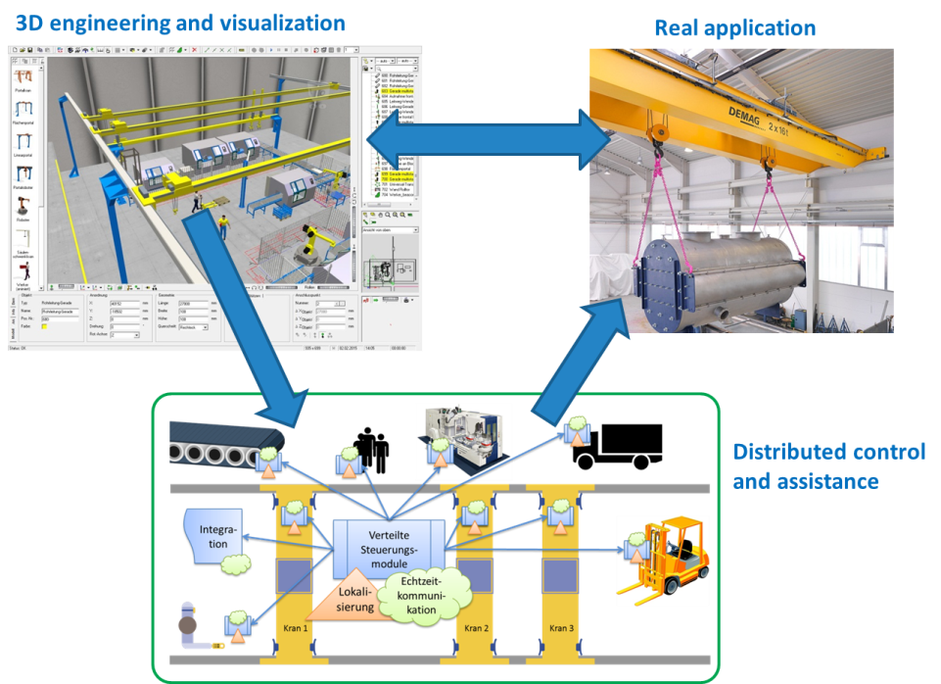

Figure 7 – OPTIMUM technical concept (for the use case of material handling)

To facilitate that approach, the OPTIMUM project is structured according to the overall work plan as shown in Figure 8. This work breakdown structure will help to realize the envisioned goals.

**How WPs relate to each other?**

At the beginning of the project, stakeholders of the different domains will provide inside views to the specific characteristics of engineering, control and application programming in their domains. Based on this, target use cases will span visions of OPTIMUM-enabled solutions in their respec­tive domains. Experience and use cases will be the basis for identifying requirements alongside the business and technological value chain addressed by OPTIMUM. These will be considered by all the technical work packages WP2 to WP5 as well as for validation in WP6. WP2 will specifi­cally consider the industrial requirements when developing a new platform or adapting available IoT platforms to the specific needs of Industry 4.0 like systems. WP3 will develop a distributed control and application platform, also being suitable to the hard real-time requirements. A well-defined interface to the underlying communication layers will allow interfacing the IIoT platform designed in WP 2 or any other upcoming technology. WP4 is dedicated to work into two direct­ions. Context and location awareness functions as well as security features will be developed and, in close collaboration with WP2 and WP3, integrated into the communication and control platform. The second direction is the development of interfaces and framework functions supporting the establishment of an application eco-system for easy application development even by third parties. WP5 will first develop component models representing the new component characteristics in addition to today’s model properties. Appropriate 3D engineering tool functions as well as visualization and supervision functions will be developed on top of these models. Concepts, frameworks and tool improvements will be evaluated within WP6. Project results will be disseminated through WP7 activities. Beside project management, effort in WP8 will be used for potential standardization activities.

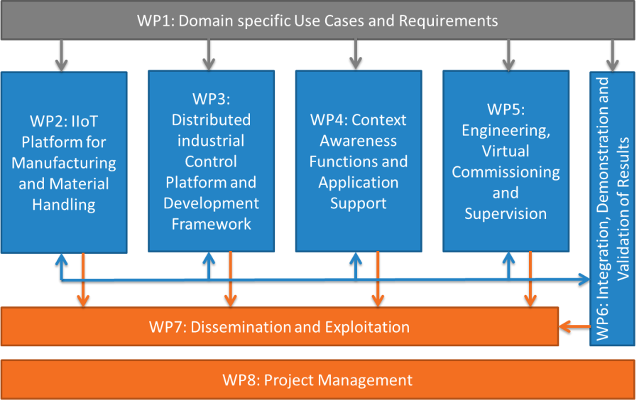

Figure 8 – OPTIMUM work package structure

**WP1: Domain specific Use Cases and Requirements (led by ERMETAL, Turkey)**

WP1 is focused on discussions of specific characteristics of engineering, control and application programming in the domains addressed by OPTIMUM as a starting point for defining target use cases that will span the visions of OPTIMUM enabled solutions. Experience and use cases will be the basis for identifying requirements alongside the business and technological value chain. Safe­ty precautions will also be considered and the requirements of the working area security need to be specified by use cases. **Results:** Use case specification, requirements matrix; **Relations:** These results will be considered by all the technical work packages WP2 to WP5 as well as for validation in WP6.

**WP2: IIoT Platform for Manufacturing and Material Handling (led by ABALIA, Spain)**

Based on the requirements set-up in WP1, WP2 will design an Industrial IoT platform suitable for supporting Industry 4.0 like applications on discrete manufacturing and material handling. This concerns basic platform services for enabling operation of the communication platform itself as well as specific services requested to run distributed control applications or context aware applications on top of the IIoT platform. Attention will be put to quality of service (QoS) requirements. Existing (I)IoT platforms and possible extensions will be investigated for suitability preferable to new developments. **Results:** IIoT platform, development support tools, specifications and implementations; **Relations:** Interface specifications of WP3 and results from WP4 (context awareness functions, security definitions, eco-system interface specifications) as well as tool chain constraints and data formats from WP5 will be considered. IIoT platform and services will be provided for use by WP3, service and QoS model information to WP5.

**WP3: Distributed Industrial Control Platform and development Framework (led by IFAK, Germany)**

Based on WP1 requirements, WP3 is dedicated to the design of a distributed control platform and an open framework for control application design that can be reused and adapted in order to provide end-user (developer) programming models. Framework functionality will be concentrated on distributed control in an efficient way and based on existing standards. Depending on used communication and hardware, best fitting security solutions, developed in WP4, shall be integrated. Specifically, Internet based real-time extensions will be investigated and adapted. The tooling has to support the application designer for creating and connecting objects. **Results:** distributed control platform, control application development framework, specifications for interfaces, platform and framework and implementations; **Relations:** results from WP2 as basis for hardware and software platform; results from WP4 (context awareness functions, security definitions, eco-system interface specifications) as well as tool chain constraints and data formats from WP5 will be considered. Application development container specifications will be provided for use by WP4, control capabilities characteristics model information to WP5.

**WP4: Context Awareness Functions and Application Support (led by BOR, Turkey)**

Directed by WP1 requirements, WP4 addresses cross-cutting activities developing capabilities related to WP2, 3, 5 and even system integration in WP6. It focusses on research and develop­ments towards context and location awareness, overall system and component’s security and safety support as well as finally on the development of the enabling technology for simple applica­tion programming and provisioning. The partners will develop a common application programming interface (API) on top of WP2 and WP3 achievements and tools for end users, as well as an app-store approach. This will be the basis for an open eco-system of application programming. **Results:** location and context awareness functions, security and safety functions, common API, common application and communication development framework, specifications and implemen­tations; **Relations:** WP4 will bring together achievements from WP2 and WP3 towards a common task-oriented development framework, results from WP4 (context awareness functions, security definitions, eco-system interface specifications) will become integrated into WP2 and WP3.

**WP5: Engineering, Virtual Commissioning and Supervision (led by TARAKOS, Germany)**

WP5 will use information on elements and their characteristics developed in WP2, 3 and 4 for de­fining models suitable for system behaviour simulation, optimization (based on predicted behaviour) towards operational and safety related constraints, as highlighted in WP1 use case defini­tions. Concepts and algorithms will be investigated supporting virtual commissioning and same models will be used as a basis for visualization and supervision of systems designed. All this will be done based on 3D technologies and will lead to enhancements of engineering tools.

**Results:** component and system models, enhanced 3D engineering tool chain, specifications and implementations; **Relations:** information from WP2, 3, 4 used for modelling, Engineering tool chain used in WP6.

**WP6: Integration, Demonstration and Validation of Results (led by SOTEC, Spain)**

WP6 addresses the validation of the project results regarding the requirements defined in WP1 and while instantiating use cases of the same WP. There will be individual tasks dedicated to the different domains addressed by the OPTIMUM project, covering integration, demonstration and validation. Relations of the results to the requirements from WP1 and fulfilments of quantification criteria (chapter 2.3.4) will be documented. **Results:** demonstrations for the domains, evaluation results, specifications, implementations and evaluation reports; **Relations:** demonstrations will be based on project achievements from WP2, 3, 4 and 5. Evaluation will be done based on WP1 requirements.

**WP7: Dissemination and Exploitation (led by ETRI, Korea)**

WP7 is dedicated to disseminating the knowledge generated in the project within the scientific, technical and market related communities. Major dissemination activities will include a project Website, publications, participation in major conferences and exhibitions, and organization of public events to promote the technology and to receive feedback from the end users. Exploitation covers common as well as individual activities. Standardization is seen as a means for exploitation. **Results:** publications, presentations, Website, dissemination and marketing events; **Relations:** input from all WPs

**WP8: Project Management (led by TEREX, Germany)**

WP8 is dedicated to the technical coordination, management, risk assessment and reporting activities at international as well as at National level.



Figure 9 – Gantt chart for the OPTIMUM work plan

* 1. Main milestones

Present the project milestones in the following table. A milestone should represent a significant intermediate achievement, a date by which major results form the basis for a subsequent phase of work (e.g. finalisation of the data processing algorithms, integration of the semantic modules in the common framework, finalisation of the first version of the prototype, compliance with end-user requirements in terms of performances, etc.), or by which decisions are needed (for example, concerning which of several technologies will be adopted as the basis for a subsequent phase of the project). Major demonstrations should also be considered as project milestones.

It is recommended to consider no more than 6 milestones in a project (i.e. on average not more than a milestone every 6 months).

Milestone titles (descriptions) should be self-explanatory. For each milestone, indicate the Key Performance Indicator (KPI) that will be used to state its achievement, as well as its completion date.

This subsection should give a good overview of the different phases of the project.

Exhaustive list of project milestones:

|  |  |  |  |
| --- | --- | --- | --- |
| ID | Description | KPI | Completion month |
| MS1 | Use Cases and requirements | Deliverable describing Use Cases, requirements available | M6 |
| MS2 | State-of-the-art description concer­ning IoT and IIoT platforms, indus­trial control, location and context awareness, security, safety and engineering in industrial domain | Deliverable describing State-of-the-Art available | M9 |
| MS3 | Overall IIoT and control platform concepts | Platform concepts are available | M12 |
| MS4 | Specification for IIoT platform, control platform and cross-cutting functions (awareness, security) | IIoT and control platform are specified (components, func­tions, interfaces, transactions) | M16 |
| MS5 | First platform functions and tool algorithms realized | First platform functions (IIoT, control) are available for demonstration | M22 |
| MS6 | Final versions of IIoT platform, control platform, cross-cutting functions, development and engineering framework realized | Final versions of IIoT platform, control platform, cross-cutting functions, development and engineering framework are ready for demonstration | M30 |
| MS7 | Demonstrators implemented | Platforms and integrated tool chain development framework are ready for evaluation | M33 |

1. Rationale for public funding

Auto-generated section: input to be provided only on the Community website. Do not edit or remove this box and do not provide any text within this annex in this chapter, but provide the requested information directly on the ITEA Community website.

On the website you must fill in one section per country represented in the consortium. This section will indicate the national coordinator and detail the national rationale for funding. At the end of the national rationale for funding, the national coordinator has to indicate the national ICT clusters the project has contacted and intends to join (a clear status with regards to the cluster has to be indicated).

The national rationale for funding has four components:

* national gain: you have to explain the benefits for the participating countries (e.g. support to national strategies, standardisation, open source, knowledge dissemination, wellbeing improvement, impact on national productivity, etc.), how the country benefits from collaboration with other countries and the risk level of the investment (i.e. why is a public incentive preferred for such investments),
* return on investment (RoI): you have to explain how the money invested by both Public Authorities and companies is expected to generate value, revenue, jobs and/or economic growth, etc.,
* value creation of the national sub-consortium: if relevant, you have to detail the collaboration amongst the national sub-consortium, how cross-fertilisation between the various participants is achieved and, if applicable, what the national use cases are, how they are organised and how they are linked with other or previous national projects;
* adequate balance between the national partners (e.g. ratio of effort as a percentage for academics, SMEs, etc.).

For each partner, in addition to contact details and a generic description (incl. type and size of the entity), three specific descriptions are requested:

* relevance of the partner within the project by describing its main role in the project, tasks and the main added value (technological and in terms of market access) it will bring to the international consortium and vice versa;
* Strategic importance of the project for the partner, i.e. how envisioned project results (if successful) fit in, and contribute to, its innovation and business strategy, or complete previous projects (with a particular focus on the publicly funded ones);
* market access, i.e. how the partner intends to exploit the project results (e.g. new product, new service, licensing, etc.) and how the market(s) will be accessed (exploitation prospects and capability); current main markets and main customers, as well as planned exploitation plans and strategies are welcome whenever doable.

NOTE: this part is crucial for the national funding agency to evaluate the chances for funding for the individual partners within the project. Please try to be as concrete as possible.

Furthermore it is key that all national coordinators get in touch with their national Public Authorities (PAs) to present them the project (idea, partnership, budget, etc.), checking funding opportunities and ensuring that the national consortium is eligible, even in countries that are not part of the ITAC (ITEA Authorities Committee). Beware of eligibility issues at national level.

For ITAC countries, information on the contact persons is available on the ITEA public website (in section “Participate in ITEA / Funding”). For the EUREKA countries that are not member of the ITAC, the contact persons are National Project Coordinators (NPCs); http://www.eurekanetwork.org/eureka-countries).

1. Summary of costs & effort breakdown

Auto-generated section: input to be provided only on the Community website. Do not edit or remove this box and do not provide any text within this annex in this chapter, but provide the requested information directly on the ITEA Community website.

This annex will contain a comprehensive summary of the costs and effort, by providing 1) costs & effort per country per WP (with totals), and 2) costs & effort per partner type. This data is automatically computed based on the detailed figures of costs & effort provided online by each partner on the Community website: it is therefore crucial that all partners provide relevant input for both costs & effort, and do not leave blank fields, which would generate erroneous breakdowns.

Detailed costs & effort per partner are provided in the related country perspective section of §4.