**PO Annex template**

ITEA 3 Call 5

**Foreword**

*Do not remove or modify in any way the sections having these notations,*

*All guidelines in the template appear in this “boxed” format. These instructions, as well as the preceding title page (“PO Annex template”) and this foreword, should never be removed manually from the submitted files: they are automatically removed by the merging function of the ITEA Community website. Potential layout issues appearing when removing the instructions (e.g. a large image leaving half a page blank) will be adjusted by the ITEA Office, between the proposal submission and the transfer of the generated PO/FPP to the reviewers.*

*NB: all texts between “<” and “>” symbols (incl. on the front page and in the headers) should be replaced or removed.*

*It is highly recommended that you carefully read all the instructions provided: they indicate for each chapter and subchapter what is expected and must be carefully taken into account.*

*It is crucial that proposal writers comply with the pre-defined formatting and styling rules: breaking these rules may create errors when inserting the auto-generated sections and thus cause the merge process to fail. Complying with formatting rules can be achieved by adhering to the following guidelines:*

* *do not remove any predefined title and do not add headers, incl. annexes, that are not supposed to be defined according to this template, at any level of the hierarchy (e.g. do not add a §5 after §4 Rationale for public funding); in particular, for references or publications, as additional annexes are forbidden, please rely on footnotes; you are, however, free to add subsections when there is no subsection yet defined (e.g. you can define a subsection §2.2.1.1 within §2.2.1 Market analysis);*
* *do not modify the predefined styles, except for standard “emphasis” effects (i.e. underlined or bold text) – we recommend using the underlined and bold formatting in a consistent and prudent way throughout the document, and on body text exclusively;*
* *only use the pre-defined styles that start with “ITEA_”: the most relevant ones are “ITEA_BodyText” for standard paragraphs (Arial 10 with a line spacing factor of 1.2 pt), “ITEA_BodyBullets” for bullet points within standard paragraphs and “ITEA_Figure”; for captions, you can use the standard “Insert Caption” function from Word, as it will automatically use the “ITEA_Caption” styling; these styles are accessible in the “Quick Styles Gallery” of the “Home” tab;*
* *do not remove the instructions (both green and orange ones), and do not remove the auto-generated sections, incl. the annexes;*
* *do not overload the document with uncompressed / excessively large images; a proposal should ideally fit in less than 10 MB.*

*It is in the interest of consortia to ensure that a merged document (i.e. including auto-generated sections) can be generated and downloaded before the submission deadline so that all the relevant information is provided in the project proposal document.*



*Items that need to be filled in exclusively via the ITEA Community website will have the following notation:*

Auto-generated section: input to be provided only on the Community website.

Do not remove or modify in any way the sections having these notations throughout the whole Annex template since they are needed to automatically merge the information provided via the ITEA Community website with your uploaded Annex document.

*Important guidelines for a successful PO-FPP preparation*

*1) The length and quality of the proposal*

*The quality of the writing and the total length of a proposal has an impact on the evaluation by the Public Authorities and the ITEA Steering Group.*

*Please avoid being verbose and keep the PO or FPP concise and informative. Use bullet points or a table to provide lengthy information in an efficient format. Succinct writing without unnecessary words and sentences will ensure better evaluation.*

*Section length recommendations (in number of words and pages) have been made to suggest the ideal length of the PO and FPP for the evaluation. The overall length of the final merged document, excluding section §4 and Annexes, must not exceed 45 pages for a merged PO and 75 pages for a merged FPP, which corresponds roughly to an uploaded file of 55 pages for a PO, and of 85 pages for an FPP (all sections included, i.e. including comments and empty auto-generated sections). A merged PO or FPP that exceeds the recommended length up to section §4 can have a negative impact on the evaluation.*

*2) The usage of Google Docs*

*The PO-FPP template cannot be copied to Google Docs and re-copied to the original PO-FPP template properly due to compatibility issues. When using Google Docs, please only copy the final “body text per paragraph” from the Google Doc and paste it to the original PO-FPP template. Do not copy the paragraph headers or other styles from Google Docs, which could corrupt the styles used in the original PO-FPP template.*

*3) Value chain analysis and design*

*ITEA provides extra guidelines for Chapter 2.2.1. ‘Market analysis and market value chain’. It is highly recommended to take the proposed tools in the guidelines into account for the PO-FPP. A high-quality market analysis and market value chain description will ensure positive PO-FPP evaluation results. These guidelines can be found at the end of the PO template in Annex B.*

**Project Outline Annex**

OWE4SC

Open Wise Edge for Smart Communities

Edited by: Daniel Pakkala

Date: 4.10.2018

Apart from the State-of-the-Art-dedicated text (§2.3.1) which is handled by the ITEA Office as public information, unless otherwise specified by the consortium, this document will be treated as strictly confidential.

**Project key data**

Auto-generated section: input to be provided only on the Community website. Do not edit or remove this box and do not provide any text within this annex in this chapter, but provide the requested information directly on the ITEA Community website.

The inserted key data will contain (among others) the acronym, full title, time frame, the respective countries and partners per country, the coordinator, as well as a short description which should include the project idea, the main expected market impact and the main technological objective.

**Table of Contents**

**Project key data 5**

**Project acronyms 7**

**1.** **Project one-page description 8**

**2.** **Project overview 9**

2.1. Rationale of the project 9

*2.1.1.* *Problem statement, solution and challenges 9*

*2.1.2.* *Project innovations and technology value chain 9*

2.2. Targeted impact 10

*2.2.1.* *Market analysis and market value chain 10*

*2.2.2.* *Consortium market access 10*

2.3. Technology 12

*2.3.1.* *State-of-the-Art (SotA) analysis 12*

*2.3.2.* *Proposed technological innovation and novelty in relation to the SotA 13*

*2.3.3.* *Expected project outputs 13*

*2.3.4.* *Quantified objectives and quantification criteria 14*

2.4. Consortium overview 15

*2.4.1.* *Cooperation added value: business level 15*

*2.4.2.* *Cooperation added value: technology level 15*

**3.** **Work description 17**

3.1. Project structure 17

3.2. Main milestones 17

**4.** **Rationale for public funding 19**

**Annex A:** **Summary of costs & effort breakdown 21**

**Annex B:** **Guideline for the value chain analysis and design 22**

**Project acronyms**

|  |  |
| --- | --- |
|  |  |
|  |  |
|  |  |
|  |  |
|  |  |
|  |  |
|  |  |
|  |  |
|  |  |
|  |  |
|  |  |
|  |  |
|  |  |
|  |  |
|  |  |
|  |  |

1. **Project one-page description**

*(Maximum length: not more than one page, approximately 600 words)*

*Provide, within one page maximum, a strategic description of your proposed project addressing:*

* *the context and goals of the proposal;*
* *the business relevance and the targeted market impact;*
* *the innovative aspects and the major expected technical outcomes;*
* *the consortium relevance.*

In our daily life (leisure and work) everything is currently under digitalization. New kind of interaction, value co-creation and innovations are possible by developing on-demand digital services aggregating and analyzing data from multiple sources. Artificial Intelligence (AI) and Edge Computing are enabling new capabilities for digital services, including near real-time automated and fine-grained sensing-analysis-actuation loops, better response time, locality with enhanced safety and privacy.

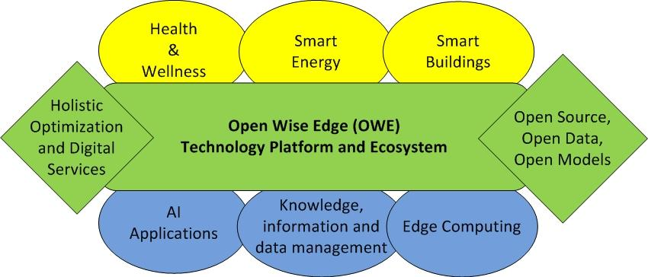

Figure 1. Illustration of context and main goals of the project.

Application domains such as Health & Wellness, Smart Energy and Smart Buildings will benefit from the AI and edge computing enabled new capabilities of digital services. This project will focus in collaborative R&D of Open Wise Edge (OWE) technology platform and ecosystem unleashing the capabilities of AI, edge computing, open source, open data and open models for holistic optimization and innovation of new digital services for smart consumer and professional communities.

The new digital service innovations for enhancing health and well-being, sustainability, safety and productivity of smart communities represents a global business opportunity for European industries and their renewing value chains and ecosystems. The key drivers for renewal of traditional value chains and ecosystems include digitalization, servitization, artificial intelligence, edge computing and cyber physical systems with the established global digital distribution channels and platforms (i.e. Internet, app markets and social media), which set the context for new European digital service innovations for smart communities globally.

The project brings together highly competent and relevant European consortium for research and co-innovation of new digital services for smart consumer and professional communities seeking new innovations in Smart Health & Wellness, Smart Energy and Smart Buildings domains to improve health and well-being of people, as well as productiveness and sustainability of business.

1. **Project overview**
   1. **Rationale of the project** 
      1. **Problem statement, solution and challenges**

*(Maximum length: 1200 words)*

*Describe the problem that the project aims to solve. Explain the current issues, limitations or bottlenecks of what currently exists, explain the needs you plan to satisfy or to create.*

*Describe the high-level solution that the project intends to explore and implement to solve the problem. Give reasons why this solution will solve the problem. Also indicate how well the solution will solve the problem by defining SMART (Specific, Measurable, Achievable, Relevant, Timely) objectives for your project.*

*Describe the societal, economic and/or technological challenges that will be addressed by the proposed project.*

*This subsection describes the context and background relevant to the project, in terms of technological and market status, not the project itself. It should convince evaluators that the project partners have a good understanding of the context in which they will be evolving, both technology- and business-wise.*

Introduction:

* Edge is heterogeneous and not well standardized/organized making collaboration on development of new digital services relying on it challenging.
* Yet, the edge is focal point of innovation of cyber-physical digital services

Problem statement:

* The current proprietary, heterogeneous and vertical silo-like technology stacks for IoT, AI, embedded computing have become a bottleneck for efficient co-innovation of new cyber-physical digital services for smart communities in their needs on digitalization of businesses. On technological level, the problem is that shared and open technology stack does not exist for efficient co-innovation of safe, reliable and near-real time cyber-physical digital services. On business level, the technological problem appears as inefficient, costly or failed digitalization projects within and among companies seeking competitive advantage from digitalization, IoT and AI. On national and European level the technological problem can lead to uncompetitive industries in global competition resulting to decreasing economies on national and European scales.

Solution:

* Research and development of open technology platform and ecosystem enabling efficient co-innovation of new cyber-physical digital services for smart communities in their needs on digitalization of businesses.
  + Open Wise Edge (OWE) Technology Platform and Ecosystem

Challenges:

* To provide open alternative for proprietary, heterogeneous and company specific technology stacks for IoT, AI and embedded computing based cyber-physical digital services innovation.
* Identification of relevant, feasible and stable open technology base for efficient co-innovation of new AI and Edge computing based digital services providing added value for digitalization in selected application domains.
* Ensuring that data-driven digital value creation via AI applications brings benefits to European economies, people and companies of all sizes.
* Establishing an ecosystem enabling European businesses to transition from vertical application silos and in-house innovation to horizontal open, safe and reliable digital infrastructure and co-innovation of new globally competitive cyber-physical digital services around it.
* Domain specific challenges:
  + Smart Health & Wellness
  + Smart Energy
  + Smart Sites/Buildings

Success indicators/KPIs for the project:

* European companies have an option to break free from vendor lock-ins via open alternative for proprietary, heterogeneous and company specific technology stacks for IoT, AI and embedded computing based cyber-physical digital services innovation.
* Open technology base for efficient co-innovation of new AI and Edge computing based cyber-physical digital services exists and is accessible for any size of European company.
* New cyber-physical digital services are piloted on OWE technology platform
* # of new cyber-physical digital service innovations in commercialization based on OWE technology platform
* Evaluation results from project pilots
* Application domain KPIs (business KPIs):
  + Amount of patients that can be helped by single caretaker
  + ...
* Infrastructure KPIs (Technical KPIs):
  + How many open technology are used
  + Maximum number of edge nodes to support
  + Performance of edge communication
    - Scalability
    - Latencies
    - Bandwidth
    1. **Project innovations and technology value chain**

*(Maximum length: 1200 words)*

*Present here a brief view of the project innovations you are introducing: focus the description on novelty in terms of the state-of-the-art. Innovation can include both technological, process, usage and business model innovations. Explain what the project brings to the table, how it differs from existing results and previous or current projects, products and services, how partners will be able to differentiate themselves from existing market actors and become competitive (or how they can create or reimagine a market). Remain concise in this section (cf. §2.2 and §2.3).*

*Describe in a few words what the project aims to achieve and how it backs the broader goals of the main partners.*

*Introduce also the technological value chain(s): it is a kind of modular architecture comprising the main functions and building blocks required to create the solution, as well as their interactions.*

*This subsection should convince evaluators of the novelty of the project proposal.*

Project innovations:

* Open Wise Edge technology platform and ecosystem enabling co-innovation of new cyber-physical digital services
  + Transatlantic R&D co-operation on open AI technologies (IBM, Google, MS, Facebook)
* Methods and tools for holistic co-innovation of new cyber-physical digital services
* Data, information and ML/DL models enabling new cyber-physical digital services in selected application domains and pilots
* Open, safe and reliable edge computing infrastructure enabling co-innovation of new globally competitive cyber-physical digital services in selected application domains
* Piloting of new cyber-physical digital services in selected application domains
* Identification of emerging markets and opportunities for value creation in co-innovation of cyber-physical digital services.
  + Applications & Services marketplaces
  + Data and Models marketplaces
  + Edge computing marketplaces

Technology value chain:

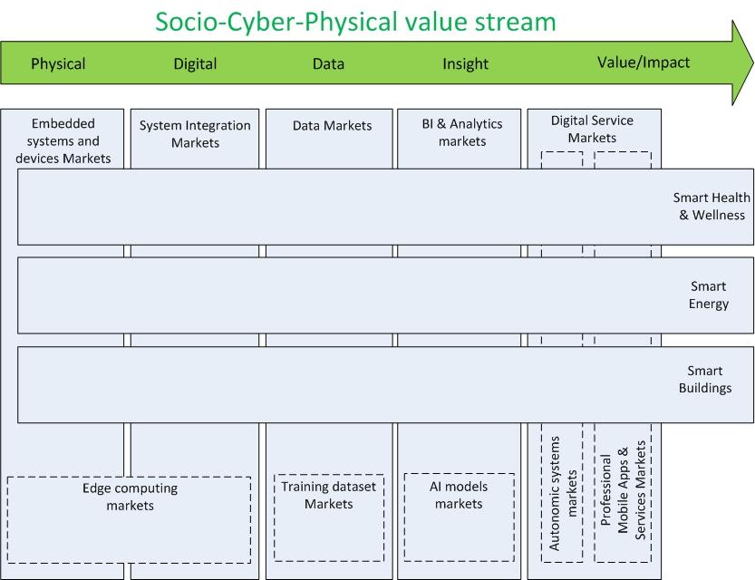

* 1. **Targeted impact**
     1. **Market analysis and market value chain**

*(Maximum length: 2700 words)*

*Present here an analysis of the markets targeted by the individual project partners. The targeted markets can differ per partner. It is better to describe these specific markets rather than giving some general market report figures. Describe and quantify the current situation and trends in these markets, the main players, main products. Do not rely solely on current market situations but consider also predictions and estimates of future growth from the latest studies.*

*Describe the existing or announced industrial products or services in the project domain. Explain which competitive advantages the market leaders have and how differentiation could be achieved towards them. Detail why smaller actors are restricted to low market share (e.g. targeting niche markets or competitiveness issue) and how volatile the market currently is (are there more and more actors or is it the opposite? In the latter case, does it derive from market consolidation or from competitors dying out?).*

*Present existing and potential and/or forecasted competitors (e.g. Google in the car industry). Do not hesitate to introduce Porter’s five forces model of competition to describe (in addition to the current industry competitors) not only suppliers and buyers, but also potential new entrants as well as threat of substitutes.*

*Describe the current market value chain(s). The market value chain is a representation of the various processes involved in producing products or services and delivering them to the market. It indicates where and how value is considered and created, and how the market actors in their respective markets can be profitable. It also describes the actors’ strategies and relative positioning: it must show all the actors involved in designing, producing, distributing the products and/or services and the relationships among them. All the peripheral actors who can influence the market(s), through regulations, recommendations, indirect suggestions, etc., must also be included. Describe clearly the interfaces between these actors and define the customer – provider relationship(s) wherever relevant.*

*ITEA provides an extra guideline for the value chain analysis and design. The guideline proposes a set of tools to facilitate the analysis and design of the business strategy of any ITEA projects. It is highly recommended to take the suggested tools into account in this chapter. The guideline can be found at the end of PO template in Annex B.*

*This subsection should convince evaluators that the project partners have a clear and detailed understanding of the market they are targeting, including not only the current situation but also the current trends, forecasted evolutions and potential threats.*

Some thoughts to work on further::

* Growing markets of digital services (value co-creation)
  + Smart Health & Wellness (IPP, MDH)
  + Smart Energy (TNO)
  + Smart Sites/Buildings (Aunia)
* AI application markets (value from data in use) (IMT, MDH)
* Edge computing/Edge Cloud, 5G and IoT markets (IMT, Montimage)
* Emerging submarkets for AI applications development (data, models) (VTT, ...)
  + 1. **Consortium market access**

*(Maximum length: 4500 words)*

*Describe how the introduced innovation will help the individual partners to achieve competitive advantage in their targeted markets. Clearly indicate and quantify the commercial opportunities that can be achieved with the targeted innovations.*

*Provide an overview of which targeted project outcomes will be (commercially) exploited in which markets and by which partners.*

*If applicable, indicate the impact, if any, that the project innovations will have on the current market value chain.*

*The detailed exploitation plans for each of the partners must be filled in online on the ITEA website and will be included in chapter 4.*

*Detail also in this section the consortium strategy deployed towards achieving the exploitation goals, for instance (and when relevant) through:*

* *Standardisation:*
* *Standardisation includes de jure/de facto standards, published APIs, open source repositories and associated communities, etc. Standardisation should be a way to enable exploitation plans, e.g. by enabling a market to take off, by helping integrators to embrace the proposed technology, by counterbalancing proprietary solutions of leading competitors, etc.*
* *When relevant, define a standardisation strategy consistent with the project and document its implementation. Projects having software- or system-engineering related activities should, whenever applicable, identify the open source strategy or the tools interoperability strategy.*
* *When Open Source Software is considered, explain how the project intends to build (on) a large, lively and strong community around the open source software and how the impact from the project will be quantified.*
* *Dissemination:*
* *Consider here dissemination towards customers, communities (industrial, scientific, etc.), incl. communications, seminars, workshops, conferences, papers, courses, etc. Dissemination must be a tool to make potential customers or partners aware of the project achievements and results, within and outside the organisations participating in the project.*
* *Define and justify a dissemination strategy supporting and having impact on the project, i.e. justify the choices made (e.g. why selecting given workshops rather than others). Indicate how the project results will be disseminated in the course and at the end of the project, i.e. by means of (e.g.) which presentations in workshops and conferences, publications, etc.*

*If fast exploitation is expected, explain what exactly is targeted, and how the consortium intends to achieve these goals.*

*This subsection should convince evaluators that the consortium is credible, legitimate and relevant to address the market and to exploit the project results (if successful) to generate business (i.e. that it can have an impact on the market). This subsection should be market oriented and should only focus on the long-term goals of the project (i.e. what is expected to be achieved thanks to the project outcomes, i.e. after the project closure).*

<Text to be inserted here>

* 1. **Technology**
     1. **State-of-the-Art (SotA) analysis**

*(Maximum length: 3000 words)*

*Describe the current technological situation in the project domain with a detailed technical state-of-the-art, with regard to current products, prototypes and research results and trends, both on the industrial and academic sides.*

*For the research state-of-the-art (SotA), also document how your proposed project relates to, and/or builds on results of, and differentiates from, other (past or running) cooperative (e.g. ITEA, H2020, or national) projects or national ICT clusters tackling related issues: we recommend filling in, for each of such projects or national ICT clusters, a short description thereof in the suggested table below, focusing on the aspects related to the proposed project and a short description of how the proposed project relates to, and/or builds on and differentiates from it. Please note that in this table below, the last column, “Relationship”, should explain:*

* *which input modules will be reused from the mentioned project;*
* *and/or what will be transferred from this proposal to the mentioned project;*
* *or the reasons why the consortium does not intend to reuse/transfer results from/to the mentioned project (i.e. why the results already achieved are not useful for this proposal).*

*NB1: The ITEA Living Roadmap (accessible through the ITEA Community website) provides a rich source of information with regard to the existing SotA. Use it but go also beyond its content to extend the known SotA (e.g. with the very latest products, achievements, publications, etc.).*

*NB2: For each past or running ITEA project, a two-page description ("Leaflet") is available on the ITEA public website.*

*The state-of-the-art described in the project proposal will have to be updated / extended in the course of the project and integrated in a public deliverable. Except for specific cases, the state-of-the-art section of the project proposals will be considered by the ITEA Office as a public document which could be added to the Living Roadmap.*

*This subsection should convince evaluators that the project partners have detailed knowledge of the technological background (and evolution) in the targeted field. ITEA considers the State-of-the-Art analysis as a key tool to clearly understand and steer innovation all along the project lifespan.*

<Text to be inserted here >

State of the art in: (contributors same than in market analysis section)

* Digitalization
  + Smart Health & Wellness
  + Smart Energy
  + Smart Sites/Buildings
* Applied AI/ML/DL in digital services
* Knowledge/Information/Data management in CPS and digital services
* Edge computing and digital infrastructure

Link to previous and/or current collaborative research projects:

|  |  |  |  |  |
| --- | --- | --- | --- | --- |
| Project Name | Cooperative Programme | Time period (approx.) | Technical Focus | Relationship |
| <ACRONYM> | <e.g. ITEA> | <2010-2013> | <Text to be inserted here> | <Text to be inserted here> |
| <ACRONYM> | <e.g. H2020> | <2012-?> | <Text to be inserted here> |  |
| <ACRONYM> |  |  |  |  |

*Table 1: Related collaborative research projects.*

* + 1. **Proposed technological innovation and novelty in relation to the SotA**

*(Maximum length: 2500 words)*

*Clearly explain the progress and technological innovation proposed by your project, with reference to the current technology state-of-the-art. Explain what differentiates the project from other R&D efforts, how it builds on the SotA and which novelty it brings from a technological standpoint.*

*This subsection should convince evaluators that the consortium has sufficient insight into the technological challenges and proposes significant breakthroughs to bring technological innovation and novelty.*

<Text to be inserted here>

VTT...

* + 1. **Expected project outputs**

*(Maximum length: 650 words)*

*Detail the concrete final results of the project: give a clear description of what will be its actual set of outputs (novel algorithms, standards, open source libraries, implemented collaborative framework, demonstrator, product prototype, new service based on some software, wearable device, etc.). The description should be detailed enough to give a clear picture of what will be generated, including the core functionalities and levels of maturity.*

*At the end of the project, the results will be confronted with the content of this subsection (potentially updated through Change Requests). A poor description will be considered as a lack of expected results, or as significant uncertainty about what will be delivered: clarity is therefore highly recommended here.*

*The requested description must focus on tangible, realistic and credible outputs that will be developed within the project (if the project extends existing solutions, then clearly clarify the specific contributions of the project) and available at project closure, i.e. demonstrated at the final project review. Post-closure results, like exploitation plans and prospects, have to be indicated in §2.2.2.*

*This subsection should convince evaluators that the project will deliver tangible results of interest that will support the business goals of the project partners.*

<Text to be inserted here>

Use Cases & Pilots on the selected application areas:

**Smart Health & Wellness:**

- CPS for eHealth (Concatel),

- Assistance/companion robotics (KOMPAI)

o Mobility assistance for nursing

o Remote monitoring and surveillance of patients

o Night surveillance at nursing homes

o Alzheimer unit assistance

o Patient stimulation and entertainment

- Remote diabetes, heart disease, lung lisease patient and elderly monitoring with holistic sensoring (SWE+PRT consortium)

**Smart Energy:**

- Electricity demand flexibility management and control at buildings with RES and EVs charging (AKKA)

- Local energy market mechanisms & connectivity (Empower)

- Flexibility uptake and management in market structures (Empower)

- Energy community services (Empower, VTT)

**Smart Buildings/Sites:**

- Remote surveillance and remote maintenance (Concatel)

- Collaborative robotics (Keyland)

- Site condition monitoring and control (Empower)

- Smart site sensoring, analytics and connectivity (Empower)

**Assistance/companion robotics (KOMPAI, France)**

**Electricity demand flexibility management and control at buildings with RES and EVs charging (AKKA, France)**

Project main outputs from work packages to be listed and described.

* + 1. **Quantified objectives and quantification criteria**

*(Maximum length: 1300 words)*

*Consider the expected project results (cf. §2.3.3), and for each one of them define appropriate quantification criteria (Key Performance Indicators - KPIs) that will be used to measure the achievements objectively. KPIs are a strong tool for project leaders to steer the project and for reviewers to evaluate the project progress and the maturity of the results. The project team is free to define any kind of KPI that is most valuable for themselves.*

*KPIs must be SMART, must have an initial (State of the Art) value and a target value:*

*- Specific (the KPI must be unambiguously)*

*- Measurable (the KPI must be measurable to indicate its progress and whether the target is reached)*

*- Achievable (the KPI target must be achievable by the current consortium)*

*- Relevant (the KPI must be relevant)*

*- Timely (the KPI target must be achievable within the project time frame)*

*We distinguish two types of KPI’s: 1) project management oriented and 2) result maturity oriented. Both types are important for your project to check whether you are reaching your goals.*

*Project management KPIs are KPIs to track the progress of your project compared to the project plan. For instance, the number of milestones or deliverables completed on time or the percentage of deviation from the planned budget and effort. These KPIs are important for the project leader to monitor and steer the project towards its goals. It provides the reviewers a quick view whether the project is on track or not.*

*Result maturity KPIs provide an indication how good the results are. If you develop for instance a new engineering methodology that will reduce the software development time significantly you need to have a KPI that indicates what the current software development time is and what the target at the end of the project is (e.g. two times or three times faster). At the end of the project you must be able to show convincing measured figures indicating to what extent you have achieved your target. These figures will also help you to convince your customers or management to use the results of your project.*

<Text to be inserted here>

* 1. **Consortium overview**

*For many Public Authorities, it is crucial to already have at the PO stage a clear national consortium as well as clear costs & effort figures: indeed, many countries need to decide on national budgets before the FPP deadline, which means significant changes between POs and FPPs at the consortium and cost levels should be limited to clearly needed updates (in particular, based on the PO evaluation feedback from reviewers and Public Authorities).*

* + 1. **Cooperation added value: business level**

*(Maximum length: 1300 words)*

*Position the consortium in the market value chains as described in §2.2.1. Explain the business rationale behind the consortium composition, providing convincing elements regarding the consortium legitimacy in terms of the business:*

* *describe the core idea motivating the partners to collaborate and explain how this consortium helps them achieve their business goals;*
* *describe how the cooperation is adding value;*
* *explain why the international collaboration (and in particular the ITEA frame) is the best way to reach the targets;*
* *in the event that the consortium does not cover the whole value chains for the respective markets, explain why this is not an issue for the project, and how the consortium intends to overcome this missing link.*

*For the software engineering focused projects, highlight the participation of the software tool vendors or, otherwise, justify why such partners are missing.*

*In any case, it is strongly recommended to involve (directly or indirectly) end-users and potential future costumers in the project, and to set up (whenever possible with these end-users) strong business cases which will derive in business-oriented demonstrations.*

*This subsection should convince the evaluators that the consortium has enough business power to have an impact on the market.*

<Text to be inserted here>

* + 1. **Cooperation added value: technology level**

*(Maximum length: 1300 words)*

*Describe who among the partners will achieve the technological innovations and detail the technological added value of the consortium collaboration. Focus on unique selling propositions that generate value.*

*Explain the interactions between the key technology-oriented players. Refer to the targeted technological architecture (cf. §2.1.2), and position the partners in that architecture while underlying their specific role, added value and relevance here.*

*Explain the technological rationale behind the consortium composition:*

* *describe the core idea motivating the partners to collaborate and explain how this consortium helps them achieve their technological goals;*
* *describe what the key partners bring in, how their expertise is complementary, i.e. what makes them relevant partners.*

*This subsection should convince the evaluators that there is enough R&D competence in the consortium, that the consortium is appropriate, and that value will be created from a technological point of view.*

*Both business and technological sleeping partners must be avoided.*

<Text to be inserted here>

WP participation matrix can be used here + inputs from the filled partner information templates

1. **Work description**
   1. **Project structure**

*(Maximum length: not longer than 3 pages)*

*Provide a global overview of the technical work to be performed and of the Work Breakdown Structure (work packages) envisaged towards it. Use diagrams where possible and do not hesitate to separate the hierarchical view (organisation of WPs and tasks in a tree) from the process view (e.g. interdependency between WPs, yearly processes, etc.).*

*Explain the interfaces and interactions between work packages, and between consortium members.*

*Justify how the project structure supports the project objectives.*

*Do not provide detailed Work Package and Task descriptions in the Project Outline. The detailed Work Package descriptions are only requested in the Full Project Proposal and will be fully discarded for the PO evaluation. Where possible, try to avoid describing task contents in a PO and focus on how the WPs relate to each other.*

*This section should convince the reviewers that the project structure helps the consortium achieve its goals.*

<Text to be inserted here>

The work package structure is planned to support co-operation of all project partners across the three selected application domain value chains (Smart Healt & Wellness, Smart Energy, Smart Sites) in collaborative R&D of the technology platform and ecosystem for co-innovation of new cyber-physical digital services enabled by AI, Knowledge/Information/Data management and Edge computing infrastructure. Short description of the work packages is provided below:

**WP1: Digital Services, Use Cases, Requirements and Business Models**

Goal of this work package is to co-innovate new cyber-physical digital services in three selected application domains: Smart Health & Wellness, Smart Energy and Smart Sites. The digital service design and engineering, carried out in this work package, will include holistic optimization and considers *health & well-being of people*, *sustainability*, *safety* and *productivity* as factors in the service engineering process. Digital services will be documented as service scenarios and further refined into technology use cases and requirements in this work packages. Work package will also study business models related to the identified digital services.

**WP2: Open Technology Platform, Ecosystem and Emerging Markets**

Goal of this work package is to identify and define the open (source/data) technology platform needed for co-innovation of new cyber-physical digital services identified in WP1. Additional goal is to establish co-operation and ecosystem activities around the open technology platform, including e.g. transatlantic workshops on open AI technologies with industrial actors investing and leading development of these technologies. The work package includes also study of emerging markets for Data/Information/Knowledge, edge computing and AI applications.

**WP3: AI and Knowledge/Information/Data Management**

Goal of this work package is to research and develop technical enablers for the cyber-physical digital services defined in WP1 relying on open technologies, which are part of the open technology platform of the project and WP2. In this work package R&D focuses on ML/DL models, data models, information models and data/information/knowledge management solutions for digital services. Work package may design and implement technological Proof of Concepts (PoCs), and demonstrations in collaboration with WP5.

**WP4: Edge Computing, IoT and Digital Infrastructure**

Goal of this work package is to research and develop technical enablers for the cyber-physical digital services defined in WP1 relying on open technologies, which are part of the open technology platform of the project and WP2. In this work package R&D focuses on Edge Computing, Internet of Things (IoT) and digital infrastructure for digital services development, deployment and operation. Work package may design and implement technological Proof of Concepts (PoCs), and demonstrations in collaboration with WP5.

**WP5: Pilots, Demonstrations, PoCs and Evaluation**

Goal of this work package is to design and implement pilots, prototype systems, demonstrations and PoC implementations for validation of research results as well as for evaluation and dissemination of the project results. Pilots will implement selected digital services from Smart Health & Wellness, Smart Energy and Smart Sites application domains for testing and evaluation in real environment with real end-users. In addition laboratory prototypes are designed and implemented for validation and demonstration of research results in close co-operation with WP1-WP4.

**WP6: Management, Exploitation and Dissemination**

Goal of this work package is to ensure efficient project management on national and international level, as well as efficient collaboration among the project consortium in different work packages. Furthermore, goal is to ensure efficient exploitation and dissemination of the project results by including these task in the same work package with overall project management.

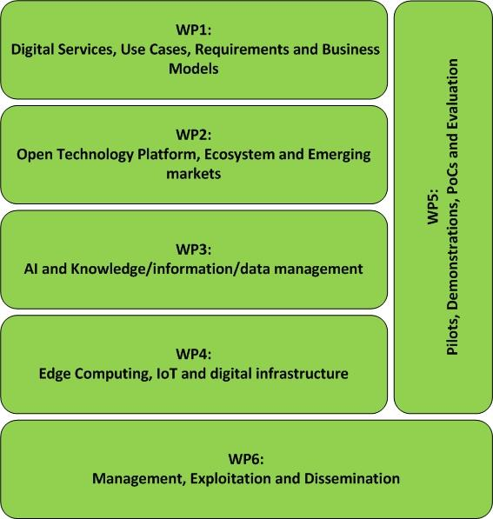

Describe iterative approach (VTT...)

* 1. **Main milestones**

*Present the project milestones in the following table. A milestone should represent a significant intermediate achievement, a date by which major results form the basis for a subsequent phase of work (e.g. finalisation of the data processing algorithms, integration of the semantic modules in the common framework, finalisation of the first version of the prototype, compliance with end-user requirements in terms of performances, etc.), or by which decisions are needed (for example, concerning which of several technologies will be adopted as the basis for a subsequent phase of the project). Major demonstrations should also be considered as project milestones.*

*It is recommended to consider no more than 6 milestones in a project (i.e. on average not more than a milestone every 6 months).*

*Milestone titles (descriptions) should be self-explanatory. For each milestone, indicate the Key Performance Indicator (KPI) that will be used to state its achievement, as well as its completion date.*

*This subsection should give a good overview of the different phases of the project.*

<If relevant and needed, text to be inserted here>

Exhaustive list of project milestones:

|  |  |  |  |
| --- | --- | --- | --- |
| ID | Description | KPI | Completion month |
| <MS1> | <e.g. implementation of prototype v1> | <e.g. software module implementing 95% of the specifications integrated and running in the common framework> | <e.g. M24> |
| <MS2> | <e.g. targeted use-case performance needs achieved> | <e.g. 99% success rate in detecting intrusions and less than 1 false alarm per hour> |  |

1. **Rationale for public funding**

Auto-generated section: input to be provided only on the Community website. Do not edit or remove this box and do not provide any text within this annex in this chapter, but provide the requested information directly on the ITEA Community website.

On the website you must fill in one section per country represented in the consortium. This section will indicate the national coordinator and detail the national rationale for funding. At the end of the national rationale for funding, the national coordinator has to indicate the national ICT clusters the project has contacted and intends to join (a clear status with regards to the cluster has to be indicated).

The national rationale for funding has four components:

* national gain: you have to explain the benefits for the participating countries (e.g. support to national strategies, standardisation, open source, knowledge dissemination, wellbeing improvement, impact on national productivity, etc.), how the country benefits from collaboration with other countries and the risk level of the investment (i.e. why is a public incentive preferred for such investments),
* return on investment (RoI): you have to explain how the money invested by both Public Authorities and companies is expected to generate value, revenue, jobs and/or economic growth, etc.,
* value creation of the national sub-consortium: if relevant, you have to detail the collaboration amongst the national sub-consortium, how cross-fertilisation between the various participants is achieved and, if applicable, what the national use cases are, how they are organised and how they are linked with other or previous national projects;
* adequate balance between the national partners (e.g. ratio of effort as a percentage for academics, SMEs, etc.).

For each partner, in addition to contact details and a generic description (incl. type and size of the entity), three specific descriptions are requested:

* relevance of the partner within the project by describing its main role in the project, tasks and the main added value (technological and in terms of market access) it will bring to the international consortium and vice versa;
* Strategic importance of the project for the partner, i.e. how envisioned project results (if successful) fit in, and contribute to, its innovation and business strategy, or complete previous projects (with a particular focus on the publicly funded ones);
* market access, i.e. how the partner intends to exploit the project results (e.g. new product, new service, licensing, etc.) and how the market(s) will be accessed (exploitation prospects and capability); current main markets and main customers, as well as planned exploitation plans and strategies are welcome whenever doable.

NOTE: this part is crucial for the national funding agency to evaluate the chances for funding for the individual partners within the project. Please try to be as concrete as possible.

Furthermore, it is key that all national coordinators get in touch with their national Public Authorities (PAs) to present them the project (idea, partnership, budget, etc.), checking funding opportunities and ensuring that the national consortium is eligible, even in countries that are not part of the ITAC (ITEA Authorities Committee). Beware of eligibility issues at national level.

For ITAC countries, information on the contact persons is available on the ITEA public website (in section “Participate in ITEA / Funding”). For the EUREKA countries that are not member of the ITAC, the contact persons are National Project Coordinators (NPCs); http://www.eurekanetwork.org/eureka-countries).

1. **Summary of costs & effort breakdown**

Auto-generated section: input to be provided only on the Community website. Do not edit or remove this box and do not provide any text within this annex in this chapter, but provide the requested information directly on the ITEA Community website.

This annex will contain a comprehensive summary of the costs and effort, by providing 1) costs & effort per country per WP (with totals), and 2) costs & effort per partner type. This data is automatically computed based on the detailed figures of costs & effort provided online by each partner on the Community website: it is therefore crucial that all partners provide relevant input for both costs & effort, and do not leave blank fields, which would generate erroneous breakdowns.

Detailed costs & effort per partner are provided in the related country perspective section of §4.

1. **Guideline for the value chain analysis and design**

*These guidelines propose a set of tools to facilitate the analysis and design of the business strategy of any ITEA projects. It is highly recommended to take the suggested tools into account while working on chapter 2.2.1 Market analysis and market value chain of PO-FPP template.*

*Annex B will be deleted from the PO-FPP template after the submission.*

*The contents of Annex B may not be reproduced, modified, adapted, published, translated, in any way, in whole or in part without the prior written consent of ITEA – All rights reserved*

**Collaborative research project’s Value chain analysis and design**

**Philippe Mils**

ITEA Steering group member (Thales Research & Technology France)

1 Avenue Augustin Fresnel 91767 Palaiseau France

[Philippe.mils@thalesgroup.com](mailto:Philippe.mils@thalesgroup.com)

10 August 2018

*This document may not be reproduced, modified, adapted, published, translated, in any way, in whole or in part without the prior written consent of ITEA – All rights reserved*

1. **Foreword**

The purpose of this document is to propose a set of tools to facilitate the analysis and design of the business strategy of any ITEA project. The proposed approach makes possible to identify weaknesses and possible corrective actions: better coverage of developed technologies in larger markets, redefinition of business model, evolution of the project's purpose and / or consortium. It is therefore recommended to start the analysis & design of the “business design” in the upstream definition phases of projects.

1. **Introduction**

The main objective for an ITEA project is to innovate for actual exploitation. Industry players have to explain how the project will serve their own economic interests (mainly producing more value for the company), which can only be accomplished if the project is realised. There is thus a confluence of individual interests materialised by the proposal of a project. Unfortunately, the confluence of business individual interests is seldom explained. Some partners often explain their business individual interests with no assumptions on how other participants will interact at the business level with them to help achieving it. In the past, this has led to large business crashes. E.g. a few years ago, the media community put a huge amount of effort to define a system solution for mobile TV (standardisation, computing solutions, software, encryption) and a lot of SMEs invested on this new promising market. But when the commercial discussions started, the Telcos explained to the media companies they would have to pay for the transport of their contents while the media companies were expecting the Telcos to pay for having access to their contents on their networks. There was no agreement on the value chain organisation! The result was that the solution was not deployed and several SMEs became bankrupt. But a lack of shared understanding of the value chain is not the only issue; sometimes business models are not viable because even the customer identity does not appear so clearly.

Some guidance has to be put in place to mitigate these issues; this is the purpose of that document through the concept of value chain analysis. Value chain analysis is introduced here to solve the business consistency issue and help engineer an overall project’s business case from the inception to the exploitation phase including steering the ITEA project itself. Formalising a value chain helps to explain the causal business links between the partners' own interests and the shared objective of the project. Value chain analysis also includes key actors involved in serving the customers or the end users even when they don’t belong to the project per se in order to clarify to whom to deliver the business value and articulate the proposed value proposition that makes sense only to its recipients. In the mobile TV market, a value chain analysis done at the beginning of the innovation process would have shown business model inconsistencies between the Telcos and the media companies and would have stressed the need to solve the issue before investing massively in R&D.

As innovation requires more and more composite technological solutions implying several partners’ participation, one cannot accept not understanding how the business will be organised as it has a potentially significant impact on the solution, furthermore sometimes enabling new businesses constructions.

* Value chain analysis encompasses different concerns when analysing potential business:
* How the value is generated by progressive transformation from actors to actors.
* How actors are rewarded from value transfer.
* How the environment may hinder or facilitate value creation.

The next section is organised according to that structure.

1. **Value chain analysis**

A project is considered as a precursor of future businesses; partners are collaborating together to prototype future business relationships which need to be established or re-enforced to create value for business participants. Therefore, we need to design what is the project’s shared vision of what these future business relationships will be and test their soundness, consistency and strength without forgetting actors outside the consortium that will influence the relationship with the customers and the end users. It is essential to understand that value chain analysis and representation does not intend to describe how the project’s partners collaborate during the project execution. Instead it represents:

* A shared vision on how the participants will execute business once the project is completed.
* The intellectual assets which must be transferred in order to enable the new business configuration to be set up.

We will be interested in three different concerns that are essential to analysing the business potential:

* Value creation: How the project’s integrated solution is built by progressive aggregation of values flows from business participants. This will foster the generator and the receiver of the value flow to work on contract agreements value flow.
* Cash reward: How value chain actors are rewarded for value delivery. This will help the generator and the receiver of the cash streams to work a pricing policy which is acceptable for the parties.
* Influencers: Who are the actors and factors that allow or prohibit a value offer to a specific market. This will help make the business potential analysis, with consideration of real world constraints, more realistic.

For the sake of clarification, we use “Value Chain” in that document to mean an overarching concept encompassing the two perspectives: value flow representation and cash reward. Analysing the environment, the actors and factors are part of “Value chain analysis”, the activity which tries to demonstrate that the value chain is realistic by considering real world constraints.

1. **Value flows representation**

A value flow diagram is a graph orientated towards one or more customers and end users operating in the same business domain and represents how value is created by progressive aggregation of values flows from business participants.

The following figure is a value flow representation containing all the notation elements that are discussed afterwards.[1]

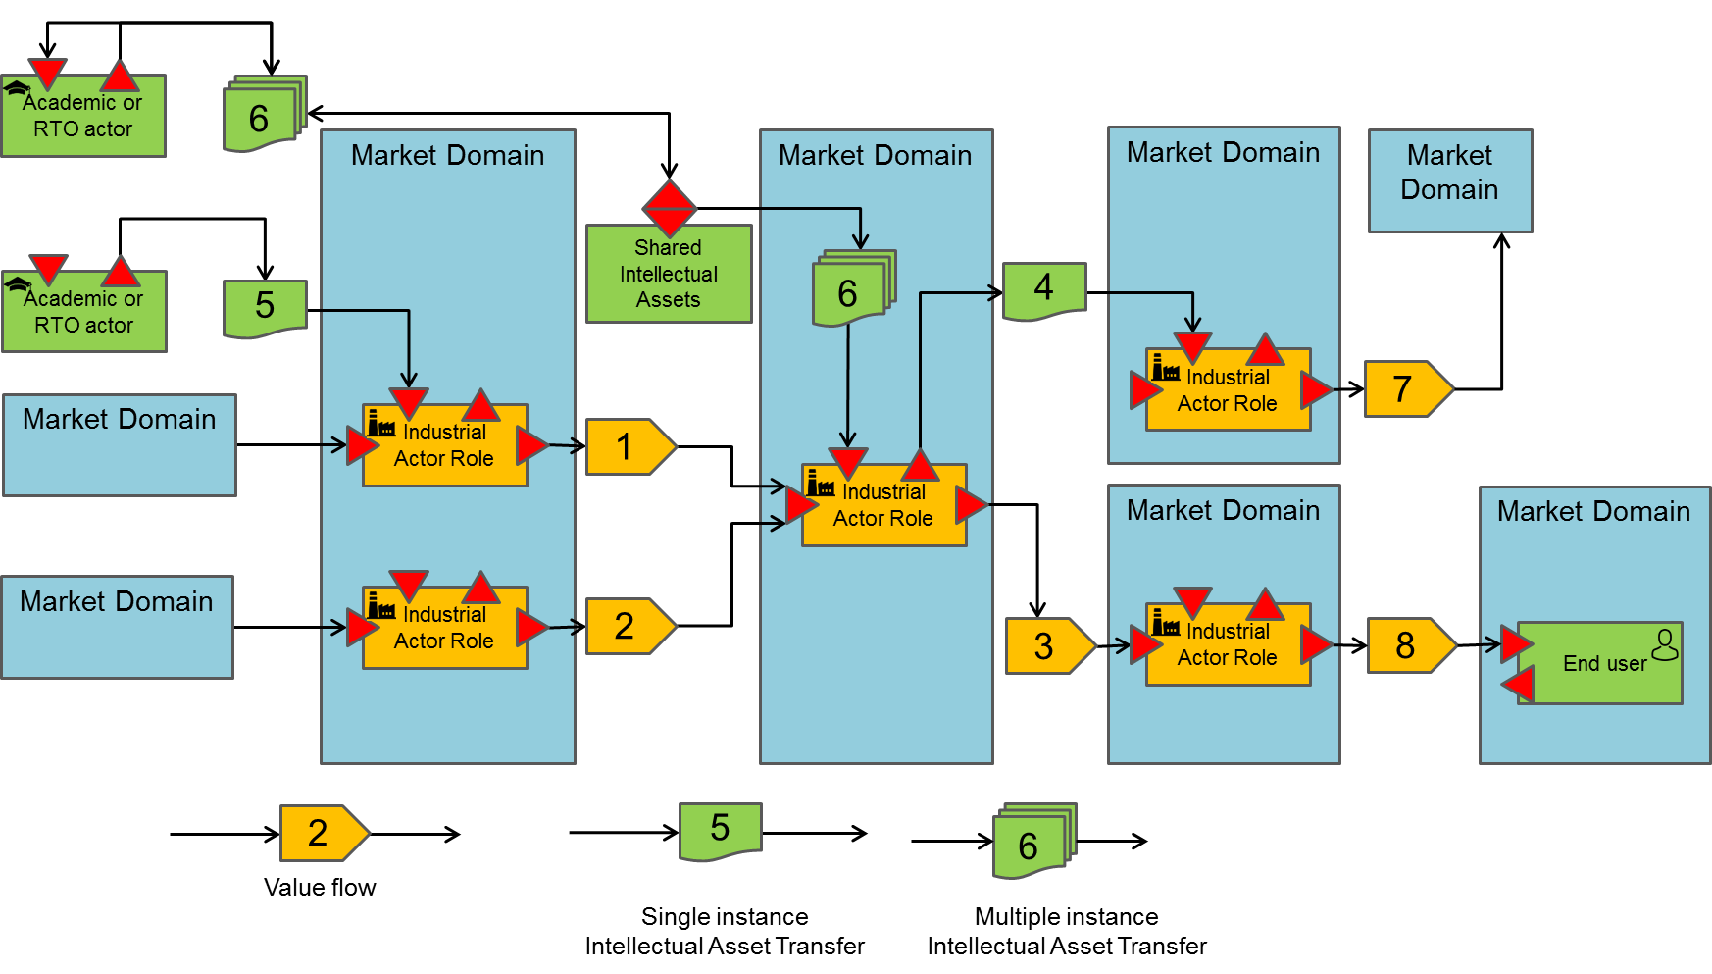

*Figure 1 Value flow we must also represent a customer that may be different from the end users*

A value flow diagram is represented as a directed graph (here from left to right) where economic actors collaborate together in order to produce some kind of good or service. It is key to representing the customers and end users that may provide invaluable information on market size and segmentation. Economic actors can be either business or academic actors that may contribute to the value chain through patent transfer or open source repository development necessary to deliver the expected goods or services. Academic actors are not the key actors of the value chain in the analysis of the potential of a business; but their role may be central to enable a business actor to become capable to deliver.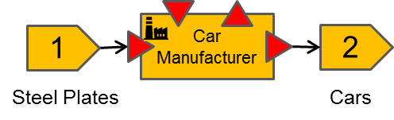

Economic actors consume input value flows and transform them into output value flows. A value flow is an exchange of goods or services between a producer and a consumer of that value. ‎**Error! Reference source not found.** shows an example of value flow transformation. In car manufacturing, plates of steel enter in the value creation process run by car manufacturers. Steel plates are transformed into cars which is the output value flow. Steel plates become part of car*s.*

*Figure SEQ Figure \* ARABIC 2 Car manufacturer Value flow transformation*

*Figure SEQ Figure \* ARABIC 3 Robots as a leverage value flow in car manufacturing*

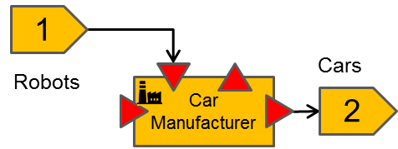

A second kind of value transfer exists: The leverage value flow. A leverage value flow is a value transfer towards an economic or an academic actor that has a leverage effect on the value transformation process of the receiver. It participates in the value transformation process without becoming part of it (here arrows on the incoming triangle of the Actor role). The leverage value flow may have two different impacts: Either it can improve the efficiency of the output value production process without changing the nature of the value flow so generating more incoming cash streams, or it can be an enabler of a value shift. By value shift we mean generating a new kind of value flow, different from the one that the economic actor has been able to produce so far. ‎Figure 3 shows that robots are a leverage value flow in the car manufacturing business. Robots do not become part of cars but add value in the cars whereby using robots in the manufacturing process we can expect higher quality cars , or cheaper cars. In other words, generating more value for money.

The notation elements are more systematically described in the following text:

*An industrial actor is an entity role that consumes one or more input value flows (left input arrow) and produces one or more output value flows or intellectual assets (right output arrow) in a specific market. By role, we mean that the industrial entity is reduced to its interaction in a specific market. E.g. Thales sells railway signalling systems and satellites, which are two different markets and thus correspond to two different business roles.*

*An industrial actor activity can benefit from additional contributions in the form of leveraged value flows or intellectual assets that have a leverage effect on its value creation process (vertical inbound arrow). This is called leveraged input. The value entering from that leveraged input entry is not integrated into the outgoing value stream; it helps make the transformation of input value flows into output value flows. For example: Academic knowledge, design environments / simulation tools helping to define products, manufacturing machines, and open-source code are all input values which improve the value created. It may also occur that an industrial actor also produces output leverage value flows, values which are not core elements of its business model.*

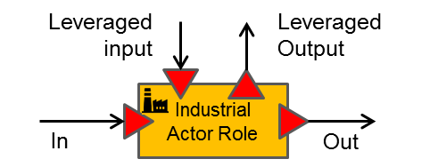

A value flow is a flow of products or services. Value flows are different from cash streams that may follow a different path than value flows. How cash streams are captured will be described in the next section.

*A value flow is an exchange of goods or services between a producer and a consumer of that value. Goods and services are produced in unbounded multiple instances. For example, cars leaving a production line, video-on-demand movies etc.*

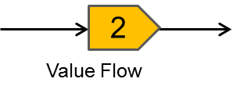

Industrial actors work in a given business domain or target their offer for a target business domain.

*A market domain is a container of actors (business or consumer actors) which compete or complement each other’s to deliver kinds of products and services. They are represented according to the left-hand side formalism.*

*We will focus on evaluating the size of the accessible market without trying to represent all the actors that make it up.*

*A market domain is also where the competition lives. If the R&D project intends to deliver an incremental or disruptive value proposition into a market domain, it is essential that the disruptive value proposition is articulated in the proposal.*

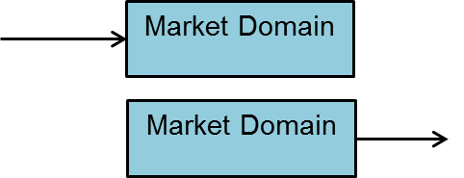

Academic actors’ fundamental goal is not to deliver products and services into a market; it is to deliver intellectual assets to economic actors that are more efficient at creating new kinds of values to markets (what we call innovation) or at improving existing value flows. An intellectual asset is discrete compared to a value flow: academic actors transfer intellectual assets non-recurrently or incrementally, while value flows are continuous (repetitive) exchanges. Representing academic actors in the value chain clarifies their catalytic role in the value chain: if the intellectual asset is not transferred, economic actors are not able to provide the value stream corresponding to the promises of the project.

*An academic actor is similar in every respect to an industrial actor except that it produces and consumes only leverage value. There is no value flow production in any dedicated business market that is ruled by competition. The leverage value takes the form of intellectual property or intellectual assets.*

*Of course, this is a reduced definition of academics and RTO. E.g. It is often the case that RTOs sell access to some prototyping infrastructure for industrial experimentation. This is a transitional situation necessary to enable a technology transfer at a later stage. Remember that we are interested in the targeted value chain definition; the transitional situation may occur during a project but should not last.*

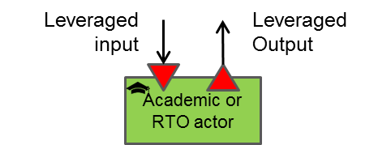

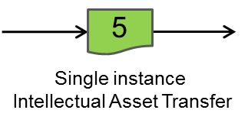

*A transfer of intellectual property corresponds to an non-recurrent transfer of intellectual asset likesome knowledge corresponding to patents, property rights etc.*

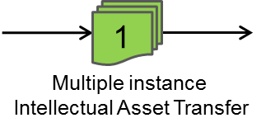

*This representation is adopted when several instances of the same intellectual asset are transferred like open-source code updates.*

End users are individuals, consuming products and services available in the public market.

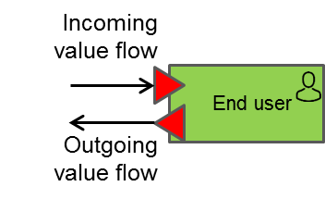

*An end user lives in the public sphere, is a consumer of value flows, can generate cash streams (typically when paying for goods or services) and may be also able to generate value flows. E.g. collecting data from end-user experience generates a value flow.*

By their very nature, economic actors at the start of the value chain (left-hand side of ‎Figure 1) produce the most generic technologies in the value flow while at the end (right side of the figure) we find vertical domain actors (automotive, energy, health ...) producing the least generic technologies and applications which are the closest to the social sphere.

Figure 1 also represents a type of role corresponding to the management and sharing of intellectual property assets (typically corresponding to the open source model). This type of entity does not produce value directly; contributors who exchange intellectual assets with this intellectual storage facility generate value through the use they make of shared technology.

*A shared intellectual assets repository receives and makes available an intellectual value to other actors, whether industrial or academic. This value may or may not be the materialisation of accumulated knowledge.*

*The extension of these accumulated intellectual assets is produced by increments of any actor using the existing content (outgoing arrow) and storing an extension or modification to the repository (incoming arrow).*

*An actor may, of course, simply be a consumer of an intellectual asset without contributing to its improvement.*

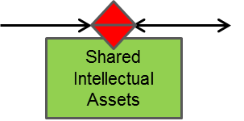

**Example:**

‎Figure 4 below represents an example of a (theoretical) value flow targeting the improvement of electricity production in the wind energy sector. It should be noted that the represented value flow is only a small part of the real value chain.

Academic1 maintains an OSS repository “OSS1”. The content of this repository, which is a Wind Turbine aerodynamic simulator, is used by the Wind Turbine Blade producer industrial actor as a leverage technology. Academic1 regularly updates the aerodynamic simulator, thus creating updates which are pushed to the Wind Blade Producer. In that example there is only one contributor to the shared asset but in general there may be several contributors to shared asset repositories.

Academic2 makes a one-off transfer of a wind field implantation simulator to a wind farm operator. Once the transfer is completed, Academic2 doesn’t own anymore the property of the Wind field simulator. There may be other patterns existing such as the granting of a licence for a limited period of time to its receiver for exclusive or non-exclusive use. One should represent all these situations the same way while the textual description of the value flow should clarify the details whenever possible.

*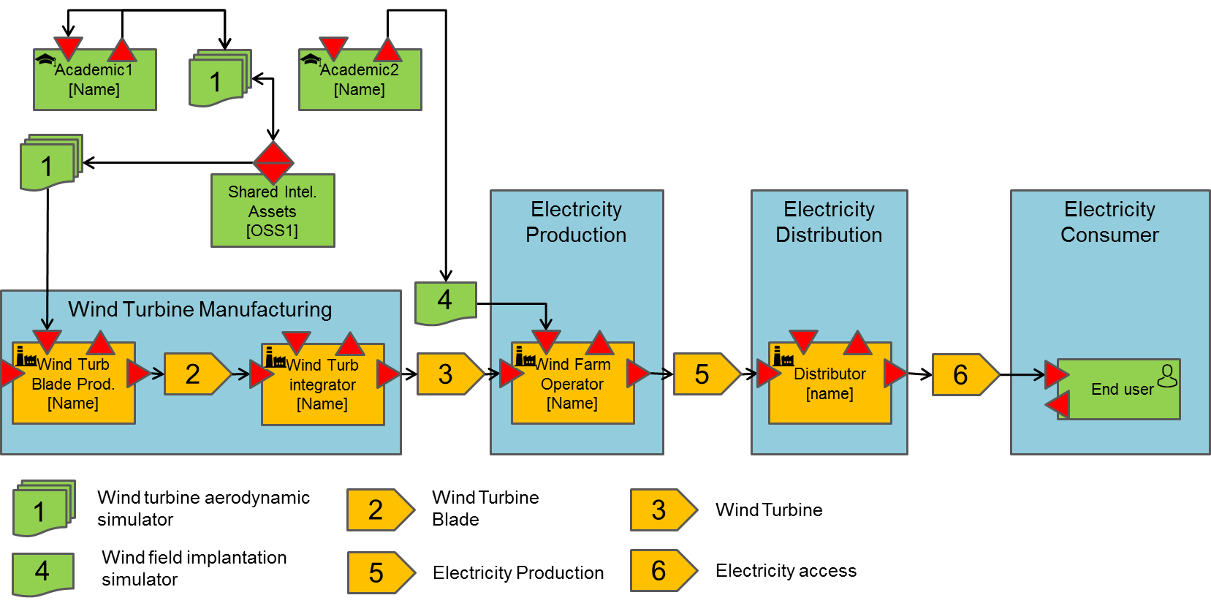Figure 4 Theoretical example of an electricity production value chain*

The wind turbine blade producer produces a flow of wind turbine blades which is consumed by the wind turbine integrator. The wind turbine integrator produces a flow of wind turbines.

The wind turbine blade producer and wind turbine integrator operate within the wind turbine manufacturing market.

The wind turbine flow is consumed by the wind farm operator that installs and operates the wind farms. It produces electricity to the electricity distribution market. In order to deploy more efficient installations, it has acquired the property of the wind field implantation simulator. This simulator is a leveraged value transfer making its activity more productive.

The distributor actor operates in the electricity distribution market. The distributor transfers a flow of electricity access to the consumer market.

It is also interesting to stress that this value chain may accept other variants:

* There are some cases where the distribution is not the customer of the electricity producer but the provider and in this case the end user is the customer of the electricity production when his first contact is the distributor.
* We can also imagine having another actor between the distributor and the end-user which actually would be the final customer when the end users are not at all a customer (E.g. Think about the social departments of cities supporting electricity access for some of the population).

There is a possibility for a Value flow to have two actors being, at the same time, customer and supplier of each other at different stage of the production of a product. The next figure represents how this situation may be represented.

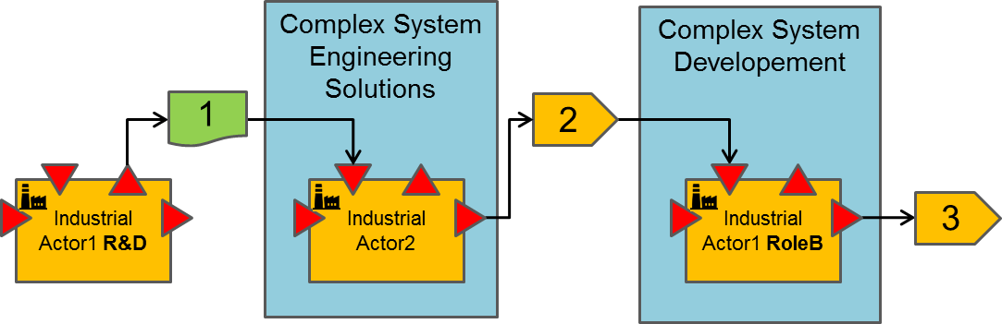

*Figure 5 Multi-role business actor*

In that figure we can see that the Industrial Actor1 intervene at two different stages of the value chain. There is nothing wrong with this as the value chain represents an industrial role within the value flow. Usually these roles correspond to different sub-organisations within a business actor. There may be several roles played by the same industrial actor which means that it can be involved in different markets, delivering different value flows. In the above figure, the R&D department transfers some intellectual property (e.g. a process, a technology prototype or a patent) to a second business actor that builds an offer from that input. That second offer is an industrial grade solution that can be procured by the business units of Actor 1. Since this was not the case with the intellectual property issued from the R&D department, there is a great business case for Actor1 as a whole to go that way. He has spent a limited effort (R&D) in the development of a solution and finally gets access to the industrial implementation of the solution at a reasonable price. Of course, this is possible as Actor2 is selling the industrial grade solution in a sufficiently large market that contains Actor1 Business Unit to make the deal viable.

1. **Cash streams representation**

As already stated, Cash stream representation describes how value chain actors will be rewarded for value delivery. This will help generators and receivers of the cash streams to work a pricing policy which is acceptable for the parties and answer the question: Are all value flow receivers willing to pay for the proposed value proposition?

Starting cash stream representation from a value flow is straightforward. Figure 6 shows the cash stream perspective derived from value flow described in ‎Figure 1. Basically, circulating the value flows in their opposite way reveals the cash streams.

However, there may be several variants for the above figure depending on participant’s strategies.

* It is not mandatory for the industrial actor to fund academic or RTOs actor for the development and maintenance of shared intellectual assets. The development of shared intellectual assets may involve more sophisticated funding models so then they should be represented.
* It is often the case that industrial actors or end-users are not willing to pay for the value which is delivered to them. However, value providers are still delivering their value to them in exchange for some other value. Think, for example, of the provision of the Google document suite delivered free of charge to individuals. Access to user data or user experience are two examples of the value that may be provided by end-users in exchange of the incoming value. In that case, the value generated from the end-user toward Google should be represented in the value flow diagram.

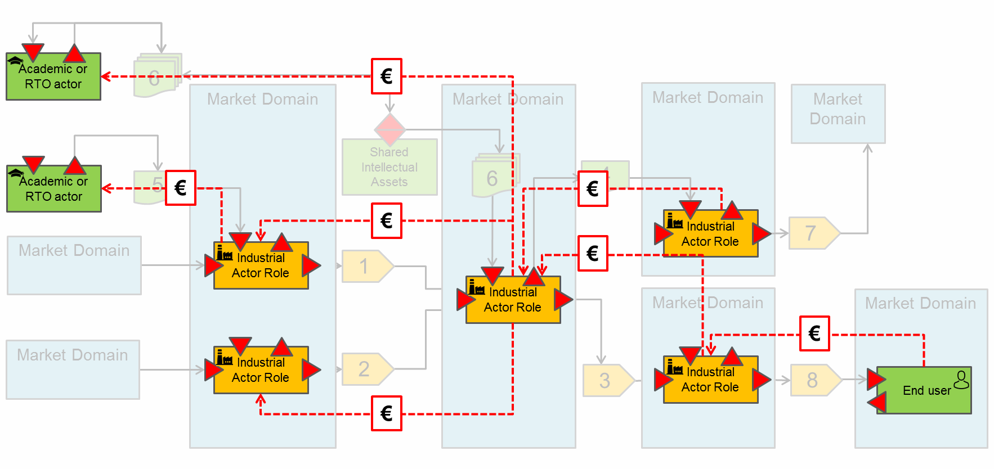

*Figure 6 Some Cash stream perspectives*

Representing the cash streams forces the business actors to ask themselves if there is a business case for their offer and often this can end up with the redesign of their business model, thus impacting in turn the value flow perspective and the products/services architectures. Then one should think about the cash stream perspective and the value flow perspective as two sides of the business between them, so one should iterate until both perspectives become balanced.

Notation elements:

*A cash stream is an exchange of currencies between a producer and a consumer. Exchange of currency can be recurring or not.*

*Non-recurring exchange of currency occurs, for example, for patent acquisition. Recurring exchange of currency may occur for reward of value flows. For example, annual subscription fees for a service. Composite currency flows may exist, for example, when there is an initial licence fee plus an annual renewal licence fee.*

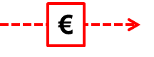

1. **External environment**

Delivering value to customers is not only a question of balance between a value proposition and pricing. There are other factors that may have a decisive impact on the capability of a new offer to generate new deals with potential customers in a market domain. These factors are external to the actors involved in the transaction but they may rule the business. These factors need to be identified as they may be powerful enough to kill or facilitate a business relationship between business actors. They are four types of external environment factors:

* Influencers
* Professional syndicates
* Standardisation organisations
* Regulation and certification authorities

The figure below suggests a representation for the factors that apply to a market domain.

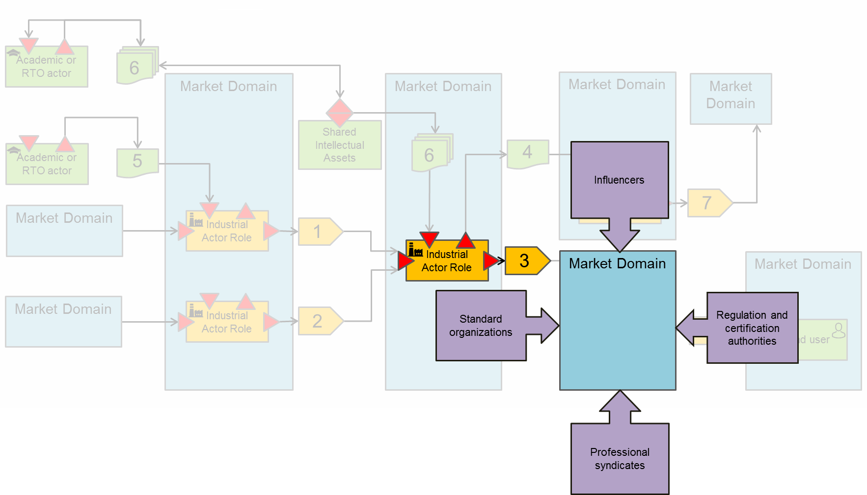

*Figure SEQ Figure \* ARABIC 7 Environment constraints*

Influencers are business actors such as large integrators that impose rules on their market domain, such as AIRBUS that defines the rules for procurement with which their subcontractors and sub-sub-contractors need to comply. It is important to be aware about these constraints before talking business with their sub-contractors.

Professional syndicates are professional organisations in direct touch with the professions; they strive to protect the interests of the members of their respective professional branch or branch of activity. They have the power to impose constraints on a specific business ecosystem in which the customer to which a value proposition is intended to be delivered is located.

Standardisation organisations are another kind of environment constraint or opportunity. The customer maybe part of it or even the supplier of a value proposition may be part of it. Standardisation organisations *define* standard but do not monitor their application. However, it is important to understand who is part of the standardisation organisations to understand where standards are heading, to understand if the value proposition discussed needs to comply with the standard and needs to remain compliant with it in the long term, and who can help in maintaining the standard in a way that is favourable for the value proposition supplier.

Regulation and certification authorities are slightly different from standardisation authorities. They are in charge of certifying that constraints and rules are fulfilled by products and services. Regulation and certification authorities behave as barriers for new actors entering existing market. One should not neglect the importance of those organisations to disabling new entrants to existing markets.

These four types of constraints that may apply to new business entrants are not independent of each other. Influencers often take a role in the definition of standards; they interact with certification authorities and professional syndicates. In a project’s proposal it is therefore necessary to identify all the actors, links and rules that may have an impact on the business. Once this is achieved, it is necessary to describe the partner strategy to overcome the potential issues or to use this environment as a business facilitator, for example by participating in the elaboration of standards. The exploitation and dissemination section of a proposal are good places to highlight the strategy for overcoming the potential issues.

There is no need to analyse the external environment for each actor of the value chain. There is a need to perform the exercise for the disruptive value flows of the project: only the value flows which exhibit a kind of value proposition that may be disruptive in a market domain. It is seldom that there are several outgoing disruptive value propositions from a research project. The project’s overall technology concept is usually the one needing attention.

1. **Conclusion**

In this document we have discussed how a value chain can help clarify a business vision analysing three different concerns. In ITEA proposals, these concerns should be addressed. They need to be discussed and agreed between participants. They need to be represented through diagrams but also described textually to explain the design decision that prevailed upon obtaining the design model. They need the involvement of a participant’s organisations beyond the R&D organisations to produce something beneficial to them. The value chain analysis is a good tool to transform research into innovation to make an impact on and in the market. The innovation can also be laid in the value chain organisation. Redesigning a value chain can be a good strategy to disrupt a situation where major leaders dominate the market. The value chain analysis usually has strong impact on the research itself due to the impact on architecture and performance level required.

*End of the Annex C*

1. Icons used in the value chain representation are available in the ITEA 3 Call 5 binder.