# Open Wise Edge for Smart Communities (OWE4SC)

In our daily life (leisure and work) everything is currently under digitalization. New kind of interaction, value co-creation and innovations are possible by developing on-demand digital services aggregating and analyzing data from multiple sources. Artificial Intelligence (AI) and Edge Computing are enabling new capabilities for digital services, including near real-time automated and fine-grained sensing-analysis-actuation loops, better response time, locality with enhanced safety and privacy.

Application domains such as Health & Wellness, Smart Energy and Smart Buildings will benefit from the AI and edge computing enabled new capabilities of digital services. This project will focus in collaborative R&D of Open Wise Edge (OWE) technology platform and ecosystem unleashing the capabilities of AI, edge computing, open source, open data and open models for holistic optimization and innovation of new digital services for smart consumer and professional communities.

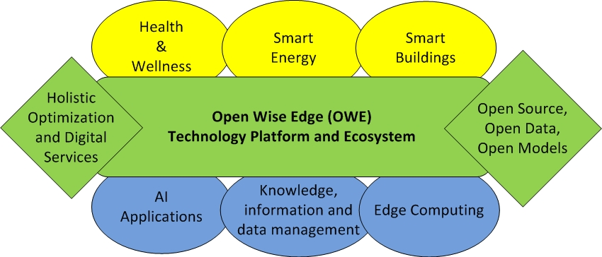

The new digital service innovations for enhancing health and well-being, sustainability, safety and productivity of smart communities represents a global business opportunity for European industries and their renewing value chains and ecosystems. The key drivers for renewal of traditional value chains and ecosystems include digitalization, servitization, artificial intelligence, edge computing and cyber physical systems with the established global digital distribution channels and platforms (i.e. Internet, app markets and social media), which set the context for new European digital service innovations for smart communities globally.

### Market Relevance

* Growing markets of digital services (value from co-creation)
* AI applications (value from data in use)
* Edge computing and micro-service markets (value from digital infrastructure)

### Innovation

* Co-creation and co-innovation of AI and Edge Computing based digital services/service features in Health & Wellness, Smart Energy and Smart Building application domains
* Holistic optimization of behavior/operations/processes via AI and Edge Computing based digital services
* Open Wise Edge (OWE) technology platform and ecosystem (Open Source, Open Data, Open Models)

### Business impact

* Open technology platform for digital services development with AI and Edge Capabilities
* Open application, model and data markets for AI and Edge computing based digital services innovation
* Increasing competitiveness, finding partners and creating cost savings via introduction of AI and Edge based digital services for consumers and businesses