## Partner contact info

Organization:

Type: Industry/SME/Research/Academia

Name:

e-mail:

Phone #:

## Partner interests within the project

<Please provide a short desctiption of your R&D and collaboration interests and expectations within the OWE4SC project>

## Open Data and Technologies

<Please shortly identify and describe the relevant open data sets, data sources and open source technologies, which you see relevant in the project especially from you organization’s perspective. Please also describe related ecosystems.>

## Success Factors/KPIs

<Please describe when you would see the project has been a success for you. Please identify and list relevant KPIs (Key Performance Indicators) from your organizations viewpoint.>

## Background

Please list previous R&D projects you see relevant regarding OWE4SC project as background/collaboration possibility:

|  |  |  |  |  |
| --- | --- | --- | --- | --- |
| Project Name | Cooperative Programme | Time period (approx.) | Technical Focus | Relationship |
| <ACRONYM> | <e.g. ITEA> | <2010-2013> | <Text to be inserted here> | <Text to be inserted here> |
| <ACRONYM> | <e.g. H2020> | <2012-?> | <Text to be inserted here> |  |

Please indicate any relevant publications (scientific papers, white papers, etc), which you see relevant for the OWE4SC project as background information:

* <publication info, link>

Please indicate any relevant market study you see relevant for the OWE4SC project objectives:

* <publication info, link>

## Collaboration

<Please describe what kind of collaboration and networking benefits and added value your organization is looking for by participating the project. Please consider both business and technological viewpoint.>

## Outputs

<Please describe outputs (novel algorithms, standards, open source libraries, implemented collaborative framework, demonstrator, product prototype, new service based on some software, wearable device, etc.) that you organization can create/contribute to during the project.

## Role of the partner

<Please describe your envisioned role in the project and list the work packages you would like to participate - with work package specific description on your planned contribution>

## Innovations and Standards

<Please list any relevant innovations and standards regarding the project from you organization perspective. Please identify any relevant standardization organizations that your organization is participating.>

## Value chain positioning

<Please describe positioning of your organization in socio-cyber-physical value stream and markets illustrated in Figure 1 below>

**Relevant markets of the socio-cyber-physical value stream for my organization:**

* <Please list>

**Positioning in the socio-cyber-physical value stream:**

<Please describe the added value your organization can bring within the value stream. What kind of organizations you envision as customers for your offering and on which markets? Which markets you need to participate and what kind of organizations you need to co-operate with to be able to provide your envisioned offering?>

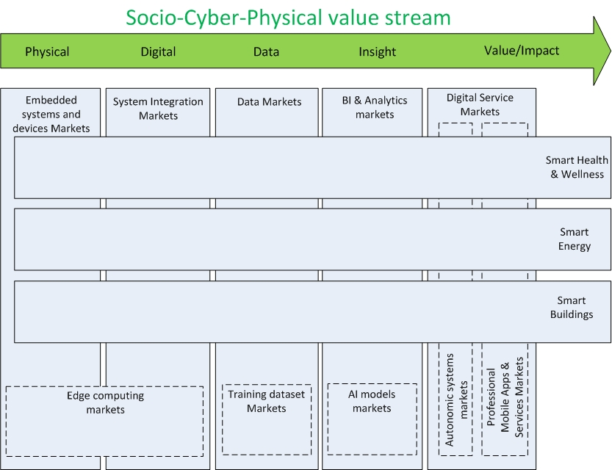

**Figure 1. Socio-Cyber-Physical value stream, related markets and application domains**.