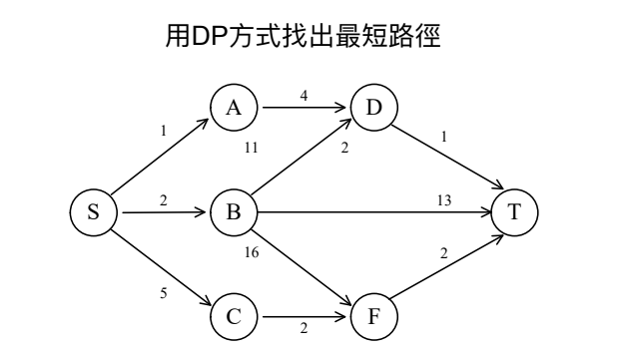

d(S,T)=min{1+d(A,T),2+d(B,T),5+d(C,T)}

1.d(A,T)=min{4+d(D,T)}=4+1=5

2.d(B,T)=min{13,11+d(D,T),16+d(F,T) }

=min{13,11+1,16+2}

=12

3.d(C,T)=min{2+d(F,T)=2+2=4}

4.Thus

d(A,T)=5

d(B,T)=12

d(C,T)=4 d(S,T)=min{1+d(A,T),2+d(B,T),5+d(C,T)}

=min{1+5,2+12,5+4}=6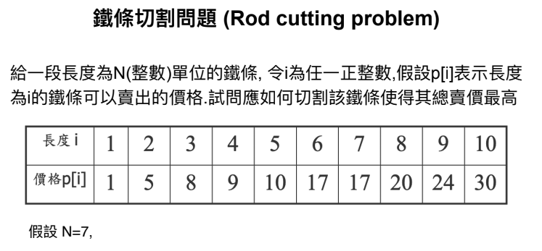

7=3+4=3+2+2 =>8+5+5=18元

7=1+6=2+2+3 =>5+5+8=18元