| **Name:**  **Ganesh Tarun S R** | **SRN:PES1UG19CS160** |  |
| --- | --- | --- |
| **SEC:C** |  |

**Problem Statement:**

A calculator application with user interface which can be used to perform basic arithmetic operations with two operands. This also stores all the calculations performed by the user and a particular problem can be fetched by the user on entering the appropriate problem number. This app also handles errors and displays appropriate messages to the user. This app was designed based on MVC.

**Model Component:**

import java.sql.Connection;

import java.sql.DriverManager;

import java.sql.ResultSet;

import java.sql.Statement;

public class Model160 {

private float calculationValue=0;

private int ser_no=0;

private View160 theView;

String message="Invalid operator!";

Model160(View160 theView)

{

this.theView=theView;

}

public void calculate(float firstNumber,char op, float secondNumber){

if(op != '+' && op != '-' && op != '*' && op != '/')

theView.displayErrorMessage(message);

else

{

switch(op)

{

case '+':

calculationValue = firstNumber + secondNumber;

break;

case '-':

calculationValue = firstNumber - secondNumber;

break;

case '*':

calculationValue = firstNumber * secondNumber;

break;

case '/':

calculationValue = firstNumber / secondNumber;

break;

default:

calculationValue = 0;

}

try{

Class.forName("com.mysql.cj.jdbc.Driver");

Connection con=DriverManager.getConnection(

"jdbc:mysql://localhost:3306/MVC_PES1UG19CS160","root","Ganesh@456");

Statement stmt=con.createStatement(ResultSet.TYPE_SCROLL_INSENSITIVE,

ResultSet.CONCUR_READ_ONLY);

ResultSet rs=stmt.executeQuery("select * from pes1ug19cs160");

if(rs.last())

ser_no=rs.getInt("sno")+1;

else

ser_no=1;

stmt.executeUpdate("insert into pes1ug19cs160 values("+ser_no+","+firstNumber+",'"+op+"',"+secondNumber+","+calculationValue+");");

//System.out.println(ser_no);

//System.out.println(rs.getInt("sno"));

/*while(rs.next())

System.out.println(rs.getInt(1)+" "+rs.getString(2)+" "+rs.getString(3)); */

con.close();

}catch(Exception e){ System.out.println(e);}

}

}

public float getCalculationValue(){

return calculationValue;

}

public String retrive(int pno) {

String s="";

try{

Class.forName("com.mysql.cj.jdbc.Driver");

Connection con=DriverManager.getConnection(

"jdbc:mysql://localhost:3306/MVC_PES1UG19CS160","root","Ganesh@456");

Statement stmt=con.createStatement(ResultSet.TYPE_SCROLL_INSENSITIVE,

ResultSet.CONCUR_READ_ONLY);

ResultSet rs=stmt.executeQuery("select * from pes1ug19cs160 where sno="+pno);

if(rs.last())

{

for(int i=2;i<=5;i++)

{

s=s+rs.getString(i);

if(i==4)

{

s=s+"=";

}

}

System.out.print(s);

}

else

s="Range exceeds";

//stmt.executeUpdate("insert into pes1ug19cs160 values("+ser_no+","+firstNumber+",'"+op+"',"+secondNumber+","+calculationValue+");");

//System.out.println(ser_no);

//System.out.println(rs.getInt("sno"));

/*while(rs.next())

System.out.println(rs.getInt(1)+" "+rs.getString(2)+" "+rs.getString(3)); */

con.close();

}catch(Exception e){ System.out.println(e);}

return s;

}

}

**View Component:**

**import java.awt.event.ActionListener;**

**import javax.swing.*;**

**public class View160 extends JFrame{**

**private JTextField firstNumber = new JTextField(5);**

**private JTextField operator = new JTextField(1);**

**private JTextField secondNumber = new JTextField(5);**

**private JButton calculateButton = new JButton("Ans=");**

**private JTextField calcSolution = new JTextField(5);**

**private JLabel number=new JLabel("Enter the problem number to be viewed:");**

**private JTextField no = new JTextField(3);**

**private JButton view = new JButton("View");**

**private JLabel lab=new JLabel("Ganesh Tarun S R\n PES1UG19CS160 \n MVC Assignment");**

**private JTextField query = new JTextField(10);**

**View160(){**

**JPanel calcPanel = new JPanel(); //container class**

**this.setDefaultCloseOperation(JFrame.EXIT_ON_CLOSE);**

**this.setSize(500,500);**

**calcPanel.add(firstNumber);**

**calcPanel.add(operator);**

**calcPanel.add(secondNumber);**

**calcPanel.add(calculateButton);**

**calcPanel.add(calcSolution);**

**calcPanel.add(number);**

**calcPanel.add(no);**

**calcPanel.add(view);**

**calcPanel.add(query);**

**calcPanel.add(lab);**

**this.add(calcPanel);**

**}**

**public float getFirstNumber(){**

**return Float.parseFloat(firstNumber.getText());**

**}**

**public float getSecondNumber(){**

**return Float.parseFloat(secondNumber.getText());**

**}**

**public int getQueryNumber(){**

**return Integer.parseInt(no.getText());**

**}**

**public char getOperator()**

**{**

**return operator.getText().charAt(0);**

**}**

**public float getCalcSolution(){**

**return Float.parseFloat(calcSolution.getText());**

**}**

**public void setCalcSolution(float solution){**

**calcSolution.setText(Float.toString(solution));**

**}**

**void addCalculateListener(ActionListener listenForCalcButton){**

**calculateButton.addActionListener(listenForCalcButton); //event is performed when button is clicked**

**}**

**void addRetriveListener(ActionListener listenForRetButton){ //attaching event to the calculate button**

**view.addActionListener(listenForRetButton);**

**}**

**public void setQuery(String res){**

**query.setText(res);**

**}**

**void displayErrorMessage(String errorMessage){**

**JOptionPane.showMessageDialog(this, errorMessage);**

**}**

**}**

**Controller Component:**

**import java.awt.event.ActionEvent;**

**import java.awt.event.ActionListener;**

**public class Controller160 {**

**private View160 theView;**

**private Model160 theModel;**

**public Controller160(View160 theView, Model160 theModel) {**

**this.theView = theView;**

**this.theModel = theModel;**

**this.theView.addCalculateListener(new CalculateListener()); //call addCalculateListener with CalculateListner obj as parameter**

**this.theView.addRetriveListener(new RetriveListener());**

**}**

**class CalculateListener implements ActionListener{**

**public void actionPerformed(ActionEvent e) {**

**float firstNumber, secondNumber = 0;**

**char op='+';**

**try{**

**firstNumber = theView.getFirstNumber();**

**secondNumber = theView.getSecondNumber();**

**op=theView.getOperator();**

**theModel.calculate(firstNumber,op, secondNumber);**

**theView.setCalcSolution(theModel.getCalculationValue());**

**}**

**catch(NumberFormatException ex){**

**System.out.println(ex);**

**theView.displayErrorMessage("You Need to Enter 2 Integers");**

**}**

**}**

**}**

**class RetriveListener implements ActionListener{**

**public void actionPerformed(ActionEvent e) {**

**int problem;**

**try{**

**problem = theView.getQueryNumber();**

**//theModel.retrive(pno);**

**theView.setQuery(theModel.retrive(problem));**

**}**

**catch(NumberFormatException ex){**

**System.out.println(ex);**

**theView.displayErrorMessage("Enter query number properly");**

**}**

**}**

**}**

**}**

**Main Class:**

**import java.sql.DriverManager;**

**import java.sql.*;**

**public class Main160 {**

**public static void main(String[] args) {**

**View160 theView = new View160(); //view obj**

**Model160 theModel = new Model160(theView); //model obj**

**Controller160 theController = new Controller160(theView,theModel); // controller obj and calling ctt**

**theView.setVisible(true);**

**}**

**}**

**Output Screen Shots:**

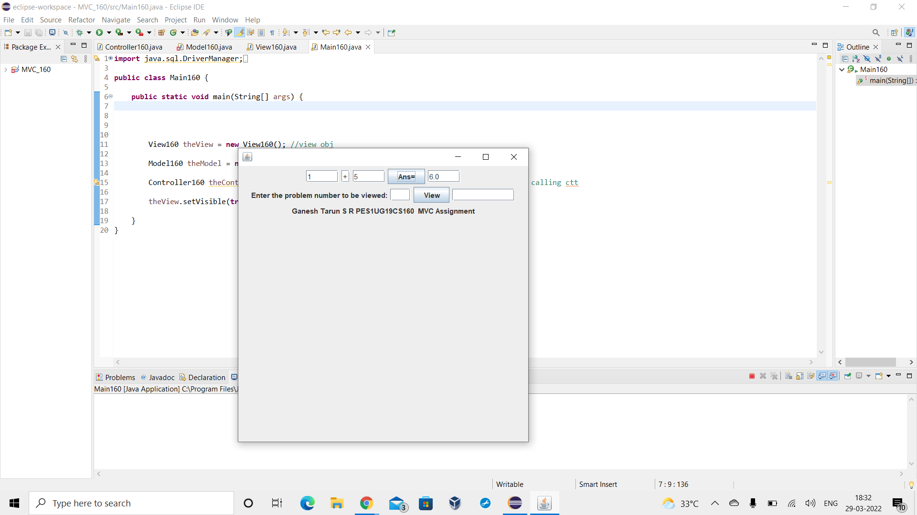

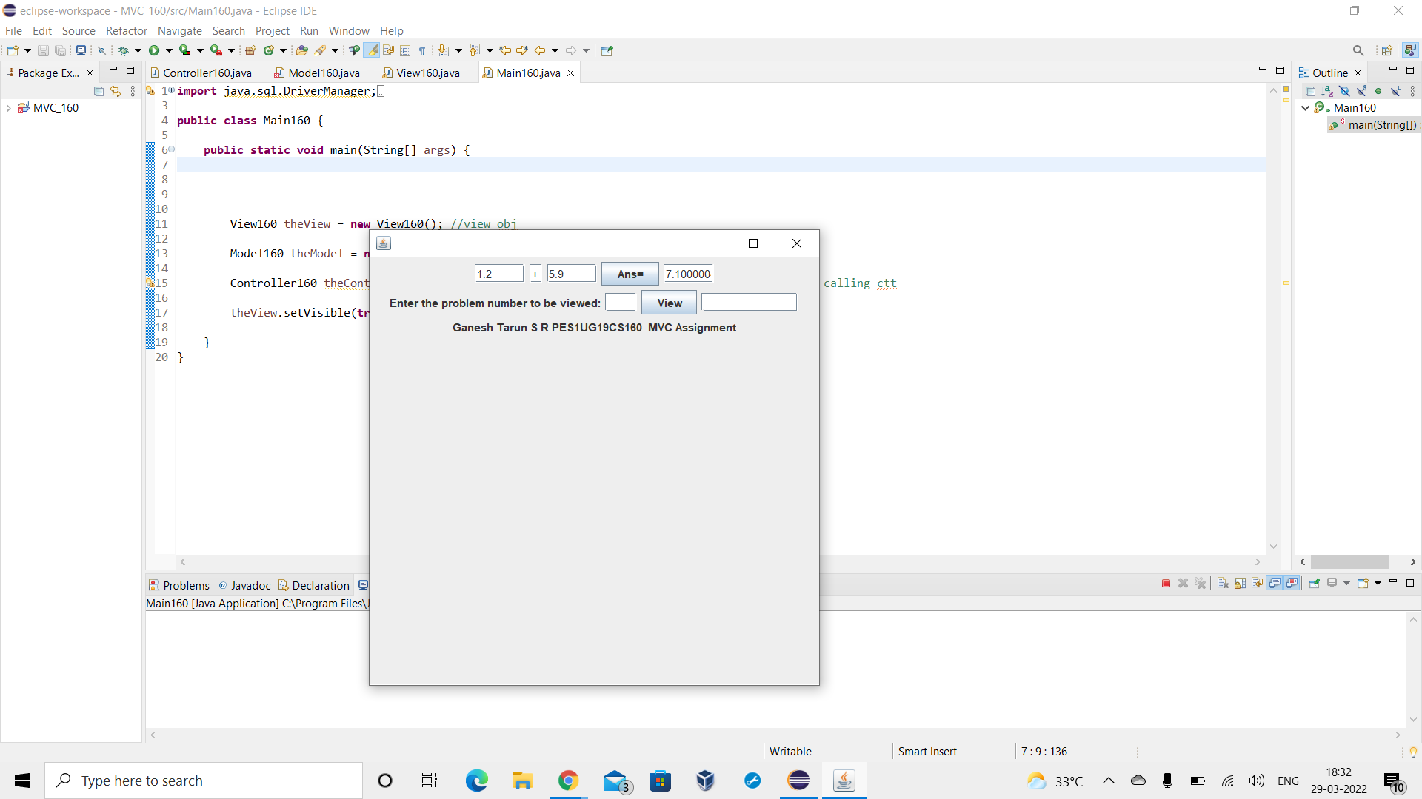

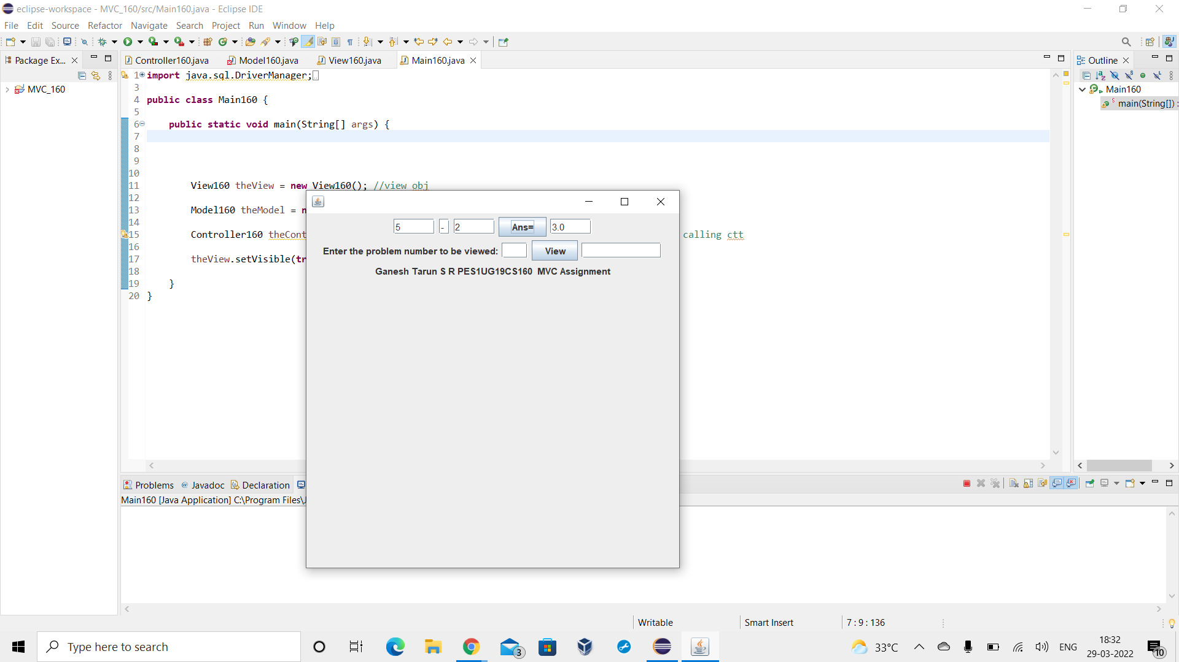

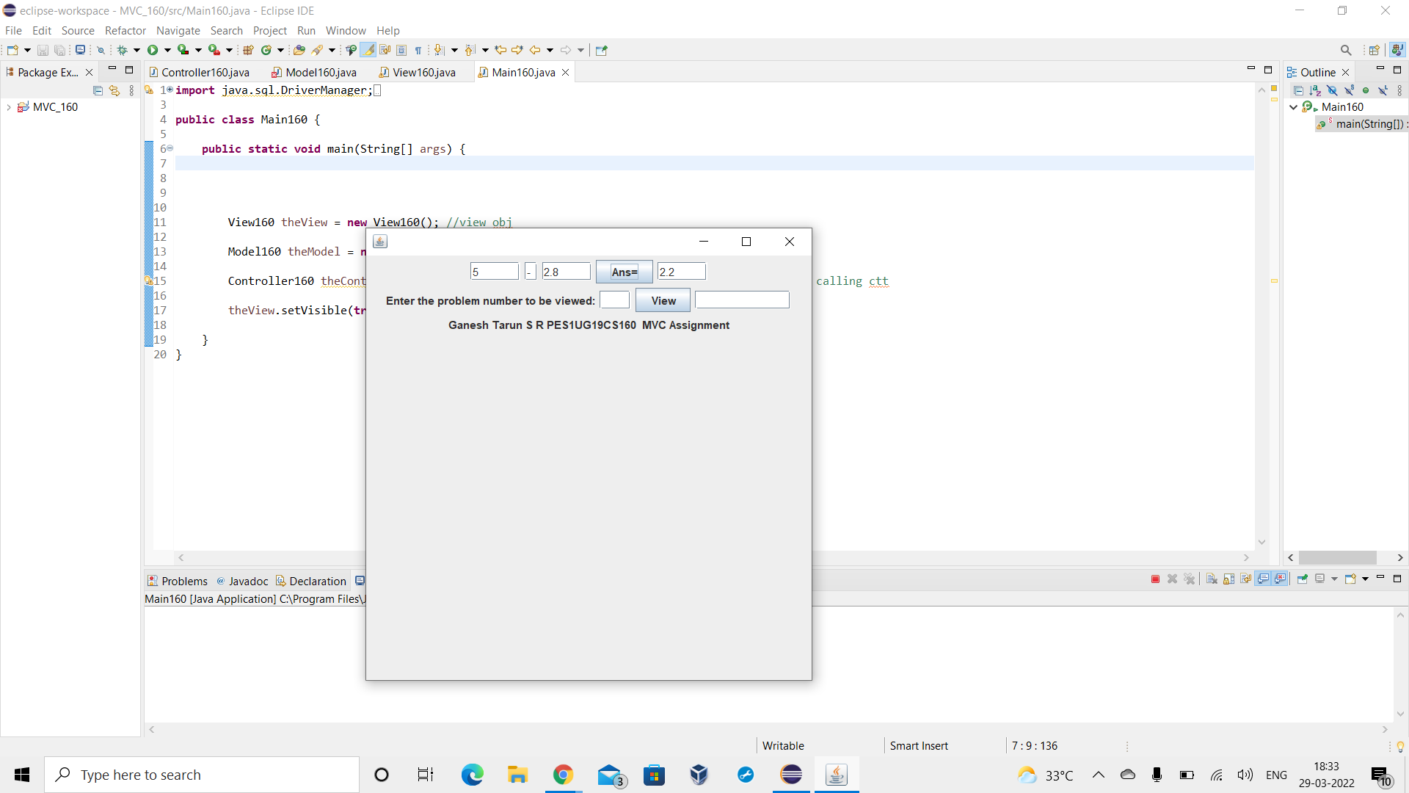

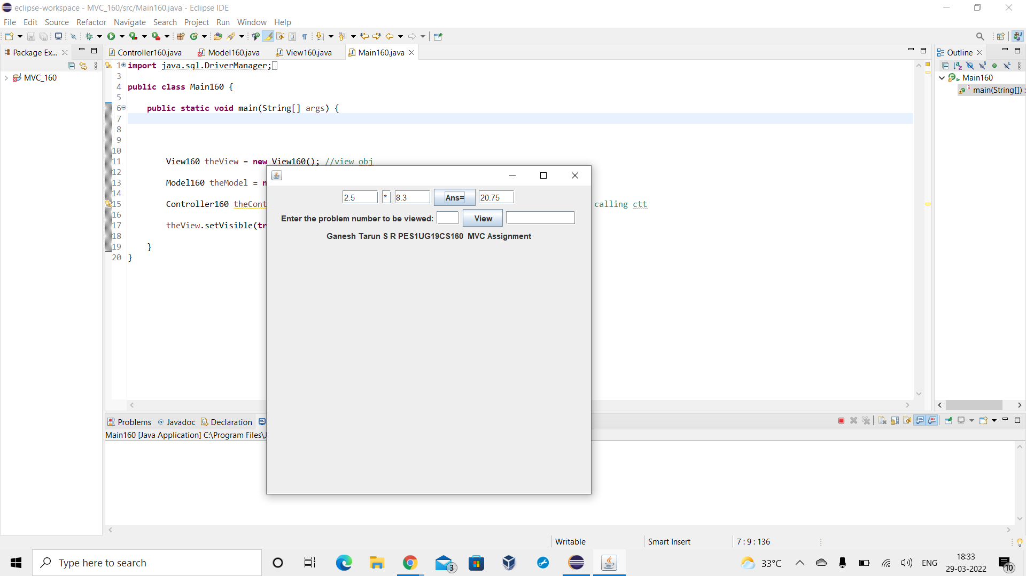

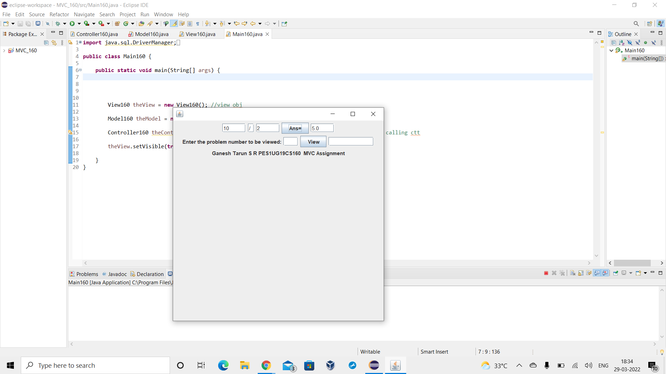

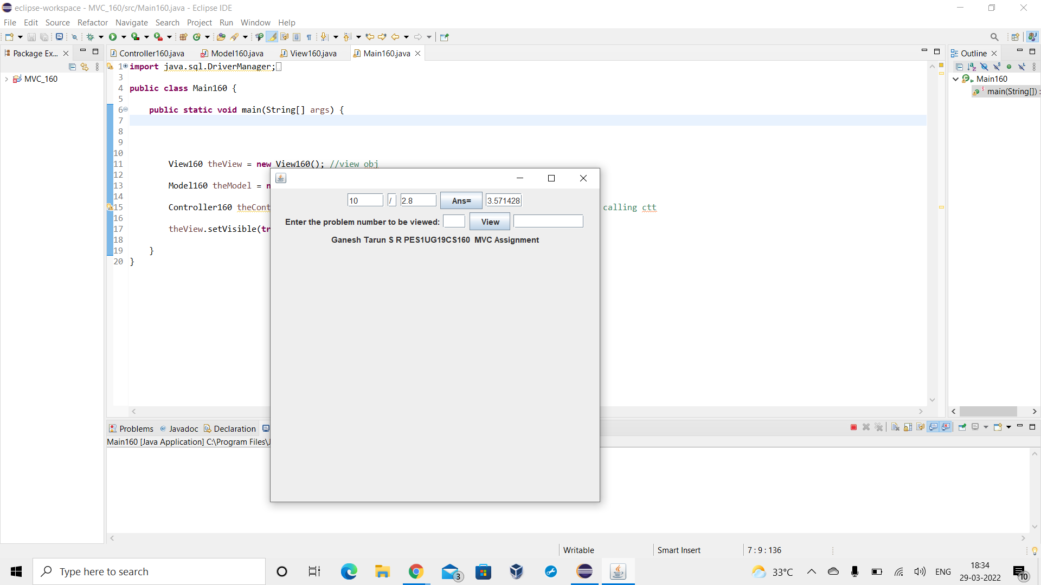

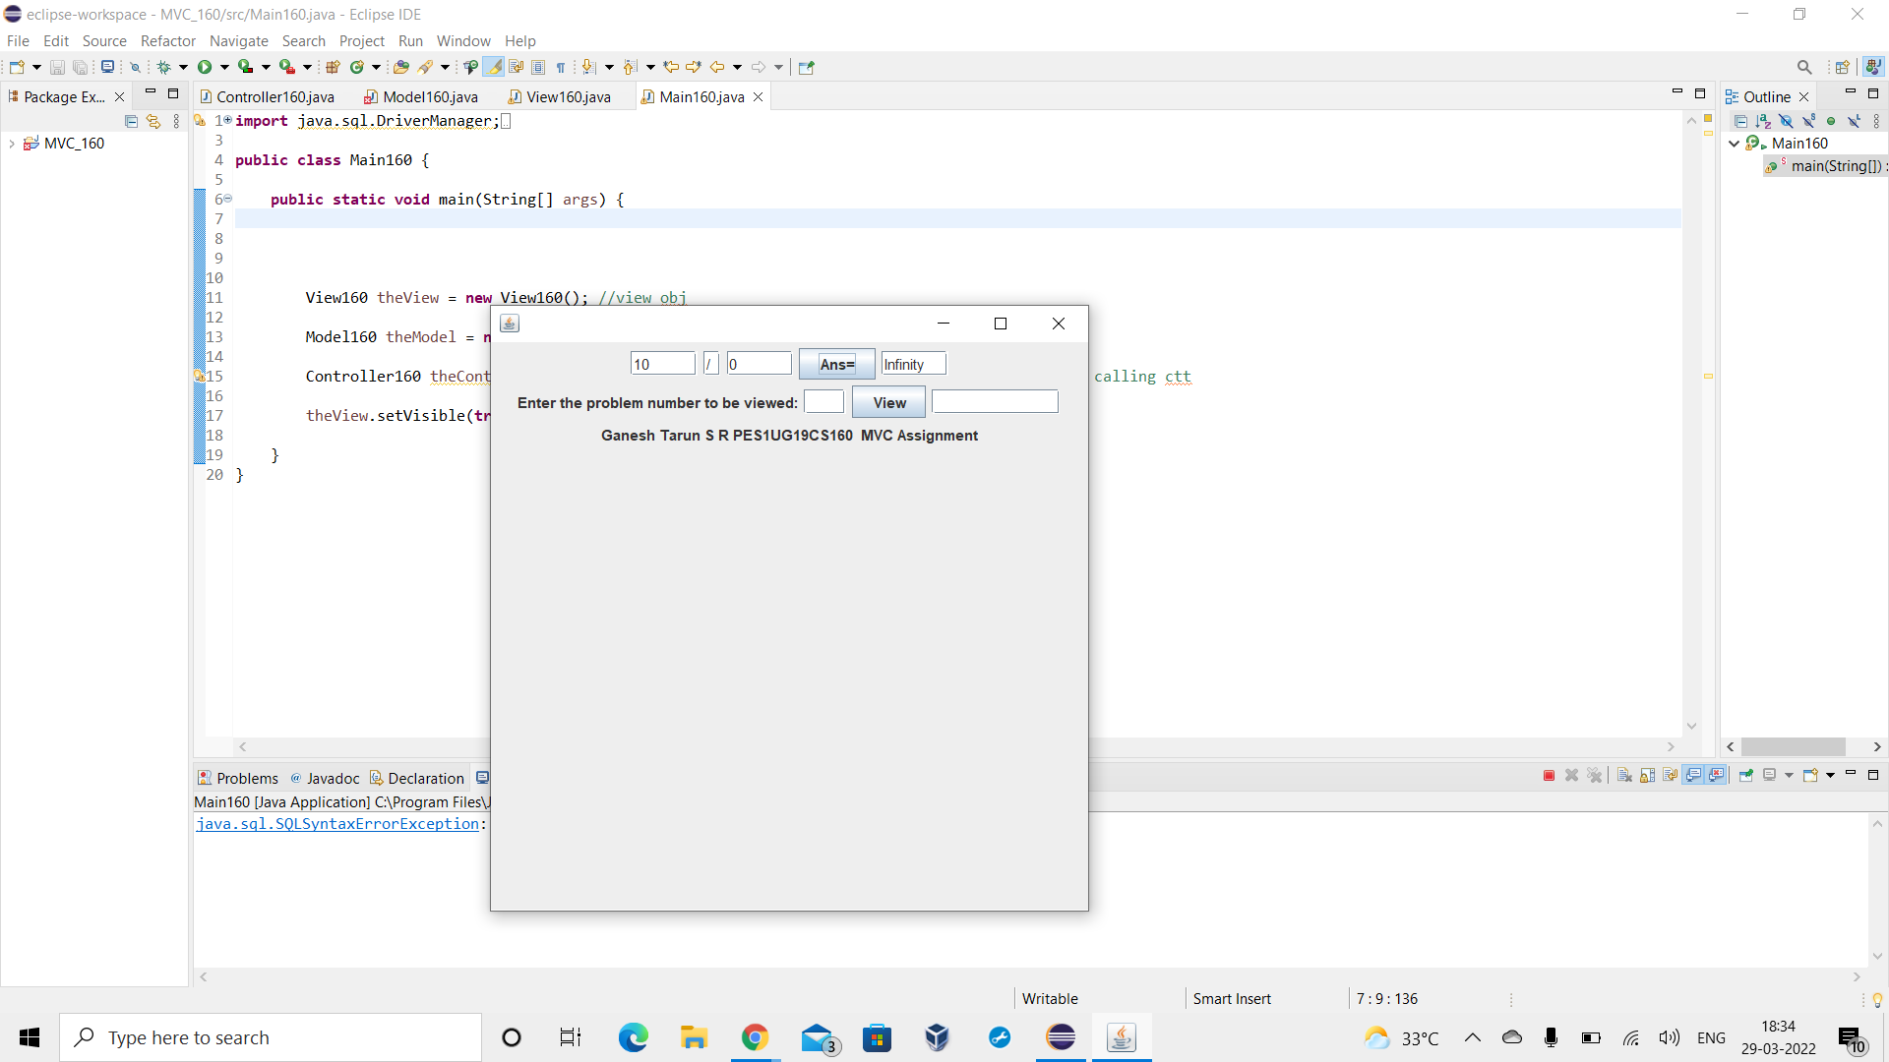

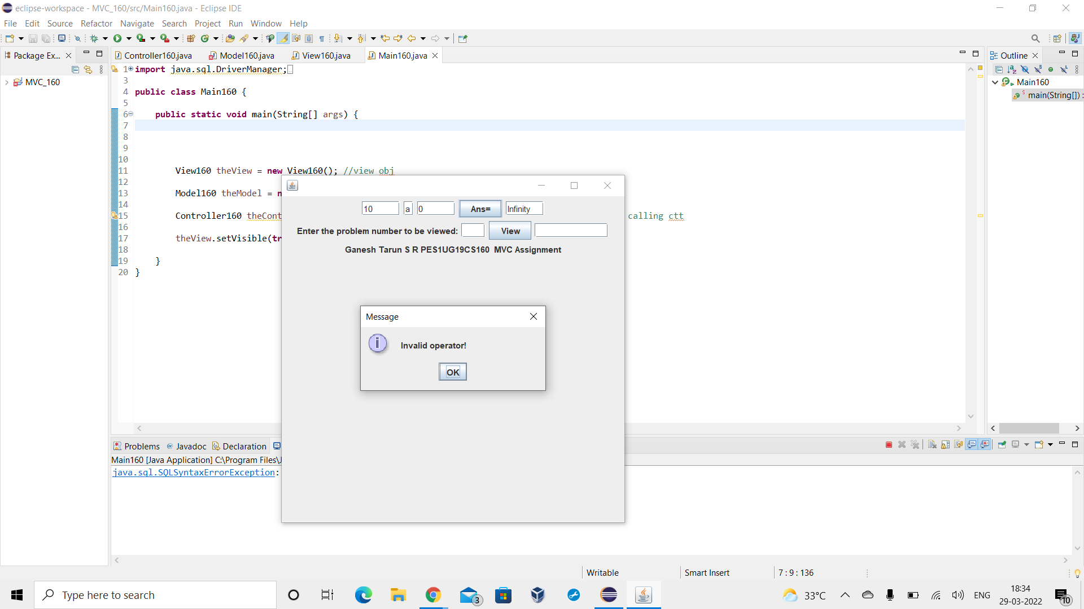

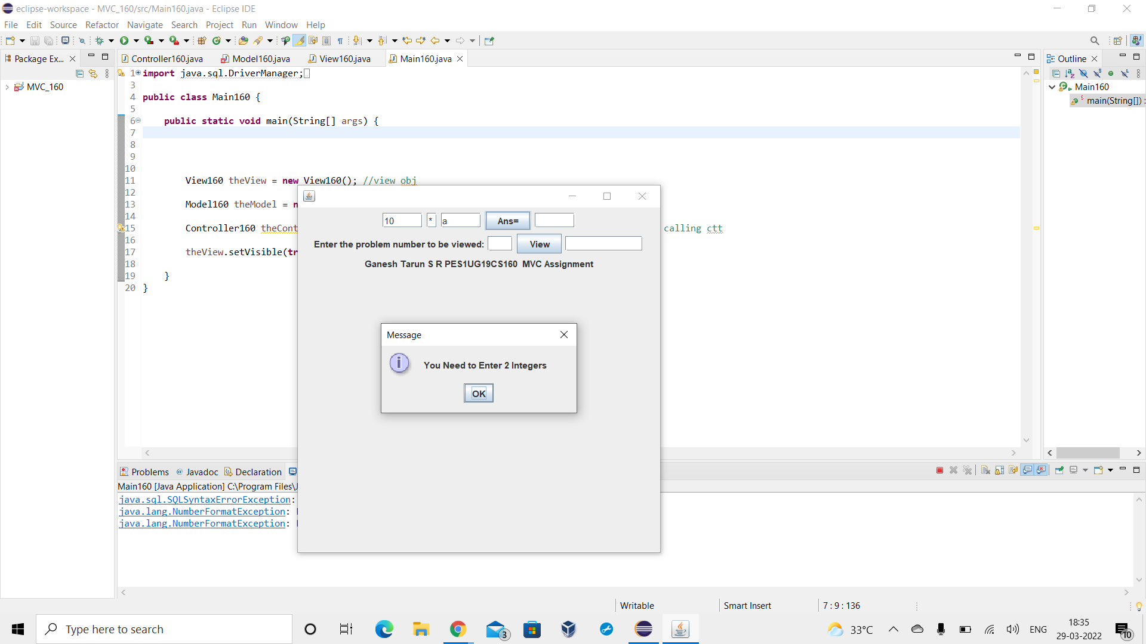

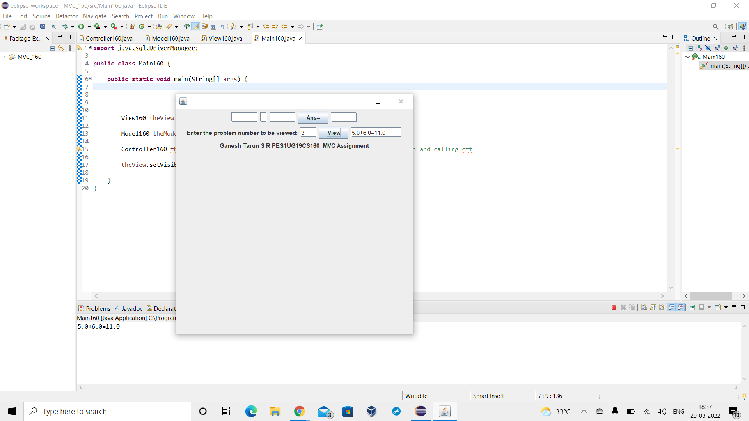

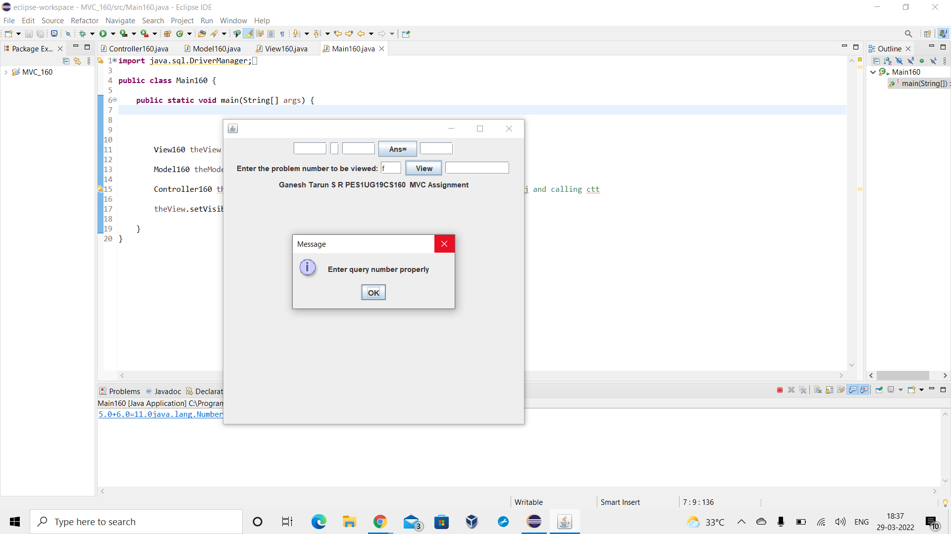

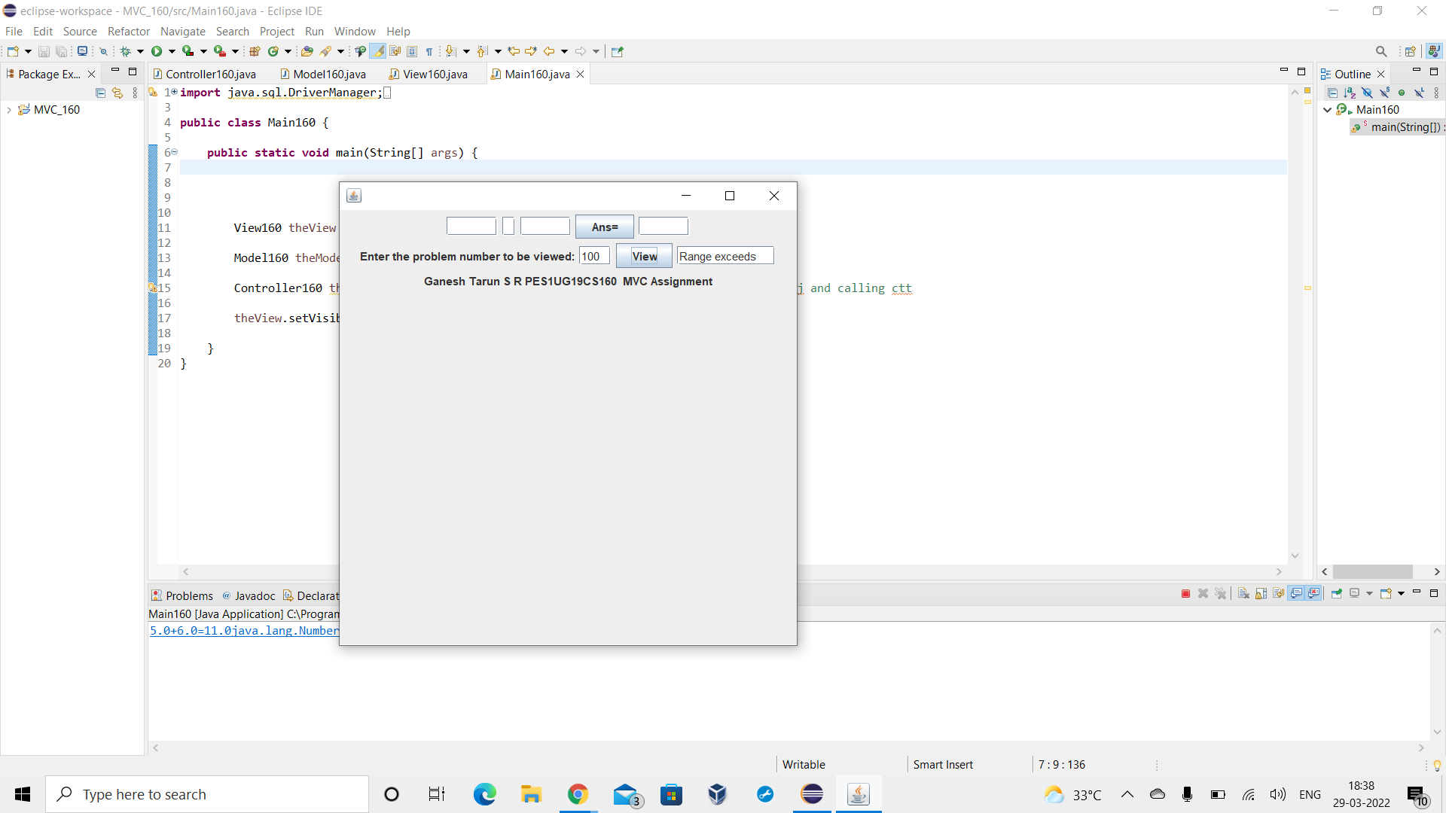

**Database:**

MySql is used in this project. Database is used to store all the problems and desired problems can be retrieved by the user from it. JDBC is used for connectivity of application with database.

**Technologies /Tools used:**

| JAVA | for application |
| --- | --- |
| MySQL | for database |
| SWING | for GUI |
| JDBC | for connectivity |
| Eclipse | IDE |