|  |  |  |  |  |  |
| --- | --- | --- | --- | --- | --- |
| BE/CO/HT  2009-06-26 | | | | | |
| Technical Note | | | | | |
| WORLDFIP INSOURCING PROJECT  NanoFIP WP3  NanoFIP  USER’S GUIDE | | | | | |
|  | | | | | |
| Authors:  E. Gousiou | | | Checked by: | |  |
|  | | | | | |
| ***History of Changes*** | | | | | |
| Rev. No. | Date | Pages | | Description of Changes | |
| 1.0 | 15-03-2011 | All | | First draft | |

Table of Contents (not compulsory, can be removed)

1 RESET inputs 5

1.1 RSTPON 5

1.2 nanoFIP internal reset 6

1.3 NANOFIP WISHBONE LOGIC RESET 6

2 Reset outputs 6

2.1 FD_RST, FIELDRIVE RESET 6

2.2 rston, user reset 6

3 WISHBONE STB and ACK 6

4 VARx_RDY signals 7

4.1 VAR1_RDY, VAR2_RDY 7

4.2 VAR3_RDY 7

5 FD_RXD and FD_RXCDN 8

6 WISHBONE interface & memories 8

7 M_ID and C_id usage 9

8 ID_DAT frames and the nanoFIP status byte 9

9 Turnaround and Silence times 9

10 nanofip device CHARACTERISTICS 10

<Page Intentionally Left Blank>

# RESET inputs

In order to reset the whole of the nanoFIP chip, the user has to activate both the **RSTIN** and the **RST_I** signals. RSTIN resets all the logic in the user 40 MHz clock domain, whereas the RST_I resets all the logic in the WISHBONE clock domain. The Power On Reset, **RSTPON** resets both “worlds”. If the operation is in stand-alone mode, RSTIN resets all the logic in use.

## RSTPON

Since in no Actel ProAsic3 documentation we could find a warrantee that all the flip-flops of the chip start at “0” right after power-up, we concluded that a Power On Reset is essential for nanoFIP. After a short survey summarized in [] we decided to use a R-C circuit that acts asynchronously and is removed synchronously.

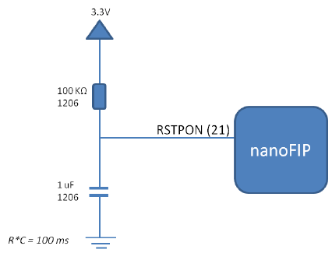

Figure : Power On Reset circuit

The RSTPON resets both the user and the WISHBONE logic, therefore the de-assertion synchronization is realised in both worlds. Two flip-flops are used for the synchronization, with the second used to remove any metastability that might be caused by the RSTPON being removed asynchronously and too close to the rising clock edge.

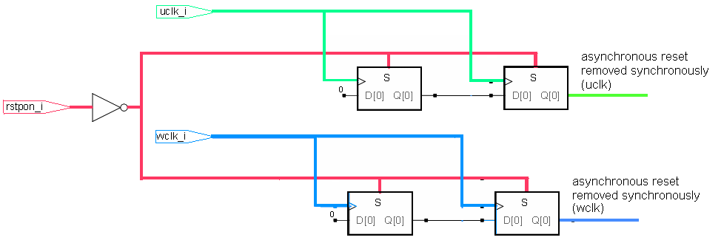

Figure : RSTPON synchronizers

*Note: The RSTPON does not activate nanoFIP’s RSTON output.*

## nanoFIP internal reset

nanoFIP logic running with the uclk is reset by:

* The RSTPON: the reset lasts for as long as the RSTPON is asserted plus 2 uclk cycles.
* The RSTIN: nanoFIP checks if RSTIN has stayed asserted for at least 8 uclk cycles and then asserts the nanoFIP internal reset for 1 uclk cycle.
* The reset variable (E0..h): nanoFIP is validating the consumed frame (in terms of Control, PDU_TYPE, Length and FCS bytes and Manchester encoding) and checks if the first byte contains the station’s address; if so, it asserts nanoFIP’s internal reset for 1 uclk cycle.

## NANOFIP WISHBONE LOGIC RESET

nanoFIP WISHBONE logic running with the wclk is reset by:

* The RSTPON: the reset lasts for as long as the RSTPON is asserted, plus 2 wclk cycles.
* The RST_I: following the WISHBONE rule 3.15 “all self-starting state machines and counters in WISHBONE interfaces MUST initialize themselves at the rising wclk edge following the assertion of RST_I. They MUST stay in the initialized state until the rising wclk edge that follows the negation of RST_I”.

# Reset outputs

## FD_RST, FIELDRIVE RESET

nanoFIP asserts the output FD_RST when:

* The RSTPON is asserted: the reset lasts for as long as the RSTPON is asserted plus 2 uclk cycles.
* The RSTIN is asserted: nanoFIP checks if RSTIN has stayed asserted for 8 uclk cycles and then asserts the FD_RST for 4 FD_TXCK cycles.
* A valid reset variable (E0..h) has been received with the first byte containing the station address: nanoFIP asserts FD_RST for 4 FD_TXCK cycles.

## rston, user reset

nanoFIP asserts the output RSTON only

* after the reception of a valid reset variable (E0..h) with the second byte containing the station address; the RSTON stays asserted for 8 uclk cycles.

# WISHBONE STB and ACK

When nanoFIP detects a rising edge on the STB_I signal, it checks:

* If the CYC_I signal is asserted and
* If the address provided ADR_I belongs to the Produced memory block and the WE_I is enabled or if the address provided belongs to the Consumed memory block and the WE_I is disabled

If so, it asserts the ACK_O for 1 wclk cycle.

Note: nanoFIP is synchronizing the WISHBONE control signals with triple buffers, therefore the ACK_O signal appears 4 wclk cycles after the STB_I rising edge.

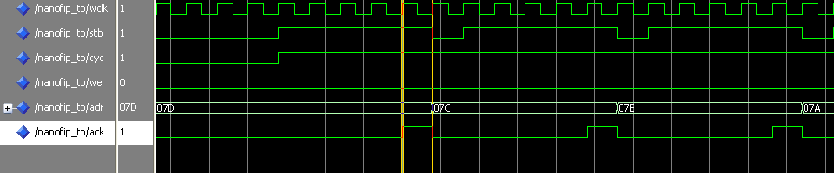

Figure : Read cycle WISHBONE control signals

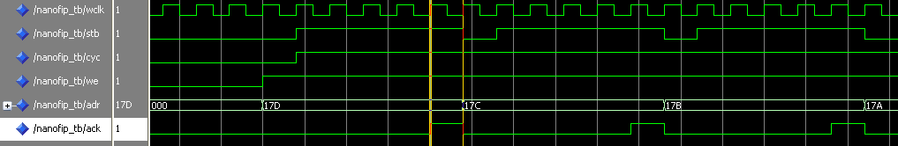

Figure : Write cycle WISHBONE contol signals

# VARx_RDY signals

## VAR1_RDY, VAR2_RDY

For the consumed variables var1 and var2, after the reception of a var1/ var2 ID_DAT, nanoFIP de-asserts the signal VAR1/2_RDY at the reception of the corresponding consumed RP_DAT FSS. After the end of the reception and the validation of the RP_DAT, nanoFIP re-asserts the VAR1/2_RDY to signal the user for the new reception.

Figure : VAR1/2_RDY handling

## VAR3_RDY

nanoFIP de-asserts the signal VAR3_RDY after the reception of a valid var3 ID_DAT. It re-asserts it at the FES delivery of the corresponding produced RP_DAT frame.

Figure : VAR3_RDY handling

# FD_RXD and FD_RXCDN

The FIELDRIVE does not provide echo cancellation, therefore in the input FD_RXD appears also what nanoFIP is putting in the line through FD_TXD.

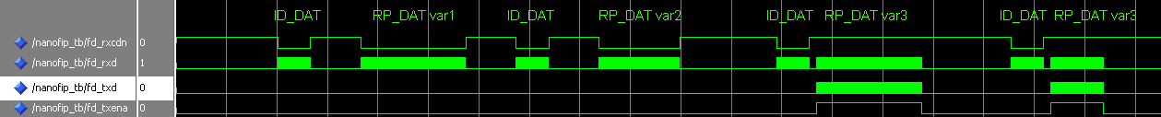

Figure : FD_RXCDN & FD_RXD nanoFIP inputs along with FD_TXD & TX_TXENA outputs

*NOTE: The reception activity signal FD_RXCDN was decided not to be used in the design, in order to make nanoFIP compatible with other transceivers too.*

# WISHBONE interface & memories

The WISHBONE signals DAT_I and ADR_I are directly connected to the nanoFIP memories.

In the case of the Produced RAM, where the user is writing bytes to the memory, the write_enable signal that is used is the ACK_O (see paragraph 3).

# ConsRAM.pngProdRAM.png

Figure : nanoFIP Memories and WISHBONE interface signals

In the case of the Consumed RAM, the DAT_O bus receives its value 1 wclk cycle after the setting of a new ADR_I.

Figure : WISHBONE reading cycle ADR_I and DAT_O signals

# M_ID and C_id usage

Each one of the four pins of the M_ID and C_ID can be connected to either Vcc, Gnd, S_ID1 or S_ID0. After 2 uclk cycles each of the pins is translated to 2 bits (Table 1) and therefore the 8 bit words for the Model and the Constructor get defined. The signals S_ID0 and S_ID1 provide 2 opposite clocks (when one is ‘0’ the other is ‘1’ and vice-versa).

|  |  |
| --- | --- |
| **M_ID, C_ID pin connected to** | **Corresponding pair of bits** |
| **Gnd** | **00** |
| **S_ID1** | **10** |
| **S_ID0** | **01** |
| **Vcc** | **11** |

Table : Options for M_ID/ C_ID pins and corresponding bits translation

The following examples clearify the concept:

|  |  |  |  |  |
| --- | --- | --- | --- | --- |
| **Model Word** | **M_ID[3]** | **M_ID[2]** | **M_ID[1]** | **M_ID[0]** |
| **00000000** | Gnd | Gnd | Gnd | Gnd |
| **00000001** | Gnd | Gnd | Gnd | S_ID0 |
| **00000101** | Gnd | Gnd | S_ID0 | S_ID0 |
| **00001010** | Gnd | Gnd | S_ID1 | S_ID1 |
| **11010110** | Vcc | S_ID0 | S_ID0 | S_ID1 |

Table : Examples of Model words with their M_ID[] pins configuration

# ID_DAT frames and the nanoFIP status byte

It is important to note that the bits 4 and 5 of the nanoFIP status byte refer only to consumed RP_DAT frames. nanoFIP is not providing information of errors that may have been detected in ID_DAT frames. Wrong ID_DAT frames are just neglected.

# Turnaround and Silence times

Turnaround is the time that nanoFIP waits after the reception of a valid presence or identification or variable3 ID_DAT before it starts delivering the corresponding RP_DAT.

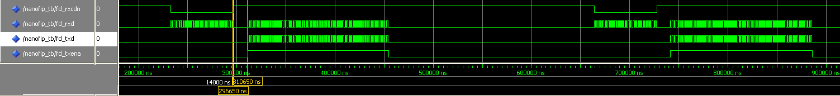

Figure : nanoFIP Turnaround time (1 MHz)

Silence time is the maximum time that nanoFIP waits for an RP_DAT after the reception of a valid variable 1 or 2 or reset ID_DAT. nanoFIP goes back to idle state if the silence time has expired and no FSS has arrived.

# nanofip device CHARACTERISTICS

Figure : nanoFIP Silence time (1 MHz)

nanoFIP is housed in an ACTEL ProASIC3 device with the following characteristics:

|  |  |
| --- | --- |
| **Family** | **ProASIC3** |
| **Die** | **A3P400** |
| **Packaging** | **208 PQFP** |
| **Speed** | **-2** |
| **Die Voltage** | **1.5** |
| **I/O Attributes** | **LVTTL** |
| **Junction Temperature** | **COM** |